SeqGraphInfer: An algorithm for inferring gene function by integrating sequence similarity embeddings and graph-based embeddings

by

NILESH KUMAR AND SAHID MUKHTAR

In preparation for Micromachines

Format adapted for dissertation

SeqGraphInfer: An algorithm for inferring gene function by integrating sequence similarity embeddings and graph-based embeddings

Abstract: Gene functional inference is a crucial step in understanding the biological role of genes and their contribution to the overall functioning of organisms. This knowledge is essential for various applications such as drug development, disease diagnosis, and an improved understanding of the fundamental mechanisms of life. Additionally, functional inference can help to annotate and interpret the vast amount of genomic data generated by modern sequencing technologies. It is widely accepted that functionally related genes tend to co-express together and have similar sequences. Co-expression suggests that genes that co-express may have similar or related functions. On the other hand, sequences which share similar sequences may have a common evolutionary origin, tend to have similar functions. Both co-expression and sequence similarity can provide valuable insights into the functional relationships between genes. Co-expression can indicate that two genes are involved in the same or related biological processes or pathways, while sequence similarity can indicate that two genes have similar functions due to a common evolutionary origin. Thus, we propose SeqGraphInfer for gene function inference. Our algorithm combines sequence similarity embeddings with graph-based representations to infer gene function. We applied SeqGraphInfer to 3 co-expression networks and were able to identify functionally related genes.

Introduction
Gene function inference is the process of determining the biological function of a gene based on its genetic and molecular characteristics. The ultimate goal of gene function inference is to gain a deeper understanding of the biology of organisms and how different genes contribute to the development and physiology of the organism [1-3].
One common approach to gene function inference is comparative genomics, which involves comparing the genetic sequences of different organisms to identify conserved regions that likely have a functional role. For example, if a particular gene is present and highly conserved across a wide range of organisms, it is likely to play an essential role in the biology of those organisms [3].
Another approach is to use experimental methods to directly study a gene's function. For example, genetic manipulation techniques such as knockouts and overexpression can be used to study the effects of a gene on an organism's development or physiology. Knockout refers to the deletion or inactivation of a specific gene in an organism, and overexpression refers to the introduction of multiple copies of a gene into an organism. These techniques can provide insights into the role of a gene in normal physiology and can also be used to study the effects of the gene in disease conditions [4].
Biochemical assays can also be used to study the function of a gene's encoded protein, such as by measuring its enzymatic activity or its ability to bind to other molecules. Proteins are known to have specific activity, such as enzymes, receptors, and transcription factors. These functional assays can help infer a gene's function based on its protein product's activity [5].

A third approach is to use bioinformatics and computational biology to infer gene function. This includes data mining, sequence similarity searches, machine learning, and graph-based methods [6].

Sequence similarity searches are one of the most commonly used methods for functional gene inference. This method compares a gene sequence to other known gene sequences to find similarities. If the gene sequence is similar to a known gene, then it is assumed that the gene has identical functions to the known gene. This method is helpful for inferring gene function in closely related organisms [7, 8].

Machine learning approaches are also used for gene function inference. This method collects data from various sources, such as gene expression data, protein-protein interactions, and metabolic pathways. This data is then used to develop a machine-learning model to predict a gene's function. Machine learning models can be trained to identify patterns in the data associated with a gene's functions [9-14].

Graph-based approaches are used to infer gene function by connecting genes together into a network. Genes connected in the network are assumed to be related and have similar functions. This method can be used to identify novel gene functions or to confirm known functions [15, 16].

In addition to these methods, there are also methods for inferring gene function by combining sequence similarity searches and graph-based approaches. These methods are known as "integrative approaches" and combine the results of multiple methods to make more accurate gene function predictions [8].

The integrative approach for gene function inference combines the results of multiple methods to make more accurate gene function predictions. These methods involve combining sequence similarity searches, machine learning, and graph-based approaches. For example, the Pathprint [17] algorithm combines gene expression profiles, pathway annotation, and prediction with large-scale profiling to create a global pathway activation map. This map compares expression profiles across species and platforms and identifies functionally matched samples.

Overall, gene functional inference is an essential tool for understanding the role of genes in various biological processes. Integrative approaches combine the results of multiple methods to make more accurate gene function predictions.

Thus, we propose SeqGraphInfer an integrative approach for gene function inference. Sequence similarity embeddings and graph-based representations are combined to infer gene function in our proposed algorithm. Sequence similarity embeddings were performed using hhsuite3 [18] (databases: UniRef30_2022_02_hhsuite) and MSA Transformer [19-21]. Further, the graph embeddings were obtained using the GraphSage (Graph Sampling and Aggregating) model [22-25]. An overview of the SeqGraphInfer workflow is described in Figure 1.

Multiple Sequence Alignment (MSA) embedding is a technique used in bioinformatics that involves representing biological sequences as numerical vectors, also known as embeddings [19]. These embeddings are learned using machine learning techniques such as neural networks and can capture the underlying structural and evolutionary information of the sequences in the MSA. MSA embedding aims to learn a representation of the sequences that is more informative than the raw sequences, which can then be used for various downstream tasks.
One of the main advantages of MSA embedding is that it can analyze distantly related sequences [18]. Traditional sequence-based methods such as sequence alignment are often unreliable when the sequences are distantly related, as the evolutionary distances between the sequences can be large. On the other hand, MSA embeddings can capture the evolutionary relationships between the sequences even when they are distantly related. By representing the sequences in a high-dimensional space, MSA embeddings allow comparing sequence similarity and conservation between different sequences.
MSA embeddings can be used for various downstream tasks, such as predicting protein function, folding, and interactions [20]. In the context of protein function prediction, MSA embeddings have been shown to improve the performance of prediction models by capturing the evolutionary information of the sequences in the MSA. In the context of protein folding, MSA embeddings have been used to predict the 3D structure of proteins by leveraging the evolutionary relationships between the sequences in the MSA [21, 26-28].
MSA embedding is also helpful for phylogenetic analysis, which studies evolutionary relationships between species. MSA embeddings can be used to analyze the evolutionary relationships between different sequences in a multiple-sequence alignment, allowing for the identification of conserved regions and the reconstruction of evolutionary history [26].

GraphSage is a representation learning method for graph-structured data. It is a neural network-based approach that learns low-dimensional embeddings (vectors) for the nodes in a graph. These embeddings capture the structural and semantic information of the graph and can be used for various downstream tasks such as node classification, link prediction, and graph clustering .
The main idea behind GraphSage is to learn a representation of the nodes in a graph that captures the relationships between the nodes, known as the graph structure. To do this, GraphSage uses a neural network architecture known as a "graph convolutional network" (GCN). This architecture is designed to propagate information between the nodes in the graph and learn a representation of each node that captures the relationships between the node and its neighbors [25].
GraphSage can be applied to various graph-structured data, such as social networks, biological networks, and knowledge graphs. In biological networks, GraphSage can be used to learn embeddings of the nodes (i.e., proteins) that capture their relationships with other proteins.
One of the main advantages of GraphSage is that it can handle large and sparse graphs. Traditional graph-based methods such as matrix factorization are often not practical for large and sparse graphs, as they require storing and manipulating a dense matrix of pairwise similarities between the nodes. GraphSage, on the other hand, can handle large and sparse graphs by only propagating information between the nodes directly connected in the graph.
To ensure the integration of sequence similarity and graph embeddings, MSA embeddings were used as node features when training the GraphSage model. Curation and validation of functional annotations are also essential aspects of gene function inference. To validate the functional enrichment analysis, we used Metascape [29].

Materials and Methods
This study's expression datasets were based on the Affymetrix platform GPL198 of Arabidopsis thaliana plant species and have a specific treatment focus, GSE50966 [30](limiting Nitrogen), GSE22966 [31] (NO3- heterogeneous environment), GSE15189 [32](Iron Deficiency), and GSE9719 [33] (hypoxia and reoxygenation). The Pearson Correlation Coefficient (PCC) method was used to construct the co-expression network.
To calculate the PCC for a co-expression network, the expression levels of the genes are first measured using techniques such as microarray or RNA sequencing [34]. The PCC is then calculated for all pairs of genes in the network using the following formula:
PCC = (n * Σxy - Σx * Σy) / √((n * Σx^2 - (Σx)^2) * (n * Σy^2 - (Σy)^2)), | (1)

Where:
x and y are the expression levels of two genes
Σx and Σy are the sums of the expression levels of all genes
Σxy is the sum of the product of the expression levels of all gene pairs
n is the number of samples
The PCC values can then be used to create a correlation matrix, which can be used to construct the co-expression network. High PCC values (close to 1 or -1) indicate a strong correlation between the corresponding genes' expression levels and their connection in the network. Low PCC values (close to 0) indicate weak correlation, and the corresponding genes are not connected in the network. Among other methods, WGCNA [35] is a popular choice for co-expression network construction. WGCNA is a hierarchical and multi-scale method that uses a topological overlap measure (TOM) to quantify the similarity between the gene expression profiles.
Moreover, all network exhibit scale-free property and follows the power-law distribution. The scale-free property of co-expression networks results from the underlying biological processes that govern gene expression [36] (Figure 2b, 2c, 2d and 2e). It is thought that a small number of "hub" genes play a central role in regulating the expression of many other genes, resulting in a highly connected sub-network of hub genes. The power-law distribution is characterized by a scaling exponent, typically between 2 and 3 for scale-free networks. This means that the number of nodes with k connections (or degree k) is proportional to k^(-γ), where γ is the scaling exponent. This results in a "long tail" in the degree distribution, where a small number of nodes have many connections, and most nodes have relatively few connections.

TAIR database [37] was used to download the protein sequences for all genes in the co-expression network. HHpred (HH-suite3 [18]) homology analysis tool and the Uniclust30 database cluster of UniProtKB sequences were to perform homology analysis using HHpred. HHpred is a sensitive and specific method for protein homology detection. The results of HHpred are typically saved in a file format called ".a3m" (aligned multiple sequence alignment in FASTA format). This file contains the multiple sequence alignment of the query protein sequence with similar sequences identified in the database (Uniclust30). If protein alignment is too long, the sequence needs to be split into smaller fragments, as MSA-transformers [19] does not support longer sequences. The MSA-transformers from the bio-transformers (v0.1.14) package (DeepChainBio; deepchain-apps [38]) is a tool used to convert the multiple sequence alignment in the “.a3m” file into a numerical representation, "MSA embeddings". MSA embeddings represent the multiple sequence alignment in a numerical format that can be used as input for deep learning or machine learning models. The MSA-transformers tool uses a neural network-based approach to convert the multiple sequence alignment into a fixed-length vector representation of the sequences. Further, MSA embeddings were used as a feature for nodes of the co-expression networks.
Unsupervised GraphSAGE, a neural network model implementation, was used from the StellarGraph [39] python library to learn the embeddings of each co-expression network containing MSA embeddings as node features. In this step, for a co-expression network, embeddings were learned using only graph structure and MSA embeddings (node features) without considering any known node class labels such as gene functions.
The main idea behind GraphSAGE is to learn a low-dimensional embedding of the nodes in a graph by sampling and aggregating the representations of the node's neighborhood. The model is trained to predict the representations of the nodes' neighborhoods given the representation of the node.
The model consists of two main components: a Graph Convolutional Network (GCN) [40] and a pooling layer. The GCN is used to propagate the representation of the node to its neighborhood. The pooling layer aggregates the neighborhood representations into a fixed-length vector representation of the node.
The model is trained by sampling subgraphs from the original graph and training the GCN to predict the representations of the sampled subgraphs. During the training process, the model learns to identify the most critical features of the graph structure, which are then used to generate the low-dimensional embeddings of the nodes.
The unsupervised GraphSAGE model can be used in applications such as node classification, link prediction, community detection, and similarity searches.
Given a list of the domain-specific known gene list and graph embedding, similar genes were enlisted using cosine similarity. Cosine similarity is a measure of similarity between two non-zero vectors of an inner product space that measures the cosine of the angle between them. In the scikit-learn library, cosine similarity is a measure of similarity between two non-zero vectors, and it is calculated as the dot product of two vectors divided by the product of their magnitudes.
In scikit-learn [41], the cosine similarity can be calculated using the cosine_similarity() function from the metrics module. This function takes a matrix or a 2D array-like object as an input and returns an array of cosine similarity values between the input rows. The closer the cosine similarity is to 1, the more similar the genes are the closer it is to 0, the more different the genes are.

Results
The computational validation of protein function prediction is a challenging task due to the complexity of proteins and their interactions within the cell. Protein function prediction methods often rely on bioinformatics techniques such as sequence alignment, homology modeling, and machine learning, which can have limitations and errors. Additionally, proteins can have multiple functions and can be involved in various biological processes, making it difficult to accurately predict their specific function. Experimentally validating the predictions made by computational methods is essential in order to increase their reliability and accuracy. GO term enrichment analysis is a commonly used method for computational validation of protein function prediction.
GO term enrichment analysis determines whether the predicted proteins are significantly over-represented in a particular GO category or term. The validation involves comparing the observed number of predicted proteins in a GO term to the expected number of proteins based on the entire genome or proteome. A significant over-representation of predicted proteins in a particular GO term would provide evidence that the predicted function for those proteins is likely to be correct. Based on the list of known proteins (products of genes in co-expression networks), SeqGraphInfer predicts similar proteins that are likely to be involved or contribute to a biological process. Moreover, SeqGraphInfer predicts similar genes for a given domain-specific gene list, and for similarity search, it used the cosine-similarity score, where most similar genes are assigned with a score close to 1. another aspect is to use a cutoff to select only specific gene from the gene predicted similar gene list. To check the effects of these two parameters, a combination of the similarity score and the number of top genes was used (Figure 2a).
For each co-expression network, GSE22966 (NO3- heterogeneous environment), GSE15189 (Iron Deficiency), and GSE9719 (hypoxia and reoxygenation), 39, 15, 5 known domain-specific genes were used, respectively. Using SeqGraphInfer, 350, 187, and 50 similar genes were predicted for co-expression networks of GSE22966, GSE15189, and GSE9719, respectively. Further predicted gene lists were used for GO enrichment analysis using Matascape (Figure 3a) [29]. Further, a non-domain-specific known gene list was used to predict similar genes (Figure 3b).
4. Discussion
Authors should discuss the results and how they can be interpreted from the perspective of previous studies and of the working hypotheses. The findings and their implications should be discussed in the broadest context possible. Future research directions may also be highlighted.
The environment plays a critical role in shaping the development and expression of an individual's genetic makeup. The interactions between an organism's genotype and the conditions in which it grows and matures, known as the genotype-environment interaction, can lead to a wide range of phenotypic outcomes. This can include differences in physical characteristics, behavior, and disease susceptibility (18048301).
The environment can also affect the expression of genes by modulating the activity of transcription factors, which are molecules that control the activity of genes. This is known as epigenetics, which studies heritable changes in gene function that do not involve changes to the underlying DNA sequence.
The phenotype being a product of genetic and environmental factors is essential to consider when predicting and validating protein function, as the same protein can have different functions depending on the environmental and developmental context. This highlights the complexity of understanding the actual function of a protein and the need for a multidisciplinary approach to study the genotype-environment interaction. Therefore, it is intuitively expected that one protein is involved in different functions.
Furthermore, since an organism's expression profile changes over time, the co-expression network may also change over time, for example, during a disease's progression. Therefore, the co-expression network can be considered a quasi-state network, as it can change over time and place, depending on the cell conditions. Similarly, the Protein-Protein network (PPI) is complex and a quasi-state, meaning that it is not a fixed state; it can change over time and place, depending on the cell conditions. PPI network and co-expression network construction can be challenging and require different data types and methods. But with plenty of high-throughput data available for a wide variety of experimental conditions, it is comparatively easy to construct a co-expression network as compared to a PPI network. Moreover, PPI databases only sometimes provide experimental conditions. Therefore co-expression is the perfect choice for studying the dynamic interplay between biomolecular entities and the dynamic nature of protein function. Graph-based representations, on the other hand, represent the relationships between genes in a cell, such as co-expression relationships. This information is valuable to infer the function of a protein based on the functions of the proteins with which it interacts or is co-expressed. Combining these two types of representations provides a more comprehensive view of the relationships between proteins and can increase function prediction accuracy. For example, a protein that is similar in sequence to a known protein with a well-established function and interacting with other proteins known to be involved in a specific pathway is more likely to have a similar function.
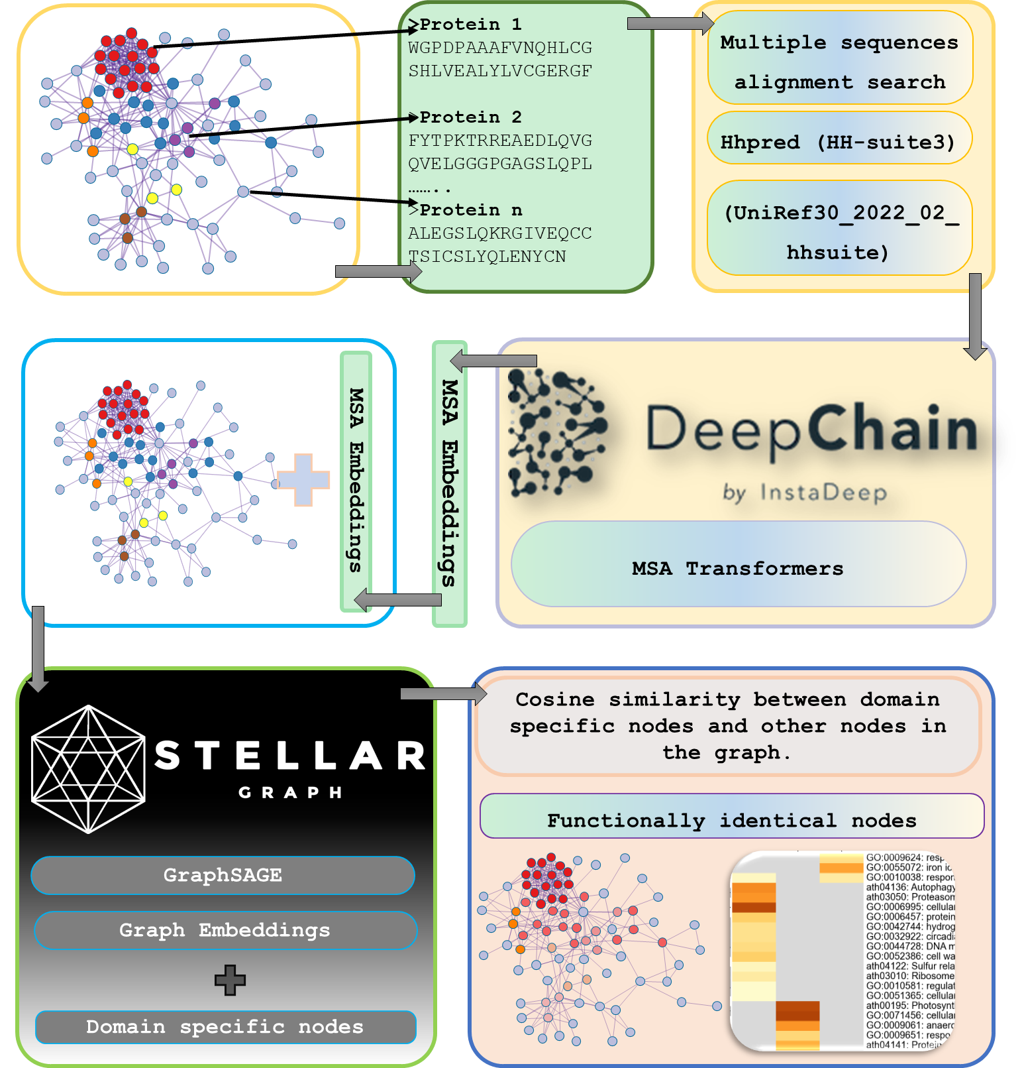

Figure 1: Workflow of SeqGraphInfer. SeqGraphInfer using sequence similarity embeddings and graph embeddings to learn graph representation to predict function of genes involved in specific biological function.
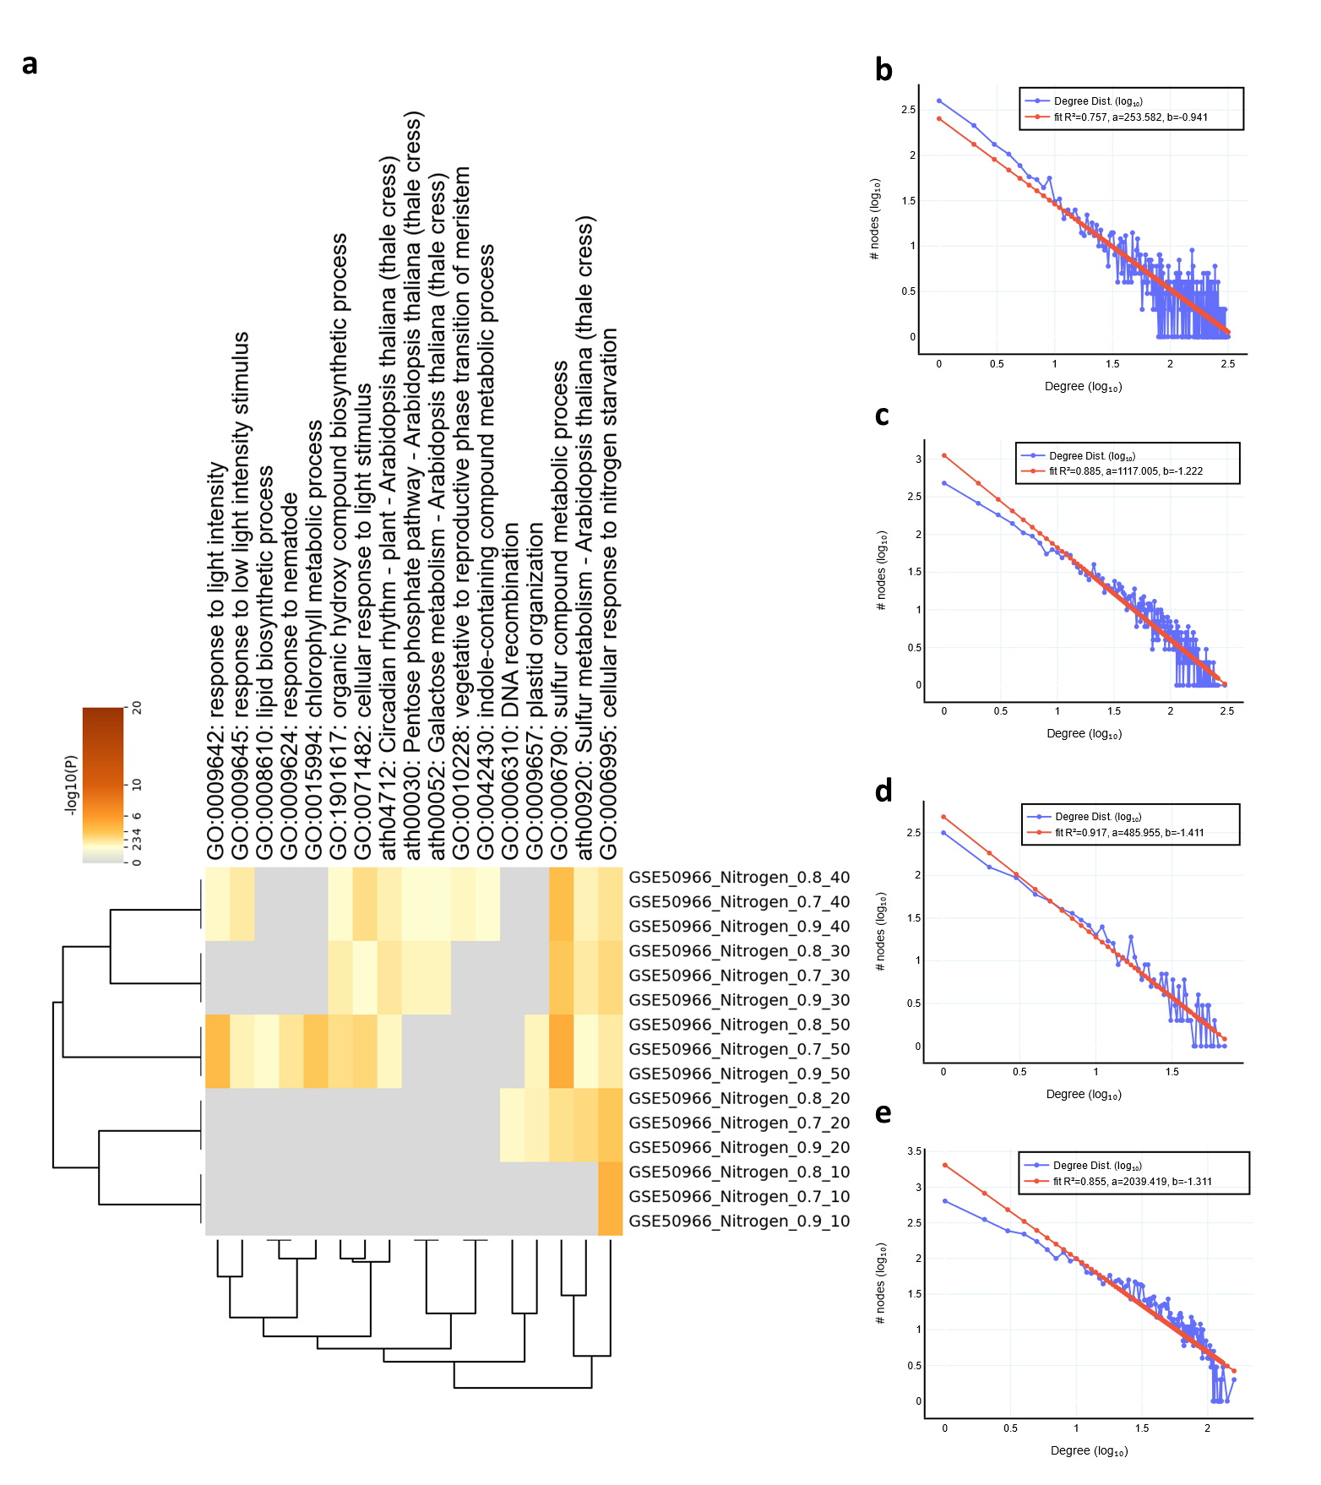

Figure 2: A combination of the similarity score and the number of top genes parameters is used to check the effects on prediction and enrichment analysis (a). The scale-free property of co-expression networks results from the underlying biological processes that govern gene expression (b, c, d and e) for co-expression of GSE50966, GSE22966, GSE15189 and GSE9719 expression datasets.
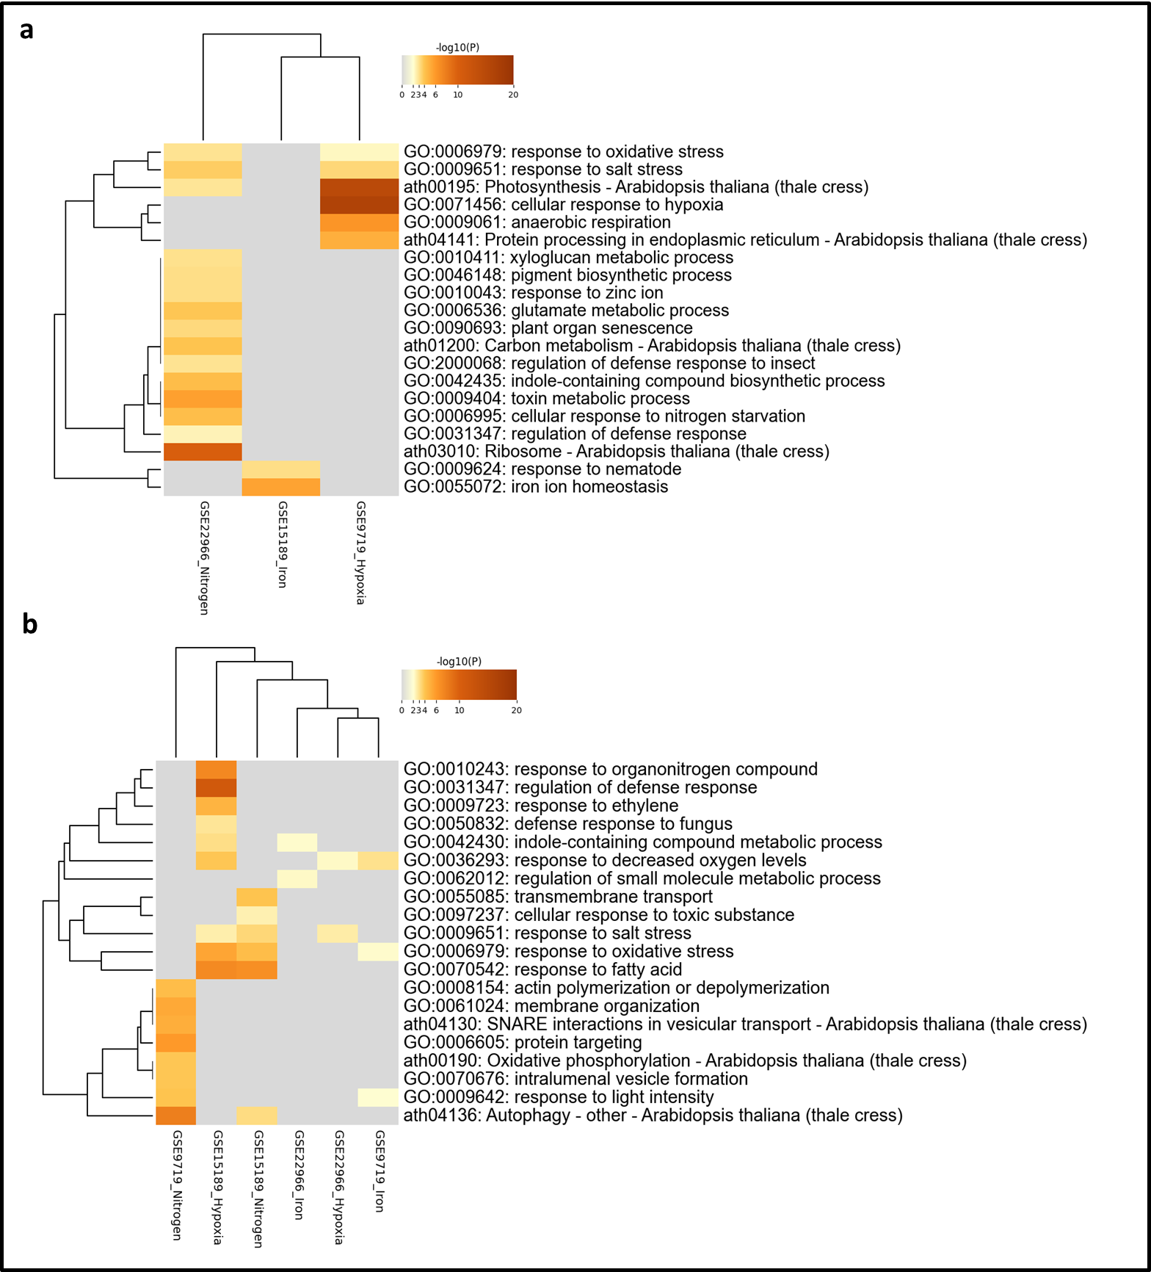

Figure 3: GO enrichment analysis of predicted gene lists (a). GO enrichment analysis of predicted gene using a non-domain-specific known gene list (b).
References

1. Mabbott, N.A., et al., An expression atlas of human primary cells: inference of gene function from coexpression networks. BMC Genomics, 2013. 14(1): p. 632.
2. Enault, F., et al., Phydbac2: improved inference of gene function using interactive phylogenomic profiling and chromosomal location analysis. Nucleic Acids Research, 2004. 32(suppl_2): p. W336-W339.
3. Zhang, P., et al., PhyloGenes: an online phylogenetics and functional genomics resource for plant gene function inference. Plant Direct, 2020. 4(12): p. e00293.
4. Rhee, S.Y. and M. Mutwil, Towards revealing the functions of all genes in plants. Trends Plant Sci, 2014. 19(4): p. 212-21.
5. Pegg, S.C., et al., Leveraging enzyme structure-function relationships for functional inference and experimental design: the structure-function linkage database. Biochemistry, 2006. 45(8): p. 2545-55.
6. Hu, P., et al., Computational prediction of cancer-gene function. Nat Rev Cancer, 2007. 7(1): p. 23-34.
7. Piovesan, D., et al., INGA: protein function prediction combining interaction networks, domain assignments and sequence similarity. Nucleic Acids Res, 2015. 43(W1): p. W134-40.
8. Yunes, J.M. and P.C. Babbitt, Effusion: prediction of protein function from sequence similarity networks. Bioinformatics, 2019. 35(3): p. 442-451.
9. Bernardes, J.S. and C.E. Pedreira, A review of protein function prediction under machine learning perspective. Recent Pat Biotechnol, 2013. 7(2): p. 122-41.
10. Faraggi, E. and A. Kloczkowski, A global machine learning based scoring function for protein structure prediction. Proteins, 2014. 82(5): p. 752-9.
11. Bonetta, R. and G. Valentino, Machine learning techniques for protein function prediction. Proteins, 2020. 88(3): p. 397-413.
12. Yan, T.C., et al., A systematic review of state-of-the-art strategies for machine learning-based protein function prediction. Comput Biol Med, 2022. 154: p. 106446.
13. Mittal, S., S. Manna, and B. Pathak, Machine Learning Prediction of the Transmission Function for Protein Sequencing with Graphene Nanoslit. ACS Appl Mater Interfaces, 2022. 14(46): p. 51645-51655.
14. Mahood, E.H., L.H. Kruse, and G.D. Moghe, Machine learning: A powerful tool for gene function prediction in plants. Appl Plant Sci, 2020. 8(7): p. e11376.
15. Nabieva, E., et al., Whole-proteome prediction of protein function via graph-theoretic analysis of interaction maps. Bioinformatics, 2005. 21 Suppl 1: p. i302-10.
16. Zhao, X.M., L. Chen, and K. Aihara, Protein function prediction with the shortest path in functional linkage graph and boosting. Int J Bioinform Res Appl, 2008. 4(4): p. 375-84.
17. Altschuler, G.M., et al., Pathprinting: An integrative approach to understand the functional basis of disease. Genome Med, 2013. 5(7): p. 68.
18. Steinegger, M., et al., HH-suite3 for fast remote homology detection and deep protein annotation. BMC Bioinformatics, 2019. 20(1): p. 473.
19. Cai, T., et al., MSA-Regularized Protein Sequence Transformer toward Predicting Genome-Wide Chemical-Protein Interactions: Application to GPCRome Deorphanization. J Chem Inf Model, 2021. 61(4): p. 1570-1582.
20. Hong, Y., et al., S-Pred: protein structural property prediction using MSA transformer. Sci Rep, 2022. 12(1): p. 13891.
21. Hong, Y., J. Lee, and J. Ko, A-Prot: protein structure modeling using MSA transformer. BMC Bioinformatics, 2022. 23(1): p. 93.
22. Zhang, Y., et al., Drug Repositioning with GraphSAGE and Clustering Constraints Based on Drug and Disease Networks. Front Pharmacol, 2022. 13: p. 872785.
23. Liu, J., et al., The prediction of molecular toxicity based on BiGRU and GraphSAGE. Comput Biol Med, 2023. 153: p. 106524.
24. Chen, J., et al., Adversarial Caching Training: Unsupervised Inductive Network Representation Learning on Large-Scale Graphs. IEEE Trans Neural Netw Learn Syst, 2022. 33(12): p. 7079-7090.
25. Hamilton, W., Z. Ying, and J. Leskovec, Inductive representation learning on large graphs. Advances in neural information processing systems, 2017. 30.
26. Jumper, J., et al., Highly accurate protein structure prediction with AlphaFold. Nature, 2021. 596(7873): p. 583-589.
27. Chang, L. and A. Perez, Ranking Peptide Binders by Affinity with AlphaFold. Angew Chem Int Ed Engl, 2022: p. e202213362.
28. Monzon, V., et al., Reciprocal best structure hits: using AlphaFold models to discover distant homologues. Bioinform Adv, 2022. 2(1): p. vbac072.
29. Zhou, Y., et al., Metascape provides a biologist-oriented resource for the analysis of systems-level datasets. Nature communications, 2019. 10(1): p. 1-10.
30. Markelz, R.J., et al., Transcriptional reprogramming and stimulation of leaf respiration by elevated CO2 concentration is diminished, but not eliminated, under limiting nitrogen supply. Plant Cell Environ, 2014. 37(4): p. 886-98.
31. Ruffel, S., et al., Nitrogen economics of root foraging: transitive closure of the nitrate-cytokinin relay and distinct systemic signaling for N supply vs. demand. Proc Natl Acad Sci U S A, 2011. 108(45): p. 18524-9.
32. Buckhout, T.J., T.J. Yang, and W. Schmidt, Early iron-deficiency-induced transcriptional changes in Arabidopsis roots as revealed by microarray analyses. BMC Genomics, 2009. 10: p. 147.
33. Sorenson, R. and J. Bailey-Serres, Selective mRNA sequestration by OLIGOURIDYLATE-BINDING PROTEIN 1 contributes to translational control during hypoxia in Arabidopsis. Proc Natl Acad Sci U S A, 2014. 111(6): p. 2373-8.
34. He, F. and S. Maslov, Pan- and core- network analysis of co-expression genes in a model plant. Sci Rep, 2016. 6: p. 38956.
35. Langfelder, P. and S. Horvath, WGCNA: an R package for weighted correlation network analysis. BMC Bioinformatics, 2008. 9: p. 559.
36. Zhou, B., X. Meng, and H.E. Stanley, Power-law distribution of degree-degree distance: A better representation of the scale-free property of complex networks. Proc Natl Acad Sci U S A, 2020. 117(26): p. 14812-14818.
37. Swarbreck, D., et al., The Arabidopsis Information Resource (TAIR): gene structure and function annotation. Nucleic Acids Res, 2008. 36(Database issue): p. D1009-14.
38. Elnaggar, A., et al., ProtTrans: Toward Understanding the Language of Life Through Self-Supervised Learning. IEEE Trans Pattern Anal Mach Intell, 2022. 44(10): p. 7112-7127.
39. StellarGraph, Welcome to StellarGraph’s documentation! — StellarGraph 1.2.1 documentation. 2023.
40. Kipf, T.N. and M. Welling, Semi-Supervised Classification with Graph Convolutional Networks. 2016.
41. Pedregosa, F., et al., Scikit-learn: Machine learning in Python. the Journal of machine Learning research, 2011. 12: p. 2825-2830.

