**Django Inbound Rules**

Django Inbound Rules is an app to allow or restrict group of users on specified url(s) based on CIDR blocks(now IPv4 only) excluding user with superuser permissions.

**CIDR Block**

Classless Inter-Domain Routing (CIDR) is a method for allocating IP addresses and for IP routing. CIDR is a new method of representation for IP addresses, now commonly known as CIDR notation, in which an address or routing prefix is written with a suffix indicating the number of bits of the prefix, such as 192.0.2.0/24 for IPv4, and 2001:db8::/32 for IPv6.

For more details : https://en.wikipedia.org/wiki/Classless_Inter-Domain_Routing

**Installation**

pip install django-inbound-rules

**Quick start**

1. Add "inbound" to your INSTALLED_APPS in settings.py like this::

INSTALLED_APPS = [

...

'inbound',

...

]

2. Add "inbound.middleware.restrict_user_middleware" to your MIDDLEWARE in settings.py like this::

MIDDLEWARE = [

...

'inbound.middleware.restrict_user_middleware',

...

]

3. Run ``python manage.py migrate`` to create the polls models.

4. Start the development server and visit http://127.0.0.1:8000/admin/ to create your Inbound Rules.

**Configuration**

After successfully implementing installation process, Your Django Admin Dashboard looks like below containing Inbound app with Rules tables::

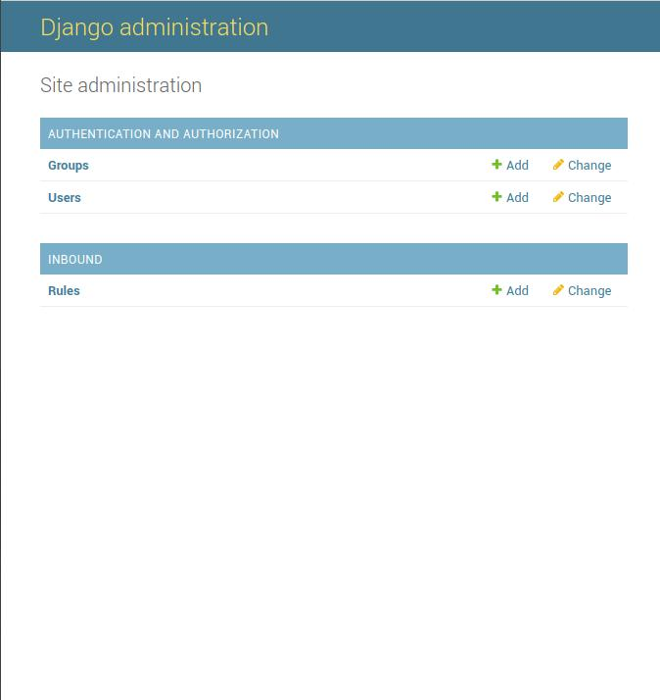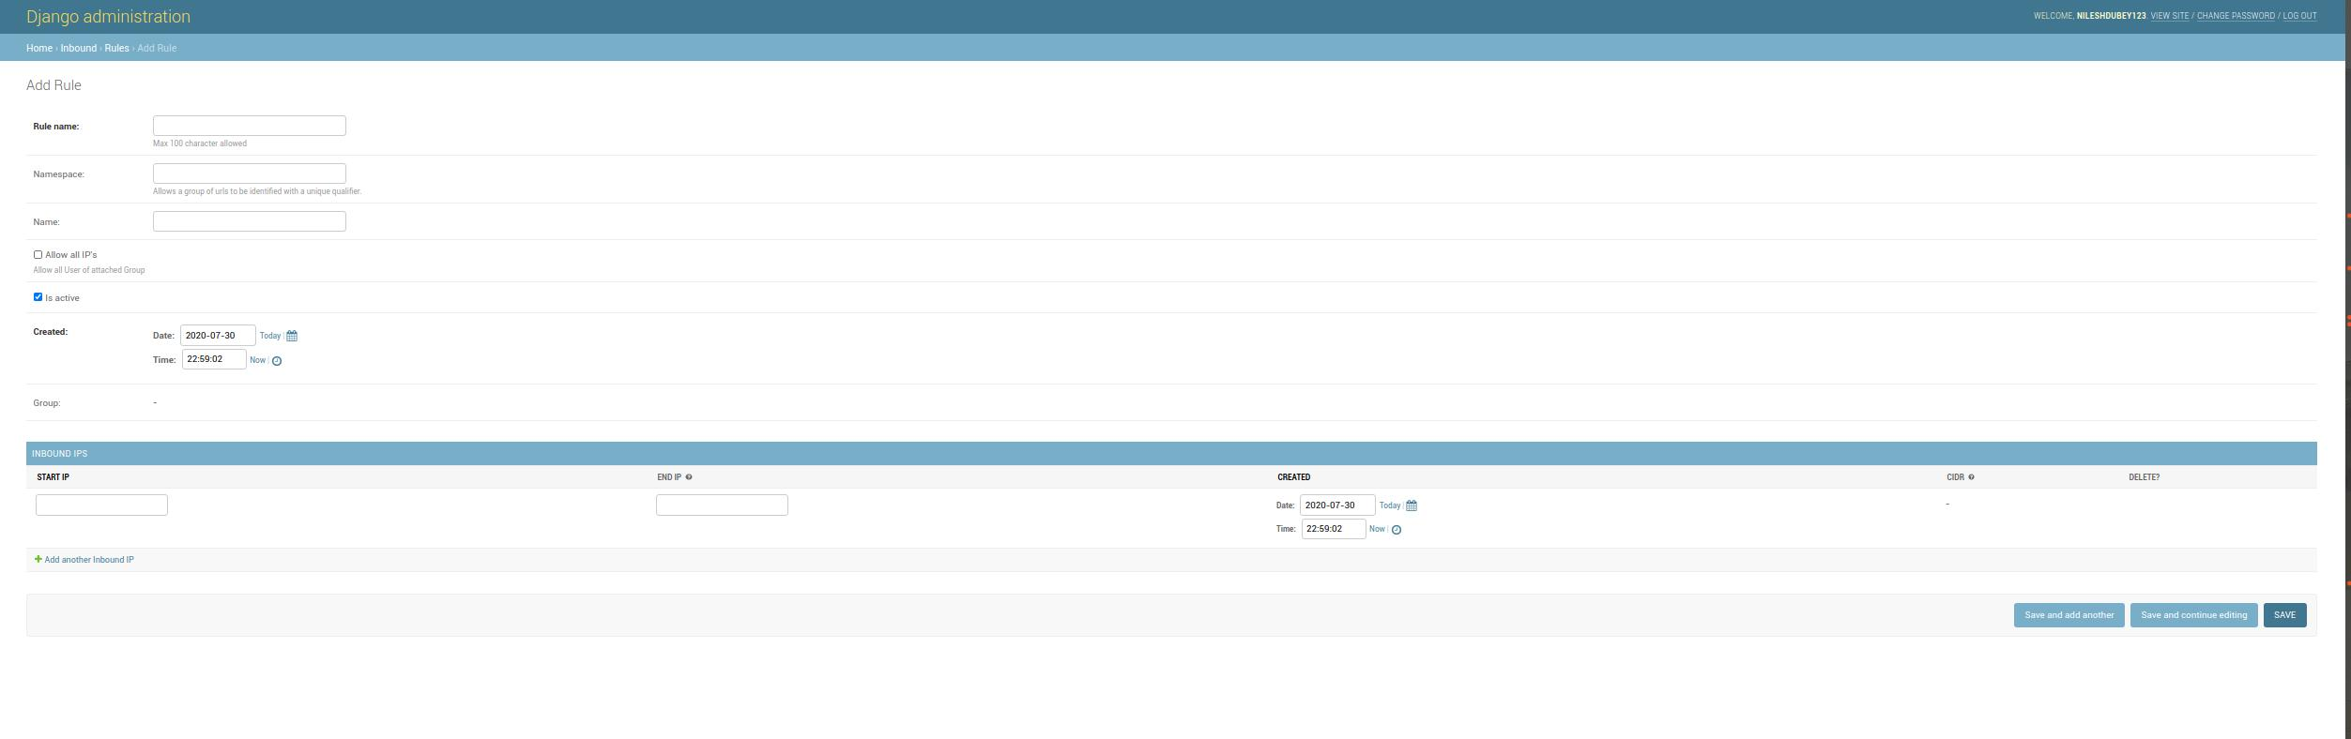

**SYNOPSIS**

I. Rule:

1. Rule Name

2. Namespace

3. Url name

4. Group

5. Allow all IP's

6. Is active

II. Inbound IPS:

1. Start IP

2. End IP

4. CIDR

**SYNOPSIS Description & Usage**

* *Rule name (string)*

1. Rule identifier having max limit of 100 characters only.
2. If Rule name exists, it will be authorized by inbound rule else notexcept of users with superuser permissions.

* *Namespace (string) & Url name (string)*

1. Namespace attribute allows a group of urls to be identified with a unique qualifier.
2. Url name is name in url.
3. Only a valid combination is allowed to register.
4. If only namespace is provided: it will validate group of urls.
5. If namespace and Url name is provided: it will validate that specific urls.
6. If only Url name is provide: it will validate that specific urls (only in-case namespace not vailable)

```

# project/urls.py(root)

urlpatterns = [

path('', include(('home.urls', 'home'), namespace='home')),

]

# home/urs.py(app)

urlpatterns = [

path('', views.home, name='home'),

]

```

* *Group*

1. Access to url(s) is allowed to users of this group only.

* *Allow all IP's (boolean field)*

1. If true, all group users can access url(s) as it will bypass all Inbound Ips.

* *Is active (boolean field)*

1. To activate or deactivate certain rule name.

* *Start IP & End IP (IPv4, genric IP address)*

1. For range of IPs of single CIDR block

* *CIDR (readonly)*

1. Based on your input: Start IP and End IP CIDR Block is created.