MCC ONLINE CEMENT
ORDERING WEBSITE

SUBMITTED BY :

  - SANCHAY BAGUL

- ABHISHEK KUMAR


Karmaveer Kakasaheb Wagh Education Society’s K. K. Wagh Arts Commerce, Science, & Computer Science College Saraswati Nagar Nashik-422003

C E R T I F I C A T E

This is to certify that,

Mr./Miss SANCHAY SANJEEV BAGUL

Has satisfactorily completed his project MCC-Online Cement ordering Website as fulfillment in B.Sc(Comp Sci) Department for the academic year 2017-2018.

Prof. Pawan Malani (Project Guide )

.

Prof. Bendale A.H.
( H.O.D. )

Internal Examiner External Examiner

ACKNOWLEDGEMENT

We own our sincere gratitude to all those people who have given us their constant support and encouragement without which our project report would not have reached this stage.

We would like to express our thanks to Mr. Pawan Malani for her /his advice and encouragement. He has been pillar of strength right through the project till the preparation of this report and helped by boosting morale, so we could surmount the difficulties that came across during completion of this project.

We would like to express our gratitude to Dr.V.M.Sewlikar, Principal, K.K.Wagh Arts, commerce, science and Computer Science College. And Prof. Bendale A.H. Head of Computer department for the support and the infrastructure they have provide, so that we could successfully complete the project on time.

Last but not the list we would like to express our sincere thanks to all staff members and our friends for their help and cooperation in all phases of the project.

 | INDEX
Sr.No | Title
1. | Problem Definition.
2. | Existing System.
3. | Proposed System.
4. | Requirement Analysis
5. | Scope of the system
6. | H/w and s/w requirement
7. | Feasibility study.
8. | ERD.
9. | UML Diagrams.
10. | Sample I/O Screen.
11. | Conclusion
12. | Future Enhancement
13. | Bibliography

INTRODUCTION

CEMENT Online Shop is the most convenient online cement ordering website. It connects the people with our Offline Store very easily.

Main modules in the project:

- Home page

- About

3.Login

4.Product View

5.Product Order

6.Feedback

Problem definition

- The existing system has main drawbacks. Also it is not user friendly & complex.

- Also it is not that responsive.

- The website is not hosted on the web.

- The contact and feedback option is not provided.

- The main drawback of the existing system is that it doesn’t have the

Android application.

Proposed system

- The proposed system is very responsive & easy to handle, also user friendly.

- Also having feedback option through which customer can add his/her

valuable feedback. & all contact details including the restaurant map is provided on website

- The admin panel is more effective & all the reports of register user, order information is maintained in well format.

System Requirements

- Minimum Hardware Requirements

PROCESSOR : PENTIUM III 866 MHz

RAM

MONITOR

HARD DISK

CD DRIVE

KEYBOARD

MOUSE

:128 MD SD RAM

: 15” COLOR

:20 GB

:LG 52X

:STANDARD 102 KEYS

:3 BUTTONS

- Minimum Software Requirements

OPERATING SYSTEM | : | Windows XP Professional
LANGUAGE | : | PHP
BACKEND | : | MySql
WEB BROWSER | : | Mozilla, Chrome, IE

Scope and objective of the system

In order to be able to define our system architecture ,we must first dearly state what our objective at the same one of our objective is to create an experience ,which is not unique to the customer ,client but also makes him feel that he has loyal attachment to the system and approaches us whether he/she needs.

To achieve better result & success by implement computerized process instead of manual process.

Feasibility study

The feasibility study is useful to evaluate the cost and benefits of the system request the feasibility study tries anticipating, future scenario of software development.

There are 3 major aspects of in the feasibility study :

- Technical feasibility

- Economical feasibility

- Operational feasibility

Technical Feasibility:

Technical feasibility of cement ordering system focused on the existing computers hardware, software and personnel. This also includes need for more hardware, software and personal and possibility of installing such a facility

Economical Feasibility:

Economical feasibility considers the cost of benefit analysis of the proposed system. The benefits are always expected to be owner weighing the cost. It is helpful to find the system development cost and checks whether it is justifiable for that it checks investigation cost, salaries and maintain ace cost etc.

Operational Feasibility

It is considered the acceptance of system. It checks whether the system will be used if it is system will be used and implement are the users of system able to handle the system whether the proposed system causes any trouble etc.

ER- Diagram
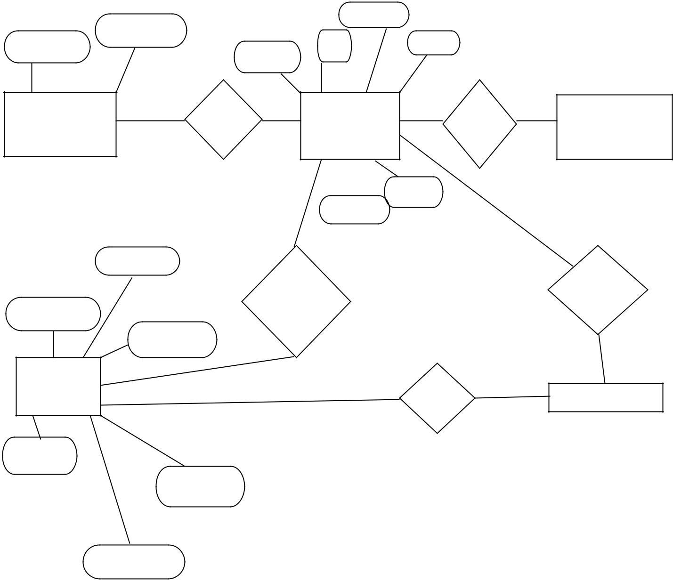

 | password | pbrand
uname | password | ptype
uname | pid | ptype
 | Grade

Admin

maintain | product | has | stock
1 | m

rate

ctype

m

lastname

purchased generate

firstname by

company

User

pays | 1 | BILL

mobile

email

address

UML DIAGRAMS

Class Diagram

 | Log-Master
 |  | Login
 | -uname:string
 | -password:string
 |  |  |  |  |  |  | Purchase
 | -Add(); |  |  |  |  |  | -book_id:int
 |  |  |  |  |  |  | -reg_id:int
 |  |  |  |  |  |  | -address:string
Register |  |  |  |  |  |  | -email:int
-fname:string
-address:string |  |  |  |  |  |  | +Add()
-contact_no:string |  |  |  |  |  |  | +Exit()
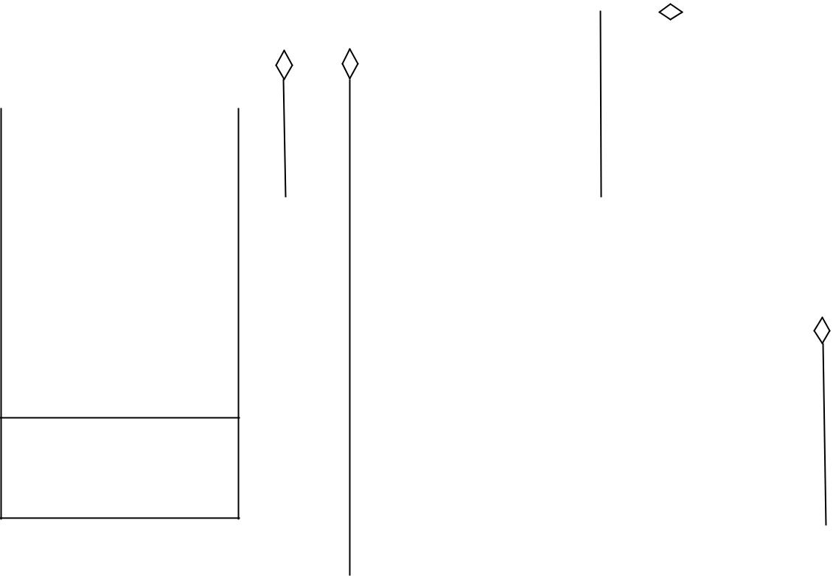

-lname:string

-cname:string

+Add()

+Exit()

 |  | Cement
Feedback |  | -cement name:string
-fname:string |  | -cement type:string
-date:int |  | -quantity:int
-feedback:string |  | +Add()
-gender:string |  | +Exit()
+Add()
+Exit()

Use Case Diagram
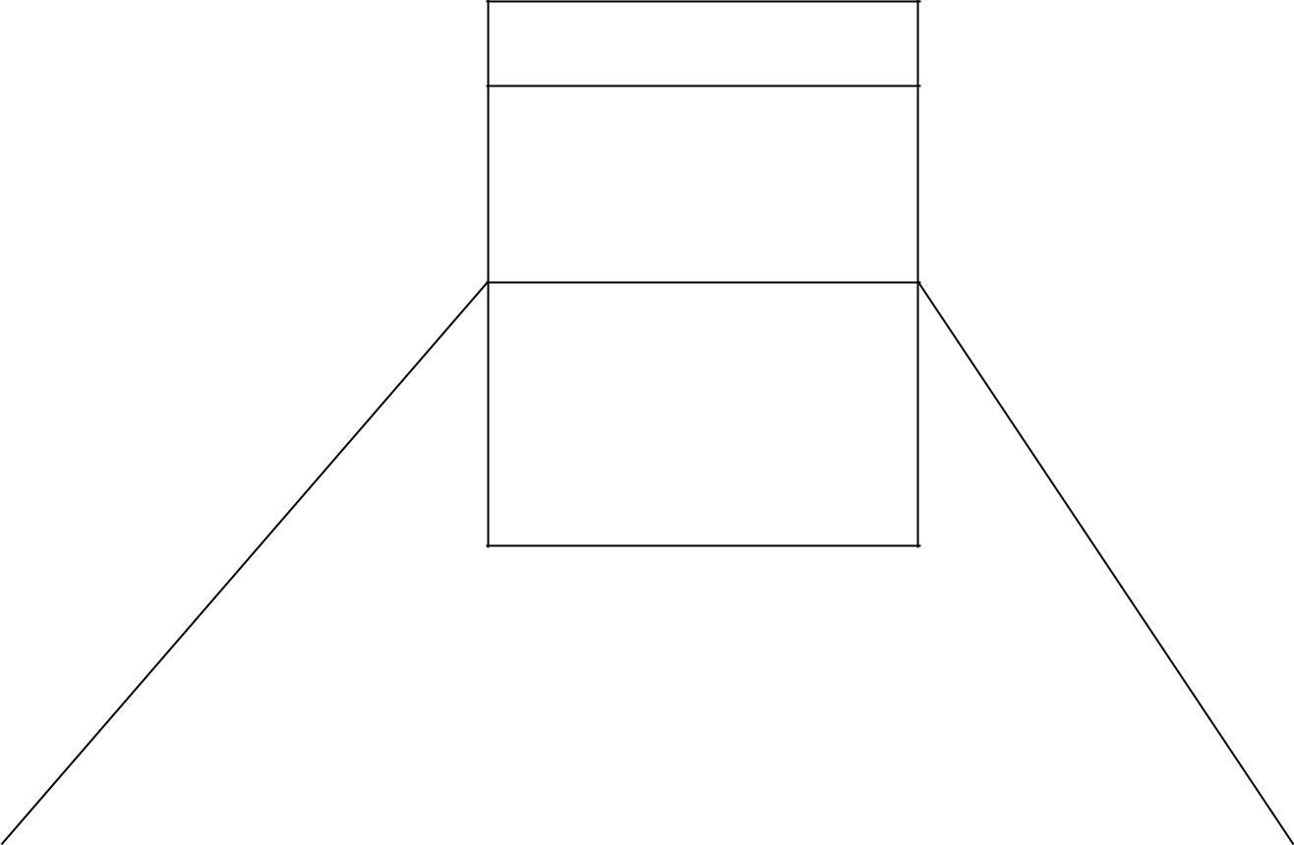

Admin

-ausn:string

-apass:string

1 | 1

Addproduct();void

UpdateStock();void

UpdateRates();void

Managed by Managed by

* | *
Customer |  | Products
-id:int |  | -pid:int
+name:int |  | +pbrand:string
+email:string |  | +prate:int
+address:string |  | +ptype:string
+mobile:string
+display():void |  | +display():void
+selectproduct():void |  | +detail():void

Activity Diagram

start
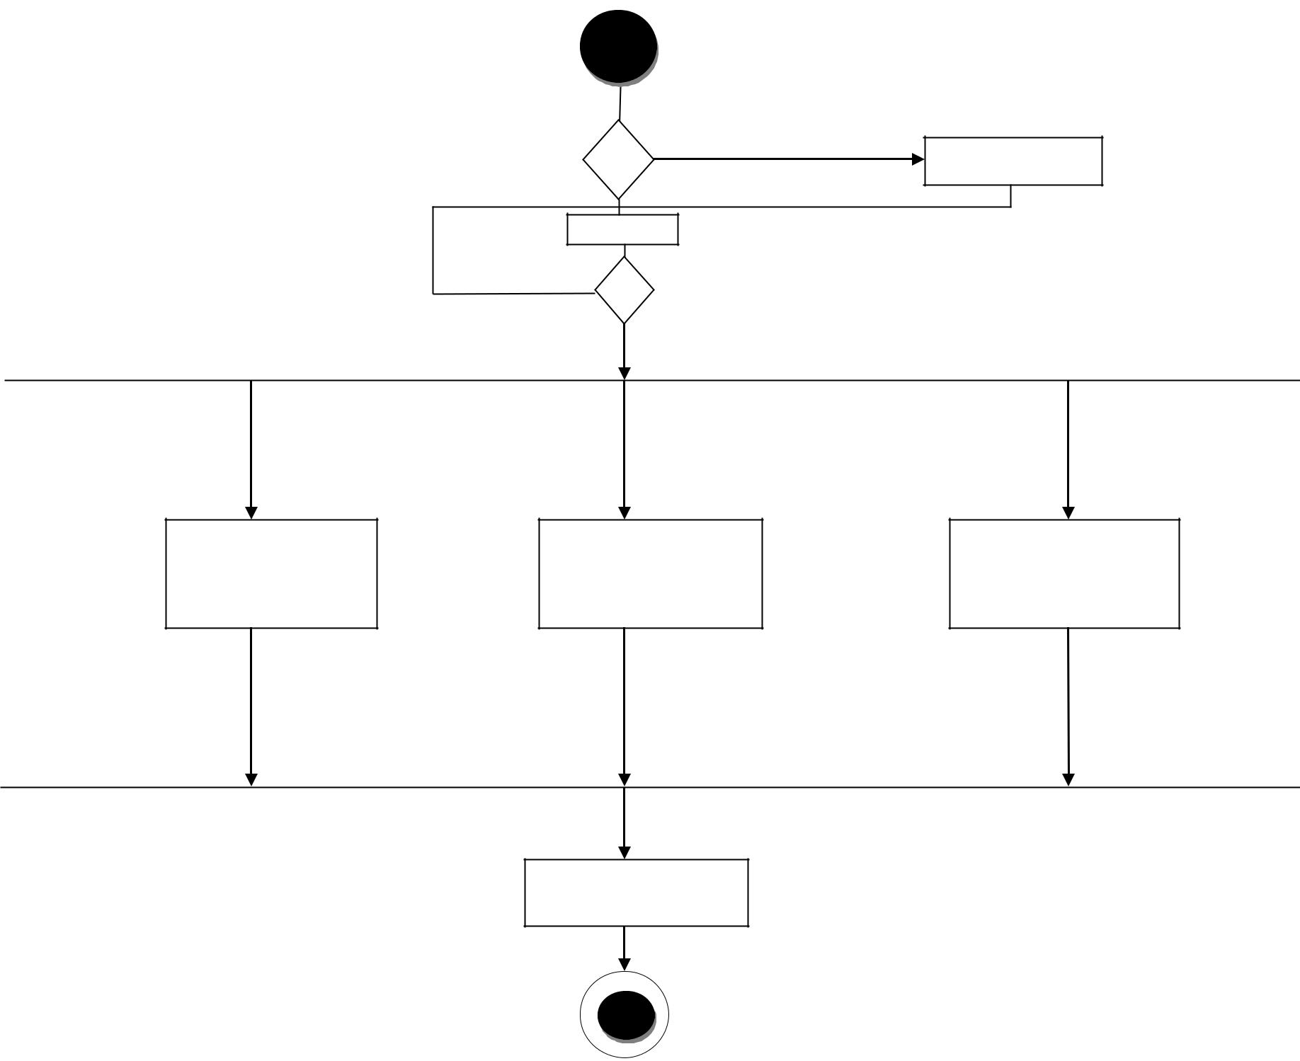

yes | no | Registeration

no login

yes

view

cement | Booking | give feedback

logout

End
Sequence Diagram

User |  |  |  |  | System |  |  |  |  | Database
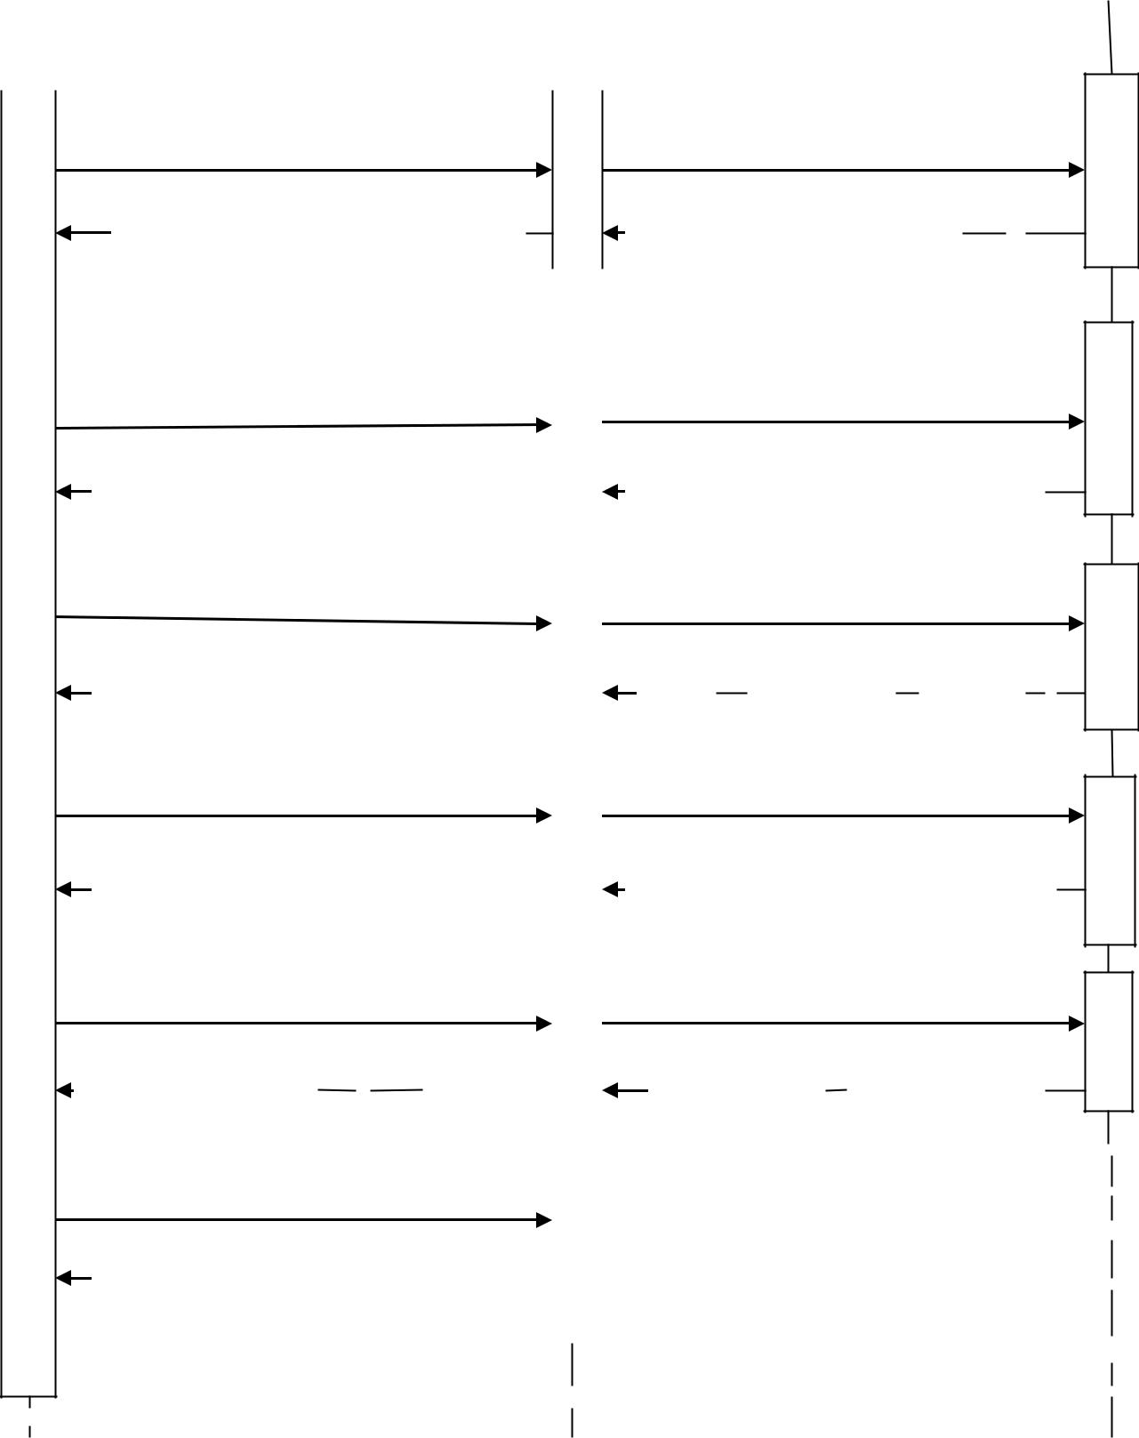

 | registration |  |  |  |  |  |  |  |  |  | Send Request
Successfully registered |  |  |  |  |  |  |  |  |  |  |  | Get Interface

 |  |  |  |  |  |  |  |  |  |  |  |  | Login |  |  |  |  |  |  |  |  |  |  |  |  |  |  |  |  |  |  |  |  |  |  |  |  |  |  |  | Send Request
 |  |  |  |  |  |  |  |  | Successfully Login |  |  |  |  |  |  |  |  |  |  |  |  |  |  |  |  |  |  |  |  |  |  |  |  |  |  |  |  |  |  |  | Get Interface
 |  |  |  |  |  |  |  |  |  |  | View Product |  |  |  |  |  |  |  |  |  |  |  |  |  |  |  |  |  |  |  |  |  |  |  |  |  |  |  |  |  | Fetch Products
 |  |  |  |  |  |  |  |  | View Successfully |  |  |  |  |  |  |  |  |  |  |  |  |  |  |  |  |  |  |  |  |  |  |  |  |  |  |  |  |  |  |  | Fetch Product details
 |  |  |  |  |  |  |  |  |  |  | Search Product |  |  |  |  |  |  |  |  |  |  |  |  |  |  |  |  |  |  |  |  |  |  |  |  |  |  |  |  |  | Fetch Details
 |  |  |  |  | Successfully order placed |  |  |  |  |  |  |  |  |  |  |  |  |  |  |  |  |  |  |  |  |  |  |  |  |  |  |  |  |  |  |  |  |  |  |  | Fetch order details
 |  |  |  |  |  |  |  |  |  | Give Feedback |  |  |  |  |  |  |  |  |  |  |  |  |  |  |  |  |  |  |  |  |  |  |  |  |  |  |  |  |  | Store Feedback details
 |  |  |  |  |  |  |  | Successfully Feedback |  |  |  |  |  |  |  |  |  |  |  |  |  |  |  |  |  |  |  |  |  |  |  |  |  |  |  |  |  |  |  |  | Successfuly
 |  |  |  |  |  |  |  |  |  |  |  | Logout
 |  |  |  |  |  |  |  |  | Logout Successfully
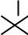

Deployment Diagram
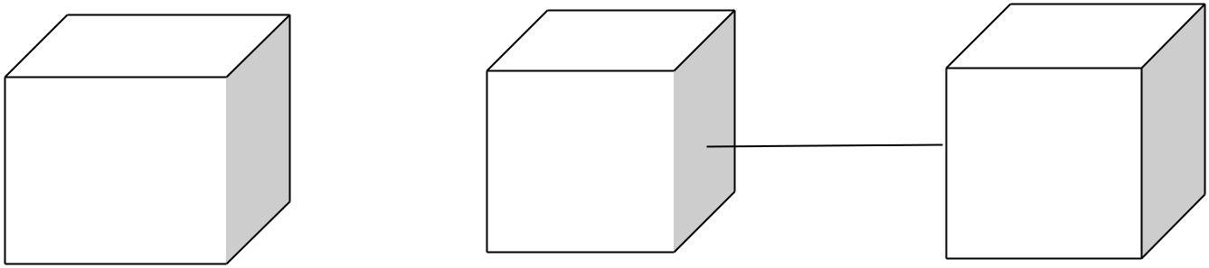

Web |  |  | Web Server | Database
Application |  | HTTP |  | MYSQL

Sample Screenshots
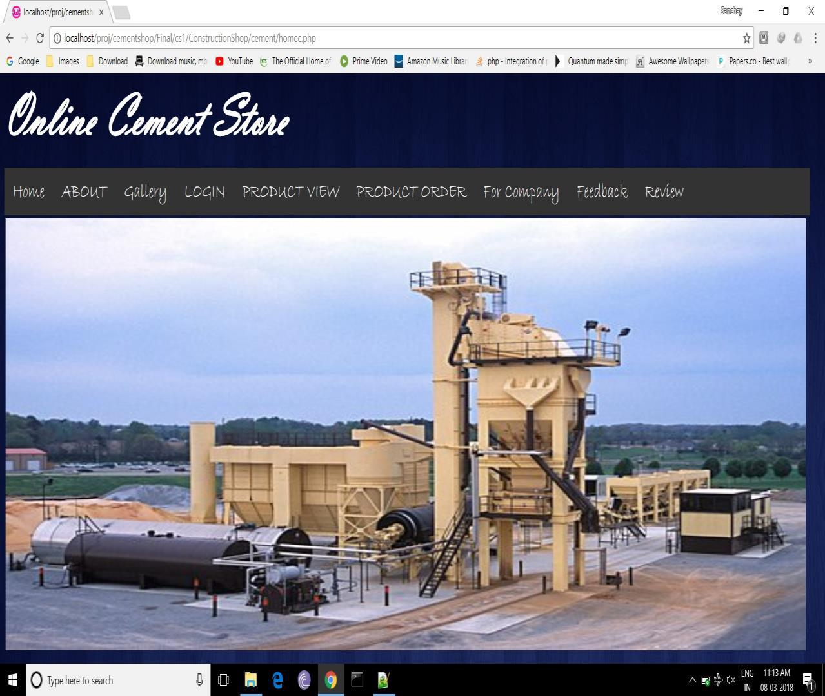
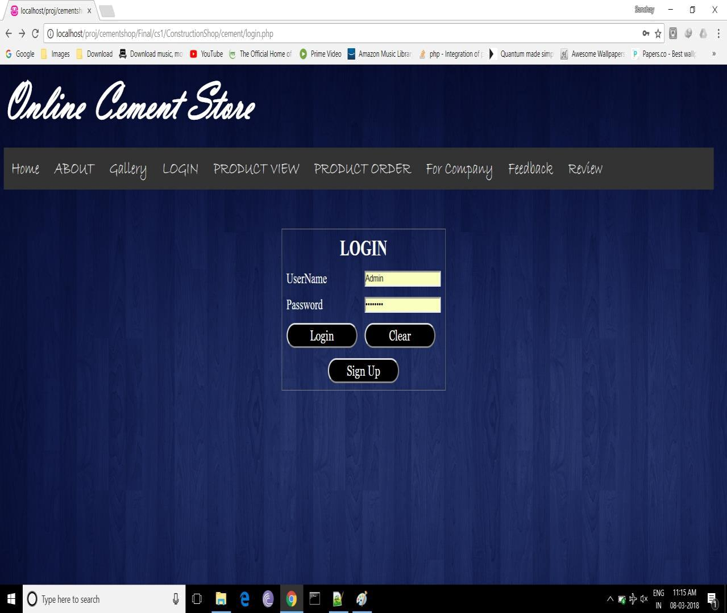
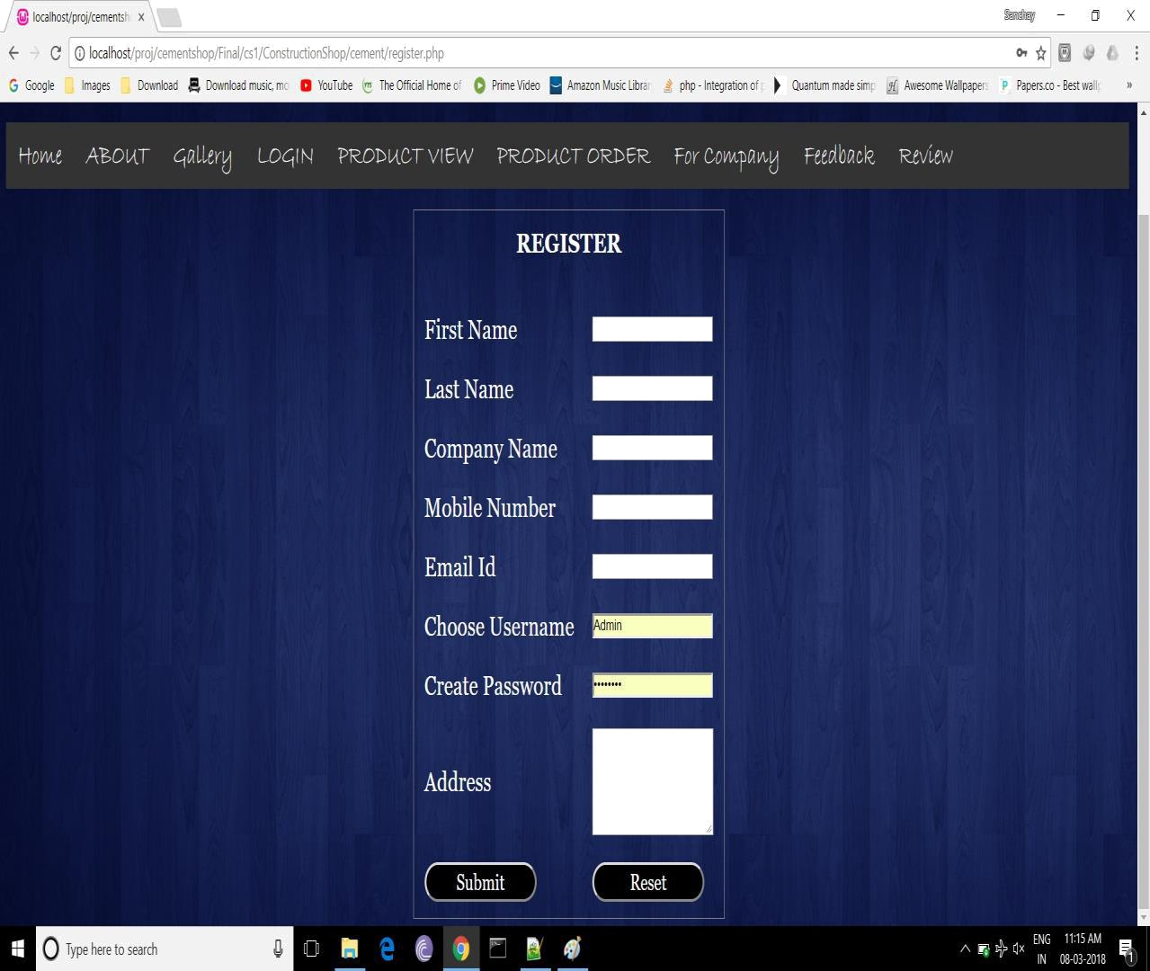
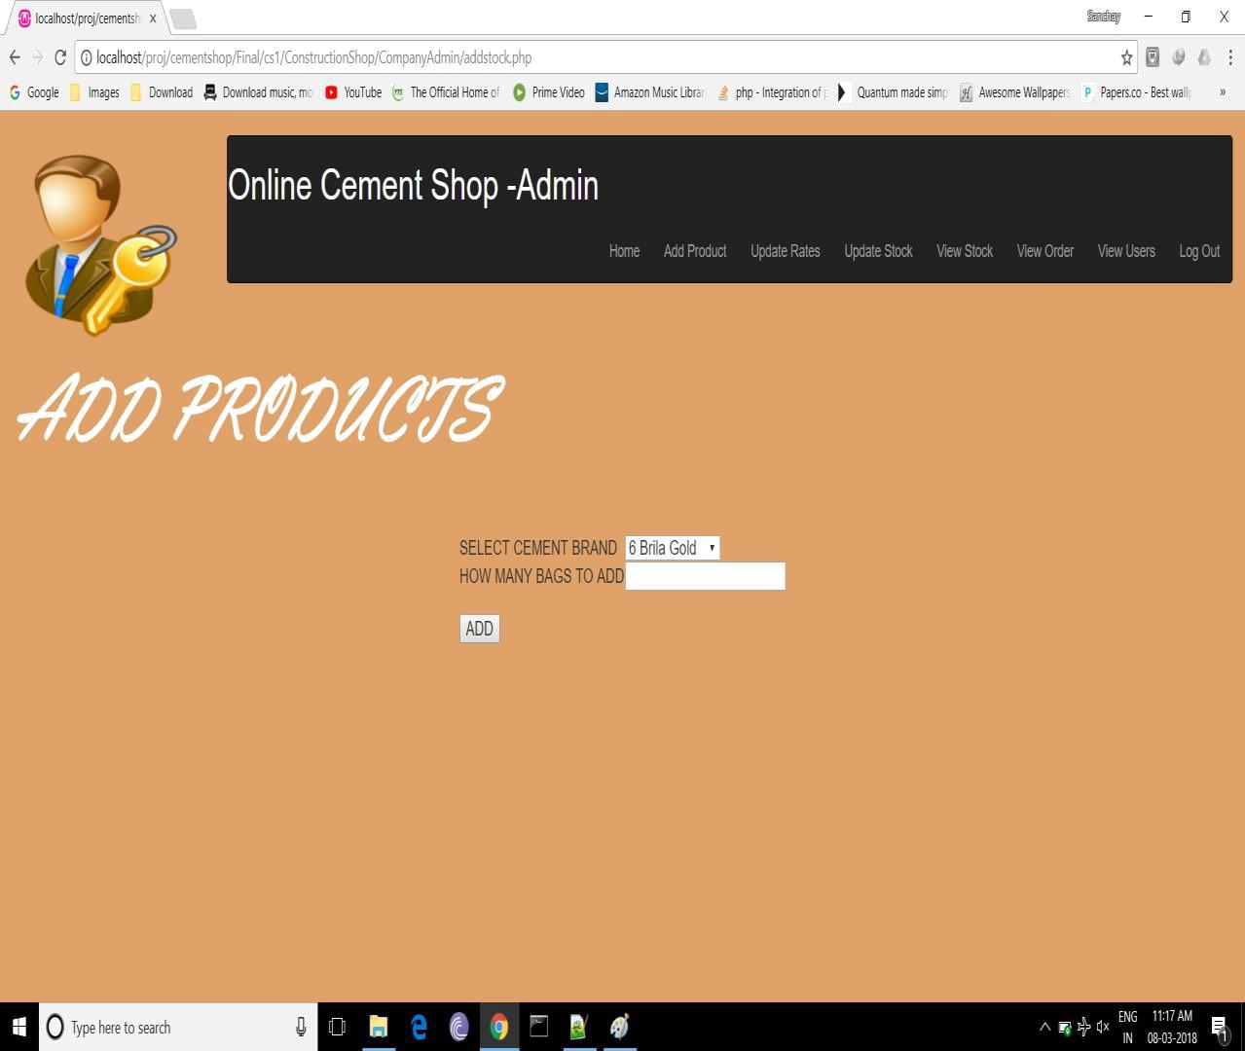
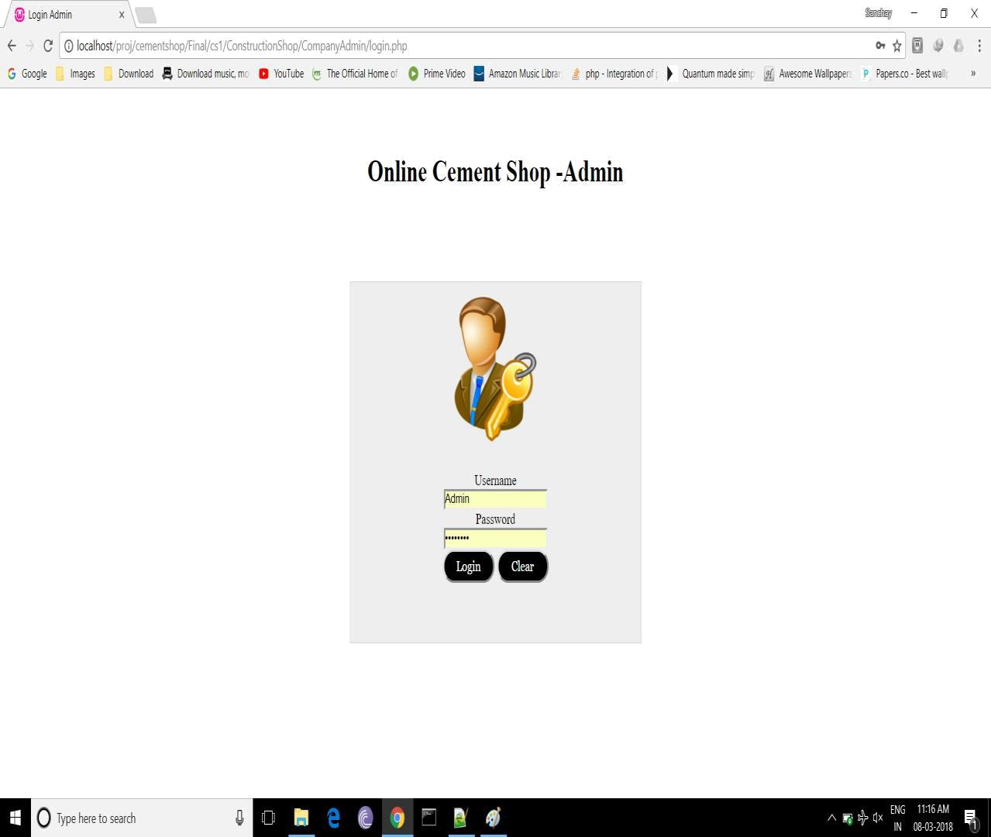
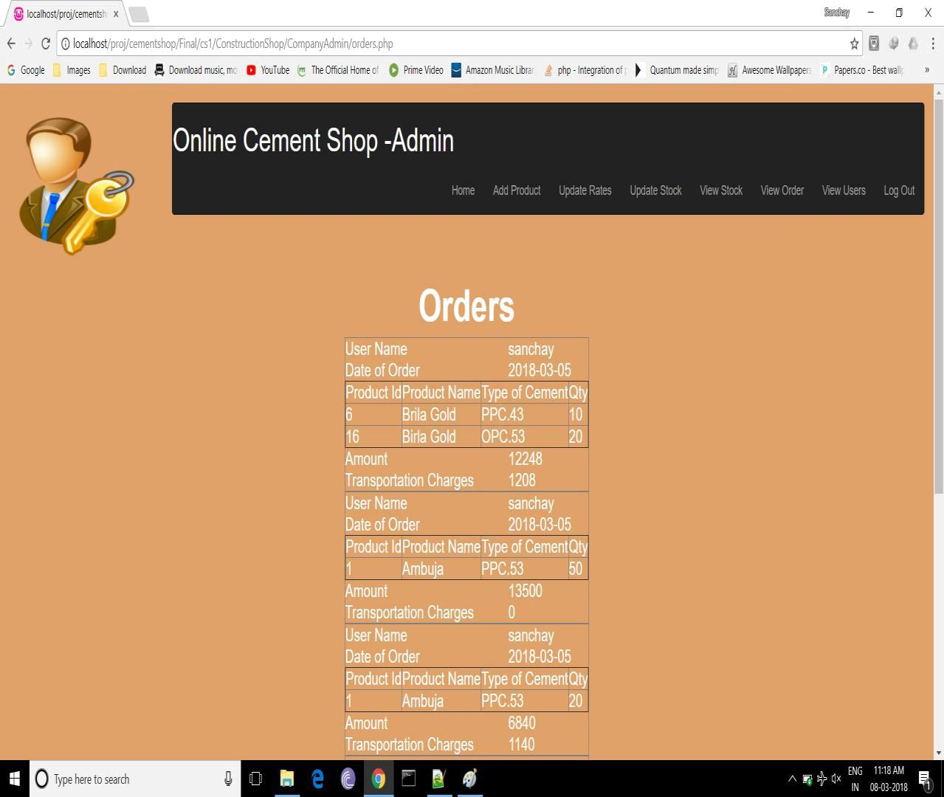
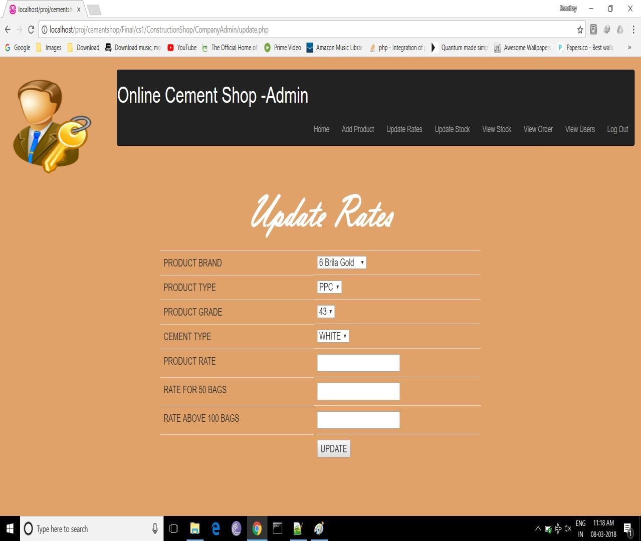

Conclusion

- It is concluded that the application works well and satisfy the customers’ needs.

- The application is tested very well and errors are properly debugged.

- It can access on any system and on the android smart phones.

- The application works accurate to the restriction provided in their browser.

- Further enhancement can made to the application to make it more attractive and user-friendly.

Future enhancement

- Every application has its own merits and demerits.

- The project has covered almost all its requirements.

- Further if we want any changes or improvement then it can be done.

- Also the online transaction is the one which is our future enhancement.

Further we will improve the website by including more features and make it attractive

Bibliography

- Php tutorial

- Android tutorial

- http://www.W3Cschool.com

- Reference books:

  - Learning PHP,Mysql and Javascript by Robin Nixon

  - PHP Solutions:Dynamic Web Design Made Easy by David Powers

