Manoj E. Patil et al, / (IJCSIT) International Journal of Computer Science and Information Technologies, Vol. 3 (3) , 2019,3871-3874

Design and Implementation of Graphical User Interface for Relational Database Management *System*

*Manoj E. Patil,, Ravi N. Mulchandani, Ravikumar R. Ahuja*

*Department of Computer, SSBT’s COET Bambhori,, Jalgaon. (MS) India*

***Abstract-This paper will explain the concept of creating a Graphical User Interface for three Relational Database Management Systems. This is a general-level GUI, which can be connected to any database residing on the* system such as Oracle, MS SQL Server, and MS Access. As a result, any database manipulation can be performed using single interface. Moreover, the queries can be executed very easily, since the user needs not to type any queries, but can simply select the appropriate options according to their requirements. Thus, this software can be used by a person with no knowledge of SQL. This software is developed using Java as front end and Oracle, MS SQL Server and MS Access as backend.**

***Keywords:* Relational Database**

1. INTRODUCTION

Database Management Systems or DBMS has evolved from a specialized computer application to a central component of modern computing environment. DBMS consists of a collection of interrelated data and a set of programs to access those data. This collection of data is referred to as a database. Database Management System involves both the definition of structures for the storage of information and provision of mechanisms for the manipulation of information.

A collection of conceptual tools for describing data, data relationships, data semantics and consistency constraints is called a data model. There are different data models, among which Relational Database Management System (RDBMS) is the most popular choice for large scale application.

The RDBMS uses a collection of tables to represent both data and the relationships among those data. Each table has multiple columns and each column has unique name and fixed data type. Each table in the database has a unique name assigned to it.

The RDBMS has established itself as the primary data model for commercial data processing applications. RDBMS is now being used in numerous applications outside the domain of traditional data processing.

To interact with the database and work with the tables in it, one need to use Structured Query Language (SQL) which includes features on defining structure of the data, for modifying data in the database and for specifying security constraints.

The project entitled ‘Graphical user interface for RDBMS is aimed at providing a user friendly and single interface for

working with different RDBMS like SQL Server, Oracle etc. The main objective of the system is to enable a user work with the databases and tables in a RDBMS even if he/she doesn’t have any knowledge of SQL.

The product is aimed at accomplishing the following:

* Create, rename and drop databases
* View and work with database objects like tables, queries, forms and reports
* View the database profile and table that exists in a particular RDBMS
* Preparing and printing various reports containing information about existing databases and objects in a database, if needed
* Provide a provision i.e. a SQL query analyzer for executing queries in SQL mode, if required

1. STUDY OF EXISTING SYSYTEM

We have many database management systems available in the market, many of them with friendly Graphical User Interfaces, using which the users can execute queries and handle tables and other objects. However, the GUIs provided by each database server are exclusive to its own database. Moreover, a person with little technical knowledge will find it difficult to use one.

*Limitations of the Existing System*

* GUIs provided by most of the database is exclusive to its own database
* Working with different databases through a single friendly interface is impossible
* The features and functionality provided by each GUIs differ from one RDBMS to another
* A GUI that provides a friendly environment to a user with little knowledge of SQL in such a way that he can work with more than one type of databases is hard to find.

The RDBMS uses a collection of tables to represent both data and the relationships among those data. Each table has multiple columns and each column has unique name and fixed data type. Each table in the database has a unique name assigned to it.

The software is developed using Java as front end using MSSQL Server, MS Access and Oracle. The software is

developed with the keen intention of creating a Graphical User Interface for 3 Relational Database Management System.

1. STUDY OF PROPOSED SYSTEM

The product entitled GUI for RDBMS is developed with the keen intention of creating a Graphical User Interface for commonly used Relational Database Management System like MSSQL Server, Oracle etc. This is a general-level GUI, which can be connected to more than one database residing on the system. As a result, any database manipulation can be performed using a single product. Moreover, the queries can be executed very easily, since the user need not type any queries, but can simply select the appropriate options according to their requirements. Thus, this product can be used by a person with no knowledge of SQL

* Database Creation

In case of MS SQL Server, by clicking on the corresponding icon, a new database can be created.

* Database Login

Once a database is created, a user can login to his/her database and, after which he/she can work with the objects in the database. In case of Oracle, we are always automatically logged into the default database of Oracle and we can login into the same as different users.

* Database Rename

A database in MSSQL server can be renamed by selecting the corresponding option.

* Database Drop

There is an option provided for dropping an already existing database when the GUI is connected to the MSSQL Server.

* Database Profile

The user can monitor and view the database properties, like name, owner, and size, date of creation, status and contents.

* Objects

The user can access the opened database through a Graphical User Interface. Through this interface, the user can view and work with the database objects like tables, queries and reports.

* Create Table

The user can create tables in the selected database. A design view is provided, through which the user can simply enter the field name, select the data type from a select list. There are separate options for setting a field as primary, unique, or not null. There is also an option for adding checking constraint on a field or a default value in a field.

* View Table

This option enables the user to view the contents (rows) in a table.

* Execute Queries

The user can execute any query on the database using the user-friendly graphical interface. All the tables in the database are listed, from which the user can select the one(s) in which he/she has to execute the query. The user can select the type of query to be executed (like select, update, make-table and delete). The field(s) in the table(s) in which the query has to

be executed can be selected from a list and the conditions can be input, all using the graphical interface. The conditions can include sorting (ascending, descending or none), fields to be displayed, criteria and any other specification, if any. The result of the query action is exhibited.

* Select

User can first select a table, and then execute select queries on it. Select query can be executed in different ways:

* + Specific fields or all fields in a table can be displayed.
  + y dOisntilnct fields can be displayed if required
  + Aggregate function can be applied to a field selected
  + Field or fields satisfying a specific condition can be selected
  + Selection can also be made using Order by or Group by clause
* Alter

Any alteration on the table can be made on a selected table using this option. Alterations that can be made includes the following

* + Alter the data type of a existing field in the selected table
  + Altering the selected table by adding a new field to the table
  + Altering the selected table by dropping an existing field in the table
  + Altering the selected table by adding a constraint to a field in the table
  + Altering the selected table by dropping a constraint specified on the field in the table
* Update

This option is used for making any updating on a selected table. Any condition for updating can also be specified if required.

* Delete

This option is used for deleting rows from a selected table. Deletion can also be performed by specifying condition so that only rows satisfying that condition is deleted.

* Drop

This option allows a user to drop an already existing table from a database

* Insert

Using this option the user can insert rows into an existing table.

* SQL query analyzer

If required, the user can execute queries in SQL mode, not using the graphical interface. A separate workspace is provided, where the query can be typed and executed.

1. SYSTEM DESIGN

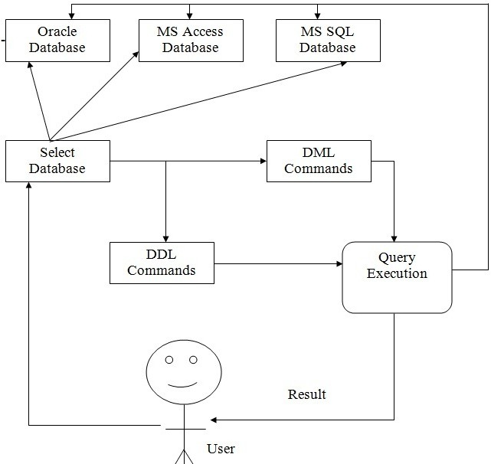

Fig. 1 System Architecture

User selects appropriate database system such as Oracle, MS access, MS SQL server. After selecting database system user will perform either DDL or DML commands. Query execution unit will execute a query and make changes to databases. Query execution unit will also provide result to user**.**

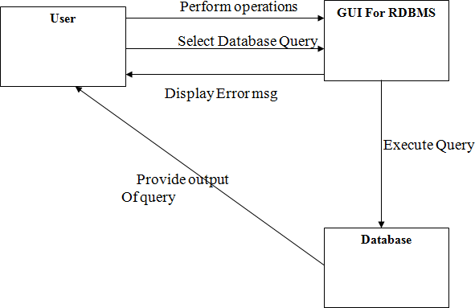

Fig. 2 User Interface Design

1. SCREEN LAYOUTS

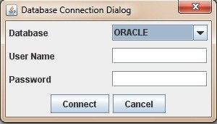

Fig. 3 Connection Dialog

In GUI for RDBMS, there is a dialog box for user using which he/she can select the database system such as Oracle, SQL Server, and MS Access.

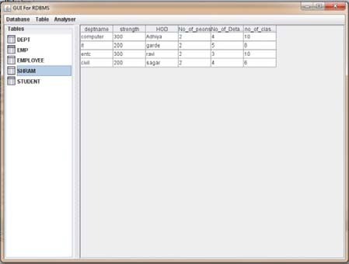

Fig. 4 Main Window

In GUI for RDBMS, there is a panel on the left hand side of the window which shows the name of tables existing in the database. By clicking on a particular table user can view the contents of that table.

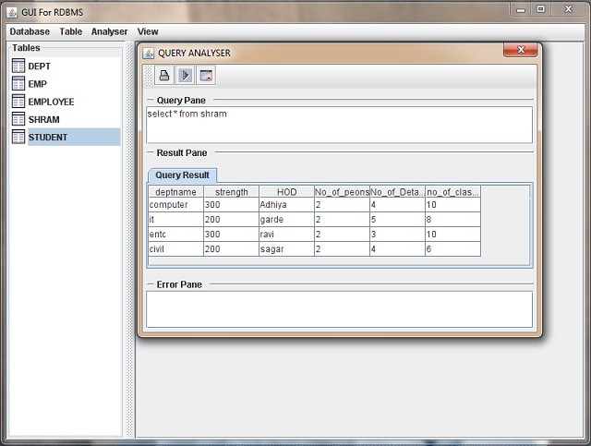

Fig. 5 Query Analyzer

In GUI for RDBMS, there is an option for Query Analyzer using which user can type and execute different queries if he/she is having knowledge of SQL (Structured Query Language).

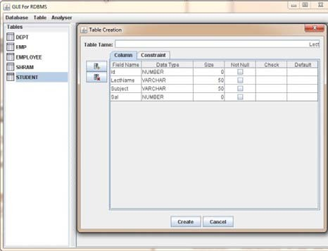

Fig. 6 Table Create

In GUI for RDBMS, there in an option for a user to create table. In this user have to specify the name of table, columns and can apply constraints.

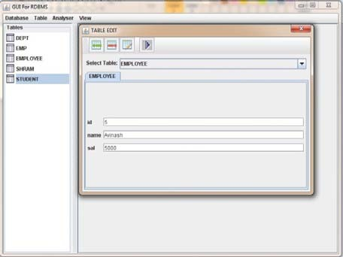

Fig.7 Edit Table

In GUI for RDBMS, there in an option for a user to edit table. In this user can insert new row, delete an existing row and modify row.

1. CONCLUSIONS

The system is developed aiming at helping a user easily access and work with databases in different RDBMS, even he/she have little knowledge of SQL. Also the developed system provides a single interface for communicating with more than one type of RDBMS. The new system is developed in Java using MS SQL Server, MS Access and Oracle. MS SQL Server and Oracle are two commonly used RDBMS, very efficient back end tool for handling databases. The Swing class of Java helped to create many user friendly features like menus, buttons, messages etc in the system.

1. FUTURE DEVELOPMENT

For making the system adaptive to the changing environment, it will be necessary that the system will be required to handle some more functions in the future to satisfy

the requirements, we can write separate program modules and combine them to the main program. For e.g.: the system can be further enhanced to handle nested queries, sub queries etc

.An option for backing up databases and restoring them is another enhancement.

REFERENCES

1. Roger S. Pressman,“*Software Engineering”,* Fifth Edition,

McGraw-Hill Companies

1. Herbert Schildit, “ *Java 2 The Complete Reference* “, Fifth Edition , McGraw-Hill.
2. Robert Eckstein, Mare Loy & Dave Wood “*Java Swing”* ,

O’Reilly

1. Silberschatz Korth, Sudarshan,” *Database System Concepts”,* Fourth Edition, Foxit PDF
2. Carlos Eduardo Rojas,”*Microsoft SQL Server 2000 Programming by Example*”, Que Publication