**Exercise Break App Description Summary**

Ash Kandari, Ben Deschand, Soham Pradhan, Nilesh Jain

Group 29

**Project Overview**

The idea of this app is to use the heartbeat sensor technology found in most smart watches to calculate and find the optimal time to take a break and either get a drink or use its GPS to find a place that could sell a sports drink. This way the user takes a break at the optimal time on their bike ride or run to take a break to steady their heart rate and rehydrate during the trip.

**The Purpose of the Project**

This app was made with the intention of helping endurance trainers to those who just want to go on jog to have a better exercise experience. The hope is by making endurance exercise more fun and less strenuous, they will feel more inclined to do these types of exercises and foster healthier habits. We will measure our success with this by seeing if people positively react to endurance exercises and have healthier habits.

**The Scope of the Work**

The client is currently using other work out apps or none at all when going on endurance exercises. The current workout apps usually track calorie consumption and the routes they took. Some monitor heart rates during the exercise but provide no information on when to take a break and how to space out their run.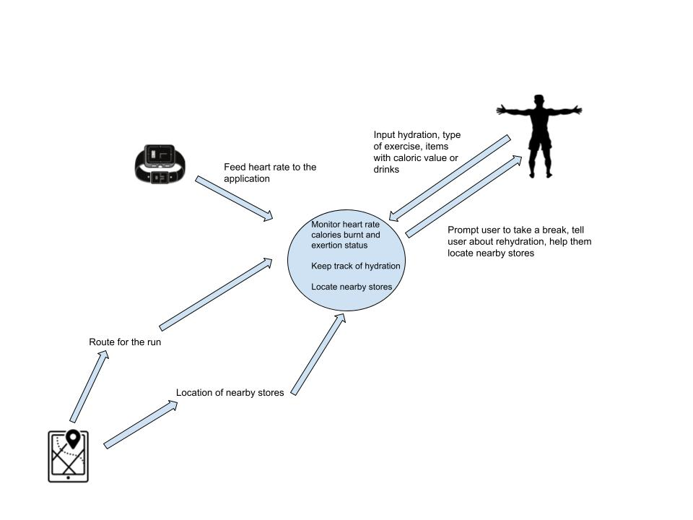

**The Scope of the Product**

**The Stakeholders**

The developers will act as the client to the project. The customer is the general public who wants to participate in endurance exercise, but can also be used for professional purposes like for athletes and their training regime. They will need to input their personal information themselves. The application can also be used by organizations that plan exercise events. We will regularly update the application as problems and solutions arise.

**Mandated Constraints**

This app requires the use of a smart watch with a heart beat sensor.It also assumes that the watch would be able to connect to the smartphone via Bluetooth/Internet and give the user appropriate response. The proposed product will operate on both iOS(WatchOS) and Android(WearOS). This application must be able to fetch data from Google maps to indicate nearby routes and shops. It is also responsible for fetching the heart beat data from the heart rate sensor every second. This application can be managed by 5 engineers. Since it is a software, there are no additional hardware costs incurred. We estimate a budget of around $1M including all the advertisement costs.