17 -06 -2026 Second test

Collection
Q and ans after collection
db.employees.insertMany([
{
empId: 101,
name: "Arun",
age: 25,
department: "IT",
salary: 45000,
city: "Chennai",
experience: 3,
skills: ["Java","MongoDB","Spring"],
active: true
},
{
empId: 102,
name: "Priya",
age: 28,
department: "HR",
salary: 55000,
city: "Bangalore",
experience: 5,
skills: ["Recruitment","Training"],
active: true
},
{
empId: 103,
name: "Rahul",
age: 32,
department: "IT",
salary: 75000,
city: "Mumbai",
experience: 8,
skills: ["Python","MongoDB","AWS"],
active: true
},
{
empId: 104,
name: "Sneha",
age: 26,
department: "Finance",
salary: 50000,
city: "Delhi",
experience: 4,
skills: ["Excel","Taxation"],
active: false
},
{
empId: 105,
name: "Karthik",
age: 30,
department: "IT",
salary: 68000,
city: "Chennai",
experience: 7,
skills: ["NodeJS","MongoDB","React"],
active: true
}
]);

Question And Answers

Q1. Insert one employee document.
Ans-1
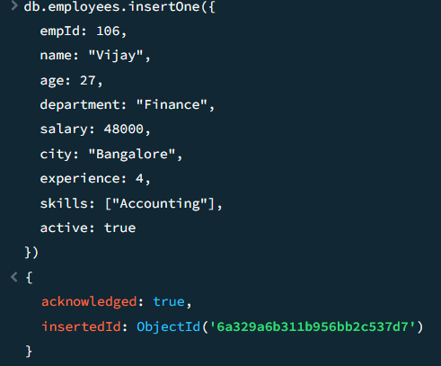

Q2->Insert multiple employee documents
Ans- 2-
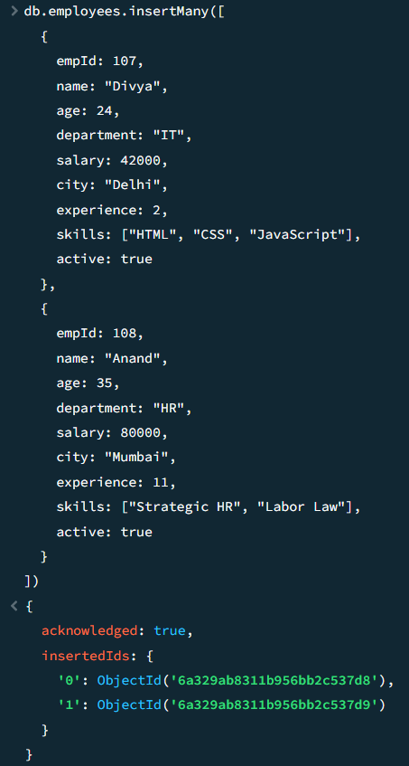
Q3->Find one employee from IT department
Ans-3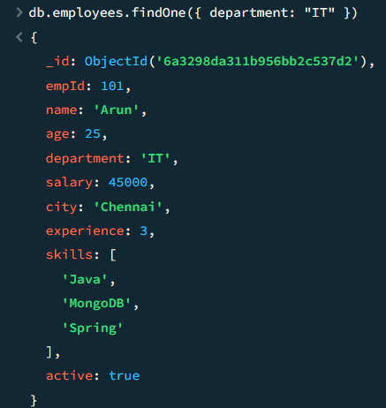
Q4->Display all employees
Ans-4 ->
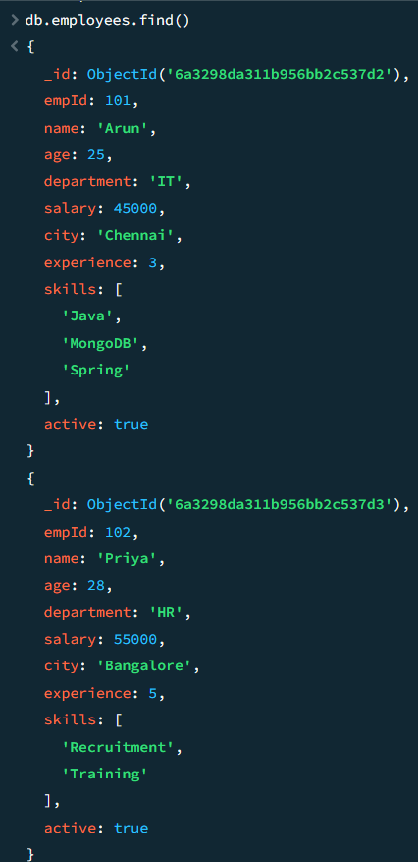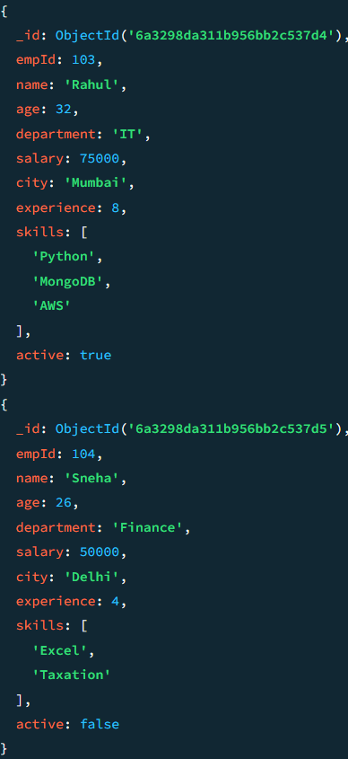

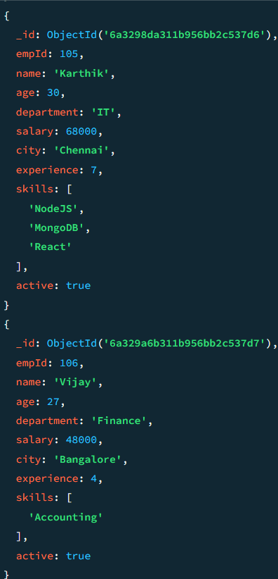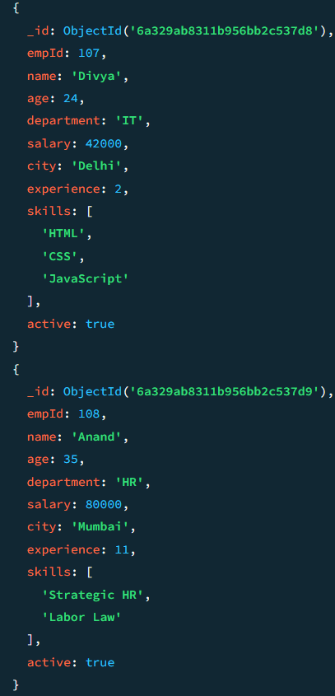
Q5->Display only name and salary.
Ans-5
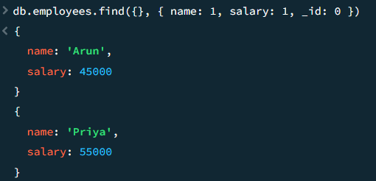
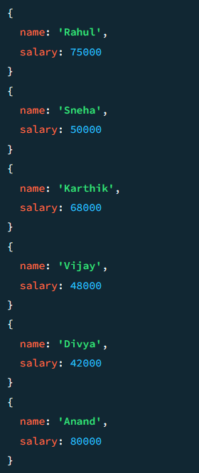
Q6->Find employees with salary equal to 50000
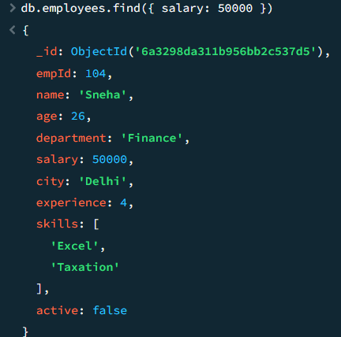
Q7->Find employees with salary less than 60000
Ans-7->
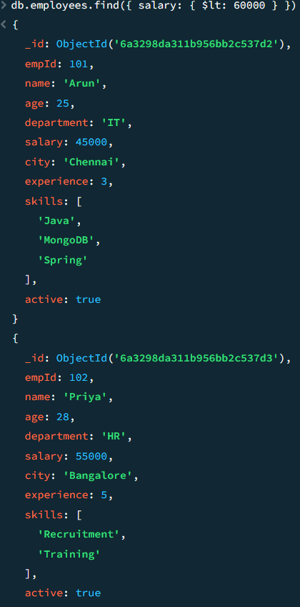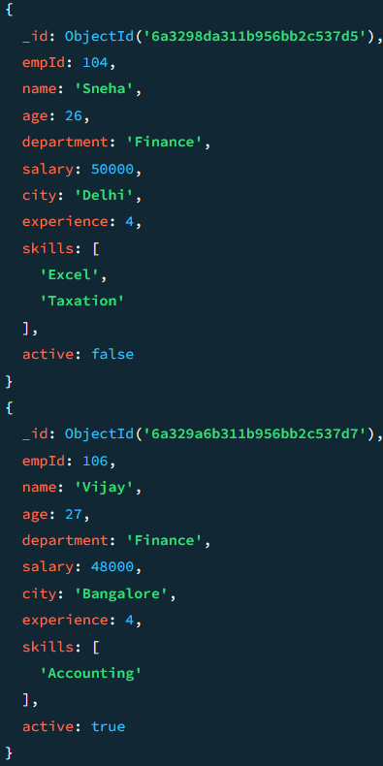
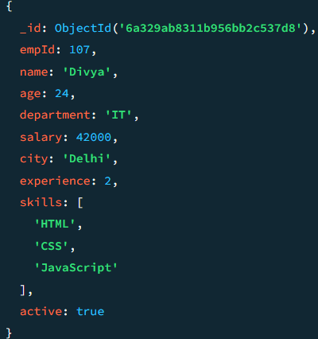
Q8->Find employees with salary greater than or equal to 60000.
Ans-8
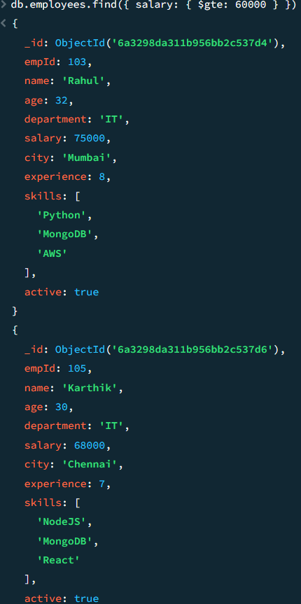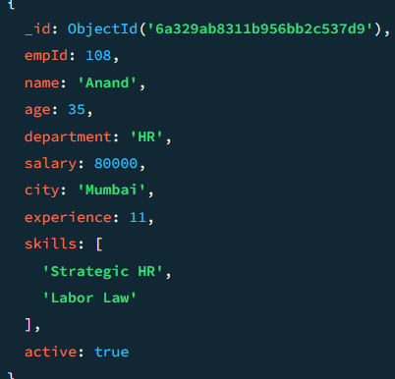
Q9->Find employees whose age is not equal to 30
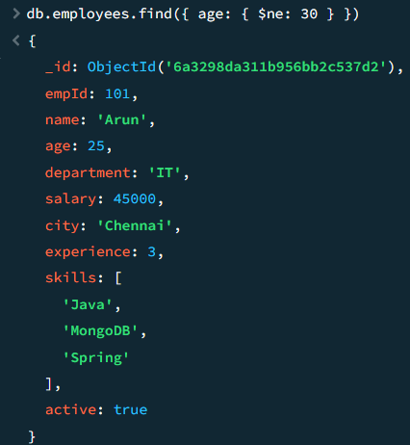
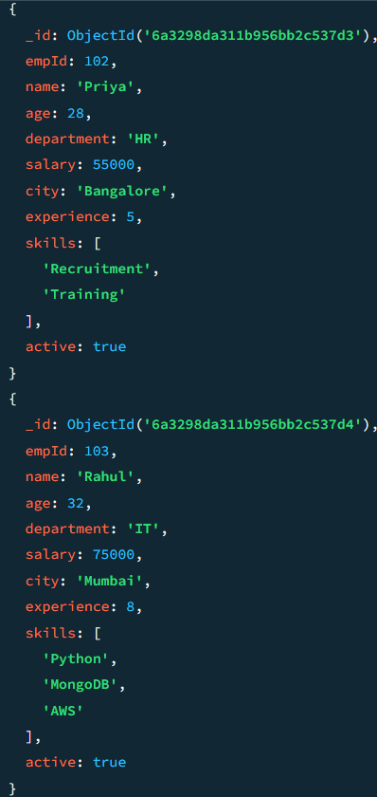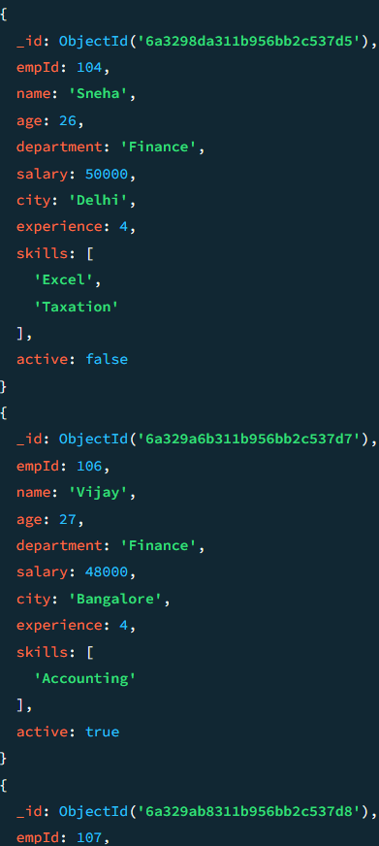

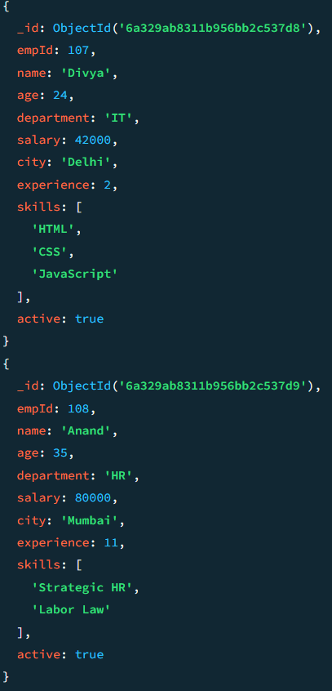

Q10 on next page

Q10 –>Find employees from Chennai or Mumbai.
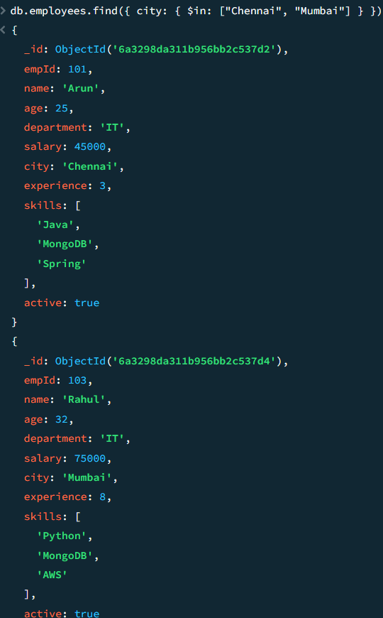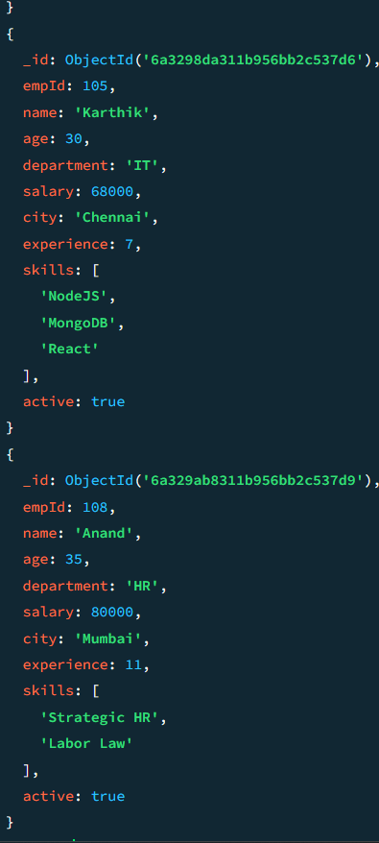
Q11. Find employees not from Chennai.
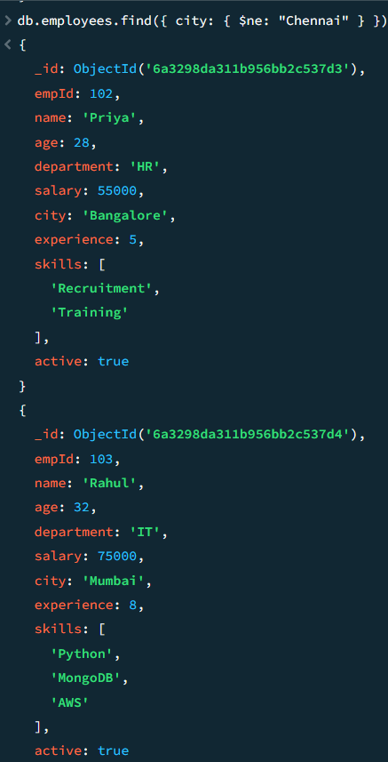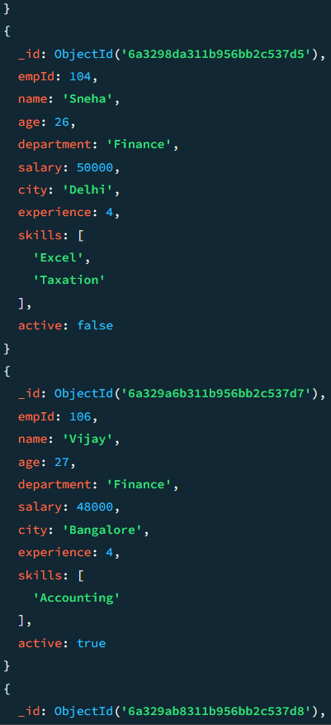
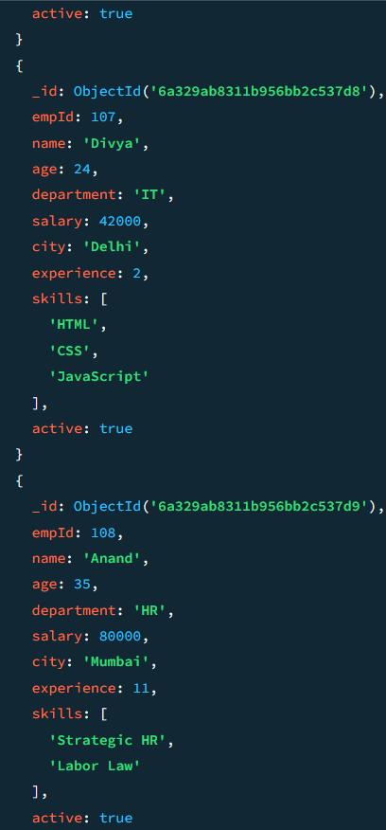

Q12. Find IT employees with salary > 50000.
Ans-12
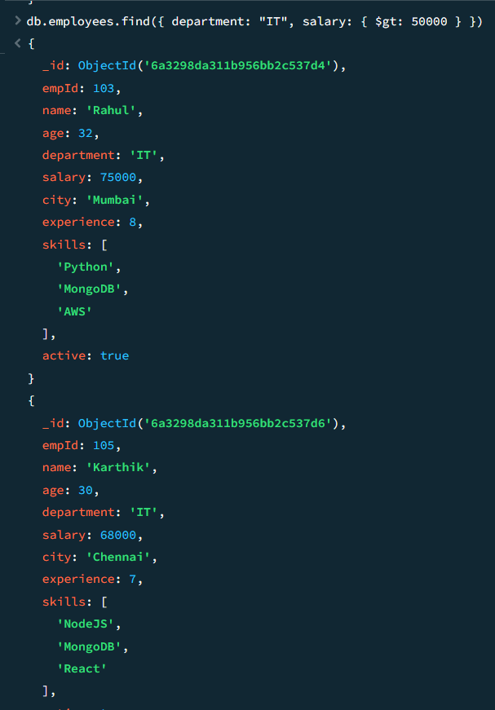

Q13. Find employees from Chennai OR Bangalore
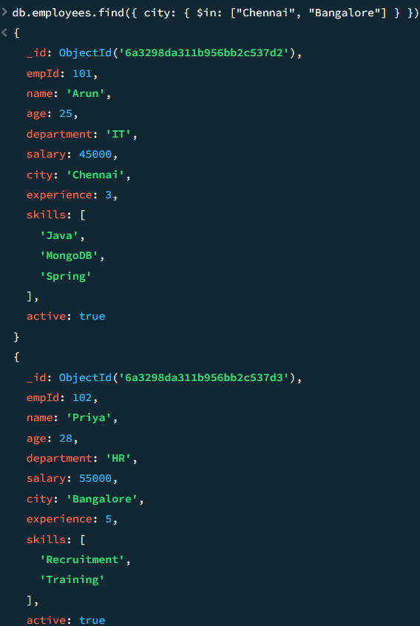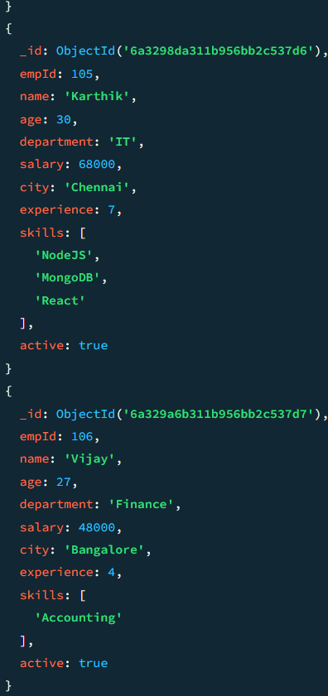

Q14. Find employees NOT earning above 60000
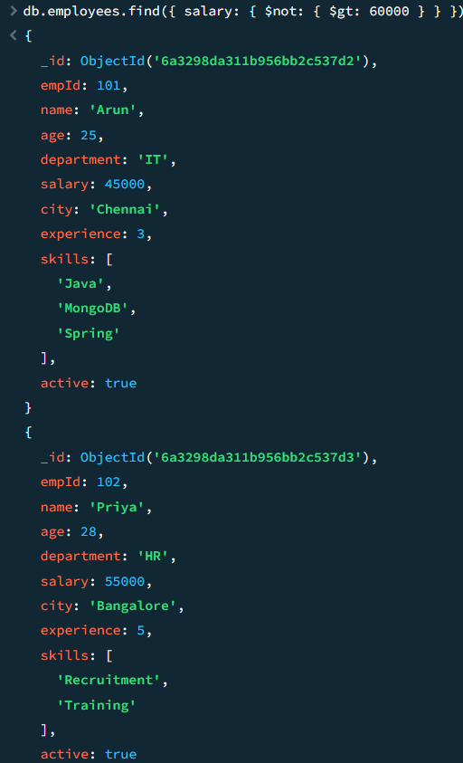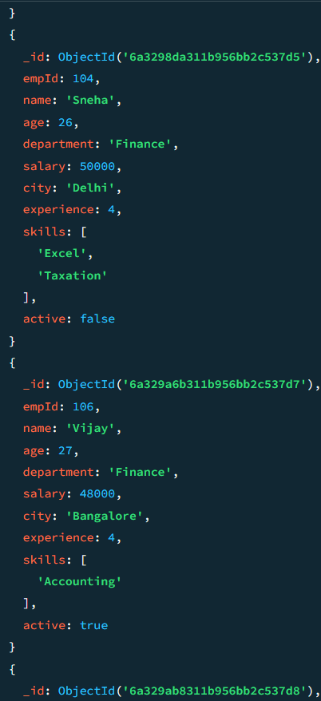
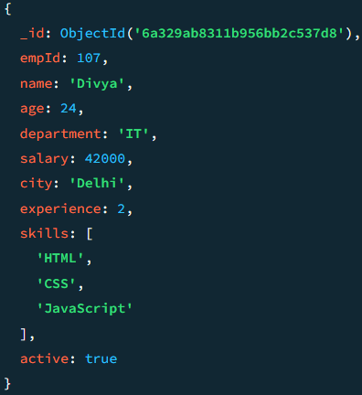

Q15.Find employees neither in IT nor HR

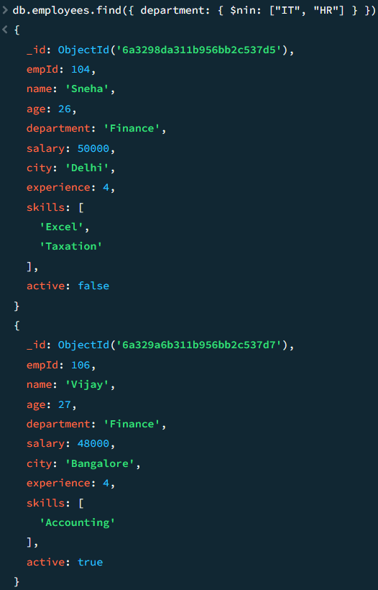

Q16. Find documents containing experience field
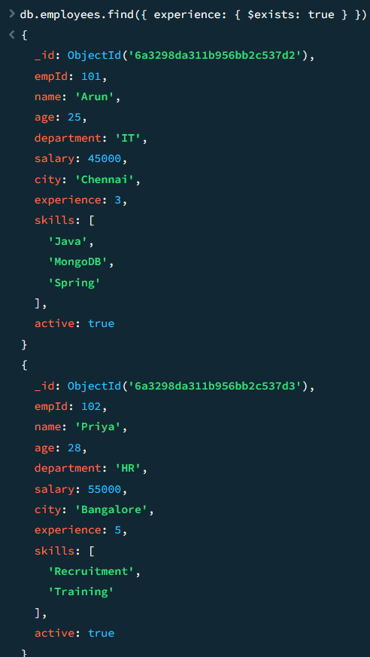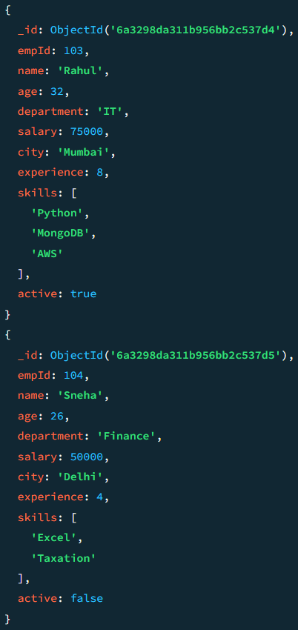

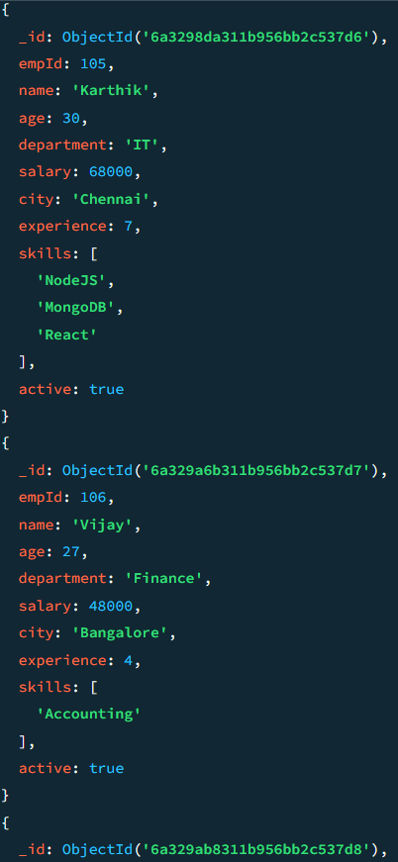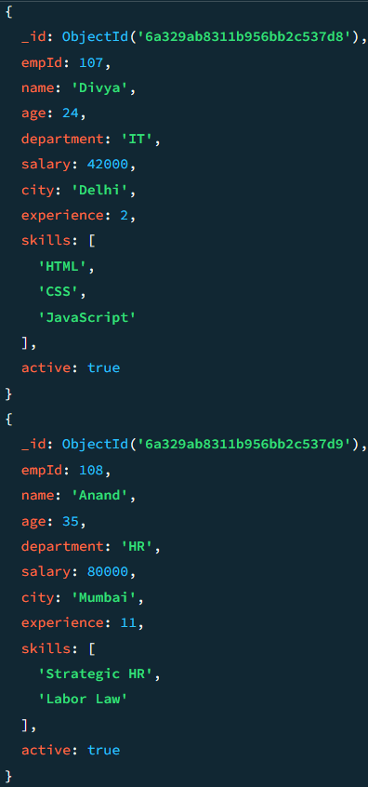

Q17. Find documents where salary is Integer
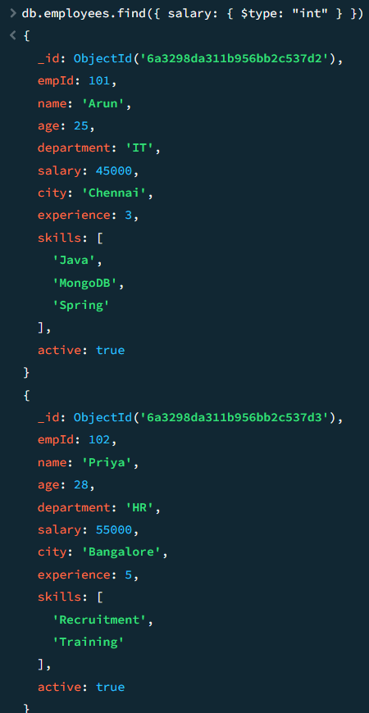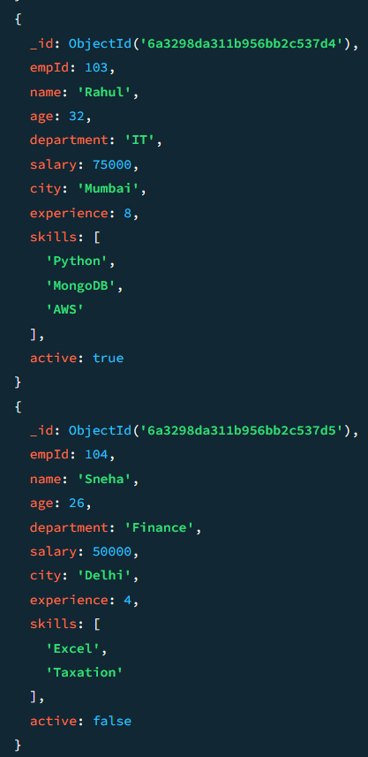

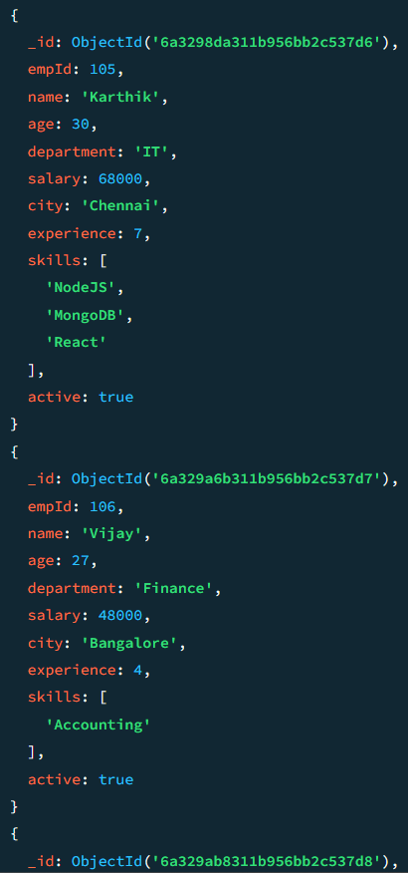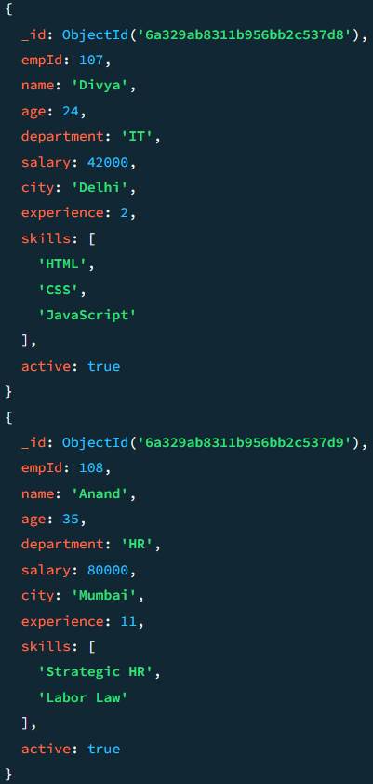

Q18. Find employees having MongoDB skill.
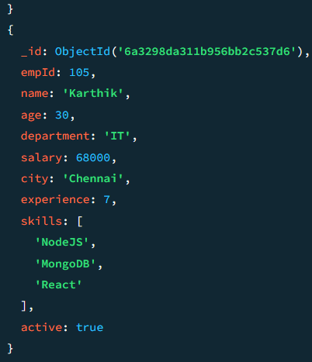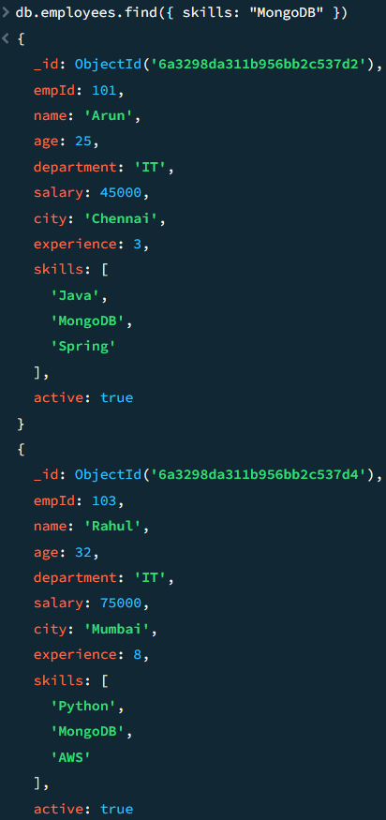

Q19 Find employees having both MongoDB and AWS
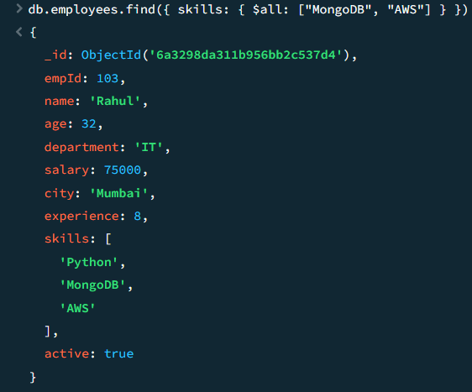
Q20 -> Find employees with exactly 3 skills
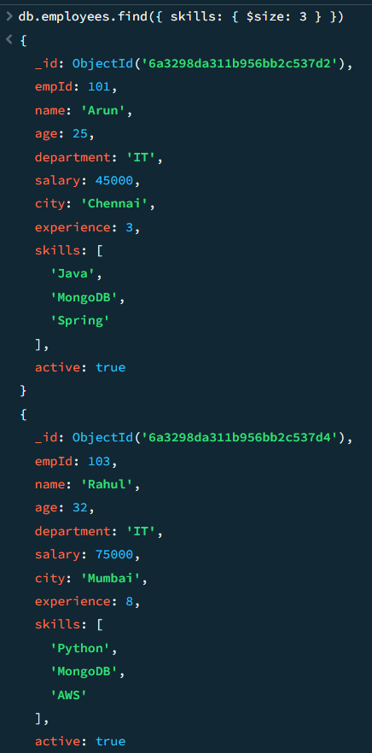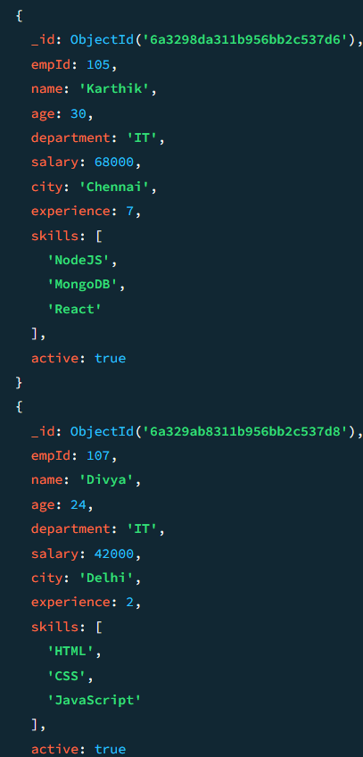
Q21. Find employees having Java skill using elemMatch.
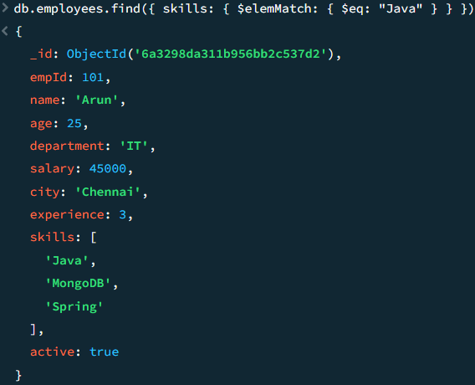
Q22Display employees sorted by salary descending
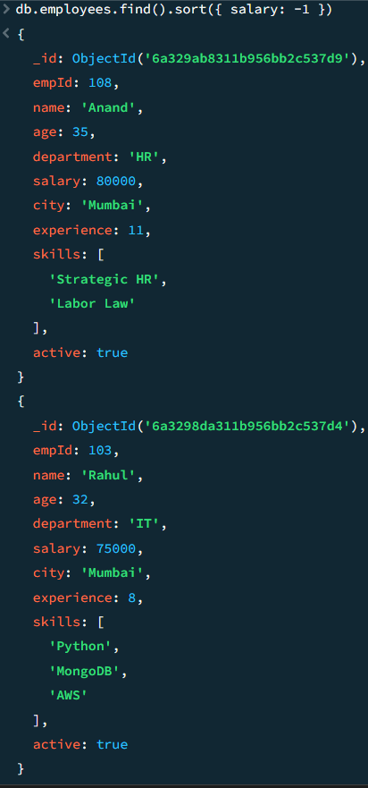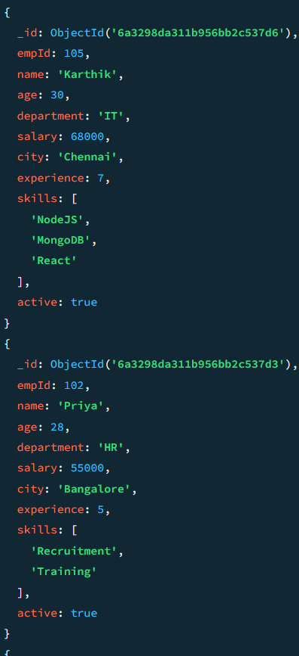
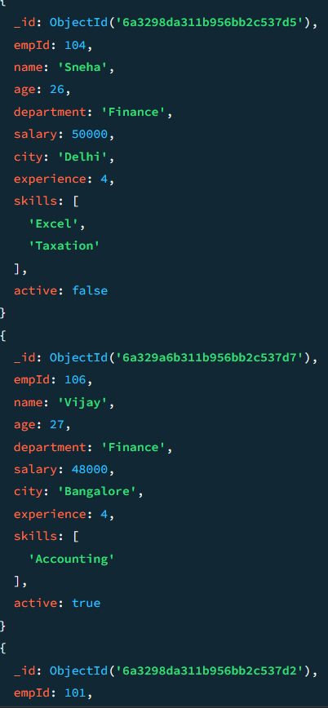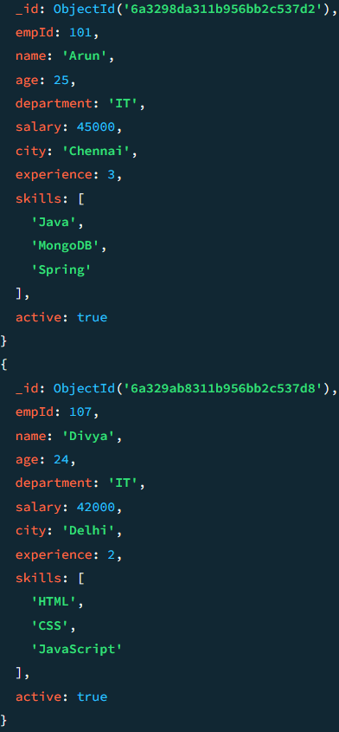

Q23. Display top 3 highest paid employees.
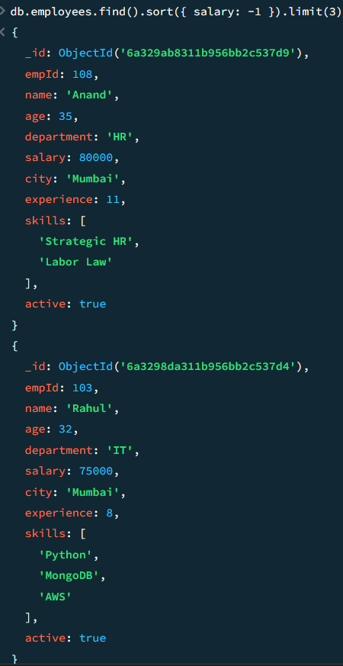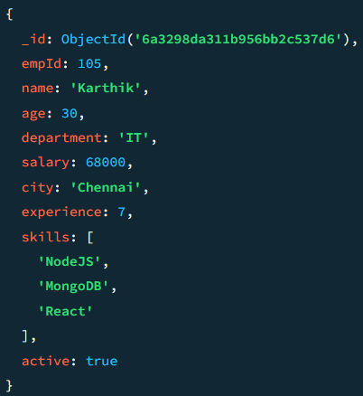
Q24. Increase salary of employee 101 by 5000
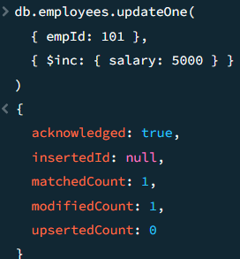
Q25. Increase salary of all IT employees by 10%.
