Food Delivery Platform
Backend System — Project Report
Subject: MongoDB DBMS Project • Node.js + Express.js + Mongoose • REST API
VIT Bhopal University • MongoDB DBMS Project • 2025-26

1. Project Description
This project is an API-based backend system for a Food Delivery Platform similar to Swiggy or Zomato. It is built using Node.js, Express.js, and MongoDB as the database, managed through Mongoose ODM. The system handles the complete lifecycle of a food delivery application — from customer registration, browsing restaurants by locality, managing shopping carts, placing orders, kitchen queue tracking, inventory management, to delivery agent assignment. All database relationships (One-to-One, One-to-Many, Many-to-Many) are implemented across 13 MongoDB collections. APIs are tested and documented using Swagger UI.

2. Tools & Technologies
Component | Tool / Technology | Version / Details
Runtime | Node.js | v22.x LTS
Package Manager | npm | v10.x
Framework | Express.js | v4.x
Database | MongoDB | v7.x (Local / Atlas)
ODM | Mongoose | v8.x
API Docs | Swagger UI + swagger-jsdoc | v5.x / v6.x
API Testing | Postman | v10.x (Desktop)
IDE | Visual Studio Code | v1.9x
Version Control | Git + GitHub | Latest
Environment | dotenv | v16.x
OS | Windows 11 | PowerShell Terminal

3. Entities & Components (Collections)
# | Collection | Purpose
1 | users | Customer accounts, saved addresses, order history references
2 | restaurants | Restaurant metadata, cuisine type, locality ID, owner reference
3 | menu_items | Dishes with price, description, tags (veg/spicy), availability status
4 | orders | Placed orders — links user, restaurant, delivery agent, and items array
5 | carts | Active shopping cart per user containing items before checkout
6 | delivery_agents | Agent availability, current order assignment, vehicle type
7 | reviews | Ratings (1-5) and comments at restaurant + dish level per order
8 | kitchen_orders | Per-item cooking status queue for kitchens (pending/cooking/ready)
9 | inventory | Ingredient stock, unit types, and reorder alerts per restaurant
10 | categories | Veg, Non-Veg, Starters, Desserts, Beverages grouping
11 | offers | Coupon codes and discount details linked to restaurants/categories
12 | localities | Pincode-based areas with list of operating restaurants
13 | preferences | User taste profile — food type preference, spice level, allergies

4. Database Relationships (Mappings)
Mapping Type | Between | How Implemented
One to One | User ↔ Cart | Each user has exactly one active cart document (unique user_id)
One to One | User ↔ Preference | Each user has one taste preference profile document
One to One | DeliveryAgent ↔ Current Order | DeliveryAgent handles one current order ID reference at a time
One to Many | Restaurant → Menu Items | Restaurant ID reference inside each MenuItem, and menu_items list in Restaurant
One to Many | Restaurant → Inventory | Each ingredient stock document is linked to one restaurant
One to Many | User → Orders | user_id reference stored inside each Order document
Many to Many | Orders ↔ Menu Items | items[] array with menu_item_id + quantity inside the Order document
Many to Many | Inventory ↔ Menu Items | linked_menu_items[] array of IDs inside the inventory document
Many to Many | Users ↔ Offers | users_used[] array of User IDs inside each Offer document
Many to One | Restaurants → Locality | locality_id reference inside each Restaurant document

5. REST API Endpoints
Method | Endpoint | Description
POST | /api/users/register | Register a new customer account
GET | /api/restaurants/nearby/:pincode | Fetch restaurants operating in the user's locality
GET | /api/restaurants/famous/:pincode | Get top rated restaurants by locality area code
GET | /api/menu/:restaurantId | Retrieve the full food menu of a restaurant
GET | /api/menu/recommended/:userId | Fetch dishes matching user's spice and diet preference
POST | /api/cart/:userId/add | Add a menu item and quantity to the user's cart
DELETE | /api/cart/:userId/remove/:itemId | Remove an item from the customer's active cart
POST | /api/orders/checkout/:userId | Convert the cart into a placed order and clear cart
PUT | /api/orders/:id/status | Update order status (preparing, out_for_delivery, delivered)
GET | /api/orders/:id | Get full details of an order with populated references
GET | /api/kitchen/:restaurantId/queue | Get pending kitchen preparation orders for a restaurant
GET | /api/inventory/:restaurantId/low-stock | List ingredients needing restock for a restaurant
POST | /api/reviews | Submit ratings and review comments for restaurant or dish
POST | /api/offers/apply | Validate and apply a coupon promo code to a cart value
DELETE | /api/admin/drop/:collection | Drop a specific database collection (administrative tool)

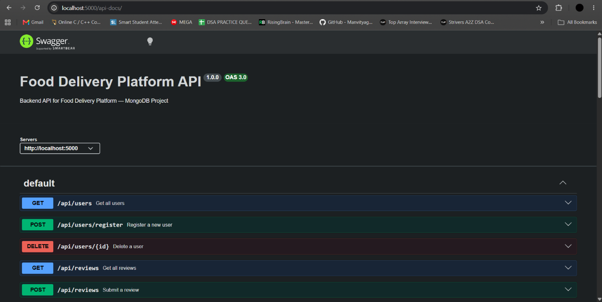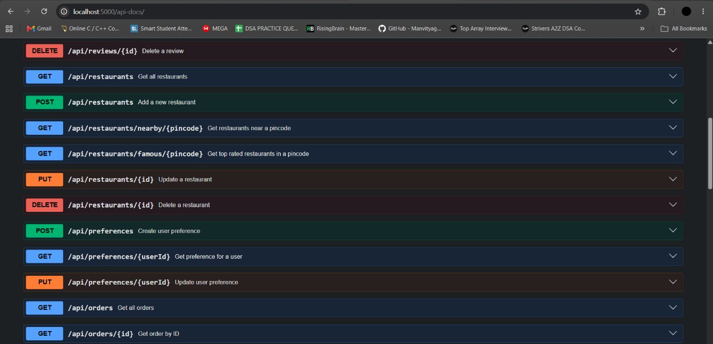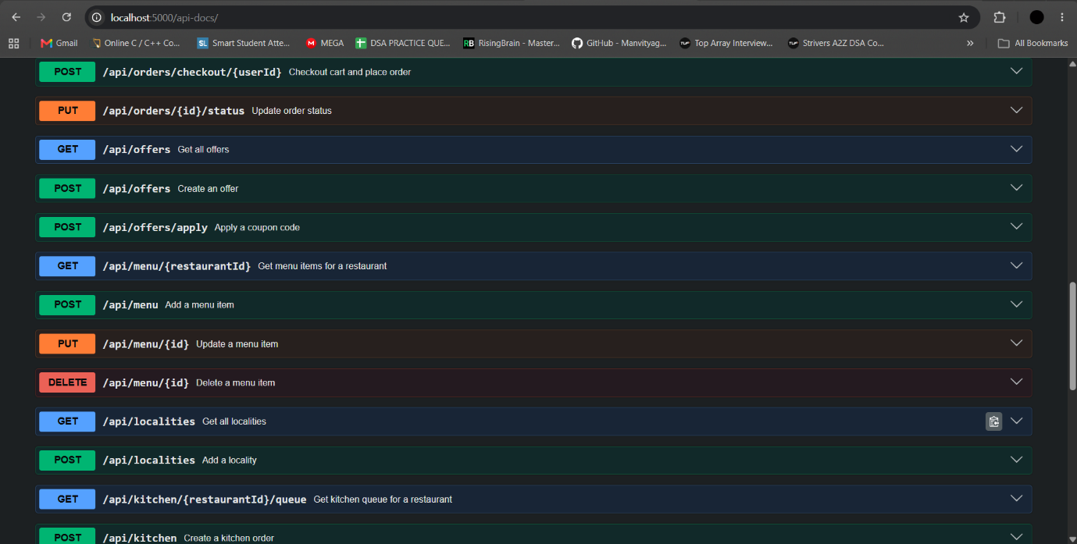

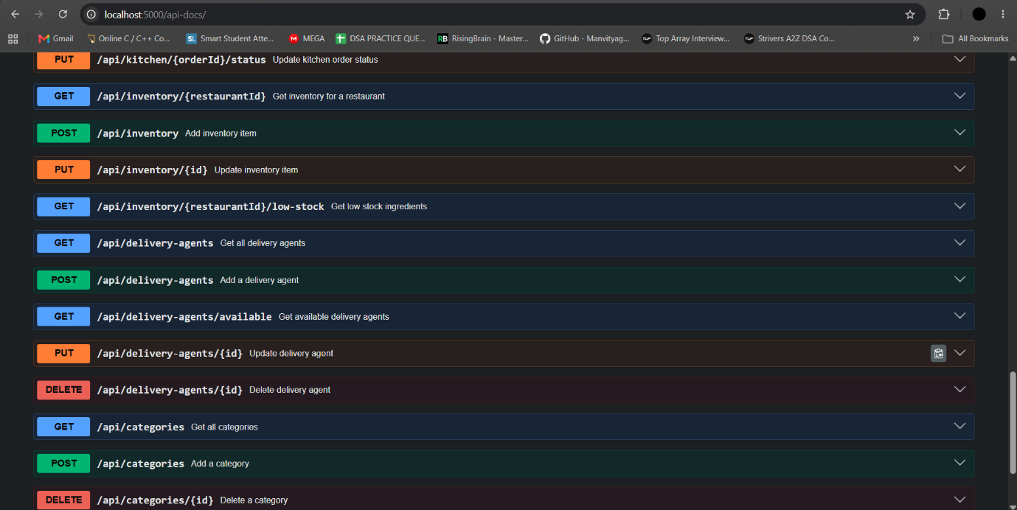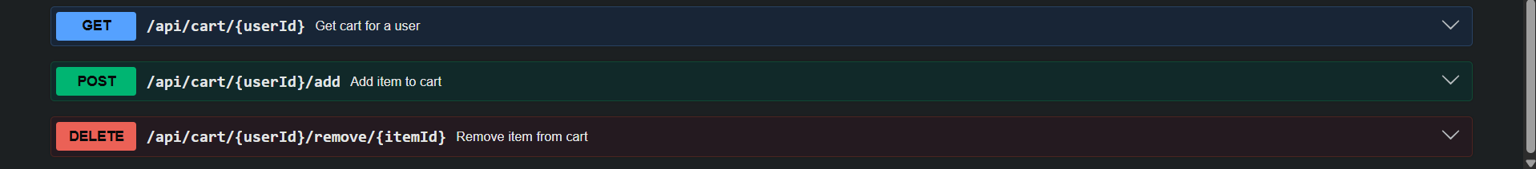

"The above screenshots show the Swagger UI dashboard running at http://localhost:5000/api-docs. It reads JSDoc annotations from the Express routes and renders a sandbox interface, allowing us to interactively test and verify CRUD requests for all 13 database collections in the browser."

6. How the System Works
Step-by-step flow of the platform:
- MongoDB connection is established via Mongoose in config/db.js using the URI loaded from the .env file.
- Express.js server starts on PORT 5000, and all routes are modularly registered.
- User Registration: User registers and their Taste Preference profile is automatically created.
- Locality search: Customer enters their pincode, and the system queries operating restaurants in that locality.
- Menu Browsing: User views the food menu, filtered or sorted by their taste preferences.
- Shopping Cart: User adds items, updating their unique active Cart document.
- Checkout: Cart contents are converted into a placed Order document and the Cart is cleared.
- Kitchen Cooking: The Order automatically triggers a KitchenOrder document. Items transition from pending → cooking → ready.
- Delivery Rider: An available DeliveryAgent is selected, and order status updates as the rider delivers it.
- Inventory Track: Each order decrements ingredient stock. Low-stock alerts trigger if level is below threshold.
- Reviews: The user submits ratings linked to the restaurant and menu items.
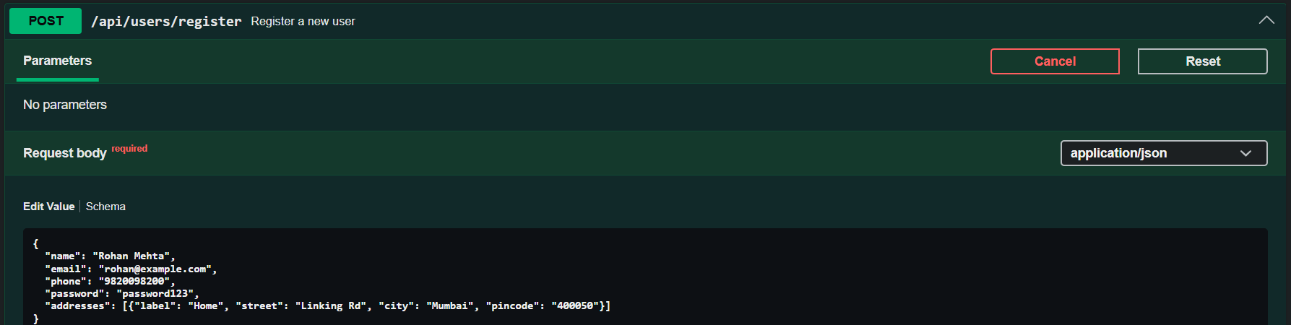
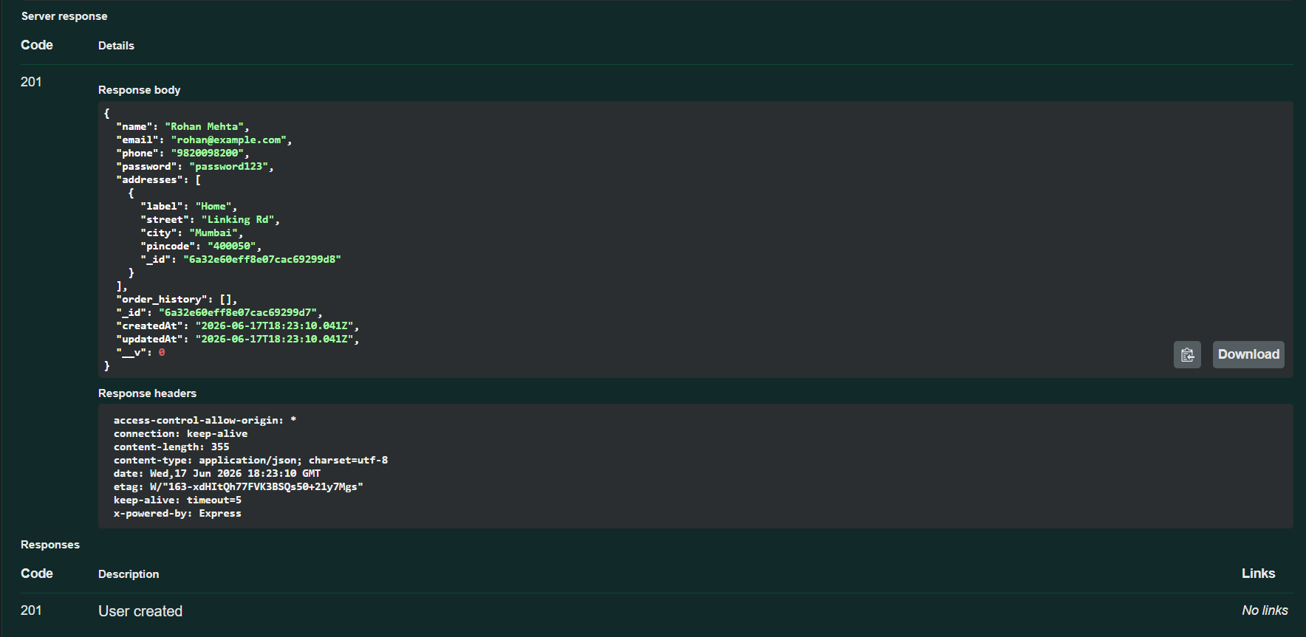

"The above screenshots show a successful POST /api/users/register response. Upon creating the user 'Rohan Mehta', the database automatically instantiates a corresponding Mongoose Preference document, establishing a One-to-One mapping to track the customer's food habits."

7. Cart Operation Flow (Adding & Checking Out)
The core customer interaction flow consists of managing items in a temporary cart and subsequently checking them out to place an order:
- Adding to Cart: Hitting POST /api/cart/{userId}/add checks for an active Cart. If absent, a Cart document is instantiated; if present, the item list is updated with the specified menu item ID and quantity.
- Checking Out: Hitting POST /api/orders/checkout/{userId} fetches the user's active Cart. It maps the items array to a new Order record, sets the initial status to "placed", pushes the order ID to the user's history, and deletes the Cart from the database.

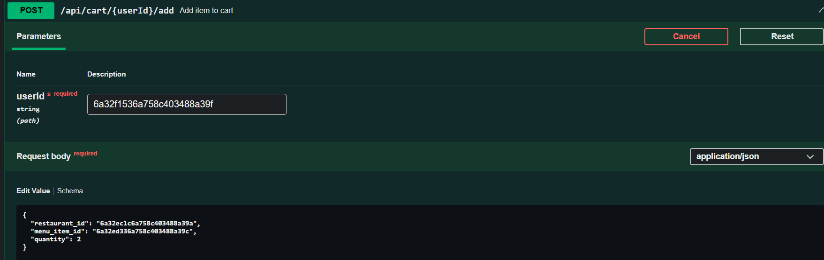
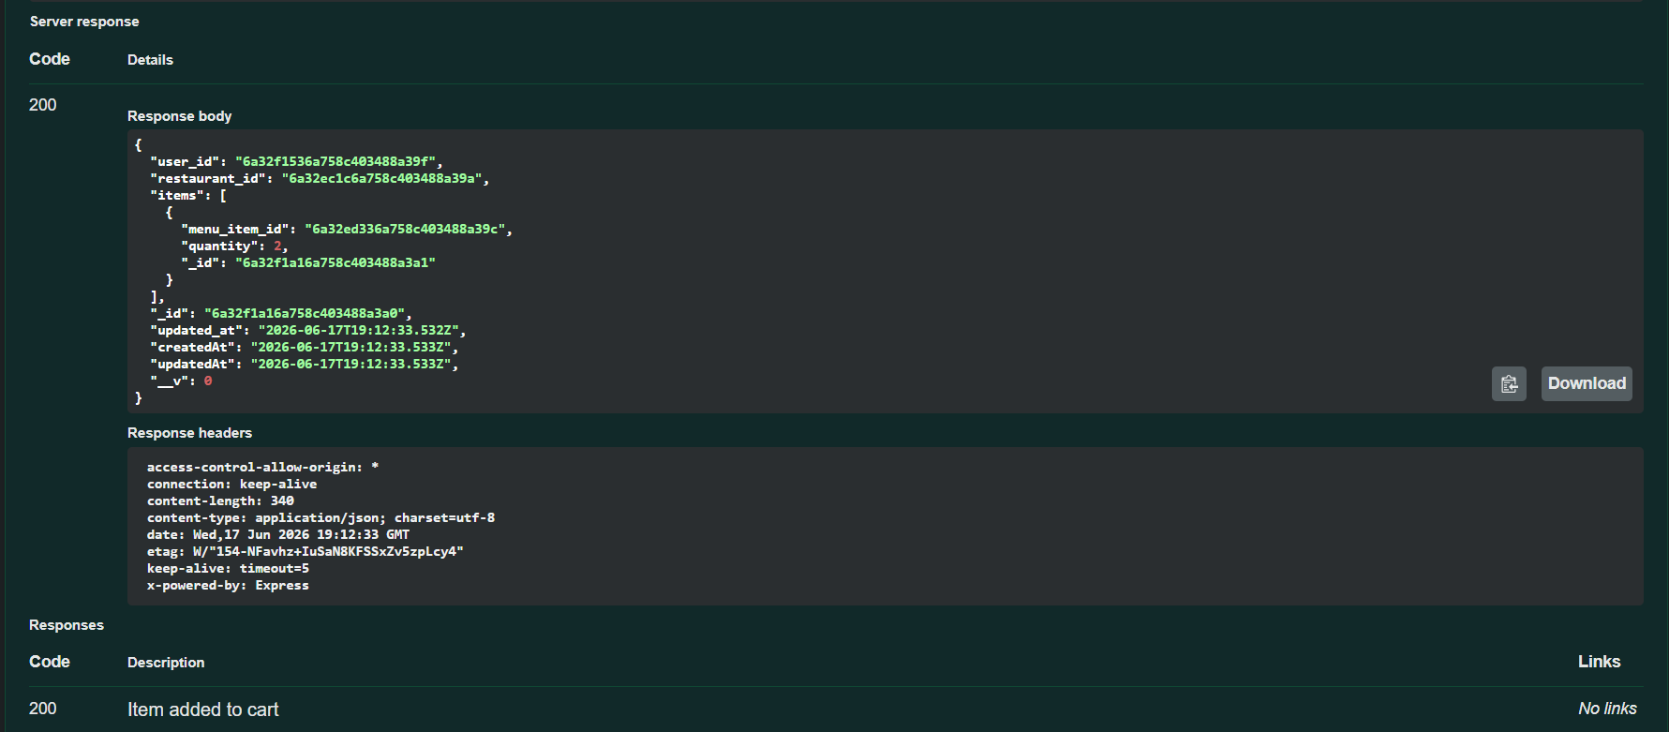
"The output shows the POST /api/cart/{userId}/add response. It verifies that Mongoose checks the Restaurant and MenuItem references before pushing the selected dish and quantity into the active Cart array for the user."

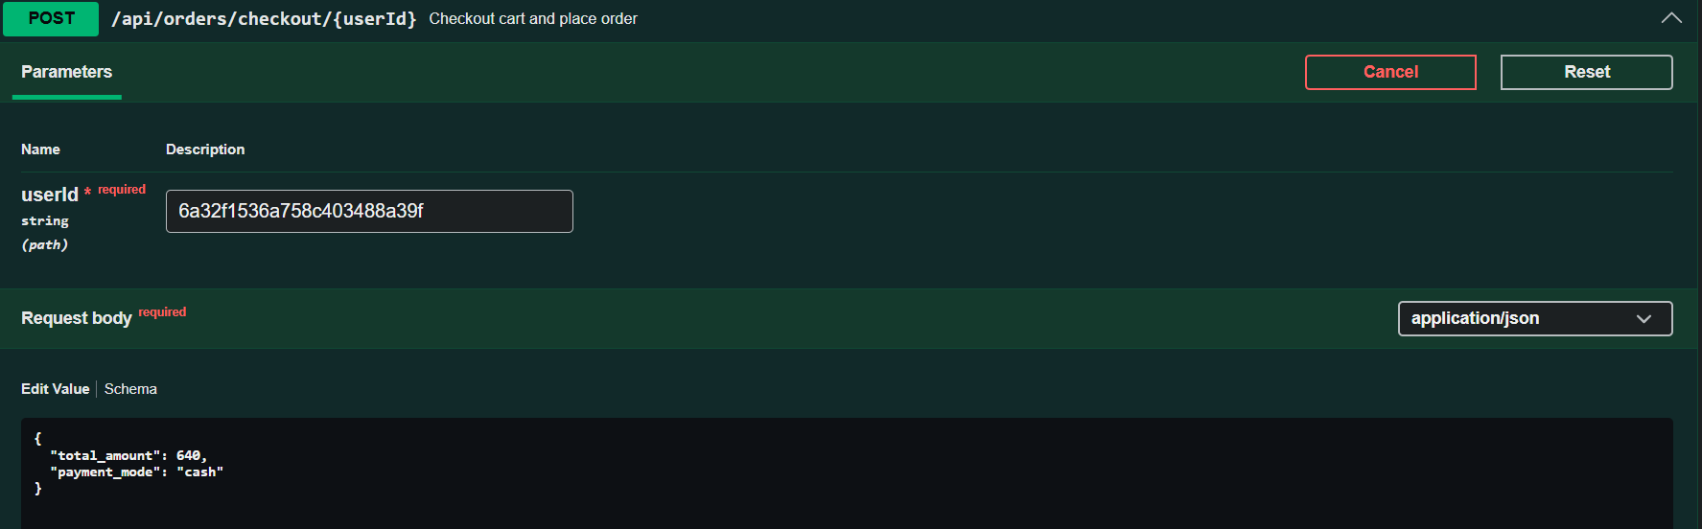
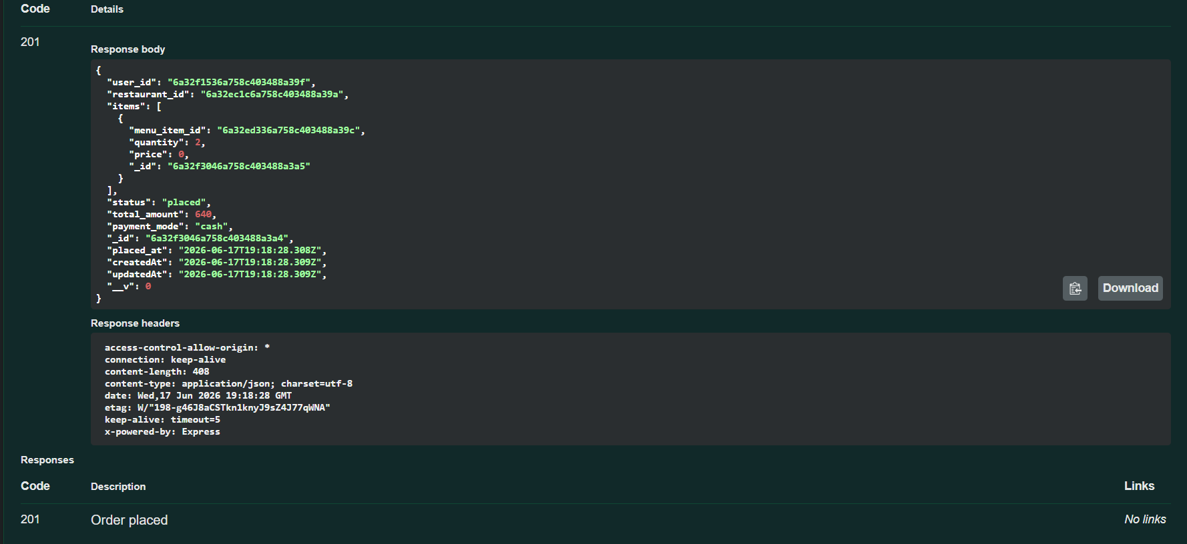
"The above screenshots show the cart checkout response from POST /api/orders/checkout/{userId}. It reads the cart, maps it to a new Order document with a status of 'placed', and deletes the temporary Cart document from MongoDB."

8. Project Outcomes
The implementation of the Food Delivery Platform backend yielded the following outcomes:
- Robust Database Integrity: Implemented strict schema definitions and validation rules utilizing Mongoose, protecting the system from garbage/malformed data.
- Seamless Modular Routes: Decoupled routing modules handle individual collections independently while populating references dynamically to fetch relational records.
- Comprehensive Sandbox Testing: Configured a fully responsive Swagger UI environment that allows developers, QA, or admins to perform CRUD operations on all collections without writing custom API queries.

9. Future Enhancements
The backend architecture is structured to support the integration of these features in the future:
- Secure Authentication & Authorization: Integrating JSON Web Tokens (JWT) for securing client sessions, and implementing Role-Based Access Control (RBAC) to differentiate standard Users, Restaurant Owners, and Delivery Agents.
- Real-Time Tracking: Implementing WebSockets (via Socket.io) to transmit GPS coordinate updates of delivery riders to the user interface in real-time.
- Automated Messaging: Integrating third-party notification APIs (such as Twilio or SendGrid) to send order dispatch and delivery confirmation alerts.
- AI Recommendation Engine: Enhancing the recommendation endpoint with machine learning algorithms to suggest dishes based on user preference history and purchase patterns.

10. Conclusion
This project demonstrates the practical application of a Document-Oriented Database management system for handling high-transaction web applications. By utilizing MongoDB's flexible schema models alongside Mongoose validation and referencing, we built a food delivery API capable of handling inventory tracking, kitchen queues, customer reviews, and orders. The backend compiles correctly, has zero server conflicts, and is ready to scale with a frontend web or mobile client.
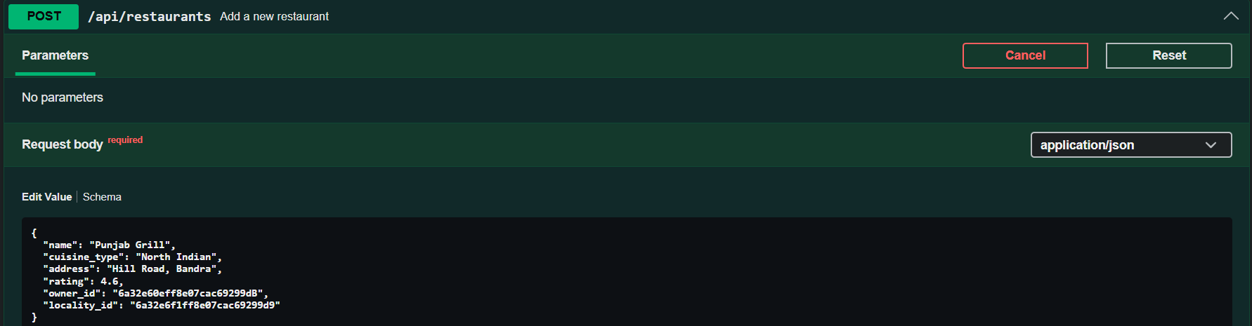
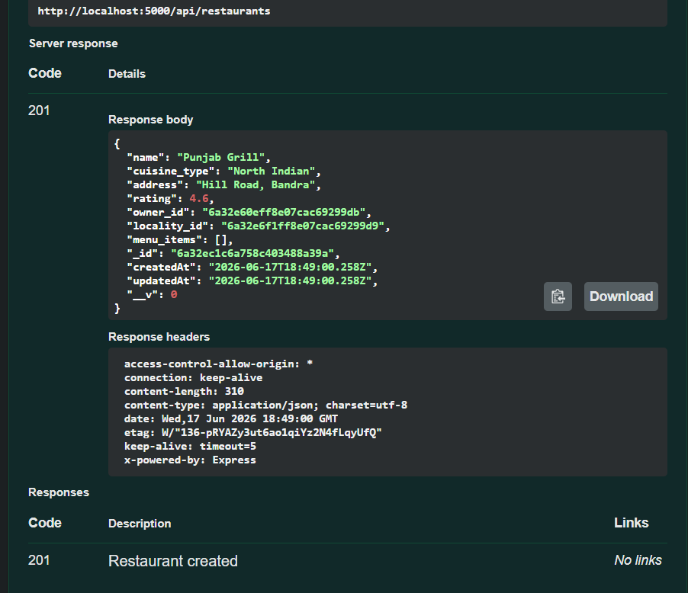
"The output shows the creation of 'Punjab Grill' restaurant and its linked 'Dal Makhani' menu item. Mongoose validates the locality and category references, successfully indexing them in the database."

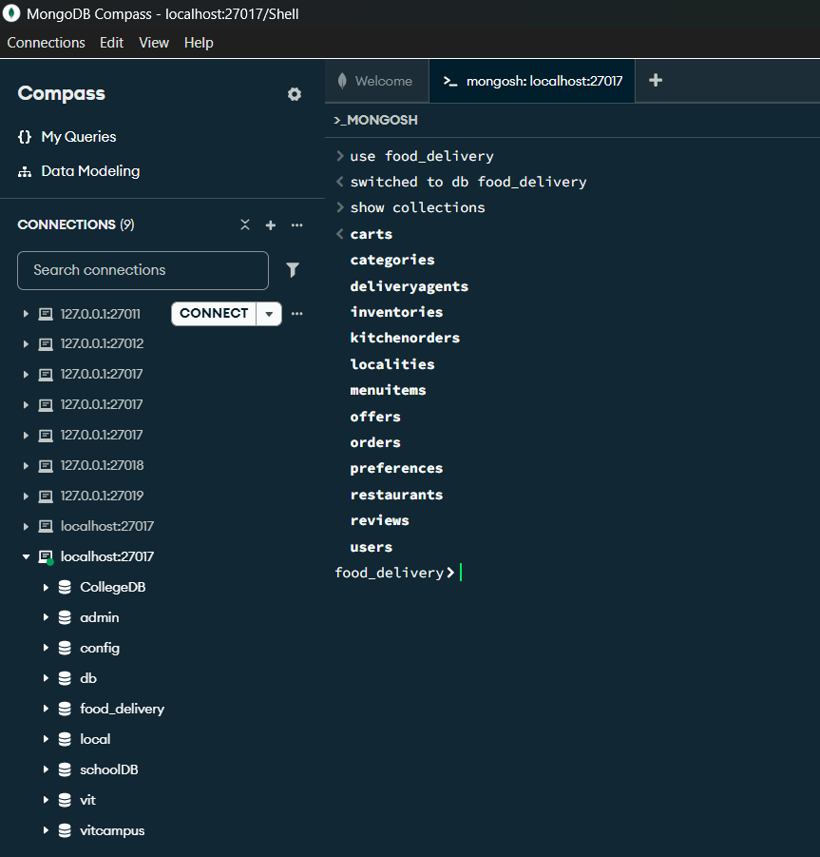
"The screenshots show MongoDB Compass connected to the local database. It confirms that the Mongoose schemas are active, showing the 13 collections under the food_delivery database with their document counts."

11. Project Folder Structure

food-delivery-backend/
├── config/
│ └── db.js → MongoDB connection setup using Mongoose
├── models/
│ └── [13 Files].js → Mongoose schema declarations
├── routes/
│ └── [13 Files].js → Express routes with Swagger documentation JSDoc
├── screenshots/
│ └── Screenshots_swagger.docx → Complete project run screenshots
├── .env.example → Database credentials template
├── .gitignore → Excludes node_modules/ and .env
├── PROJECT_REPORT.doc → Academic project report document (this file)
├── README.md → User configuration instructions
├── swagger.js → Swagger specification configuration
└── server.js → Main entry server startup script

12. Setup & Connection Steps
- Install Node.js v22.x LTS and verify installation using terminal commands: node --version and npm --version.
- Install MongoDB Community Server locally, or use a MongoDB Atlas cloud database cluster.
- Open the project terminal directory and run npm install to install dependencies.
- Create a .env configuration file with:
- MONGO_URI=mongodb://localhost:27017/food_delivery
PORT=5000
- Start the server by running node server.js in the console. The console outputs:
- Server running on http://localhost:5000
MongoDB Connected Successfully
- Open your web browser and go to http://localhost:5000/api-docs to open the Swagger API interface and test the project.
Food Delivery Platform Backend Project Report • VIT Bhopal University

