Docker version



Docker service status

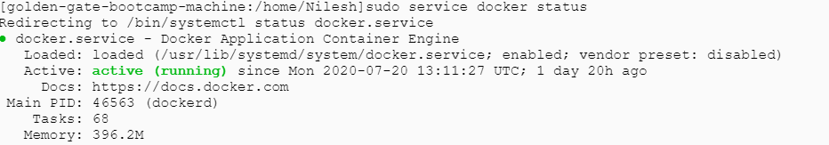

Docker ps

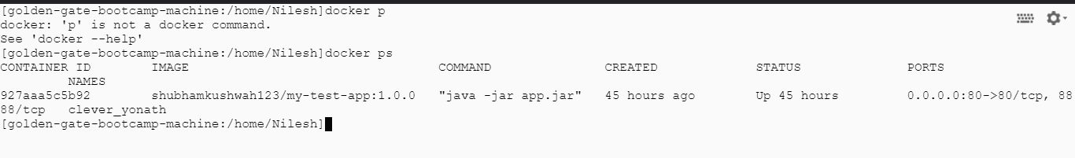

Docker ps -a command

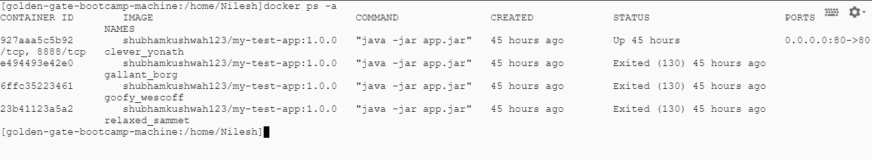

Docker images

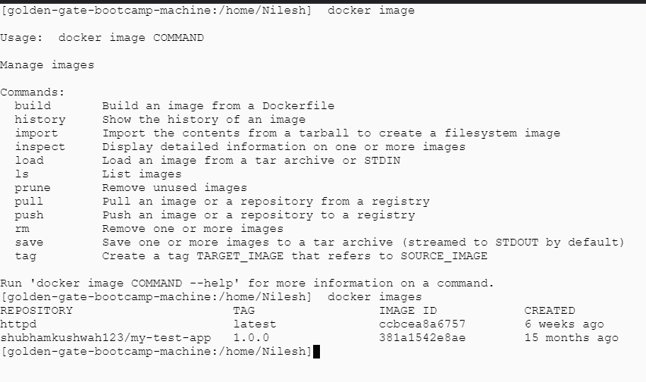

Docker rmi command

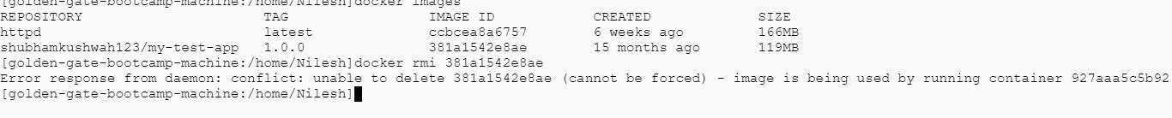

Dockerfile

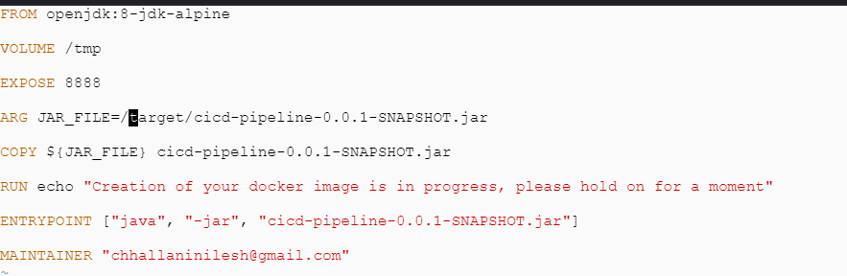

Build a Dockerfile

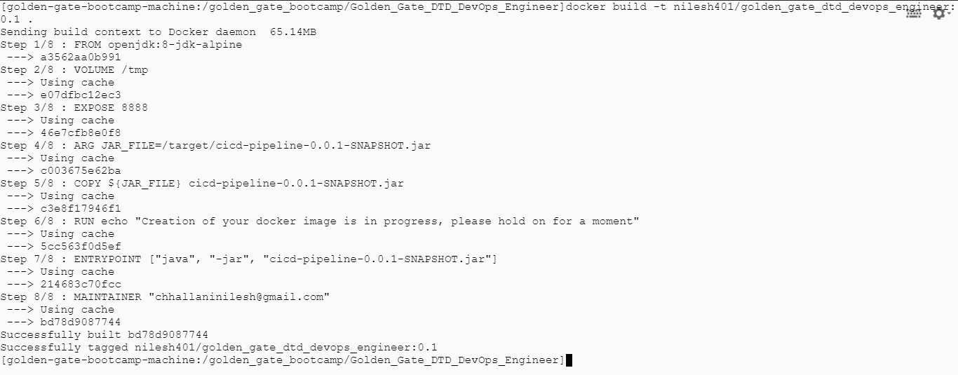

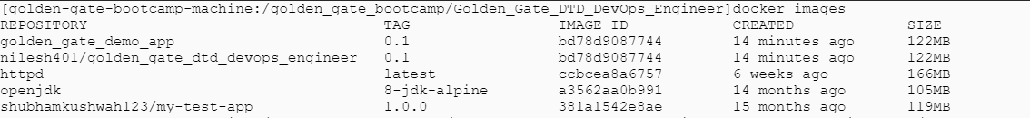

Docker hub login

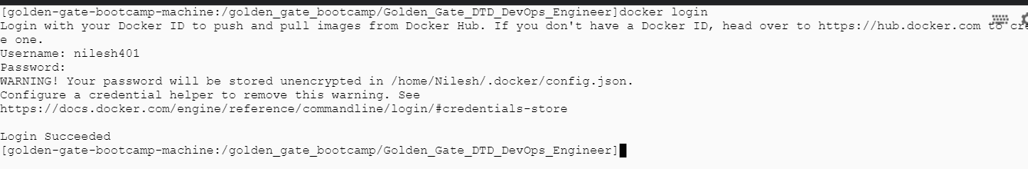

Docker push

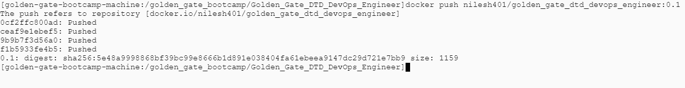

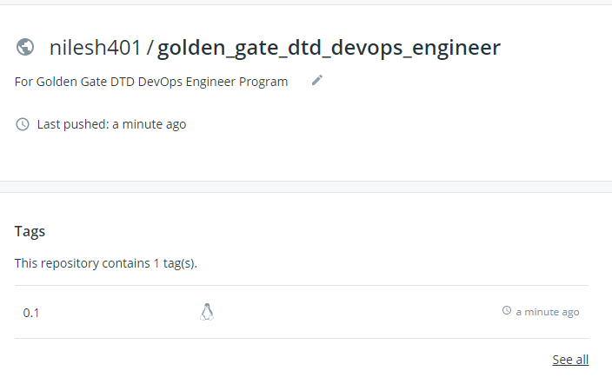

Docker run

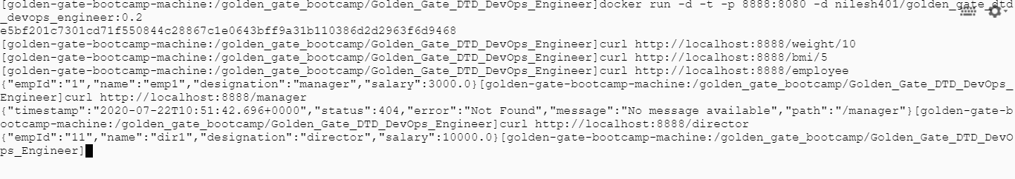

Docker compose

