**How to generate gradle java based project structure using gradle .**

* Install gradle in your Pc.
* Check version.

**gradle -version**

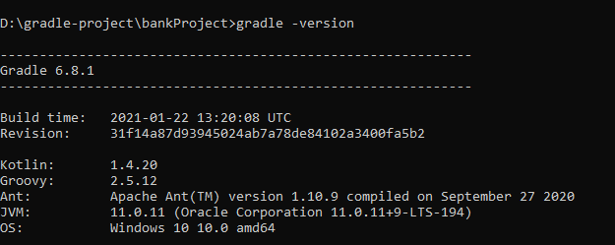

* Go to the directory where you wants to create an gradle project and open CMD.

Use command **gradle init** and select accordingly or press enter to select default

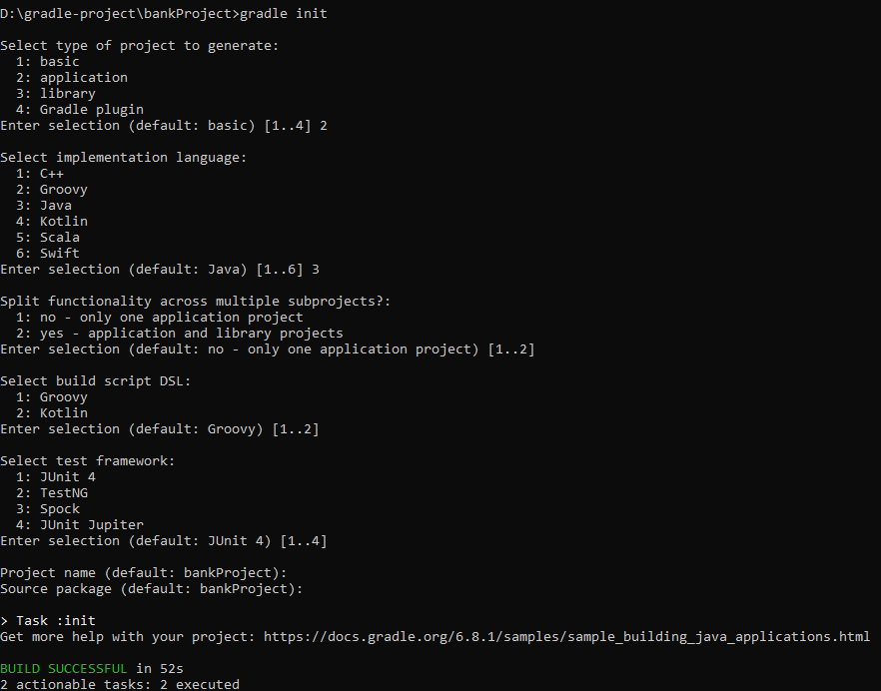

* Now we can see our gradle project has been created.

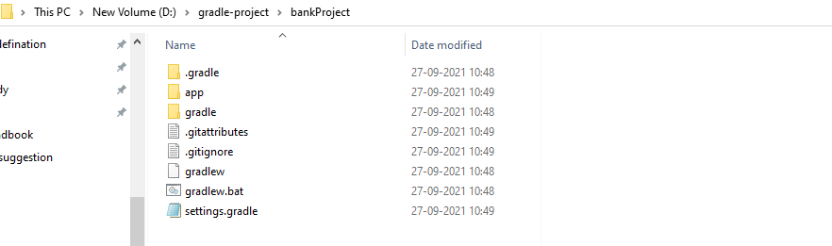

* Now go inside app folder cut the src folder and build.gradle file , paste in bannkProject folder after that delete app folder.

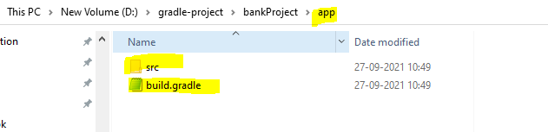

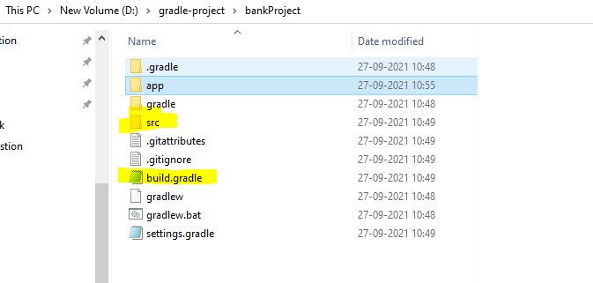

Delete app folder

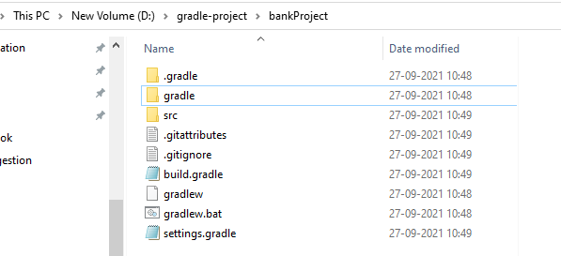

* In build. Gradle add below plugin and repository

apply plugin: 'java'

apply plugin: 'application'

apply plugin: 'eclipse'

repositories {

mavenCentral()

}

* Now run command , **gradle cleanEclipse eclipse**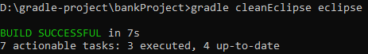
* **Now we can see that .classpath and .project file has been added in project folder and build folder has been created.**

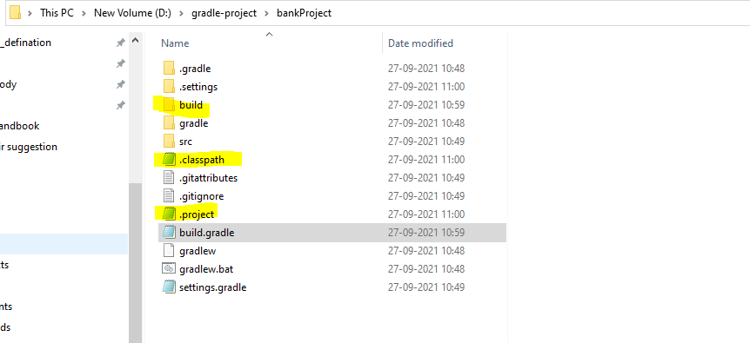

* Now we can import into our eclipse or sts IDE and start to code.
* Before pushing code to git add git ignore file content.
* Remember following coloured file to be commited.

Remaining else will be automatically created while building your project locally.

