BMP Tutors: Comprehensive Visual Analytics & Market Intelligence
Complete Empirical Dossier: 107,723 Verified Educators, 403,353 Subject Offerings, 37 States & UTs, and Academic Pricing Architecture
Dataset Source: TeacherOn India Platform • Date: September 2026 • Status: Validated, Cleaned & Normalized (Master 3-Sheet Relational Schema)
TOTAL TUTORS | ALL-INDIA AVG FEE | ONLINE ADOPTION | ACTIVE EDUCATORS | SUBJECT LINKS | STATES & UTS
107,723  100% deduplicated | ₹657 / hr  Valid ₹50-₹5,000 | 74.3%  80,038 tutors | 85,618  79.5% active rate | 403,353  3.7 subjects / tutor | 37 Covered  Full pan-India scope

1. Geographic Market Distribution: Map of India & District Spatial Structure
Private tutoring supply in India displays strong geographic concentration across regional economic hubs and educational belts. Replicating the clean academic architecture of the Visual Analytics Dashboard, this section presents: (1) The Map of India showing state-wise administrative boundaries with direct in-polygon verified tutor counts for all 36 states and union territories, (2) The complete census table covering all 37 Indian states and union territories, and (3) Individual state administrative diagrams displaying localized district boundaries, headcount labels, and full district data tables for every state.

Figure 1A: Map of India — State-Wise Boundaries & Data Labels (N = 107,723)
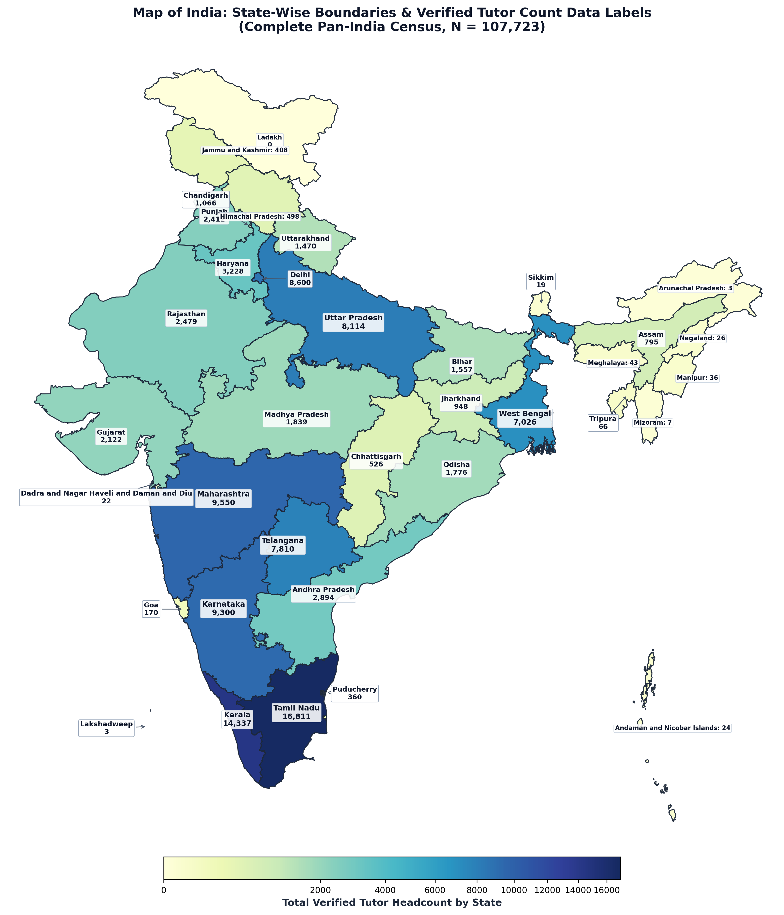
State administrative boundaries with direct in-polygon numerical labels and choropleth shading, matching the Visual Analytics Dashboard. Every single state and union territory in India is labeled with its verified tutor headcount. Leading markets include Tamil Nadu (16,811), Kerala (14,337), Maharashtra (9,550), Karnataka (9,300), Delhi NCR (8,600), Uttar Pradesh (8,114), Telangana (7,810), West Bengal (7,026), and Haryana (3,228).

Table 1: All-India State & Union Territory Complete Distribution
Rank | State / Union Territory | Zone | Tutors (N) | Share (%) | Avg Fee (₹) | Online % | Active
1 | Tamil Nadu | South | 16,811 | 15.61% | ₹713 | 97.2% | 11,806
2 | Kerala | South | 14,337 | 13.31% | ₹582 | 98.4% | 10,072
3 | Maharashtra | West | 9,550 | 8.87% | ₹1039 | 95.7% | 6,906
4 | Karnataka | South | 9,300 | 8.63% | ₹903 | 97.8% | 6,717
5 | Delhi | North | 8,600 | 7.98% | ₹1020 | 95.8% | 6,278
6 | Uttar Pradesh | North | 8,114 | 7.53% | ₹978 | 96.7% | 5,957
7 | Telangana | South | 7,810 | 7.25% | ₹943 | 96.9% | 5,699
8 | West Bengal | East | 7,026 | 6.52% | ₹921 | 94.0% | 5,174
9 | Haryana | North | 3,228 | 3.00% | ₹1026 | 97.7% | 2,382
10 | Andhra Pradesh | South | 2,894 | 2.69% | ₹855 | 98.4% | 2,067
11 | Rajasthan | North | 2,479 | 2.30% | ₹968 | 97.1% | 1,806
12 | Punjab | North | 2,412 | 2.24% | ₹890 | 96.3% | 1,784
13 | Gujarat | West | 2,122 | 1.97% | ₹981 | 96.7% | 1,506
14 | Madhya Pradesh | Central | 1,839 | 1.71% | ₹941 | 98.0% | 1,332
15 | Odisha | East | 1,776 | 1.65% | ₹848 | 92.6% | 1,282
16 | Bihar | East | 1,557 | 1.45% | ₹857 | 96.9% | 1,126
17 | Uttarakhand | North | 1,470 | 1.36% | ₹991 | 95.7% | 1,053
18 | Not Specified | Not Specified | 1,268 | 1.18% | — | 0.0% | 94
19 | Chandigarh | North | 1,066 | 0.99% | ₹986 | 93.8% | 776
20 | Jharkhand | East | 948 | 0.88% | ₹850 | 96.3% | 673
21 | Assam | East | 795 | 0.74% | ₹774 | 93.5% | 565
22 | Chhattisgarh | Central | 526 | 0.49% | ₹884 | 97.3% | 373
23 | Himachal Pradesh | North | 498 | 0.46% | ₹839 | 99.0% | 361
24 | Jammu and Kashmir | North | 408 | 0.38% | ₹945 | 98.3% | 286
25 | Puducherry | South | 360 | 0.33% | ₹700 | 97.2% | 242
26 | Goa | West | 170 | 0.16% | ₹946 | 96.5% | 130
27 | Tripura | East | 66 | 0.06% | ₹759 | 95.5% | 44
28 | Meghalaya | East | 43 | 0.04% | ₹1063 | 95.3% | 31
29 | Manipur | East | 36 | 0.03% | ₹621 | 94.4% | 23
30 | Nagaland | East | 26 | 0.02% | ₹750 | 100.0% | 20
31 | Andaman and Nicobar Islands | South | 24 | 0.02% | ₹901 | 100.0% | 18
32 | Sikkim | East | 19 | 0.02% | ₹730 | 94.7% | 13
33 | Dadra and Nagar Haveli | West | 18 | 0.02% | ₹583 | 100.0% | 17
34 | Mizoram | East | 7 | 0.01% | ₹813 | 100.0% | 5
35 | Daman and Diu | West | 4 | 0.00% | ₹550 | 100.0% | 2
36 | Arunachal Pradesh | East | 3 | 0.00% | ₹2667 | 100.0% | 0
37 | Lakshadweep | West | 3 | 0.00% | ₹238 | 100.0% | 3
— | Total / Pan-India Average | All Zones | 107,613 | 100.00% | ₹865 | 95.6% | 76,623
Notes: All 37 states and union territories sorted by total tutor volume. Average hourly rates exclude unverified outliers outside ₹50–₹5,000/hr.

1.3 Individual States & Union Territories: Complete District-Wise Data Portfolio
This section provides the comprehensive micro-geographic breakdown of private tutoring supply for every individual Indian state and union territory. Written on the top of each state's section is an executive profile detailing total registered educator volume, national market share, pan-India rank, average hourly lesson fee, online delivery adoption, and active engagement, followed by the complete census of all constituent administrative districts.

State 1: Tamil Nadu — District-Wise Tutoring Supply (N = 16,811)
EXECUTIVE SUMMARY & STATE PROFILE: TAMIL NADU
• Total Registered Educators: 16,811 verified tutors (15.61% national market share | Pan-India Rank: #1 of 36)
• Average Hourly Tuition Rate: ₹713 / hr (statewide median pricing)
• Online Delivery Adoption: 97.2% of educators teach via digital platforms
• Active Educators: 11,806 tutors (70.2% engagement rate)
• Geographic Zone: South Region
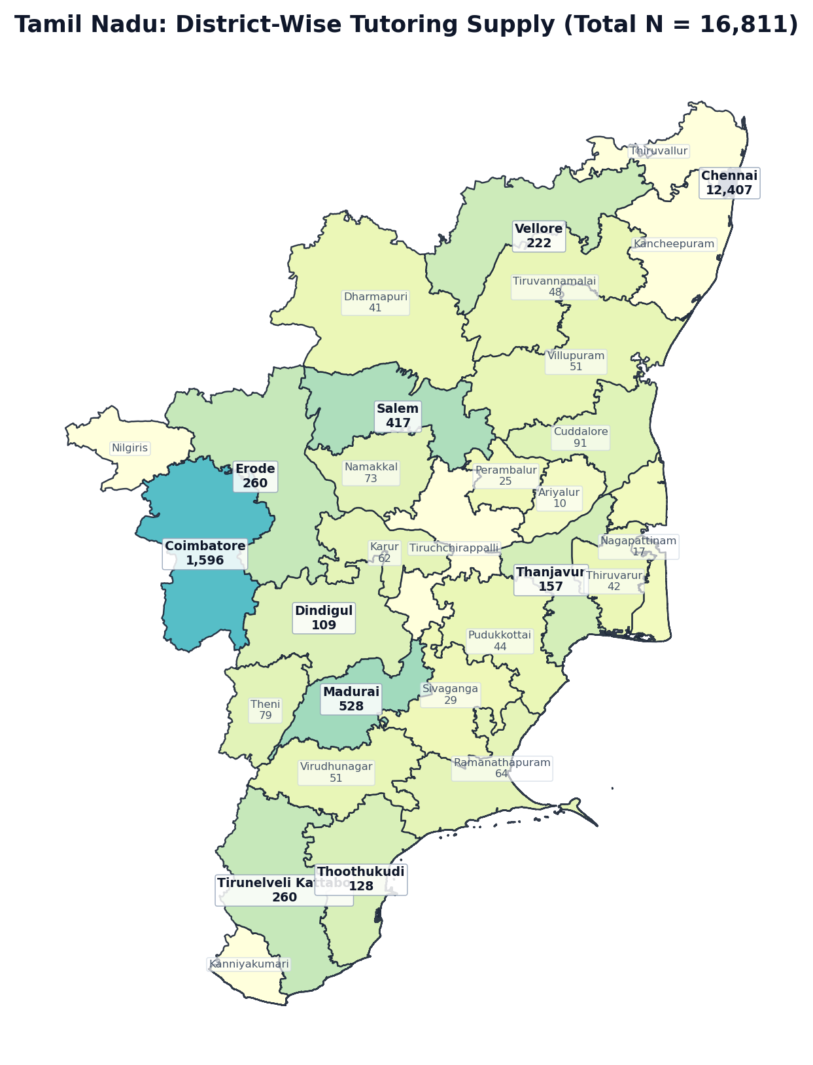
Figure 1.1: Tamil Nadu District Boundary Diagram — Localized Tutor Counts (N = 16,811)
Rank | District / Administrative Division | Tutors (N) | Share of State (%) | Avg Fee (₹/hr) | Online %
1 | Chennai | 12,407 | 73.8% | ₹722 | 96.7%
2 | Coimbatore | 1,596 | 9.5% | ₹715 | 98.7%
3 | Madurai | 528 | 3.1% | ₹724 | 99.4%
4 | Salem | 417 | 2.5% | ₹619 | 98.3%
5 | Erode | 260 | 1.5% | ₹609 | 98.5%
6 | Tirunelveli Kattabo | 260 | 1.5% | ₹626 | 100.0%
7 | Vellore | 222 | 1.3% | ₹754 | 98.6%
8 | Thanjavur | 157 | 0.9% | ₹628 | 99.4%
9 | Thoothukudi | 128 | 0.8% | ₹674 | 100.0%
10 | Dindigul | 109 | 0.6% | ₹693 | 100.0%
11 | Cuddalore | 91 | 0.5% | ₹687 | 97.8%
12 | Theni | 79 | 0.5% | ₹743 | 98.7%
13 | Namakkal | 73 | 0.4% | ₹666 | 100.0%
14 | Ramanathapuram | 64 | 0.4% | ₹696 | 98.4%
15 | Karur | 62 | 0.4% | ₹634 | 96.8%
16 | Villupuram | 51 | 0.3% | ₹615 | 100.0%
17 | Virudhunagar | 51 | 0.3% | ₹574 | 100.0%
18 | Tiruvannamalai | 48 | 0.3% | ₹621 | 97.9%
19 | Pudukkottai | 44 | 0.3% | ₹603 | 97.7%
20 | Thiruvarur | 42 | 0.2% | ₹593 | 100.0%
21 | Dharmapuri | 41 | 0.2% | ₹541 | 100.0%
22 | Sivaganga | 29 | 0.2% | ₹1389 | 100.0%
23 | Perambalur | 25 | 0.1% | ₹641 | 100.0%
24 | Nagapattinam | 17 | 0.1% | ₹592 | 94.1%
25 | Ariyalur | 10 | 0.1% | ₹480 | 90.0%
26 | Kancheepuram | 0 | 0.0% | — | 0.0%
27 | Kanniyakumari | 0 | 0.0% | — | 0.0%
28 | Nilgiris | 0 | 0.0% | — | 0.0%
29 | Thiruvallur | 0 | 0.0% | — | 0.0%
30 | Tiruchchirappalli | 0 | 0.0% | — | 0.0%
— | Tamil Nadu Total | 16,811 | 100.0% | ₹713 | 97.2%

State 2: Kerala — District-Wise Tutoring Supply (N = 14,337)
EXECUTIVE SUMMARY & STATE PROFILE: KERALA
• Total Registered Educators: 14,337 verified tutors (13.31% national market share | Pan-India Rank: #2 of 36)
• Average Hourly Tuition Rate: ₹582 / hr (statewide median pricing)
• Online Delivery Adoption: 98.4% of educators teach via digital platforms
• Active Educators: 10,072 tutors (70.3% engagement rate)
• Geographic Zone: South Region
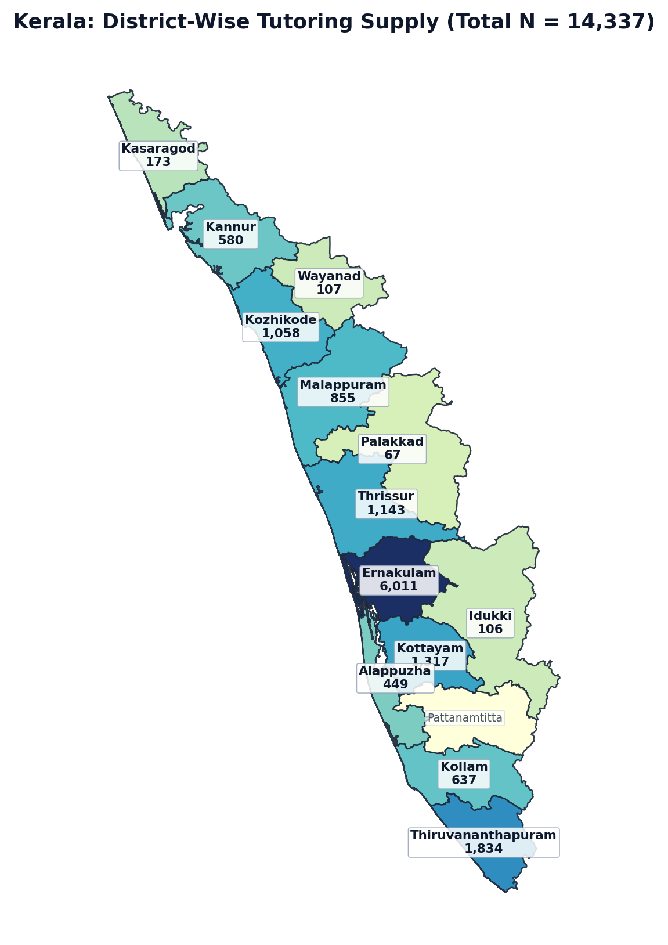
Figure 1.2: Kerala District Boundary Diagram — Localized Tutor Counts (N = 14,337)
Rank | District / Administrative Division | Tutors (N) | Share of State (%) | Avg Fee (₹/hr) | Online %
1 | Ernakulam | 6,011 | 41.9% | ₹582 | 98.1%
2 | Thiruvananthapuram | 1,834 | 12.8% | ₹598 | 96.4%
3 | Kottayam | 1,317 | 9.2% | ₹567 | 99.4%
4 | Thrissur | 1,143 | 8.0% | ₹591 | 98.7%
5 | Kozhikode | 1,058 | 7.4% | ₹570 | 99.3%
6 | Malappuram | 855 | 6.0% | ₹513 | 99.1%
7 | Kollam | 637 | 4.4% | ₹609 | 98.8%
8 | Kannur | 580 | 4.0% | ₹624 | 99.7%
9 | Alappuzha | 449 | 3.1% | ₹601 | 99.4%
10 | Kasaragod | 173 | 1.2% | ₹662 | 98.8%
11 | Wayanad | 107 | 0.7% | ₹572 | 100.0%
12 | Idukki | 106 | 0.7% | ₹512 | 100.0%
13 | Palakkad | 67 | 0.5% | ₹622 | 100.0%
14 | Pattanamtitta | 0 | 0.0% | — | 0.0%
— | Kerala Total | 14,337 | 100.0% | ₹582 | 98.4%

State 3: Maharashtra — District-Wise Tutoring Supply (N = 9,550)
EXECUTIVE SUMMARY & STATE PROFILE: MAHARASHTRA
• Total Registered Educators: 9,550 verified tutors (8.87% national market share | Pan-India Rank: #3 of 36)
• Average Hourly Tuition Rate: ₹1039 / hr (statewide median pricing)
• Online Delivery Adoption: 95.7% of educators teach via digital platforms
• Active Educators: 6,906 tutors (72.3% engagement rate)
• Geographic Zone: West Region
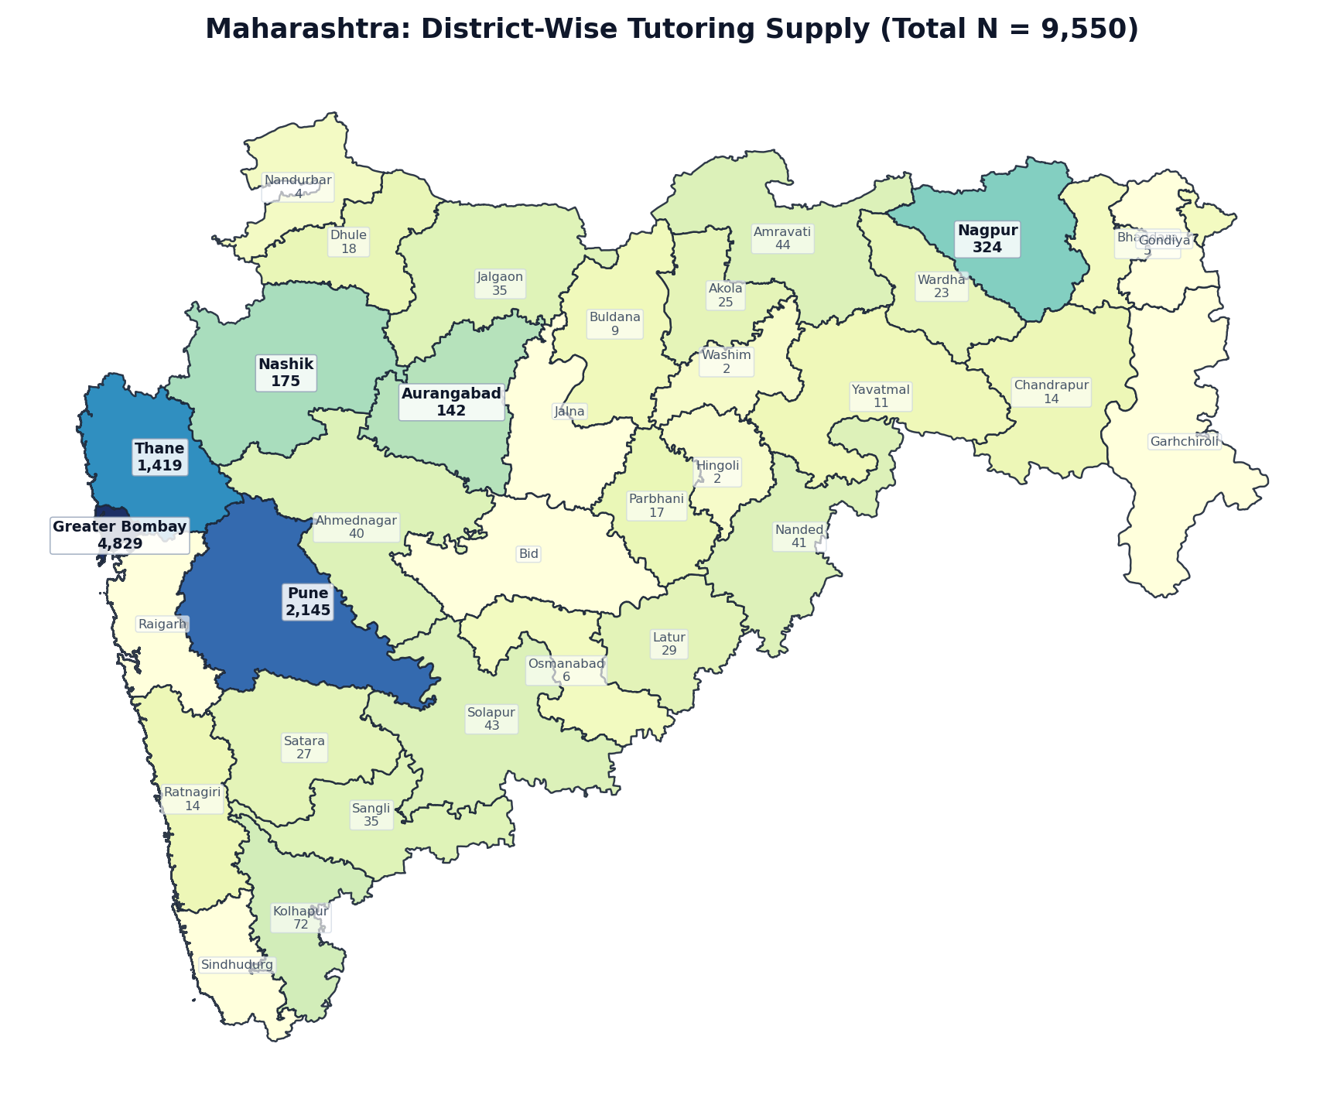
Figure 1.3: Maharashtra District Boundary Diagram — Localized Tutor Counts (N = 9,550)
Rank | District / Administrative Division | Tutors (N) | Share of State (%) | Avg Fee (₹/hr) | Online %
1 | Greater Bombay | 4,829 | 50.6% | ₹1076 | 94.2%
2 | Pune | 2,145 | 22.5% | ₹1031 | 98.3%
3 | Thane | 1,419 | 14.9% | ₹1005 | 95.1%
4 | Nagpur | 324 | 3.4% | ₹967 | 98.4%
5 | Nashik | 175 | 1.8% | ₹914 | 97.7%
6 | Aurangabad | 142 | 1.5% | ₹929 | 99.3%
7 | Kolhapur | 72 | 0.8% | ₹1038 | 95.8%
8 | Amravati | 44 | 0.5% | ₹1069 | 97.8%
9 | Solapur | 43 | 0.5% | ₹904 | 95.3%
10 | Nanded | 41 | 0.4% | ₹912 | 95.1%
11 | Ahmednagar | 40 | 0.4% | ₹1018 | 95.0%
12 | Jalgaon | 35 | 0.4% | ₹946 | 97.1%
13 | Sangli | 35 | 0.4% | ₹933 | 97.2%
14 | Latur | 29 | 0.3% | ₹1105 | 100.0%
15 | Satara | 27 | 0.3% | ₹1305 | 96.3%
16 | Akola | 25 | 0.3% | ₹1003 | 100.0%
17 | Wardha | 23 | 0.2% | ₹1145 | 100.0%
18 | Dhule | 18 | 0.2% | ₹530 | 100.0%
19 | Parbhani | 17 | 0.2% | ₹908 | 100.0%
20 | Chandrapur | 14 | 0.1% | ₹569 | 92.9%
21 | Ratnagiri | 14 | 0.1% | ₹750 | 100.0%
22 | Yavatmal | 11 | 0.1% | ₹866 | 100.0%
23 | Buldana | 9 | 0.1% | ₹919 | 100.0%
24 | Osmanabad | 6 | 0.1% | ₹475 | 100.0%
25 | Bhandara | 5 | 0.1% | ₹500 | 100.0%
26 | Nandurbar | 4 | 0.0% | ₹1500 | 100.0%
27 | Hingoli | 2 | 0.0% | ₹662 | 100.0%
28 | Washim | 2 | 0.0% | ₹1100 | 100.0%
29 | Bid | 0 | 0.0% | — | 0.0%
30 | Garhchiroli | 0 | 0.0% | — | 0.0%
31 | Gondiya | 0 | 0.0% | — | 0.0%
32 | Jalna | 0 | 0.0% | — | 0.0%
33 | Raigarh | 0 | 0.0% | — | 0.0%
34 | Sindhudurg | 0 | 0.0% | — | 0.0%
— | Maharashtra Total | 9,550 | 100.0% | ₹1039 | 95.7%

State 4: Karnataka — District-Wise Tutoring Supply (N = 9,300)
EXECUTIVE SUMMARY & STATE PROFILE: KARNATAKA
• Total Registered Educators: 9,300 verified tutors (8.63% national market share | Pan-India Rank: #4 of 36)
• Average Hourly Tuition Rate: ₹903 / hr (statewide median pricing)
• Online Delivery Adoption: 97.8% of educators teach via digital platforms
• Active Educators: 6,717 tutors (72.2% engagement rate)
• Geographic Zone: South Region
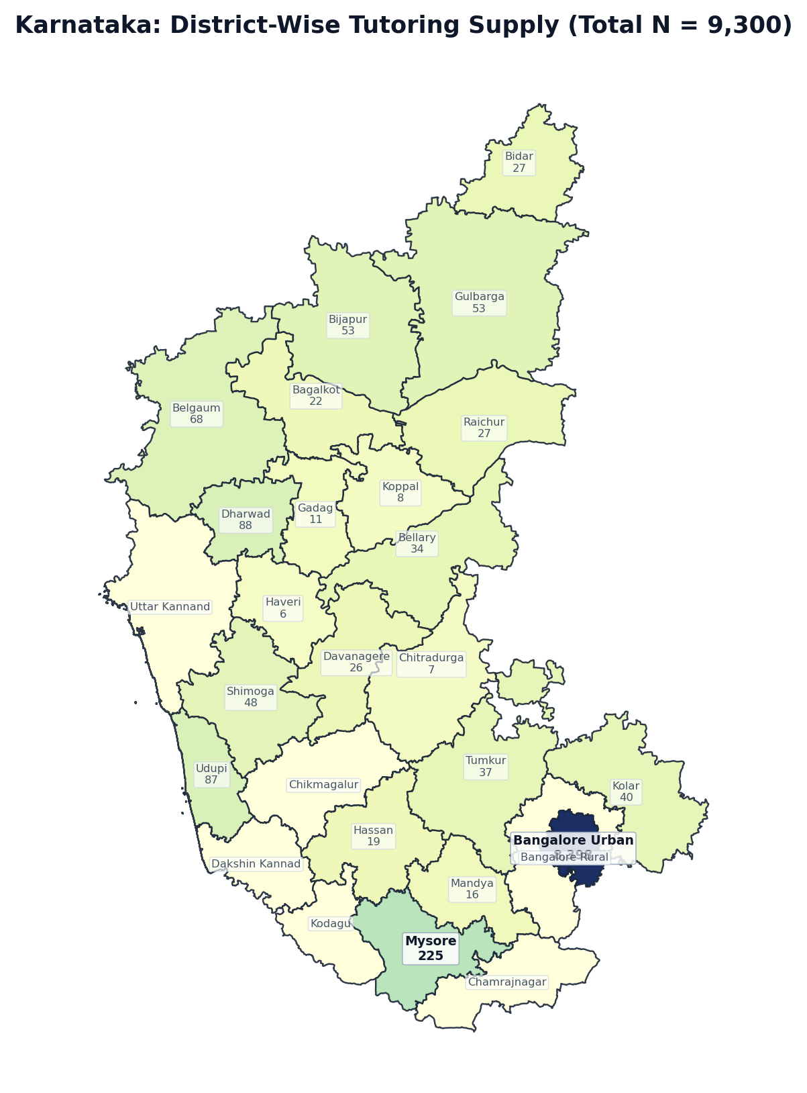
Figure 1.4: Karnataka District Boundary Diagram — Localized Tutor Counts (N = 9,300)
Rank | District / Administrative Division | Tutors (N) | Share of State (%) | Avg Fee (₹/hr) | Online %
1 | Bangalore Urban | 8,398 | 90.3% | ₹915 | 97.7%
2 | Mysore | 225 | 2.4% | ₹822 | 99.1%
3 | Dharwad | 88 | 0.9% | ₹800 | 98.9%
4 | Udupi | 87 | 0.9% | ₹734 | 100.0%
5 | Belgaum | 68 | 0.7% | ₹798 | 95.6%
6 | Bijapur | 53 | 0.6% | ₹800 | 98.1%
7 | Gulbarga | 53 | 0.6% | ₹1122 | 98.1%
8 | Shimoga | 48 | 0.5% | ₹810 | 100.0%
9 | Kolar | 40 | 0.4% | ₹1043 | 95.0%
10 | Tumkur | 37 | 0.4% | ₹722 | 100.0%
11 | Bellary | 34 | 0.4% | ₹904 | 100.0%
12 | Bidar | 27 | 0.3% | ₹1152 | 96.3%
13 | Raichur | 27 | 0.3% | ₹885 | 100.0%
14 | Davanagere | 26 | 0.3% | ₹910 | 100.0%
15 | Bagalkot | 22 | 0.2% | ₹1137 | 100.0%
16 | Hassan | 19 | 0.2% | ₹562 | 100.0%
17 | Mandya | 16 | 0.2% | ₹624 | 100.0%
18 | Gadag | 11 | 0.1% | ₹644 | 100.0%
19 | Koppal | 8 | 0.1% | ₹622 | 100.0%
20 | Chitradurga | 7 | 0.1% | ₹316 | 100.0%
21 | Haveri | 6 | 0.1% | ₹533 | 100.0%
22 | Bangalore Rural | 0 | 0.0% | — | 0.0%
23 | Chamrajnagar | 0 | 0.0% | — | 0.0%
24 | Chikmagalur | 0 | 0.0% | — | 0.0%
25 | Dakshin Kannad | 0 | 0.0% | — | 0.0%
26 | Kodagu | 0 | 0.0% | — | 0.0%
27 | Uttar Kannand | 0 | 0.0% | — | 0.0%
— | Karnataka Total | 9,300 | 100.0% | ₹903 | 97.8%

State 5: Delhi — District-Wise Tutoring Supply (N = 8,600)
EXECUTIVE SUMMARY & STATE PROFILE: DELHI
• Total Registered Educators: 8,600 verified tutors (7.98% national market share | Pan-India Rank: #5 of 36)
• Average Hourly Tuition Rate: ₹1020 / hr (statewide median pricing)
• Online Delivery Adoption: 95.8% of educators teach via digital platforms
• Active Educators: 6,278 tutors (73.0% engagement rate)
• Geographic Zone: North Region
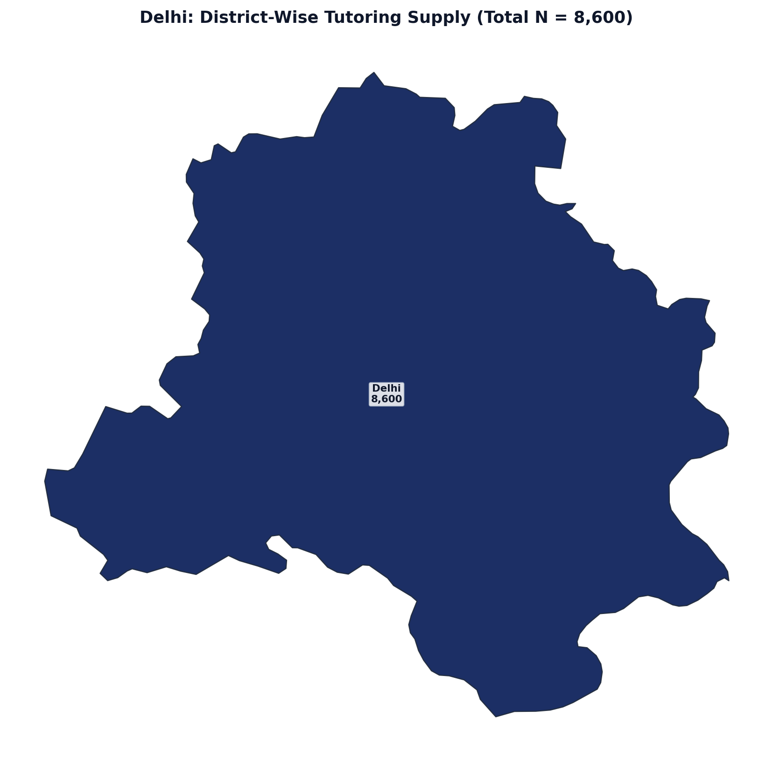
Figure 1.5: Delhi District Boundary Diagram — Localized Tutor Counts (N = 8,600)
Rank | District / Administrative Division | Tutors (N) | Share of State (%) | Avg Fee (₹/hr) | Online %
1 | Delhi | 8,600 | 100.0% | ₹1020 | 95.8%
— | Delhi Total | 8,600 | 100.0% | ₹1020 | 95.8%

State 6: Uttar Pradesh — District-Wise Tutoring Supply (N = 8,114)
EXECUTIVE SUMMARY & STATE PROFILE: UTTAR PRADESH
• Total Registered Educators: 8,114 verified tutors (7.53% national market share | Pan-India Rank: #6 of 36)
• Average Hourly Tuition Rate: ₹978 / hr (statewide median pricing)
• Online Delivery Adoption: 96.7% of educators teach via digital platforms
• Active Educators: 5,957 tutors (73.4% engagement rate)
• Geographic Zone: North Region
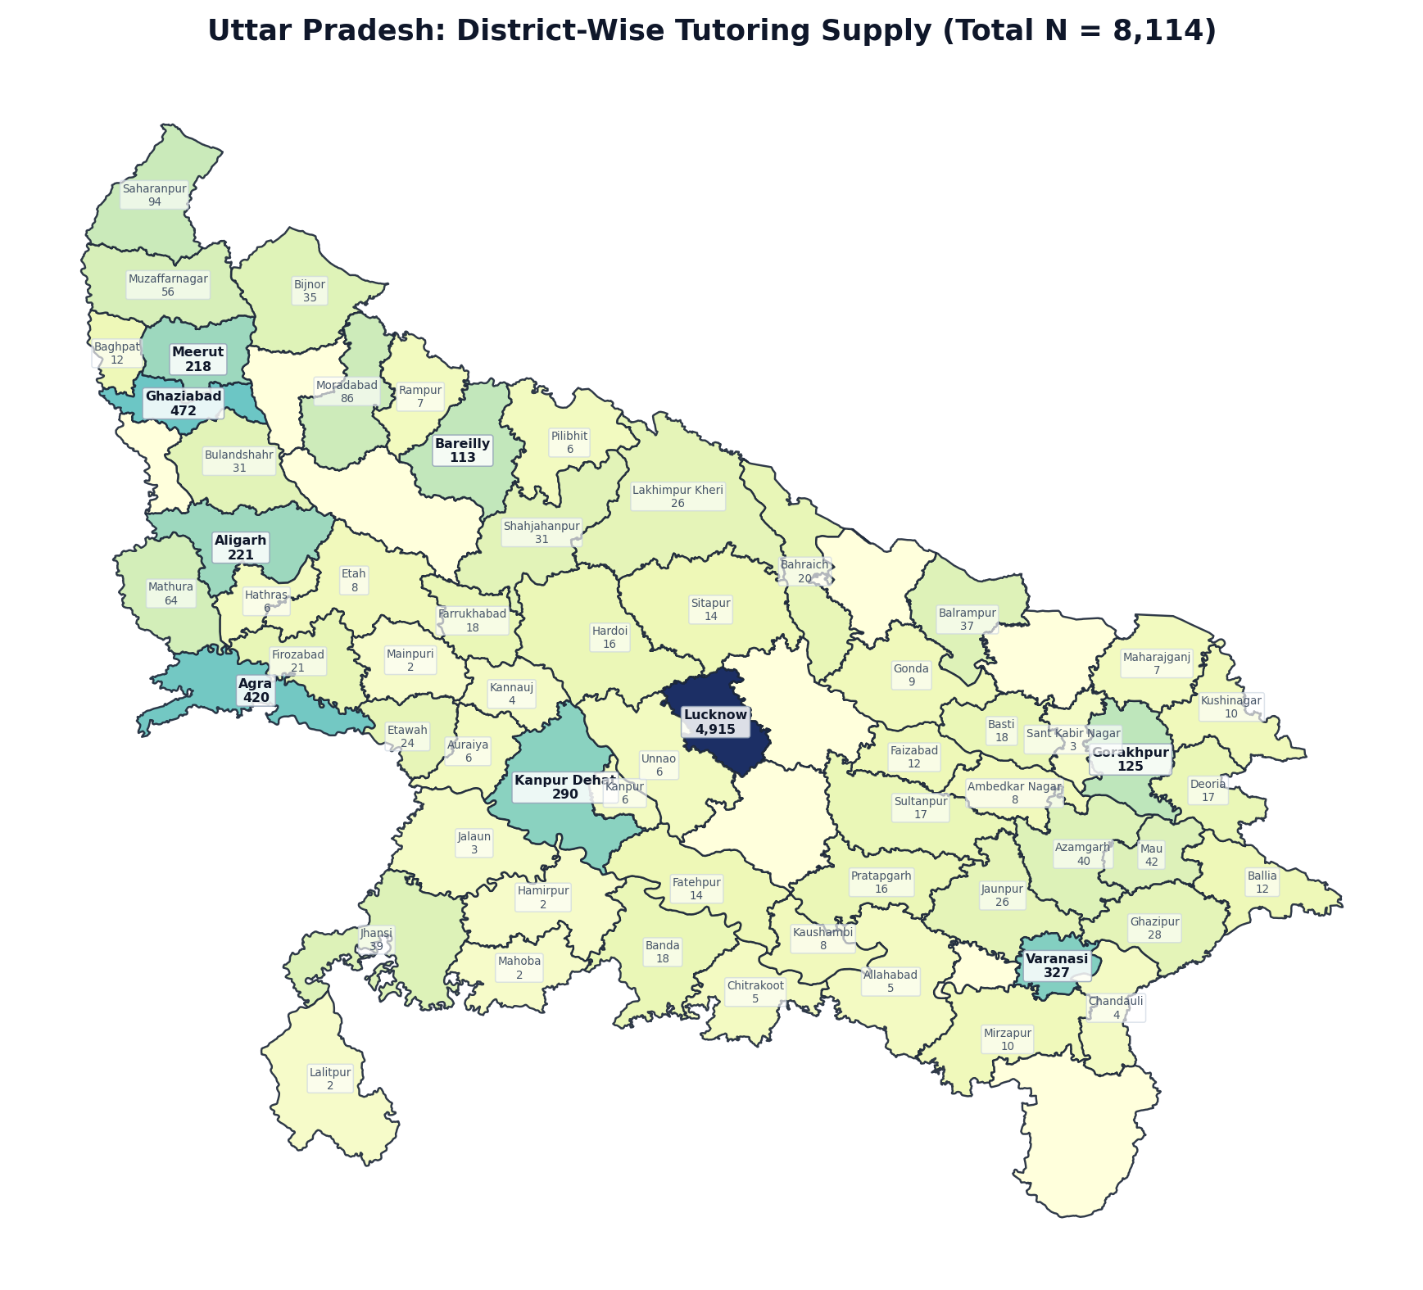
Figure 1.6: Uttar Pradesh District Boundary Diagram — Localized Tutor Counts (N = 8,114)
Rank | District / Administrative Division | Tutors (N) | Share of State (%) | Avg Fee (₹/hr) | Online %
1 | Lucknow | 4,915 | 60.6% | ₹991 | 95.8%
2 | Ghaziabad | 472 | 5.8% | ₹970 | 97.7%
3 | Agra | 420 | 5.2% | ₹1026 | 97.6%
4 | Varanasi | 327 | 4.0% | ₹999 | 97.5%
5 | Kanpur Dehat | 290 | 3.6% | ₹1011 | 97.6%
6 | Aligarh | 221 | 2.7% | ₹922 | 97.7%
7 | Meerut | 218 | 2.7% | ₹939 | 99.1%
8 | Gorakhpur | 125 | 1.5% | ₹1102 | 98.4%
9 | Bareilly | 113 | 1.4% | ₹1018 | 99.1%
10 | Saharanpur | 94 | 1.2% | ₹758 | 94.7%
11 | Moradabad | 86 | 1.1% | ₹964 | 100.0%
12 | Mathura | 64 | 0.8% | ₹902 | 100.0%
13 | Muzaffarnagar | 56 | 0.7% | ₹771 | 100.0%
14 | Mau | 42 | 0.5% | ₹920 | 100.0%
15 | Azamgarh | 40 | 0.5% | ₹1058 | 100.0%
16 | Jhansi | 39 | 0.5% | ₹860 | 97.5%
17 | Balrampur | 37 | 0.5% | ₹962 | 97.3%
18 | Bijnor | 35 | 0.4% | ₹866 | 97.2%
19 | Bulandshahr | 31 | 0.4% | ₹982 | 90.3%
20 | Shahjahanpur | 31 | 0.4% | ₹992 | 96.8%
21 | Ghazipur | 28 | 0.3% | ₹1268 | 100.0%
22 | Jaunpur | 26 | 0.3% | ₹1062 | 100.0%
23 | Lakhimpur Kheri | 26 | 0.3% | ₹780 | 100.0%
24 | Etawah | 24 | 0.3% | ₹744 | 95.9%
25 | Firozabad | 21 | 0.3% | ₹1116 | 95.2%
26 | Bahraich | 20 | 0.2% | ₹1020 | 100.0%
27 | Banda | 18 | 0.2% | ₹545 | 100.0%
28 | Basti | 18 | 0.2% | ₹677 | 94.4%
29 | Farrukhabad | 18 | 0.2% | ₹967 | 100.0%
30 | Deoria | 17 | 0.2% | ₹732 | 94.1%
31 | Sultanpur | 17 | 0.2% | ₹1034 | 100.0%
32 | Hardoi | 16 | 0.2% | ₹572 | 100.0%
33 | Pratapgarh | 16 | 0.2% | ₹1136 | 100.0%
34 | Fatehpur | 14 | 0.2% | ₹699 | 100.0%
35 | Sitapur | 14 | 0.2% | ₹1138 | 100.0%
36 | Baghpat | 12 | 0.1% | ₹481 | 100.0%
37 | Ballia | 12 | 0.1% | ₹972 | 100.0%
38 | Faizabad | 12 | 0.1% | ₹867 | 100.0%
39 | Kushinagar | 10 | 0.1% | ₹1200 | 100.0%
40 | Mirzapur | 10 | 0.1% | ₹856 | 100.0%
41 | Gonda | 9 | 0.1% | ₹725 | 100.0%
42 | Ambedkar Nagar | 8 | 0.1% | ₹640 | 100.0%
43 | Etah | 8 | 0.1% | ₹771 | 100.0%
44 | Kaushambi | 8 | 0.1% | ₹804 | 100.0%
45 | Maharajganj | 7 | 0.1% | ₹883 | 85.7%
46 | Rampur | 7 | 0.1% | ₹750 | 100.0%
47 | Auraiya | 6 | 0.1% | ₹962 | 100.0%
48 | Hathras | 6 | 0.1% | ₹1225 | 100.0%
49 | Kanpur | 6 | 0.1% | ₹579 | 83.4%
50 | Pilibhit | 6 | 0.1% | ₹624 | 100.0%
51 | Unnao | 6 | 0.1% | ₹388 | 100.0%
52 | Allahabad | 5 | 0.1% | ₹1244 | 100.0%
53 | Chitrakoot | 5 | 0.1% | ₹365 | 100.0%
54 | Chandauli | 4 | 0.0% | ₹4625 | 100.0%
55 | Kannauj | 4 | 0.0% | ₹850 | 100.0%
56 | Jalaun | 3 | 0.0% | ₹475 | 100.0%
57 | Sant Kabir Nagar | 3 | 0.0% | ₹400 | 100.0%
58 | Hamirpur | 2 | 0.0% | ₹350 | 100.0%
59 | Lalitpur | 2 | 0.0% | ₹300 | 100.0%
60 | Mahoba | 2 | 0.0% | ₹500 | 100.0%
61 | Mainpuri | 2 | 0.0% | ₹312 | 100.0%
62 | Badaun | 0 | 0.0% | — | 0.0%
63 | Bara Banki | 0 | 0.0% | — | 0.0%
64 | Gautam Buddha Nagar | 0 | 0.0% | — | 0.0%
65 | Jyotiba Phule Nagar | 0 | 0.0% | — | 0.0%
66 | Rae Bareli | 0 | 0.0% | — | 0.0%
67 | Sant Ravi Das Nagar | 0 | 0.0% | — | 0.0%
68 | Shravasti | 0 | 0.0% | — | 0.0%
69 | Siddharth Nagar | 0 | 0.0% | — | 0.0%
70 | Sonbhadra | 0 | 0.0% | — | 0.0%
— | Uttar Pradesh Total | 8,114 | 100.0% | ₹978 | 96.7%

State 7: Telangana — District-Wise Tutoring Supply (N = 7,810)
EXECUTIVE SUMMARY & STATE PROFILE: TELANGANA
• Total Registered Educators: 7,810 verified tutors (7.25% national market share | Pan-India Rank: #7 of 36)
• Average Hourly Tuition Rate: ₹943 / hr (statewide median pricing)
• Online Delivery Adoption: 96.9% of educators teach via digital platforms
• Active Educators: 5,699 tutors (73.0% engagement rate)
• Geographic Zone: South Region
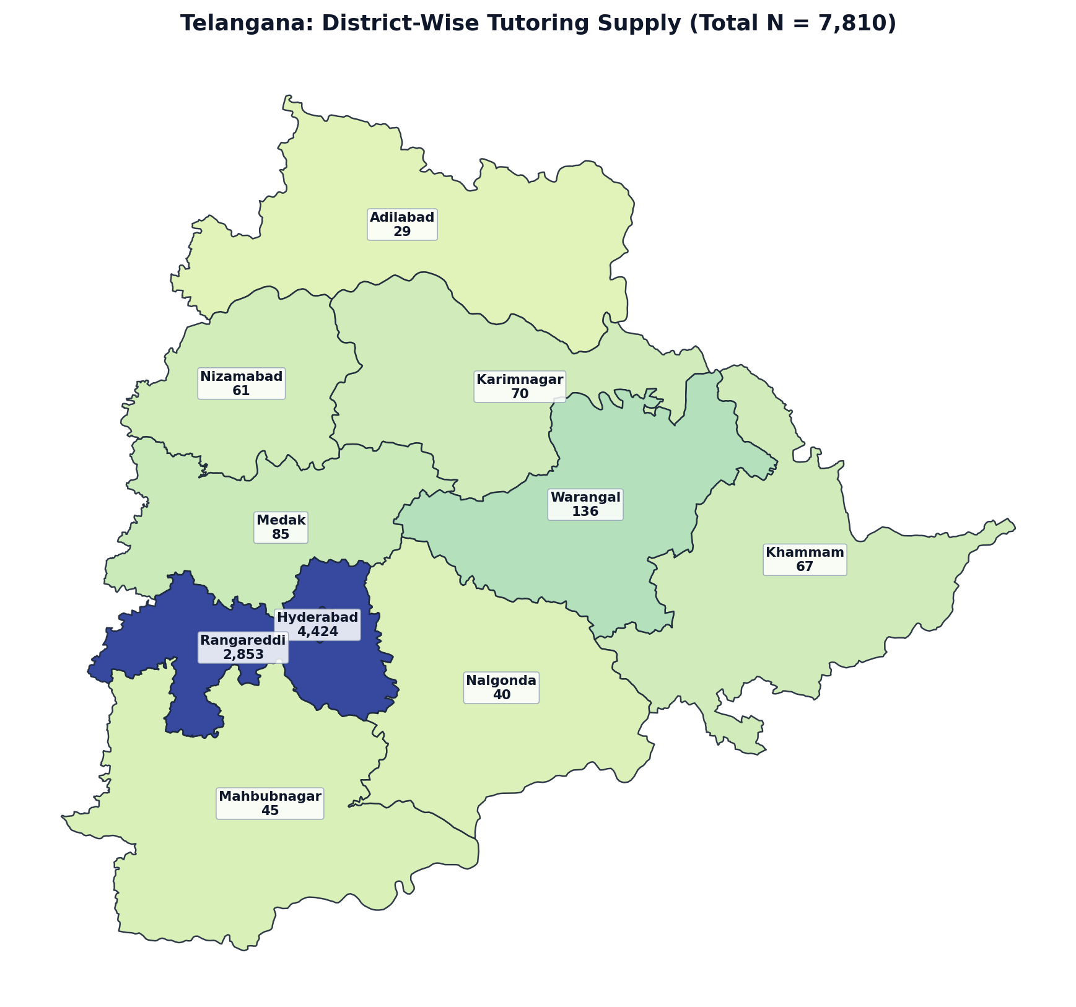
Figure 1.7: Telangana District Boundary Diagram — Localized Tutor Counts (N = 7,810)
Rank | District / Administrative Division | Tutors (N) | Share of State (%) | Avg Fee (₹/hr) | Online %
1 | Hyderabad | 4,424 | 56.6% | ₹952 | 96.7%
2 | Rangareddi | 2,853 | 36.5% | ₹956 | 97.0%
3 | Warangal | 136 | 1.7% | ₹925 | 97.1%
4 | Medak | 85 | 1.1% | ₹794 | 96.5%
5 | Karimnagar | 70 | 0.9% | ₹957 | 98.6%
6 | Khammam | 67 | 0.9% | ₹780 | 98.5%
7 | Nizamabad | 61 | 0.8% | ₹1005 | 98.3%
8 | Mahbubnagar | 45 | 0.6% | ₹839 | 95.5%
9 | Nalgonda | 40 | 0.5% | ₹822 | 100.0%
10 | Adilabad | 29 | 0.4% | ₹850 | 100.0%
— | Telangana Total | 7,810 | 100.0% | ₹943 | 96.9%

State 8: West Bengal — District-Wise Tutoring Supply (N = 7,026)
EXECUTIVE SUMMARY & STATE PROFILE: WEST BENGAL
• Total Registered Educators: 7,026 verified tutors (6.52% national market share | Pan-India Rank: #8 of 36)
• Average Hourly Tuition Rate: ₹921 / hr (statewide median pricing)
• Online Delivery Adoption: 94.0% of educators teach via digital platforms
• Active Educators: 5,174 tutors (73.6% engagement rate)
• Geographic Zone: East Region
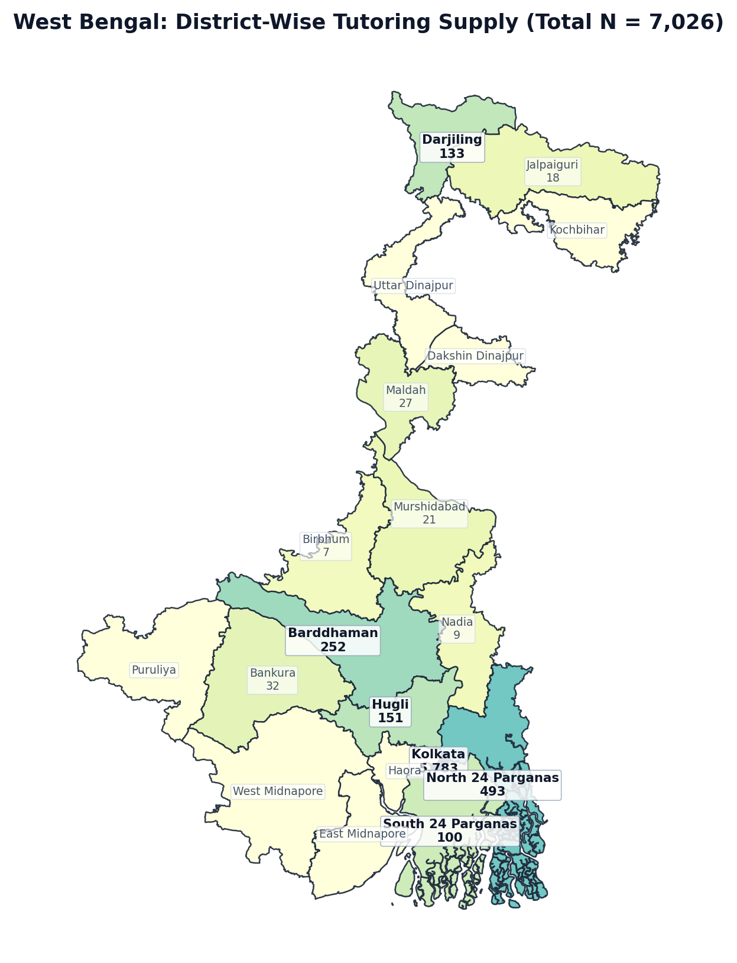
Figure 1.8: West Bengal District Boundary Diagram — Localized Tutor Counts (N = 7,026)
Rank | District / Administrative Division | Tutors (N) | Share of State (%) | Avg Fee (₹/hr) | Online %
1 | Kolkata | 5,783 | 82.3% | ₹925 | 93.8%
2 | North 24 Parganas | 493 | 7.0% | ₹976 | 94.5%
3 | Barddhaman | 252 | 3.6% | ₹846 | 96.0%
4 | Hugli | 151 | 2.1% | ₹949 | 94.7%
5 | Darjiling | 133 | 1.9% | ₹886 | 94.8%
6 | South 24 Parganas | 100 | 1.4% | ₹1070 | 93.0%
7 | Bankura | 32 | 0.5% | ₹478 | 100.0%
8 | Maldah | 27 | 0.4% | ₹490 | 96.3%
9 | Murshidabad | 21 | 0.3% | ₹525 | 95.2%
10 | Jalpaiguri | 18 | 0.3% | ₹737 | 94.4%
11 | Nadia | 9 | 0.1% | ₹1085 | 100.0%
12 | Birbhum | 7 | 0.1% | ₹465 | 100.0%
13 | Dakshin Dinajpur | 0 | 0.0% | — | 0.0%
14 | East Midnapore | 0 | 0.0% | — | 0.0%
15 | Haora | 0 | 0.0% | — | 0.0%
16 | Kochbihar | 0 | 0.0% | — | 0.0%
17 | Puruliya | 0 | 0.0% | — | 0.0%
18 | Uttar Dinajpur | 0 | 0.0% | — | 0.0%
19 | West Midnapore | 0 | 0.0% | — | 0.0%
— | West Bengal Total | 7,026 | 100.0% | ₹921 | 94.0%

State 9: Haryana — District-Wise Tutoring Supply (N = 3,228)
EXECUTIVE SUMMARY & STATE PROFILE: HARYANA
• Total Registered Educators: 3,228 verified tutors (3.00% national market share | Pan-India Rank: #9 of 36)
• Average Hourly Tuition Rate: ₹1026 / hr (statewide median pricing)
• Online Delivery Adoption: 97.7% of educators teach via digital platforms
• Active Educators: 2,382 tutors (73.8% engagement rate)
• Geographic Zone: North Region
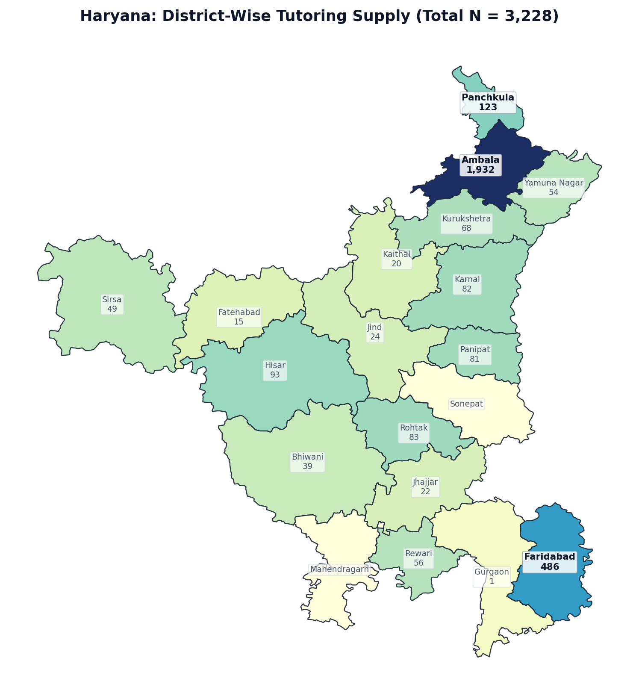
Figure 1.9: Haryana District Boundary Diagram — Localized Tutor Counts (N = 3,228)
Rank | District / Administrative Division | Tutors (N) | Share of State (%) | Avg Fee (₹/hr) | Online %
1 | Ambala | 1,932 | 59.9% | ₹1081 | 97.6%
2 | Faridabad | 486 | 15.1% | ₹1023 | 97.5%
3 | Panchkula | 123 | 3.8% | ₹972 | 94.3%
4 | Hisar | 93 | 2.9% | ₹994 | 100.0%
5 | Rohtak | 83 | 2.6% | ₹899 | 98.8%
6 | Karnal | 82 | 2.5% | ₹930 | 100.0%
7 | Panipat | 81 | 2.5% | ₹719 | 98.7%
8 | Kurukshetra | 68 | 2.1% | ₹967 | 98.5%
9 | Rewari | 56 | 1.7% | ₹737 | 98.2%
10 | Yamuna Nagar | 54 | 1.7% | ₹838 | 98.1%
11 | Sirsa | 49 | 1.5% | ₹777 | 100.0%
12 | Bhiwani | 39 | 1.2% | ₹982 | 94.9%
13 | Jind | 24 | 0.7% | ₹941 | 95.9%
14 | Jhajjar | 22 | 0.7% | ₹632 | 100.0%
15 | Kaithal | 20 | 0.6% | ₹1163 | 100.0%
16 | Fatehabad | 15 | 0.5% | ₹1081 | 100.0%
17 | Gurgaon | 1 | 0.0% | ₹3500 | 100.0%
18 | Mahendragarh | 0 | 0.0% | — | 0.0%
19 | Sonepat | 0 | 0.0% | — | 0.0%
— | Haryana Total | 3,228 | 100.0% | ₹1026 | 97.7%

State 10: Andhra Pradesh — District-Wise Tutoring Supply (N = 2,894)
EXECUTIVE SUMMARY & STATE PROFILE: ANDHRA PRADESH
• Total Registered Educators: 2,894 verified tutors (2.69% national market share | Pan-India Rank: #10 of 36)
• Average Hourly Tuition Rate: ₹855 / hr (statewide median pricing)
• Online Delivery Adoption: 98.4% of educators teach via digital platforms
• Active Educators: 2,067 tutors (71.4% engagement rate)
• Geographic Zone: South Region
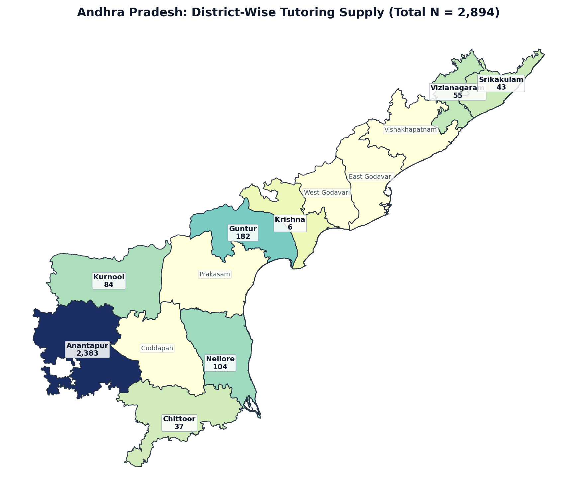
Figure 1.10: Andhra Pradesh District Boundary Diagram — Localized Tutor Counts (N = 2,894)
Rank | District / Administrative Division | Tutors (N) | Share of State (%) | Avg Fee (₹/hr) | Online %
1 | Anantapur | 2,383 | 82.3% | ₹863 | 98.4%
2 | Guntur | 182 | 6.3% | ₹872 | 98.3%
3 | Nellore | 104 | 3.6% | ₹896 | 98.1%
4 | Kurnool | 84 | 2.9% | ₹759 | 100.0%
5 | Vizianagaram | 55 | 1.9% | ₹821 | 98.1%
6 | Srikakulam | 43 | 1.5% | ₹864 | 95.4%
7 | Chittoor | 37 | 1.3% | ₹632 | 97.3%
8 | Krishna | 6 | 0.2% | ₹554 | 100.0%
9 | Cuddapah | 0 | 0.0% | — | 0.0%
10 | East Godavari | 0 | 0.0% | — | 0.0%
11 | Prakasam | 0 | 0.0% | — | 0.0%
12 | Vishakhapatnam | 0 | 0.0% | — | 0.0%
13 | West Godavari | 0 | 0.0% | — | 0.0%
— | Andhra Pradesh Total | 2,894 | 100.0% | ₹855 | 98.4%

State 11: Rajasthan — District-Wise Tutoring Supply (N = 2,479)
EXECUTIVE SUMMARY & STATE PROFILE: RAJASTHAN
• Total Registered Educators: 2,479 verified tutors (2.30% national market share | Pan-India Rank: #11 of 36)
• Average Hourly Tuition Rate: ₹968 / hr (statewide median pricing)
• Online Delivery Adoption: 97.1% of educators teach via digital platforms
• Active Educators: 1,806 tutors (72.9% engagement rate)
• Geographic Zone: North Region
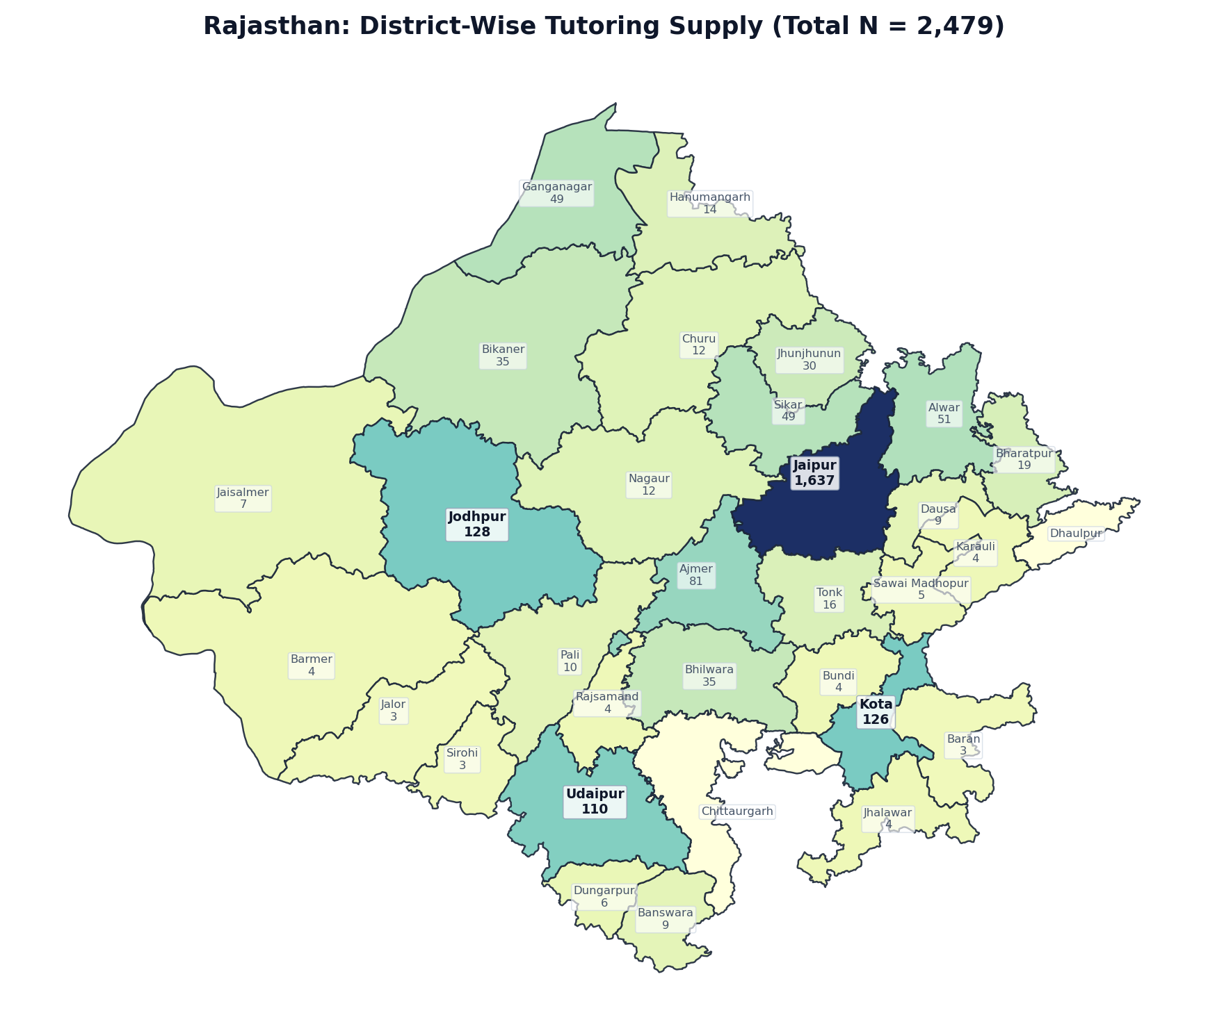
Figure 1.11: Rajasthan District Boundary Diagram — Localized Tutor Counts (N = 2,479)
Rank | District / Administrative Division | Tutors (N) | Share of State (%) | Avg Fee (₹/hr) | Online %
1 | Jaipur | 1,637 | 66.0% | ₹990 | 96.5%
2 | Jodhpur | 128 | 5.2% | ₹880 | 99.2%
3 | Kota | 126 | 5.1% | ₹1079 | 98.4%
4 | Udaipur | 110 | 4.4% | ₹973 | 98.1%
5 | Ajmer | 81 | 3.3% | ₹998 | 93.8%
6 | Alwar | 51 | 2.1% | ₹917 | 98.0%
7 | Ganganagar | 49 | 2.0% | ₹1022 | 98.0%
8 | Sikar | 49 | 2.0% | ₹954 | 100.0%
9 | Bhilwara | 35 | 1.4% | ₹804 | 100.0%
10 | Bikaner | 35 | 1.4% | ₹1054 | 100.0%
11 | Jhunjhunun | 30 | 1.2% | ₹1036 | 100.0%
12 | Bharatpur | 19 | 0.8% | ₹842 | 100.0%
13 | Tonk | 16 | 0.6% | ₹1200 | 100.0%
14 | Hanumangarh | 14 | 0.6% | ₹1113 | 100.0%
15 | Churu | 12 | 0.5% | ₹842 | 100.0%
16 | Nagaur | 12 | 0.5% | ₹801 | 91.7%
17 | Pali | 10 | 0.4% | ₹743 | 100.0%
18 | Banswara | 9 | 0.4% | ₹543 | 100.0%
19 | Dausa | 9 | 0.4% | ₹595 | 100.0%
20 | Jaisalmer | 7 | 0.3% | ₹589 | 100.0%
21 | Dungarpur | 6 | 0.2% | ₹725 | 100.0%
22 | Sawai Madhopur | 5 | 0.2% | ₹1000 | 100.0%
23 | Barmer | 4 | 0.2% | ₹1275 | 100.0%
24 | Bundi | 4 | 0.2% | ₹766 | 75.0%
25 | Jhalawar | 4 | 0.2% | ₹350 | 100.0%
26 | Karauli | 4 | 0.2% | ₹452 | 100.0%
27 | Rajsamand | 4 | 0.2% | ₹588 | 100.0%
28 | Baran | 3 | 0.1% | ₹417 | 100.0%
29 | Jalor | 3 | 0.1% | ₹617 | 100.0%
30 | Sirohi | 3 | 0.1% | ₹562 | 100.0%
31 | Chittaurgarh | 0 | 0.0% | — | 0.0%
32 | Dhaulpur | 0 | 0.0% | — | 0.0%
— | Rajasthan Total | 2,479 | 100.0% | ₹968 | 97.1%

State 12: Punjab — District-Wise Tutoring Supply (N = 2,412)
EXECUTIVE SUMMARY & STATE PROFILE: PUNJAB
• Total Registered Educators: 2,412 verified tutors (2.24% national market share | Pan-India Rank: #12 of 36)
• Average Hourly Tuition Rate: ₹890 / hr (statewide median pricing)
• Online Delivery Adoption: 96.3% of educators teach via digital platforms
• Active Educators: 1,784 tutors (74.0% engagement rate)
• Geographic Zone: North Region
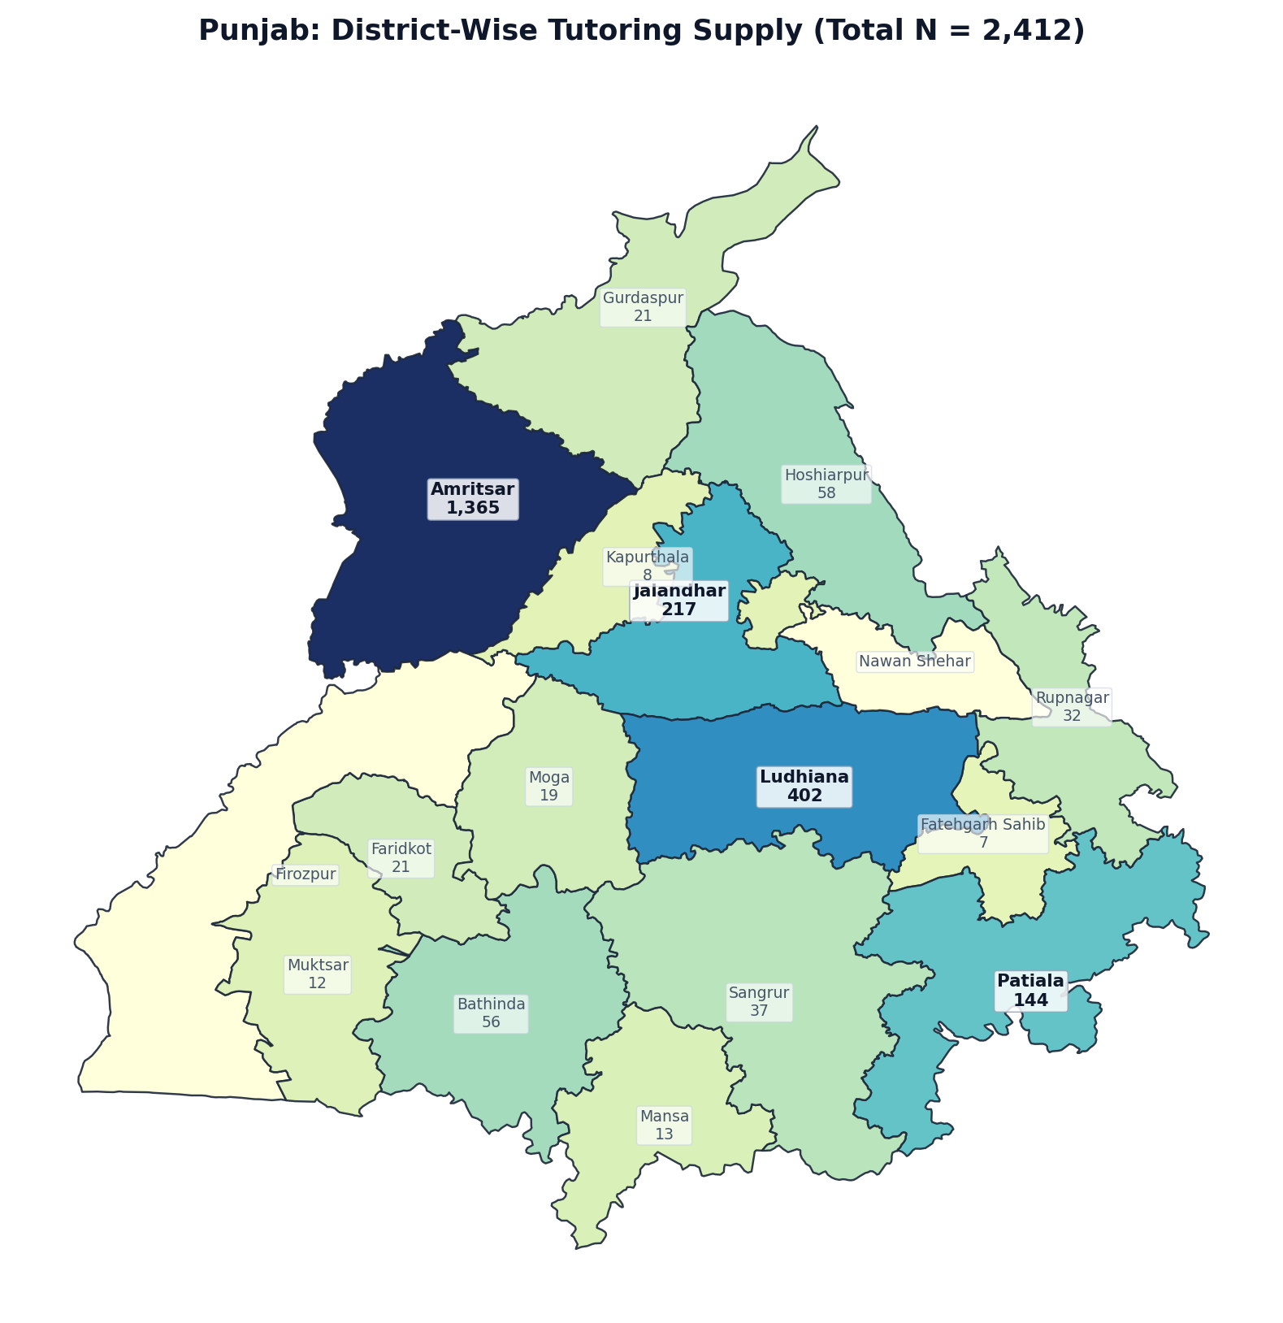
Figure 1.12: Punjab District Boundary Diagram — Localized Tutor Counts (N = 2,412)
Rank | District / Administrative Division | Tutors (N) | Share of State (%) | Avg Fee (₹/hr) | Online %
1 | Amritsar | 1,365 | 56.6% | ₹876 | 94.7%
2 | Ludhiana | 402 | 16.7% | ₹853 | 97.5%
3 | Jalandhar | 217 | 9.0% | ₹915 | 98.6%
4 | Patiala | 144 | 6.0% | ₹939 | 99.3%
5 | Hoshiarpur | 58 | 2.4% | ₹845 | 100.0%
6 | Bathinda | 56 | 2.3% | ₹946 | 100.0%
7 | Sangrur | 37 | 1.5% | ₹881 | 94.6%
8 | Rupnagar | 32 | 1.3% | ₹1390 | 96.9%
9 | Faridkot | 21 | 0.9% | ₹580 | 100.0%
10 | Gurdaspur | 21 | 0.9% | ₹873 | 100.0%
11 | Moga | 19 | 0.8% | ₹654 | 100.0%
12 | Mansa | 13 | 0.5% | ₹1208 | 100.0%
13 | Muktsar | 12 | 0.5% | ₹1233 | 100.0%
14 | Kapurthala | 8 | 0.3% | ₹733 | 100.0%
15 | Fatehgarh Sahib | 7 | 0.3% | ₹325 | 100.0%
16 | Firozpur | 0 | 0.0% | — | 0.0%
17 | Nawan Shehar | 0 | 0.0% | — | 0.0%
— | Punjab Total | 2,412 | 100.0% | ₹890 | 96.3%

State 13: Gujarat — District-Wise Tutoring Supply (N = 2,122)
EXECUTIVE SUMMARY & STATE PROFILE: GUJARAT
• Total Registered Educators: 2,122 verified tutors (1.97% national market share | Pan-India Rank: #13 of 36)
• Average Hourly Tuition Rate: ₹981 / hr (statewide median pricing)
• Online Delivery Adoption: 96.7% of educators teach via digital platforms
• Active Educators: 1,506 tutors (71.0% engagement rate)
• Geographic Zone: West Region
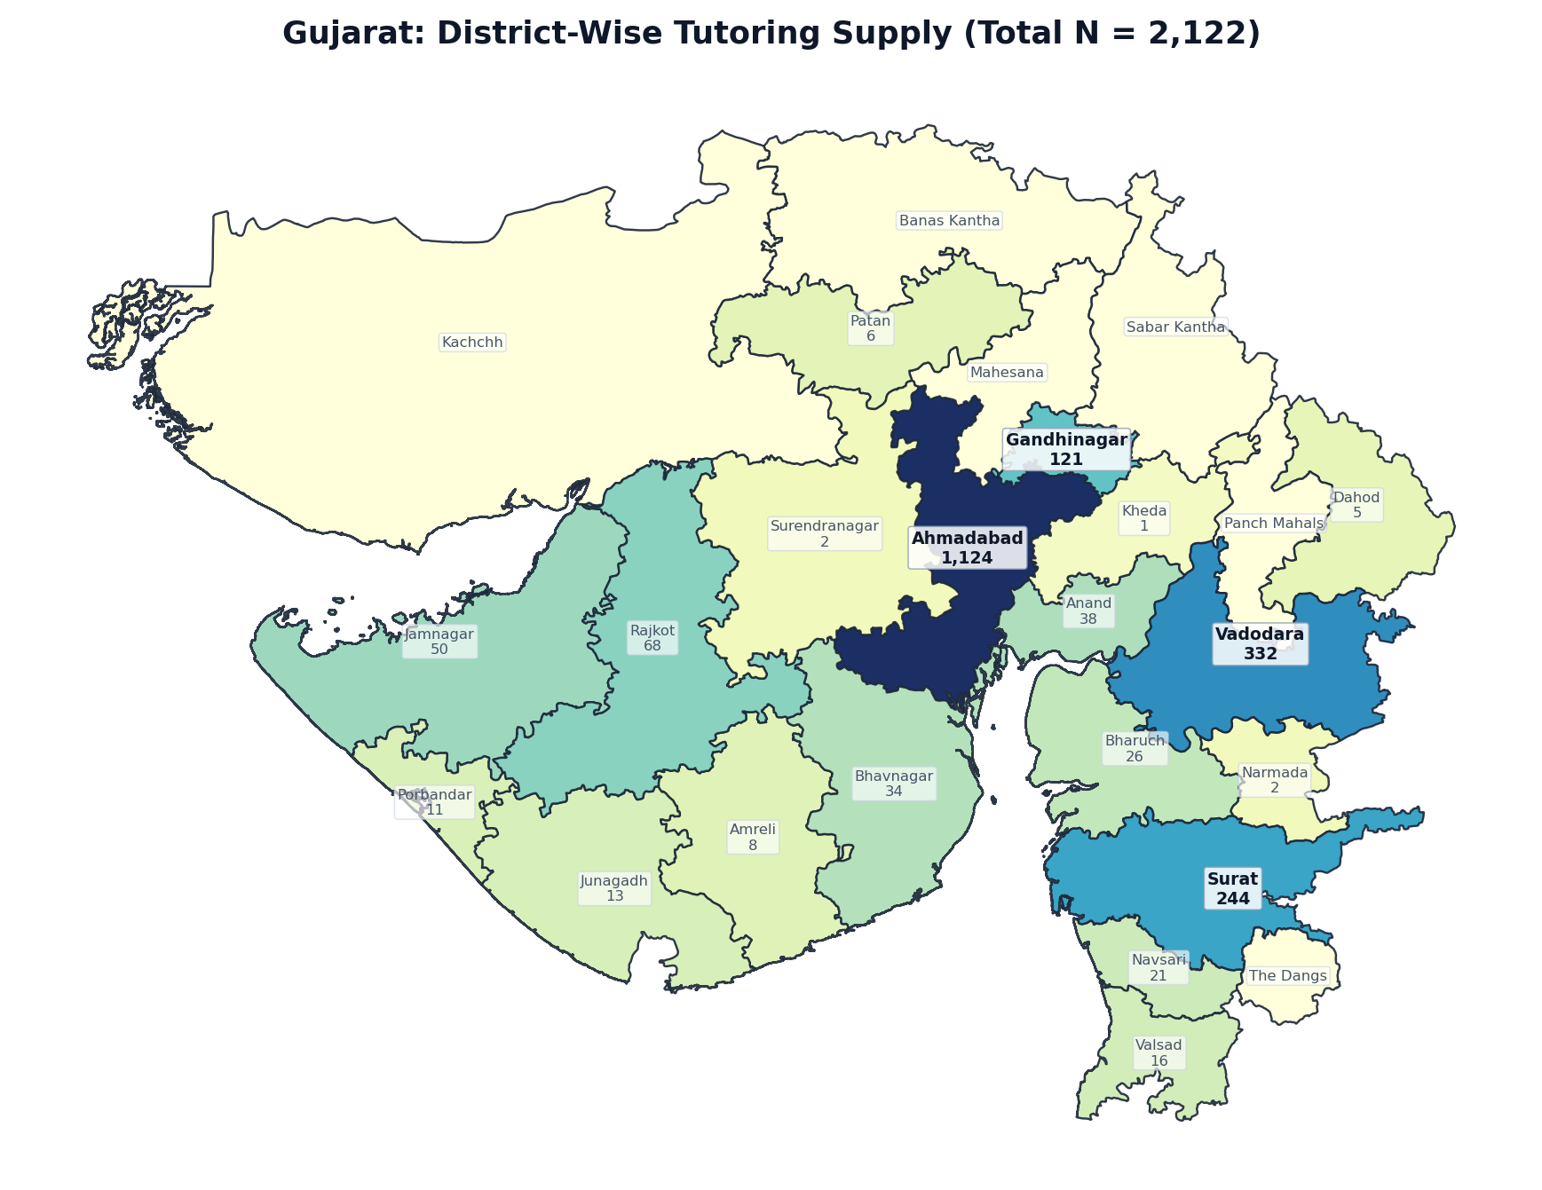
Figure 1.13: Gujarat District Boundary Diagram — Localized Tutor Counts (N = 2,122)
Rank | District / Administrative Division | Tutors (N) | Share of State (%) | Avg Fee (₹/hr) | Online %
1 | Ahmadabad | 1,124 | 53.0% | ₹997 | 96.1%
2 | Vadodara | 332 | 15.6% | ₹881 | 95.2%
3 | Surat | 244 | 11.5% | ₹950 | 99.2%
4 | Gandhinagar | 121 | 5.7% | ₹925 | 95.9%
5 | Rajkot | 68 | 3.2% | ₹1282 | 100.0%
6 | Jamnagar | 50 | 2.4% | ₹1083 | 100.0%
7 | Anand | 38 | 1.8% | ₹1191 | 100.0%
8 | Bhavnagar | 34 | 1.6% | ₹917 | 97.1%
9 | Bharuch | 26 | 1.2% | ₹1132 | 96.2%
10 | Navsari | 21 | 1.0% | ₹931 | 95.2%
11 | Valsad | 16 | 0.8% | ₹904 | 100.0%
12 | Junagadh | 13 | 0.6% | ₹766 | 100.0%
13 | Porbandar | 11 | 0.5% | ₹706 | 100.0%
14 | Amreli | 8 | 0.4% | ₹617 | 100.0%
15 | Patan | 6 | 0.3% | ₹1850 | 100.0%
16 | Dahod | 5 | 0.2% | ₹1090 | 100.0%
17 | Narmada | 2 | 0.1% | ₹2262 | 100.0%
18 | Surendranagar | 2 | 0.1% | ₹500 | 100.0%
19 | Kheda | 1 | 0.0% | ₹450 | 100.0%
20 | Banas Kantha | 0 | 0.0% | — | 0.0%
21 | Kachchh | 0 | 0.0% | — | 0.0%
22 | Mahesana | 0 | 0.0% | — | 0.0%
23 | Panch Mahals | 0 | 0.0% | — | 0.0%
24 | Sabar Kantha | 0 | 0.0% | — | 0.0%
25 | The Dangs | 0 | 0.0% | — | 0.0%
— | Gujarat Total | 2,122 | 100.0% | ₹981 | 96.7%

State 14: Madhya Pradesh — District-Wise Tutoring Supply (N = 1,839)
EXECUTIVE SUMMARY & STATE PROFILE: MADHYA PRADESH
• Total Registered Educators: 1,839 verified tutors (1.71% national market share | Pan-India Rank: #14 of 36)
• Average Hourly Tuition Rate: ₹941 / hr (statewide median pricing)
• Online Delivery Adoption: 98.0% of educators teach via digital platforms
• Active Educators: 1,332 tutors (72.4% engagement rate)
• Geographic Zone: Central Region
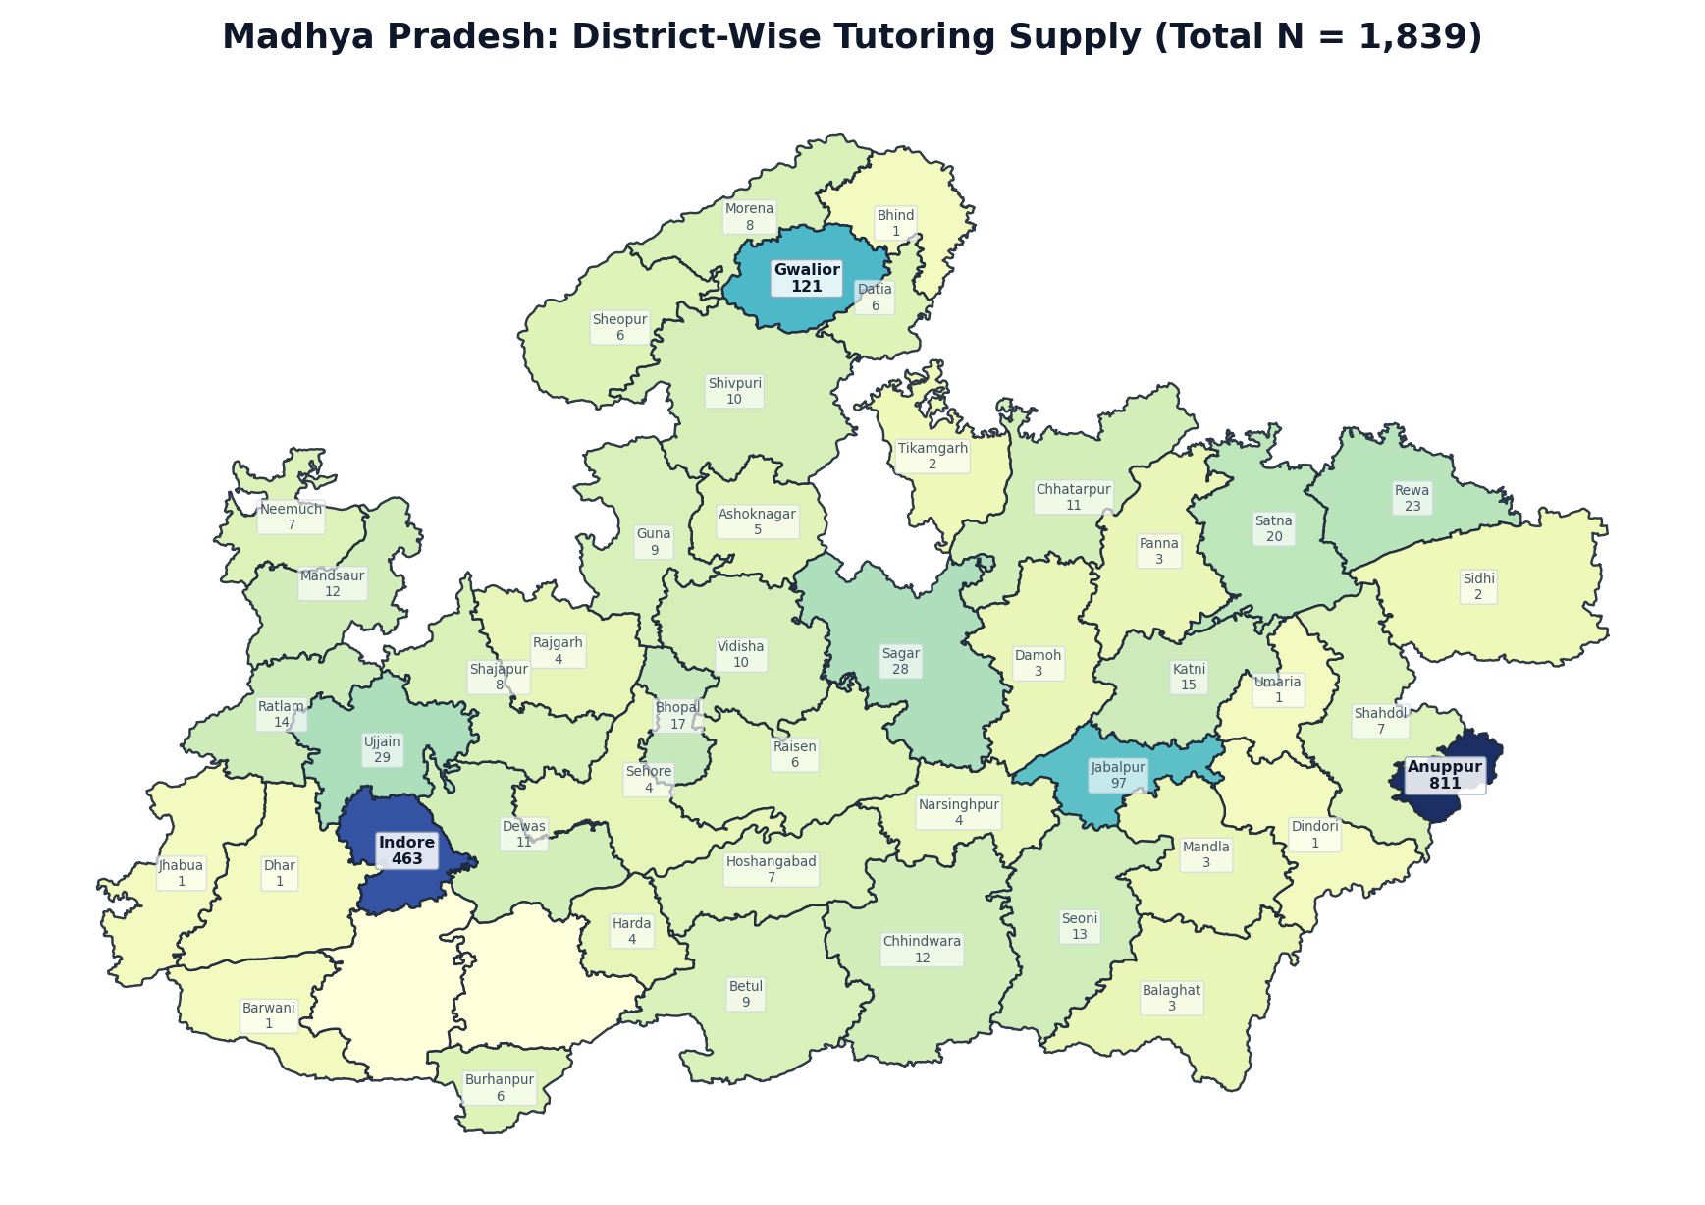
Figure 1.14: Madhya Pradesh District Boundary Diagram — Localized Tutor Counts (N = 1,839)
Rank | District / Administrative Division | Tutors (N) | Share of State (%) | Avg Fee (₹/hr) | Online %
1 | Anuppur | 811 | 44.1% | ₹935 | 96.8%
2 | Indore | 463 | 25.2% | ₹987 | 98.9%
3 | Gwalior | 121 | 6.6% | ₹891 | 100.0%
4 | Jabalpur | 97 | 5.3% | ₹1052 | 97.9%
5 | Ujjain | 29 | 1.6% | ₹745 | 96.6%
6 | Sagar | 28 | 1.5% | ₹499 | 100.0%
7 | Rewa | 23 | 1.3% | ₹1184 | 100.0%
8 | Satna | 20 | 1.1% | ₹688 | 100.0%
9 | Bhopal | 17 | 0.9% | ₹998 | 100.0%
10 | Katni | 15 | 0.8% | ₹1144 | 93.3%
11 | Ratlam | 14 | 0.8% | ₹1230 | 100.0%
12 | Seoni | 13 | 0.7% | ₹901 | 100.0%
13 | Chhindwara | 12 | 0.7% | ₹1408 | 100.0%
14 | Mandsaur | 12 | 0.7% | ₹706 | 100.0%
15 | Chhatarpur | 11 | 0.6% | ₹1014 | 100.0%
16 | Dewas | 11 | 0.6% | ₹684 | 100.0%
17 | Shivpuri | 10 | 0.5% | ₹714 | 100.0%
18 | Vidisha | 10 | 0.5% | ₹894 | 100.0%
19 | Betul | 9 | 0.5% | ₹444 | 100.0%
20 | Guna | 9 | 0.5% | ₹600 | 100.0%
21 | Morena | 8 | 0.4% | ₹982 | 100.0%
22 | Shajapur | 8 | 0.4% | ₹454 | 100.0%
23 | Hoshangabad | 7 | 0.4% | ₹657 | 100.0%
24 | Neemuch | 7 | 0.4% | ₹1450 | 100.0%
25 | Shahdol | 7 | 0.4% | ₹1613 | 100.0%
26 | Burhanpur | 6 | 0.3% | ₹1070 | 100.0%
27 | Datia | 6 | 0.3% | ₹756 | 83.3%
28 | Raisen | 6 | 0.3% | ₹662 | 100.0%
29 | Sheopur | 6 | 0.3% | ₹838 | 100.0%
30 | Ashoknagar | 5 | 0.3% | ₹455 | 100.0%
31 | Harda | 4 | 0.2% | ₹600 | 100.0%
32 | Narsinghpur | 4 | 0.2% | ₹1008 | 100.0%
33 | Rajgarh | 4 | 0.2% | ₹756 | 100.0%
34 | Sehore | 4 | 0.2% | ₹616 | 100.0%
35 | Balaghat | 3 | 0.2% | ₹550 | 100.0%
36 | Damoh | 3 | 0.2% | ₹238 | 100.0%
37 | Mandla | 3 | 0.2% | ₹900 | 100.0%
38 | Panna | 3 | 0.2% | ₹475 | 100.0%
39 | Sidhi | 2 | 0.1% | — | 100.0%
40 | Tikamgarh | 2 | 0.1% | ₹1500 | 100.0%
41 | Barwani | 1 | 0.1% | — | 100.0%
42 | Bhind | 1 | 0.1% | ₹550 | 100.0%
43 | Dhar | 1 | 0.1% | ₹375 | 100.0%
44 | Dindori | 1 | 0.1% | ₹500 | 100.0%
45 | Jhabua | 1 | 0.1% | ₹600 | 100.0%
46 | Umaria | 1 | 0.1% | ₹1400 | 100.0%
47 | East Nimar | 0 | 0.0% | — | 0.0%
48 | West Nimar | 0 | 0.0% | — | 0.0%
— | Madhya Pradesh Total | 1,839 | 100.0% | ₹941 | 98.0%

State 15: Odisha — District-Wise Tutoring Supply (N = 1,776)
EXECUTIVE SUMMARY & STATE PROFILE: ODISHA
• Total Registered Educators: 1,776 verified tutors (1.65% national market share | Pan-India Rank: #15 of 36)
• Average Hourly Tuition Rate: ₹848 / hr (statewide median pricing)
• Online Delivery Adoption: 92.6% of educators teach via digital platforms
• Active Educators: 1,282 tutors (72.2% engagement rate)
• Geographic Zone: East Region
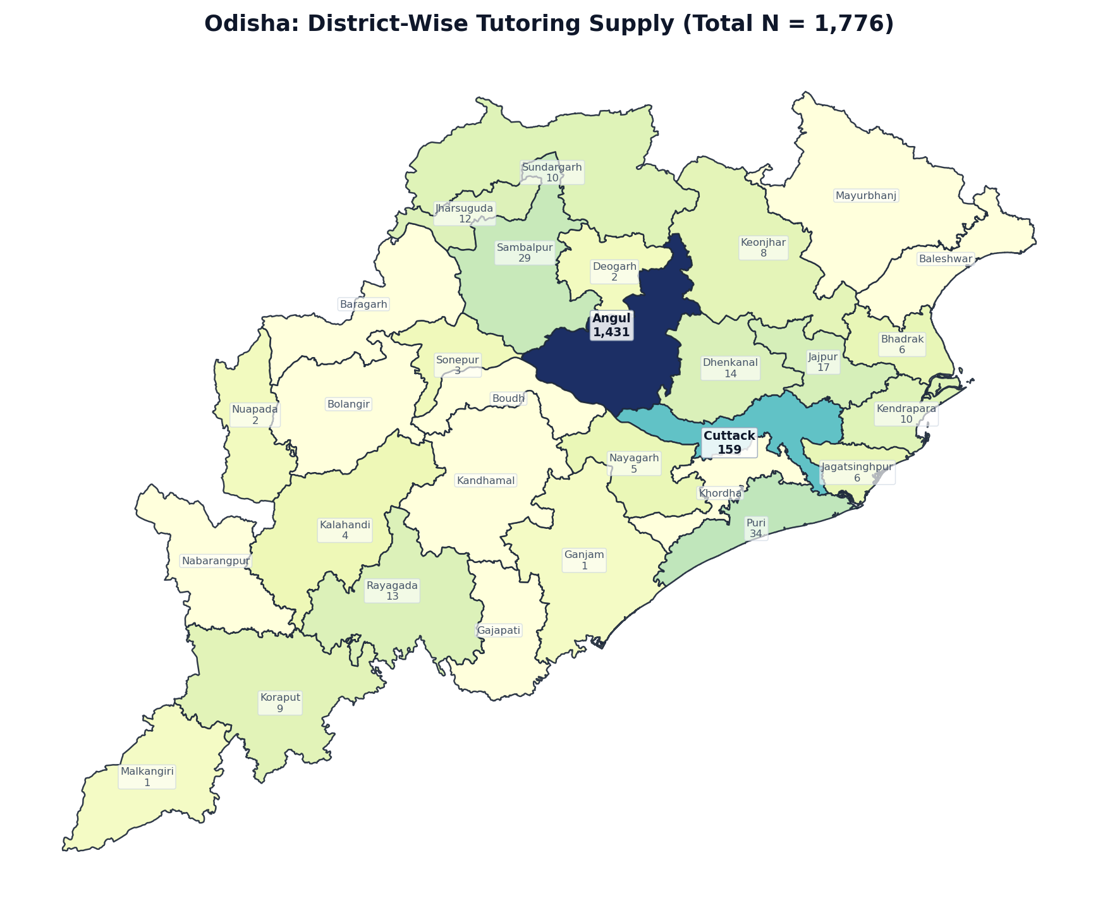
Figure 1.15: Odisha District Boundary Diagram — Localized Tutor Counts (N = 1,776)
Rank | District / Administrative Division | Tutors (N) | Share of State (%) | Avg Fee (₹/hr) | Online %
1 | Angul | 1,431 | 80.6% | ₹869 | 91.7%
2 | Cuttack | 159 | 9.0% | ₹868 | 93.1%
3 | Puri | 34 | 1.9% | ₹584 | 100.0%
4 | Sambalpur | 29 | 1.6% | ₹755 | 96.6%
5 | Jajpur | 17 | 1.0% | ₹809 | 100.0%
6 | Dhenkanal | 14 | 0.8% | ₹918 | 100.0%
7 | Rayagada | 13 | 0.7% | ₹1105 | 100.0%
8 | Jharsuguda | 12 | 0.7% | ₹538 | 100.0%
9 | Kendrapara | 10 | 0.6% | ₹944 | 100.0%
10 | Sundargarh | 10 | 0.6% | ₹687 | 100.0%
11 | Koraput | 9 | 0.5% | ₹778 | 100.0%
12 | Keonjhar | 8 | 0.5% | ₹544 | 100.0%
13 | Bhadrak | 6 | 0.3% | ₹650 | 83.3%
14 | Jagatsinghpur | 6 | 0.3% | ₹730 | 83.3%
15 | Nayagarh | 5 | 0.3% | ₹665 | 100.0%
16 | Kalahandi | 4 | 0.2% | ₹944 | 100.0%
17 | Sonepur | 3 | 0.2% | ₹775 | 100.0%
18 | Deogarh | 2 | 0.1% | ₹762 | 100.0%
19 | Nuapada | 2 | 0.1% | ₹700 | 100.0%
20 | Ganjam | 1 | 0.1% | ₹650 | 100.0%
21 | Malkangiri | 1 | 0.1% | ₹400 | 100.0%
22 | Baleshwar | 0 | 0.0% | — | 0.0%
23 | Baragarh | 0 | 0.0% | — | 0.0%
24 | Bolangir | 0 | 0.0% | — | 0.0%
25 | Boudh | 0 | 0.0% | — | 0.0%
26 | Gajapati | 0 | 0.0% | — | 0.0%
27 | Kandhamal | 0 | 0.0% | — | 0.0%
28 | Khordha | 0 | 0.0% | — | 0.0%
29 | Mayurbhanj | 0 | 0.0% | — | 0.0%
30 | Nabarangpur | 0 | 0.0% | — | 0.0%
— | Odisha Total | 1,776 | 100.0% | ₹848 | 92.6%

State 16: Bihar — District-Wise Tutoring Supply (N = 1,557)
EXECUTIVE SUMMARY & STATE PROFILE: BIHAR
• Total Registered Educators: 1,557 verified tutors (1.45% national market share | Pan-India Rank: #16 of 36)
• Average Hourly Tuition Rate: ₹857 / hr (statewide median pricing)
• Online Delivery Adoption: 96.9% of educators teach via digital platforms
• Active Educators: 1,126 tutors (72.3% engagement rate)
• Geographic Zone: East Region
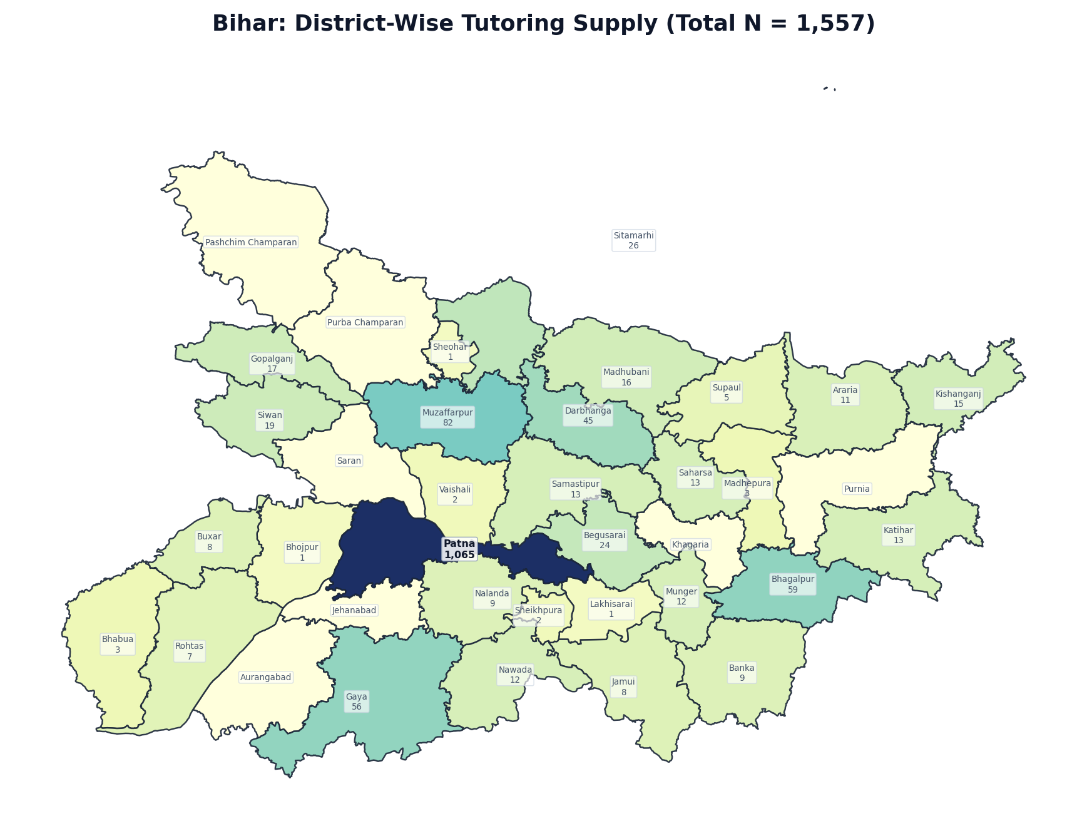
Figure 1.16: Bihar District Boundary Diagram — Localized Tutor Counts (N = 1,557)
Rank | District / Administrative Division | Tutors (N) | Share of State (%) | Avg Fee (₹/hr) | Online %
1 | Patna | 1,065 | 68.4% | ₹906 | 96.3%
2 | Muzaffarpur | 82 | 5.3% | ₹941 | 97.6%
3 | Bhagalpur | 59 | 3.8% | ₹910 | 98.3%
4 | Gaya | 56 | 3.6% | ₹658 | 98.2%
5 | Darbhanga | 45 | 2.9% | ₹786 | 100.0%
6 | Sitamarhi | 26 | 1.7% | ₹587 | 100.0%
7 | Begusarai | 24 | 1.5% | ₹550 | 100.0%
8 | Siwan | 19 | 1.2% | ₹584 | 100.0%
9 | Gopalganj | 17 | 1.1% | ₹753 | 100.0%
10 | Madhubani | 16 | 1.0% | ₹849 | 93.7%
11 | Kishanganj | 15 | 1.0% | ₹914 | 100.0%
12 | Katihar | 13 | 0.8% | ₹1104 | 100.0%
13 | Saharsa | 13 | 0.8% | ₹700 | 100.0%
14 | Samastipur | 13 | 0.8% | ₹1004 | 100.0%
15 | Munger | 12 | 0.8% | ₹458 | 91.7%
16 | Nawada | 12 | 0.8% | ₹604 | 100.0%
17 | Araria | 11 | 0.7% | ₹1131 | 90.9%
18 | Banka | 9 | 0.6% | ₹543 | 100.0%
19 | Nalanda | 9 | 0.6% | ₹558 | 88.9%
20 | Buxar | 8 | 0.5% | ₹1134 | 100.0%
21 | Jamui | 8 | 0.5% | ₹481 | 100.0%
22 | Rohtas | 7 | 0.4% | ₹325 | 85.7%
23 | Supaul | 5 | 0.3% | ₹350 | 100.0%
24 | Bhabua | 3 | 0.2% | ₹750 | 100.0%
25 | Madhepura | 3 | 0.2% | ₹600 | 100.0%
26 | Sheikhpura | 2 | 0.1% | ₹600 | 100.0%
27 | Vaishali | 2 | 0.1% | ₹1400 | 100.0%
28 | Bhojpur | 1 | 0.1% | ₹1000 | 100.0%
29 | Lakhisarai | 1 | 0.1% | ₹650 | 100.0%
30 | Sheohar | 1 | 0.1% | — | 100.0%
31 | Aurangabad | 0 | 0.0% | — | 0.0%
32 | Jehanabad | 0 | 0.0% | — | 0.0%
33 | Khagaria | 0 | 0.0% | — | 0.0%
34 | Pashchim Champaran | 0 | 0.0% | — | 0.0%
35 | Purba Champaran | 0 | 0.0% | — | 0.0%
36 | Purnia | 0 | 0.0% | — | 0.0%
37 | Saran | 0 | 0.0% | — | 0.0%
— | Bihar Total | 1,557 | 100.0% | ₹857 | 96.9%

State 17: Uttarakhand — District-Wise Tutoring Supply (N = 1,470)
EXECUTIVE SUMMARY & STATE PROFILE: UTTARAKHAND
• Total Registered Educators: 1,470 verified tutors (1.36% national market share | Pan-India Rank: #17 of 36)
• Average Hourly Tuition Rate: ₹991 / hr (statewide median pricing)
• Online Delivery Adoption: 95.7% of educators teach via digital platforms
• Active Educators: 1,053 tutors (71.6% engagement rate)
• Geographic Zone: North Region
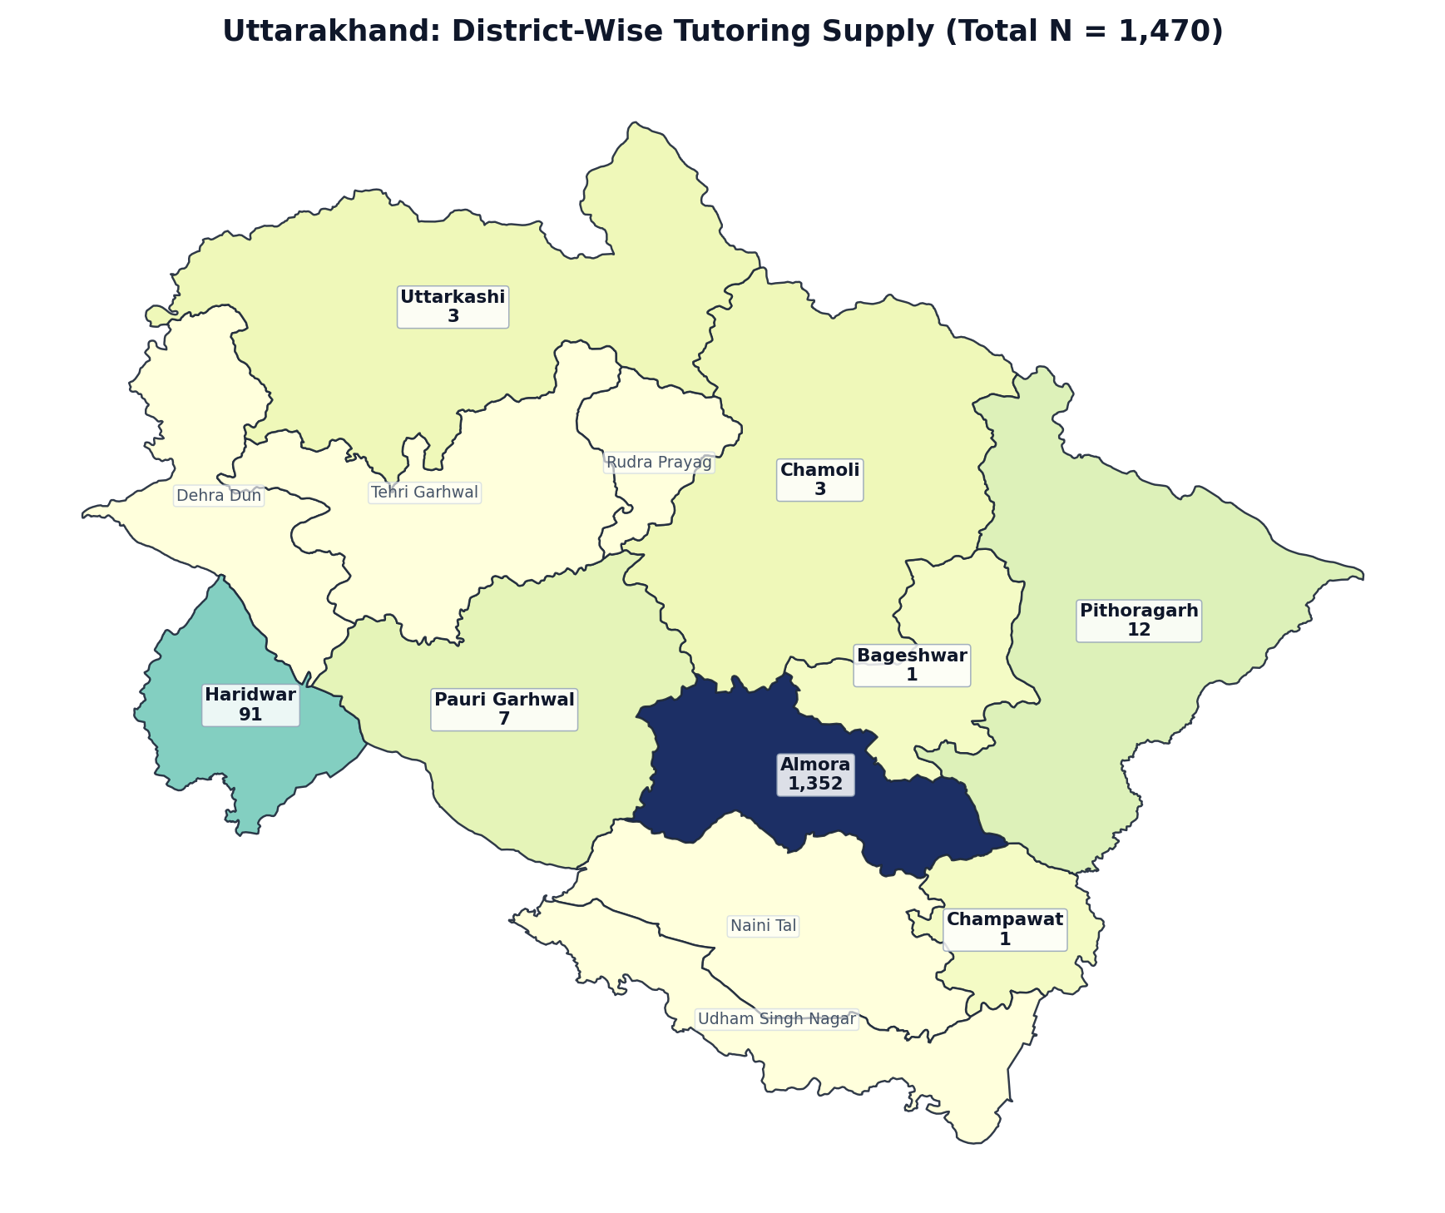
Figure 1.17: Uttarakhand District Boundary Diagram — Localized Tutor Counts (N = 1,470)
Rank | District / Administrative Division | Tutors (N) | Share of State (%) | Avg Fee (₹/hr) | Online %
1 | Almora | 1,352 | 92.0% | ₹968 | 95.9%
2 | Haridwar | 91 | 6.2% | ₹1057 | 94.5%
3 | Pithoragarh | 12 | 0.8% | ₹884 | 91.7%
4 | Pauri Garhwal | 7 | 0.5% | ₹479 | 85.7%
5 | Chamoli | 3 | 0.2% | ₹633 | 100.0%
6 | Uttarkashi | 3 | 0.2% | ₹883 | 100.0%
7 | Bageshwar | 1 | 0.1% | ₹200 | 100.0%
8 | Champawat | 1 | 0.1% | — | 100.0%
9 | Dehra Dun | 0 | 0.0% | — | 0.0%
10 | Naini Tal | 0 | 0.0% | — | 0.0%
11 | Rudra Prayag | 0 | 0.0% | — | 0.0%
12 | Tehri Garhwal | 0 | 0.0% | — | 0.0%
13 | Udham Singh Nagar | 0 | 0.0% | — | 0.0%
— | Uttarakhand Total | 1,470 | 100.0% | ₹991 | 95.7%

State 18: Chandigarh — District-Wise Tutoring Supply (N = 1,066)
EXECUTIVE SUMMARY & STATE PROFILE: CHANDIGARH
• Total Registered Educators: 1,066 verified tutors (0.99% national market share | Pan-India Rank: #18 of 36)
• Average Hourly Tuition Rate: ₹986 / hr (statewide median pricing)
• Online Delivery Adoption: 93.8% of educators teach via digital platforms
• Active Educators: 776 tutors (72.8% engagement rate)
• Geographic Zone: North Region
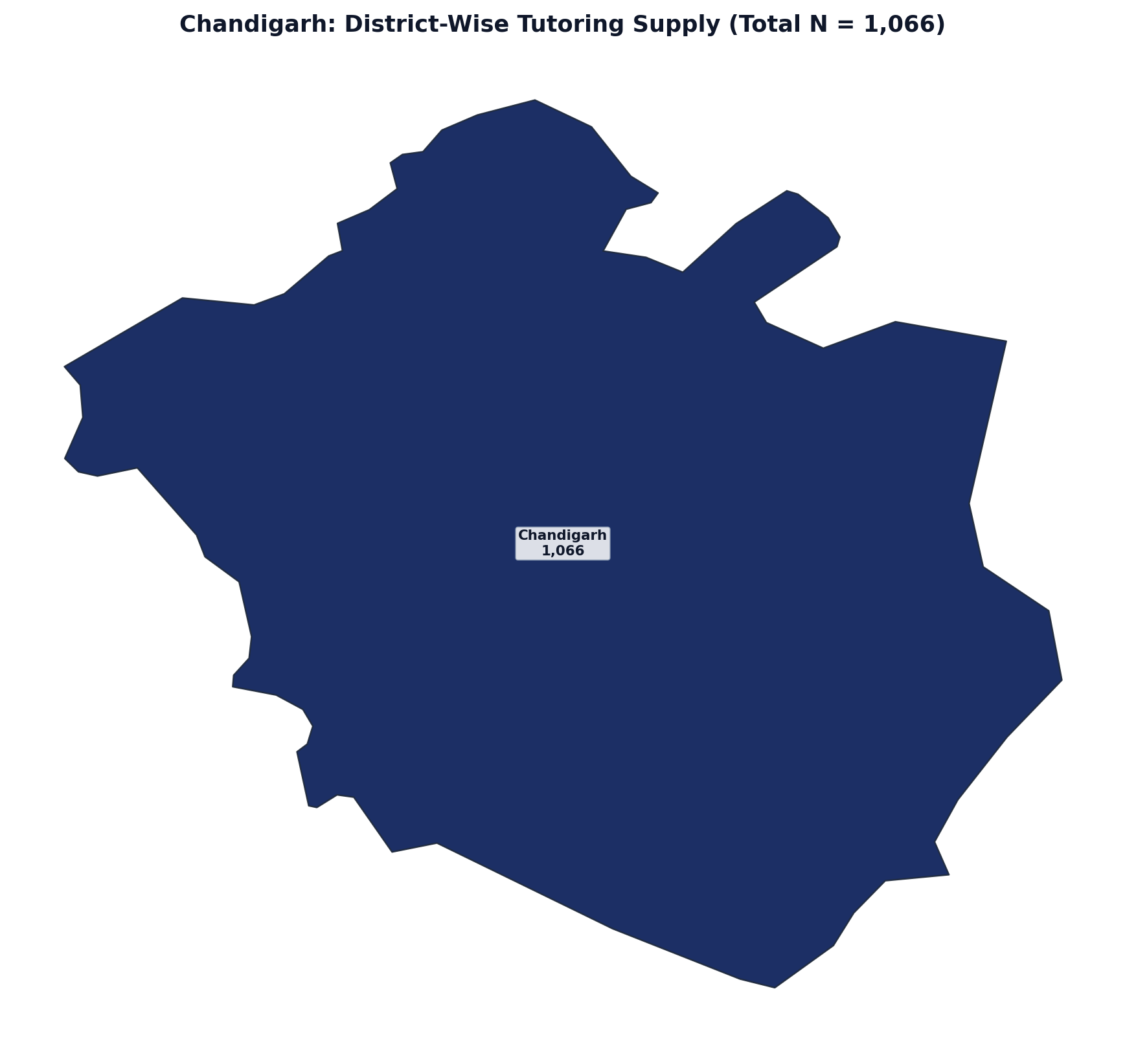
Figure 1.18: Chandigarh District Boundary Diagram — Localized Tutor Counts (N = 1,066)
Rank | District / Administrative Division | Tutors (N) | Share of State (%) | Avg Fee (₹/hr) | Online %
1 | Chandigarh | 1,066 | 100.0% | ₹977 | 93.8%
— | Chandigarh Total | 1,066 | 100.0% | ₹986 | 93.8%

State 19: Jharkhand — District-Wise Tutoring Supply (N = 948)
EXECUTIVE SUMMARY & STATE PROFILE: JHARKHAND
• Total Registered Educators: 948 verified tutors (0.88% national market share | Pan-India Rank: #19 of 36)
• Average Hourly Tuition Rate: ₹850 / hr (statewide median pricing)
• Online Delivery Adoption: 96.3% of educators teach via digital platforms
• Active Educators: 673 tutors (71.0% engagement rate)
• Geographic Zone: East Region
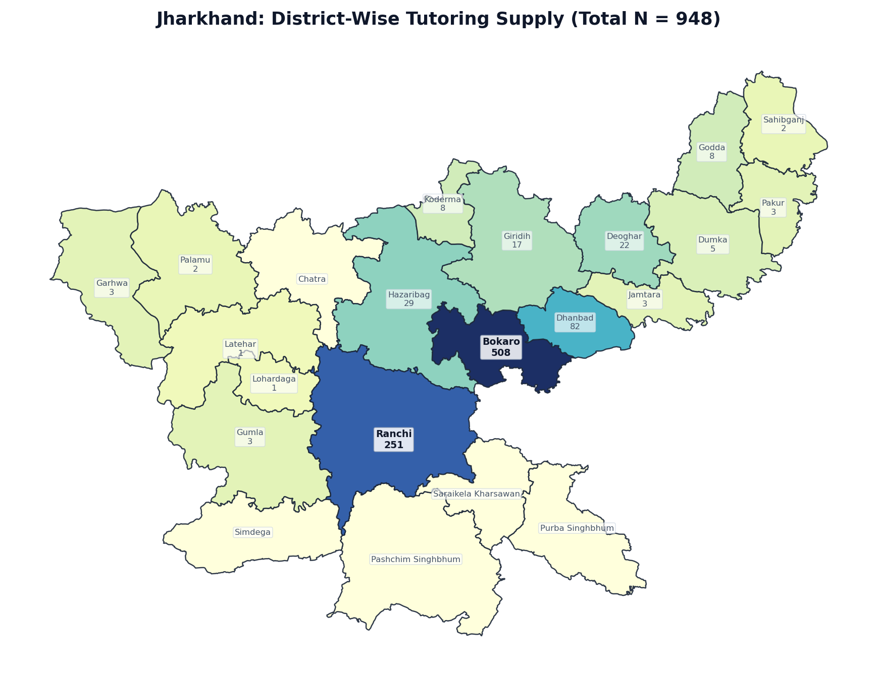
Figure 1.19: Jharkhand District Boundary Diagram — Localized Tutor Counts (N = 948)
Rank | District / Administrative Division | Tutors (N) | Share of State (%) | Avg Fee (₹/hr) | Online %
1 | Bokaro | 508 | 53.6% | ₹851 | 94.5%
2 | Ranchi | 251 | 26.5% | ₹910 | 98.4%
3 | Dhanbad | 82 | 8.6% | ₹712 | 97.6%
4 | Hazaribag | 29 | 3.1% | ₹702 | 100.0%
5 | Deoghar | 22 | 2.3% | ₹594 | 100.0%
6 | Giridih | 17 | 1.8% | ₹1231 | 94.1%
7 | Godda | 8 | 0.8% | ₹1467 | 100.0%
8 | Koderma | 8 | 0.8% | ₹1858 | 100.0%
9 | Dumka | 5 | 0.5% | ₹362 | 100.0%
10 | Garhwa | 3 | 0.3% | ₹833 | 100.0%
11 | Gumla | 3 | 0.3% | ₹525 | 100.0%
12 | Jamtara | 3 | 0.3% | ₹450 | 100.0%
13 | Pakur | 3 | 0.3% | ₹888 | 100.0%
14 | Palamu | 2 | 0.2% | ₹550 | 100.0%
15 | Sahibganj | 2 | 0.2% | ₹500 | 100.0%
16 | Latehar | 1 | 0.1% | ₹600 | 100.0%
17 | Lohardaga | 1 | 0.1% | ₹350 | 100.0%
18 | Chatra | 0 | 0.0% | — | 0.0%
19 | Pashchim Singhbhum | 0 | 0.0% | — | 0.0%
20 | Purba Singhbhum | 0 | 0.0% | — | 0.0%
21 | Saraikela Kharsawan | 0 | 0.0% | — | 0.0%
22 | Simdega | 0 | 0.0% | — | 0.0%
— | Jharkhand Total | 948 | 100.0% | ₹850 | 96.3%

State 20: Assam — District-Wise Tutoring Supply (N = 795)
EXECUTIVE SUMMARY & STATE PROFILE: ASSAM
• Total Registered Educators: 795 verified tutors (0.74% national market share | Pan-India Rank: #20 of 36)
• Average Hourly Tuition Rate: ₹774 / hr (statewide median pricing)
• Online Delivery Adoption: 93.5% of educators teach via digital platforms
• Active Educators: 565 tutors (71.1% engagement rate)
• Geographic Zone: East Region
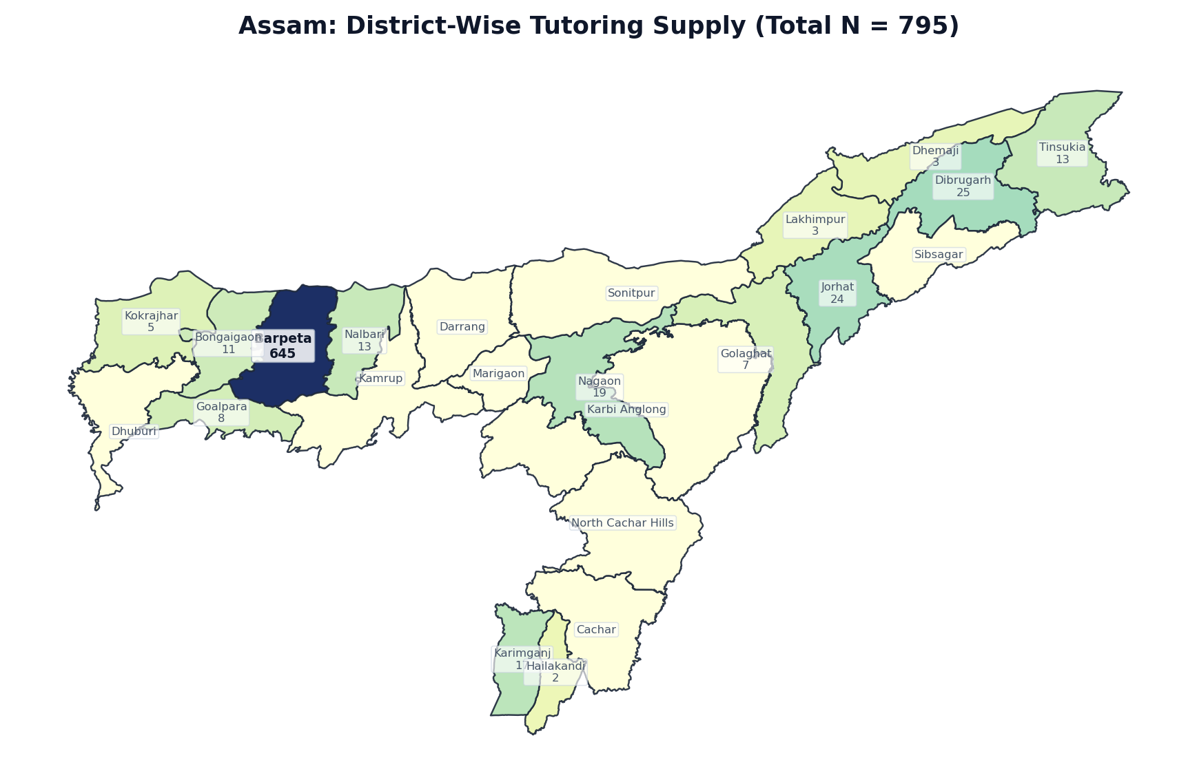
Figure 1.20: Assam District Boundary Diagram — Localized Tutor Counts (N = 795)
Rank | District / Administrative Division | Tutors (N) | Share of State (%) | Avg Fee (₹/hr) | Online %
1 | Barpeta | 645 | 81.1% | ₹780 | 93.0%
2 | Dibrugarh | 25 | 3.1% | ₹702 | 80.0%
3 | Jorhat | 24 | 3.0% | ₹1104 | 100.0%
4 | Nagaon | 19 | 2.4% | ₹610 | 94.7%
5 | Karimganj | 17 | 2.1% | ₹481 | 100.0%
6 | Nalbari | 13 | 1.6% | ₹811 | 100.0%
7 | Tinsukia | 13 | 1.6% | ₹718 | 100.0%
8 | Bongaigaon | 11 | 1.4% | ₹1268 | 100.0%
9 | Goalpara | 8 | 1.0% | ₹506 | 100.0%
10 | Golaghat | 7 | 0.9% | ₹730 | 100.0%
11 | Kokrajhar | 5 | 0.6% | ₹431 | 100.0%
12 | Dhemaji | 3 | 0.4% | ₹1483 | 100.0%
13 | Lakhimpur | 3 | 0.4% | ₹300 | 100.0%
14 | Hailakandi | 2 | 0.3% | ₹800 | 50.0%
15 | Cachar | 0 | 0.0% | — | 0.0%
16 | Darrang | 0 | 0.0% | — | 0.0%
17 | Dhuburi | 0 | 0.0% | — | 0.0%
18 | Kamrup | 0 | 0.0% | — | 0.0%
19 | Karbi Anglong | 0 | 0.0% | — | 0.0%
20 | Marigaon | 0 | 0.0% | — | 0.0%
21 | North Cachar Hills | 0 | 0.0% | — | 0.0%
22 | Sibsagar | 0 | 0.0% | — | 0.0%
23 | Sonitpur | 0 | 0.0% | — | 0.0%
— | Assam Total | 795 | 100.0% | ₹774 | 93.5%

State 21: Chhattisgarh — District-Wise Tutoring Supply (N = 526)
EXECUTIVE SUMMARY & STATE PROFILE: CHHATTISGARH
• Total Registered Educators: 526 verified tutors (0.49% national market share | Pan-India Rank: #21 of 36)
• Average Hourly Tuition Rate: ₹884 / hr (statewide median pricing)
• Online Delivery Adoption: 97.3% of educators teach via digital platforms
• Active Educators: 373 tutors (70.9% engagement rate)
• Geographic Zone: Central Region
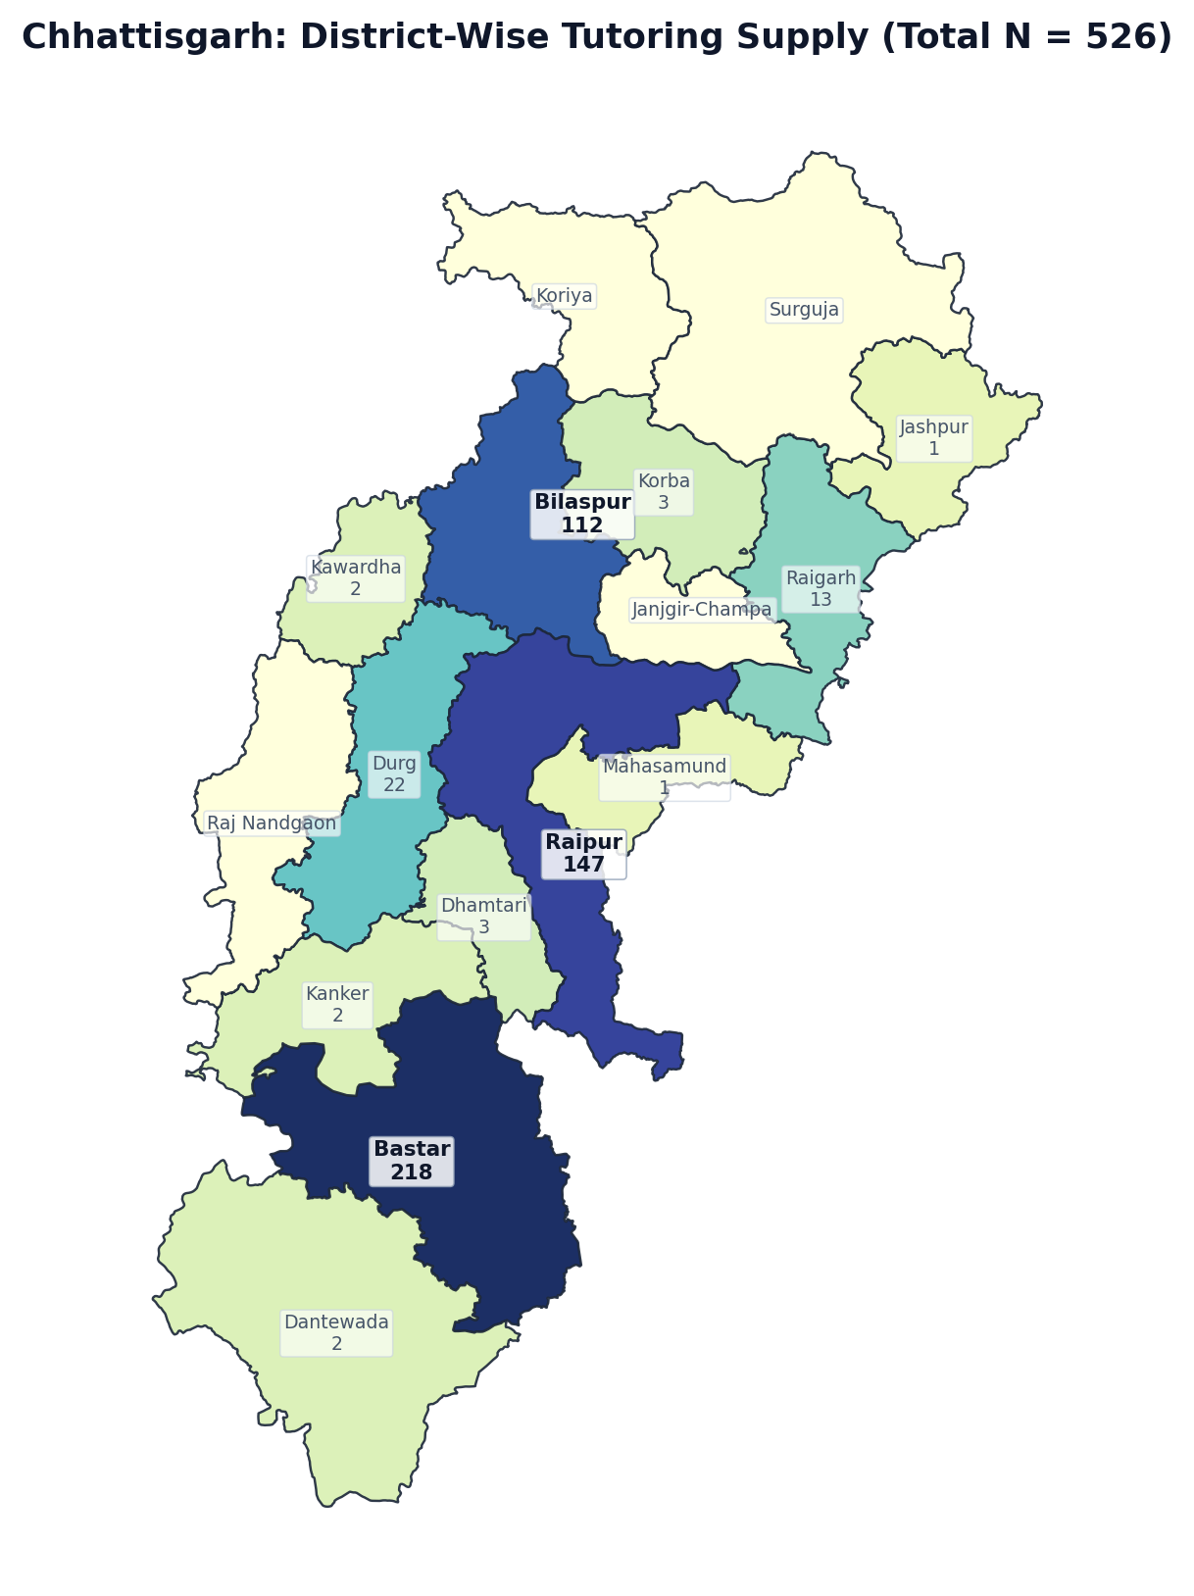
Figure 1.21: Chhattisgarh District Boundary Diagram — Localized Tutor Counts (N = 526)
Rank | District / Administrative Division | Tutors (N) | Share of State (%) | Avg Fee (₹/hr) | Online %
1 | Bastar | 218 | 41.4% | ₹857 | 95.9%
2 | Raipur | 147 | 27.9% | ₹1001 | 97.9%
3 | Bilaspur | 112 | 21.3% | ₹814 | 99.1%
4 | Durg | 22 | 4.2% | ₹926 | 100.0%
5 | Raigarh | 13 | 2.5% | ₹774 | 92.3%
6 | Dhamtari | 3 | 0.6% | ₹483 | 100.0%
7 | Korba | 3 | 0.6% | ₹1050 | 100.0%
8 | Dantewada | 2 | 0.4% | ₹1100 | 100.0%
9 | Kanker | 2 | 0.4% | ₹325 | 100.0%
10 | Kawardha | 2 | 0.4% | ₹525 | 100.0%
11 | Jashpur | 1 | 0.2% | — | 100.0%
12 | Mahasamund | 1 | 0.2% | ₹425 | 100.0%
13 | Janjgir-Champa | 0 | 0.0% | — | 0.0%
14 | Koriya | 0 | 0.0% | — | 0.0%
15 | Raj Nandgaon | 0 | 0.0% | — | 0.0%
16 | Surguja | 0 | 0.0% | — | 0.0%
— | Chhattisgarh Total | 526 | 100.0% | ₹884 | 97.3%

State 22: Himachal Pradesh — District-Wise Tutoring Supply (N = 498)
EXECUTIVE SUMMARY & STATE PROFILE: HIMACHAL PRADESH
• Total Registered Educators: 498 verified tutors (0.46% national market share | Pan-India Rank: #22 of 36)
• Average Hourly Tuition Rate: ₹840 / hr (statewide median pricing)
• Online Delivery Adoption: 99.0% of educators teach via digital platforms
• Active Educators: 361 tutors (72.5% engagement rate)
• Geographic Zone: North Region
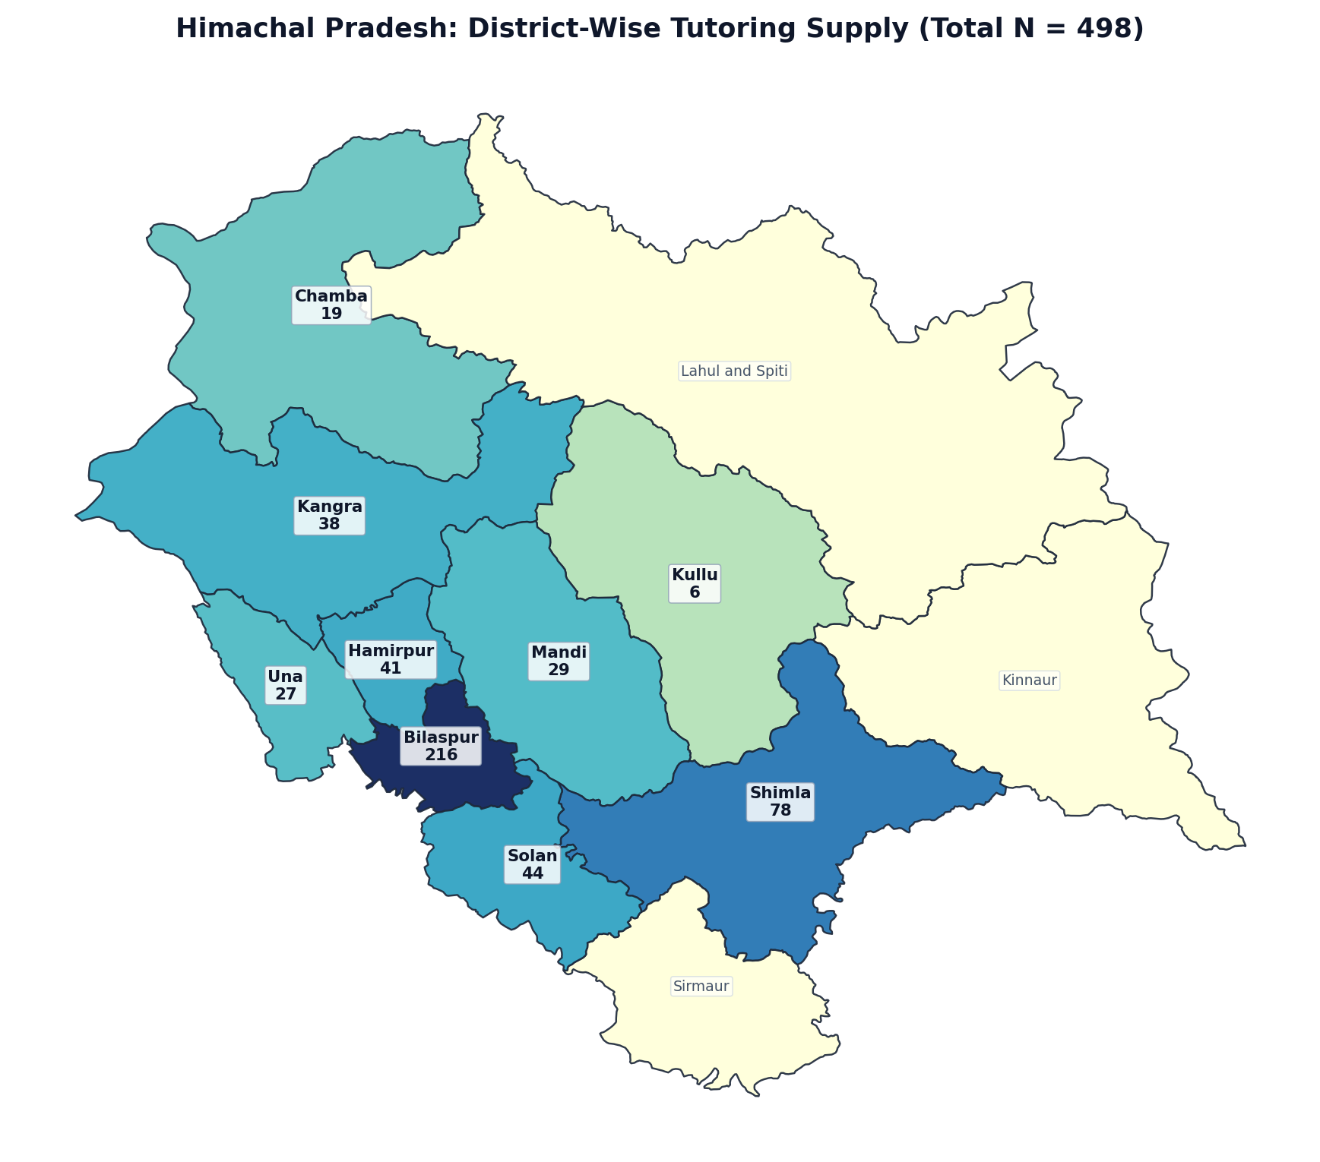
Figure 1.22: Himachal Pradesh District Boundary Diagram — Localized Tutor Counts (N = 498)
Rank | District / Administrative Division | Tutors (N) | Share of State (%) | Avg Fee (₹/hr) | Online %
1 | Bilaspur | 216 | 43.4% | ₹773 | 98.6%
2 | Shimla | 78 | 15.7% | ₹979 | 98.7%
3 | Solan | 44 | 8.8% | ₹850 | 100.0%
4 | Hamirpur | 41 | 8.2% | ₹714 | 97.6%
5 | Kangra | 38 | 7.6% | ₹952 | 100.0%
6 | Mandi | 29 | 5.8% | ₹980 | 100.0%
7 | Una | 27 | 5.4% | ₹710 | 100.0%
8 | Chamba | 19 | 3.8% | ₹1025 | 100.0%
9 | Kullu | 6 | 1.2% | ₹1038 | 100.0%
10 | Kinnaur | 0 | 0.0% | — | 0.0%
11 | Lahul and Spiti | 0 | 0.0% | — | 0.0%
12 | Sirmaur | 0 | 0.0% | — | 0.0%
— | Himachal Pradesh Total | 498 | 100.0% | ₹840 | 99.0%

State 23: Jammu and Kashmir — District-Wise Tutoring Supply (N = 408)
EXECUTIVE SUMMARY & STATE PROFILE: JAMMU AND KASHMIR
• Total Registered Educators: 408 verified tutors (0.38% national market share | Pan-India Rank: #23 of 36)
• Average Hourly Tuition Rate: ₹945 / hr (statewide median pricing)
• Online Delivery Adoption: 98.3% of educators teach via digital platforms
• Active Educators: 286 tutors (70.1% engagement rate)
• Geographic Zone: North Region
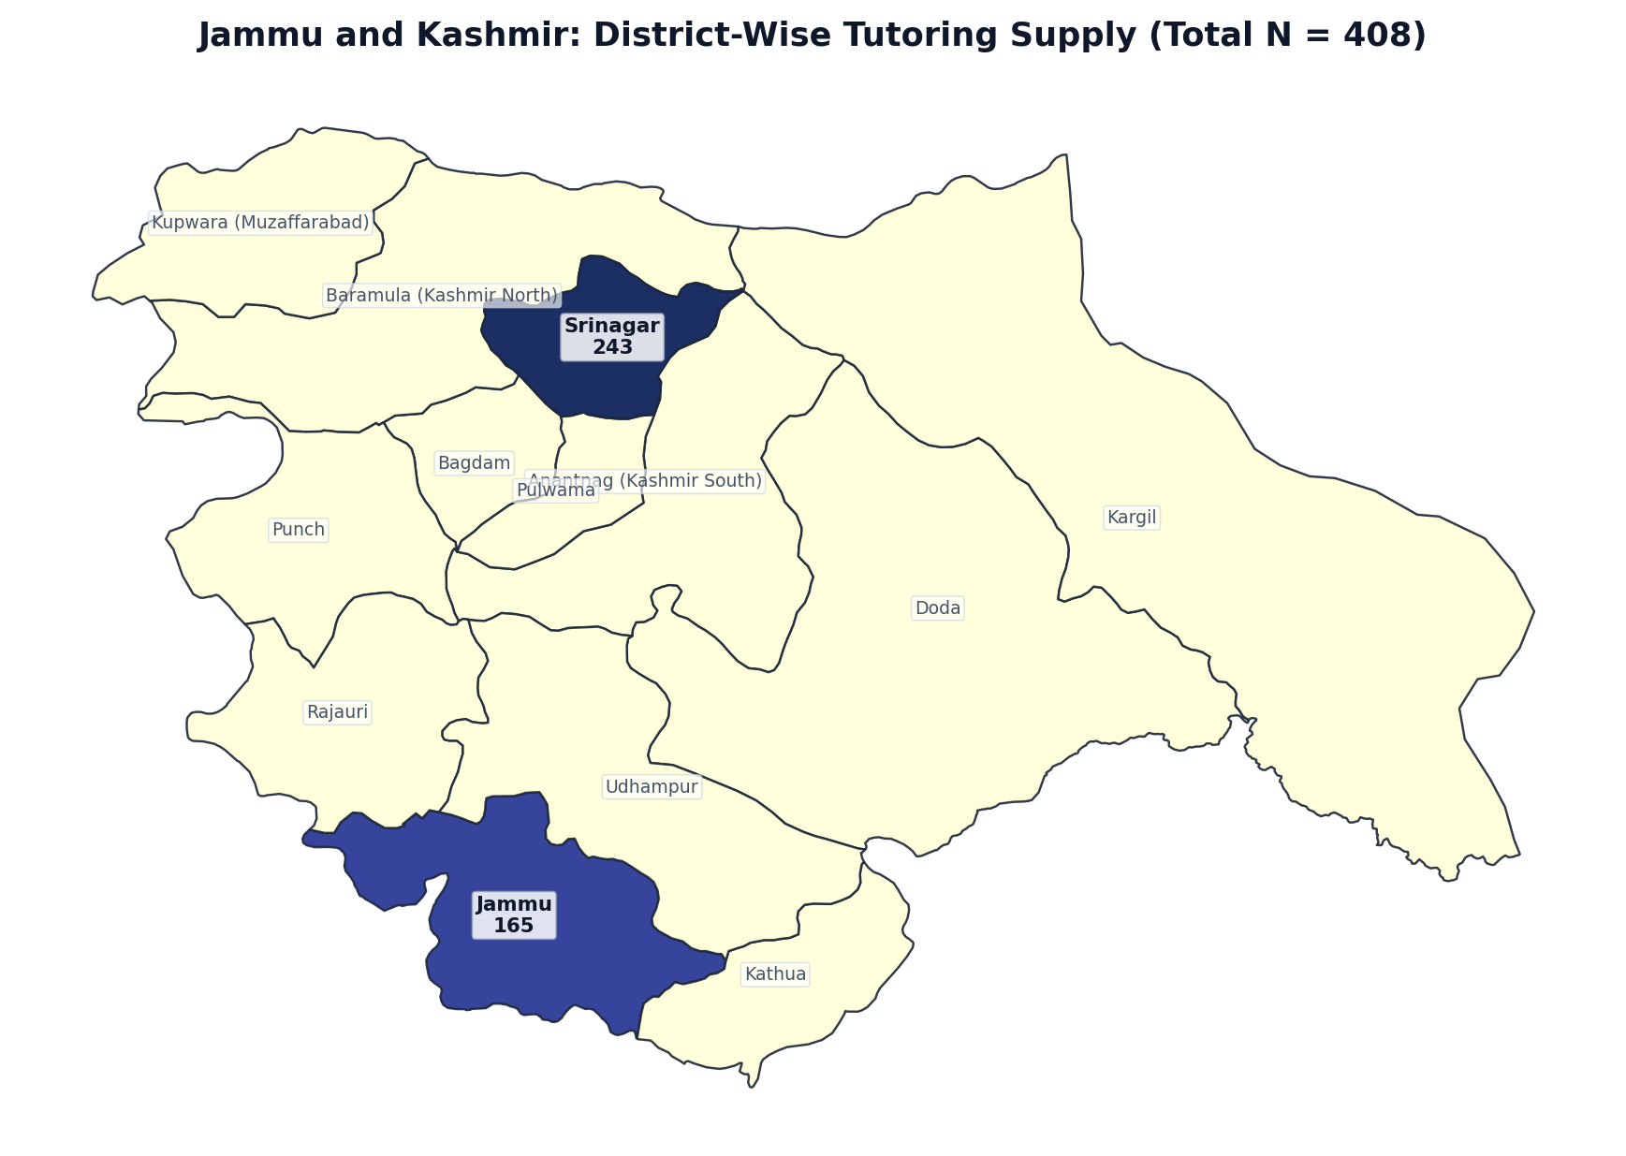
Figure 1.23: Jammu and Kashmir District Boundary Diagram — Localized Tutor Counts (N = 408)
Rank | District / Administrative Division | Tutors (N) | Share of State (%) | Avg Fee (₹/hr) | Online %
1 | Srinagar | 243 | 59.6% | ₹928 | 98.8%
2 | Jammu | 165 | 40.4% | ₹970 | 97.5%
3 | Anantnag (Kashmir South) | 0 | 0.0% | — | 0.0%
4 | Bagdam | 0 | 0.0% | — | 0.0%
5 | Baramula (Kashmir North) | 0 | 0.0% | — | 0.0%
6 | Doda | 0 | 0.0% | — | 0.0%
7 | Kargil | 0 | 0.0% | — | 0.0%
8 | Kathua | 0 | 0.0% | — | 0.0%
9 | Kupwara (Muzaffarabad) | 0 | 0.0% | — | 0.0%
10 | Pulwama | 0 | 0.0% | — | 0.0%
11 | Punch | 0 | 0.0% | — | 0.0%
12 | Rajauri | 0 | 0.0% | — | 0.0%
13 | Udhampur | 0 | 0.0% | — | 0.0%
— | Jammu and Kashmir Total | 408 | 100.0% | ₹945 | 98.3%

State 24: Puducherry — District-Wise Tutoring Supply (N = 360)
EXECUTIVE SUMMARY & STATE PROFILE: PUDUCHERRY
• Total Registered Educators: 360 verified tutors (0.33% national market share | Pan-India Rank: #24 of 36)
• Average Hourly Tuition Rate: ₹700 / hr (statewide median pricing)
• Online Delivery Adoption: 97.2% of educators teach via digital platforms
• Active Educators: 242 tutors (67.2% engagement rate)
• Geographic Zone: South Region
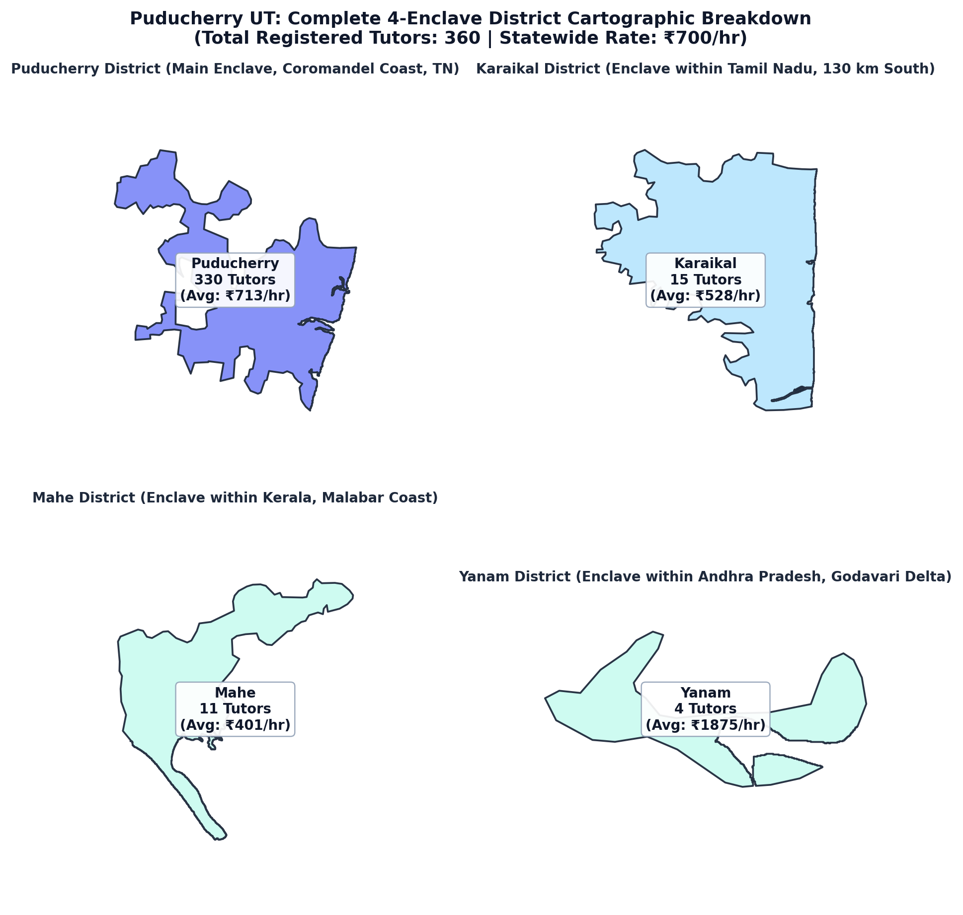
Figure 1.24: Puducherry District Boundary Diagram — Localized Tutor Counts (N = 360)
Rank | District / Administrative Division | Tutors (N) | Share of State (%) | Avg Fee (₹/hr) | Online %
1 | Puducherry | 330 | 91.7% | ₹713 | 96.9%
2 | Karaikal | 15 | 4.2% | ₹528 | 100.0%
3 | Mahe | 11 | 3.1% | ₹401 | 100.0%
4 | Yanam | 4 | 1.1% | ₹1875 | 100.0%
— | Puducherry Total | 360 | 100.0% | ₹700 | 97.2%

State 25: Goa — District-Wise Tutoring Supply (N = 170)
EXECUTIVE SUMMARY & STATE PROFILE: GOA
• Total Registered Educators: 170 verified tutors (0.16% national market share | Pan-India Rank: #25 of 36)
• Average Hourly Tuition Rate: ₹946 / hr (statewide median pricing)
• Online Delivery Adoption: 96.5% of educators teach via digital platforms
• Active Educators: 130 tutors (76.5% engagement rate)
• Geographic Zone: West Region
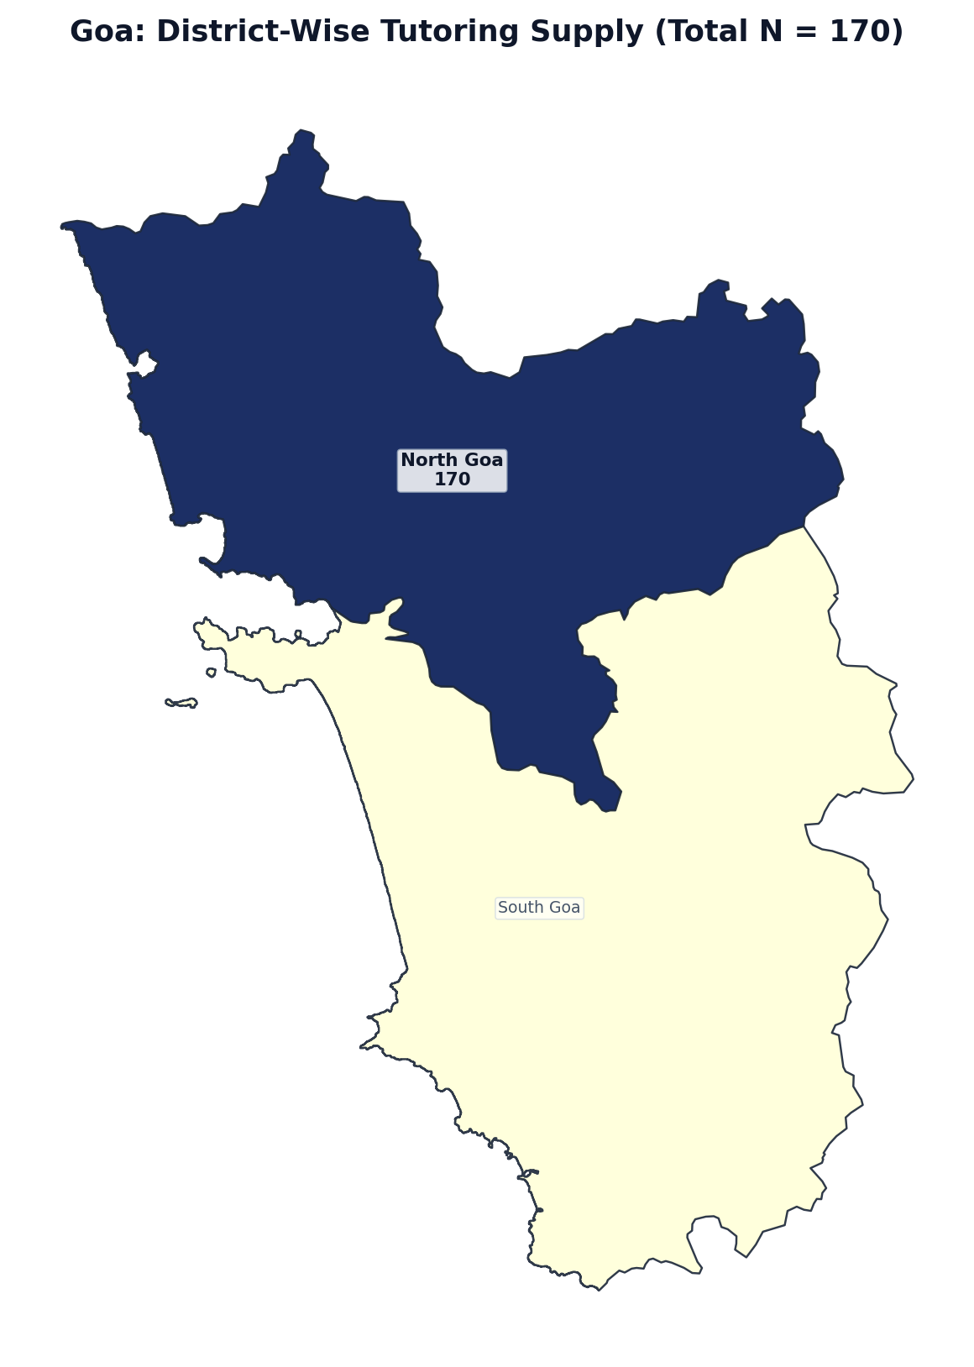
Figure 1.25: Goa District Boundary Diagram — Localized Tutor Counts (N = 170)
Rank | District / Administrative Division | Tutors (N) | Share of State (%) | Avg Fee (₹/hr) | Online %
1 | North Goa | 170 | 100.0% | ₹953 | 96.5%
2 | South Goa | 0 | 0.0% | — | 0.0%
— | Goa Total | 170 | 100.0% | ₹946 | 96.5%

State 26: Tripura — District-Wise Tutoring Supply (N = 66)
EXECUTIVE SUMMARY & STATE PROFILE: TRIPURA
• Total Registered Educators: 66 verified tutors (0.06% national market share | Pan-India Rank: #26 of 36)
• Average Hourly Tuition Rate: ₹760 / hr (statewide median pricing)
• Online Delivery Adoption: 95.5% of educators teach via digital platforms
• Active Educators: 44 tutors (66.7% engagement rate)
• Geographic Zone: East Region
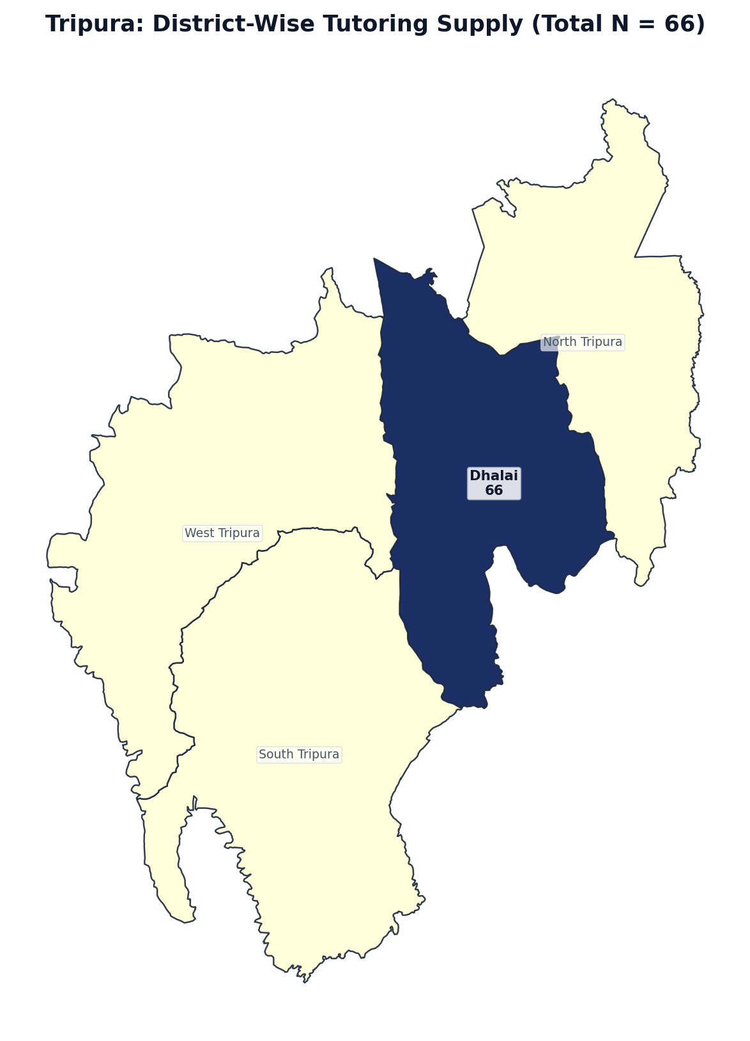
Figure 1.26: Tripura District Boundary Diagram — Localized Tutor Counts (N = 66)
Rank | District / Administrative Division | Tutors (N) | Share of State (%) | Avg Fee (₹/hr) | Online %
1 | Dhalai | 66 | 100.0% | ₹760 | 95.4%
2 | North Tripura | 0 | 0.0% | — | 0.0%
3 | South Tripura | 0 | 0.0% | — | 0.0%
4 | West Tripura | 0 | 0.0% | — | 0.0%
— | Tripura Total | 66 | 100.0% | ₹760 | 95.5%

State 27: Meghalaya — District-Wise Tutoring Supply (N = 43)
EXECUTIVE SUMMARY & STATE PROFILE: MEGHALAYA
• Total Registered Educators: 43 verified tutors (0.04% national market share | Pan-India Rank: #27 of 36)
• Average Hourly Tuition Rate: ₹1063 / hr (statewide median pricing)
• Online Delivery Adoption: 95.3% of educators teach via digital platforms
• Active Educators: 31 tutors (72.1% engagement rate)
• Geographic Zone: East Region
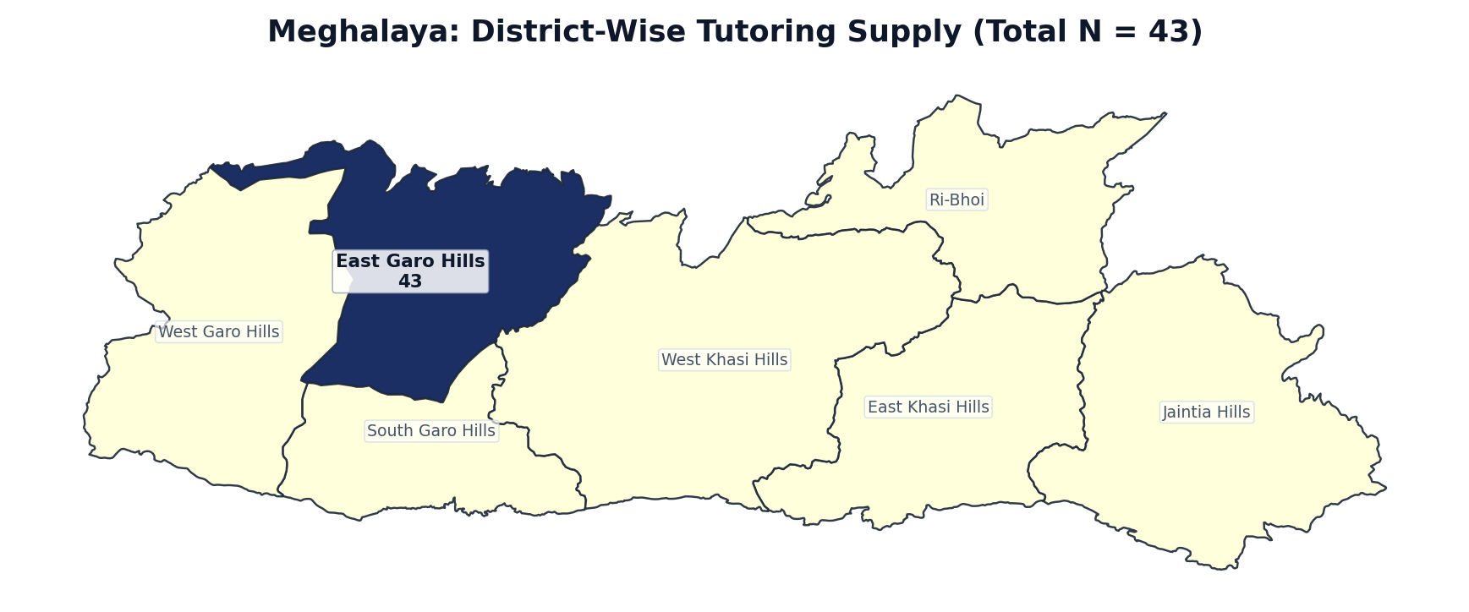
Figure 1.27: Meghalaya District Boundary Diagram — Localized Tutor Counts (N = 43)
Rank | District / Administrative Division | Tutors (N) | Share of State (%) | Avg Fee (₹/hr) | Online %
1 | East Garo Hills | 43 | 100.0% | ₹1065 | 95.3%
2 | East Khasi Hills | 0 | 0.0% | — | 0.0%
3 | Jaintia Hills | 0 | 0.0% | — | 0.0%
4 | Ri-Bhoi | 0 | 0.0% | — | 0.0%
5 | South Garo Hills | 0 | 0.0% | — | 0.0%
6 | West Garo Hills | 0 | 0.0% | — | 0.0%
7 | West Khasi Hills | 0 | 0.0% | — | 0.0%
— | Meghalaya Total | 43 | 100.0% | ₹1063 | 95.3%

State 28: Manipur — District-Wise Tutoring Supply (N = 36)
EXECUTIVE SUMMARY & STATE PROFILE: MANIPUR
• Total Registered Educators: 36 verified tutors (0.03% national market share | Pan-India Rank: #28 of 36)
• Average Hourly Tuition Rate: ₹621 / hr (statewide median pricing)
• Online Delivery Adoption: 94.4% of educators teach via digital platforms
• Active Educators: 23 tutors (63.9% engagement rate)
• Geographic Zone: East Region
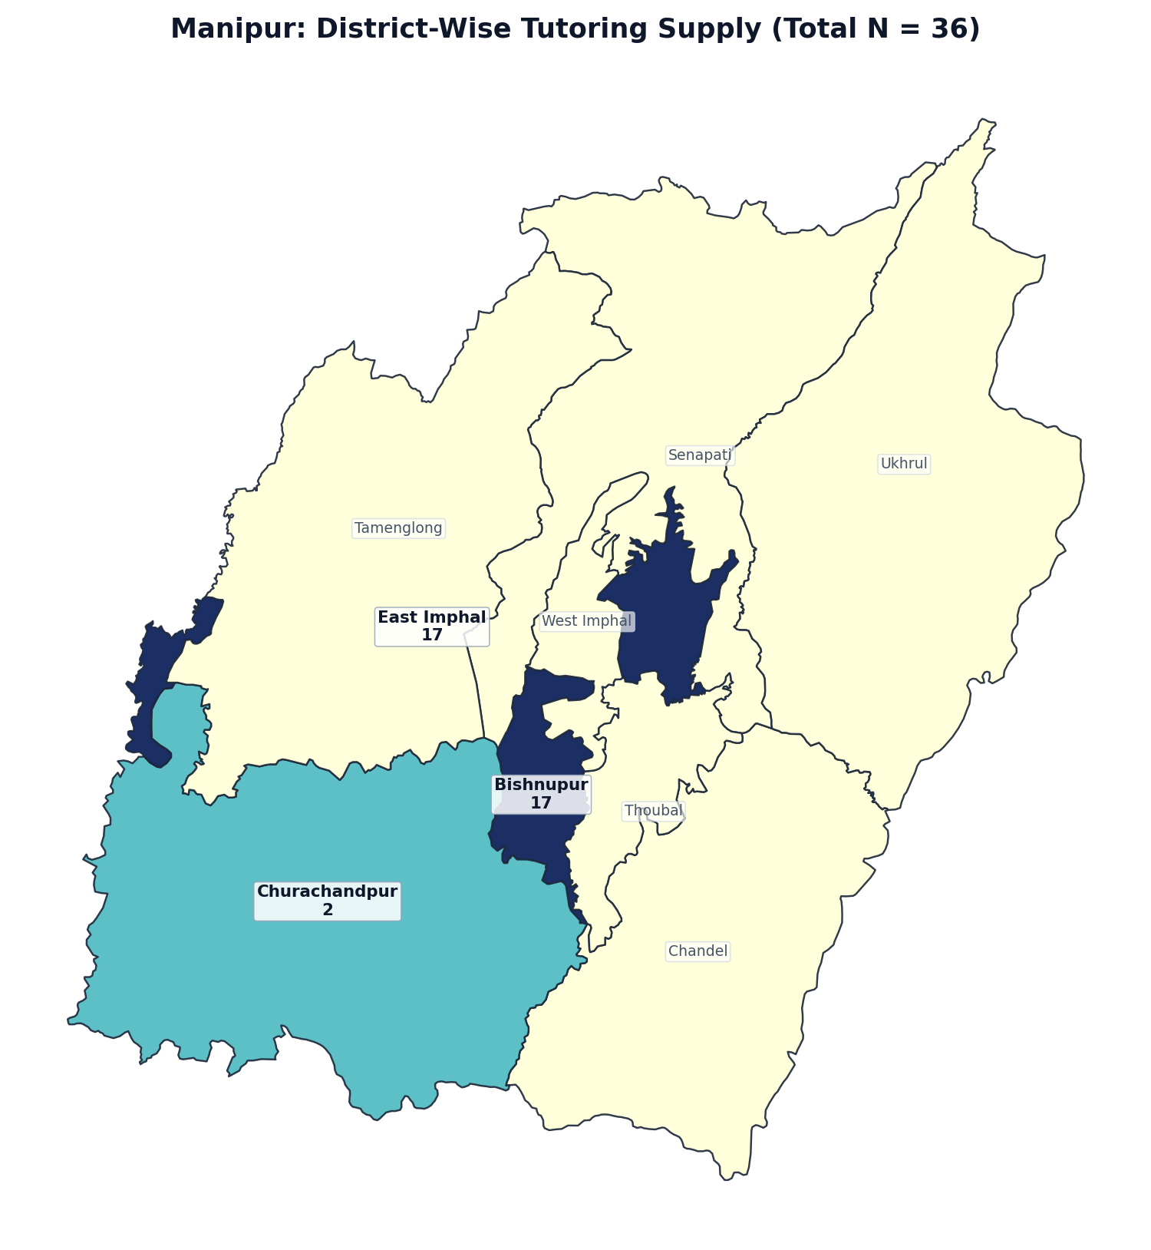
Figure 1.28: Manipur District Boundary Diagram — Localized Tutor Counts (N = 36)
Rank | District / Administrative Division | Tutors (N) | Share of State (%) | Avg Fee (₹/hr) | Online %
1 | Bishnupur | 17 | 47.2% | ₹725 | 88.2%
2 | East Imphal | 17 | 47.2% | ₹527 | 100.0%
3 | Churachandpur | 2 | 5.6% | ₹600 | 100.0%
4 | Chandel | 0 | 0.0% | — | 0.0%
5 | Senapati | 0 | 0.0% | — | 0.0%
6 | Tamenglong | 0 | 0.0% | — | 0.0%
7 | Thoubal | 0 | 0.0% | — | 0.0%
8 | Ukhrul | 0 | 0.0% | — | 0.0%
9 | West Imphal | 0 | 0.0% | — | 0.0%
— | Manipur Total | 36 | 100.0% | ₹621 | 94.4%

State 29: Nagaland — District-Wise Tutoring Supply (N = 26)
EXECUTIVE SUMMARY & STATE PROFILE: NAGALAND
• Total Registered Educators: 26 verified tutors (0.02% national market share | Pan-India Rank: #29 of 36)
• Average Hourly Tuition Rate: ₹750 / hr (statewide median pricing)
• Online Delivery Adoption: 100.0% of educators teach via digital platforms
• Active Educators: 20 tutors (76.9% engagement rate)
• Geographic Zone: East Region
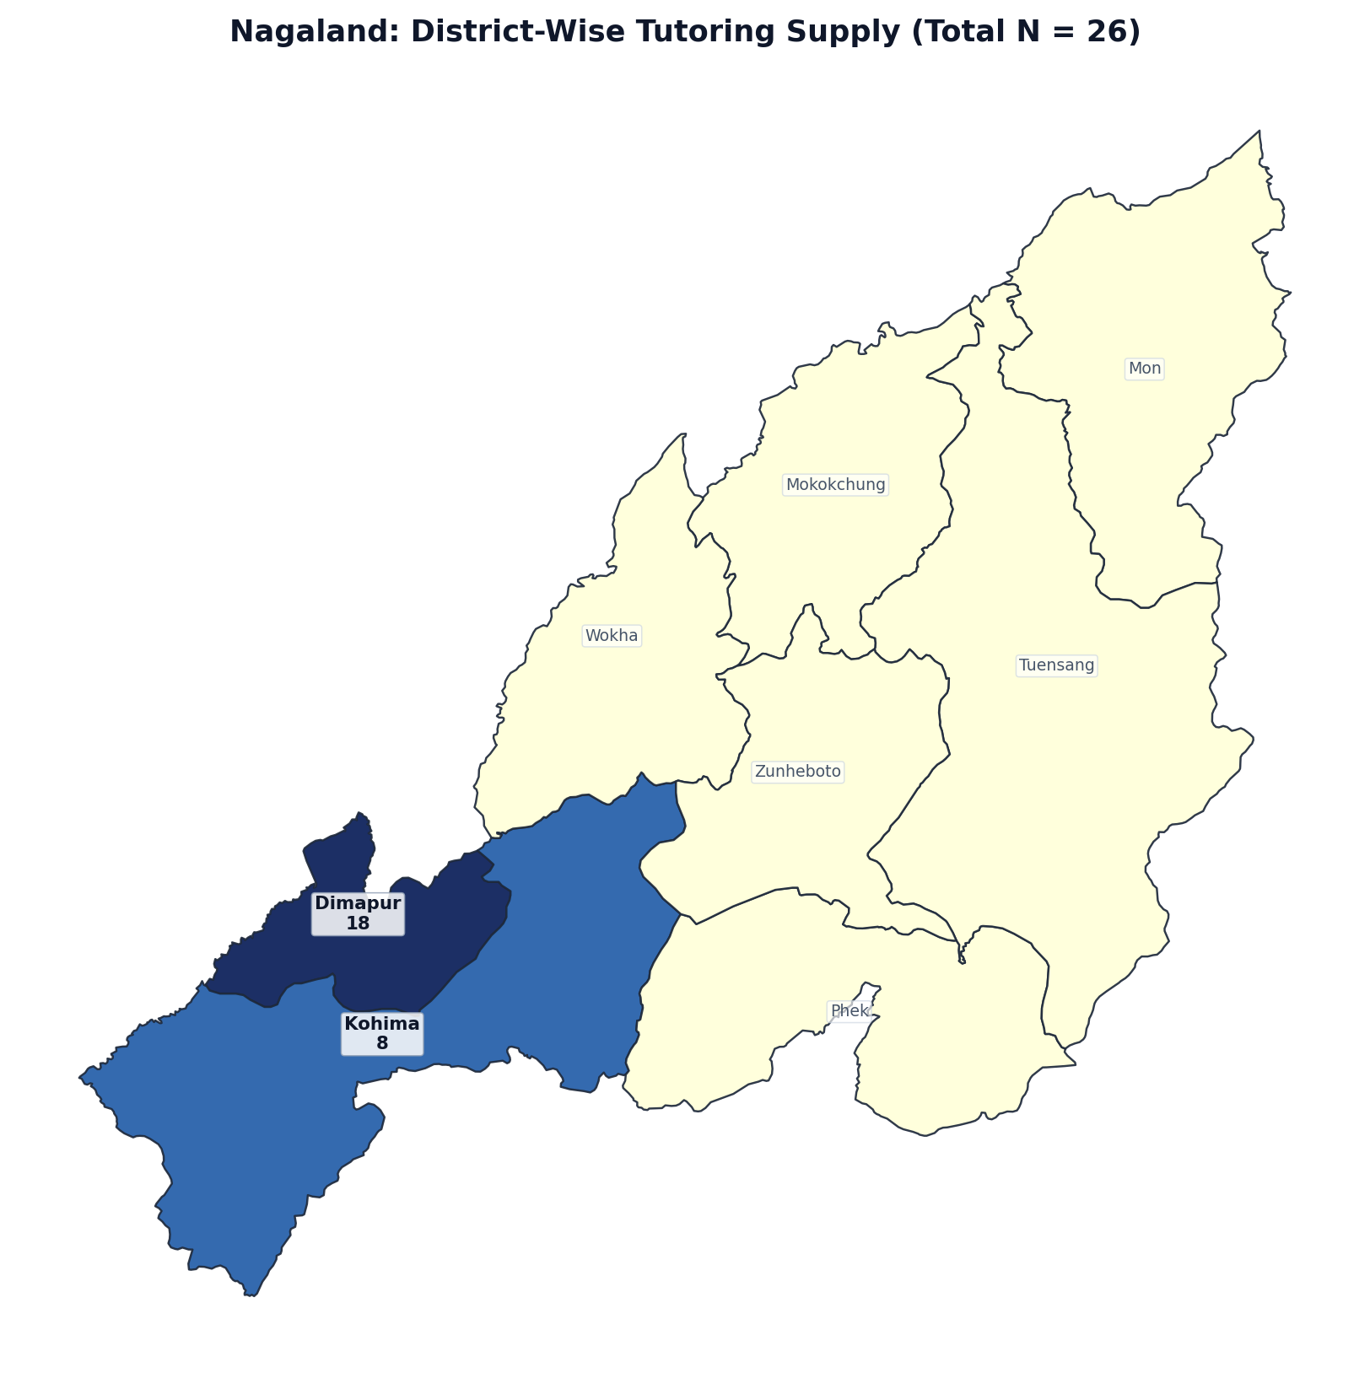
Figure 1.29: Nagaland District Boundary Diagram — Localized Tutor Counts (N = 26)
Rank | District / Administrative Division | Tutors (N) | Share of State (%) | Avg Fee (₹/hr) | Online %
1 | Dimapur | 18 | 69.2% | ₹852 | 100.0%
2 | Kohima | 8 | 30.8% | ₹460 | 100.0%
3 | Mokokchung | 0 | 0.0% | — | 0.0%
4 | Mon | 0 | 0.0% | — | 0.0%
5 | Phek | 0 | 0.0% | — | 0.0%
6 | Tuensang | 0 | 0.0% | — | 0.0%
7 | Wokha | 0 | 0.0% | — | 0.0%
8 | Zunheboto | 0 | 0.0% | — | 0.0%
— | Nagaland Total | 26 | 100.0% | ₹750 | 100.0%

State 30: Andaman and Nicobar Islands — District-Wise Tutoring Supply (N = 24)
EXECUTIVE SUMMARY & STATE PROFILE: ANDAMAN AND NICOBAR ISLANDS
• Total Registered Educators: 24 verified tutors (0.02% national market share | Pan-India Rank: #30 of 36)
• Average Hourly Tuition Rate: ₹901 / hr (statewide median pricing)
• Online Delivery Adoption: 100.0% of educators teach via digital platforms
• Active Educators: 18 tutors (75.0% engagement rate)
• Geographic Zone: South Region
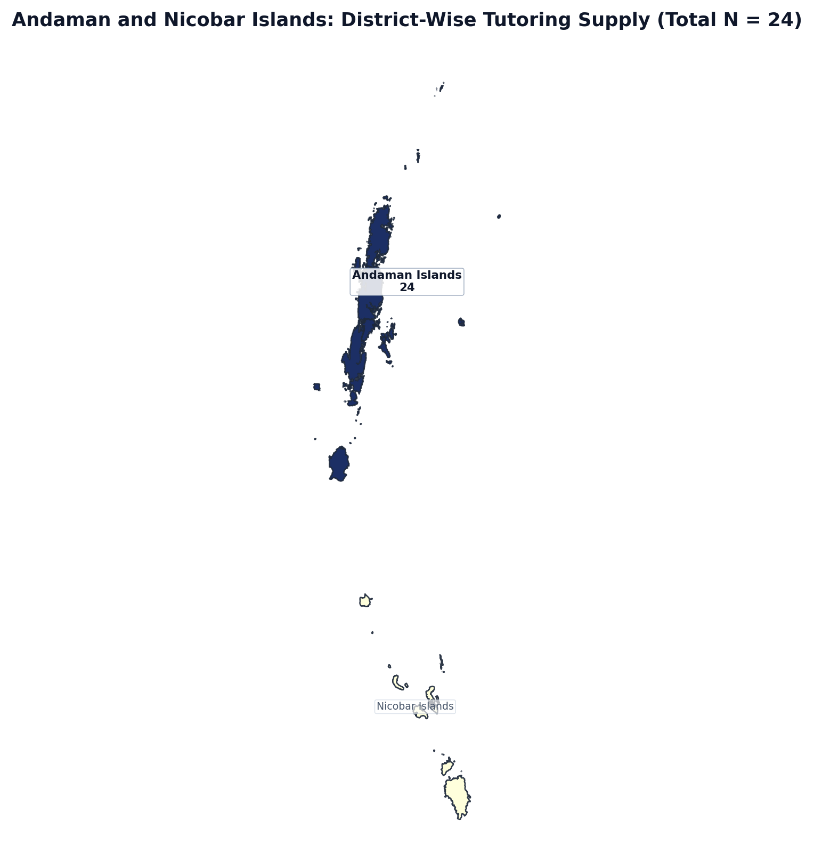
Figure 1.30: Andaman and Nicobar Islands District Boundary Diagram — Localized Tutor Counts (N = 24)
Rank | District / Administrative Division | Tutors (N) | Share of State (%) | Avg Fee (₹/hr) | Online %
1 | Andaman Islands | 24 | 100.0% | ₹901 | 100.0%
2 | Nicobar Islands | 0 | 0.0% | — | 0.0%
— | Andaman and Nicobar Islands Total | 24 | 100.0% | ₹901 | 100.0%

State 31: Dadra and Nagar Haveli and Daman and Diu — District-Wise Tutoring Supply (N = 22)
EXECUTIVE SUMMARY & STATE PROFILE: DADRA AND NAGAR HAVELI AND DAMAN AND DIU
• Total Registered Educators: 22 verified tutors (0.02% national market share | Pan-India Rank: #31 of 36)
• Average Hourly Tuition Rate: ₹688 / hr (statewide median pricing)
• Online Delivery Adoption: 100.0% of educators teach via digital platforms
• Active Educators: 17 tutors (77.3% engagement rate)
• Geographic Zone: West Region
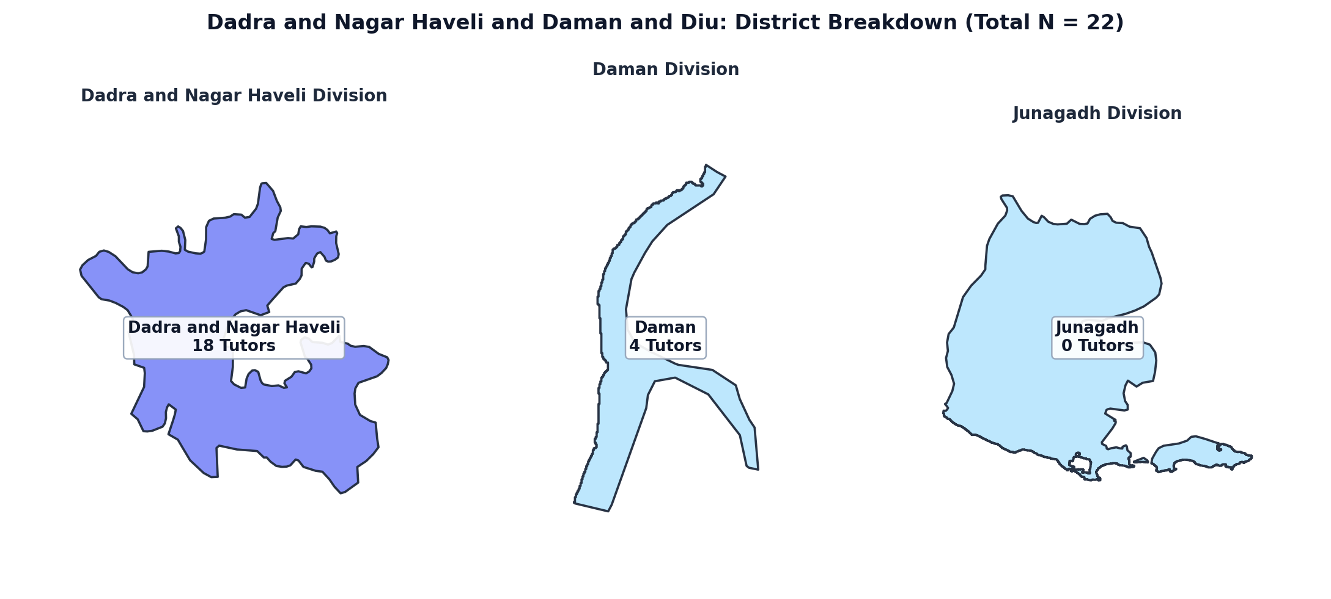
Figure 1.31: Dadra and Nagar Haveli and Daman and Diu District Boundary Diagram — Localized Tutor Counts (N = 22)
Rank | District / Administrative Division | Tutors (N) | Share of State (%) | Avg Fee (₹/hr) | Online %
1 | Dadra and Nagar Haveli | 18 | 81.8% | ₹583 | 100.0%
2 | Daman | 4 | 18.2% | ₹550 | 100.0%
3 | Junagadh | 0 | 0.0% | — | 0.0%
— | Dadra and Nagar Haveli and Daman and Diu Total | 22 | 100.0% | ₹688 | 100.0%

State 32: Sikkim — District-Wise Tutoring Supply (N = 19)
EXECUTIVE SUMMARY & STATE PROFILE: SIKKIM
• Total Registered Educators: 19 verified tutors (0.02% national market share | Pan-India Rank: #32 of 36)
• Average Hourly Tuition Rate: ₹730 / hr (statewide median pricing)
• Online Delivery Adoption: 94.7% of educators teach via digital platforms
• Active Educators: 13 tutors (68.4% engagement rate)
• Geographic Zone: East Region
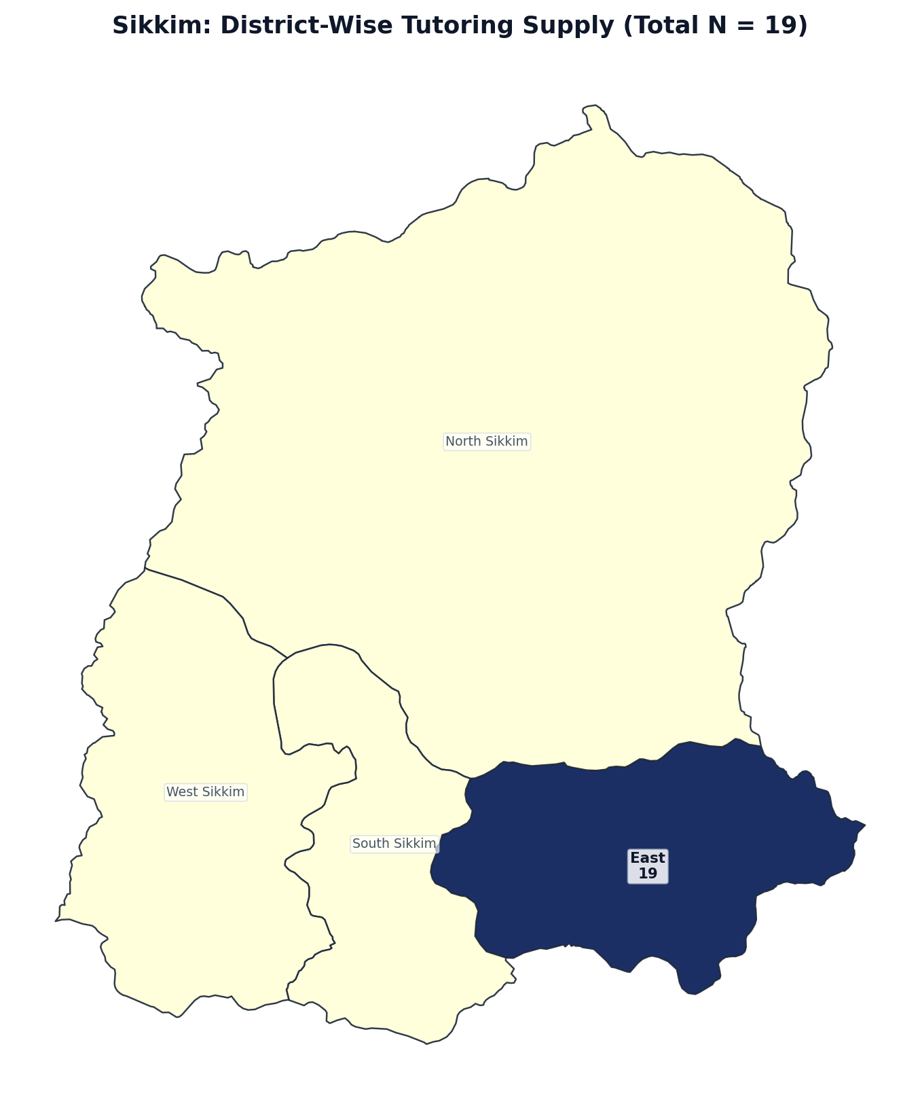
Figure 1.32: Sikkim District Boundary Diagram — Localized Tutor Counts (N = 19)
Rank | District / Administrative Division | Tutors (N) | Share of State (%) | Avg Fee (₹/hr) | Online %
1 | East | 19 | 100.0% | ₹734 | 94.7%
2 | North Sikkim | 0 | 0.0% | — | 0.0%
3 | South Sikkim | 0 | 0.0% | — | 0.0%
4 | West Sikkim | 0 | 0.0% | — | 0.0%
— | Sikkim Total | 19 | 100.0% | ₹730 | 94.7%

State 33: Mizoram — District-Wise Tutoring Supply (N = 7)
EXECUTIVE SUMMARY & STATE PROFILE: MIZORAM
• Total Registered Educators: 7 verified tutors (0.01% national market share | Pan-India Rank: #33 of 36)
• Average Hourly Tuition Rate: ₹812 / hr (statewide median pricing)
• Online Delivery Adoption: 100.0% of educators teach via digital platforms
• Active Educators: 5 tutors (71.4% engagement rate)
• Geographic Zone: East Region
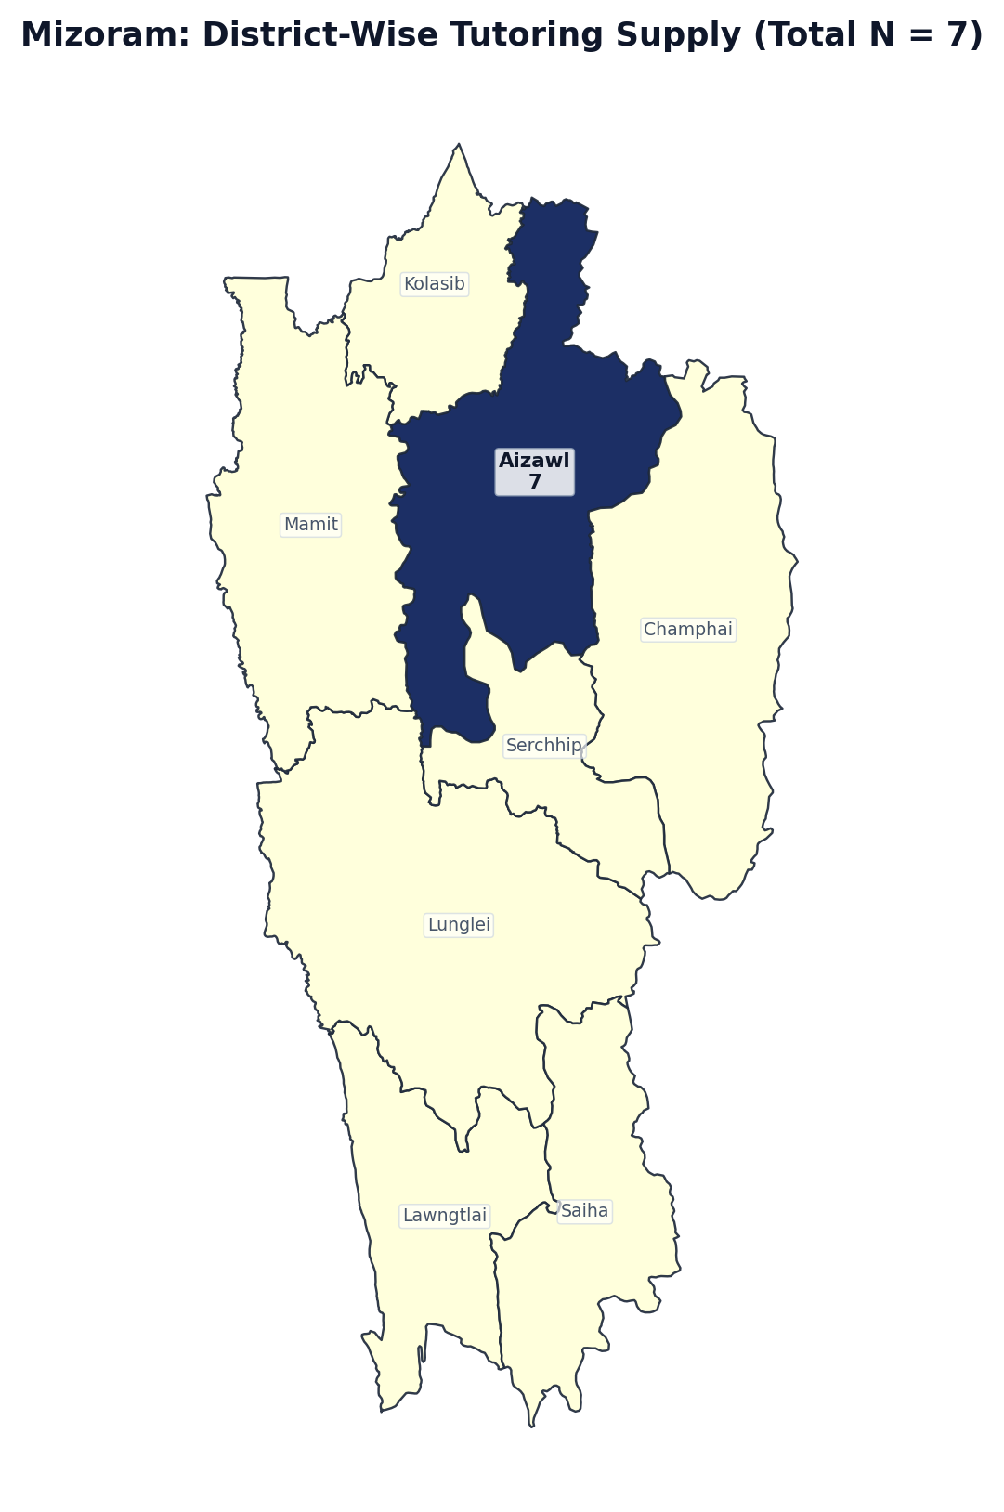
Figure 1.33: Mizoram District Boundary Diagram — Localized Tutor Counts (N = 7)
Rank | District / Administrative Division | Tutors (N) | Share of State (%) | Avg Fee (₹/hr) | Online %
1 | Aizawl | 7 | 100.0% | ₹812 | 100.0%
2 | Champhai | 0 | 0.0% | — | 0.0%
3 | Kolasib | 0 | 0.0% | — | 0.0%
4 | Lawngtlai | 0 | 0.0% | — | 0.0%
5 | Lunglei | 0 | 0.0% | — | 0.0%
6 | Mamit | 0 | 0.0% | — | 0.0%
7 | Saiha | 0 | 0.0% | — | 0.0%
8 | Serchhip | 0 | 0.0% | — | 0.0%
— | Mizoram Total | 7 | 100.0% | ₹812 | 100.0%

State 34: Arunachal Pradesh — District-Wise Tutoring Supply (N = 3)
EXECUTIVE SUMMARY & STATE PROFILE: ARUNACHAL PRADESH
• Total Registered Educators: 3 verified tutors (0.00% national market share | Pan-India Rank: #34 of 36)
• Average Hourly Tuition Rate: ₹2667 / hr (statewide median pricing)
• Online Delivery Adoption: 100.0% of educators teach via digital platforms
• Active Educators: 0 tutors (0.0% engagement rate)
• Geographic Zone: East Region
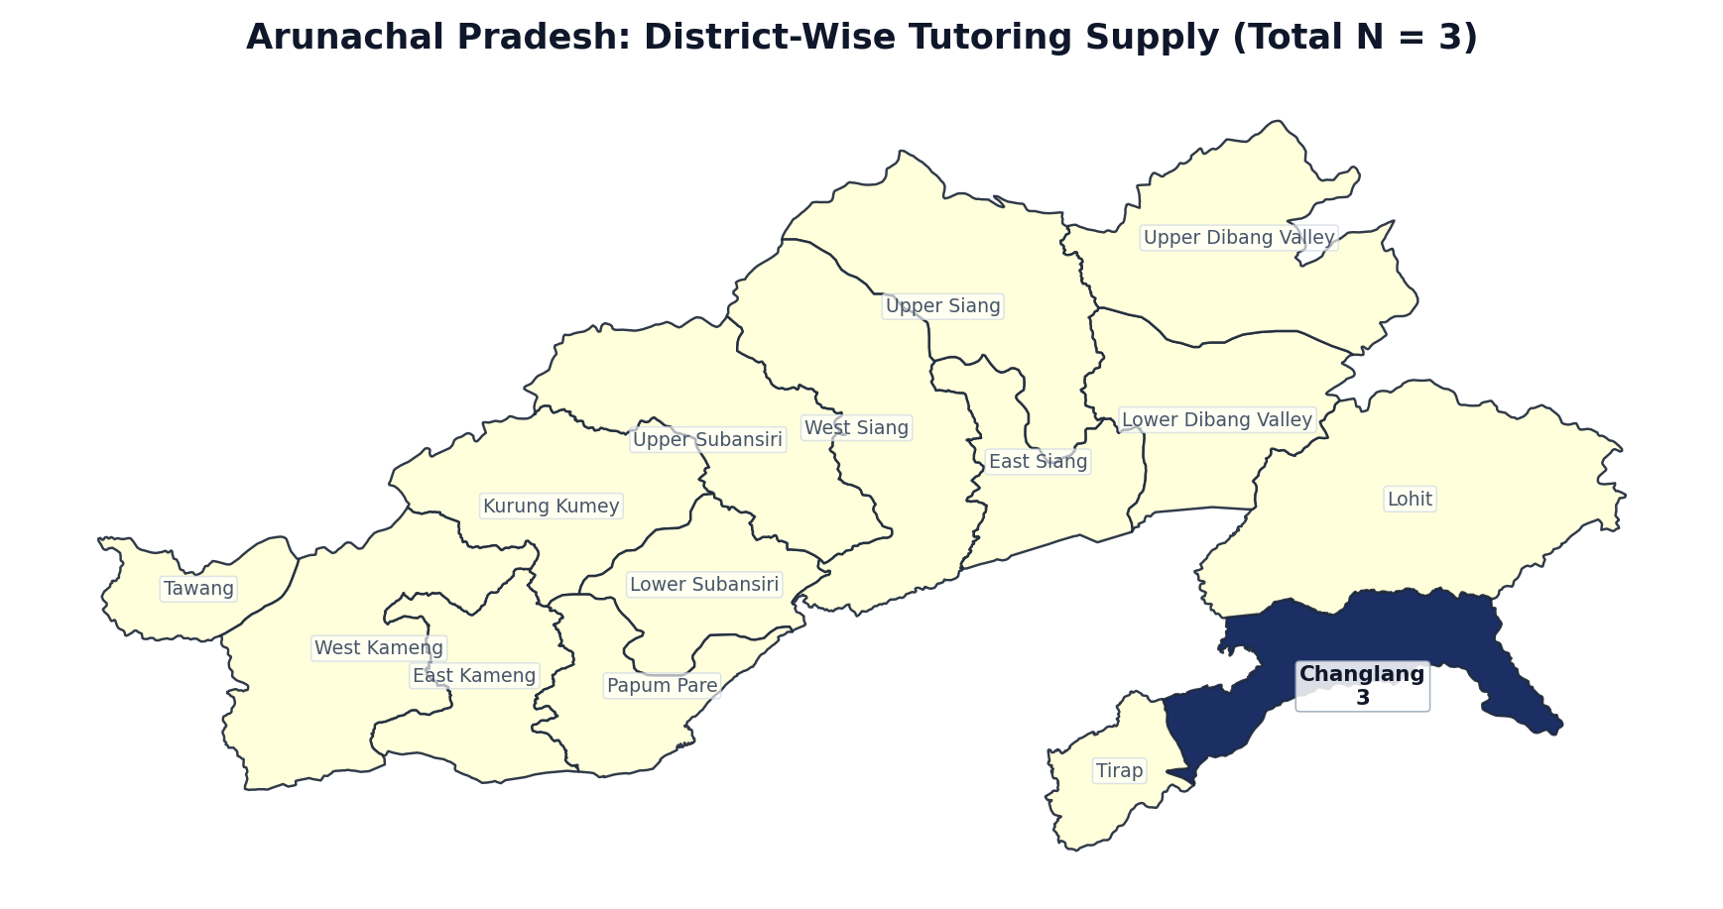
Figure 1.34: Arunachal Pradesh District Boundary Diagram — Localized Tutor Counts (N = 3)
Rank | District / Administrative Division | Tutors (N) | Share of State (%) | Avg Fee (₹/hr) | Online %
1 | Changlang | 3 | 100.0% | ₹2667 | 100.0%
2 | East Kameng | 0 | 0.0% | — | 0.0%
3 | East Siang | 0 | 0.0% | — | 0.0%
4 | Kurung Kumey | 0 | 0.0% | — | 0.0%
5 | Lohit | 0 | 0.0% | — | 0.0%
6 | Lower Dibang Valley | 0 | 0.0% | — | 0.0%
7 | Lower Subansiri | 0 | 0.0% | — | 0.0%
8 | Papum Pare | 0 | 0.0% | — | 0.0%
9 | Tawang | 0 | 0.0% | — | 0.0%
10 | Tirap | 0 | 0.0% | — | 0.0%
11 | Upper Dibang Valley | 0 | 0.0% | — | 0.0%
12 | Upper Siang | 0 | 0.0% | — | 0.0%
13 | Upper Subansiri | 0 | 0.0% | — | 0.0%
14 | West Kameng | 0 | 0.0% | — | 0.0%
15 | West Siang | 0 | 0.0% | — | 0.0%
— | Arunachal Pradesh Total | 3 | 100.0% | ₹2667 | 100.0%

State 35: Lakshadweep — District-Wise Tutoring Supply (N = 3)
EXECUTIVE SUMMARY & STATE PROFILE: LAKSHADWEEP
• Total Registered Educators: 3 verified tutors (0.00% national market share | Pan-India Rank: #35 of 36)
• Average Hourly Tuition Rate: ₹238 / hr (statewide median pricing)
• Online Delivery Adoption: 100.0% of educators teach via digital platforms
• Active Educators: 3 tutors (100.0% engagement rate)
• Geographic Zone: West Region
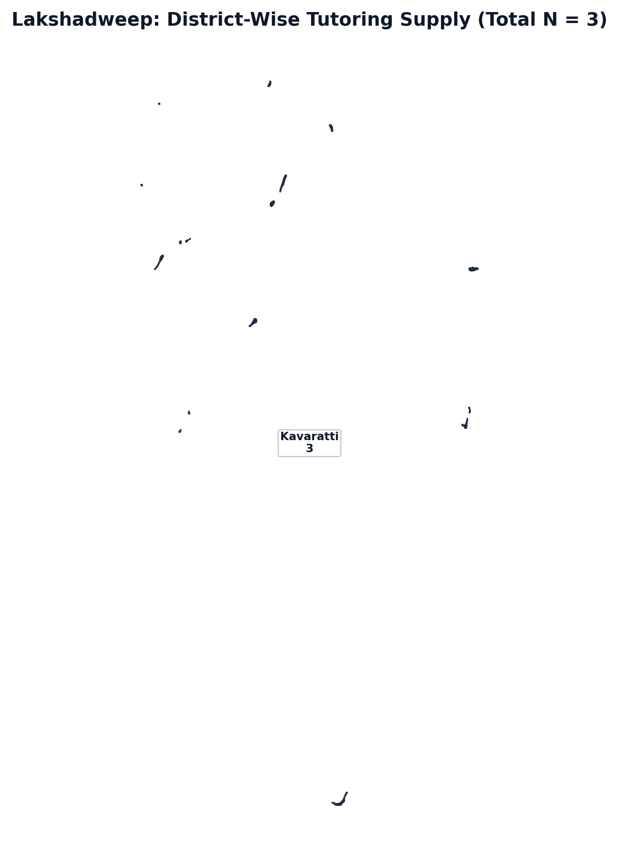
Figure 1.35: Lakshadweep District Boundary Diagram — Localized Tutor Counts (N = 3)
Rank | District / Administrative Division | Tutors (N) | Share of State (%) | Avg Fee (₹/hr) | Online %
1 | Kavaratti | 3 | 100.0% | ₹283 | 100.0%
— | Lakshadweep Total | 3 | 100.0% | ₹238 | 100.0%

State 36: Ladakh — District-Wise Tutoring Supply (N = 0)
EXECUTIVE SUMMARY & STATE PROFILE: LADAKH
• Total Registered Educators: 0 verified tutors (0.00% national market share | Pan-India Rank: #36 of 36)
• Average Hourly Tuition Rate: ₹0 / hr (statewide median pricing)
• Online Delivery Adoption: 0.0% of educators teach via digital platforms
• Active Educators: 0 tutors (0.0% engagement rate)
• Geographic Zone: North Region
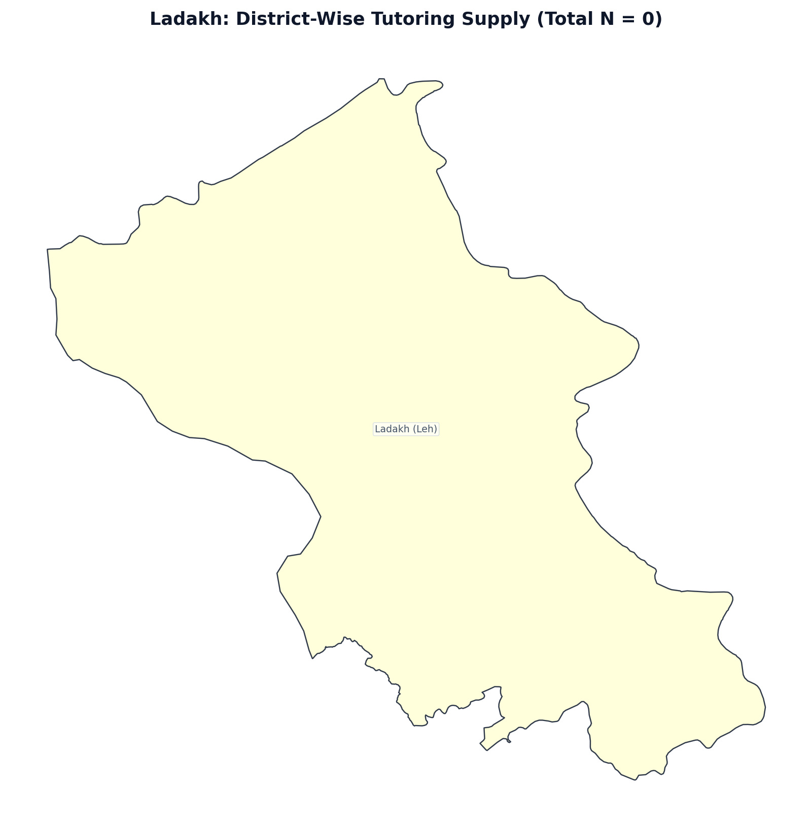
Figure 1.36: Ladakh District Boundary Diagram — Localized Tutor Counts (N = 0)
Rank | District / Administrative Division | Tutors (N) | Share of State (%) | Avg Fee (₹/hr) | Online %
1 | Ladakh (Leh) | 0 | 0.0% | — | 0.0%
— | Ladakh Total | 0 | 100.0% | — | 0.0%

2. Gender Distribution Across Tutoring Disciplines
In line with academic literature on private tutoring, gender segregation differs across subject domains. Overall, women comprise 58.7% of registered tutors in India ($N = 62,551$), while men represent 41.3% ($N = 44,001$). However, STEM sciences and computer programming demonstrate significantly higher male tutor shares compared to languages and primary education.

Table 2: Gender Distribution by Tutoring Subject (Broad Domains & Top Subjects)
Subject Domain / Discipline | Men (%) | Women (%) | Sample Size (N)
Natural sciences & mathematics (physics, chemistry, biology, math) | 43% | 57% | 80,698
Foreign & modern languages (English, Hindi, Tamil, French, etc.) | 25% | 75% | 39,062
Computer science & programming (Python, Java, web dev, AI/ML) | 57% | 43% | 19,733
History, geography, social sciences & humanities | 32% | 68% | 12,295
Commerce, economics & business studies (accounting, finance) | 43% | 57% | 9,409
Creative arts, music, yoga & extracurricular activities | 42% | 58% | 8,369
General elementary & primary school foundation (all subjects) | 29% | 71% | 4,059
Top Specific Individual Tutoring Disciplines (N >= 4,000)
• Mathematics | 42% | 58% | 37,566
• English | 22% | 78% | 24,393
• Science (General) | 33% | 67% | 23,229
• Physics | 52% | 48% | 14,732
• Biology & Life Sciences | 27% | 73% | 10,952
• Hindi | 21% | 79% | 9,601
• Chemistry | 45% | 55% | 9,319
• Computer Science & Programming | 53% | 47% | 6,108
• Business Studies & Management | 46% | 54% | 4,565
• Tamil | 11% | 89% | 4,277
• Python | 65% | 35% | 4,058
Total Unique Educators | 41% | 59% | 106,552
Notes: If tutors offer tutoring in two or more subjects, they are counted for each subject. Percentages are calculated across tutors with specified gender records.

3. Pricing Architecture & Educational Stage Escalation
Tuition rates in India demonstrate sharp escalation across educational tiers. Elementary stages (Primary & Middle School) command lower hourly fees (₹650–₹700/hr), whereas Senior Secondary (Classes 11–12 board and entrance exam preparation) and College-level tuition climb significantly, exceeding ₹1,000–₹1,220/hr, particularly in Computer Science/Coding and Mathematics.

Table 3: Hourly Tuition Fees by Educational Level and Geographic Zone (Maths & English)
Region / Zone | Primary (Cl  Maths | Primary (Cl  English | Secondary (  Maths | Secondary (  English | Senior Sec  Maths | Senior Sec  English | Higher Ed (  Maths | Higher Ed (  English
Geographic Zone | Maths (₹|n) | English (₹|n) | Maths (₹|n) | English (₹|n) | Maths (₹|n) | English (₹|n) | Maths (₹|n) | English (₹|n)
Nationwide (All India) | ₹701 (n=5118) | ₹670 (n=4229) | ₹772 (n=11688) | ₹737 (n=5731) | ₹1032 (n=22903) | ₹806 (n=8456) | ₹1178 (n=6066) | ₹851 (n=2405)
North Zone | ₹835 (n=1290) | ₹782 (n=1031) | ₹888 (n=2954) | ₹870 (n=1541) | ₹1205 (n=6484) | ₹884 (n=2434) | ₹1430 (n=1707) | ₹957 (n=675)
South Zone | ₹608 (n=2676) | ₹578 (n=2210) | ₹652 (n=5852) | ₹635 (n=2867) | ₹833 (n=10439) | ₹699 (n=3906) | ₹893 (n=2775) | ₹743 (n=1200)
West Zone | ₹784 (n=536) | ₹731 (n=415) | ₹964 (n=1383) | ₹831 (n=596) | ₹1358 (n=3130) | ₹956 (n=942) | ₹1371 (n=700) | ₹1027 (n=237)
East Zone | ₹748 (n=480) | ₹761 (n=444) | ₹805 (n=1190) | ₹759 (n=618) | ₹969 (n=2321) | ₹892 (n=979) | ₹1449 (n=731) | ₹908 (n=233)
Central Zone | ₹776 (n=126) | ₹842 (n=124) | ₹970 (n=294) | ₹957 (n=99) | ₹1178 (n=494) | ₹834 (n=188) | ₹1403 (n=145) | ₹919 (n=57)
Notes: Values show mean hourly price (₹/hr) and sample size (n) for tutors offering each subject at that educational tier.

Cross-Tabulation Matrix: Mean Fees (₹/hr) Across All 5 Core Subjects & Stages
Subject Discipline | Primary (Class 1-8) | Secondary (Class 9-10) | Senior Sec (11-12) | Higher Ed (College) | Combined Mean | Total N
Mathematics | ₹701 (n=5,118) | ₹772 (n=11,688) | ₹1032 (n=22,903) | ₹1178 (n=6,066) | ₹948/hr | 45,775
English Language & Literature | ₹670 (n=4,229) | ₹737 (n=5,731) | ₹806 (n=8,456) | ₹851 (n=2,405) | ₹765/hr | 20,821
Natural Sciences (Physics, Chem, Bio) | ₹701 (n=5,282) | ₹706 (n=15,915) | ₹956 (n=34,411) | ₹993 (n=8,899) | ₹879/hr | 64,507
Computer Science & Programming | ₹947 (n=1,457) | ₹987 (n=4,415) | ₹1002 (n=9,146) | ₹1222 (n=16,050) | ₹1,111/hr | 31,068
Other Languages (Hindi, Regional) | ₹650 (n=4,353) | ₹722 (n=8,443) | ₹714 (n=9,470) | ₹769 (n=2,797) | ₹712/hr | 25,063
Key Finding: Computer Science & Coding commands the highest tuition fee at all levels (₹947 to ₹1,222/hr, combined ₹1,111/hr), followed by Mathematics (₹948/hr) and Natural Sciences (₹879/hr).

4. Academic Figures: Subjects & Teaching Experience
Visualizations constructed in accordance with empirical specifications from reference tutoring literature. Figure 1 depicts overall subject volume across broad clusters and top disciplines. Figure 2 illustrates educator experience structure (serving as proxy for age distribution).
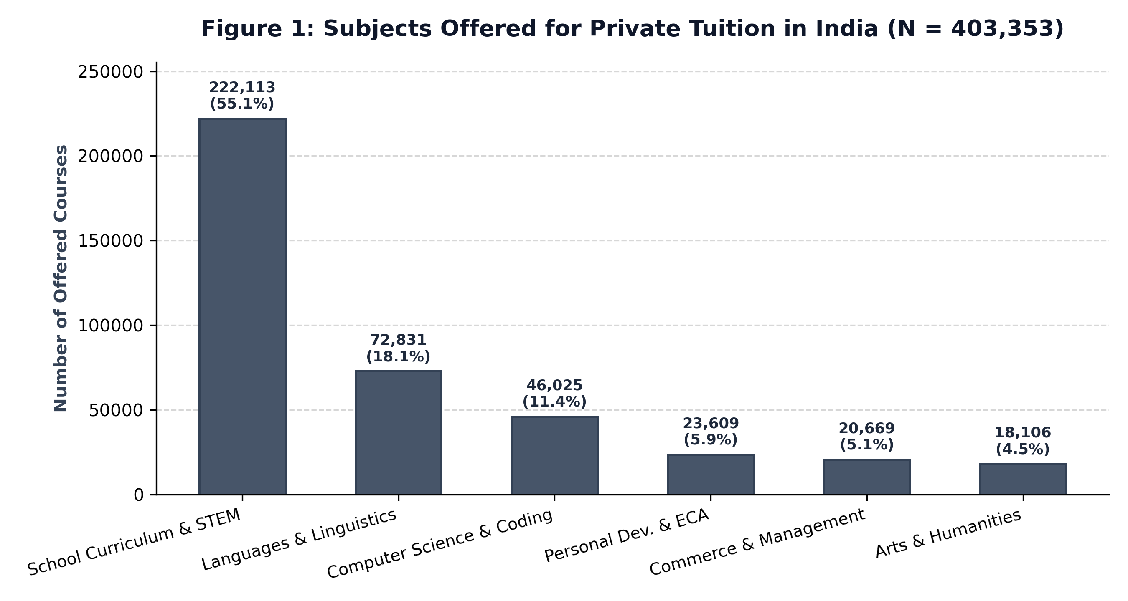
Figure 1: Subjects Offered for Private Tuition in India (Macro Academic Clusters, N = 403,353).
Analytical Commentary: Academic curriculum subjects and STEM represent over 55.1% of all tutoring offerings (222,113 courses), underscoring the strong school curriculum doubt-clearing and board-prep focus of the Indian market. Modern languages follow at 18.1% (72,831 offerings), while professional coding commands 11.4% (46,025 offerings).
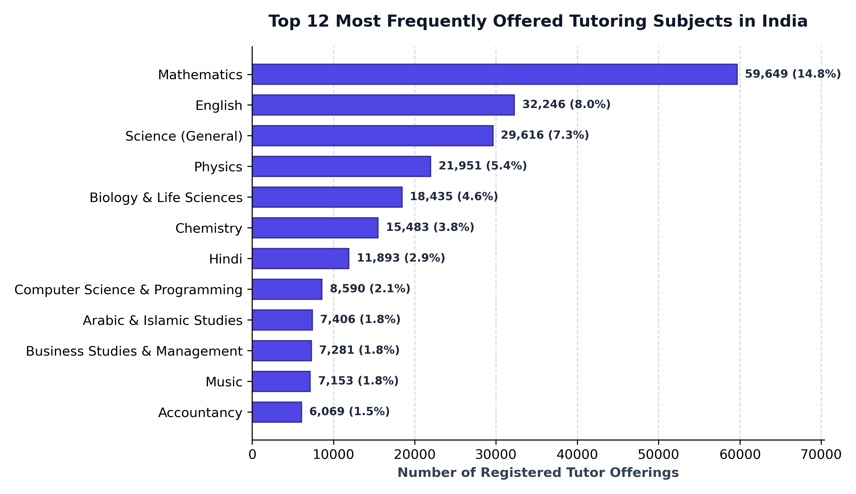
Figure 1B: Top 12 Specific Individual Tutoring Disciplines by Offerings Volume.
Analytical Commentary: Mathematics is the single largest individual subject with 59,649 offerings (14.8% market share), nearly double English (32,246 offerings, 8.0%) and General Science (29,616 offerings, 7.3%). Physics (21,951) and Biology (18,435) also demonstrate substantial dedicated demand.

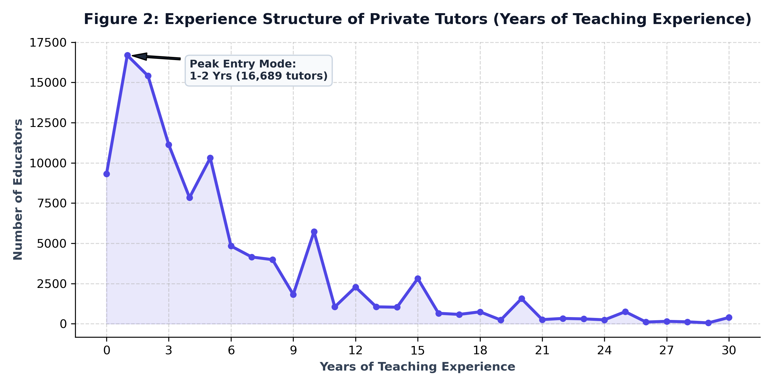
Figure 2: Experience Structure of Private Tutors (Teaching Experience in Years).
Analytical Commentary: The teaching experience distribution shows sharp right-skewness, peaking early at 1–2 years of experience (16,689 tutors at 1 year; 15,411 tutors at 2 years). Median experience is 3.0 years, mean experience is 4.6 years, and 47.3% of tutors possess 3 or fewer years of experience. Local spikes occur at round professional milestones (5, 10, 15, 20, 25 years), reflecting career self-reporting patterns.
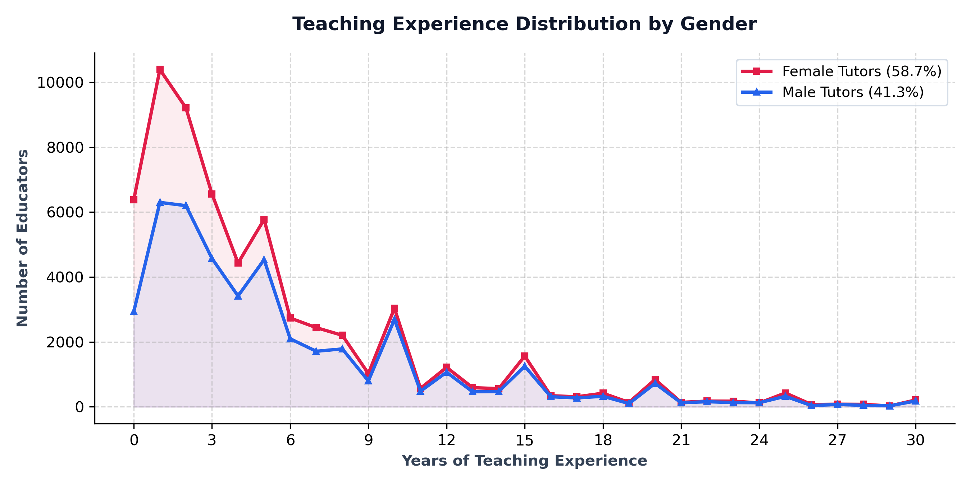
Figure 2B: Experience Distribution Disaggregated by Gender (Women vs Men).
Analytical Commentary: Women maintain higher participation rates across early and mid-career stages (years 0 through 10), while male tutors display slightly higher persistence in late-career brackets (15+ years), consistent with broader workforce gender dynamics.

5. Core Market Structure & Pedagogical Profiles
Comprehensive distribution charts covering educator credentials, pedagogical seniority tiers, competitive examination coaching frequency, and target learning stages across 107,723 tutors.
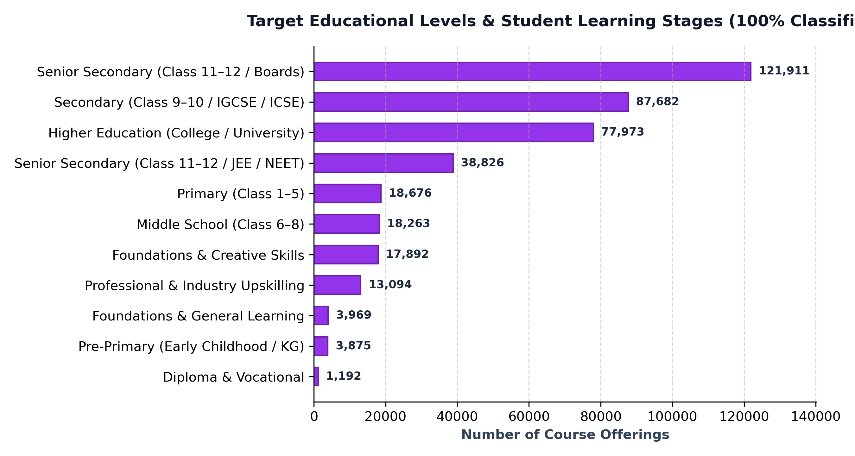
Chart 1: Target Educational Levels (Senior Secondary 11-12 Boards & JEE/NEET form the primary market share).
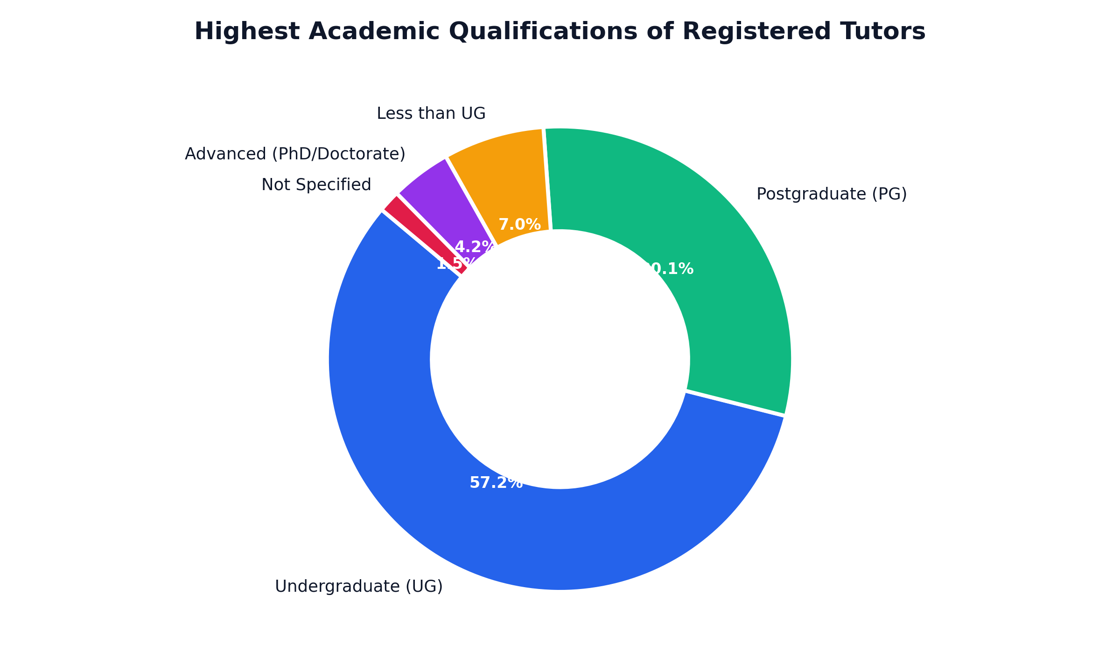
Chart 2: Highest Academic Qualifications (Post-graduates & Master's degree holders represent over 43% of tutors).

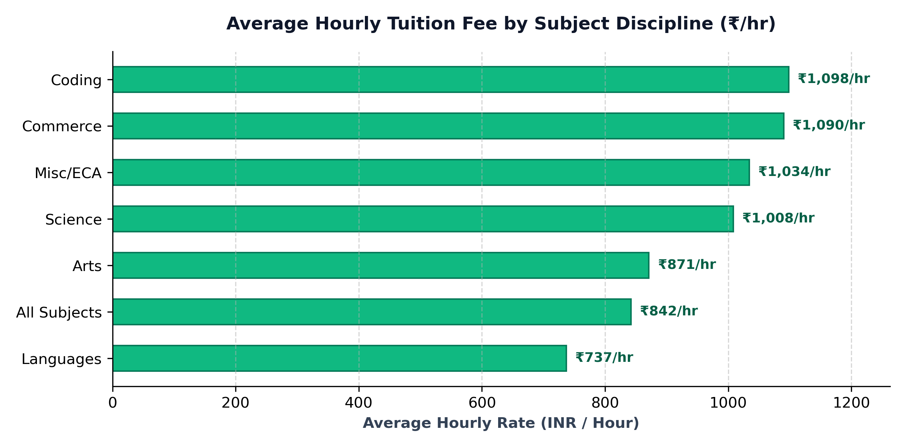
Chart 3: Average Hourly Fee Across Subject Specializations (Coding and STEM command premium pricing).
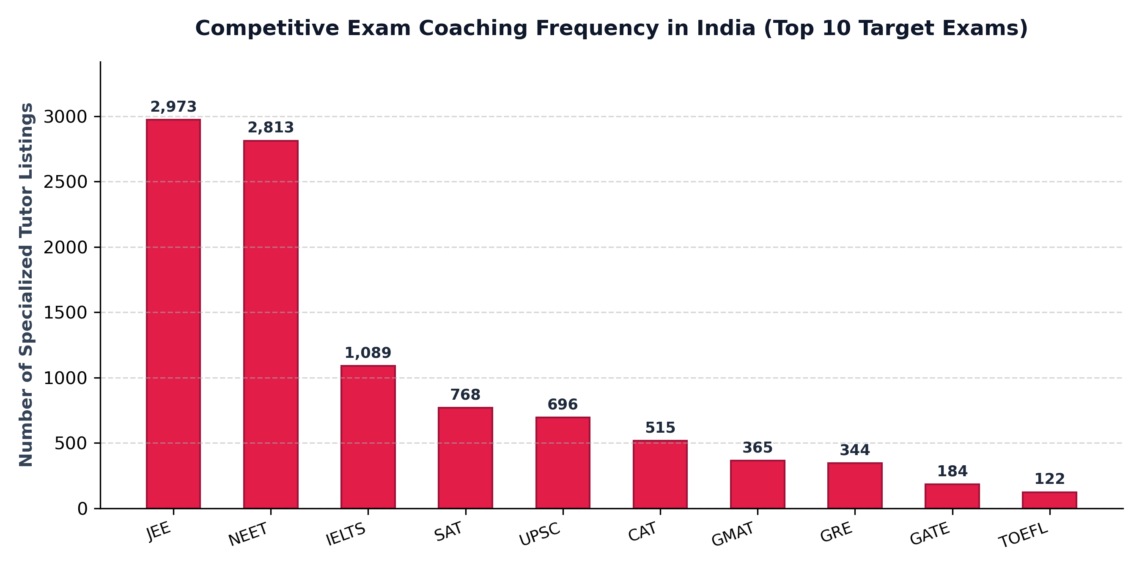
Chart 4: Competitive Exam Coaching Frequency (JEE, NEET, IELTS, and SAT lead test preparation demand).
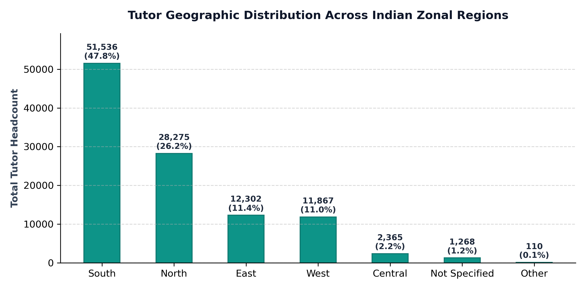
Chart 5: Geographic Supply Disaggregated by Zonal Region (Southern and Northern zones supply over 65% of tutors).

6. Professional Landscape — Non-Teaching & Side Occupations Analysis
A defining structural feature of India's private tutoring market is its function as a vibrant gig-economy and moonlighting platform for highly qualified domain practitioners whose primary career lies outside traditional school education. Across the dataset of 107,723 educators, detailed parsing of biographical narratives, professional hooklines, and credentials identified 36,525 tutors (33.9% of the national supply) who actively practice a non-teaching primary or side profession. This section analyzes the occupational diversity, pricing power differentials, online delivery readiness, and pedagogical specializations across these diverse professional cohorts.
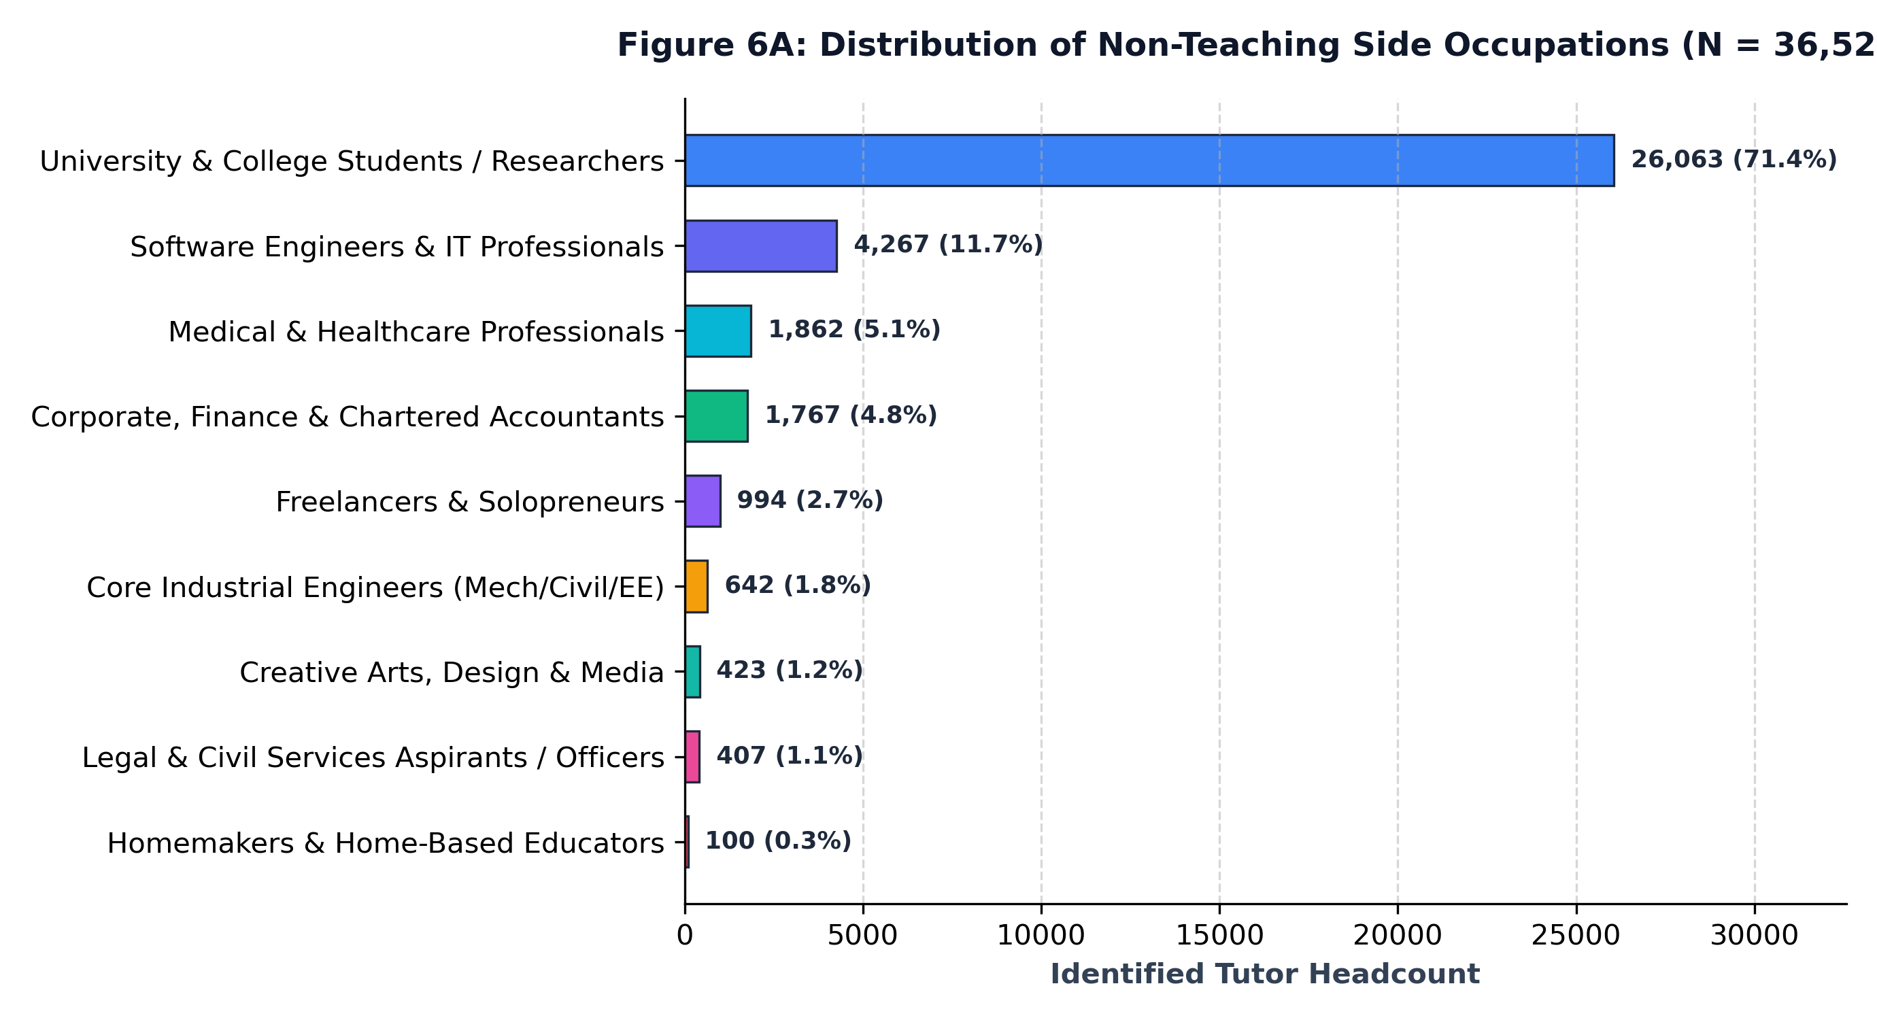
Figure 6A: Professional Landscape — Distribution of Non-Teaching Side Occupations (N = 36,525).
Analytical Commentary: University and college students along with research scholars represent the single largest cohort (26,063 tutors, 71.4% of side practitioners), leveraging peer tutoring for supplementary income while pursuing higher degrees. Software engineers and IT professionals form the second-largest professional group (4,267 tutors, 11.7%), followed by medical and healthcare professionals (1,862 tutors, 5.1%), and corporate finance practitioners including Chartered Accountants (1,767 tutors, 4.8%). Specialized freelance consultants, core industrial engineers, civil service aspirants, and homemakers account for the remainder of this multi-disciplinary teaching supply.
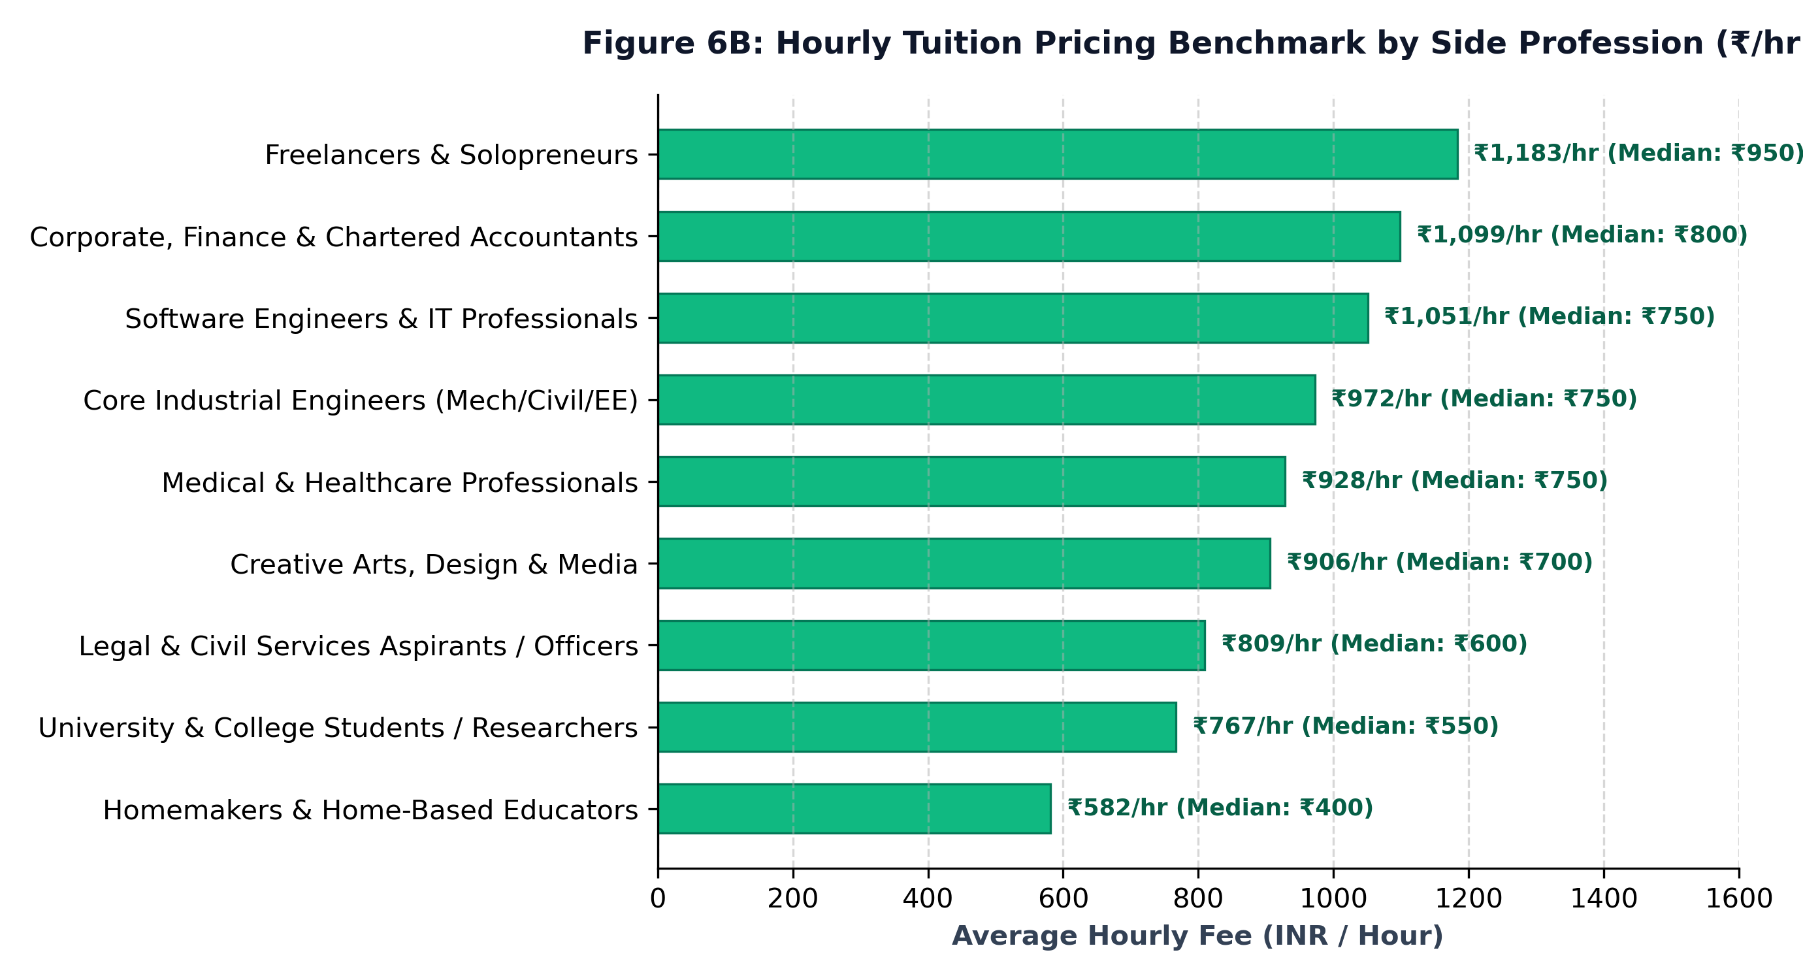
Figure 6B: Hourly Tuition Pricing Benchmark by Side Profession (Mean & Median INR / Hour).
Analytical Commentary: Hourly fees demonstrate sharp occupational stratification. Independent freelancers and startup founders command the highest hourly average rate (₹1,183/hr, median ₹950/hr), closely followed by Corporate, Finance & Chartered Accountants (₹1,099/hr, median ₹800/hr) and Software Engineers & IT Professionals (₹1,051/hr, median ₹750/hr). In contrast, University and college students provide accessible high-volume tuition at an average rate of ₹767/hr (median ₹550/hr), while home-based homemakers average ₹582/hr (median ₹400/hr). This demonstrates that industry practitioners monetizing niche technical expertise command up to an 80% pricing premium over entry-level peer educators.
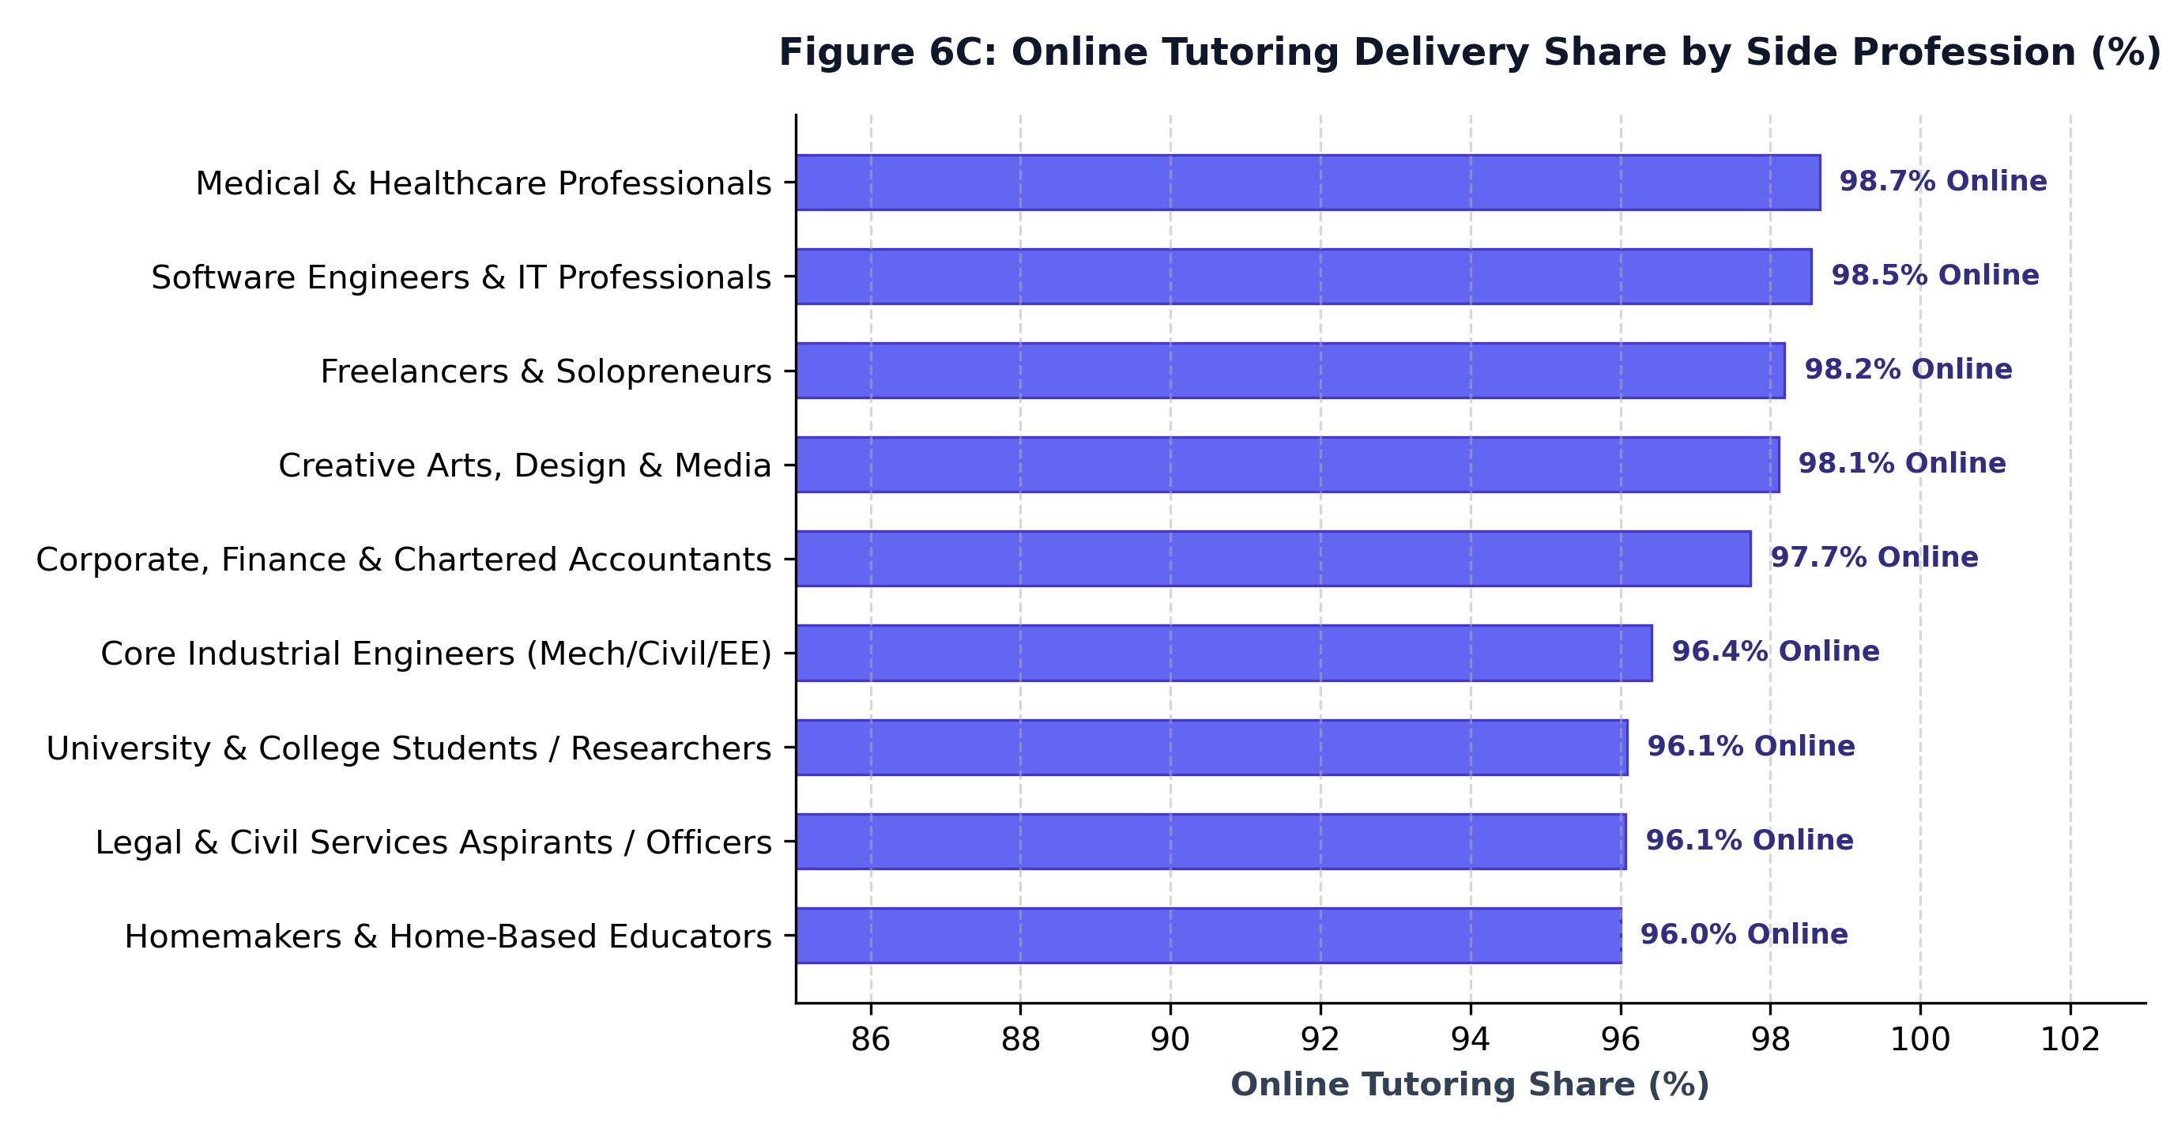
Figure 6C: Online Tutoring Delivery Share Across Non-Teaching Side Professions (%).
Analytical Commentary: Side-profession tutors demonstrate overwhelming digital readiness, with online delivery shares exceeding 96% across all categories. Healthcare professionals (98.7%) and software engineers (98.5%) exhibit the highest online teaching adoption, utilizing virtual classrooms to overcome geographic constraints while balancing their full-time primary careers.

Table 4: Comprehensive Structural Matrix of Non-Teaching & Side Occupations
Granular benchmark detailing headcount distribution, cohort share, hourly fee metrics (mean & median), online adoption, and core curricular specializations for all 9 identified non-teaching occupational groups.
Side Occupation Category | Tutors (N) | Share (%) | Avg Fee | Median Fee | Online (%) | Core Specializations
University & College Students / Researchers | 26,063 | 71.4% | ₹767 | ₹550 | 96.1% | Mathematics, Physics, Computer Science, Engineering Basics
Software Engineers & IT Professionals | 4,267 | 11.7% | ₹1,051 | ₹750 | 98.5% | Python, Java, Web Development, Data Science, C++, DSA
Medical & Healthcare Professionals | 1,862 | 5.1% | ₹928 | ₹750 | 98.7% | Biology, NEET Prep, Anatomy, Physiology, Chemistry
Corporate, Finance & Chartered Accountants | 1,767 | 4.8% | ₹1,099 | ₹800 | 97.7% | Accountancy, Financial Management, Economics, Taxation, Commerce
Freelancers & Solopreneurs | 994 | 2.7% | ₹1,183 | ₹950 | 98.2% | Digital Marketing, Spoken English, Web Design, Business Studies
Core Industrial Engineers (Mech/Civil/EE) | 642 | 1.8% | ₹972 | ₹750 | 96.4% | Engineering Mechanics, AutoCAD, Mathematics, Thermodynamics
Creative Arts, Design & Media | 423 | 1.2% | ₹906 | ₹700 | 98.1% | Graphic Design, Creative Writing, Languages, Art, Animation
Legal & Civil Services Aspirants / Officers | 407 | 1.1% | ₹809 | ₹600 | 96.1% | Political Science, Legal Studies, History, UPSC GS, Constitution
Homemakers & Home-Based Educators | 100 | 0.3% | ₹582 | ₹400 | 96.0% | Primary School All Subjects, Hindi, Phonics, Early Maths
Total Identified Cohort | 36,525 | 100.0% | ₹845 | ₹600 | 96.7% | Cross-Disciplinary Industry & Academic Base
Note: Identified through automated computational extraction from self-reported hooklines, bios, and qualification records. Hourly fees exclude outliers outside ₹50–₹5,000/hr range. Represents 33.9% of total registered tutors (N = 107,723).

7. Methodology, Data Cleaning & Relational Architecture
Relational Bridge Normalization: To resolve multi-subject profile contamination where tutors teach up to 15 subjects across multiple levels, the dataset was normalized into a 3-sheet relational schema: 'Cleaned_Tutors' (107,723 unique tutor master rows), 'Tutor_Subjects_Bridge' (403,353 standardized subject-grade-exam linkages), and 'Data_Dictionary' defining all 37 attributes.
Experience Role & Seniority Tier Imputation: Experience roles (School Educator, Faculty, Online Educator, Student Tutor) were classified by parsing biographical text and professional hooklines, eliminating missing values (0% 'Not Specified'). Seniority tiers (Entry-Level, Mid-Level, Senior Educator, Star Faculty) were inferred from years of experience, degrees, and hourly fee levels.
Price Outlier Bounds: Hourly fees were validated within ₹50 to ₹5,000/hr, excluding corrupted entry fees while preserving genuine premium coaching tiers. All summary tables compute sample-weighted means ($n$) to prevent aggregation bias.
BMP Tutors Research Working Paper • All Visuals & Tables Ready for Publication • Generated September 2026

