LISA transcription-factor analysis
The increasing- and decreasing-over-time RNA-seq gene sets were submitted to LISA to prioritize candidate transcriptional regulators. In the combined LISA ChIP-seq model, the interactive result labels identified YAP1 and TEAD1 among the highlighted transcription-factor candidates. Their plotted signals were stronger along the increasing-gene-set axis than along the decreasing-gene-set axis, supporting YAP/TEAD-associated regulation as a candidate explanation for part of the senescence-related expression trend.
LISA integrates public chromatin profiles with transcription-factor ChIP-seq or motif-derived binding information to rank likely regulators. The displayed YAP1 and TEAD1 labels refer to public reference datasets (NCI-H2052 and SF268, respectively), not direct binding measurements in WI-38 cells. These findings therefore prioritize YAP1/TEAD1 for follow-up but do not demonstrate direct binding or causality in WI-38 fibroblasts (Qin et al., 2020).
Figure 1
LISA comparison of transcription-factor enrichment for increasing and decreasing gene sets
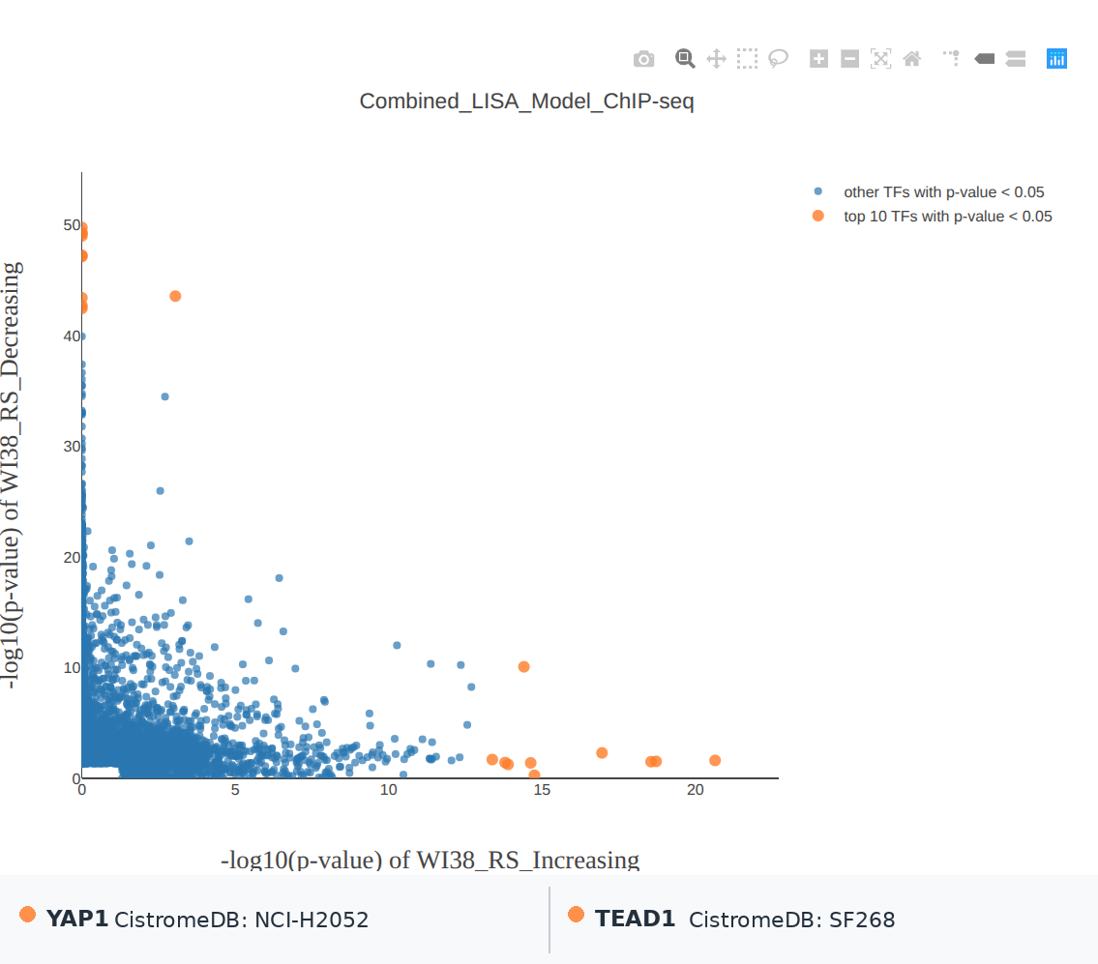
Note. The x-axis shows minus log10(p-value) for the increasing gene set, and the y-axis shows minus log10(p-value) for the decreasing gene set. Orange points mark the top 10 transcription factors with p < 0.05; blue points mark other transcription factors with p < 0.05. The labels below the plot summarize the displayed YAP1 and TEAD1 hover details. LISA results are hypothesis-generating and rely on public reference cistromes.
Reference: Qin, Q., Fan, J., Zheng, R., et al. (2020). Lisa: Inferring transcriptional regulators through integrative modeling of public chromatin accessibility and ChIP-seq data. Genome Biology, 21, 32. https://doi.org/10.1186/s13059-020-1934-6

