Prepared By: Ramya
version 1.0 | 29/11/2025
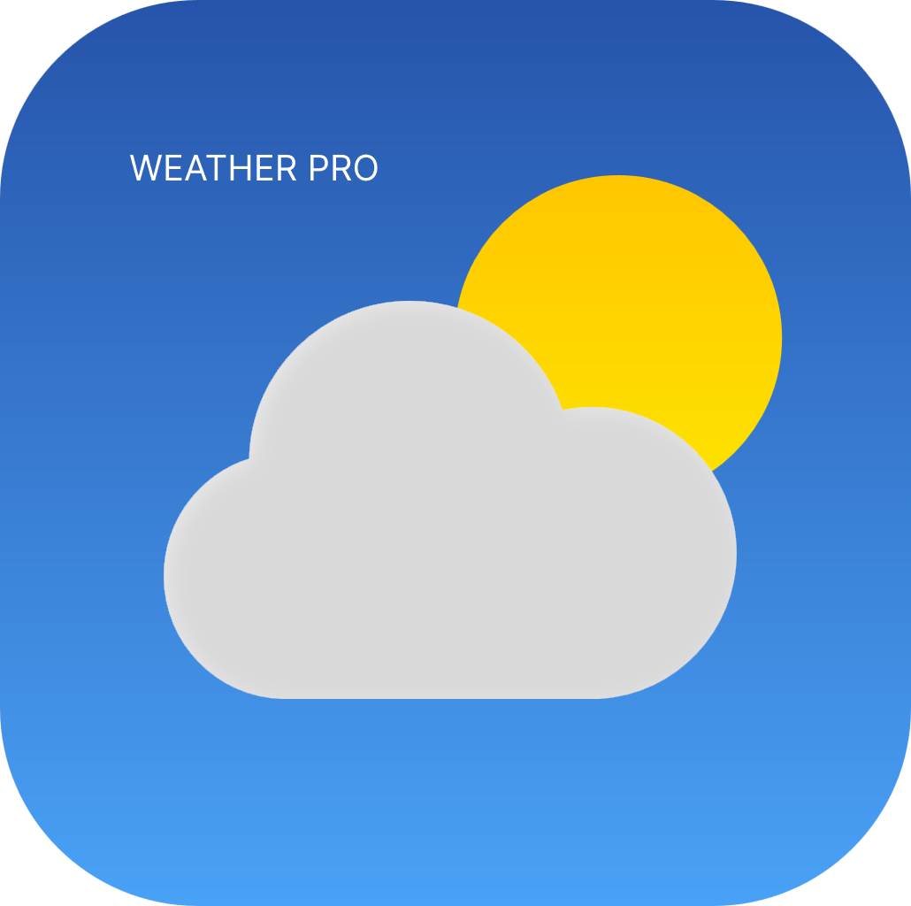 WEATHER PRO
SOFTWARE REQUIREMENTS SPECIFICATION (SRS)
THE REACT WEATHER DASHBOARD

Contents
Software Requirements Specification (SRS) 3.
Project: The React Weather Dashboard – Weather Pro 3.
1. Introduction 3.
1.1 Purpose 3.
1.2 Scope 4.
1.3 Definitions & Acronyms 4.
2. Overall Description 5.
2.1 Product Perspective 5.
2.2 Product Functions 5.
2.3 Constraints 6.
2.4 Dependencies 6.
3. Specific Requirements 6.
3.1 Functional Requirements 6.
3.2 Non-Functional Requirements 7.
3.3 External Interface Requirements 7.
4. Other Requirements 8.
5. Appendices 9.
5.1 Dataflow Diagram 10.

Software Requirements Specification (SRS)

Project: The React Weather Dashboard – Weather Pro

1. Introduction

Purpose:
This SRS defines the requirements for an API-based weather application that provides weather data for user-specified locations. It now includes dark mode support, a custom logo, and API documentation routing for developers.

Scope:
The system allows users to search for cities and view current and forecast weather using a clean UI. It provides location support with latitude and longitude of the specified location.

User Stories:

As a user, I want to see the current temperature, condition (sunny, rain), and humidity for my selected location.

As a user, I want to search for a location by city name so I can view weather anywhere.

As a user, I want to view an hourly forecast for the next 24 hours so I can plan short-term events.

As a user, I want to view a 5-day extended forecast so I can plan for the upcoming week.

As a user, I want to toggle dark mode for better accessibility and comfort.

Definitions & Acronyms:

API – Application Programming Interface

UI – User Interface

2. Overall Description

Product Perspective:
A single-page web application built with React and TailwindCSS. It fetches and displays weather data dynamically using the OpenWeatherMap REST API.

Product Functions:

Search for locations and retrieve weather data.

Display current weather, hourly forecast, and 5-day forecast.

Show interactive maps with Leaflet.

Provide dark mode toggle in the header.

Display branding/logo in the header.

Offer quick navigation links in the footer.

Constraints:

Requires third-party weather API availability.

Browser compatibility (Chrome, Firefox, Edge).

Dependencies:

OpenWeatherMap API uptime.

3. Specific Requirements

3.1 Functional Requirements

FR1: The system shall allow the user to enter a location in the SearchBox.

FR2: The system shall fetch current weather data from the OpenWeatherMap API.

FR3: The system shall display the current temperature and atmospheric conditions.

FR4: The system shall display a weather icon for the condition.

FR5: The system shall display an hourly forecast and 5-day forecast.

FR6: The system shall handle invalid city errors gracefully.

FR7: The system shall show a loading spinner while fetching data.

FR8: The system shall allow users to view selected locations on a map.

FR9: The system shall provide a dark mode toggle in the header.

FR10: The system shall display a logo in the header.

FR11: The system shall provide active quick links in the footer for navigation.

FR12: The system shall render API documentation at /api-docs.

3.2 Non-Functional Requirements

Performance: App must respond within 2 seconds to user input.

Usability: New users should access info without prior training.

Reliability: App available 99% of the time.

Security: Uses HTTPS for all data transfer.

Compatibility: Works on Chrome, Firefox, Edge.

Accessibility: Supports dark mode and WCAG compliance.

3.3 External Interface Requirements

User Interface:

App.jsx – main entry point.

Header.jsx – logo, navigation, dark mode toggle.

Footer.jsx – branding, quick links, contact options.

Dashboard.jsx – weather cards, forecasts, maps.

SearchBox.jsx – input field for city search.

WeatherCard.jsx – current weather details.

ForecastList.jsx – 5-day forecast.

HourlyForecast.jsx – hourly forecast.

MapView.jsx – interactive maps.

openapi.yaml – API documentation schema.

Software Interface:

Integrates with OpenWeatherMap API.

4. Other Requirements

Accessibility standards: WCAG compliance.

Maintainability: Well-documented, modular React components.

Scalability: Easy to extend with new features (alerts, favorites).

5. Appendices
Appendix A: Glossary
- API – Application Programming Interface, used to fetch weather data from OpenWeatherMap.
- Leaflet – A JavaScript library for interactive maps.
- Tailwind CSS – A utility‑first CSS framework for styling.
- Vercel – A cloud platform for deploying frontend applications.
Appendix B: References
- OpenWeatherMap API Documentation
- Tailwind CSS Documentation
- Vercel Deployment Guide
Appendix C: Deployment Setup
- Environment Variables
  - VITE_WEATHER_API_KEY → OpenWeatherMap API key
Appendix D: Troubleshooting Notes
- React Hook Import Error → Fixed by reinstalling dependencies and locking React to 18.2.0.
- Leaflet Version Conflict → Resolved by locking Leaflet to 1.9.4.
- Swagger UI Removal → Replaced with a placeholder docs page for clean deployment.

Appendix E: Future Enhancements
- Analytics → Track user searches, performance metrics, and visitor traffic.
- Map Overlays → Add temperature zones, AQI data, and radar imagery on Leaflet maps.

Dataflow Diagram

[User] | v [SearchBox.jsx] ---> [api.js] <-----> [External Weather API] | | v v [WeatherCard.jsx] [ForecastList.jsx] | | ------------------------------- | [Dashboard.jsx/UI] | [Header.jsx + Footer.jsx] | [App.jsx + Router] |

