ShieldV: Hardware Control-Flow Protection for In-Order and Out-of-Order RV32IM Processors on FPGA
Project Abstract · CS2202L Hardware Lab, IIT Guwahati
Group number: 8 · Team : Nilesh Das (Team Leader) - 250101066, Nishant - 250101067, Avani Sharma - 250101023, Priyank Patel Nileshkumar - 250101072, Laxmidhar Mohapatra - 250101056
Platform: Digilent Nexys A7-100T (Xilinx Artix-7 XC7A100T), Vivado, RISC-V GCC (-march=rv32im -mabi=ilp32)

1. System Description
ShieldV is an RV32IM system on the Nexys A7 with two interchangeable cores: a 3-stage in-order pipeline (the committed baseline) and an out-of-order Tomasulo core (the extension), both protected by a hardware shadow stack. Every call saves its return address in an isolated on-chip memory that no load or store can reach; every return is checked against it, and a mismatch traps before any attacker-chosen instruction runs. Boot code then locks the protection settings, so a later memory write cannot switch them off.

2. Use Cases
- Bare-metal embedded firmware: controllers in medical devices, vehicles and IoT nodes run C with no OS protection, so one stack overflow can redirect execution. ShieldV blocks that attack class in hardware.
- Workloads: recursive Fibonacci, factorial, quicksort, binary-tree traversal, matrix multiply (MUL) and primes/GCD (DIV, REM), plus controlled overwrite tests and false-alarm checks such as deep recursion.
- Comparing defences on one core: hardware shadow stack versus compiler stack canaries, and the check placed in an in-order versus an out-of-order core, with cost measured in cycles, clock speed and LUTs. Hardware shadow stacks are established (HCFI 2016, Intel CET 2020, RetTag 2022, CVA6-CFI 2026); ShieldV studies them on a teaching-scale core.

3. FPGA Relevance
- Isolation is physical: the shadow stack is a separate LUTRAM with no path from the data bus. Only real hardware, not a software model, can demonstrate that an attacker's store cannot reach it.
- Cost is measured, not estimated: cycle counters give the CPI of both cores, and Vivado reports give the clock-speed and LUT cost of ShieldV itself, built with and without it.
- The attack is visible live: switch-controlled protection, LEDs, 8-digit display, UART reports and Vivado ILA captures of the exact cycle an attack is caught.

4. System Scope
Minimum system (commitment, working end to end by 1 Nov)
- RV32IM 3-stage in-order pipeline on the Nexys A7: all RV32I instructions plus MUL, MULH, MULHSU, MULHU, DIV, DIVU, REM, REMU, with forwarding, stalls and flushes.
- At least 5 C programs compiled with -march=rv32im run correctly on the FPGA, with results on UART and the 7-segment display.
- A 32-entry hardware shadow stack detects an overwritten return address and traps to a handler that reports the faulting PC, expected and actual address over UART and on the display; a switch turns protection on and off.
- Lock bit: once boot code enables protection and sets the lock, the control and handler-address registers ignore all writes until reset.
- ShieldV's own cost reported: clock speed and LUTs with and without ShieldV, from Vivado.
Goal system
- Out-of-order core: Tomasulo scheduling with register renaming, a 16-entry reorder buffer, reservation stations, a load/store queue and a common data bus; tournament branch predictor, BTB and return-address stack; ShieldV checks returns at commit. The in-order core remains the fallback build.
- Landing-pad check for indirect jumps (forward-edge protection, inspired by Zicfilp).
- Evaluation: stack canaries (-fstack-protector) versus ShieldV; CPI of both cores; branch-prediction accuracy; performance counters for cycles, instructions, branches, calls, returns and violations.
- Verification: three ShieldV safety properties proven with SymbiYosys; random programs compared instruction by instruction with a golden model.
Stretch goal
- Two-wide dispatch; decoding the ratified Zicfiss instructions (sspush, sspopchk, ssrdp) with the shadow stack spilled to protected memory; machine/user privilege modes.

5. Design Goals
Goal | Target | Measured by
Correctness | 100% of riscv-tests rv32ui and rv32um on both cores; workloads match the Spike reference simulator | Regression suite, random differential tests
Detection | Mismatch trapped before the redirect; 0 attacker instructions executed | Simulation trace, ILA capture
Lock integrity | 0 changes to the control or handler registers after the lock is set | Directed write tests, formal proof
Protection overhead | 0 extra cycles per call or return; clock and LUT cost reported | Cycle counters; Vivado reports with vs without ShieldV
MUL / DIV latency | ≤ 2 cycles / ≤ 34 cycles | Testbench cycle counts
Clock | ≥ 50 MHz in-order (target 100 MHz); out-of-order reported as measured | Vivado timing report
Out-of-order speed | CPI per workload against the in-order core; target ≥ 1.0× geometric mean | Performance counters on both cores
Branch prediction | ≥ 85% of branches and jumps predicted correctly | Branch and misprediction counters
Resources | ShieldV ≤ 500 LUTs, 0 BRAM; full SoC ≤ 25% of LUTs (≤ 15,850 of 63,400) | Vivado utilization report
Security correctness | 0 false alarms; 100% of injected return mismatches caught; canary comparison reported | Test matrix, fault injection
Clock and resource figures are estimates until confirmed in Vivado; the out-of-order core's clock speed is the main open risk.

6. Implementation Approach
- New modules: RV32M unit (DSP multiplier, 32-step divider, start/busy/done handshake); ShieldV unit (call/return detector, 32-entry LUTRAM shadow stack, comparator, violation FSM, lock bit, fault registers, landing-pad check); out-of-order engine (rename table, reorder buffer, reservation stations, load/store queue, common data bus, tournament predictor, BTB, return-address stack); memory-mapped SoC (UART, 7-segment driver, LEDs, switches, performance counters).
- Datapath and control: the in-order core sends each committed jal/jalr to ShieldV from EX, and the out-of-order core from the reorder-buffer head, through the same interface; ShieldV's trap blocks the PC redirect; the control registers become read-only after the lock; a build option selects which core the SoC uses.
- Verification: self-checking module testbenches with golden I/O; riscv-tests on both cores; random programs compared with a golden model; SymbiYosys proofs of three ShieldV properties; 5+ C programs plus attack and false-alarm tests; FPGA validation with the Vivado ILA.
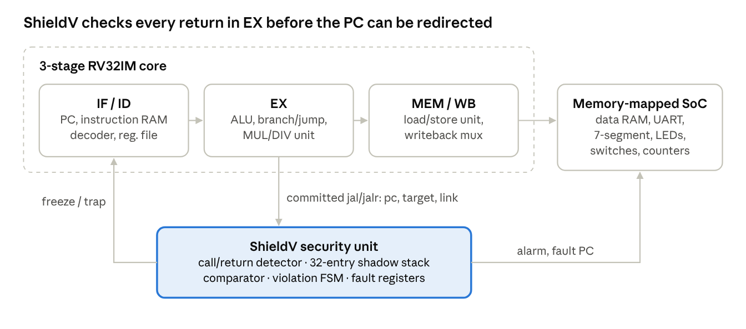
Figure 1 · ShieldV top-level architecture (in-order core shown; the out-of-order core connects to ShieldV at commit)
EX sends every committed call and return to ShieldV, which can freeze the pipeline before the program counter is redirected to an attacker's address.

7. Demonstration Plan
- Input: C programs with a hidden stack-buffer overflow, plus the normal workloads; switch SW0 turns protection on or off; either the in-order or the out-of-order bitstream is loaded.
- Processing: the core runs the program while ShieldV records every committed call and checks every committed return.
- Output: protection off: the hijacked function runs and the LEDs show HACKED. Protection on: a trap before the first attacker instruction, a red alarm LED, the faulting PC on the display and a UART report; a write to the locked control register is ignored. Workloads print results, cycle counts and branch statistics over UART.

8. High-Level Timeline
The in-order system with ShieldV works on the FPGA by 1 Nov; the out-of-order core and the evaluation follow, with the in-order build as the fallback.
Week | Milestone | Deliverable
5–11 Oct | M1: ALU, register file, decoder, immediate generator and memories; a single-cycle RV32I core runs assembly in simulation. MUL and DIV units pass 10,000 random and all edge-case tests. Call/return detector and shadow-stack RAM verified. Attack program confirmed on Spike. | Code + testbenches
12–18 Oct | M2: 3-stage pipeline passes riscv-tests rv32ui in simulation. UART, 7-segment, LED and switch I/O working on the FPGA. ShieldV commit control, violation FSM and lock bit verified. Branch predictor and rename table verified as blocks. | Code + testbenches; FPGA I/O demo
19–25 Oct | M3 (22 Oct): in-order core + SoC on the FPGA; C programs print results over UART. M4 (25 Oct): RV32M integrated, rv32um passes; reorder buffer, reservation stations and load/store queue verified as blocks. | FPGA demo
26 Oct–1 Nov | M5: ShieldV with lock bit and trap handler on the in-order core on the FPGA; all workloads with zero false alarms; the attack is blocked or allowed by the switch. Minimum system complete. Out-of-order core passes riscv-tests in simulation. | FPGA demo
2–6 Nov | M6: out-of-order core through Vivado and on the board if timing is met; landing pads; canary comparison, CPI, prediction and cost measurements; formal proofs; timing diagrams; final report and video. | FPGA demo + report

9. Team Work Plan
Five members work in three groups (2 + 2 + 1). Every member owns at least one hardware module and its testbenches, as the grading scheme requires.
Group | Member | Hardware module owned | Also responsible for
G1 · Core | Avani Sharma | Datapath (ALU, register file, decoder, immediate generator, branch unit, memories) and branch predictor (BHT, gshare, BTB, return-address stack) | riscv-tests regression, prediction-accuracy study
G1 · Core | Laxmidhar Mohapatra | Pipeline control (pipeline registers, forwarding, hazards, flush, load/store unit) and the out-of-order engine (rename table, reorder buffer, reservation stations, load/store queue, common data bus, commit) | Random differential testing, timing diagrams
G2 · RV32M + SoC | Nishant | RV32M unit: multiplier, divider, start/busy/done handshake | MUL/DIV edge-case suite, canary vs ShieldV comparison
G2 · RV32M + SoC | Nilesh Das | SoC and FPGA: bus decoder, UART, 7-segment driver, switches, performance counters, pin constraints | Vivado builds, ILA, clock and LUT cost measurement, demo video
G3 · ShieldV | Priyank Patel | ShieldV unit: call/return detector, shadow stack, comparator, violation FSM, lock bit, trap handler, landing-pad check | Formal proofs, C runtime, workloads, attack and false-alarm tests
Collaboration: module interfaces (ports and memory map) are frozen in docs/interfaces.md before any RTL is written. Each member develops their blocks on their own branch, commits from their own GitHub account, and has another member review before merge. CI runs lint and all testbenches on every push. Groups integrate every Sunday; the team leader coordinates integration and the weekly reports. AI-assisted files are recorded in docs/PROVENANCE.md for the code-provenance section.

10. GitHub Link
Repository: github.com/nileshdas092006-hash/hardware_lab_shieldv. Course TAs will be added as collaborators.

