Project

Topic: Start & stop AWS EC2 automatically using Lambda & EventBridge.

Project Description:

In this project, we are going to automate starting and stopping EC2 via Lambda & EventBridge at regular intervals (e.g.running EC2 from 8:00 am to 8:00 pm). While the EC2 is stopped, we can save the compute cost during this time.

In order to let Lambda be able to start and stop the EC2 instance, we first need to assign the required IAM permission for lambda in Step1.

Once it is done, we can create two lambda functions, which the first one is for starting the EC2 and the second one is for stopping the EC2. After that, we can create the EventBridge Schedule to trigger the lambda function at the desired times.

Step Summary:

Step 1: Create IAM role for Lambda

Step 2: Create 2 Lambda function for starting and stopping EC2

Step 3: Create 2 EventBridge Schedule to invoke 2 Lambda functions

**Step 1: Create IAM Role for Lambda**

1. **Navigate to IAM**:
   * Go to the AWS Management Console.
   * Select "IAM" from the services menu.
2. **Create a Role**:
   * Click on "Roles" in the left sidebar.

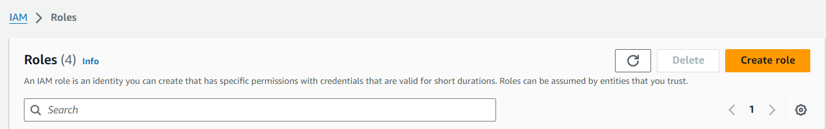

* + Press the "Create role" button.

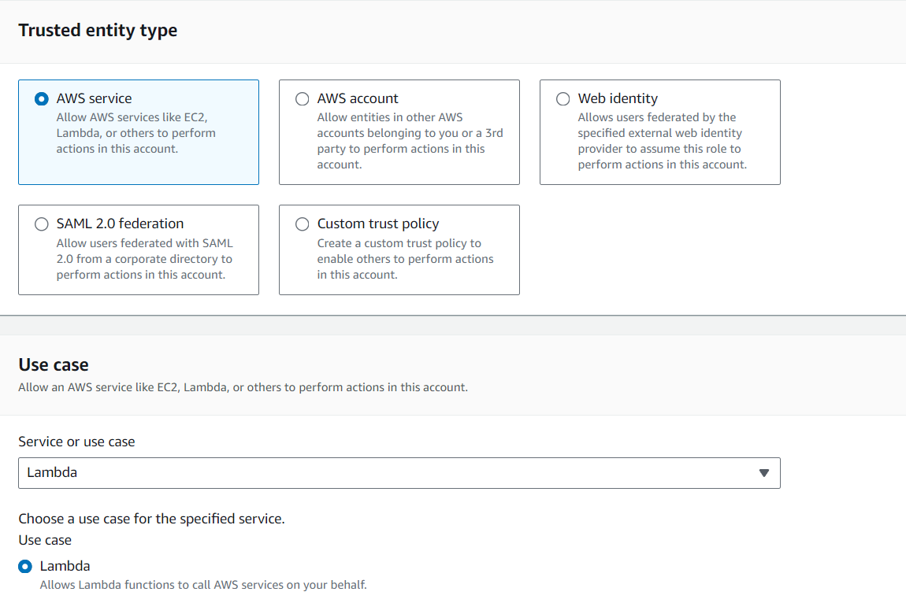

* + Select "AWS service" as the type of trusted entity.
  + Choose "Lambda" and press "Next".
  + Press "Next: Tags" (optional).
  + Press "Next: Review".

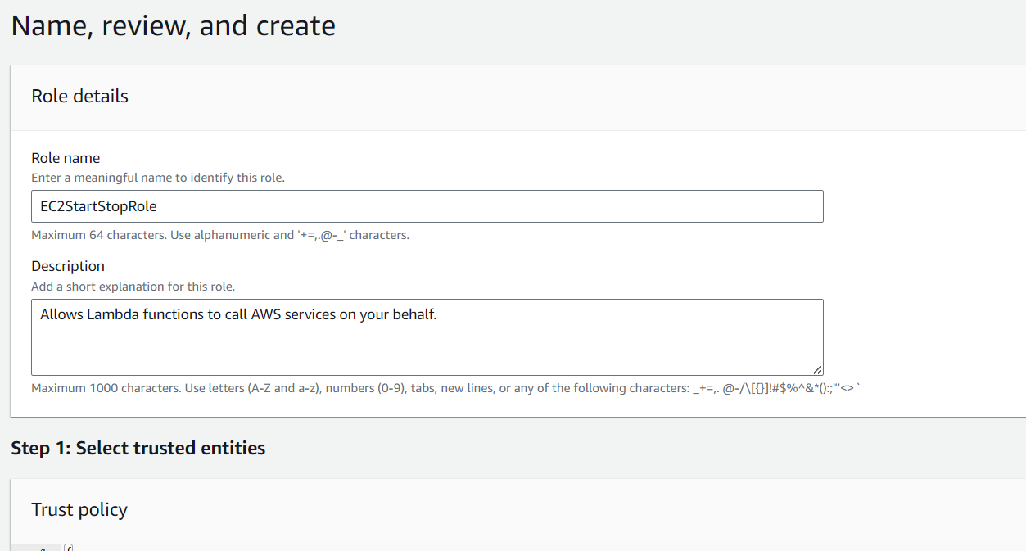

* + Name the role (e.g., "EC2StartStopRole") and press "Create role".

1. **Under Policies, Create a Policy**:

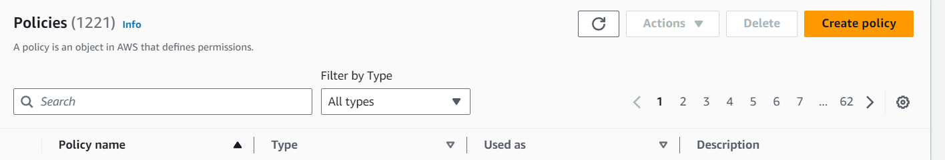

* + Click "Create policy".
  + Go to the "JSON" tab.

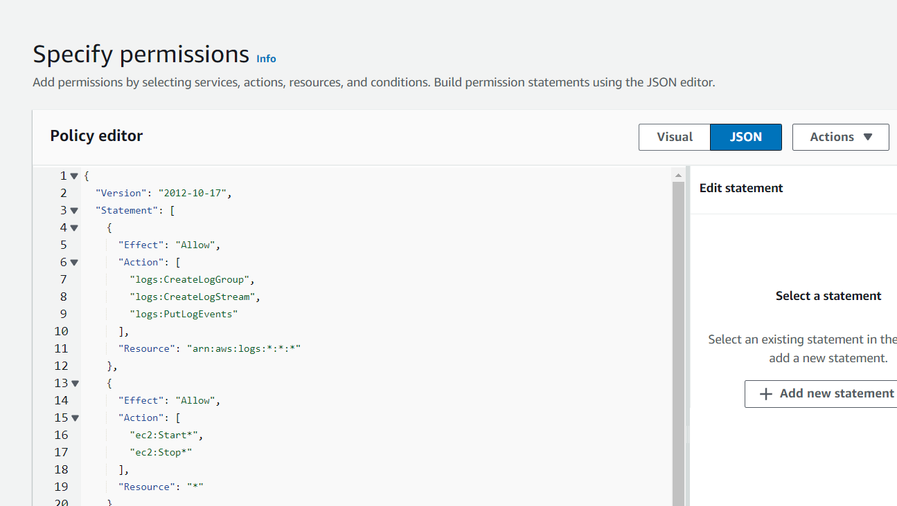

* + Copy and paste the following JSON policy:

json

Copy code

{

"Version": "2012-10-17",

"Statement": [

{

"Effect": "Allow",

"Action": [

"logs:CreateLogGroup",

"logs:CreateLogStream",

"logs:PutLogEvents"

],

"Resource": "arn:aws:logs:*:*:*"

},

{

"Effect": "Allow",

"Action": [

"ec2:Start*",

"ec2:Stop*"

],

"Resource": "*"

},

{

"Effect": "Allow",

"Action": [

"ses:SendEmail",

"ses:SendRawEmail"

],

"Resource": "*"

}

]

}

1. **Create the Policy**:
   * Click "Review policy".

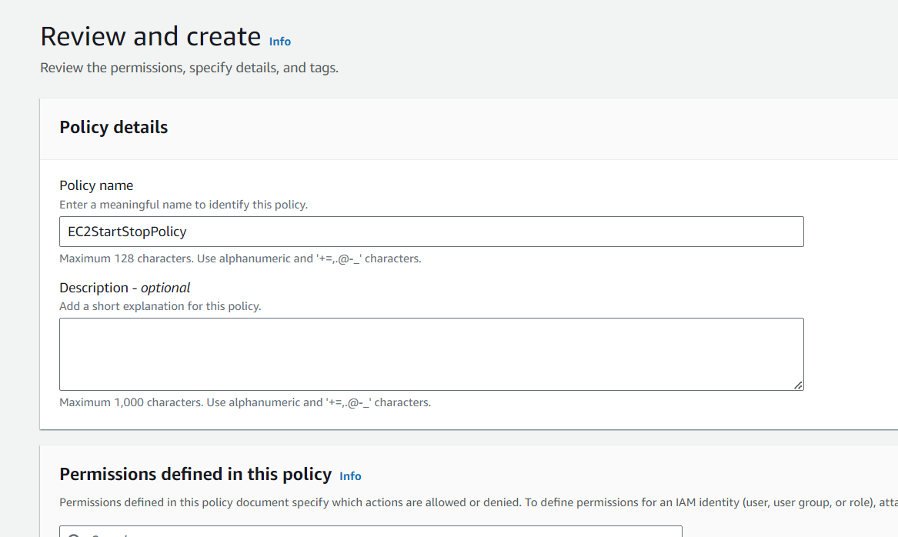

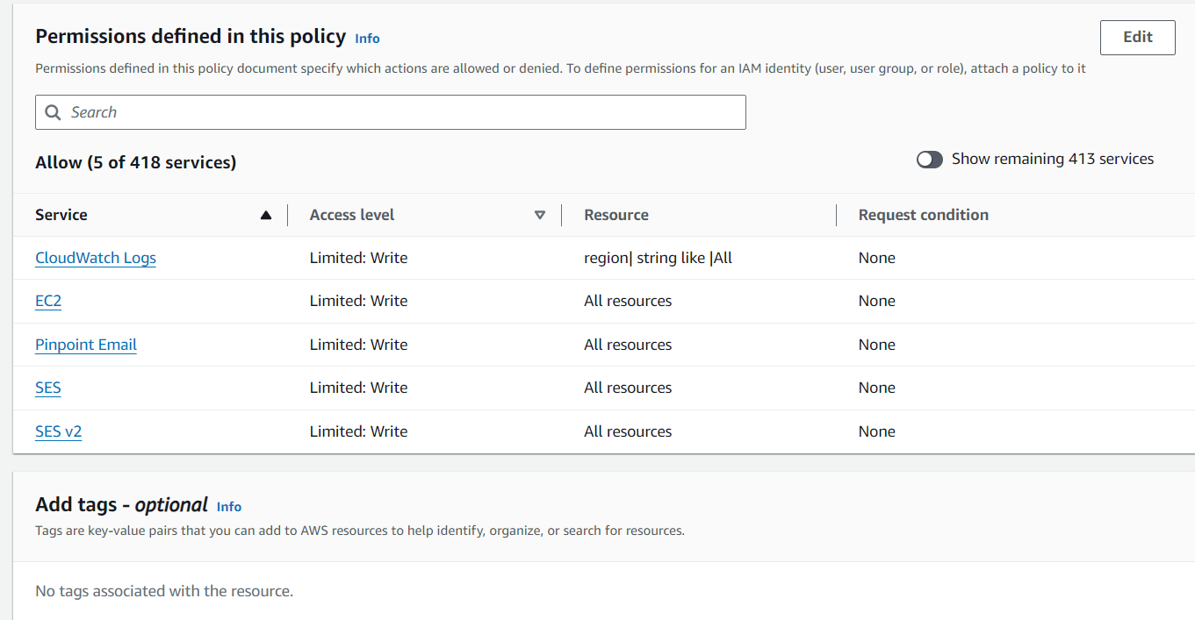

* + Name the policy (e.g., "EC2StartStopPolicy") and press "Create policy".

1. **Attach the Policy to the Role**:

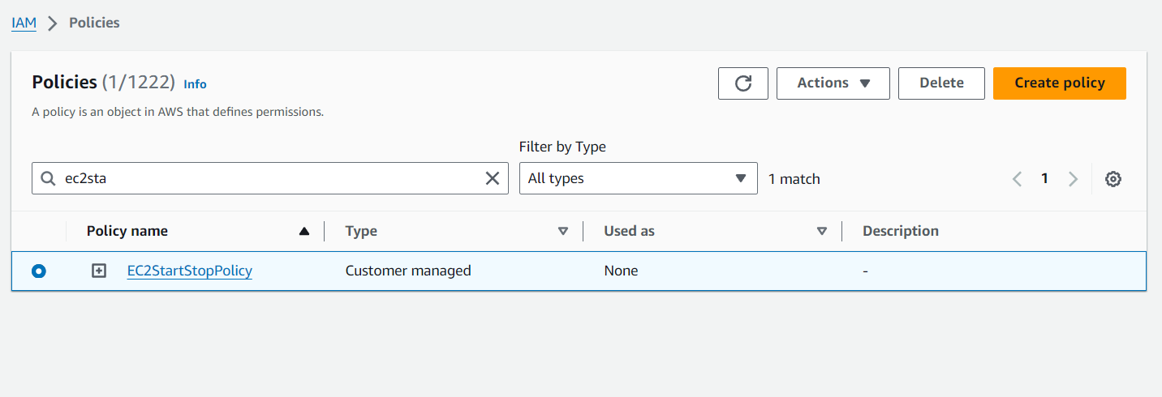

* + Select the newly created policy.
  + Press "Actions” .
  + Press "Attach".

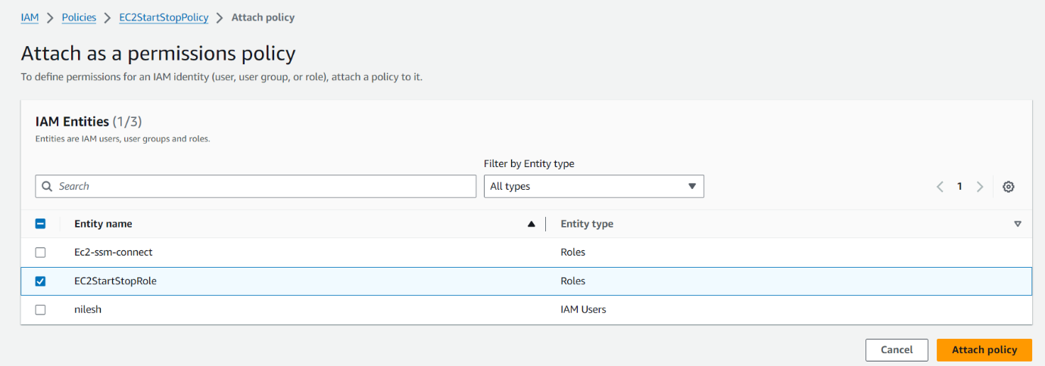

* + select the role "EC2StartStopRole" and press "Attach Policy".

**Step 2: Create Lambda Functions for Starting and Stopping EC2**

1. **Navigate to Lambda**:
   * Go to the AWS Management Console.

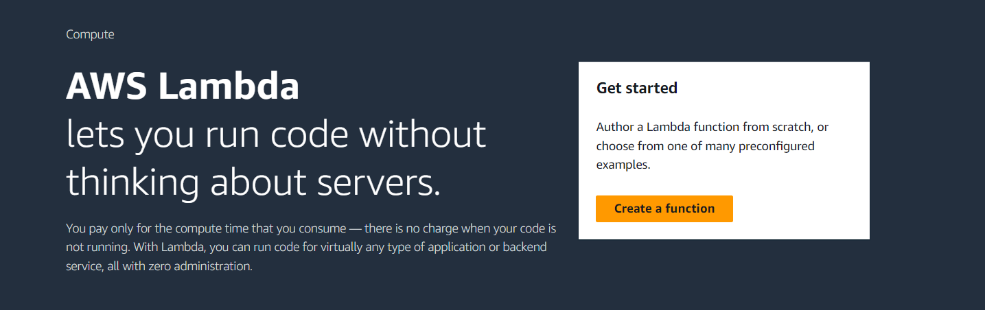

* + Select "Lambda" from the services menu.

1. **Create Lambda Function for Starting EC2**:
   * Press "Create function".

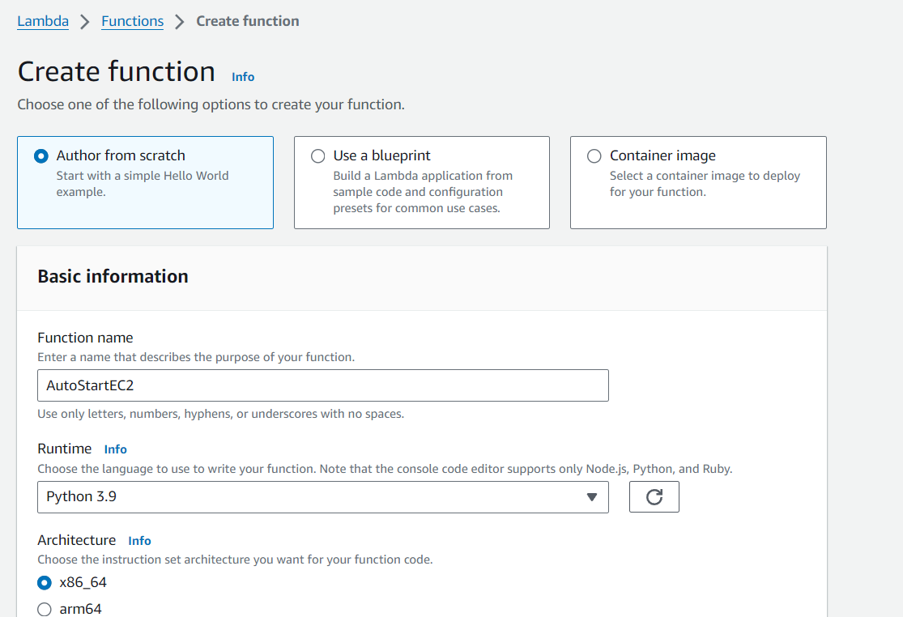

* + Select "Author from scratch".
  + Name the function (e.g., "AutoStartE.C2").
  + Select "Python 3.9" as the runtime.

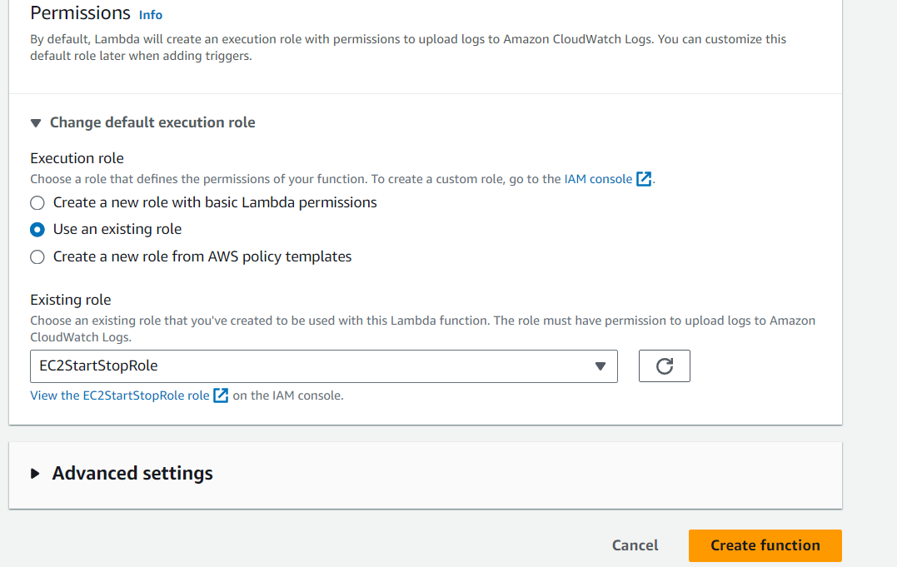

* + Choose the IAM role created in Step 1 (e.g., "EC2StartStopRole").
  + Press "Create function".

1. **Add the Code for Starting EC2**:
   * In the "Code source" editor, replace the default code with the following:

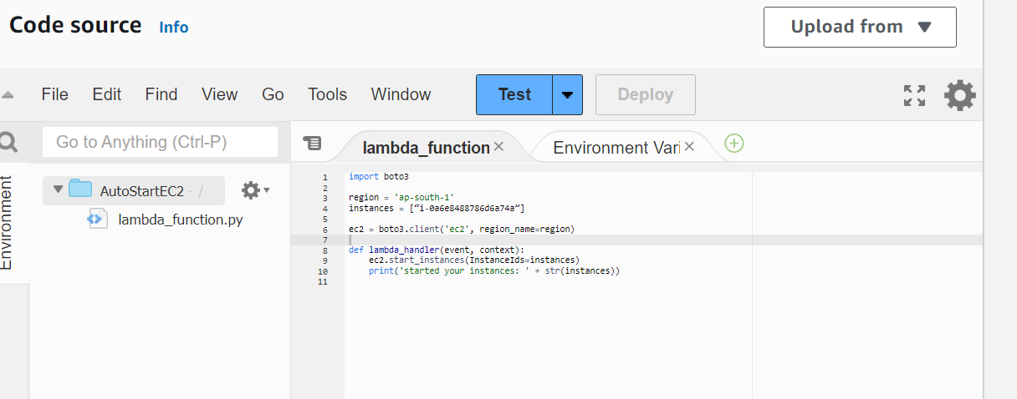

python

Copy code

import boto3

region = 'ap-south-1'

instances = [“i-0a6e8488786d6a74a”]

ec2 = boto3.client('ec2', region_name=region)

def lambda_handler(event, context):

ec2.start_instances(InstanceIds=instances)

print('started your instances: ' + str(instances))

* + Replace 'ap-south-1' with your designated region.
  + Replace [“i-0a6e8488786d6a74a”] with your EC2 instance IDs.
  + Press "Deploy".

1. **Create Lambda Function for Stopping EC2**:

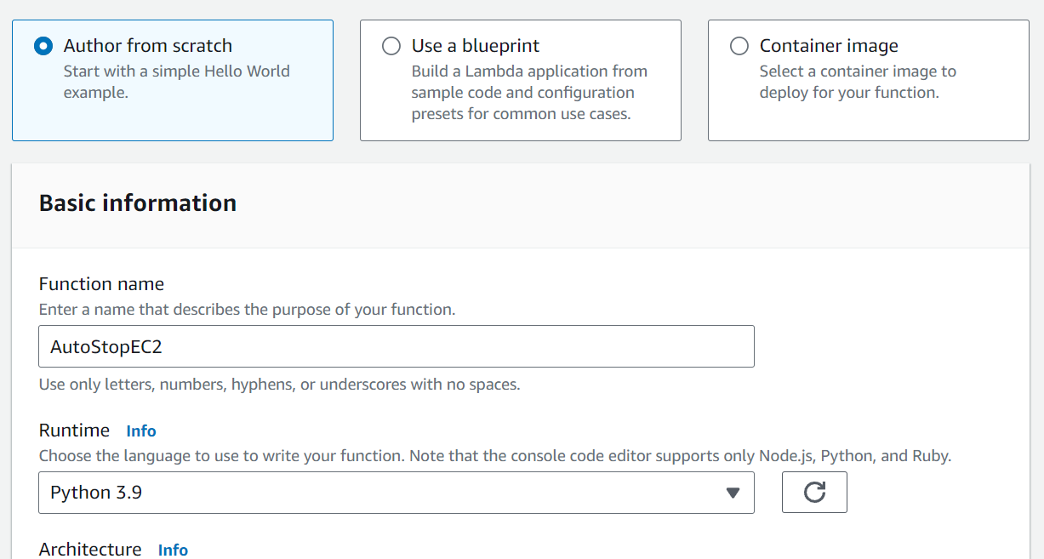

* + Repeat the steps to create another function (e.g., "AutoStopEC2").

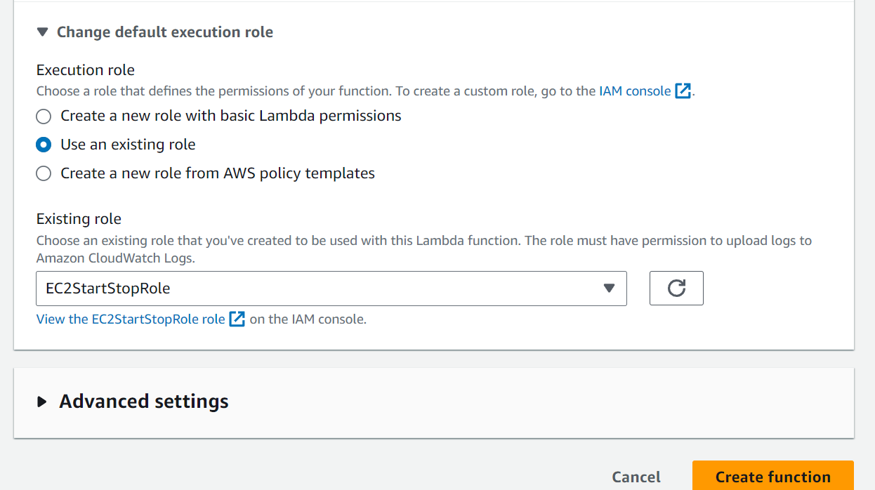

* + Use the following code:

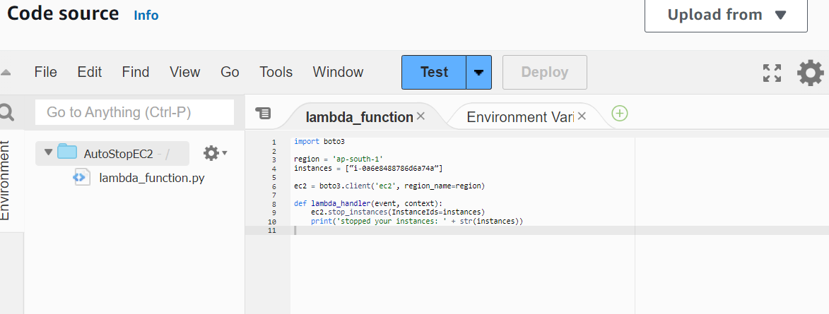

python

Copy code

import boto3

region = 'ap-south-1'

instances = [“i-0a6e8488786d6a74a”]

ec2 = boto3.client('ec2', region_name=region)

def lambda_handler(event, context):

ec2.stop_instances(InstanceIds=instances)

print('stopped your instances: ' + str(instances))

* + Replace 'ap-south-1' and the instance IDs as needed.
  + Press "Deploy".

**Step 3: Create EventBridge Schedules to Invoke Lambda Functions**

1. **Navigate to EventBridge**:
   * Go to the AWS Management Console.

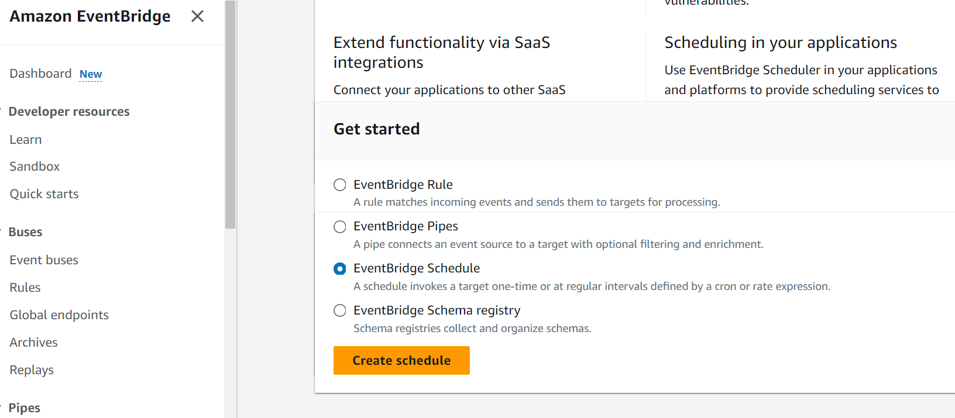

* + Select "EventBridge" from the services menu.

1. **Create a Schedule to Start EC2**:
   * Select "EventBridge Schedule".

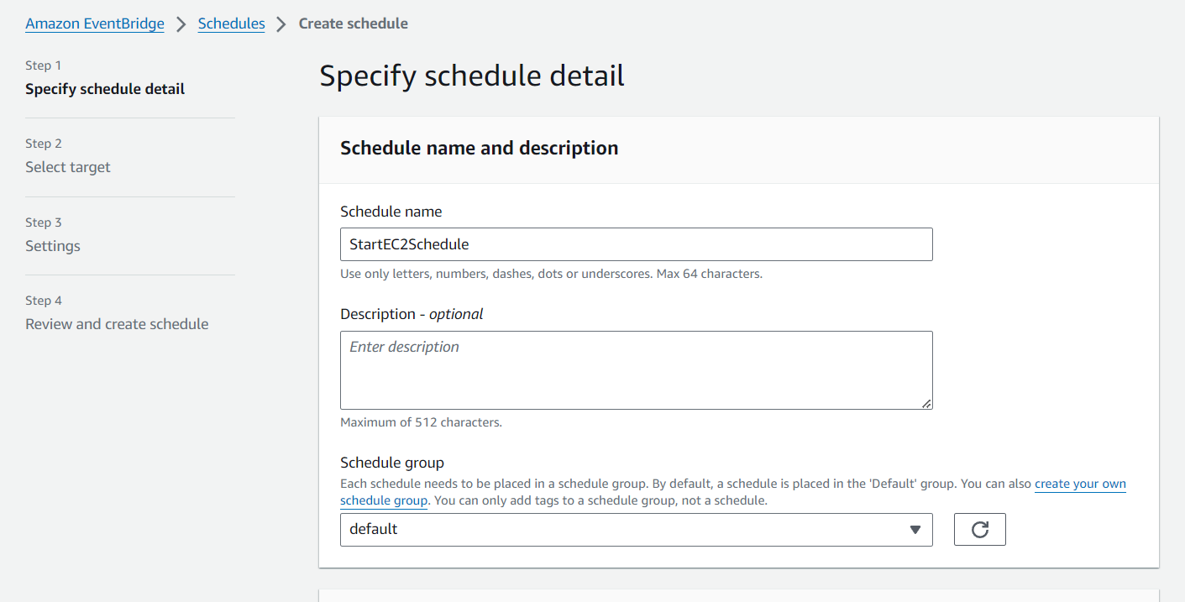

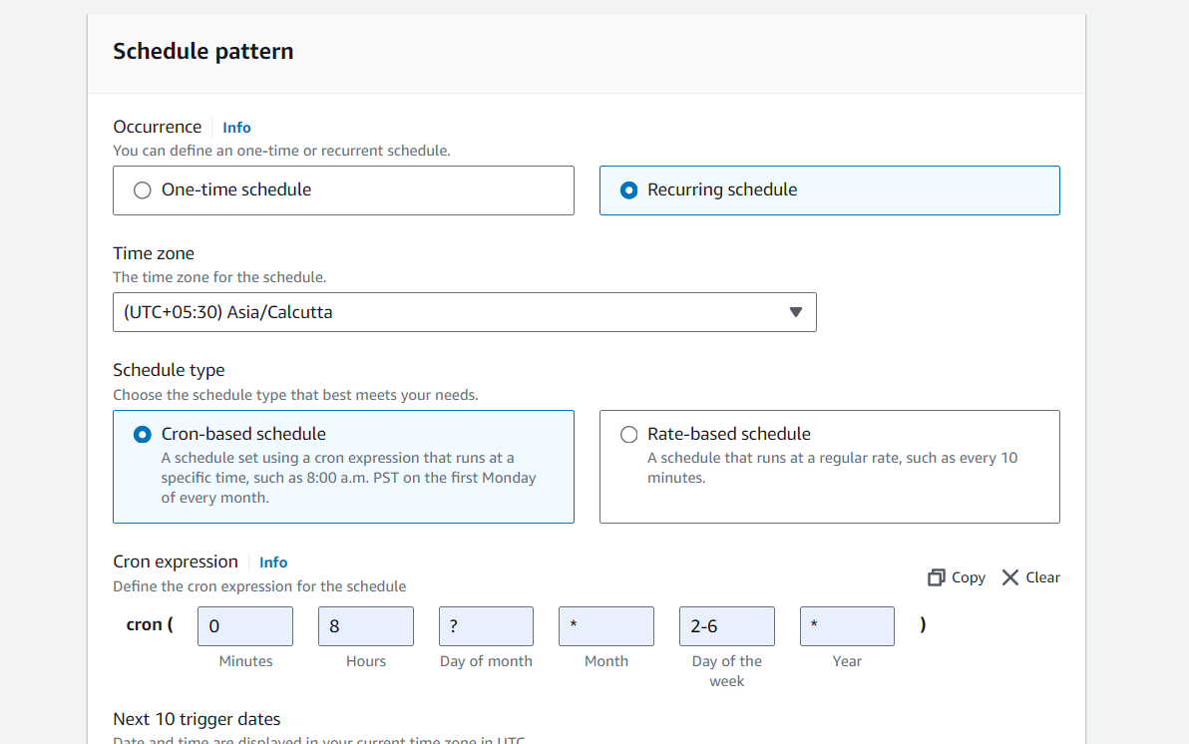

* + Choose "Cron-based schedule" and define the cron expression for 8:00 AM Monday to Friday.
  + Set the timezone.
  + Press "Next".

1. **Set the Target to Lambda Function**:
   * Select "Lambda function" as the target.

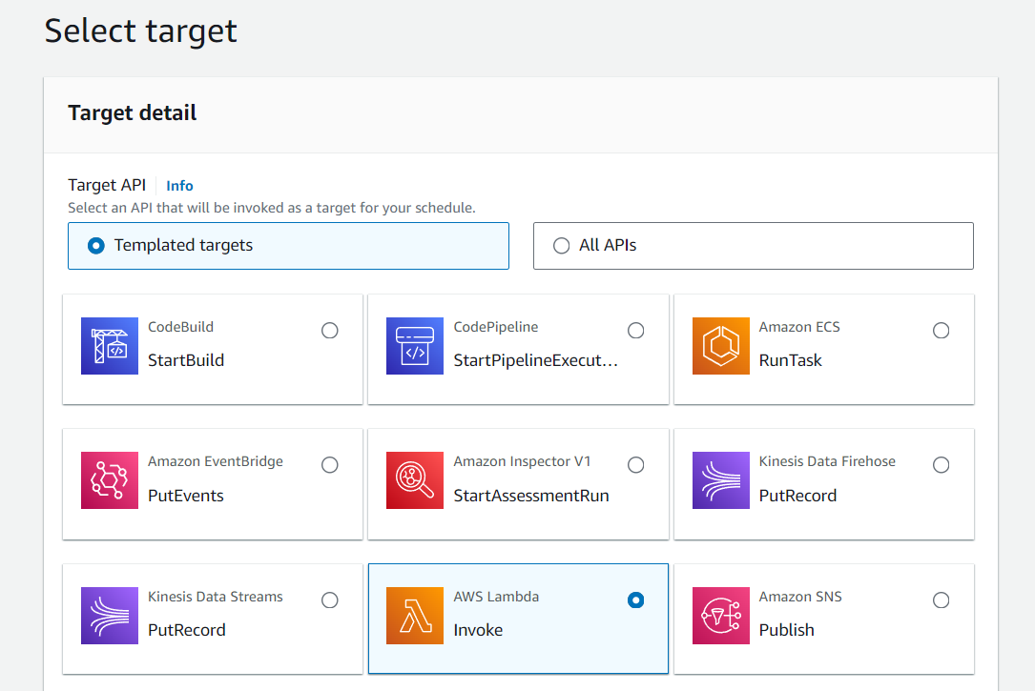

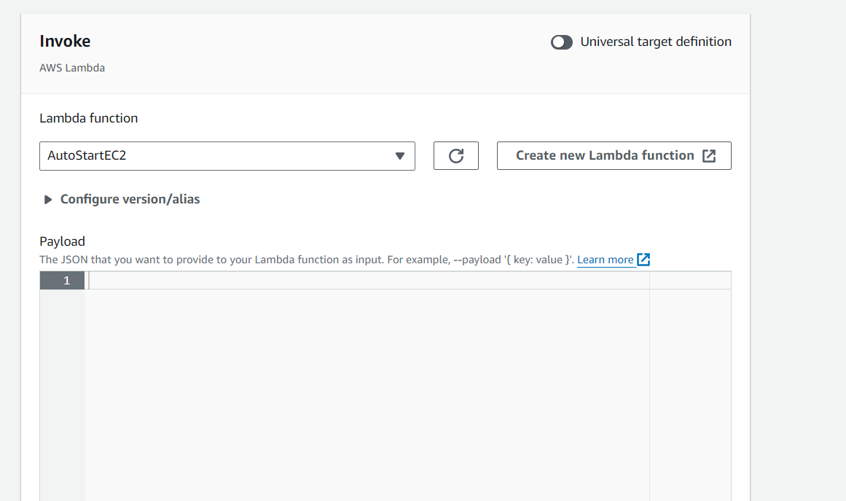

* + Choose the "AutoStartEC2" Lambda function.
  + Press "Next".
  + Review the settings and press "Create rule".

1. **Create a Schedule to Stop EC2**:

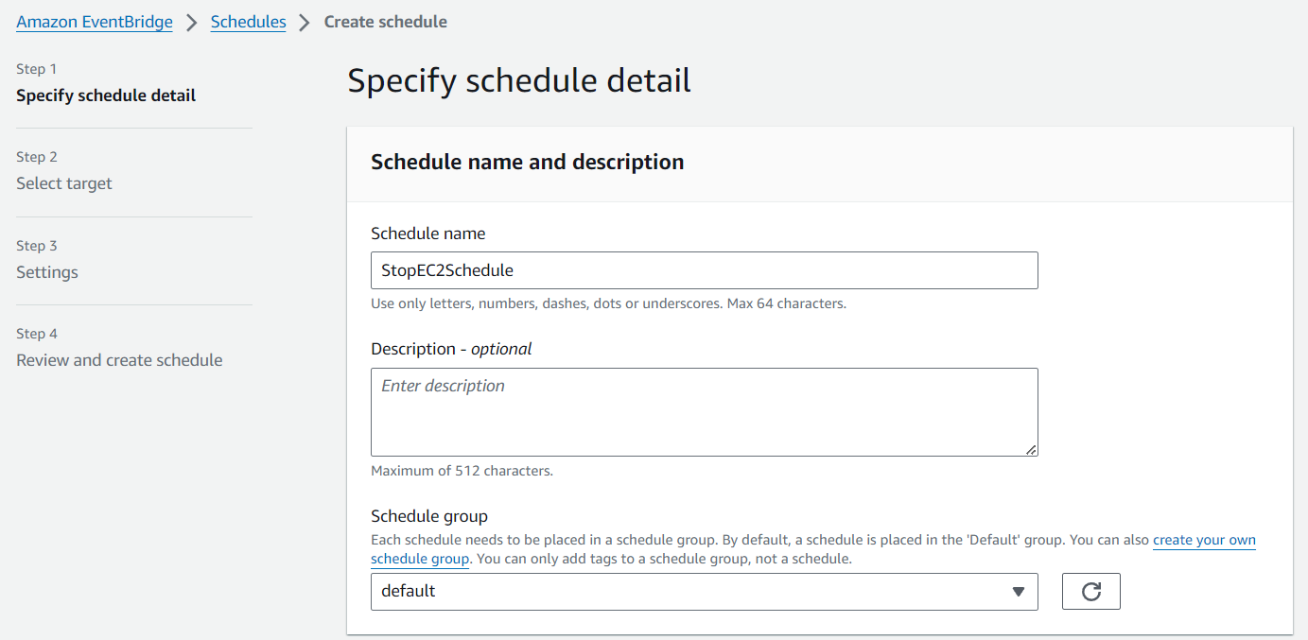

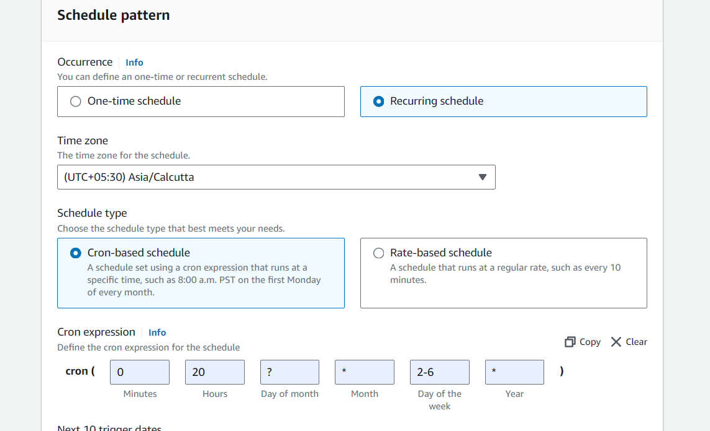

* + Repeat the steps to create another schedule (e.g., "StopEC2Schedule").
  + Use the cron expression 0 20 ? 2-6 * for 8:00 PM Monday to Friday.

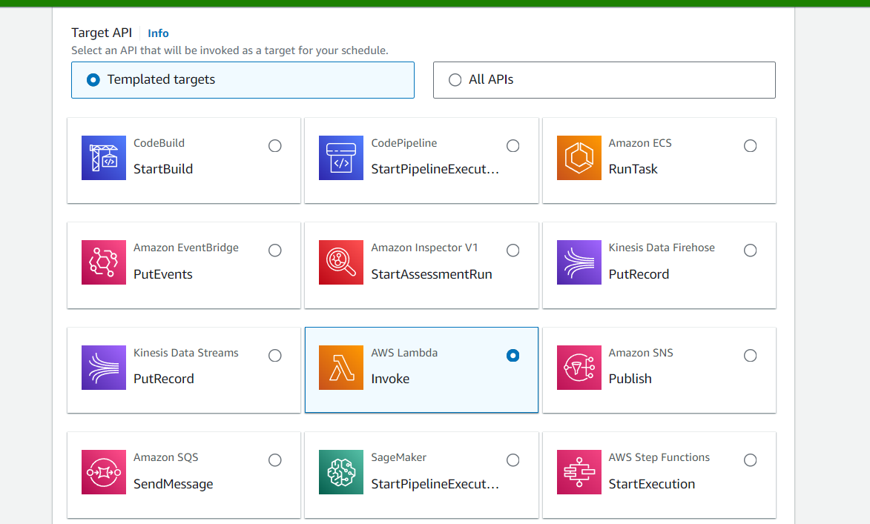

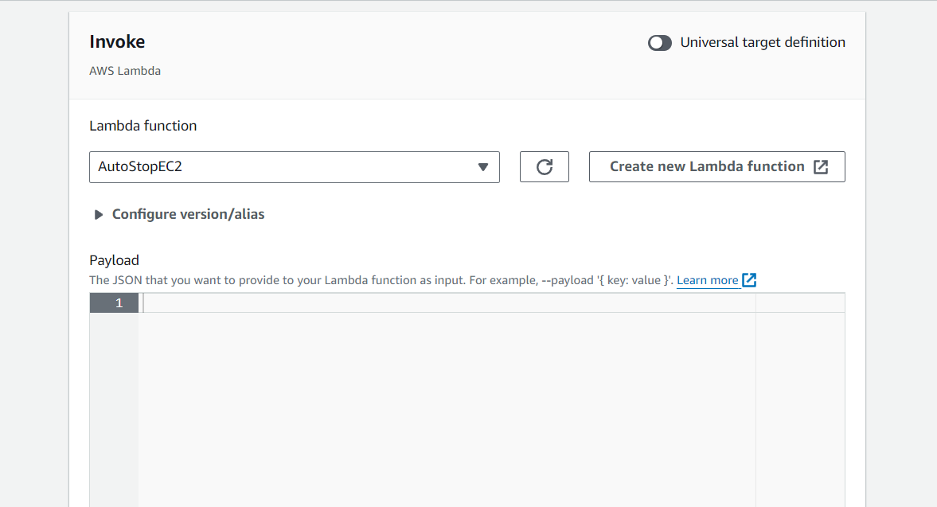

* + Select the "AutoStopEC2" Lambda function.