**Question 1:**

**Take 5 subjects marks each subject 100 marks;**

**calculate the percentage;**

**based on the percentage print the grade and the percentage;**

**Program:**

import java.util.Scanner;

public class Percentage

{

public static void main(String args[])

{

int marks[] = new int[5];

int i;

float total=0, avg,percent;

Scanner scanner = new Scanner(System.in);

for(i=0; i<5; i++) {

System.out.print("Enter Marks of Subject"+(i+1)+":");

marks[i] = scanner.nextInt();

total = total + marks[i];

}

scanner.close();

avg = total/5;

System.out.println("Average is:"+avg);

percent = (total / 500) * 100;

System.out.println("Percentage is:"+percent);

System.out.print("The student Grade is: ");

if(percent>=80)

{

System.out.print("A");

}

else if(percent>=60 && percent<80)

{

System.out.print("B");

}

else if(percent>=40 && percent<60)

{

System.out.print("C");

}

else

{

System.out.print("D");

}

}

}

**Output:**

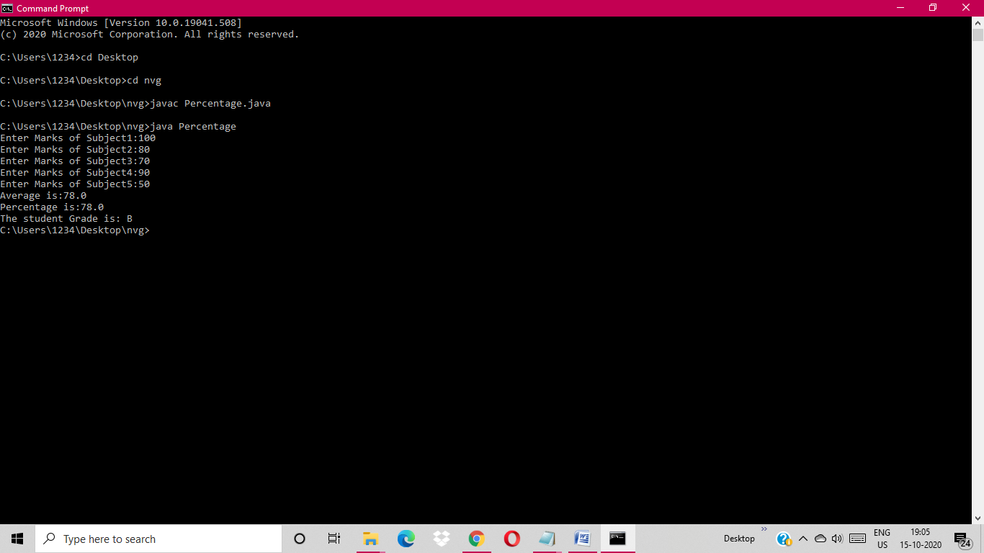

**Question 2:**

**Take employee name,date of birth,month of birth**

**birth year, monthly salary;**

**5l - 20%;**

**4l - 15%;**

**3l- 10%;**

**2l -5%;**

**Display name,age,annual salary and the tax amount.**

**Program:**

import java.io.*;

import java.util.Scanner;

class EmpData

{

int current_date=15;

int current_month=10;

int current_year=2020;

int birth_date;

int birth_month;

int birth_year;

String name;

int monthsalary;

int annualsalary;

int tax;

static void findAge(int current_date, int current_month,

int current_year, int birth_date,

int birth_month, int birth_year)

{

int month[] = { 31, 28, 31, 30, 31, 30, 31,

31, 30, 31, 30, 31 };

if (birth_date > current_date) {

current_month = current_month - 1;

current_date = current_date + month[birth_month - 1];

}

if (birth_month > current_month) {

current_year = current_year - 1;

current_month = current_month + 12;

}

int calculated_date = current_date - birth_date;

int calculated_month = current_month - birth_month;

int calculated_year = current_year - birth_year;

System.out.println("\n Present Age:");

System.out.println("Years: " + calculated_year +

" Months: " + calculated_month + " Days: " +

calculated_date);

}

public void salary_tax()

{

annualsalary=monthsalary*12;

if(annualsalary>100000 && annualsalary<=200000)

{

tax = (annualsalary*5)/100;

System.out.println("\n Annual Salary:"+annualsalary);

System.out.println("\n Tax Amount is:"+tax);

}

else if(annualsalary>200000 && annualsalary<=300000)

{

tax = (annualsalary*10)/100;

System.out.println("\n Annual Salary:"+annualsalary);

System.out.println("\n Tax Amount is:"+tax);

}

else if(annualsalary>300000 && annualsalary<=400000)

{

tax = (annualsalary*15)/100;

System.out.println("\n Annual Salary:"+annualsalary);

System.out.println("\n Tax Amount is:"+tax);

}

else if(annualsalary>400000 && annualsalary<=500000)

{

tax = (annualsalary*20)/100;

System.out.println("\n Annual Salary:"+annualsalary);

System.out.println("\n Tax Amount is:"+tax);

}

}

public void getDetails()

{

Scanner sc=new Scanner(System.in);

System.out.println("\n Enter name:");

name=sc.nextLine();

System.out.println("\n Enter Monthly Salary:");

monthsalary=sc.nextInt();

System.out.println("\n Enter Birth date:");

birth_date=sc.nextInt();

System.out.println("\n Enter Birth month:");

birth_month=sc.nextInt();

System.out.println("\n Enter Birth year:");

birth_year=sc.nextInt();

}

public void display()

{

System.out.println("\n Name:"+name);

salary_tax();

findAge(current_date, current_month, current_year,

birth_date, birth_month, birth_year);

}

public static void main(String[] args)

{

EmpData e[] = new EmpData[3];

for(int i=0; i<3; i++)

{

e[i] = new EmpData();

e[i].getDetails();

}

System.out.println("**** Data Entered as below ****");

for(int i=0; i<3; i++)

{

e[i].display();

}

}

}

**Output:**

