**Program 10**

**(PROGRAM FOR CREATING A PACKAGE)**

CREATE OR REPLACE PACKAGE personnel AS

-- get employee's fullname

FUNCTION get_fullname(n_emp_id NUMBER)

RETURN VARCHAR2;

-- get employee's salary

FUNCTION get_salary(n_emp_id NUMBER)

RETURN NUMBER;

END personnel;

**Output:**

Package created.

**Program 9**

**(Program for block level)**

<<label>>

DECLARE

v_name VARCHAR2(25) := 'Maria';

BEGIN

DBMS_OUTPUT.PUT_LINE(label.v_name);

END;

/

**Output:**

Maria

Statement processed.

## Program 8

## (Example of PL/SQL Procedures)

create table employee(employee_id numeric(10),employee_name varchar(20),employee_salary numeric(20));

insert into employee values('111','Ajit','15000');

insert into employee values('112','Sachin','20000');

insert into employee values('113','Asmita','10000');

insert into employee values('114','Priyanka','18000');

insert into employee values('115','Chaitali','12000');

select * from employee;

CREATE OR REPLACE PROCEDURE adjust_salary(

in_employee_id IN EMPLOYEE.EMPLOYEE_ID%TYPE,

in_percent IN NUMBER

) IS

BEGIN

-- update employee's salary

UPDATE employee

SET employee_salary = employee_salary + employee_salary * in_percent / 100

WHERE employee_id = in_employee_id;

END;

**Output:**

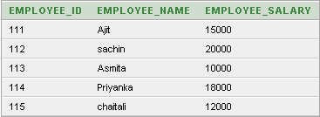

Procedure created.