|  |  |  |
| --- | --- | --- |
| **TOPIC**  **1.histogram**  i- frequency curve  ii- frequency polygon  iii- histogram | **DATE**  21/01/14 | **SIGN** |
| **2.frequency distribution**  i-mean, median, mode  ii-measure central tendency  iii-cumulative frequency curve | 28/01/14  4/2/14 |  |
| **3.measure of dispersion**  i-quartile deviation  ii-mean deviation  iii-standard deviation  iv coefficient of variance | 25/02/14 |  |
| **4. skewness & kurtosis**  i- karl pearsons  ii bowley coefficient of skewness  iii. kurtosis | 4/3/14  22/03/14 |  |
| **5.correlation &regression**  i-karl pearson coefficient of correlation for discrete distance | 1/04/14 |  |
| **6.test of hypothesis**  i.2 tail test  ii t-test  iii. analysis of variance | 19/04/14 |  |

**Assignment 1**

**1.Create a bell shaped frequency curve for the following data:**

|  |  |
| --- | --- |
| MARKS | FREQUENCY |
|  |  |
| 10 | 40 |
| 20 | 70 |
| 30 | 120 |
| 40 | 160 |
| 50 | 180 |
| 60 | 160 |
| 70 | 120 |
| 80 | 70 |
| 90 | 40 |

**OUTPUT:**

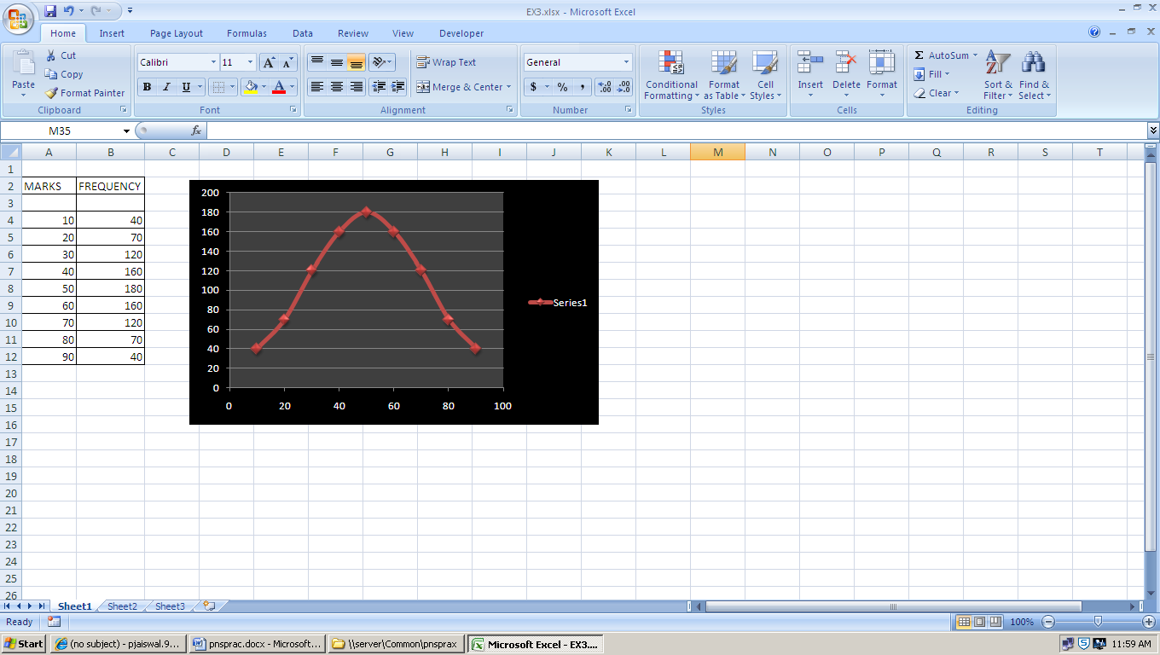

**2) Create a frequency polygon, frequency curve and histogram for the following data:**

|  |  |  |  |  |  |  |  |  |  |
| --- | --- | --- | --- | --- | --- | --- | --- | --- | --- |
| 326 | 326 | 326 | 326 | 326 | 326 | 326 | 326 | 326 | 326 |
| 344 | 344 | 344 | 344 | 344 | 344 | 344 | 344 | 344 | 344 |
| 333 | 333 | 333 | 333 | 333 | 333 | 333 | 333 | 333 | 333 |
| 346 | 346 | 346 | 346 | 346 | 346 | 346 | 346 | 346 | 346 |
| 339 | 339 | 339 | 339 | 339 | 339 | 339 | 339 | 339 | 339 |
| 353 | 353 | 353 | 353 | 353 | 353 | 353 | 353 | 353 | 353 |
| 310 | 310 | 310 | 310 | 310 | 310 | 310 | 310 | 310 | 310 |
| 350 | 350 | 350 | 350 | 350 | 350 | 350 | 350 | 350 | 350 |
| 351 | 351 | 351 | 351 | 351 | 351 | 351 | 351 | 351 | 351 |
| 348 | 348 | 348 | 348 | 348 | 348 | 348 | 348 | 348 | 348 |

**OUTPUT:**

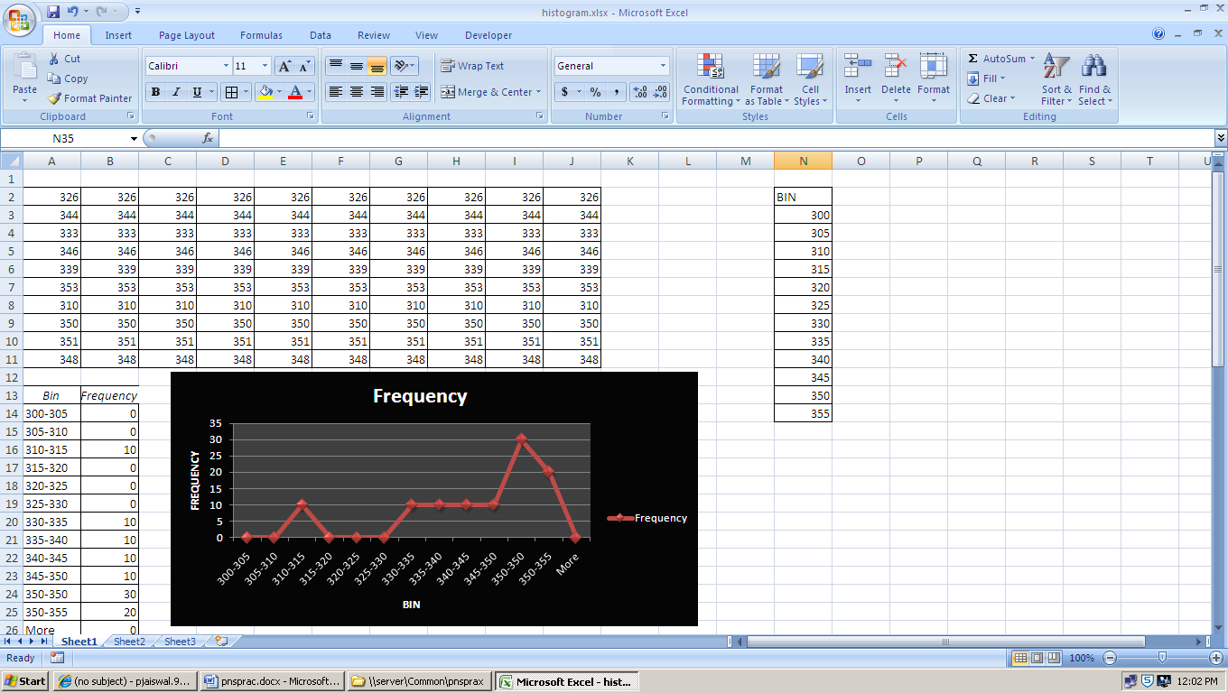

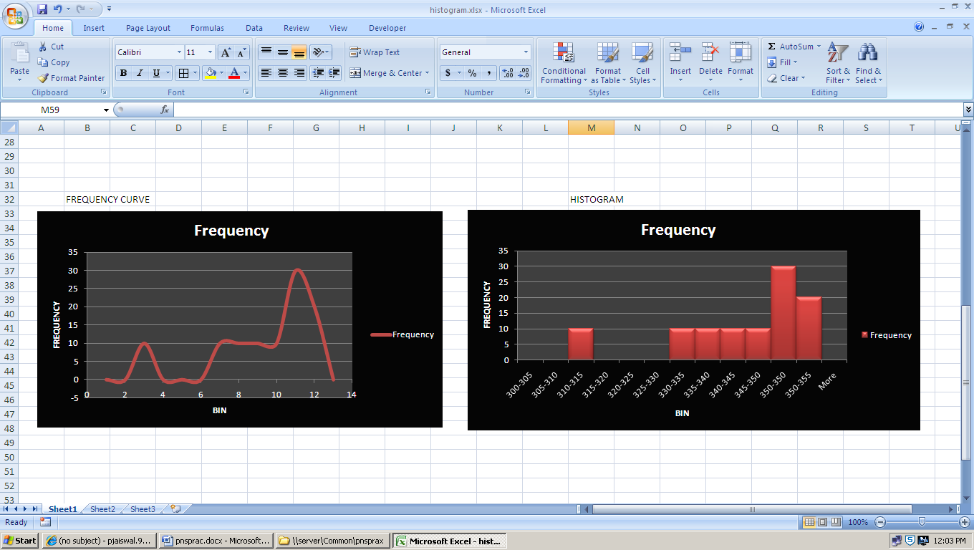

**Assignment 2**

**1. Suppose the marks obtained in the statistics examination were**

|  |  |  |  |  |  |  |  |  |  |
| --- | --- | --- | --- | --- | --- | --- | --- | --- | --- |
| 24 | 27 | 36 | 48 | 52 | 52 | 53 | 53 | 59 | 60 |

|  |  |  |
| --- | --- | --- |
| 85 | 90 | 95 |

Describe the overall performance of these 13 students by calculating an ‘average’ score using the mean, median and mode.

**CODE:**

Sub Mean()

Dim sum, i, j, avg, median, medval, max, count1, maxi, mode

For i = 2 To 14

sum = Sheet1.Cells(i, 3) + sum

Count = Count + 1

Next i

avg = sum / 13

Sheet1.Cells(18, 3) = sum

Sheet1.Cells(19, 3) = avg

Sheet1.Cells(20, 3) = sum / 13

medval = Count / 2

medval = medval + 2

i = 2

While (i < medval)

i = i + 1

Wend

median = Sheet1.Cells(i, 3)

Sheet1.Cells(21, 3) = median

For i = 2 To 14

For j = 2 To 14

If Sheet1.Cells(i, 3) = Sheet1.Cells(j, 3) Then

count1 = count1 + 1

End If

Next j

If (count1 > max) Then

max = count1

maxi = i

End If

count1 = 0

Next i

mode = Sheet1.Cells(maxi, 3)

Sheet1.Cells(22, 3) = mode

End Sub

**OUTPUT:**

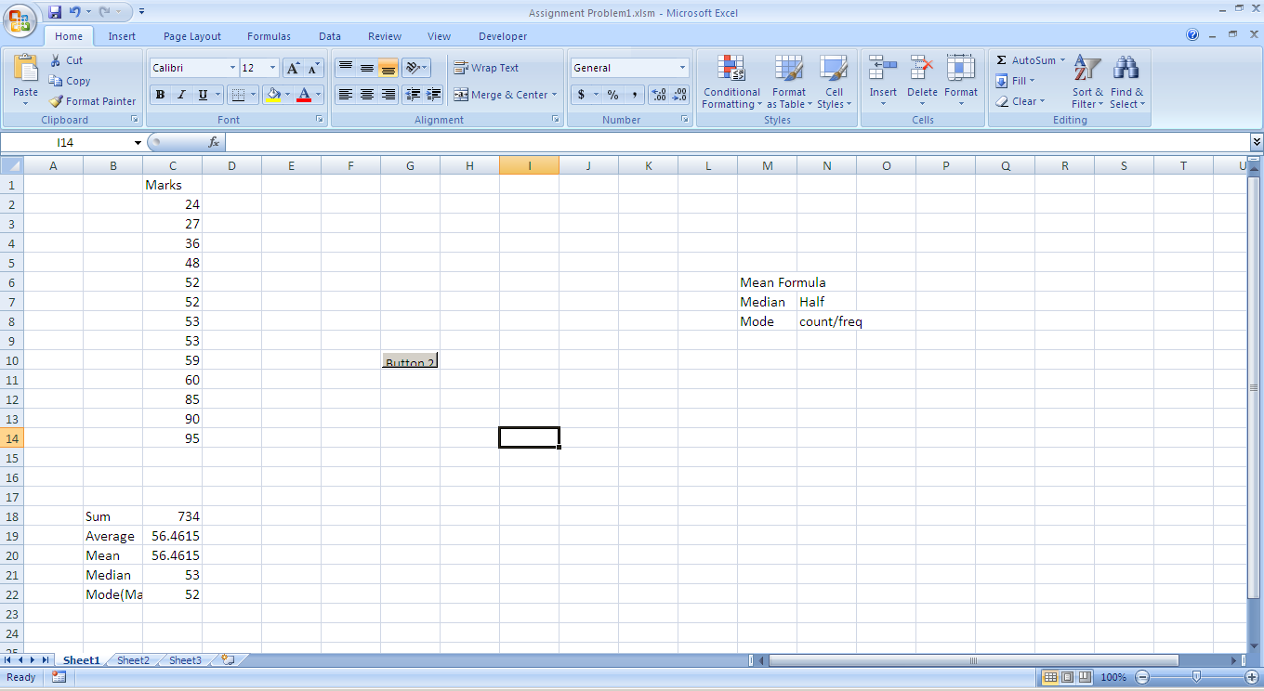

**2. The distribution of insurance claims processed each day is a follows:**

|  |  |  |  |  |  |  |  |  |  |  |
| --- | --- | --- | --- | --- | --- | --- | --- | --- | --- | --- |
| Claims(x) | 1 | 2 | 3 | 4 | 5 | 6 | 7 | 8 | 9 | 10 |
| Freq (f) | 3 | 4 | 4 | 5 | 5 | 7 | 5 | 3 | 3 | 1 |

Find Measure of central tendency.

**CODE:**

Sub Calculate()

Dim N, sumfn, cf, nby2, maxcount, count1

For i = 2 To 11

N = N + Sheet1.Cells(i, 2)

Sheet1.Cells(i, 3) = Sheet1.Cells(i, 1) * Sheet1.Cells(i, 2)

sumfn = sumfn + Sheet1.Cells(i, 3)

cf = cf + Sheet1.Cells(i, 2)

Sheet1.Cells(i, 4) = cf

Next i

Sheet1.Cells(14, 3) = N

Sheet1.Cells(15, 3) = sumfn

Sheet1.Cells(16, 3) = sumfn / N

nby2 = N / 2

Sheet1.Cells(17, 3) = nby2

i = 2

While (Sheet1.Cells(i, 4) < nby2)

i = i + 1

Wend

Sheet1.Cells(18, 3) = Sheet1.Cells(i, 1)

For i = 2 To 11

For j = 2 To 14

If Sheet1.Cells(i, 2) = Sheet1.Cells(j, 2) Then

count1 = count1 + 1

End If

Next j

If (count1 > Max) Then

Max = count1

maxi = i

End If

count1 = 0

Next i

End Sub

**OUTPUT:**

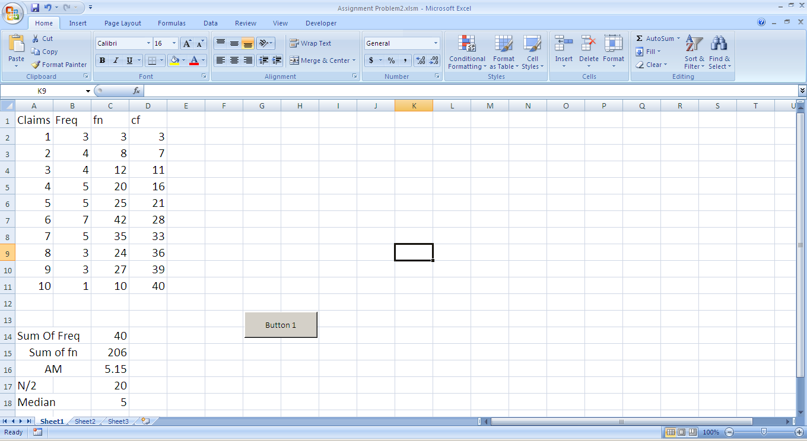

**3) The distribution of marks of 400 candidates in an A-level examination are given below**

**a) Calculate the mean value**

**b) Construct the cumulative frequency curve and estimate the median, lower and upper quartile values.**

|  |  |
| --- | --- |
| Marks | Frequency |
| 0-10 | 6 |
| 11-20 | 15 |
| 21-30 | 31 |
| 31-40 | 80 |
| 41-50 | 93 |
| 51-60 | 69 |
| 61-70 | 54 |
| 71-80 | 33 |
| 81-90 | 12 |
| 91-100 | 7 |

**CODE:**

Sub Button3_Click()

Dim i, cf, n, lower, upper, nby2

count = 1

For i = 2 To 11

n = n + Sheet1.Cells(i, 4)

Sheet1.Cells(12, 4) = n

cf = cf + Sheet1.Cells(i, 4)

Sheet1.Cells(i, 5) = cf

Next i

Sheet1.Cells(12, 4) = n

nby2 = n / 2

Sheet1.Cells(13, 4) = nby2

i = 2

While (nby2 > Sheet1.Cells(i, 5))

i = i + 1

Wend

For i = 2 To 1

lower = Sheet1.Cells(i, 2)

Sheet1.Cells(15, 2) = lower

upper = Sheet1.Cells(i, 3)

Sheet1.Cells(16, 2) = upper

Next i

End Sub

**OUTPUT:**

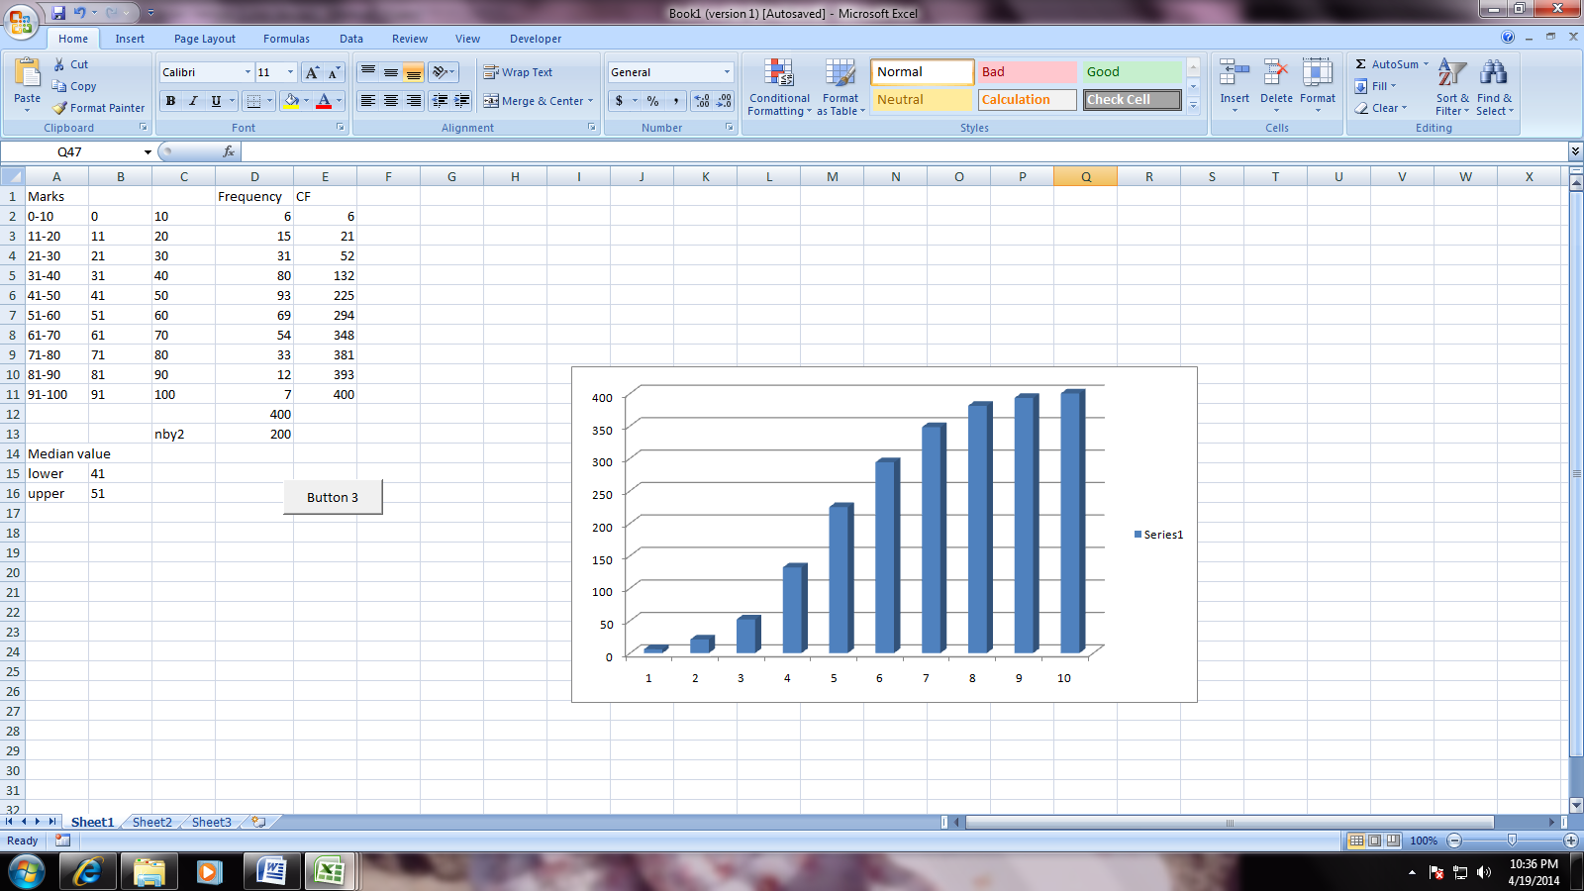

**Assignment 3**

1. **Calculate measure of dispersion for the following frequency distribution (Quartile deviation, mean deviation, Standard deviation and coefficient of all the above.)**

|  |  |
| --- | --- |
| Class | frequency |
| 16-18 | 50 |
| 18-20 | 250 |
| 20-22 | 350 |
| 22-24 | 225 |
| 24-26 | 25 |

**CODE:**

Sub Button1_Click()

Dim cf, n, nby34, nby4, l, h, Q1, sumx, countcls

countcls = 1

For i = 2 To 6

cf = cf + Sheet1.Cells(i, 3)

Sheet1.Cells(i, 4) = cf

n = n + Sheet1.Cells(i, 3)

Sheet1.Cells(i, 5) = (Sheet1.Cells(i, 2) + Sheet1.Cells(i, 1)) / 2

sumx = sumx + Sheet1.Cells(i, 5)

countcls = countcls + 1

Next i

Sheet1.Cells(9, 2) = n

nby4 = n / 4

Sheet1.Cells(10, 2) = nby4

nby34 = 3 * (n / 4)

Sheet1.Cells(11, 2) = nby34

i = 2

While (nby4 > Sheet1.Cells(i, 4))

i = i + 1

Wend

l = Sheet1.Cells(i, 1)

h = Sheet1.Cells(i, 2) - Sheet1.Cells(i, 1)

f = Sheet1.Cells(i, 3)

c = Sheet1.Cells(i - 1, 4)

Q1 = l + ((nby4 - c) * h) / f

Sheet1.Cells(13, 2) = Q1

i = 2

While (nby34 > Sheet1.Cells(i, 4))

i = i + 1

Wend

l = Sheet1.Cells(i, 1)

h = Sheet1.Cells(i, 2) - Sheet1.Cells(i, 1)

f = Sheet1.Cells(i, 3)

c = Sheet1.Cells(i - 1, 4)

Q3 = l + ((nby34 - c) * h) / f

Sheet1.Cells(14, 2) = Q3

Q312 = (Q3 - Q1) / 2

Sheet1.Cells(15, 2) = Q312

Sheet1.Cells(17, 2) = sumx

meancls = (countcls + 2) / 2

Sheet1.Cells(18, 2) = meancls

End Sub

**OUTPUT:**

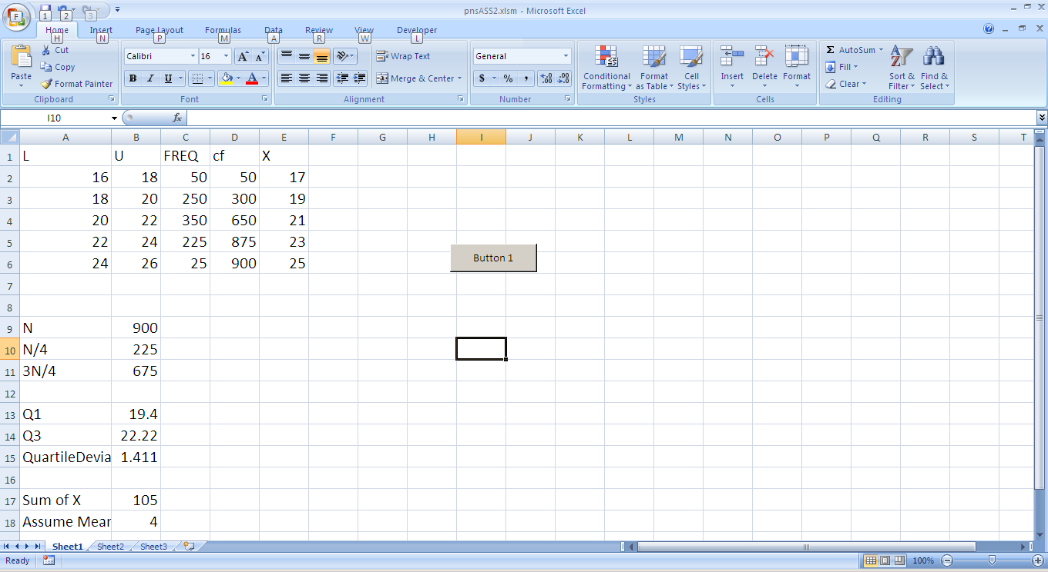

**Assignment 4**

1. **Calculate the Karl’s Pearson and Bowley’s coefficient of skewnessfor the following data**

|  |  |
| --- | --- |
| Class | frequency |
| 0-10 | 5 |
| 10-20 | 12 |
| 20-30 | 20 |
| 30-40 | 16 |
| 40-50 | 5 |
| 50-60 | 2 |

**CODE:**

Sub button2()

Dim N, fd, sfd, sfd2, mean, maxfreq, a, h, d, nby2, medcls

a = 25

h = 10 'assume mean

For i = 2 To 7

x = (Sheet1.Cells(i, 1) + Sheet1.Cells(i, 2)) / 2

Sheet1.Cells(i, 4) = x

N = N + Sheet1.Cells(i, 3)

d = (x - a) / h

Sheet1.Cells(i, 5) = d

fd = Sheet1.Cells(i, 3) * d

fd2 = fd * d

Sheet1.Cells(i, 6) = fd

Sheet1.Cells(i, 8) = fd2

''to find maxfreq

cf = cf + Sheet1.Cells(i, 3)

Sheet1.Cells(i, 7) = cf

sfd = sfd + Sheet1.Cells(i, 6)

sfd2 = sfd2 + Sheet1.Cells(i, 8)

Next i

Sheet1.Cells(8, 3) = N

Sheet1.Cells(8, 6) = sfd

Sheet1.Cells(8, 8) = sfd2

nby2 = N / 2

mean = (sfd / N)

mean = mean * h

mean = mean + a

Sheet1.Cells(10, 3) = mean

i = 2

'modeclass

While (Sheet1.Cells(i, 7) < nby2)

i = i + 1

Wend

medcls = i

med = nby2 - (Sheet1.Cells(i - 1, 7))

med = h * med

med = med / Sheet1.Cells(i, 3)

med = med + Sheet1.Cells(i, 1)

Sheet1.Cells(11, 3) = med

'sfd2/f

fd2f = sfd2 / N

'sfdf square

fd2f2 = (sfd / N) * (sfd / N)

SD = fd2f - fd2f2

SD = SD ^ (1 / 2)

Sheet1.Cells(12, 3) = SD

skw = 3 * (mean - med)

skw = skw / SD

Sheet1.Cells(13, 3) = skw

End Sub

**OUTPUT:**

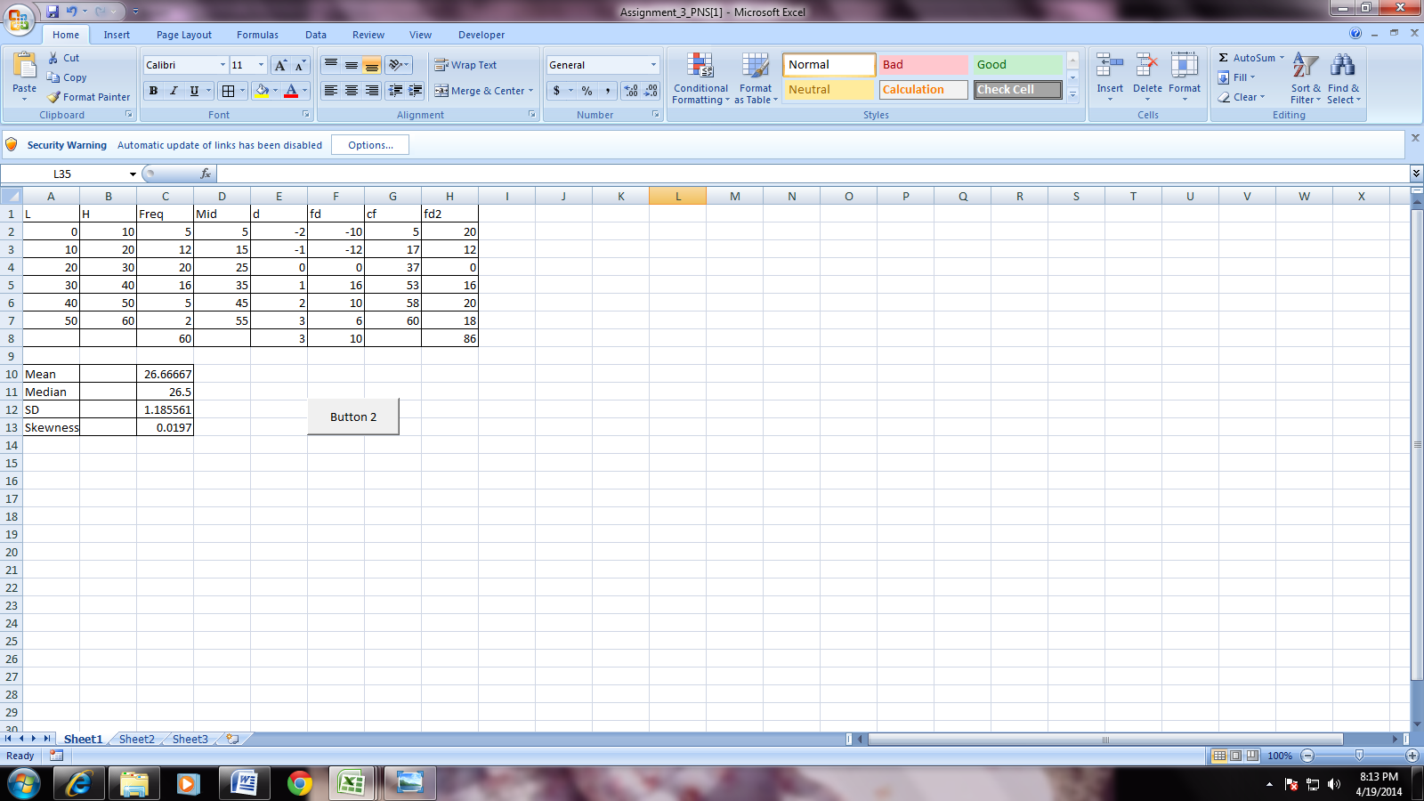

' ---------------for bowleys-------------'

For i = 2 To 7

'for q1'

nb4 = sum / 4

Sheet1.Cells(22, 2) = nb4

i = 2

While (Sheet1.Cells(i, 4) < nb4)

i = i + 1

Wend

qclass = i

Sheet1.Cells(23, 2) = qclass

l = Sheet1.Cells(qclass, 1)

u = Sheet1.Cells(qclass, 2)

Sheet1.Cells(24, 2) = l

Sheet1.Cells(25, 2) = u

h = u - l

Sheet1.Cells(26, 2) = h

f1 = Sheet1.Cells(3, 3)

Sheet1.Cells(27, 2) = f1

cf1 = Sheet1.Cells(i - 1, qclass)

Sheet1.Cells(28, 2) = cf1

q1 = l + (h / f1) * (cf1 - nb4)

Sheet1.Cells(29, 2) = q1

'for q3'

nb = 3 * (sum / 4)

Sheet1.Cells(31, 2) = nb

i = 2

While (Sheet1.Cells(i, 4) < nb)

i = i + 1

Wend

q1class = i

Sheet1.Cells(32, 2) = q1class

lo = Sheet1.Cells(q1class, 1)

up = Sheet1.Cells(q1class, 2)

Sheet1.Cells(33, 2) = lo

Sheet1.Cells(34, 2) = up

h1 = up - lo

Sheet1.Cells(35, 2) = h1

ff = Sheet1.Cells(5, 3)

Sheet1.Cells(36, 2) = ff

cff = Sheet1.Cells(i - 1, q1class)

Sheet1.Cells(37, 2) = cff

q3 = lo + (h1 / ff) * (cff - nb)

Sheet1.Cells(38, 2) = q3

qsk = q3 + q1 - (2 * Median) / (q3 - q1)

Sheet1.Cells(39, 2) = qsk

Next i

End Sub

**OUTPUT:**

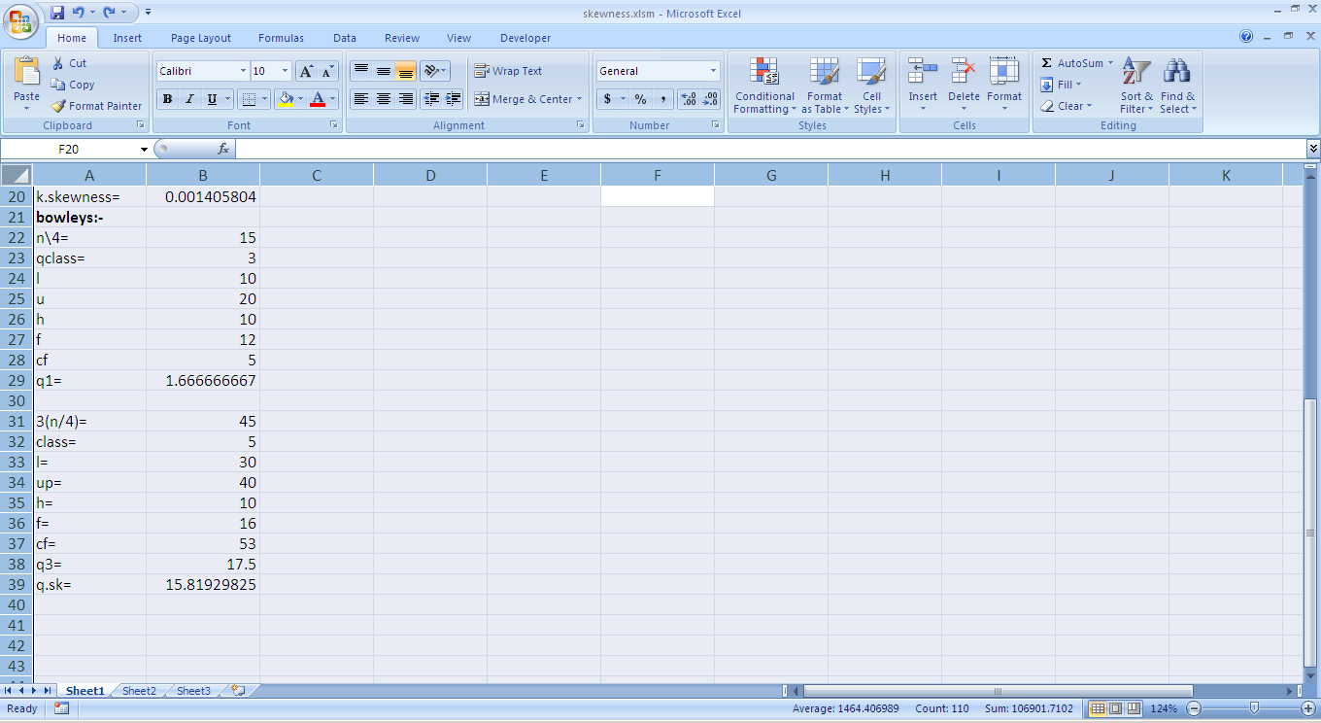

**Assignment 4:**

**1) Calculate the Karl Pearson’s Coefficient of Correlation for Discrete Distribution:**

**A)Discrete Distribution**

|  |  |  |
| --- | --- | --- |
| No. | X | y |
| 1 | 39 | 47 |
| 2 | 65 | 53 |
| 3 | 62 | 58 |
| 4 | 90 | 86 |
| 5 | 82 | 62 |
| 6 | 75 | 68 |

**CODE:**

Sub Button1_Click()

Dim x, y, xx, yy, xy, dx, dy

For i = 2 To 7

x = Sheet1.Cells(i, 1) + x

Sheet1.Cells(8, 1) = x

y = Sheet1.Cells(i, 2) + y

Sheet1.Cells(8, 2) = y

Sheet1.Cells(i, 3) = Sheet1.Cells(i, 1) * Sheet1.Cells(i, 1)

Sheet1.Cells(i, 4) = Sheet1.Cells(i, 2) * Sheet1.Cells(i, 2)

Sheet1.Cells(i, 5) = Sheet1.Cells(i, 1) * Sheet1.Cells(i, 2)

xx = Sheet1.Cells(i, 3) + xx

Sheet1.Cells(8, 3) = xx

yy = Sheet1.Cells(i, 4) + yy

Sheet1.Cells(8, 4) = yy

xy = Sheet1.Cells(i, 5) + xy

Sheet1.Cells(8, 5) = xy

count1 = count1 + 1

Next i

Sheet1.Cells(10, 2) = count1

a = (xy / count1)

Sheet1.Cells(12, 1) = a

b = x / count1

Sheet1.Cells(12, 2) = b

c = y / count1

Sheet1.Cells(12, 3) = c

dx = ((xx / count1) - (b * b))

Sheet1.Cells(12, 4) = dx

dy = ((yy / count1) - (c * c))

sq1 = VBA.Sqr(dx)

Sheet1.Cells(12, 4) = sq1

sq2 = VBA.Sqr(dy)

Sheet1.Cells(12, 5) = sq2

kp1 = (a - (b * c))

kp2 = (sq1 * sq2)

kp3 = kp1 / kp2

Sheet1.Cells(14, 2) = kp3

End Sub

**OUTPUT:**

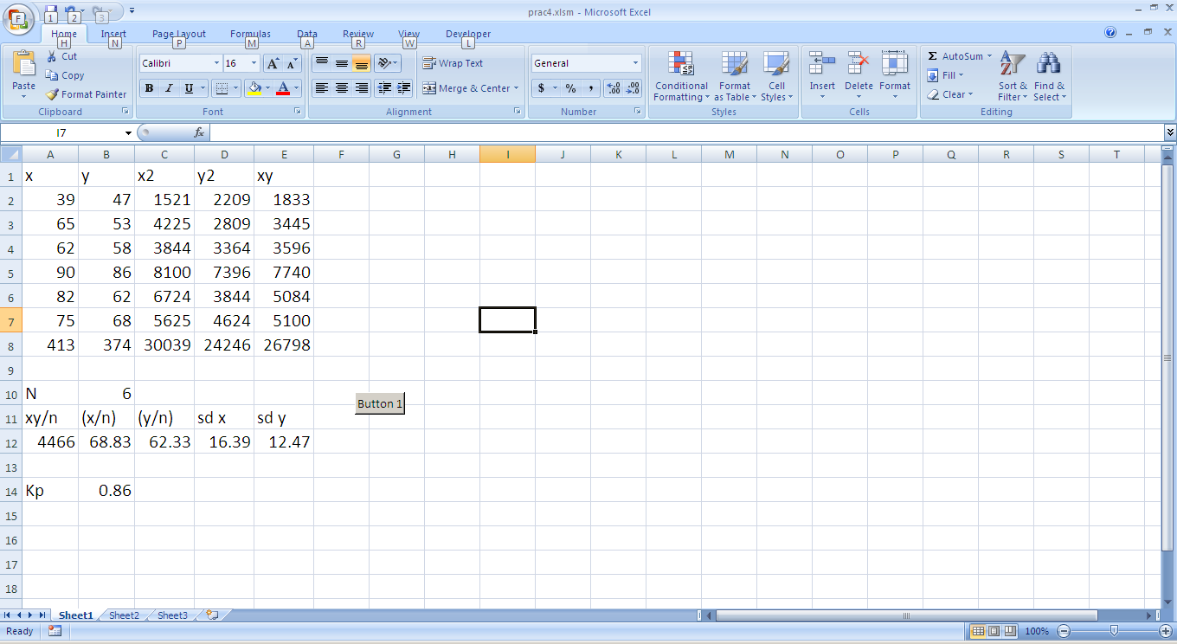

**B) Calculate the Kurtosis for the following distribution:**

|  |  |
| --- | --- |
| Profit in Lac | No. of Comp |
| 10-20 | 16 |
| 20-30 | 20 |
| 30-40 | 30 |
| 40-50 | 22 |
| 50-60 | 10 |

**CODE:**

Sub Button2_Click()

Dim x

For i = 2 To 6

x = (Sheet1.Cells(i, 1) + Sheet1.Cells(i, 2)) / 2

Sheet1.Cells(i, 4) = x

h = Sheet1.Cells(i, 2) - Sheet1.Cells(i, 1)

Sheet1.Cells(9, 2) = h

Next i

a = 35

For i = 2 To 6

d = (Sheet1.Cells(i, 4) - a) / h

Sheet1.Cells(i, 5) = d

fd = Sheet1.Cells(i, 3) * Sheet1.Cells(i, 5)

Sheet1.Cells(i, 6) = fd

fd2 = Sheet1.Cells(i, 6) * Sheet1.Cells(i, 5)

Sheet1.Cells(i, 7) = fd2

fd3 = Sheet1.Cells(i, 7) * Sheet1.Cells(i, 5)

Sheet1.Cells(i, 8) = fd3

fd4 = Sheet1.Cells(i, 8) * Sheet1.Cells(i, 5)

Sheet1.Cells(i, 9) = fd4

sumfd = sumfd + Sheet1.Cells(i, 6)

Sheet1.Cells(7, 6) = sumfd

sumfd2 = sumfd2 + Sheet1.Cells(i, 7)

Sheet1.Cells(7, 7) = sumfd2

sumfd3 = sumfd3 + Sheet1.Cells(i, 8)

Sheet1.Cells(7, 8) = sumfd3

sumfd4 = sumfd4 + Sheet1.Cells(i, 9)

Sheet1.Cells(7, 9) = sumfd4

n = n + Sheet1.Cells(i, 3)

Sheet1.Cells(11, 2) = n

u1 = sumfd / n

Sheet1.Cells(11, 3) = u1

u2 = sumfd2 / n

Sheet1.Cells(11, 4) = u2

u3 = sumfd3 / n

Sheet1.Cells(11, 5) = u3

u4 = sumfd4 / n

Sheet1.Cells(11, 6) = u4

Next i

un1 = 0

Sheet1.Cells(13, 3) = un1

un2 = u2 - (u1 * u1)

Sheet1.Cells(13, 4) = un2

un3 = (u3 - (3 * (u2 * u1)) + (2 * (u1 * u1 * u1)))

Sheet1.Cells(13, 5) = un3

un4 = (u4 - (4 * (u3 * u1)) + (6 * (u2 * u1)) - (3 * (u1 * u1 * u1 * u1)))

Sheet1.Cells(13, 6) = un4

End Sub

**OUTPUT:**

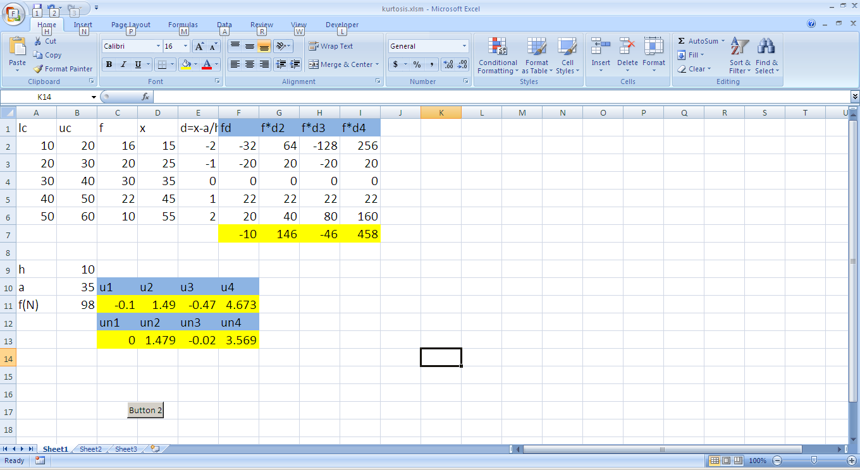

**Assignment 6**

**1) A sample of 200 bulbs made by a company given a life time mean of 1540 hrs with standard deviation of 42 hrs. It is likely that the sample has been drawn from a population with a mean lifetime of 1500 hrs. Use 5%level of significance**

**CODE:**

Sub Button1_Click()

Dim u

s = VBA.Sqr(Sheet1.Cells(3, 2))

Sheet1.Cells(8, 2) = s

u = (Sheet1.Cells(5, 2) - Sheet1.Cells(4, 2)) / (Sheet1.Cells(6, 2) / s)

Sheet1.Cells(9, 2) = u

End Sub

**OUTPUT:**

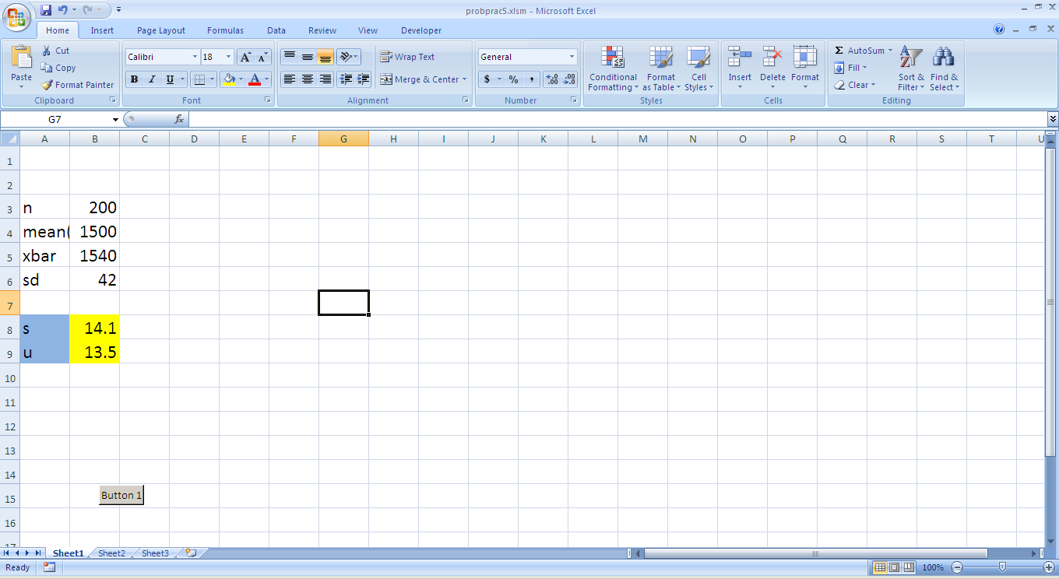

**2) A worker demands average time of 15 min for an operation the industrial engineer that operation takes much less time than 15 min.he observes 16 randomly selected repetition of the operation and calculate the average as 12.4 min with a standard deviation of 1.3 min for a significance level of 1%. How good is the case for the industrial engineer.**

**CODE:**

Private Sub CommandButton1_Click()

Dim x, m1, s, n, a, b As Integer

x = InputBox("Enter the value of x")

meu = InputBox("Enter the value for meu")

s = InputBox("Enter the value of s")

n = InputBox("Enter the value of n")

a = VBA.Sqr(((n - 1) * (s * s)) / (n - 2))

b = ((x - 15) / (a * (VBA.Sqr(1 / 16))))

Sheet2.Cells(2, 4) = a

If (a < 2.6) Then

MsgBox ("Null hypothesis is accepted")

Else

MsgBox ("Null hypothesis is rejected")

End If

End Sub

**OUTPUT:**

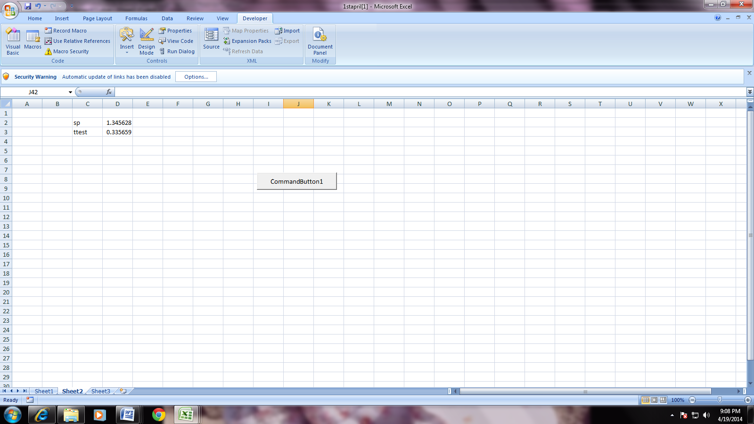

**3) To test the significance of variance in retail price of commodity in three principles cities Mumbai, Kolkata and Delhi. Four shops are chosen at random and price are given below**

**Mumbai 16, 8, 12, 14**

**Kolkata 14, 10, 10, 6**

**Delhi 4, 10, 8, 8**

**Does data indicates prices in these cities are significantly different.**

**CODE:** Private Sub CommandButton1_Click()

Dim a, sum1, sum2, sum3, sum11, sum22, sum33 As Integer

For a = 2 To 5

Sheet1.Cells(a, 2) = Sheet1.Cells(a, 1) ^ 2

Sheet1.Cells(a, 4) = Sheet1.Cells(a, 3) ^ 2

Sheet1.Cells(a, 6) = Sheet1.Cells(a, 5) ^ 2

sum1 = sum1 + Sheet1.Cells(a, 1)

sum11 = sum11 + Sheet1.Cells(a, 2)

sum2 = sum2 + Sheet1.Cells(a, 3)

sum22 = sum22 + Sheet1.Cells(a, 4)

sum3 = sum3 + Sheet1.Cells(a, 5)

sum33 = sum33 + Sheet1.Cells(a, 6)

Next a

Sheet1.Cells(6, 1) = sum1

Sheet1.Cells(6, 2) = sum11

Sheet1.Cells(6, 3) = sum2

Sheet1.Cells(6, 4) = sum22

Sheet1.Cells(6, 5) = sum3

Sheet1.Cells(6, 6) = sum33

Dim t, n, cf, sst, ssb, ssw As Integer

t = sum1 + sum2 + sum3

Sheet1.Cells(12, 5) = t

n = WorksheetFunction.Count(Range("A2:A5, C2:C5, E2:E5"))

cf = t * t / n

Sheet1.Cells(13, 5) = cf

sst = sum11 + sum22 + sum33 - cf

Sheet1.Cells(14, 5) = sst

Dim r1, r2, r3 As Integer

r1 = WorksheetFunction.Count(Range("A2:A5"))

r2 = WorksheetFunction.Count(Range("C2:C5"))

r3 = WorksheetFunction.Count(Range("E2:E5"))

ssb = (((sum1 ^ 2) / r1) + ((sum2 ^ 2) / r2) + ((sum3 ^ 2) / r3)) - cf

Sheet1.Cells(15, 5) = ssb

ssw = sst - ssb

Sheet1.Cells(16, 5) = ssw

Sheet1.Cells(10, 10) = ssb

Sheet1.Cells(11, 10) = ssw

Sheet1.Cells(12, 10) = ssb + ssw

Sheet1.Cells(12, 11) = n

Dim dfb, dfw As Integer

'since there are 3 columns i.e 1,2,3 Therfore,(number_of column =3)

'df_between_sample will be (number_of_column -1)

Sheet1.Cells(10, 11) = 3 - 1

dfb = Sheet1.Cells(10, 11)

'since the number_of column is 3,

'df_within_sample will be (total_df-df_between_sample)

Sheet1.Cells(11, 11) = Sheet1.Cells(12, 11) - Sheet1.Cells(10, 11)

dfw = Sheet1.Cells(11, 11)

Dim msqb, msqw As Integer

msqb = ssb / dfb

Sheet1.Cells(10, 12) = msqb

msqw = ssw / dfw

Sheet1.Cells(11, 12) = msqw

Dim fcal, ftab As Double

fcal = msqb / msqw

Sheet1.Cells(17, 5) = fcal

ftab = InputBox("enter value of Ftab")

Sheet1.Cells(18, 5) = ftab

If fcal > ftab Then

MsgBox ("Ho is rejected.")

Else

MsgBox ("Ho is accepted.")

End If

End Sub

**OUTPUT:**

