Monthly Budget

Software Requirements Specification

# Revision History

|  |  |  |
| --- | --- | --- |
| Date | Version | Description |
| June 29, 2012 | 1.0 | Initial |

Table of Contents

Introduction 4

Purpose 4

Scope 4

Definitions, Acronyms and Abbreviations 4

References 4

Technologies to be used 4

Overall Description 6

Product Perspective 6

Software Interface 6

Hardware Interface 6

Client Side 6

Server Side 6

Product Function 7

User Characteristics 7

Constraints 7

Architecture Diagram 8

Use-Case Model Description 8

Package Diagram 9

Database Design 10

EER Diagram 10

Assumptions and Dependencies 10

Specific Requirements 11

Functional Requirements 11

Non-Functional Requirements 12

Sequence Flow 13

Use case Reports 14

# Introduction

## Purpose

To build an application that help in planning monthly budget and to update related users by mail. The application will allow administrator to plan the budget for the month and update the user with the mail about the budget allocation. It also allow user to update the expenditure under the supervision of administrator.

## Scope

* Create different user role with different privileges.
* Manage all the account details of users from one central location.
* Track all the users and their transaction details.
* View all the details of all the user interactions.
* User will authenticate to avail the services, the service can be third party authentication or own implementation.
* Maintain logs of all the activities performed in the system by the users for auditing.
* Providing help for basic understanding of facilities.
* Maintain a centralized database.

## Definitions, Acronyms and Abbreviations

* Income item: where the amount flows in to the system.
* Expense item: form where the amount goes out of the system.
* User: the users associated with the system.
* Role: the role the user is playing in the system.
* Budget: is the money planning for the particular month.
* Transaction: is the entry in the system containing the details for the event.
* Item: can be anything that can change the state of the system.

## References

* IEEE SRS Format

## Technologies to be used

* Database: MySQL.
* Language: J2EE.
* Framework: Spring, Hibernate.
* Front end: HTML, JSP, JQuery.

# Overall Description

Describe the general factors that affect the product and its requirements.

## Product Perspective

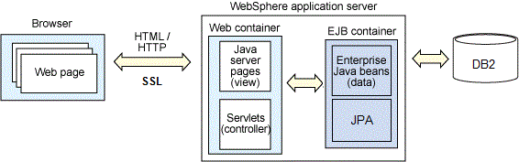

## Software Interface

* **Client on Internet:** Web Browser, Operating System (any)
* **Web Server:** WAS, Operating System (any)
* **Data Base Server:** MySQL, Operating System (any)
* **Development End:** Spring Tool Suite (J2EE, Java, Java Bean, Servlets, HTML), DB2, OS (Windows), Web Server.

## Hardware Interface

### Client Side

* **Processor:** Pentium II at 500 MHz or higher
* **RAM :** 64 MB or greater
* **Disk Space**: 1 GB or greater
* **Browser**: Internet Explorer 7 or later

### Server Side

* **Processor:** Pentium Dual Core at 1GHz or higher
* **RAM :** 2 GB or greater
* **Disk Space**: 14 GB or greater.

## Product Function

* **Budget**
  + Allow to plan currency allocation for the expense item
  + Display currency left for the budget item.
* **Accounts**
  + Allow to create new account and assign user to it.
  + Feature to include account in monthly budget.
* **Logbook**
  + Will display all the transaction done till the date in descending order.
* **New entry**
  + Allow to create new transaction.
  + Transaction can be expense, income and transfer.
* **Option**
  + Allow to change currency.

## User Characteristics

* Every user should be comfortable of working with computer and browsing.

## Constraints

* GUI is only in English.
* User must have Google account for login.
* This project is implemented on cloud infrastructure.
* There is no maintainability of back up.
* Limited to HTTP/HTTPS.

## Architecture Diagram

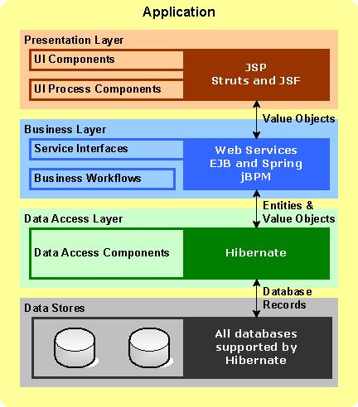

## Use-Case Model Description

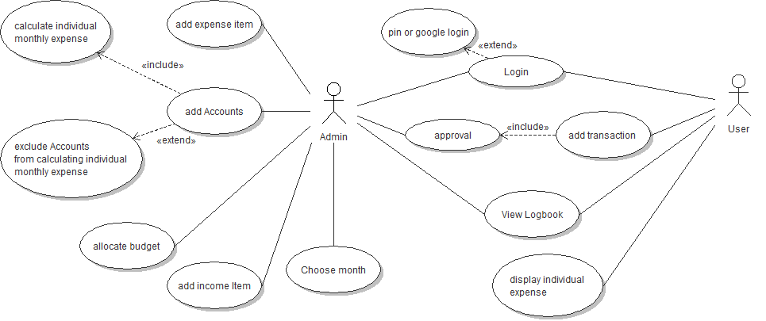

**Administrator:** Administrator is responsible for the adding the account, expense item, Income Item, Allocate budget for expense item and approving the user transaction. Administrator has access to add, view and edit the logbook.

**User:** Users is responsible for adding the transaction, View logbook, view individual expenditure.

## Package Diagram

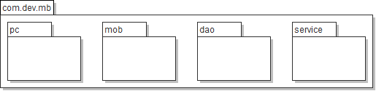

## Database Design

### EER Diagram

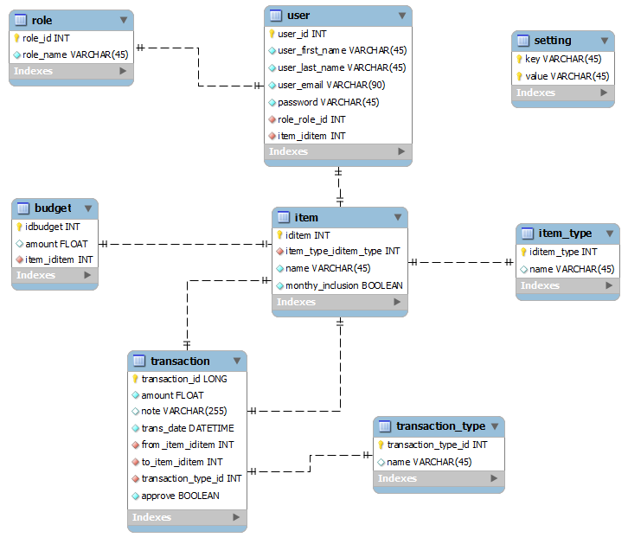

## Assumptions and Dependencies

* User will pay his/her individual budget timely and in any means outside this system.
* Any transfer or payment is done conceptually.
* Login is subjected to Google service availability.

# Specific Requirements

## Functional Requirements

* **Accounts**
  + Ability to add Accounts
    - Example: Hemant, Nilesh, Nishant & Monthly cash
  + Ability to add expense item
    - Example: Add Rent as Expense item
  + Ability to add income Item
    - Example: Add Accounts as Income Item
    - If added as income item, it should calculate for individual monthly expense by default
  + Ability to exclude Accounts from calculating individual monthly expense.
  + It should show individual expense for each individual (Account).
  + Income account should be mapped to the users account. Cash account is always mapped to administrator role.
* **New entry**
  + Ability to add transaction for expense, income and transfer
    - Example: Expense (only option available for users)
      * Amount, date, Account, Category, Note
    - Example: Income
      * Amount, date, Account, Category, Note
    - Example: Transfer
      * Amount, date, Account, To Account, Note
  + Users can add transactions but need approval from administrator
* **Budget**
  + Each expense item can have budget for each month.
  + Ability to allocate budget for any expense category
    - Example: Category, Monthly Budget
  + Cary out savings of this month to next month.
  + Savings should be income for next month.
* **Setting**
  + Ability to change administrator password.
  + Ability to change administrator username.
  + Ability to change currency symbol.
* **Login/Logout**
  + Google API can be implemented.
* **Logbook**
  + Should be able to view all records of transaction by month
  + User should be able to see individual monthly expense

## Non-Functional Requirements

* Secure access of confidential data (user’s details). SSL can be used.
* 365 X 24 X 7 availability.
* Better component design to get better performance at peak time.
* Flexible service based architecture will be highly desirable for future extension.
* Customizing skins
* Mobile Interface

## Sequence Flow

Administrator flow is show in the figure below.

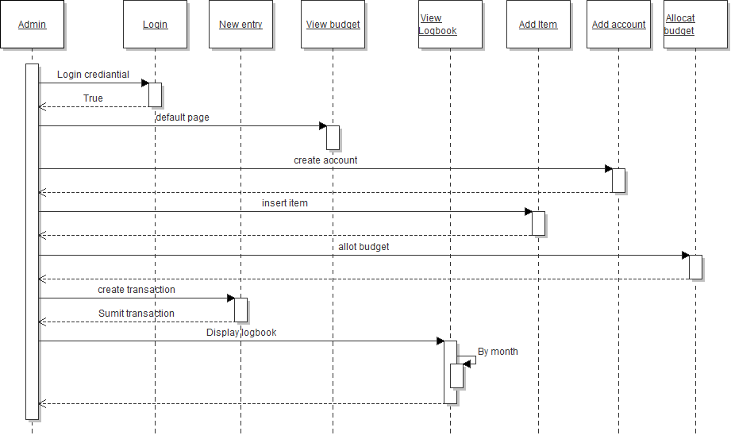

User flow is shown in the figure below.

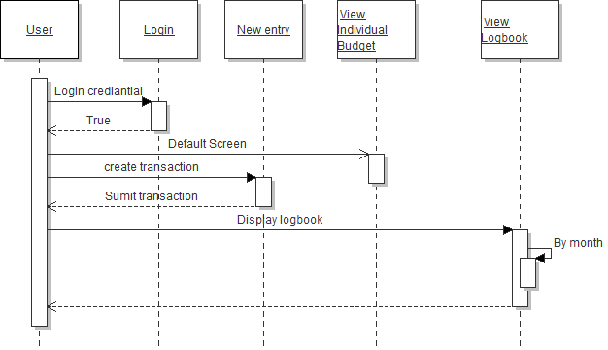

## Use case Reports

* **Name of Use Case: login/logout.**
  + Description: Login and logout module need to be implemented using Google openID API.
  + Precondition:
    - None
  + Normal Flow:
    - Click on the “Sign with Google” button
    - Enter the Username and password
    - Click on the “Sign In” button
  + Alternative flow:
    - User should be allowed to create and Google account.
  + Post Condition:
    - User should be redirected to the
  + Reference: [click here](http://krams915.blogspot.in/2011/02/spring-security-3-openid-login-with_13.html)
* **Name of Use Case: Add account.**
  + Description: User will able to add expense and income item from this use case.
  + Precondition:
    - User must login.
    - User must be in default page.
  + Normal Flow:
    - User will click on the “Accounts” button.
    - Click on the “+” button to add new item.
    - Enter the “Name” of the item.
    - Select the “Type” of the item.
    - If type is “Income”
      * Select the user to link with the account.
      * select Monthly Inclusion
    - Enter the “Description”
    - Click on the “save” button
  + Alternative flow:
    - Click on the “Add account”
    - Rest is same as normal flow
  + Post Condition:
    - Item will be added.
  + Reference: None
* **Name of Use Case: Allocate budget.**
  + Description: User will able to allocate the budget for the expense item.
  + Precondition:
    - User must login.
    - There must be at least one expense item added before.
  + Normal Flow:
    - User will click on the “Budget” button.
    - Click on the “+” button to add new budget item.
    - Select the “Category” of the expense item.
    - Enter “Monthly budget” amount.
    - Click on the “save” button
  + Alternative flow:
    - Click on the “Add Budget”
    - Rest is same as normal flow
  + Post Condition:
    - Budget Item will be added.
  + Reference: None
* **Name of Use Case: Select month.**
  + Description: User will able to choose month.
  + Precondition:
    - User must login.
    - User must be in default page.
  + Normal Flow:
    - User will click on the “Month” button.
    - Select the “Month” to work with.
    - Click on the “Ok” button
  + Alternative flow:
    - None
  + Post Condition:
    - Working month will get change.
  + Reference: None
* **Name of Use Case: New entry**
  + Description: User will able to add new transactions.
  + Precondition:
    - User must login.
    - User must be in default page.
  + Normal Flow:
    - User will click on the “New entry” button.
    - Click on the “Approve” button.
    - Click on the “Ok” button.
  + Alternative flow:
    - User will click on the “New Entry” button.
    - Enter “Amount”.
    - Select “Date”.
    - Select “Account”
    - Select “Category”
    - Enter “Note”
    - Select “Transaction type”
    - Click on the “save” button.
  + Post Condition:
    - Transaction will be saved and mailed to the user.
  + Reference: None
* **Name of Use Case: Approval**
  + Description: Admin will able to approve the transaction submitted by the user.
  + Precondition:
    - User must login.
    - User must be in default page.
  + Normal Flow:
    - User will click on the “Approval” button.
    - Click on the “Approve” button.
    - Click on the “Ok” button.
  + Alternative flow:
    - User will click on the “Approval” button.
    - Click on the “Decline” button.
    - Click on the “Ok” button.
  + Post Condition:
    - Transaction will be saved and mailed to the user.
  + Reference: None
* **Name of Use Case: View logbook**
  + Description: user will able to see all the transaction done for the month.
  + Precondition:
    - User must login.
    - User must be in default page.
  + Normal Flow:
    - User will click on the “logbook” button.
    - Page will display all the transaction for the month.
    - Click on the “back” button.
  + Alternative flow:
    - User will click on the “logbook” button.
    - Click on the “month” button.
    - Select “Month”
    - Page will display for that month.
    - Click on the “back” button.
  + Post Condition:
    - Transaction will be saved and mailed to the user.
  + Reference: None
* **Name of Use Case: Display individual expense**
  + Description: user will able to see his monthly expense.
  + Precondition:
    - User must login.
  + Normal Flow:
    - It will be shown on the default page
  + Alternative flow:
    - None
  + Post Condition:
    - None.
  + Reference: None