STUDENT PERFORMANCE ANALYSIS
Project Report | Project 1
Prepared by: Nilesh Vasant Mahale
Data Science & Data Analytics Internship — Cognevance Technologies

1. Project Overview
This project analyzes a student performance dataset to understand exam results, attendance patterns, and score distribution. Microsoft Excel was used to organize the data, calculate summary statistics, and create visualizations.

2. Objectives
- Review student attendance and academic performance.
- Summarize exam marks and overall scores.
- Visualize student marks, pass/fail results, and score distribution.
- Examine the relationship between attendance and overall score.
- Present insights and recommendations based on the analysis.

3. Dataset Description
The project uses a sample dataset containing 500 student records, including Student_ID, Gender, Attendance_Percent, Assignment_Score, Exam_Marks, Overall_Score, and Result. The dataset is synthetic/sample data and is not official data from a real institution.

4. Methodology
- Prepared the sample dataset.
- Checked for missing values, duplicate Student_ID values, valid ranges, and appropriate data types.
- Calculated average attendance, average exam marks, highest/lowest marks, pass/fail counts, and average overall score.
- Calculated the correlation between attendance percentage and overall score.
- Created Excel visualizations and documented insights and recommendations.

5. Key Analysis Results
Metric | Result
Total students | 500
Average attendance | 67.436%
Average exam marks | 65.636
Highest exam marks | 100
Lowest exam marks | 10
Passed students | 474 (94.8%)
Failed students | 26 (5.2%)
Average overall score | 64.178
Attendance vs. overall score correlation | 0.7162553

6. Visualizations

- Student-wise Exam Marks — compares exam marks across students.

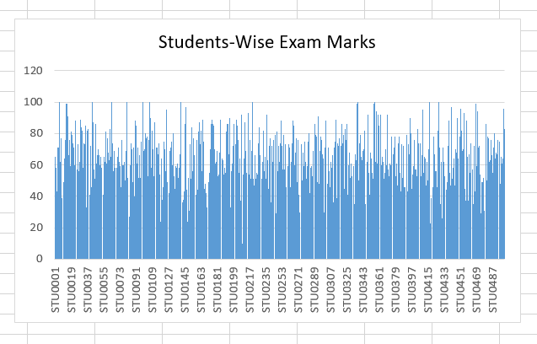
- Student Performance: Pass vs. Fail — shows the proportion of passed and failed students.

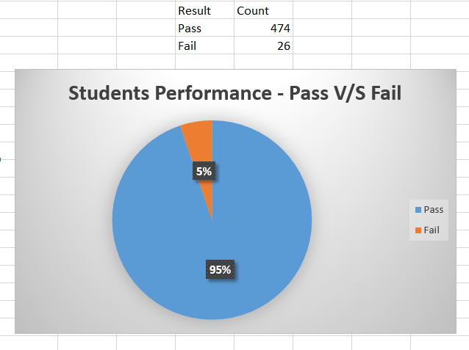

- Student Performance Distribution — shows student counts across exam-mark ranges.

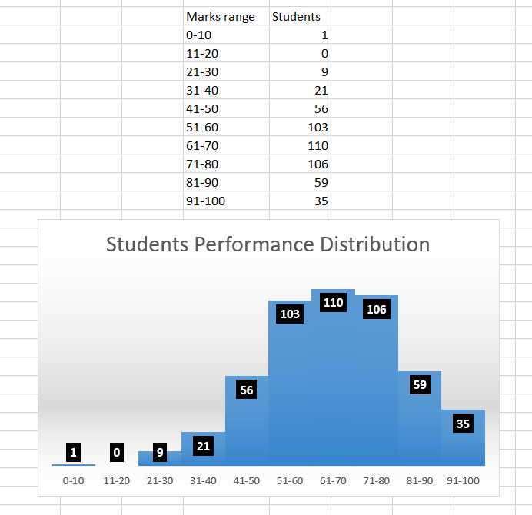
The charts were created in Microsoft Excel and are included in the accompanying workbook.

7. Insights and Recommendations
High pass percentage: 474 of 500 students passed (94.8%). Recommendation: Continue effective learning practices and support students who are struggling.
Positive attendance–score relationship: Correlation is 0.7162553, indicating a positive relationship in this sample. Recommendation: Encourage regular attendance and support students with low attendance. Correlation does not establish causation.
Many students scored between 51 and 80: 319 students are in the 51–80 marks range. Recommendation: Provide targeted practice and revision resources.
A small group failed: 26 students (5.2%) failed. Recommendation: Consider remedial support, individual guidance, and progress monitoring.
Variation in exam marks: Marks range from 10 to 100. Recommendation: Use assessments to identify different learning needs and provide suitable support.

8. Conclusion
The analysis summarizes performance patterns in the 500-record sample. Most students passed, and attendance showed a positive association with overall score. The metrics and charts communicate these patterns, while the recommendations suggest areas for academic support. Because the dataset is synthetic, these findings are illustrative and should be validated with real institutional data before real-world decisions.

9. Tools Used
Microsoft Excel — data organization, summary analysis, and visualizations.

