stripe-pipeline: design
Status: draft, revised after design review. Decided items are marked Decided. Each stage is tagged with the version that introduces it (V1 to V4). The diagram shows the full target; V1 only needs the DuckDB and dbt path.

Goal
Pull realistic subscription-business data from an HTTP API, store it in a relational shape, and build transformations and analytics on top of it. The pipeline is a consumer of apiframework (the API_framework repo), so it also exercises the library end to end.
This is a demo built on test data. The design still follows production rules (privacy, secrets, retention, incremental loads), so the same design can be reused with real data.

Data flow
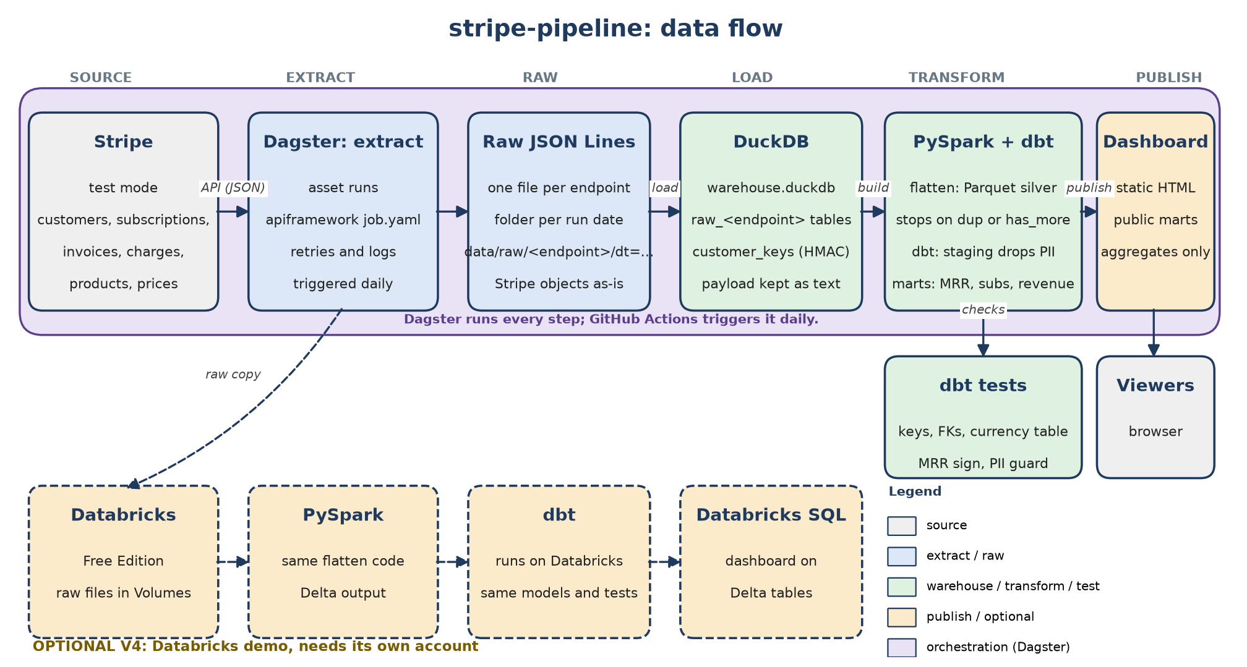
Figure 1. Target flow. The solid path is the zero-cost baseline; the dashed path is the optional V4 Databricks demo.

Tiers: what to run
Three tiers keep the first run simple. A new user only needs the first tier to see results.
Tier | Contents | Needs | Versions
Minimum demo | Stripe, apiframework, PySpark (flatten to Parquet), DuckDB, dbt. Output: marts in warehouse.duckdb. | Python 3.10+, uv, Java (any JDK that PySpark supports), a Stripe test key | V1 and Quickstart
Full demo | Adds Dagster, GitHub Actions schedule, incremental loads, and a static dashboard page built from public marts. | A GitHub account with Actions. GitHub Pages on a private repo needs a paid plan. | V2 and V3
Optional | Databricks V4 demo. | A Databricks account | V4

PySpark is part of the minimum demo, so Java is a prerequisite for the first run. The Java version is not pinned, so each user installs a JDK (the README says how). PySpark 4.2.0 was smoke-tested on Java 21 and Java 25. The Java install is large; this is accepted.

Data layers (bronze, silver, gold)
The pipeline follows the bronze, silver, and gold layering. Each layer has one job, and each builds on the one before it.
Bronze (raw): the data as Stripe sent it, one JSON object per line in data/raw/<endpoint>/dt=<date>/, kept for 7 days. In the warehouse, the raw_<endpoint> tables hold the same objects as text, with personal fields masked (see Personal data and privacy).
Silver (cleaned): staging views (stg_*) keep only allowlisted fields, with typed columns, UTC timestamps, and customer_key. Subscription items are also written as Parquet in data/silver/subscription_items/, with one folder per run date.
Gold (business): fct_subscription_items and the mart_* tables, which answer the business questions: MRR, active subscriptions, revenue, and cancellations. The tables tagged public are copied to data/public/public.duckdb for the dashboard.
To see each layer, see Viewing the layers in the README.

Repository layout and output paths
Decided: all generated data lives under one git-ignored folder, data/. The repo holds code and config only.
Path | Contents | Format | Retention
data/raw/<endpoint>/dt=YYYY-MM-DD/ | Bronze. Raw Stripe objects from one run, personal fields included | JSON Lines | 7 days, then deleted by the job
data/silver/subscription_items/dt=YYYY-MM-DD/ | Silver. Flattened subscription items | Parquet | Same as raw
data/warehouse/warehouse.duckdb | Bronze (raw tables), silver (staging), and gold (marts) | DuckDB file | Rebuilt from raw, or restored in V2
state/checkpoints.json | Not a data layer. Last successful extract time per endpoint (V2) | JSON, committed | Kept in git
models/ | Not a data layer. Code that builds the silver and gold models: dbt project with models, seeds, macros, tests, and the project files (dbt_project.yml, profiles.yml) | SQL and YAML | In git
data/site/ | Gold, public copy. Static dashboard page built from public marts (V3) | HTML and Python-generated SVG | In git
job.yaml, dagster/, .github/workflows/ | Not a data layer. Job definition, Dagster assets, workflow | YAML and Python | In git

- Dated folders (V1): the job writes to data/raw/<endpoint>/dt=YYYY-MM-DD/. The apiframework CLI takes a fixed output path, so V1 uses a small runner script that sets the date folder and calls apiframework. In V2, Dagster partitions set the same path.
- Each dt= folder holds every run for that date. Each run writes its own file, named with its run time, such as subscriptions.20261014T235333Z.jsonl, so nothing is overwritten. The loader reads all files and keeps the newest copy of each id.

Source: Stripe test mode
Stripe test mode is free, has no expiry, and holds no real money or customer data. Its objects are linked by ID (customer, then subscription, then price, then product; invoice and charge link to customer), so they give a clear relational schema.
Alternatives considered:
Option | Why not chosen
Salesforce Developer Edition | 5 MB storage cap, API limits not verified, dev org may expire. Good candidate for a later second source.
Shopify dev store | Needs a store setup and a token per store. Possible later.
PokeAPI | Relational, but not a company scenario.
Open Food Facts, World Bank, SEC EDGAR | Keyless and real, but not payment or subscription data.

Secrets

Local (developer machine)
- Stripe test account; no activation or business details are needed.
- The secret test key (sk_test_...) and PSEUDONYM_SALT are kept outside the repo. Locally they live in ~/.config/stripe-pipeline/secrets.env, a file readable only by the owner (mode 600). The quickstart script reads that file and refuses to run if the mode is wider. Alternatively, they can be exported in each terminal session. Neither value is ever written into a repo file.
- The job file references ${STRIPE_TEST_KEY}, and the loader rejects pasted keys.

Continuous integration (GitHub Actions)
- Decided: store STRIPE_TEST_KEY and PSEUDONYM_SALT as secrets of a GitHub Environment named stripe-test (repo Settings, then Environments). The scheduled job declares environment: stripe-test. Environment secrets are only given to jobs that name the environment.
- Decided: map secrets into env in the step that needs them, for example env: STRIPE_TEST_KEY: ${{ secrets.STRIPE_TEST_KEY }}. GitHub masks secret values in logs. The apiframework library already redacts auth headers, so keep log_bodies off.
- Decided: the workflow runs only on schedule and workflow_dispatch. Secrets are not passed to pull requests from forks, so a fork cannot read the key.
- Decided: least-privilege token. The workflow sets permissions: contents: read at the top. Only the job that commits the checkpoint file gets contents: write.
- Decided: pin third-party actions to a full commit SHA, not a tag, so a changed tag cannot change what runs.
- Decided: one run at a time. Use a concurrency group named pipeline, so overlapping scheduled and manual runs queue rather than collide.
- Live keys later: a separate environment named stripe-live with required reviewers, so a live key is only used after someone approves the run.
- Cloud later: prefer OIDC (GitHub signs a short-lived token that AWS or Databricks trusts) over stored long-lived keys, where the platform supports it.
- Rotation: rotate the Stripe key in the Stripe dashboard, update the environment secret, and note the date in the repo README. Rotating PSEUDONYM_SALT breaks existing customer_key joins, so do it only with a full rebuild.

Personal data (PII) and privacy
Test data is synthetic, but the design treats the data as real. Decided for test data only: when the warehouse is saved, name and phone are masked (the first letter of the name, and the last two digits of the phone), and address lines are removed, keeping only the country. Emails are already replaced by customer_key. Masking is weaker than keyed hashing, because masked values can still narrow down a person. This is acceptable only because the data is test data. Before any real customer data is loaded, this decision must be revisited, and keyed hashing or removal must replace masking. The masking is implemented in the loader (mask_personal in load.py), so the warehouse holds masked values only. The customer_key is computed from the raw email first, and it is kept in customer_keys, which is only upserted. The table lists the personal fields in these endpoints and how each is handled.
Object | Personal fields | Class | Handling
customers | email, name, phone, address (line1, line2, city, state, postal_code, country) | Direct (email, name, phone); quasi (address, postal code) | Raw only. Staging keeps customer_key (see below) and country. Name, phone, and address are dropped.
customers.shipping; charges.billing_details | shipping name, address, phone; billing name, email, phone, address | Direct and quasi | Dropped in staging. Raw only.
invoices | customer_email, customer_name, customer_address, customer_phone | Direct and quasi | Dropped in staging. customer_email is replaced by customer_key.
charges.payment_method_details.card | last4, exp_month, exp_year, fingerprint, brand, country | Quasi; fingerprint is a stable identifier | Keep brand and country only. Drop last4, expiry, and fingerprint.
Any object: metadata, description, custom_fields | Free text that a business can fill with anything | Unknown until read | Dropped in staging. Never in public marts.
Stripe IDs (cus_, sub_, in_, ch_) | Customer and transaction references | Pseudonymous identifiers | Kept inside the warehouse. Public marts use aggregates only.

Rules that follow from the table:
- Minimize at staging. Only fields the marts need pass from raw to staging. Stripe returns full objects, so the pipeline filters fields after download (verify whether Stripe offers server-side field selection).
- Pseudonymize joins. The load step computes customer_key = HMAC-SHA256(PSEUDONYM_SALT, lower(trim(email))) in Python, because DuckDB has no HMAC function. The keys go into a customer_keys table with the customer id and no email. Staging joins customer_keys, so the same customer gets the same key across sources, and a later CRM join works without spreading emails. The salt is a secret, separate from the Stripe key, and the loader stops if it is not set. A keyed hash is still personal data under GDPR, so raw and staging stay restricted.
- Restrict raw and staging. Raw files and the warehouse file contain personal data. In CI, do not upload the warehouse or raw data as a workflow artifact unless the repo is private and access is limited. Keep artifact retention short (see Zero-cost constraint and persistence).
- Public site uses aggregates only. The dashboard (V3) reads only a separate database that holds the models tagged public, which are aggregates by month, plan, and currency. No row-level customer data appears on GitHub Pages.
- Enforce it in tests. Tag personal columns in dbt (meta: pii: true). A dbt test fails if a public model has a column tagged pii, or a personal column name in the warehouse, even when the column was added without a tag, so a future change cannot publish personal data silently.
- Logs. No payloads in logs. The job keeps log_bodies off, and no step prints a row.
- Deletion requests. Delete the customer in Stripe, then rebuild. For incremental loads, the runbook deletes rows by customer_key from the warehouse and removes raw files for that customer.
- Retention. Raw files are deleted after 7 days by the job. Workflow artifacts use a retention of 7 days or less.

Test data
Created with the Stripe CLI: stripe trigger customer.subscription.created, run with --api-key set to the same key, so it writes to the same account. Each run creates one customer, one product, one price, one subscription, and related invoices and payment methods.
Current state (test mode): 9 customers in the warehouse. Six have emails: five created by seed.py and one earlier test customer. Three are Stripe CLI customers with no email. There are 3 subscriptions, all active, all with livemode false. has_more is true at page size 2, and the paging check gives the same line count at both page sizes.
Resolved: seed.py creates test customers with emails (seed-customer-N@example.com, on a reserved domain). It is safe to rerun, because it skips emails that already exist.

Schema (entity relationship diagram)
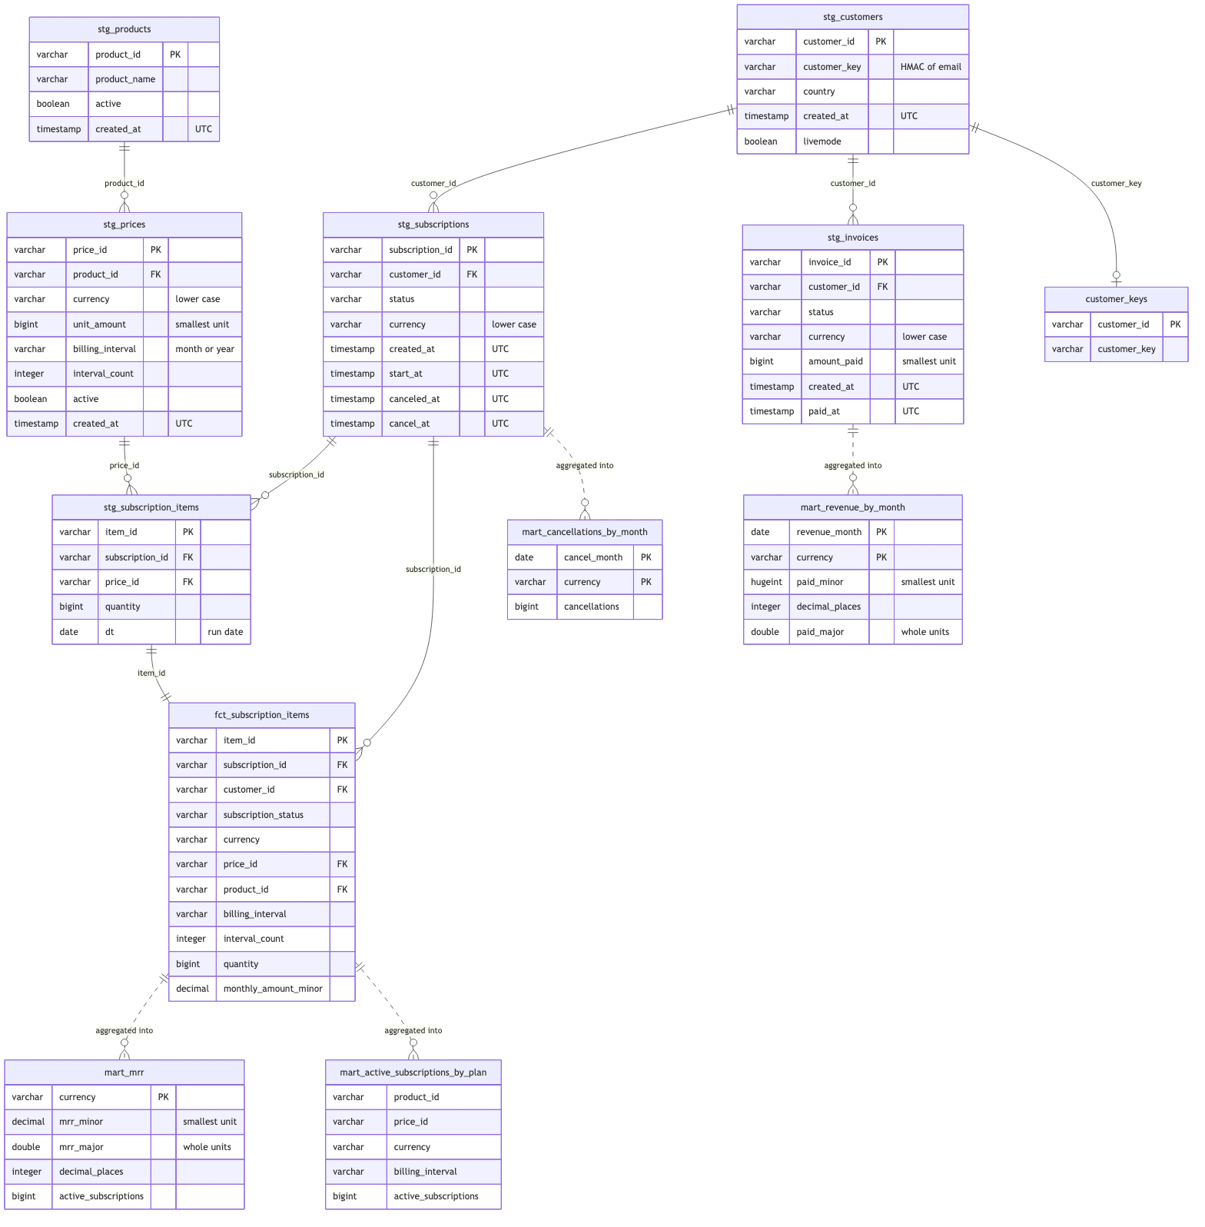
Figure 2. Staging and mart tables and how they join. Personal fields are not in staging, so they do not appear. Source: design_doc/schema.md.

Endpoints and schema (raw layer)
Extraction runs through job.yaml. Each endpoint is a list call with has_more pagination (items_path: data), written to data/raw/<endpoint>/dt=.../<endpoint>.jsonl.
Endpoint | Key | Relations | Planned fields (staging)
customers | id | none | customer_key, country, created, livemode
products | id | none | name, active, created
prices | id | product to products | unit_amount, currency, interval, active
subscriptions | id | customer to customers | status, created, current_period_start, current_period_end, cancel_at
subscription_items (V1) | id | subscription (embedded items) | subscription_id, price_id, quantity
invoices | id | customer, subscription | status, amount_paid, currency, created, paid_at
charges | id | customer, invoice | amount, currency, status, created

- Subscription items (V1): the subscriptions endpoint returns each subscription with its items embedded (items.data, items.has_more). The flatten step reads them from the warehouse's subscription list, which holds every subscription, so no extra API calls are needed. If items.has_more is true for any subscription, the flatten step fails and names the subscription, so an incomplete list is never written silently. A per-subscription fetch of the subscription items endpoint is added only if that failure happens with real data.
- Money is stored as an integer in the currency's smallest unit, and converted only for display. Smallest unit is not always cents: zero-decimal currencies such as JPY and KRW are already in whole units, and three-decimal currencies such as KWD use thousandths. A currency table holds each currency's decimal places (0, 2, or 3), and the display step divides by 10 to that power. Each row keeps its own currency code, stored in lower case. Reports are per currency. Marts never sum amounts across currencies, and there is no currency conversion in this design.
- Timestamps are Unix seconds, which are always UTC. Staging converts them to UTC timestamps. All dates in marts are UTC dates: daily and monthly buckets use the UTC day and month, and the mart definitions say so. Raw folder dates (dt=) also use UTC, as run_extract.sh already does with date -u. Dashboards label the timezone as UTC, so a revenue figure near midnight is not mistaken for local time.
- Revenue date: created is when an invoice was made. Revenue reports use the paid date (paid_at, verify the field path), and bookings use created. The mart definitions say which one they use.

Zero-cost constraint and persistence
Decided: the baseline must cost nothing and keep running for at least a year. A new AWS Free-plan account closes after about six months, and Databricks Free Edition has no fixed lifetime and can delete inactive accounts, so neither is in the baseline. Databricks appears only as the optional V4 demo.
Decided: Stripe is the source of truth. The pipeline can always rebuild the warehouse from Stripe, so GitHub does not need to keep data for a year. What must persist between runs is small:
- Checkpoints (V2): state/checkpoints.json is committed by the scheduled workflow with [skip ci] in the commit message, so the commit does not start another run. The commit also keeps the repo active, which helps with the 60-day rule for scheduled workflows.
- Warehouse (V2): each run restores data/warehouse/warehouse.duckdb from the previous run's artifact for incremental loads. If the artifact has expired, the run does a full rebuild from Stripe. The run log records which path it took.
- Test data (V3 dashboard): a separate workflow, test-invoice, creates one paid test invoice a day in the Stripe test account, half an hour before the pipeline, so the dashboard gets a new day. It is the only job that writes to Stripe. The pipeline itself stays read-only, and the script refuses any key that is not a test-mode key.
- Decided, Dagster run history per run: each Actions run starts with an empty Dagster instance, so the Dagster UI shows the current run only. The GitHub Actions log is the run record, and the checkpoint file is the source of truth for what has been loaded. Dagster's hosted service is a later option if the UI history is wanted for the demo; the assets would not change.
- Actions cache is not used for data: cache entries expire after about a week without use (verify), so they can't be relied on.

Partitioning (phase 1: low cost)
Decided: partition only where it's cheap now. Two rules, applied from V1:
- Raw files are written to a folder per run date (see Repository layout). Each run adds a file to that folder, and nothing is overwritten. Earlier days are never touched, so each day can still be replayed or audited on its own.
- Marts filter on the business date of each record (Stripe created or paid date, per the mart definition). This is a WHERE clause in dbt, with no new structure.
Deferred to later phases: daily subscription snapshots for MRR and churn over time (new milestone, V2 or later), Dagster daily partitions for backfills (V2), and region or business-unit partitions, which stay out unless access or residency rules require them. Dimension tables such as customers and products stay unpartitioned.

Data formats
Decided: each stage has one format, and Parquet is the first columnar format, written by the flatten step.
Stage | Format | Location | Shape
Raw | JSON Lines (UTF-8) | data/raw/<endpoint>/dt=YYYY-MM-DD/ | One Stripe object per line, unchanged and nested.
Loaded raw | DuckDB table | warehouse.duckdb, raw_<endpoint> | id (key), payload (whole object as text), _dt, _loaded_at.
Flattened (V1, PySpark) | Parquet | data/silver/subscription_items/dt=YYYY-MM-DD/ | One row per subscription item: subscription_id, price_id, quantity, dt.
Staging and marts | DuckDB tables (dbt) | warehouse.duckdb, stg_* and mart tables | Typed columns: timestamps, integer cents, lower-case currency, customer_key.

- Raw stays JSON Lines because it matches the library's output. Stripe objects change over time, so the loaded raw table stores the whole object as text, and new fields never break the load.
- Parquet is used where the schema is fixed and typed: the flattened subscription items. It is columnar, so queries that read a few columns stay fast, and it is the standard lake format for Spark and Databricks.
- To inspect a Parquet file, query it with DuckDB, for example SELECT * FROM 'file.parquet' LIMIT 5. The file is binary, so a text editor won't show it.

Pipeline stages (with versions)
- Extract (V1): the runner calls apiframework with job.yaml and writes dated raw JSON Lines. Dagster asset in V2.
- Load (V1): raw files load into one DuckDB table per endpoint, upserted by id, so the newest dt= folder wins and reruns do not duplicate rows. Then customer_keys is rebuilt from the raw customers, using the HMAC described under Personal data.
- Stage (V1): dbt staging models (stg_*) keep only allowlisted fields. They join customer_key, drop name, email, phone, and address, and convert Unix seconds to UTC timestamps and amounts to typed integers. Charges are not staged yet, because no mart uses them.
- Flatten (V1): a PySpark script (flatten_items.py) reads the full subscription list from the warehouse, so incremental runs still give a complete result. It stops, naming each duplicated id and its count, if any run file repeats an id. It also stops if any items.has_more is set. Otherwise it takes the embedded items and writes Parquet. When it stops, it writes nothing. Staging reads only the newest date folder, because each folder is a full snapshot of all items.
- Marts and tests (V1): dbt builds fct_subscription_items, mart_mrr, mart_active_subscriptions_by_plan, mart_revenue_by_month, and mart_cancellations_by_month. MRR counts active and trialing subscriptions, and yearly prices are divided by 12. Tests cover keys, uniqueness, foreign keys, accepted statuses and intervals, the currency table, and non-negative MRR. A failing test fails the run.
- Orchestrate (V2): Dagster runs the steps as assets with retries, logs, and a UI. GitHub Actions triggers the job daily, with the secrets and concurrency rules above.
- Publish (V3): a Python script builds a static HTML page from public marts only. The public marts are copied into their own database first, and the page reads only that. The workflow publishes it to GitHub Pages through a deploy job, which is skipped while the repository is private.

Scale and reliability
- Incremental extract (V2): each endpoint reads created at or after its checkpoint minus an overlap window of one day, to catch late records. A weekly full refresh catches records whose status changed after creation, since a created-date filter misses those updates.
- Idempotent loads: upsert by id, so overlap windows and retries do not duplicate rows.
- Rate limits: set the rate_limits and retry settings in job.yaml, using apiframework's limits, rather than relying on Stripe's errors. Stripe's test-mode limits are not verified yet.
- Schema drift: staging tests fail when an expected column is missing, and raw payloads keep unknown new fields for later use.
- Overlapping runs: the concurrency group in the workflow queues runs, so two runs never write the warehouse at once.
- Snapshots (later): daily subscription status snapshots for MRR and churn over time, as described under Partitioning.

Open decisions
- Restricted read-only Stripe key (rk_test_...): switch before any shared use. Decide before V2.
- PSEUDONYM_SALT storage and rotation policy: confirm the environment secret approach and who may rotate it.
- Decided: PySpark is pinned to 4.2.0 in pyproject.toml and uv.lock. Java is not pinned yet. Users install their own JDK, and the workflow's Java version is decided when V2 is built.
- Second source: Salesforce or HubSpot, joined to Stripe by customer_key. Not scheduled.
- Databricks (V4): the same PySpark and dbt code on Databricks Free Edition with Delta tables. Decided: log in with a personal access token, kept in the environment variable DATABRICKS_TOKEN and never in the repo. Renew it before its 90-day expiry. A service principal is not used, because Free Edition has no account-level API access.

Library dependencies
- The pipeline installs apiframework from the local checkout (../API_framework, editable).
- The has_more strategy and the CLI output-folder fix are merged into the library's main branch.
- When the library is published, the dependency moves to PyPI and uv.lock gets committed.
- Known library gap: a has_more endpoint whose response lacks the flag stops after page one with no error. The fix (raise an error when the flag is missing) is proposed in the library, not done.

Non-goals
- No real customer data and no live keys in this demo.
- No Airflow or other second orchestrator. Dagster is the only orchestrator.
- No response data in apiframework's state store (a library invariant). Checkpoints live in the pipeline repo, not the library.
- No AWS in the plan. Glue, Athena, and S3 are dropped; Databricks covers the cloud demo.

Milestones
- V1 (local MVP): dated raw files, PySpark flatten to Parquet, idempotent DuckDB load, staging with personal fields removed, dbt marts and tests, seeding script for customers with emails. Exit: dbt build passes, and a rerun on the same day gives the same counts.
- Quickstart (end of V1): on a new machine with Java installed, clone the repo, set STRIPE_TEST_KEY, and run one command from the README. Exit: the marts are produced, and the row counts match the counts documented in the README.
- V2 (orchestrated): Dagster assets with partitions, retries, and a UI; scheduled GitHub Actions with the stripe-test environment and concurrency group; incremental extract with checkpoints and an overlap window; warehouse restore from the previous artifact with a full-rebuild fallback; Java installed in the workflow, with the version decided when the workflow is built. Exit: a forced failure retries and shows in the Dagster UI; the second scheduled run is incremental; a run with an expired artifact falls back to a full rebuild and produces the same counts.
- V3 (published): static dashboard page from public marts only, published to GitHub Pages by the workflow once the repository is public; dbt PII guard test; README on rebuilding. Exit: the page updates after a scheduled run, and the guard test fails when a personal column is added to a public model.
- V4 (optional cloud demo): the same PySpark job runs on Databricks Free Edition, writing Delta tables, with the dbt models and a Databricks SQL dashboard. Exit: dbt tests pass on Databricks, and the dashboard numbers match the DuckDB marts. Needs a Databricks account. Status: dbt build passes on Databricks (45 tests), and the dashboard figures match the DuckDB marts. The dashboard is an AI/BI dashboard on the four marts. Data is loaded by hand from a masked Parquet export (export_databricks) into Unity Catalog tables, not on a schedule. Free Edition does not support custom storage locations, so S3 is not used.

