LAB 1:

Q1)

Q2)

Q3)

LAB 2:

Q1: (TCP)

Server:

#include<string.h>
#include<unistd.h>
#include<sys/socket.h>
#include<sys/types.h>
#include<netinet/in.h>
#include<stdlib.h>
#include<stdio.h>
#define MAX_LEN 100

void replaceAll (char *str, const char *oldWord, const char *newWord) {
char *pos = NULL, temp[1000];
int index = 0;
int owlen;
owlen = strlen(oldWord);
while((pos = strstr(str,oldWord)) != NULL) {
strcpy(temp, str);
index = pos-str;
str[index] = '\0';
strcat(str, newWord);
strcat(str, temp + index + owlen);
}
}

int main()
{
int s,r,recb,sntb,x,ns,a=0;
socklen_t len;
struct sockaddr_in server,client;
char buff[50];
s=socket(AF_INET,SOCK_STREAM,0);
if(s==-1) {
printf("\nSocket creation error.");
exit(0);
}
server.sin_family=AF_INET;
server.sin_port=htons(7503);
server.sin_addr.s_addr=htonl(INADDR_ANY);
r=bind(s,(struct sockaddr*)&server,sizeof(server));
if(r==-1) {
printf("\nBinding error."); exit(0);
} else {
printf("Bind Successful!");
}
r=listen(s,5);
if(r==-1) {
close(s); exit(0);
}

printf("\nServer listening.....\n");
len = sizeof(client);
ns = accept(s, (struct sockaddr*) &client, &len);
if(ns==-1) {
close(s);
exit(0);
}

recb=recv(ns,buff,sizeof(buff),0);
printf("\nFile Name Received!\n");
char fil[50];
if( access(buff, F_OK) != -1 ) {
strcpy(fil,buff);
strcpy(buff,"File exists");
}
else {
strcpy(buff,"File does not exist!");
}
sntb=send(ns,buff,sizeof(buff),0);

if(strcmp(buff,"File does not exist!")==0) {
close(s);
close(ns);
exit(0);
}

int ch=0;
while(ch!=4)
{
recb=recv(ns,buff,sizeof(buff),0);
ch = buff[0];
int i,n,n1,n2,j;
char str[50],str1[50],str2[50];
char strTempData[MAX_LEN];
char **strData = NULL;
int noOfLines = 0;
switch(ch)
{
case 1:
//Searching for file
printf("\nSearching..\n");
n=buff[1];
for(i=0;i<n;i++)
str[i]=buff[i+2];
str[n]='\0';
FILE *fp;
int line_num = 1;
int find_result = 0;
char temp[512];
if((fp = fopen(fil, "r")) == NULL) {
printf("\nFile not found");
close(s);
close(ns);
exit(0);
}

while(fgets(temp, 512, fp) != NULL) {
if((strstr(temp, str)) != NULL) {
find_result++;
}
line_num++;
}

if(fp) {
fclose(fp);
}
buff[0]=find_result;
sntb=send(ns,buff,sizeof(buff),0);
break;
case 2:
//replacing word
n1=buff[1];
i=2;
for(j=0;j<n1;j++) {
str1[j]=buff[i];
i++;
}
str1[j]='\0';
recb=recv(ns,buff,sizeof(buff),0);
n=buff[1]; i=2;
for(j=0;j<n;j++) {
str2[j]=buff[i];
i++;
}
str2[j]='\0';

printf("\nReplacing %s with %s..\n",str1,str2);
FILE * fPtr;
FILE * fTemp;
char buffer[1000];
fPtr = fopen(fil, "r");
fTemp = fopen("replace.tmp", "w");
if (fPtr == NULL || fTemp == NULL) {
printf("\nUnable to open file.\n");
exit(0);
}
while ((fgets(buffer, 1000, fPtr)) != NULL) {
replaceAll(buffer, str1, str2);
fputs(buffer, fTemp);
}
fclose(fPtr);
fclose(fTemp);
remove(fil);
rename("replace.tmp", fil);
strcpy(buff,"String replaced");
sntb=send(ns,buff,sizeof(buff),0);
break;
case 3:
printf("\nOrdering file..\n");
FILE * ptrFileLog = NULL;
FILE * ptrSummary = NULL;
if ( (ptrFileLog = fopen(fil, "r")) == NULL ) {
fprintf(stderr,"Error: Could not open %s\n",fil);
return 1;
}
if ((ptrSummary = fopen("temp.txt", "a")) == NULL ) {
fprintf(stderr,"Error: Could not open temp.txt\n");
return 1;
}
while(fgets(strTempData, MAX_LEN, ptrFileLog) != NULL) {
if(strchr(strTempData,'\n'))
strTempData[strlen(strTempData)-1] = '\0';
strData = (char**)realloc(strData, sizeof(char**)*(noOfLines+1));
strData[noOfLines] = (char*)calloc(MAX_LEN,sizeof(char));
strcpy(strData[noOfLines], strTempData);
noOfLines++;
}
for(i= 0; i < (noOfLines - 1); ++i) {
for(j = 0; j < ( noOfLines - i - 1); ++j) {
if(strcmp(strData[j], strData[j+1]) > 0) {
strcpy(strTempData, strData[j]);
strcpy(strData[j], strData[j+1]);
strcpy(strData[j+1], strTempData);
}
}
}

for(i = 0; i < noOfLines; i++)
fprintf(ptrSummary,"%s\n",strData[i]);
for(i = 0; i < noOfLines; i++)
free(strData[i]);

free(strData);
remove(fil);
rename("temp.txt",fil);
fclose(ptrFileLog);
fclose(ptrSummary);
strcpy(buff,"Ordering done!");
sntb=send(ns,buff,sizeof(buff),0);
break;
case 4:
ch=4;
break;
}
}
close(ns);
close(s);
}

Client:

#include<string.h>
#include<arpa/inet.h>
#include<stdlib.h>
#include<stdio.h>
#include<unistd.h>
#include<sys/socket.h>
#include<sys/types.h>
#include<netinet/in.h>
#include<fcntl.h>
#include<sys/stat.h>

int main()
{
int s,r,recb,sntb,x;
struct sockaddr_in server;
char buff[50];
s=socket(AF_INET,SOCK_STREAM,0);
server.sin_family=AF_INET;
server.sin_port=htons(7503);
server.sin_addr.s_addr=inet_addr("127.0.0.1");
r=connect(s,(struct sockaddr*)&server,sizeof(server));
if(r==-1) {
printf("\nConnection error.");
exit(0);
}
printf("Enter File Name: ");
scanf("%s", buff);

sntb=send(s,buff,sizeof(buff),0);
recb=recv(s,buff,sizeof(buff),0);
printf("\n%s\n", buff);
if(strcmp(buff,"File does not exist!")==0) {
close(s);
exit(0);
}
int ch=0;
while(ch!=4)
{
printf("\n1.Search\n2.Replace\n3.Reorder\n4.Exit\nEnter your choice: ");
scanf("%d",&ch);
buff[0]=ch;
char str1[50],str2[50];
int n,i,j;
switch(ch)
{
case 1:
printf("\nEnter string to be searched: ");
scanf("%s",str1);
n=strlen(str1);
buff[1]=n;
for(i=0;i<n;i++)
buff[i+2]=str1[i];
buff[i+2]='\0';
sntb=send(s,buff,sizeof(buff),0);
recb=recv(s,buff,sizeof(buff),0);
n=buff[0];
printf("\nWord Count: %d\n",n);
break;
case 2:
printf("\nEnter string to be searched: ");
scanf("%s",str1);
n=strlen(str1);
buff[1]=n;
for(i=0;i<n;i++)
buff[i+2]=str1[i];
buff[i+2]='\0';
sntb=send(s,buff,sizeof(buff),0);
printf("\nEnter replacement string: ");
scanf("%s",str2);
n=strlen(str2);
buff[1]=n;
i=2;
for(j=0;j<n;j++) {
buff[i]=str2[j];
i++;
}
buff[i]='\0';
sntb=send(s,buff,sizeof(buff),0);
recb=recv(s,buff,sizeof(buff),0);
printf("%s\n",buff);
break;
case 3:
sntb=send(s,buff,sizeof(buff),0);
recb=recv(s,buff,sizeof(buff),0);
printf("%s\n",buff);
break;
case 4:
sntb=send(s,buff,sizeof(buff),0);
break;
default:
printf("\n Try Again!\n");
}
}
close(s);
}

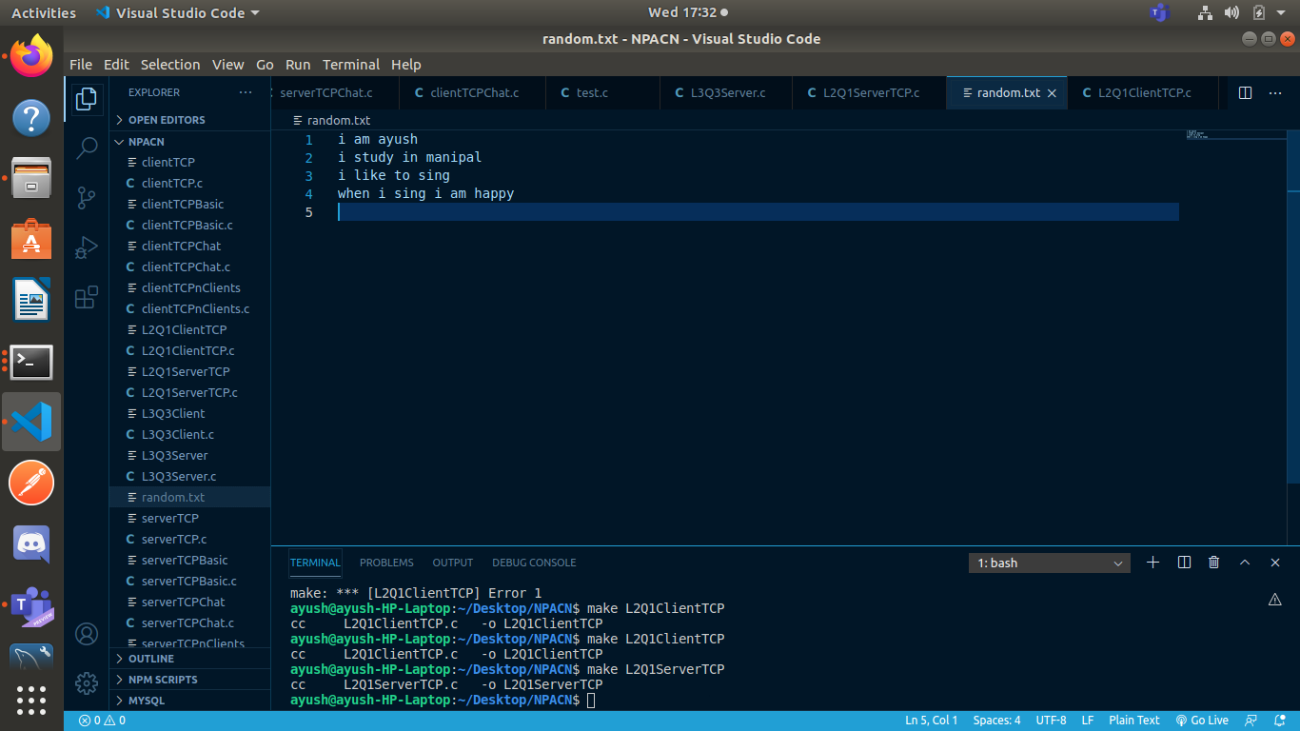
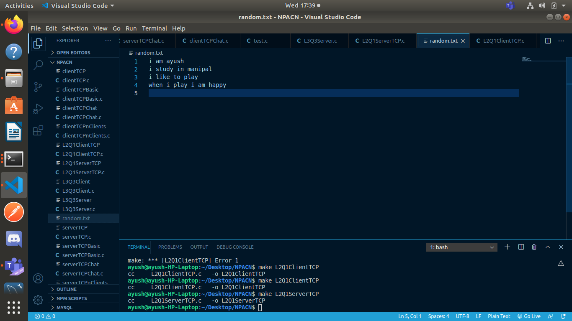
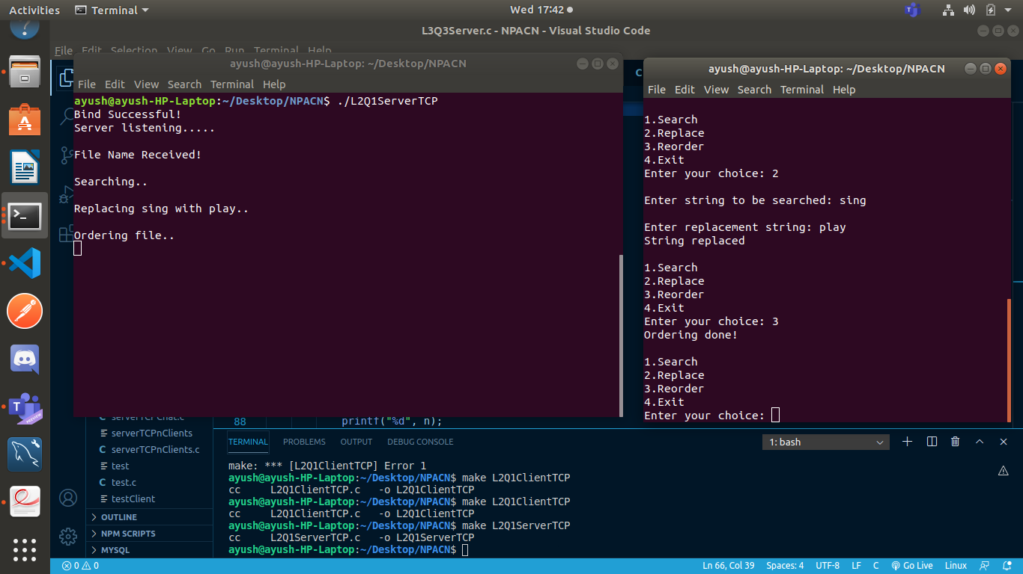
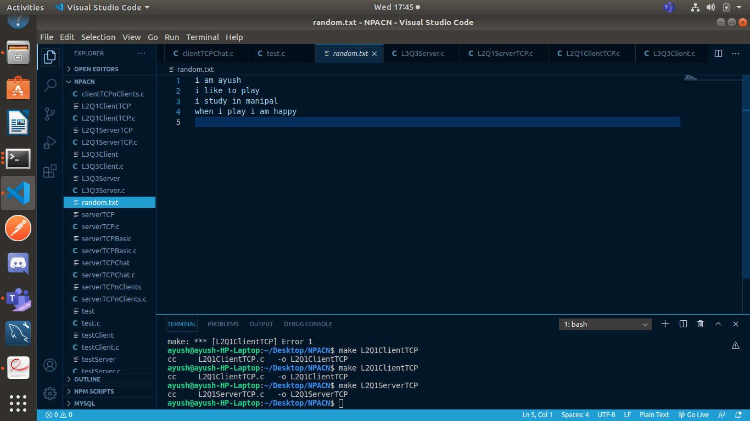

Q1) UDP:

Server:

#include<string.h>
#include<unistd.h>
#include<sys/socket.h>
#include<sys/types.h>
#include<netinet/in.h>
#include<stdlib.h>
#include<stdio.h>
#define MAX_LEN 100
void replaceAll(char *str, const char *oldWord, const char *newWord)
{
char *pos, temp[1000];
int index = 0;
int owlen;
owlen = strlen(oldWord);
while ((pos = strstr(str, oldWord)) != NULL)
{
strcpy(temp, str);
index = pos - str;
str[index] = '\0';
strcat(str, newWord);
strcat(str, temp + index + owlen);
}
}

int main()
{
int s,r,recb,sntb,x;
int ca;
socklen_t len;
struct sockaddr_in server,client;
char buff[50];
s=socket(AF_INET,SOCK_DGRAM,0);
server.sin_family=AF_INET;
server.sin_port=htons(7504);
server.sin_addr.s_addr=htonl(INADDR_ANY);
len=sizeof(client);
ca=sizeof(client);
r=bind(s,(struct sockaddr*)&server,sizeof(server));
if(r==-1) {
printf("\nBinding error.");
exit(0);
} else {
printf("Bind successful!\n");
}
recb=recvfrom(s,buff,sizeof(buff),0,(struct sockaddr*)&client,&ca);
printf("\nFile Name Received!\n");char fil[50];
if( access( buff, F_OK ) != -1 ) {
strcpy(fil,buff);
strcpy(buff,"File exists");
} else {
strcpy(buff,"File does not exist!");
}
sntb=sendto(s,buff,sizeof(buff),0,(struct sockaddr*)&client,len);
if(strcmp(buff,"File does not exist!")==0) {
close(s); exit(0);
}
int ch=0;
while(ch!=4) {
recb=recvfrom(s,buff,sizeof(buff),0,(struct sockaddr*)&client,&ca);
ch = buff[0];
int i,n,n1,n2,j;
char str[50],str1[50],str2[50];
char strTempData[MAX_LEN];
char **strData = NULL;
int noOfLines = 0;
switch(ch) {
case 1:
printf("\nSearching..\n");
n=buff[1];
for(i=0;i<n;i++)
str[i]=buff[i+2];
str[n]='\0';
FILE *fp;
int line_num = 1;
int find_result = 0;
char temp[512];
if((fp = fopen(fil, "r")) == NULL) {
printf("\nFile not found");
close(s);
exit(0);
}
while(fgets(temp, 512, fp) != NULL) {
if((strstr(temp, str)) != NULL)
find_result++;
line_num++;
}
if(fp) fclose(fp);
buff[0]=find_result;
sntb=sendto(s,buff,sizeof(buff),0,(struct sockaddr*)&client,len);
break;

case 2:
//replacing word
n1=buff[1];
i=2;
for(j=0;j<n1;j++) {
str1[j]=buff[i];
i++;
}
str1[j]='\0';
recb=recvfrom(s,buff,sizeof(buff),0,(struct sockaddr*)&client,&ca);
n=buff[1];
i=2;
for(j=0;j<n;j++) {
str2[j]=buff[i];
i++;
}
str2[j]='\0';
printf("\nReplacing %s with %s..\n",str1,str2);
FILE * fPtr;
FILE * fTemp;
char buffer[1000];
fPtr = fopen(fil, "r");
fTemp = fopen("replace.tmp", "w");
if (fPtr == NULL || fTemp == NULL) {
printf("\nUnable to open file.\n");
exit(0);
}
while ((fgets(buffer, 1000, fPtr)) != NULL) {
replaceAll(buffer, str1, str2);
fputs(buffer, fTemp);
}
fclose(fPtr);
fclose(fTemp);
remove(fil);
rename("replace.tmp", fil);
strcpy(buff,"String replaced");
sntb=sendto(s,buff,sizeof(buff),0,(struct sockaddr*)&client,len);
break;

case 3:
printf("\nOrdering file..\n");
FILE * ptrFileLog = NULL;
FILE * ptrSummary = NULL;
if ( (ptrFileLog = fopen(fil, "r")) == NULL ) {
fprintf(stderr,"Error: Could not open %s\n",fil);
return 1;
}
if ( (ptrSummary = fopen("temp.txt", "a")) == NULL ) {
fprintf(stderr,"Error: Could not open temp.txt\n");
return 1;
}
while(fgets(strTempData, MAX_LEN, ptrFileLog) != NULL) {
if(strchr(strTempData,'\n'))
strTempData[strlen(strTempData)-1] = '\0';
strData = (char**)realloc(strData, sizeof(char**)*(noOfLines+1));strData[noOfLines] = (char*)calloc(MAX_LEN,sizeof(char));
strcpy(strData[noOfLines], strTempData);
noOfLines++;
}
for(i= 0; i < (noOfLines - 1); ++i) {
for(j = 0; j < ( noOfLines - i - 1); ++j) {
if(strcmp(strData[j], strData[j+1]) > 0) {
strcpy(strTempData, strData[j]);
strcpy(strData[j], strData[j+1]);
strcpy(strData[j+1], strTempData);
}
}
}
for(i = 0; i < noOfLines; i++)
fprintf(ptrSummary,"%s\n",strData[i]);
for(i = 0; i < noOfLines; i++)
free(strData[i]);
free(strData);
remove(fil);rename("temp.txt",fil);
fclose(ptrFileLog);
fclose(ptrSummary);
strcpy(buff,"Ordering done!");
sntb=sendto(s,buff,sizeof(buff),0,(struct sockaddr*)&client,len);
break;

case 4:
ch=4;
break;
}
}
close(s);
}

Client:

#include<string.h>
#include<arpa/inet.h>
#include<stdlib.h>
#include<stdio.h>
#include<unistd.h>
#include<sys/socket.h>
#include<sys/types.h>
#include<netinet/in.h>
#include<fcntl.h>
#include<sys/stat.h>
int main()
{
int s,r,recb,sntb,x;
int sa;
socklen_t len;
struct sockaddr_in server,client;
char buff[50];
s=socket(AF_INET,SOCK_DGRAM,0);
server.sin_family=AF_INET;
server.sin_port=htons(7504);
server.sin_addr.s_addr=inet_addr("127.0.0.1");
sa=sizeof(server);
len=sizeof(server);
printf("\nEnter File Name: ");
scanf("%s", buff);
sntb=sendto(s,buff,sizeof(buff),0,(struct sockaddr *)&server, len);
recb=recvfrom(s,buff,sizeof(buff),0,(struct sockaddr *)&server,&sa);
printf("\n%s\n", buff);
if(strcmp(buff,"File does not exist!")==0) {
close(s); exit(0);
}
int ch=0;
while(ch!=4)
{
printf("\n1.Search\n2.Replace\n3.Reorder\n4.Exit\nEnter your choice: ");
scanf("%d",&ch);
buff[0]=ch;
char str1[50],str2[50];
int n,i,j;
switch(ch)
{
case 1:
printf("\nEnter string to be searched: ");
scanf("%s",str1);
n=strlen(str1);
buff[1]=n;
for(i=0;i<n;i++)
buff[i+2]=str1[i];
buff[i+2]='\0';
sntb=sendto(s,buff,sizeof(buff),0,(struct sockaddr *)&server, len);
recb=recvfrom(s,buff,sizeof(buff),0,(struct sockaddr *)&server,&sa);
n=buff[0];
printf("\nWord Count: %d\n",n);
break;

case 2:
printf("\nEnter string to be searched: ");
scanf("%s",str1);
n=strlen(str1);
buff[1]=n;
for(i=0;i<n;i++)
buff[i+2]=str1[i];
buff[i+2]='\0';
sntb=sendto(s,buff,sizeof(buff),0,(struct sockaddr *)&server, len);
printf("\nEnter replacement string: ");
scanf("%s",str2);
n=strlen(str2);
buff[1]=n;
i=2;
for(j=0;j<n;j++) {
buff[i]=str2[j];
i++;
}
buff[i]='\0';
sntb=sendto(s,buff,sizeof(buff),0,(struct sockaddr *)&server, len);
recb=recvfrom(s,buff,sizeof(buff),0,(struct sockaddr *)&server,&sa);
printf("%s\n",buff);
break;

case 3:
sntb=sendto(s,buff,sizeof(buff),0,(struct sockaddr *)&server, len);
recb=recvfrom(s,buff,sizeof(buff),0,(struct sockaddr *)&server,&sa);
printf("%s\n",buff);
break;

case 4:
sntb=sendto(s,buff,sizeof(buff),0,(struct sockaddr *)&server, len);
break;

default:
printf("\n Try Again!\n");
}
}
close(s);
}

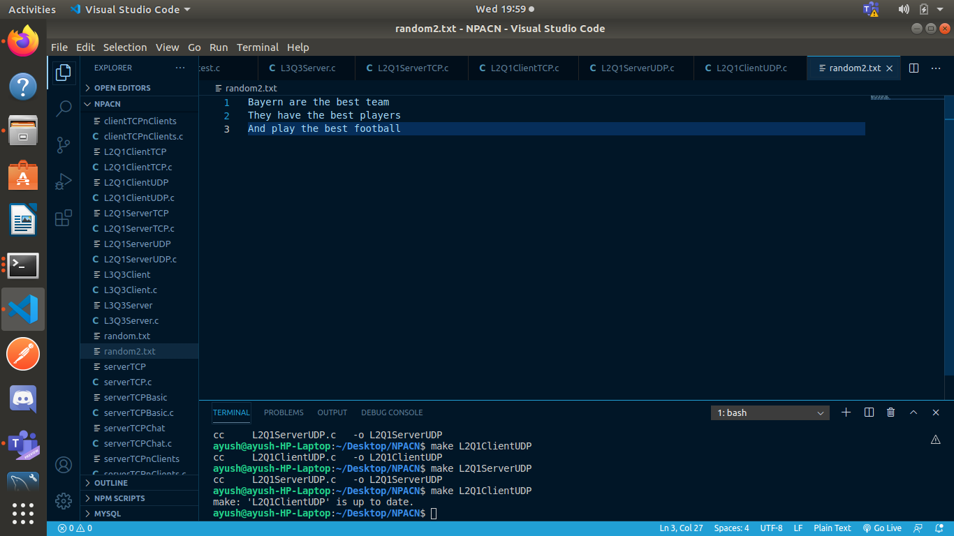
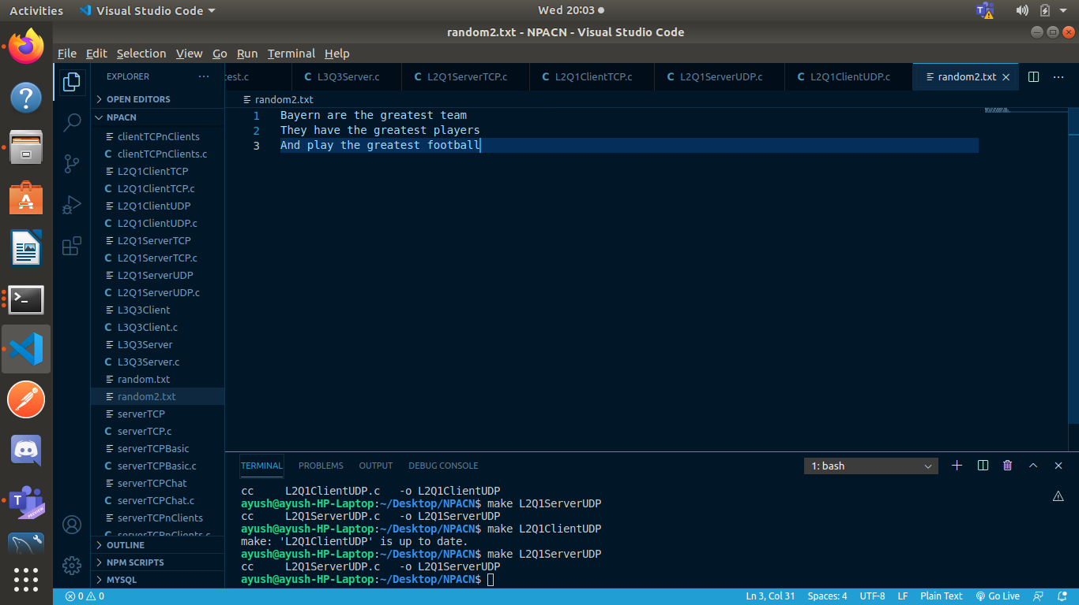
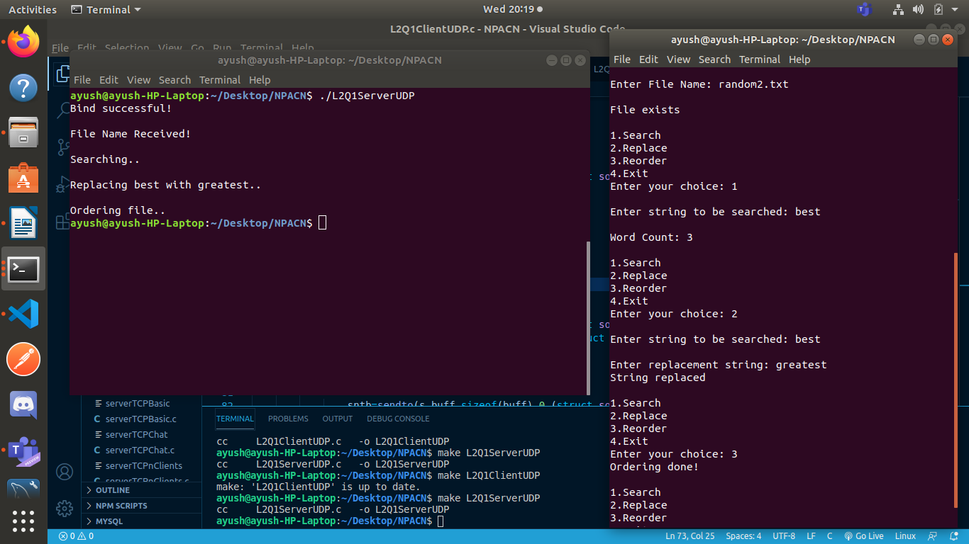

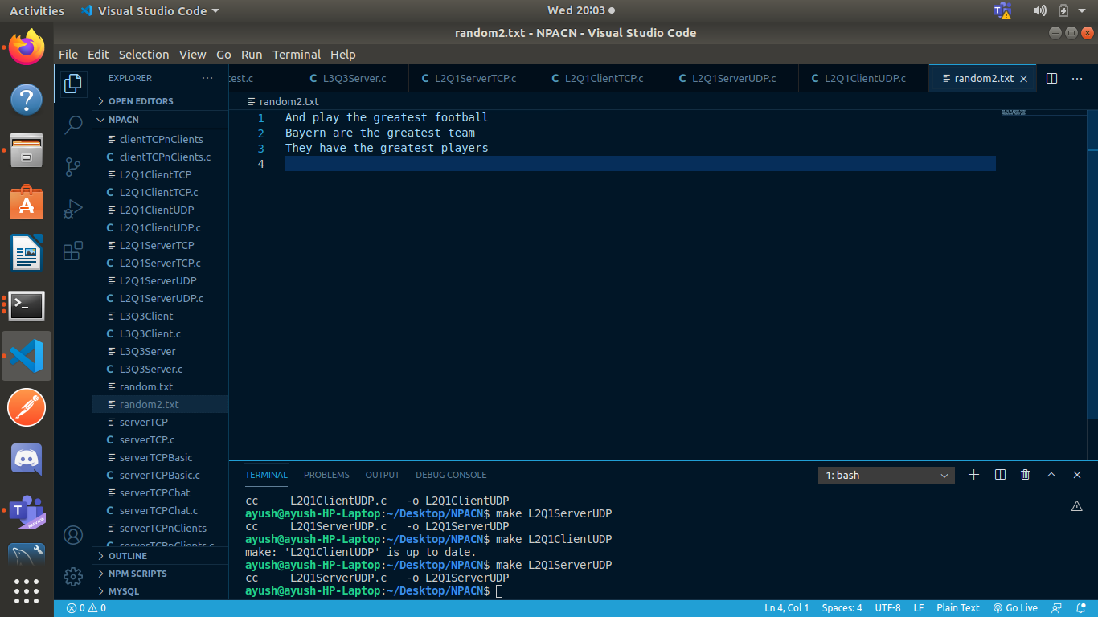

LAB 3:
Q1)

Server:

#include <stdio.h>
#include <sys/socket.h>
#include <netinet/in.h>
#include <string.h>
#include <stdlib.h>

int main() {
int serverSocket = socket(AF_INET, SOCK_STREAM, 0);
struct sockaddr_in server, client;

server.sin_family = AF_INET;
server.sin_port = htons(7500);
server.sin_addr.s_addr = inet_addr("127.0.0.1");
memset(server.sin_zero, 0, sizeof(server.sin_zero));

if (bind(serverSocket, (struct sockaddr*) &server, sizeof(server)) < 0) {
printf("Bind failed");
close(serverSocket); exit(0);
} else {
printf("Bind successful\n");
}

if (listen(serverSocket, 5) < 0) {
printf("Listening error");
close(serverSocket); exit(0);
} else {
printf("Server Listening.....\n");
}

socklen_t addrLen = sizeof(client);
int connSocket = accept(serverSocket, (struct sockaddr*) &client, &addrLen);
if (connSocket < 0) {
printf("Can't accept connection");
close(serverSocket); exit(0);
} else {
printf("Connection Accepted! Start chatting\n");
}

int pid = fork();
char buff[50];

while(1) {
if(pid == 0) { //child reads
int bytes = recv(connSocket, buff, sizeof(buff), 0);
buff[bytes] = '\0';
printf("Client: %s", buff);
printf("Received by child process: %d\n", getpid());
if(strcmp(buff, "bye\n") == 0) {
printf("Receiving process stopped\n");
break;
}
strcpy(buff, "");
} else { //parent sends
fgets(buff, 50, stdin);
send(connSocket, buff, sizeof(buff), 0);
printf("Sent by parent process: %d\n", getpid());
if(strcmp(buff, "bye\n") == 0) {
printf("Sending process stopped \n");
break;
}
strcpy(buff, "");
}
}

close(connSocket);
close(serverSocket);

}

Client:

#include <stdio.h>
#include <sys/socket.h>
#include <netinet/in.h>
#include <string.h>
#include <stdlib.h>

int main() {

int clientSocket = socket(AF_INET, SOCK_STREAM, 0);
struct sockaddr_in server;

server.sin_family = AF_INET;
server.sin_port = htons(7500);
server.sin_addr.s_addr = inet_addr("127.0.0.1");
memset(server.sin_zero, 0, sizeof(server.sin_zero));

if (connect(clientSocket, (struct sockaddr*) &server, sizeof(server)) < 0) {
printf("Can't connect to server");
exit(0); close(clientSocket);
} else {
printf("Connected to server!\n");
}

int pid = fork();
char buff[50];
while(1) {
if(pid == 0) { //child sends
fgets(buff, 50, stdin);
send(clientSocket, buff, sizeof(buff), 0);
printf("Sent by child process: %d\n", getpid());
if(strcmp("bye\n", buff) == 0) {
printf("Sending process stopped\n");
break;
}
strcpy(buff, "");
} else { //parent reads
int bytes = recv(clientSocket, buff, sizeof(buff), 0);
buff[bytes] = '\0';
printf("Server: %s", buff);
printf("Received by parent process: %d\n", getpid());
if(strcmp("bye\n", buff) == 0) {
printf("Receiving process stopped \n");
break;
}
strcpy(buff, "");
}
}

close(clientSocket);

}

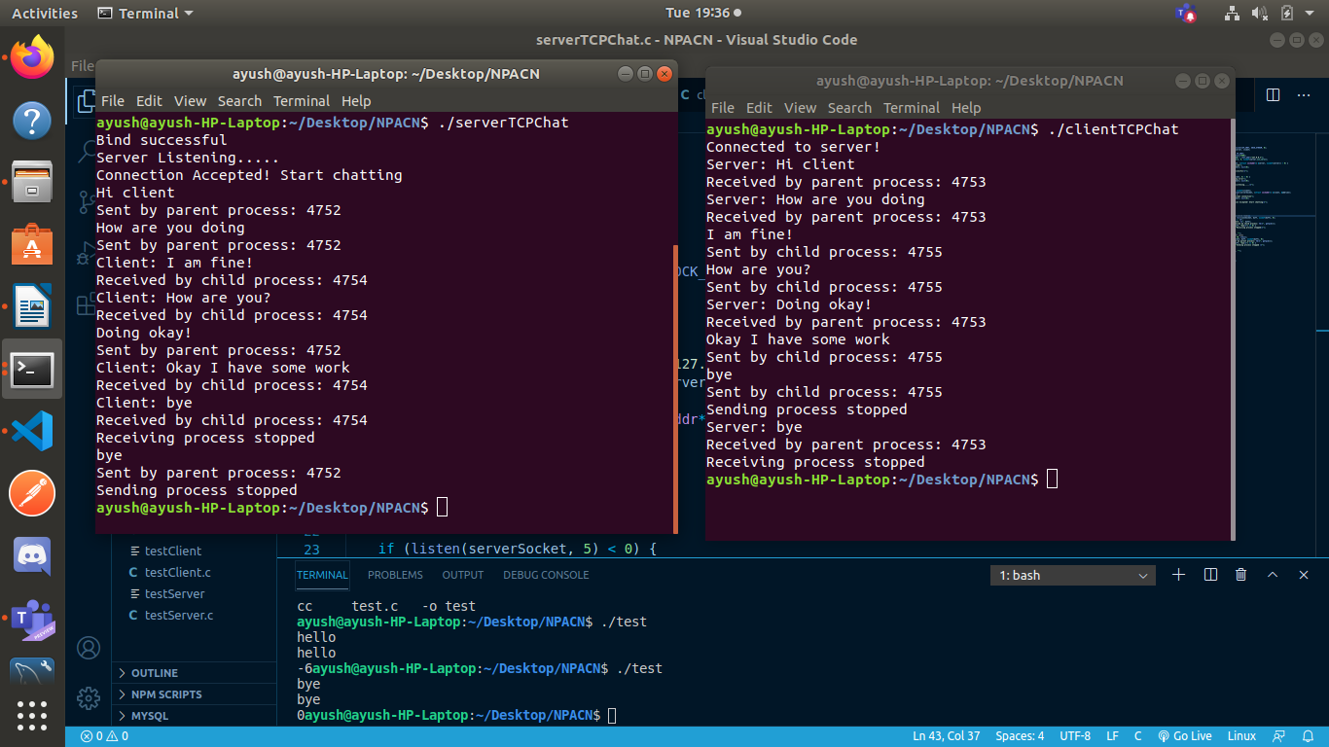

Q2)

Server:
#include <stdio.h>
#include <sys/socket.h>
#include <netinet/in.h>
#include <stdlib.h>
#include <string.h>

void swap(char *x, char *y) {
char temp; temp = *x; *x = *y; *y = temp;
}

void permute(char *a, int l, int r) {
int i;
if (l == r)
printf("%s\n", a);
else {
for (i=l; i<=r; i++) {
swap((a+l), (a+i));
permute(a, l+1, r);
swap((a+l), (a+i));
}
}
}

int main() {
int serverSocket = socket(AF_INET, SOCK_DGRAM, 0);
struct sockaddr_in server, client;

memset(&server, 0, sizeof(server));
server.sin_addr.s_addr = inet_addr("127.0.0.1");
server.sin_family = AF_INET;
server.sin_port = htons(7505);
if(bind(serverSocket, (struct sockaddr *) &server, sizeof(server)) < 0) {
printf("Bind failed\n");
} else {
printf("Bind Successful\n");
}

char buff[50];
while(1) {
socklen_t len = sizeof(client);
recvfrom(serverSocket, buff, sizeof(buff), 0, (struct sockaddr *) &client, &len);
if(strcmp("bye", buff) == 0) {
break;
}
permute(buff, 0, strlen(buff)-1);
strcpy(buff,"Permutations printed!");
sendto(serverSocket, buff, sizeof(buff), 0, (struct sockaddr *) &client, sizeof(client));
strcpy(buff, "");
}
close(serverSocket);

}

Client:
#include <stdio.h>
#include <sys/socket.h>
#include <netinet/in.h>
#include <stdlib.h>
#include <string.h>

int main() {
int clientSocket = socket(AF_INET, SOCK_DGRAM, 0);
struct sockaddr_in server;

memset(&server, 0, sizeof(server));
server.sin_addr.s_addr = inet_addr("127.0.0.1");
server.sin_family = AF_INET;
server.sin_port = htons(7505);

char buff[50];
while(1) {
printf("Enter string: ");
scanf("%s", buff);
sendto(clientSocket, buff, sizeof(buff), 0, (struct sockaddr *) &server, sizeof(server));
if(strcmp("bye", buff) == 0) {
break;
}
socklen_t len = sizeof(server);
recvfrom(clientSocket, buff, sizeof(buff), 0, (struct sockaddr *) &server, &len);
printf("%s\n", buff);
strcpy(buff, "");
}
close(clientSocket);

}

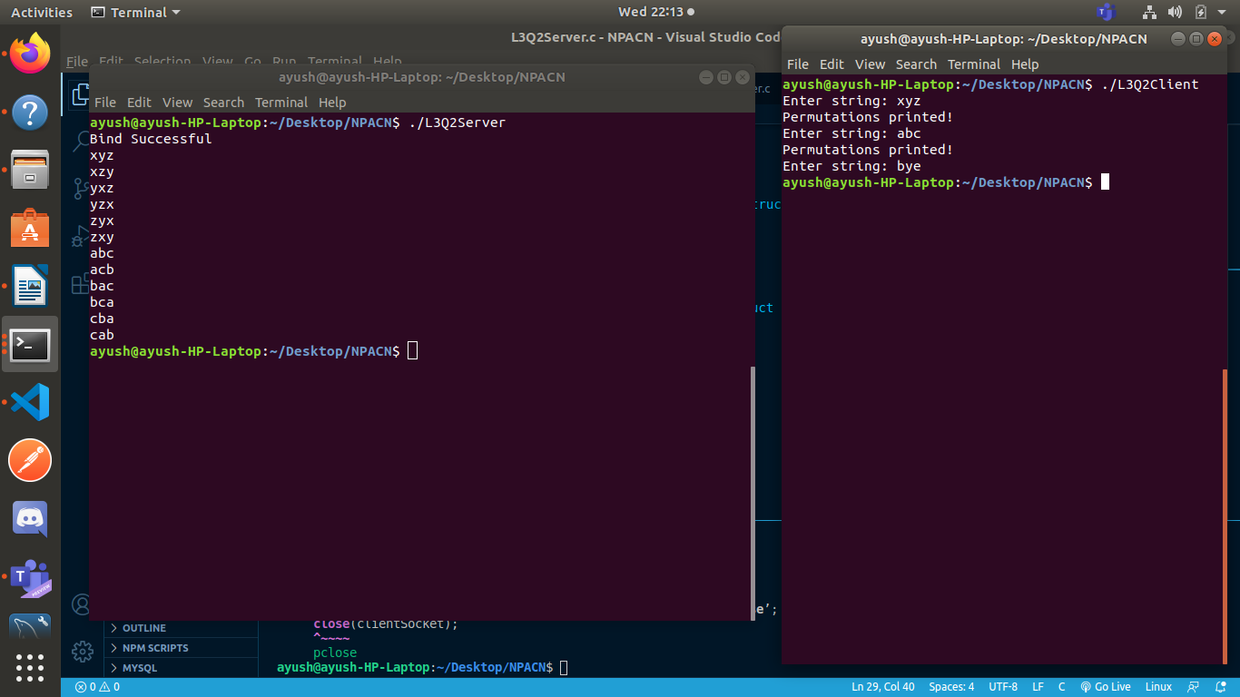

Q3)

Server:

#include <stdio.h>
#include <sys/socket.h>
#include <netinet/in.h>
#include <string.h>
#include <stdlib.h>

int compare (const void * a, const void * b) {
return ( *(int*)a - *(int*)b );
}

int compare1 (const void * a, const void * b) {
return ( *(int*)b - *(int*)a );
}

int main() {
int serverSocket = socket(AF_INET, SOCK_STREAM, 0);
struct sockaddr_in server, client;

server.sin_family = AF_INET;
server.sin_port = htons(7501);
server.sin_addr.s_addr = inet_addr("127.0.0.1");
memset(server.sin_zero, 0, sizeof(server.sin_zero));

if (bind(serverSocket, (struct sockaddr*) &server, sizeof(server)) < 0) {
printf("Bind failed");
close(serverSocket); exit(0);
} else {
printf("Bind successful\n");
}

if (listen(serverSocket, 5) < 0) {
printf("Listening error");
close(serverSocket); exit(0);
} else {
printf("Server Listening.....\n");
}

socklen_t addrLen = sizeof(client);
int connSocket = accept(serverSocket, (struct sockaddr*) &client, &addrLen);
if (connSocket < 0) {
printf("Can't accept connection");
close(serverSocket); exit(0);
} else {
printf("Connection Accepted!\n");
}

char buff[50];
int bytes = recv(connSocket, buff, sizeof(buff), 0);
buff[bytes] = '\0';
printf("Received String: %s\n", buff);
int pid = fork();
int t = 1;
while(t--) {
if(pid == 0) { //child
int num[50], n=1, i;
for(i=0; i<strlen(buff); i++) {
if(buff[i]>='0' && buff[i]<='9') {
num[n++] = buff[i] - 48;
}
}
qsort(num, n, sizeof(int), compare);
num[0] = n;
printf("Sorted numbers: ");
for(i=1; i<n; i++) {
printf("%d ", num[i]);
} printf("\n");
num[n] = getpid();
send(connSocket, num, sizeof(num), 0);
close(connSocket);
close(serverSocket);
} else { //parent
int chars[50], n=1, i;
for(i=0; i<strlen(buff); i++) {
if(buff[i]>='a' && buff[i]<='z') {
chars[n++] = buff[i];
}
}
chars[0] = n;
qsort(chars, n, sizeof(int), compare1);
printf("Sorted characters: ");
for(i=0; i<=n; i++) {
printf("%c ", (char)chars[i]);
} printf("\n");
chars[0] = n;
chars[n] = getpid();
send(connSocket, chars, sizeof(chars), 0);
break;
}
}
close(connSocket);
close(serverSocket);
}

Client:

#include <stdio.h>
#include <sys/socket.h>
#include <netinet/in.h>
#include <string.h>
#include <stdlib.h>

int main() {

int clientSocket = socket(AF_INET, SOCK_STREAM, 0);
struct sockaddr_in server;

server.sin_family = AF_INET;
server.sin_port = htons(7501);
server.sin_addr.s_addr = inet_addr("127.0.0.1");
memset(server.sin_zero, 0, sizeof(server.sin_zero));

if (connect(clientSocket, (struct sockaddr*) &server, sizeof(server)) < 0) {
printf("Can't connect to server");
exit(0); close(clientSocket);
} else {
printf("Connected to server!\n");
}

char buff[50];
int buff1[50], buff2[50];
printf("Enter alphanumeric string: ");
scanf("%s", buff);
send(clientSocket, buff, sizeof(buff), 0);
int bytes = recv(clientSocket, buff1, sizeof(buff1), 0);
printf("Received from process: %d\n", buff1[buff1[0]]);
bytes = recv(clientSocket, buff2, sizeof(buff2), 0);
printf("Received from process: %d\n", buff2[buff2[0]]);
close(clientSocket);
}

