**Project Synopsis**

**Group Id:23**

**Group Members:**

|  |  |  |
| --- | --- | --- |
| **no** | **names** | **Roll_no** |
| **1** | **Mahajan Nilesh Navnath** | **105** |
| **2** | **Magar shubham** | **103** |
| **3** | **Londhe Nikhil** | **101** |
| **4** | **Barhate Siddesh** | **014** |

**Project Title:** Health and Disease analysis.

**Problem statement:**

Implement A Project Based on Python, R, SQL which analyze disease , health .which takes input from users on the basis of hospital or disease that how much patients are found for every month and store it in database. show this data in the form of charts by using R language on the basis of location, date, age, gender, time wise to user

It gate updated every month the GUI is build using python framework Django for processing python is used and for data analysis R is used.

**Objectives:**

* To get health report real time.
* To study about various diseases via location, age, gender, time wise and form some conclusion.
* Show data in graphical form.
* Get data monthly from hospital
* Get status of various disease that they get decrease or not.
* To get monthly report about disease from various hospitals of different locations.

n disease quantity of patients is increasing or not.

* To study disease quantity of patients is increasing or not.

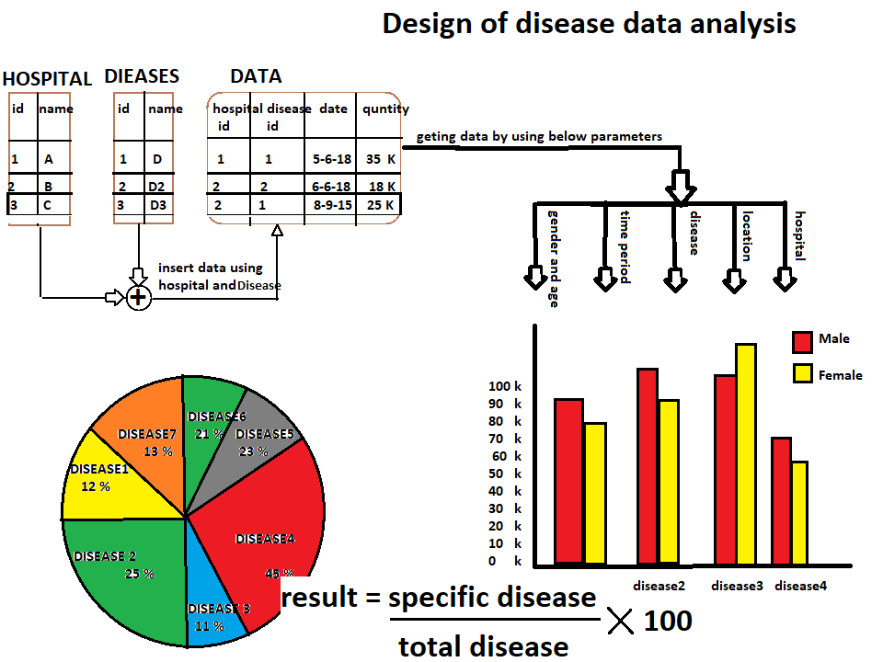

**Implementation:**

* This project accept data from hospital by providing the secret ID to each hospital also it can get from government record for old records.
* Store it in data base with location, date-time and hospital name.
* Access this data for showing result to user as his requirement.
* For processing data use R language and for accept use python language is used. Used for storing data use SQL and for GUI Django is get use.

**Applications:**

* Used for study about specific disease that how much it is spread.
* Find a location that where the quantity of that disease is more in quantity and after founding that the health camp can be arranged on that places.
* Some diseases occurred in specific time so we can study basis of time period and find out those diseases and we can give prescription on that before they get occurred.