**Project Title:** Health and Disease analysis.

**Problem statement:**

Implement A Project Based on Python, R, SQL which analyze disease , health .which takes input from users on the basis of hospital or disease that how much patients are found for every month and store it in database. show this data in the form of charts by using R language on the basis of location, date, age, gender, time wise to user

It gate updated every month the GUI is build using python framework Django for processing python is used and for data analysis R is used.

**Introduction**

Introduction is one of the important aspect,it gives brief information

about what we are going to demonstrate in the project.

In this project we have done analysis on various disease occurring in various locations.We have taken real time data.Hospitals can sign-up in site,they can add, acess data when they want.Normal user can see various terms in the site.

We have analyzed disease report from year 2001 to 2018 according to the various

Aspects involving in it.

They are as follows:

1)According to the month.

2)Male-Female wise.

3)Sesonwise data analyzation.

4)Most spreading disease.

5)Disease wise graphs such as pie-charts,graphs.

6)top- least most disease caused according to month.

**Scope and Objectives**

**a)Hospital-**

1)New hospital can resister.

2)Registered hospital can add monthly data of their hospital.

3)They can view past submitted data.

4)Hospital have assign their descripted profile,they can modify it.

5)They can acess their report.

**B)Normal User-**

1)Normal user can see their report generated by system.

2)If they want,can get soft-copy of report.

**c)System Adminstrator-**

1)They have access to add new disese or remove it.

2)Also have acess to add new hospital and remove previous hospital data.

3)He have privilege to change analysis of algorithm.

4)Can modify Viewing structure of project.

**Objectives-**

1)To get whole report of disese which are most spreading disease and

Which disesase are spreaded in various Sesons.

2) To know which year-nonth wise diseases sprading disease.

**Limitations**

1)Analysis is done only for resistered hospital data that we have got due to

What accuracy of analyzing data may be affected to some extent.

2)Out of hospital that have registered,they may provide wrong data which further

Lead to miss-interpretation of data.

3)We dosent have data of all hospitals so we generated report not as per the the similar to actual condition,it may vary.

**Requirement**

**a)Hardware requirement-**

1)Server

2)NIC

**B] Network -**

Continuous internet connection with static ip address

**C] software requirement-**

1]python

2]OS

**Implementation:**

* This project accept data from hospital by providing the secret ID to each hospital also it can get from government record for old records.
* Store it in data base with location, date-time and hospital name.
* Access this data for showing result to user as his requirement.
* For processing data use R language and for accept use python language is used. Used for storing data use SQL and for GUI Django is get use.

**Applications:**

* Used for study about specific disease that how much it is spread.
* Find a location that where the quantity of that disease is more in quantity and after founding that the health camp can be arranged on that places.
* Some diseases occurred in specific time so we can study basis of time period and find out those diseases and we can give prescription on that before they get occurred.

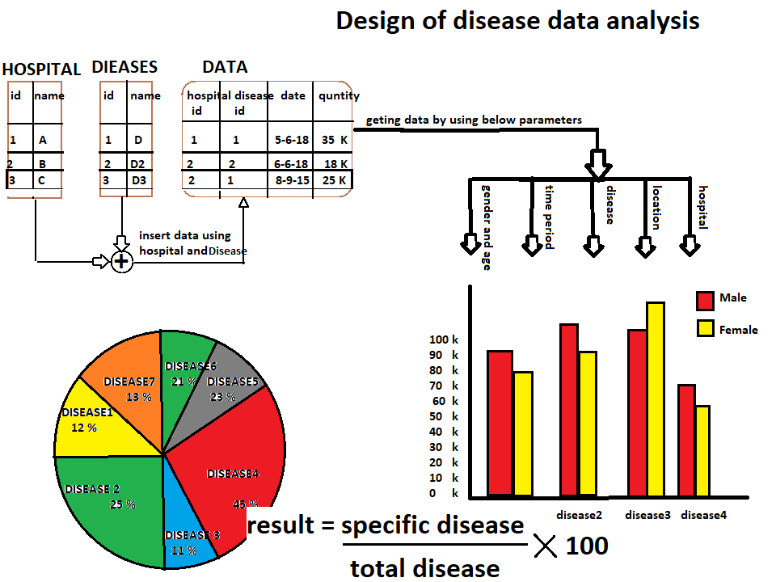

Web View Of project

-- Hospital --

Login 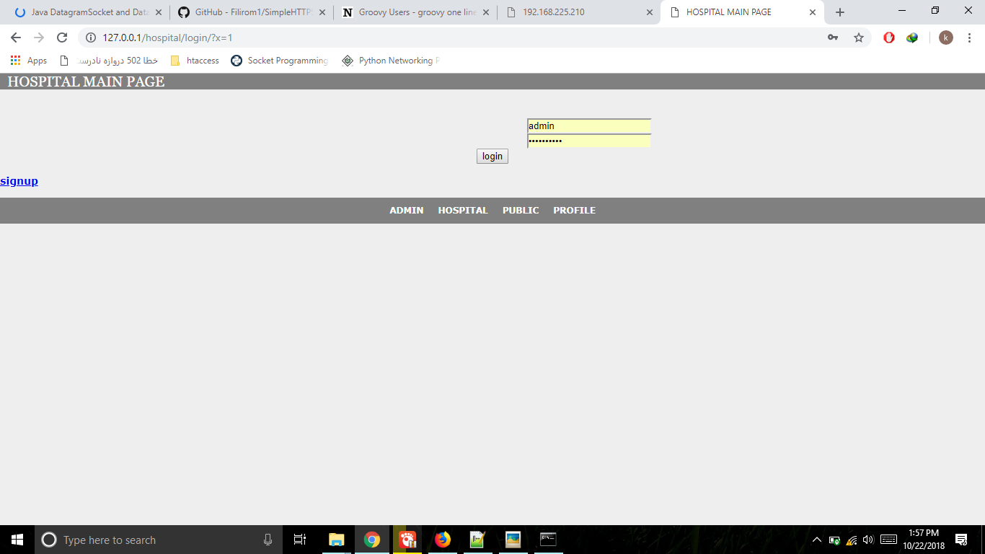Signup Step 1 Out 2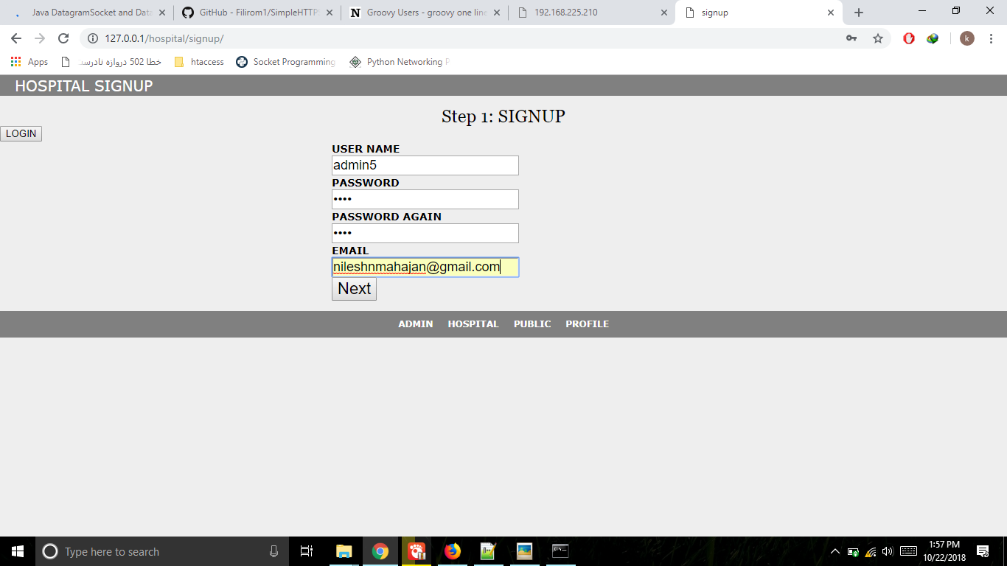

Signup step2 out of 2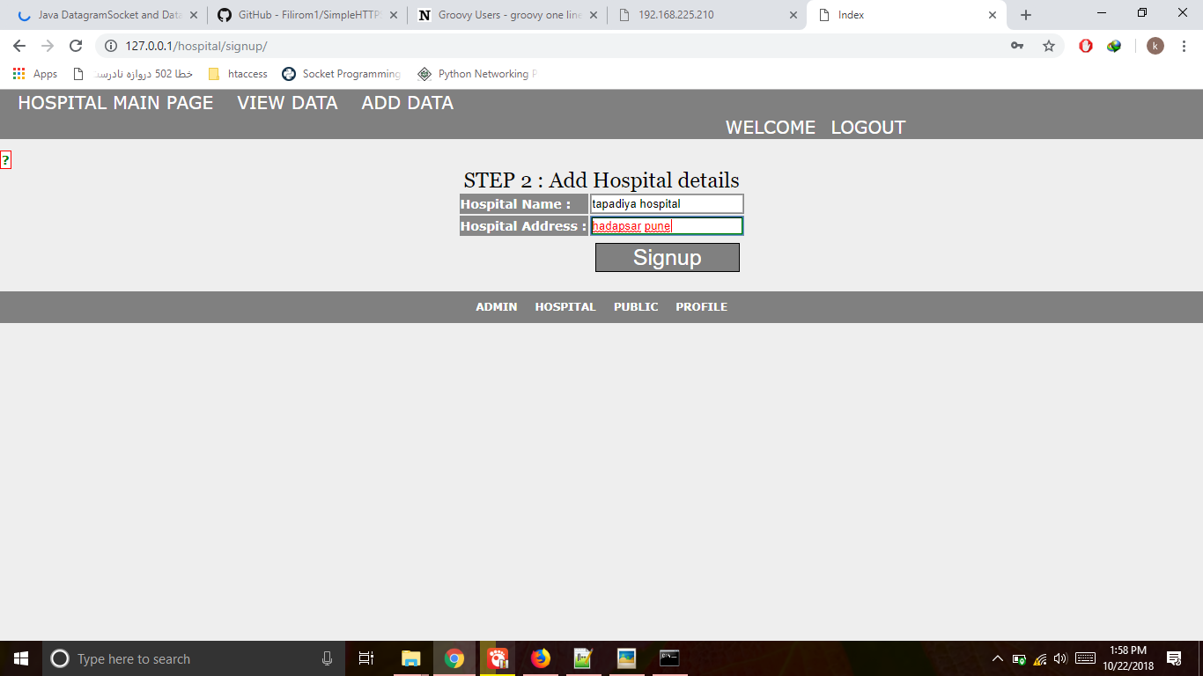 Hospital: Add New Data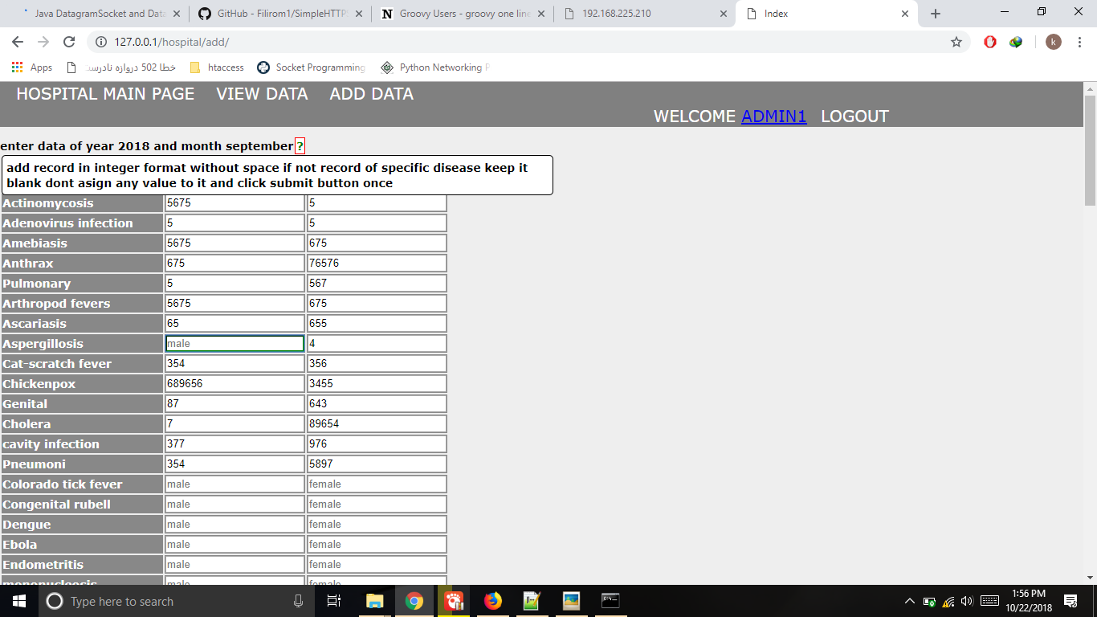

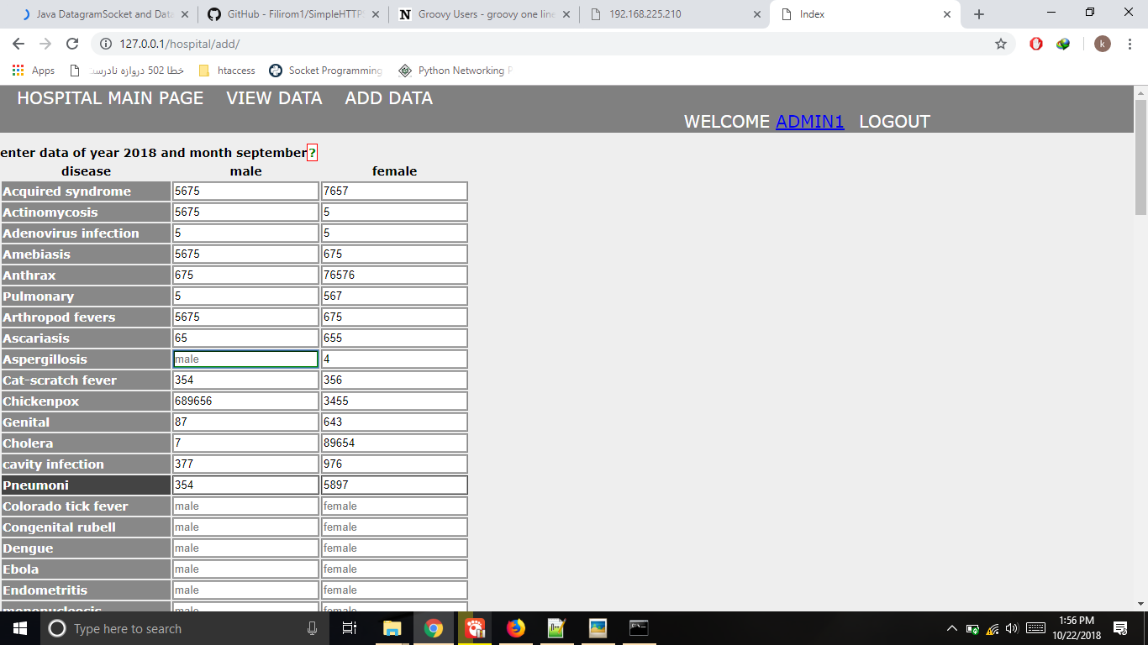

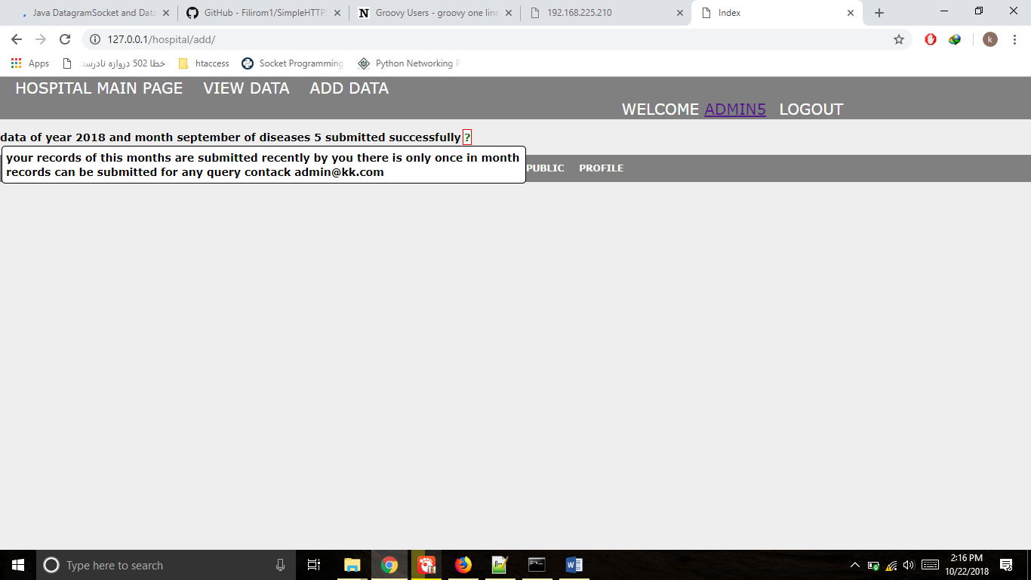

Hospital viewing their old data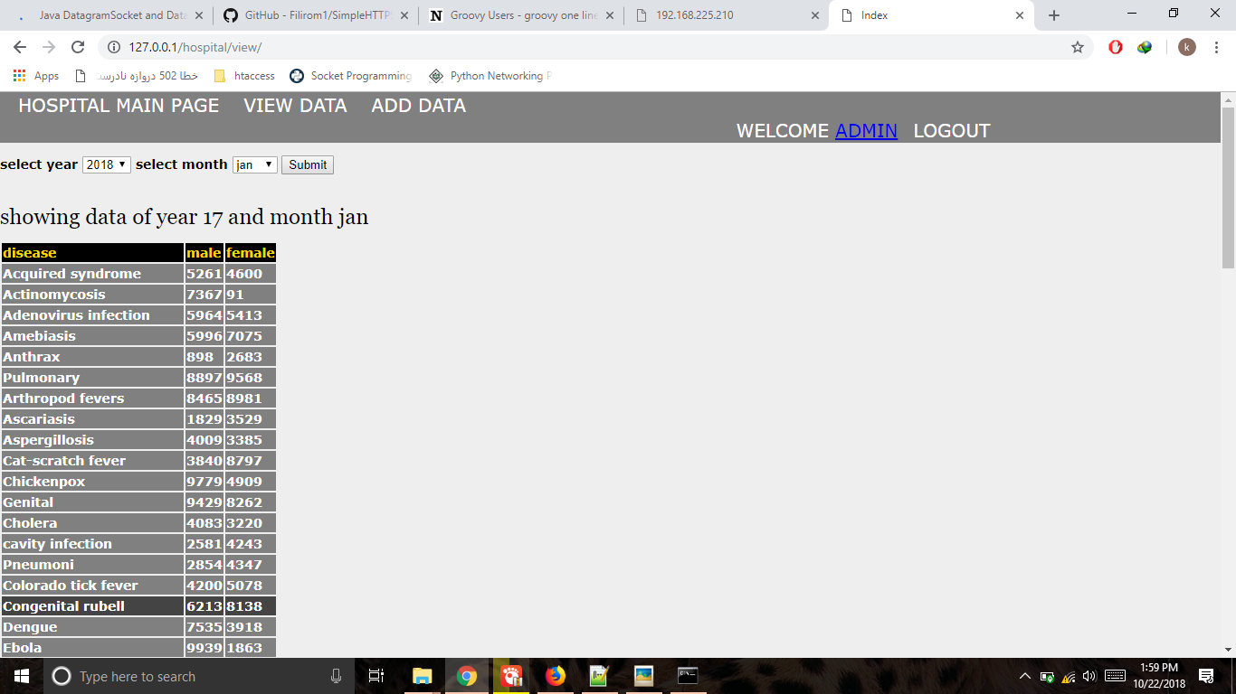

Hospital Profile with Help text: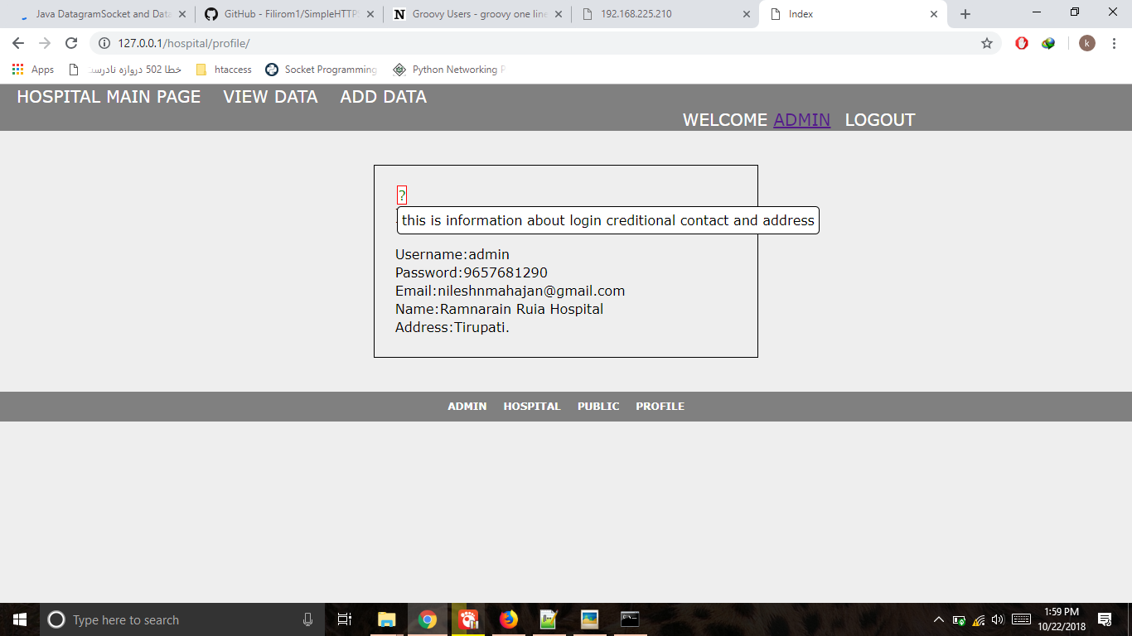

-- Admin --

Admin : view Hospitals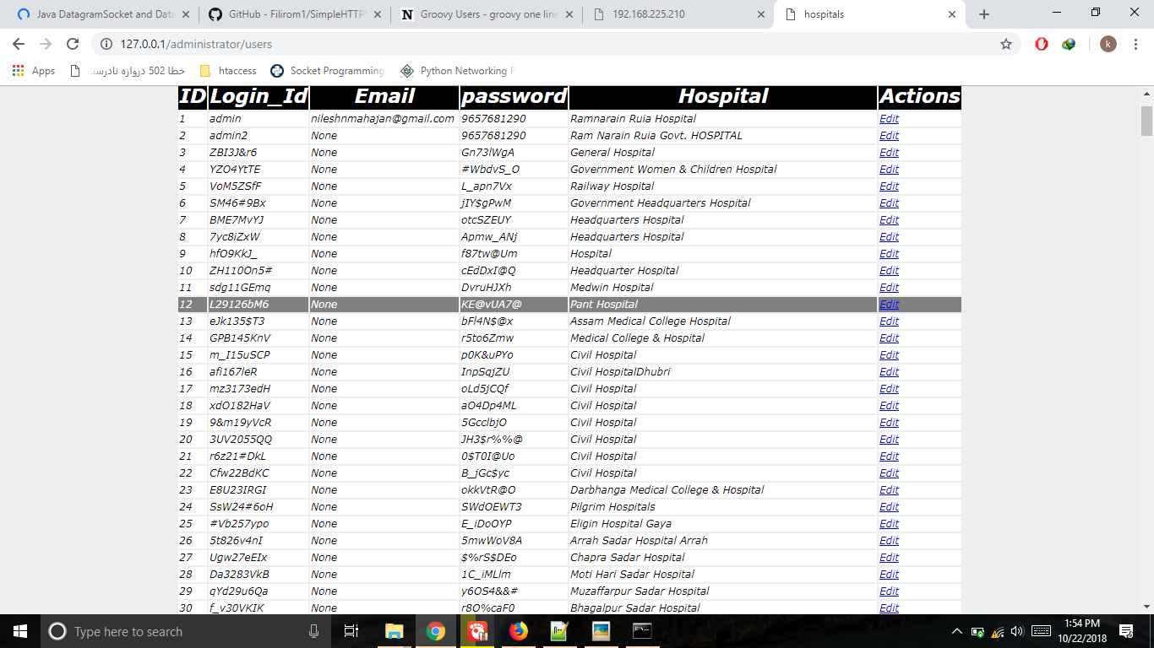

Admin: view Diseases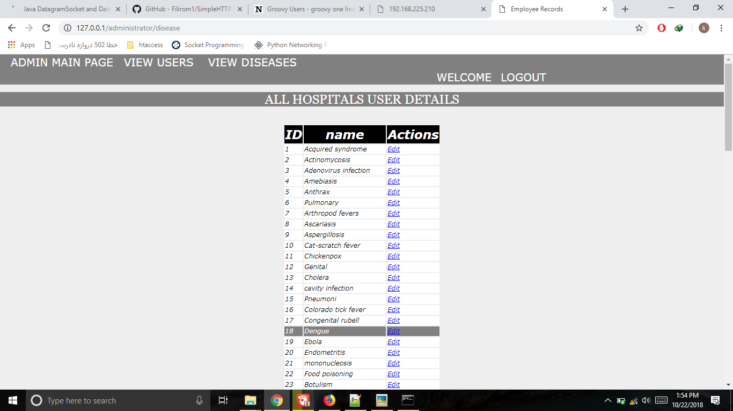Admin: update disease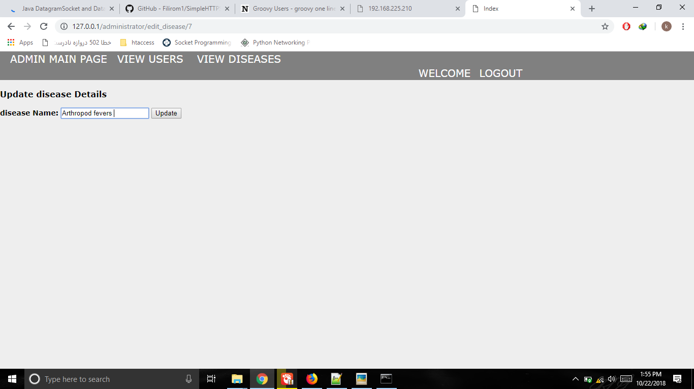

-- Analysis –

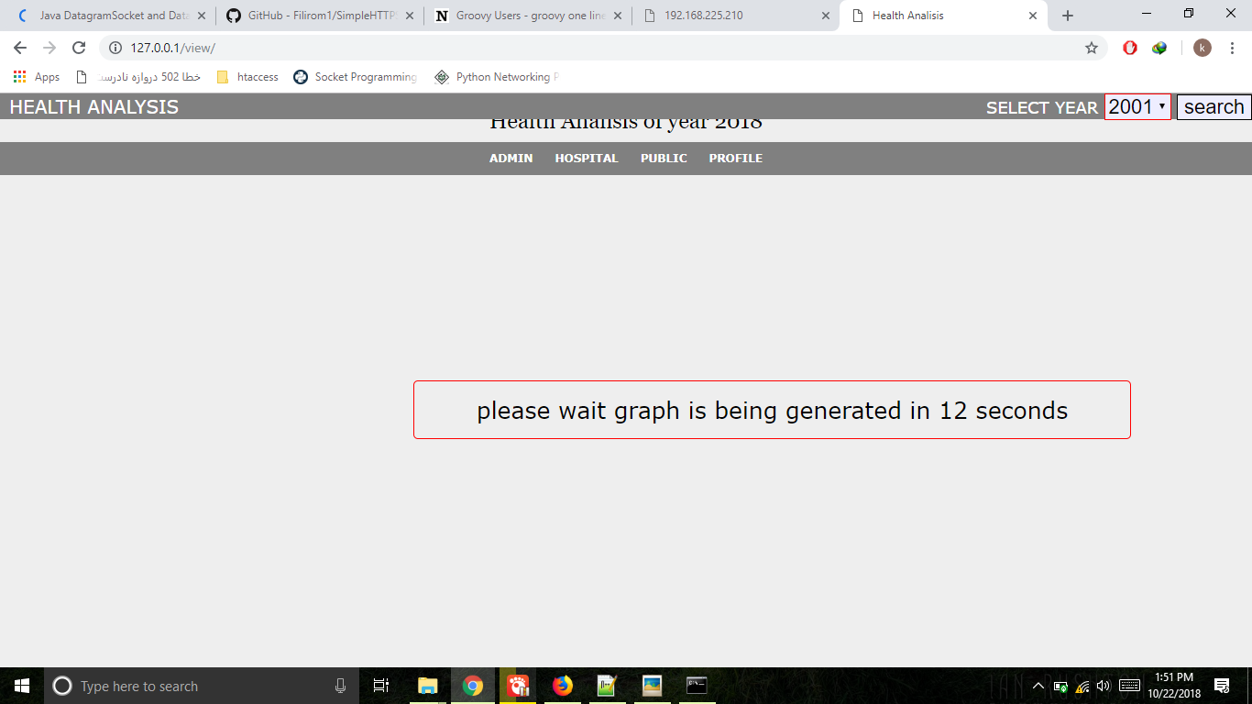

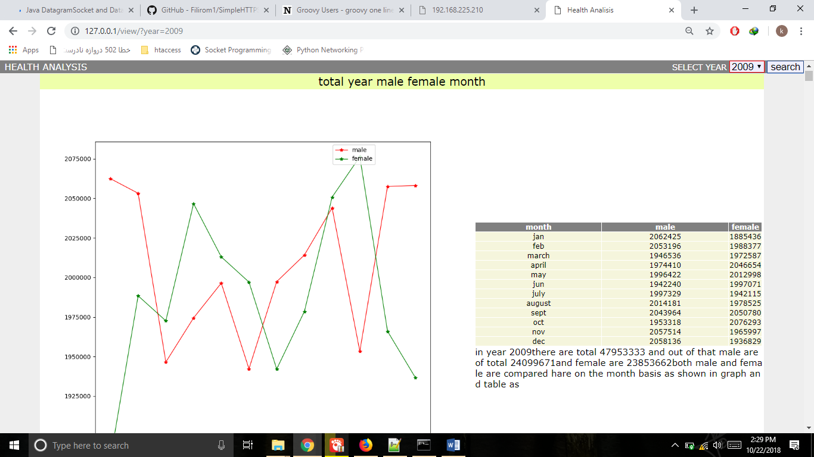

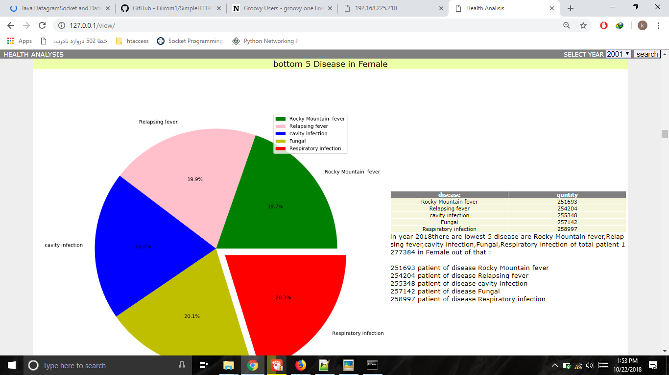

**Data description**

**Disease:**

We have take list of 100 disease in CSV format then stored them it in Sqlite with ID.

**Patient:**

We took patient data from internet in CSV format.it is with year,month,no of male, no of female.It is very huge amount of data so we have don’t used CSV file due to time-space complexity also while inserting data multi-instance is not supported by file

So further we use Sqlite and stored this data in tabular form in Sqlite Again it takes some extra time for comparison and data selection due to huge no of rows so further we divided database in year basis.And created separate database each year.

In each record there is unique id assingned.it have month,disease,hospital,no of male-female details.

**Hospital:**

We have hospital database in which there is hospital name,hospital address are stored and for identifying hospital there is one unique id given to each hospital.

**Users:**

When new hospital registered his credintials are stored in databse.After we get hospital detail from him and stored them in hospital database.And this hospital_id assigned to user in this user table.

**Data Processing:**

**Validating and inserting data-**

We get monthly data fronm hospital.hospital disease will give information that you want.he can keep blank or assign non-delete value.

After getting data it will check that it greater than zero and less than define max length and it must be in integer format.

**Getting data:**

All data stored in SQL databse so for getting data use sql queries with required conditons using python sqlite library.

**Graphical Presentation**

**Total year male-female months:**

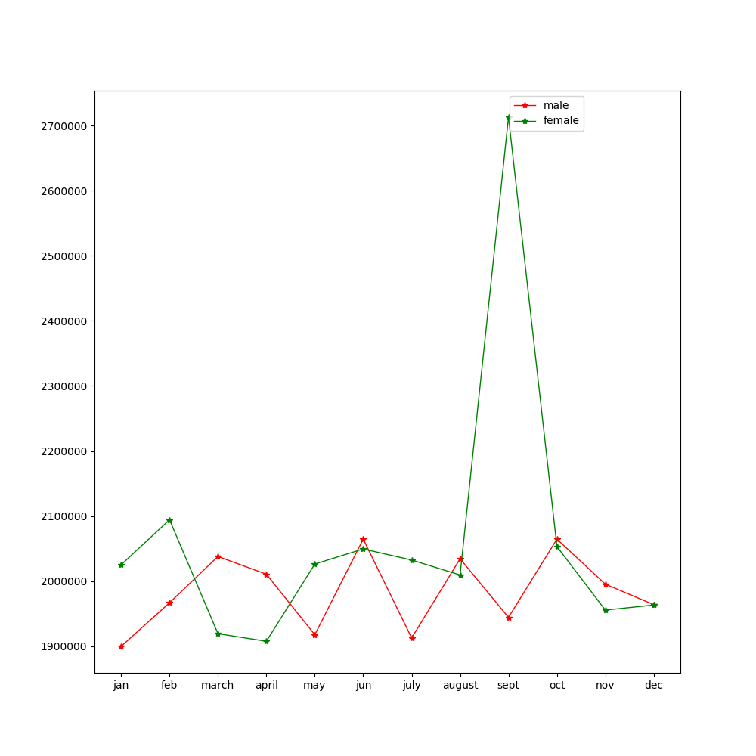

In year 2018 there are total 48558086 and out of that male are of total 23810635 and female are 24747451 both male and female are compared here on the month basis as shown in graph and table as

|  |  |  |
| --- | --- | --- |
| **month** | **male** | **female** |
| jan | 1899532 | 2025053 |
| feb | 1966595 | 2094192 |
| march | 2037773 | 1919048 |
| april | 2010483 | 1907363 |
| may | 1917504 | 2026121 |
| jun | 2064516 | 2049371 |
| july | 1912508 | 2032308 |
| august | 2034261 | 2009327 |
| sept | 1944090 | 2058644 |
| oct | 2064443 | 2053030 |
| nov | 1995183 | 1955276 |
| dec | 1963692 | 1963154 |

**Function Code:**

for month in range(1,13):

q='select sum(male),sum(female) from patient where month = '+str(month)

for row in cur.execute(q):

male[month-1]=male[month-1]+row[0]

female[month-1]=female[month-1]+row[1]

count=count+1

**Top 4 Disease in rain Season:**

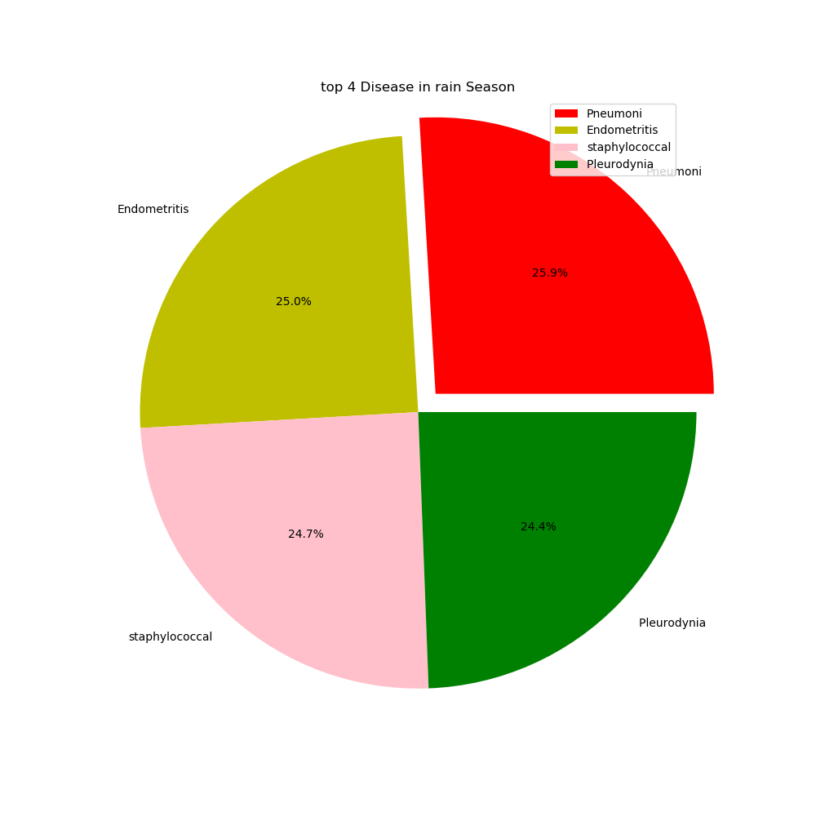

In year 2018 there are highest spread 4 diseases total is 907682 are Pneumoni, Endometritis, staphylococcal Pleurodynia in rain season out of that it in details as   
 235360 patient are Pneumoni  
 226852 patient are Endometritis  
 223966 patient are staphylococcal  
 221504 patient are Pleurodynia

|  |  |
| --- | --- |
| **disease** | **quantity** |
| Pneumoni | 235360 |
| Endometritis | 226852 |
| staphylococcal | 223966 |
| Pleurodynia | 221504 |

**Function Code:**

for row in cur.execute('select dis_id,sum(male+female) as total from patient where month IN (7,8,9,1)group by dis_id order by total desc limit 4'):

data.append(row[1])

q="select dname from disease where id = "+str(row[0])

for row2 in cur2.execute(q):

rog.append(row2[0])

**Top 10 Disease in jan 2018:**

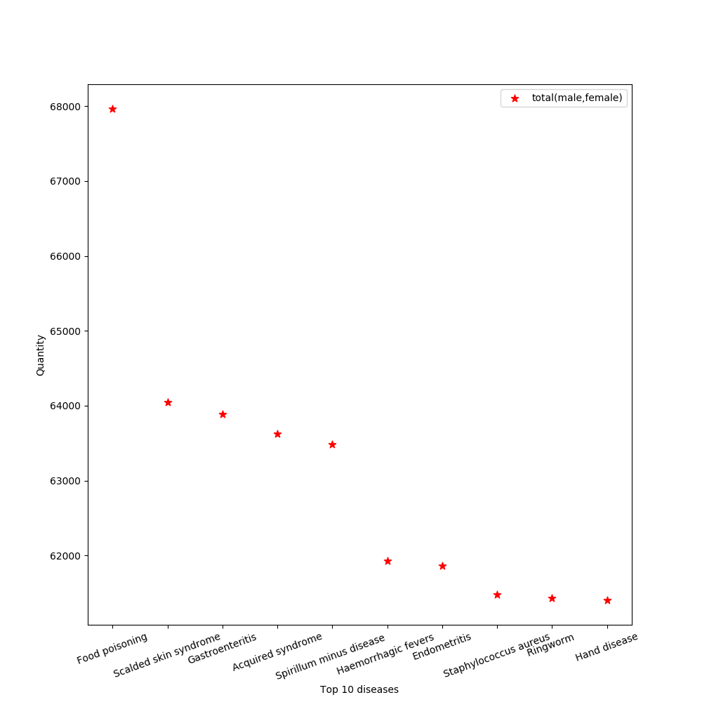

In year 2018 there are top 10 disease in jan month are Food poisoning,Scalded skin syndrome,Gastroenteritis,Acquired syndrome,Spirillum minus disease ,Haemorrhagic fevers ,Endometritis,Staphylococcus aureus,Ringworm ,Hand disease of total patient 631114 in total year out of that :

67964 patient of disease Food poisoning  
 64049 patient of disease Scalded skin syndrome  
 63891 patient of disease Gastroenteritis  
 63622 patient of disease Acquired syndrome  
 63488 patient of disease Spirillum minus disease   
 61932 patient of disease Haemorrhagic fevers   
 61860 patient of disease Endometritis  
 61476 patient of disease Staphylococcus aureus  
 61429 patient of disease Ringworm   
 61403 patient of disease Hand disease

|  |  |
| --- | --- |
| **disease** | **quantity** |
| Food poisoning | 67964 |
| Scalded skin syndrome | 64049 |
| Gastroenteritis | 63891 |
| Acquired syndrome | 63622 |
| Spirillum minus disease | 63488 |
| Haemorrhagic fevers | 61932 |
| Endometritis | 61860 |
| Staphylococcus aureus | 61476 |
| Ringworm | 61429 |
| Hand disease | 61403 |

**Function Code:**

for row in cur.execute('select dis_id,sum(male+female) as total from patient where month=1 group by dis_id order by total desc limit 10'):

data.append(row[1])

q="select dname from disease where id = "+str(row[0])

for row2 in cur2.execute(q):

rog.append(row2[0])

**Conclusion**

After Completing This Project, it conclude that it can be helpful to analysis real time data. And it is directaly openly available to public to view and can be get it download after some updation in it.

After all this project is fully dependant on hospital and data given by them so there may be chance to this data may not be fully correct so the result being get produce is may be vary from actual reality.

Beyond that this project can be get use it need to be host in online server and it be most usefull for hospital ,public, and govt.

And the Project Conclussion is Get form in almost in each result and it is a final but it can again get derived and form more advance result from that. Currently it taking 20-30 second for output it can also get decrease if high Processor is get used.

**Reference**

1. [**https://kkbuilds.com/project/all.php**](https://kkbuilds.com/project/all.php)
2. [**https://javatpoint/python-tutorial**](https://javatpoint/python-tutorial)
3. [**https://geeksforgeeks.org/sqlite-embed-in-python**](https://geeksforgeeks.org/sqlite-embed-in-python)