Name:Nilesh pandit

Class:TE-A-22

Expt.no.:18(a&b)

(i)Calculate Square,Square root,Cube,Cuberoot of given number.\*/

import java.awt.\*;

import java.applet.\*;

import java.awt.event.\*;

/\*

\* <Applet code="AppletDemo" width=500 height=500>

\*/

public class AppletDemo extends Applet implements ActionListener{

Button b1,b2,b3,b4;

TextField t1;

Label l1;

Math m1;

public void init()

{ setLayout(null);

t1=new TextField();

t1.setBounds(100,50,80,50);

add(t1);

b1=new Button("Squre");

b1.setBounds(100, 150, 80, 50);

b1.addActionListener(this);

add(b1);

b2=new Button("Squre Root");

b2.setBounds(200, 150, 80, 50);

b2.addActionListener(this);

add(b2);

b3=new Button("Qube");

b3.setBounds(300, 150, 80, 50);

b3.addActionListener(this);

add(b3);

b4=new Button("Qube root");

b4.setBounds(400, 150, 80, 50);

b4.addActionListener(this);

add(b4);

l1=new Label();

l1.setBounds(200, 50, 150, 50);

add(l1);

}

public void actionPerformed(ActionEvent ae)

{

if(ae.getSource()==b1)

{ try

{ String s=t1.getText();

int x=Integer.parseInt(s);

l1.setText("Squre:"+(x\*x));

}

catch(NumberFormatException e)

{ l1.setText("Invalid no."); }

}

if(ae.getSource()==b2)

{ try

{ String s=t1.getText();

int x=Integer.parseInt(s);

l1.setText("Squre root:"+m1.sqrt(x));

}

catch(NumberFormatException e)

{ l1.setText("Invalid no."); }

}

if(ae.getSource()==b3)

{

try

{ String s=t1.getText();

int x=Integer.parseInt(s);

l1.setText("qube:"+(x\*x\*x));

}

catch(NumberFormatException e)

{ l1.setText("Invalid no."); }

}

if(ae.getSource()==b4)

{

try

{

String s=t1.getText();

int x=Integer.parseInt(s);

l1.setText(" qube root:"+m1.cbrt(x));

}

catch(NumberFormatException e)

{

l1.setText("Invalid no.");

}

}

}

}

Output:-

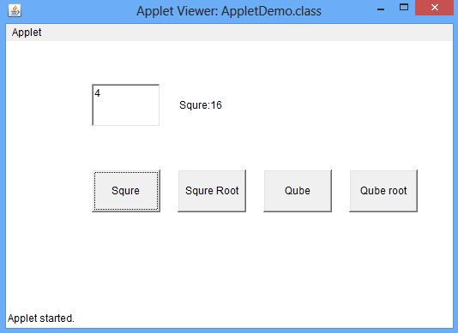

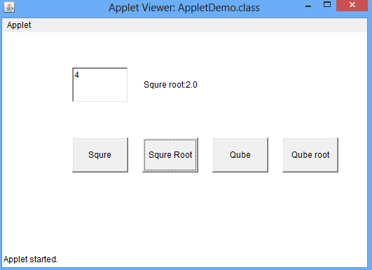

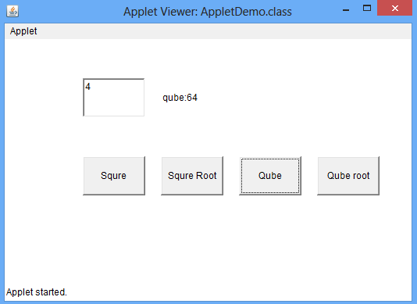

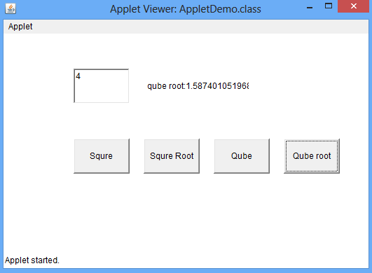

/\*(ii)Change color of Rectangle when we select color from checkbox\*/

import java.awt.\*;

import java.awt.event.\*;

import java.applet.\*;

/\*

<applet code="App12" width="300" height="300"></applet>

\*/

public class App12 extends Applet implements ItemListener

{

Checkbox c1,c2,c3;

CheckboxGroup cg;

public void init()

{

setLayout(null);

c1=new Checkbox ("Red",true,cg);

c1.setBounds(50,50,100,20);

add(c1);

c1.addItemListener(this);

c2=new Checkbox ("Green",false,cg);

c2.setBounds(50,100,100,20);

add(c2);

c2.addItemListener(this);

c3=new Checkbox ("Blue",false,cg);

c3.setBounds(50,150,100,20);

add(c3);

c3.addItemListener(this);

}

public void paint(Graphics gr)

{

int r=0,b=0,g=0;

if(c1.getState()) r=255;

if(c2.getState()) g=255;

if(c3.getState()) b=255;

gr.setColor(new Color(r,g,b));

gr.fillRect(200,50,100,100);

}

public void itemStateChanged(ItemEvent ie)

{

if(ie.getSource()==c1||ie.getSource()==c2||ie.getSource()==c3)

{

repaint();

}

}

}

OUTPUT:-

