A Mini Project Report on

***“ Time Table Management System”***

Submitted in partial fulfillment of the requirements for the award of the degree of

#### Bachelor of Engineering

in

#### Computer Engineering

by

#### Nilesh Parab (M221454)

#### Ananya Yadav (M221429)

#### Riya Singh (M221422)

#### Sandesh Parbhane(M221455)

Under the Guidance of

**Prof Nilesh Mehta**



##### Department of Computer Engineering

**Watumull Institute of Electronics Engineering and Computer Technology**

**Ulhasnagar**

UNIVERSITY OF MUMBAI

##### Academic Year 2021-2022

**Approval Sheet**

This Mini Project Report entitled ***“Time Table Management System ”*** Submitted by ***“Nilesh Parab” (M221454), “Ananya Yadav” (M221429), “Riya Singh ” (M221422), “Sandesh Parbhane” (M221455)*** is approved for the partial fulfillment of the requirement for the award of the degree of ***Bachelor of Engineering*** in ***Branch Name*** from ***University of Mumbai***.

Under The Guidance of

**Prof Nilesh Mehta**

Head Department of Computer Engineering

Place:

Date:

#### CERTIFICATE

This is to certify that the mini project entitled ***“Time Table Management System ”*** Submitted by ***“Nilesh Parab” (M221454), “Ananya Yadav” (M221429), “Riya Singh ” (M221422), “Sandesh Parbhane” (M221455)***  or the partial fulfillment of the requirement for award of a degree ***Bachelor of Engineering*** in ***Computer Engineering***,to the University of Mumbai, is a bonafide work carried out during academic year 2021-2022.

Guide Name & Signature Examiners:

1.

2.

Head Department of Computer Engineering Principal

Place:

Date:

#### Declaration

We declare that this written submission represents our ideas in our own words and where others’ ideas or words have been included, We have adequately cited and referenced the original sources. We also declare that we have adhered to all principles of academic honesty and integrity and have not misrepresented or fabricated or falsified any idea/data/fact/source in our submission. We understand that any violation of the above will be cause for disciplinary action by the Institute and can also evoke penal action from the sources which have thus not been properly cited or from whom proper permission has not been taken when needed.

———————————————

(Signature)

———————————————

#### Nilesh Parab (M221454)

#### Ananya Yadav (M221429)

#### Riya Singh (M221422)

#### Sandesh Parbhane(M221455)

Date:

##### Abstract

##### Timetable management system is very useful to faculty. Because the timetable is the most important document for lecturers as well as students. Normally all institutes make timetable manually, but the cause of technology they also try to change the system. Today technology changed our lives to an easy way. We can do many things without doing much physical things. So, this method is applying to the making timetable also. Mostly the assistant is making the timetable manually for every week. The Assistant is a human being and there may be mistakes due to human error. From this system we can reduce the mistakes of it by features of the TTMS. For example, by a mistake the assistant may enter the same lecture hall to two lectures for the same time slot. By the TTMS, lecture hall can be disabled so that it can be entered once for a particular time slot of the week. This system is more efficient than the manual process. Also, we can obtain a correct timetable with minimum number of errors than the manual process.

# List of Abbreviations-

# TTMC- Time table management system

# CRUD- Create, read, update and delete

# Chapter 1 Introduction

* Timetable Management System contain a database ,which stores the

staff and lab personal details.

* Only the administrator can view ,add and delete the data in the timetable.
* It is a unanimous requirement for planning class and lab in college.
* It is simple and save time and energy.
* This is also useful for faculties\students through which they can view when it is classes and practical

**PROBLEM STATEMENT**

* Timing slots for different teacher is different .
* If one teacher are in two years then we cannot assign same teachers in two different theory at same time .
* Labs overlapping is not be possible .

**Solution**

Input 2d Matrix is used

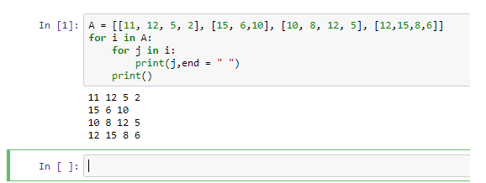

# Chapter 2 Existing System/Project

The main problem is clashing of lecture halls in intakes. Because the timetable is made

by manually by a person, by human error two lectures can get allocated to the same lecture hall.

Lecturers should physically meet assistant and request to change a lecture when they

have an issue with a lecture. Also, they must contact other lecturers to get

# Chapter-3

# Technology stack

# Visual studio code

# pycharm

# Word docs

# python

**Chapter 4**

**Benefits**

* Saves Time and Effort. ...
* Reduces Error. ...
* Secure and User-Friendly. ...
* Instant Notifications for changes. ...
* Substitute management. ...
* Easy customization. ...
* Smooth integration into the college calendar

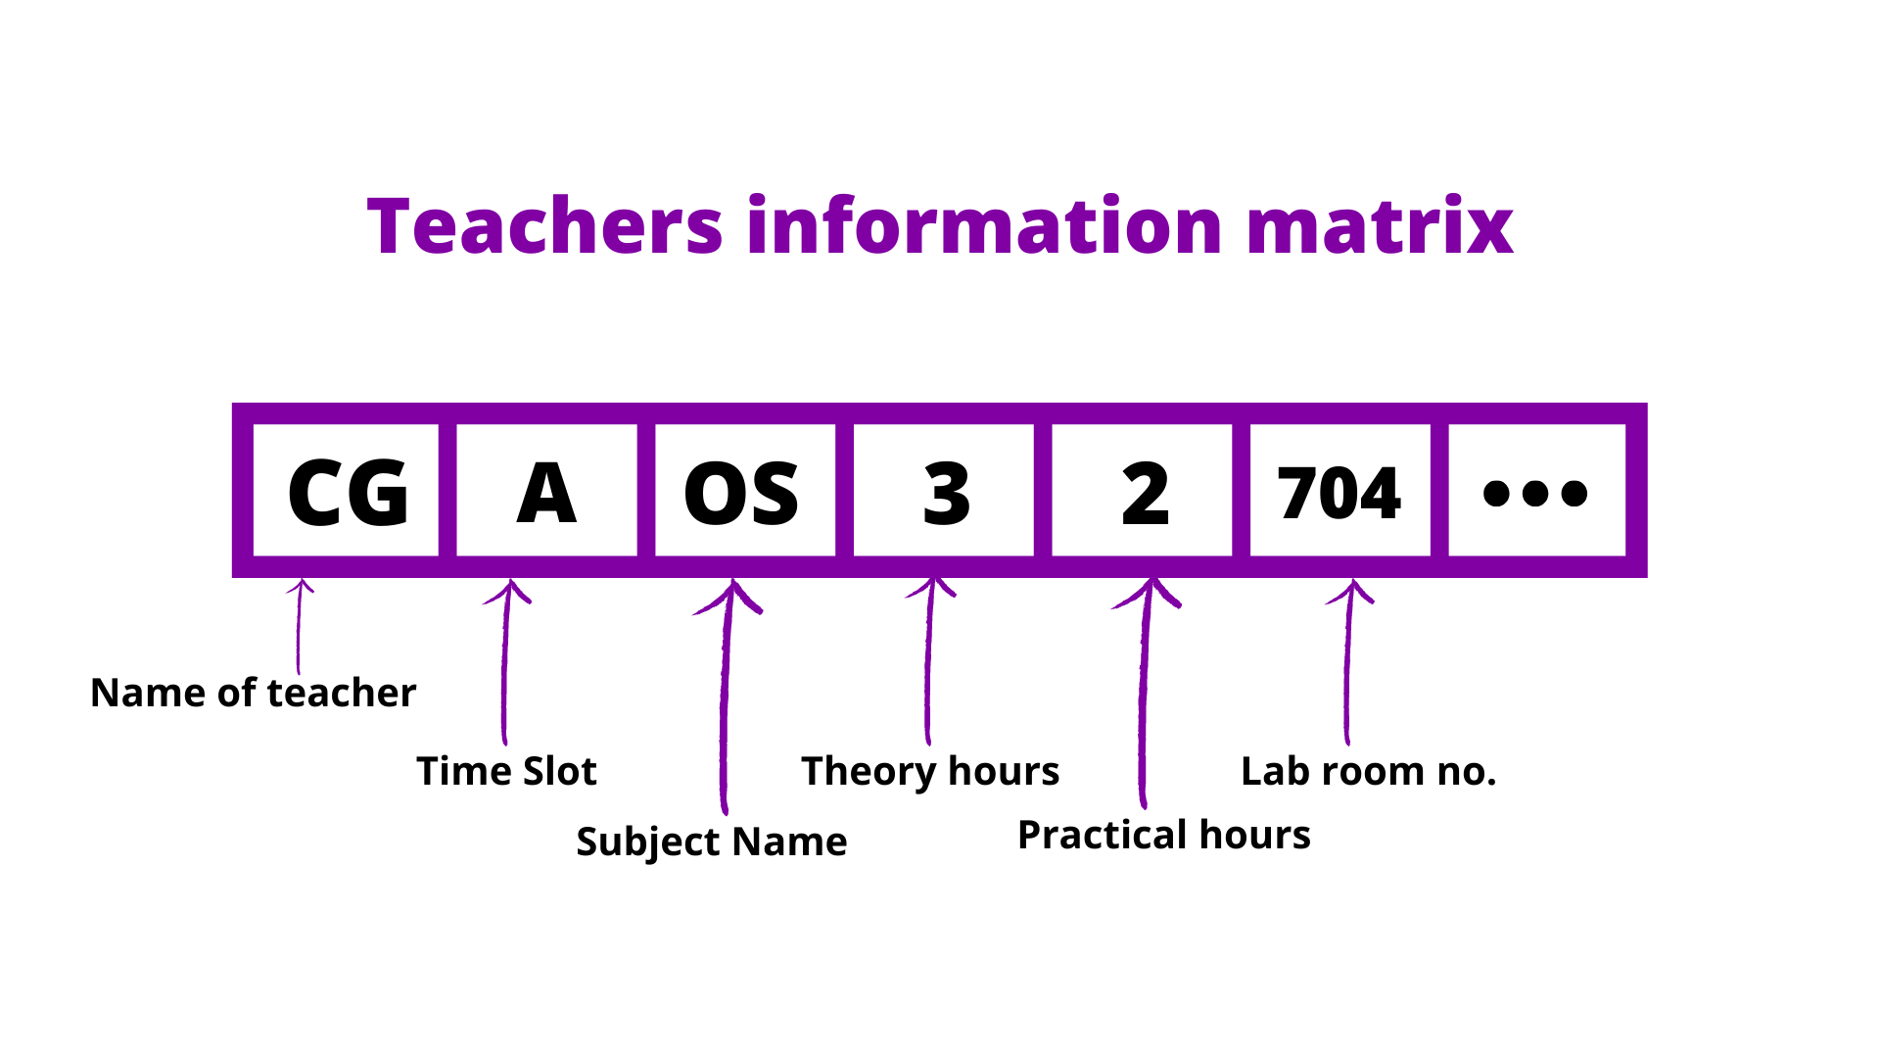**Chapter 5 Project Design**

**Chapter 6**

**Project Implementation**

Second Year Timetable

|  |  |  |  |  |  |  |
| --- | --- | --- | --- | --- | --- | --- |
|  | 9:45-10:45 | 10:45-11:45 | 11:45-12:45 | 12:45-1:45 | 2:15-3:15 | 3:15-4:45 |
| MON | LAB() | LAB() | OS(CG) | AOA(DR) | DBMS(AG) |  |
| TUE | MP(NM) | PYTHON(AS) | LAB() | LAB() | EM4(AJ) |  |
| WED | MP(NM) | DBMS(AG) | DBMS(AG) | OS(CG) | EM4(AJ) |  |
| THU | MP(NM) | PYTHON(AS) | OS(CG) | AOA(DR) |  |  |
| FRI | LAB() | LAB() | EM4(AJ) | AOA(DR) |  |  |
| SAT | LAB() | LAB() | LAB() | LAB() |  |  |

Third Year Timetable

|  |  |  |  |  |  |  |
| --- | --- | --- | --- | --- | --- | --- |
|  | 9:45-10:45 | 10:45-11:45 | 11:45-12:45 | 12:45-1:45 | 2:15-3:15 | 3:15-4:45 |
| MON | SPCC(RJ) | AI(NV) | MC(RS) | MC(RS) | LAB() | LAB() |
| TUE | IOT(DNR) | AI(NV) | IOT(DNR) | MC(RS) | LAB() | LAB() |
| WED | IOT(DNR) | AI(NV) | LAB() | LAB() | LAB() | LAB() |
| THU | SPCC(RJ) | CNSS(UA) | CNSS(UA) |  | LAB() | LAB() |
| FRI | SPCC(RJ) | CNSS(UA) | LAB() | LAB() | LAB() | LAB() |
| SAT |  |  |  |  |  |  |

Final Year Timetable

|  |  |  |  |  |  |  |
| --- | --- | --- | --- | --- | --- | --- |
|  | 9:45-10:45 | 10:45-11:45 | 11:45-12:45 | 12:45-1:45 | 2:15-3:15 | 3:15-4:45 |
| MON | HMI(SS) | DC(SS) | LAB() | LAB() | AWN(TRP) |  |
| TUE | LAB() | LAB() | HMI(SS) | AWN(TRP) | DC(SS) |  |
| WED | LAB() | LAB() | AWN(TRP) | DC(SS) | LAB() | LAB() |
| THU | AWN(TRP) | HMI(SS) | LAB() | LAB() | EM(VJ) |  |
| FRI | HMI(SS) | DC(SS) | EM(VJ) | EM(VJ) |  |  |
| SAT |  |  |  |  |  |  |

**Chapter 7**

**Output:**

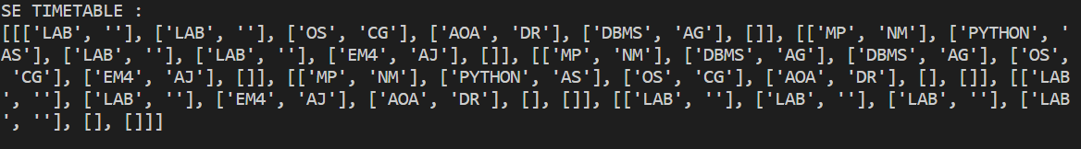

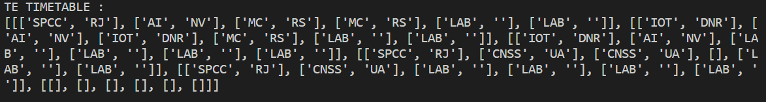

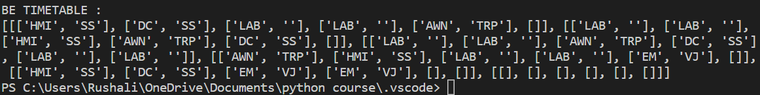

# Appendices-

# The college time table management system is a very useful system for students, faculties and administration through which student can get the information about them schedule.

# This is also useful for faculties through which they can view when is it classes. Administrator can add or remove students ,assign different jobs to different faculities.

**Acknowledgement**

We have great pleasure in presenting the mini project report on **Project Title.** We take this opportunity to express our sincere thanks towards our guide **Guide Name** Department of Computer Engineering, APSIT thane for providing the technical guidelines and suggestions regarding line of work. We would like to express our gratitude towards his constant encouragement, support and guidance through the development of project.

We thank **Prof.Sachin Malave** Head of Department, Computer Engineering, APSIT for his encouragement during progress meeting and providing guidelines to write this report.

We also thank the entire staff of APSIT for their invaluable help rendered during the course of this work. We wish to express our deep gratitude towards all our colleagues of APSIT for their encouragement.

#### Nilesh Parab (M221454)

#### Ananya Yadav (M221429)

#### Riya Singh (M221422)

#### Sandesh Parbhane(M221455)