Using Concept of Function Pointers write the program to provide a solution to below problem mentioned in image :
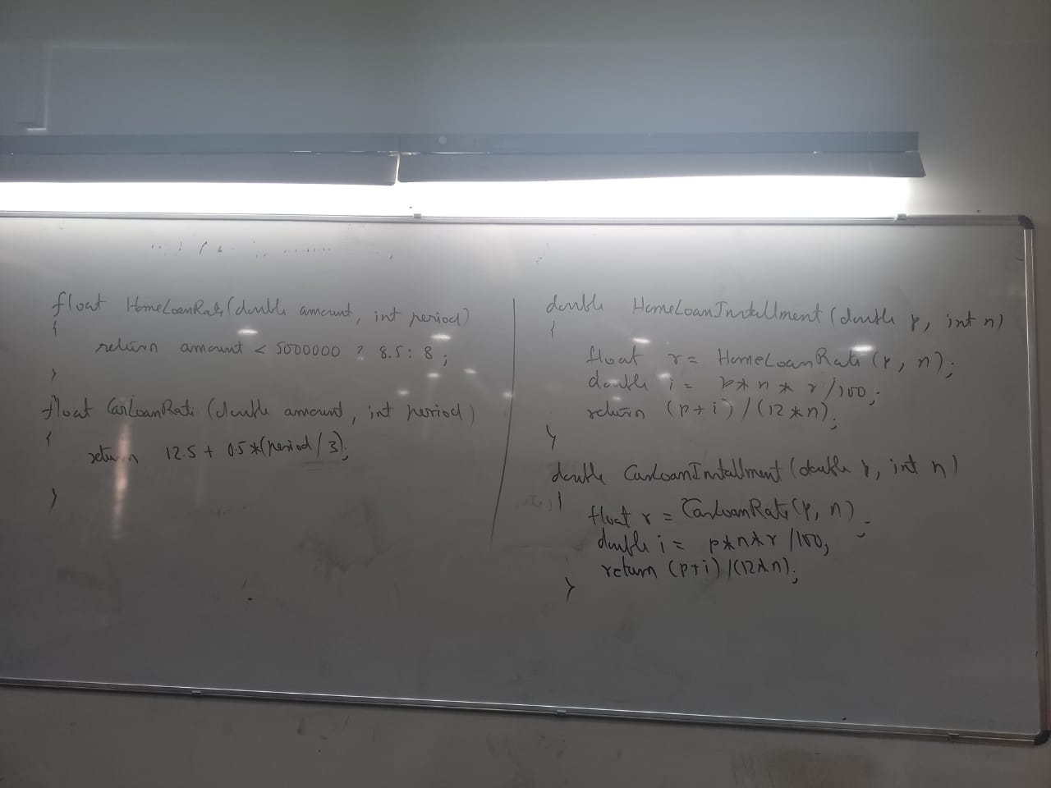
Refer your Whatsapp image

- Provide a Solution to above problem using Function pointers

