Cyclistic Rider Behavior Analysis Report
A Data-Driven Study to Support Membership Conversion
Prepared by: Nilesh Tayade
Google Data Analytics Capstone Project
- Introduction
Cyclistic is a bike-share service in Chicago offering more than 5,800 bikes. This report analyzes differences between casual riders and annual members to support membership conversion strategies.
- Business Task
Cyclistic aims to increase its annual membership base because annual members generate higher long-term revenue than casual riders.
The key business question is:

“How do annual members and casual riders differ in their bike usage behavior, and how can Cyclistic use these insights to improve membership conversions?”

- Data Sources
12 months of Divvy trip data; ~5.5M rows; public domain; contains timestamps, ride IDs, rider type, bike type, locations, station name and id’s etc.
- Data Preparation

Data cleaned in Power BI Power Query:
- Removed null or missing values
- Removed invalid records (negative, 0-minute rides), We can also ignore rides greater than 24 hours
- Standardized data types

Feature Engineered (New calculated columns added):
- ride_length_minutes
Duration.TotalMinutes([ended_at] - [started_at])
- ride_length_bucket
Categorized into: 0–5, 6–10, 11–20, 21–30, 31–45, 46–60, 60+ minutes
- day_of_week
- month
- weekday_number (for proper sorting)
These steps prepared the dataset for fast DAX calculations and visualization.

- Analysis W/ Supporting Visualizations
Here is the dashboard –
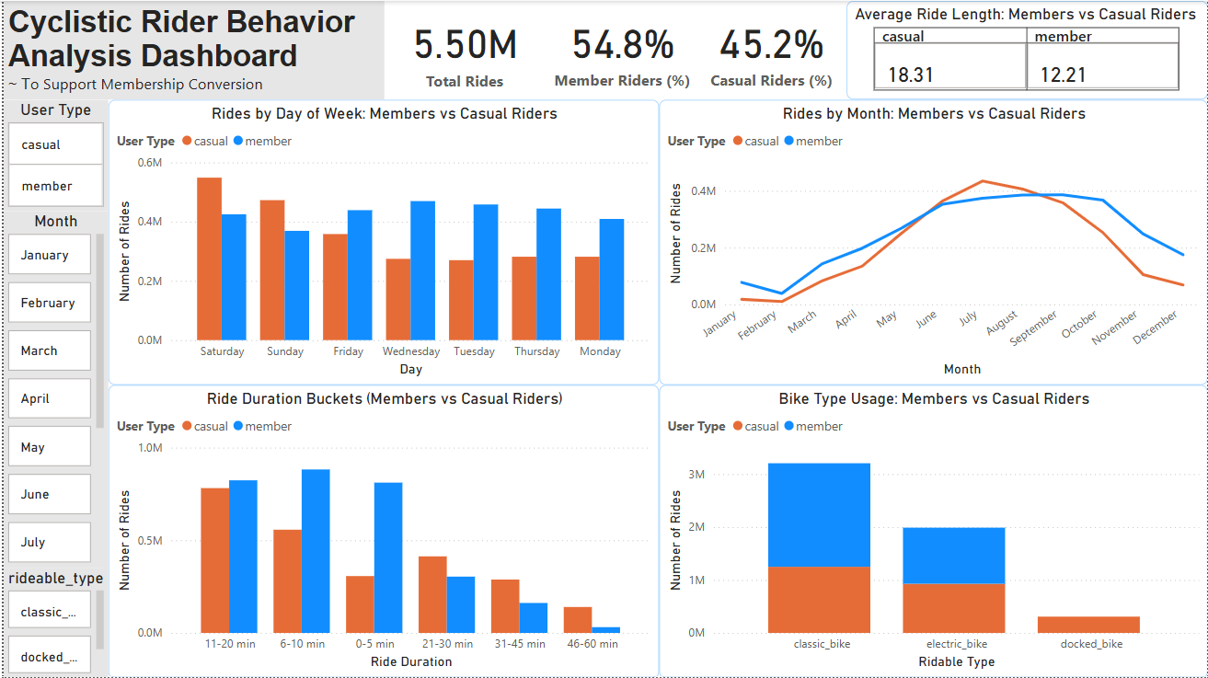
Insights:
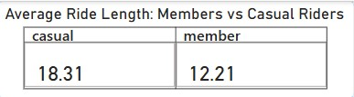
1. Casual riders take longer rides
- Casual Avg: 18.31 minutes
- Members Avg: 12.21 minutes
Casual riders use bikes for recreation, while members ride for commuting.
2. Casuals peak on weekends, members on weekdays
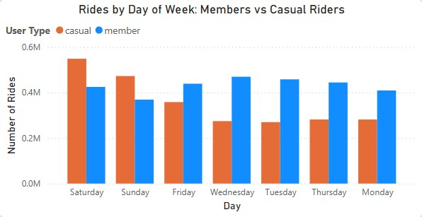
- Casual: Highest on Saturday & Sunday
- Members: Highest Monday–Friday
This confirms leisure vs commute patterns.
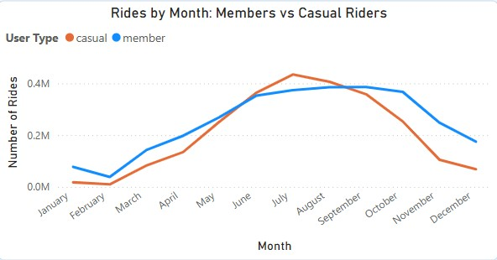
3. Seasonality affects casual riders more
- Both groups peak during summer
- Casual usage fluctuates greatly
- Member usage is more stable

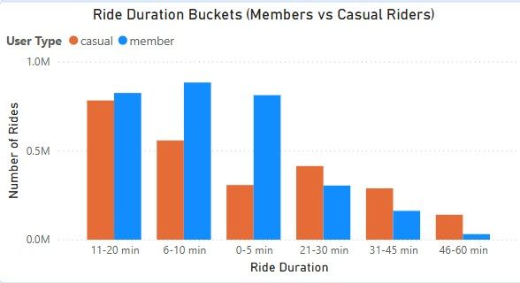
4. Ride duration buckets differ dramatically
- Members dominate short rides (0–20 min)
- Casuals dominate longer rides (21–60 min)

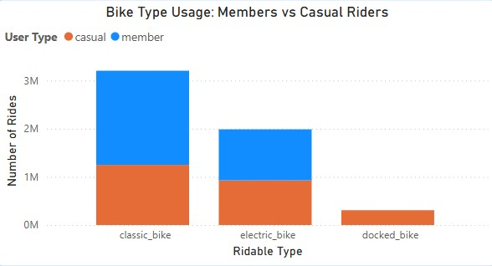
5. Bike type preferences are different
- Members prefer classic bikes
- Casual riders use electric bikes more often

- Recommendations

1. Weekend Membership Promotions (Weekend-focused promotions)
Target casual weekend riders with:
- Weekend passes
- Seasonal membership discounts
- Tourist promotions
- Referral bonuses
2. Market Memberships as a Commuter Solution
Promote:
- Convenience
- Unlimited rides
- Cost savings vs per-ride fees
- Priority access
Target office commuters near business districts and transit hubs.
3. Incentives for Electric Bike Users
Offer:
- Electric-bike credits
- Discounted membership upgrades
- Exclusive electric bike benefits
Appeal directly to casual riders who favor convenience.
- Conclusion
This analysis highlights clear behavioral differences between casual and member riders. Casual riders represent strong conversion potential. Using targeted marketing strategies based on these insights can significantly increase Cyclistic’s annual membership base. The insights and visuals in this report provide a strong foundation for data-driven decision-making.

