**1510 Initial Email Notification (default text – custom text appears above the default text)**

You have a pending course evaluation for the course(s) listed below:

ACC101 (02) | Malik, Sonia

MAT350 (01) | Multiple Instructors

SOC250 (43) | Allen, Chad

Due: 04/05/2014 01:00 AM

Please click on the following link to complete the course evaluation(s).   
  
<https://onlinetraining.tk20.com/campustoolshighered/externalAction.do?user=1d02a8c01d53ecf13ab5944a2d-7774&pk=7b02a8c01dffb206143061d1d16-7ffd>  
  
If the browser does not open, please copy-paste the link into your browser's Address bar.

**1510 Initial Email Notification Explanation**

You have a pending course evaluation for the course(s) listed below:

ACC101 (02) | Malik, Sonia This is: Course Number<space>(section)|<space>Last,<space>First

MAT350 (01) | Multiple Instructors

SOC250 (43) | Allen, Chad Courses are listed in alphanumeric order first, then by section number then by instructor last name, then by instructor first name. If the user has selected to send one course evaluation for all instructors of course, then Multiple Instructors will appear in place of the instructor names. When ordering the course list the word “Multiple” will be counted as “instructor last name”.

Due: 04/05/2014 01:00 AM Course evaluation instance due date and time.

Please click on the following link to complete the course evaluation(s).   
  
<https://onlinetraining.tk20.com/campustoolshighered/externalAction.do?user=1d02a8c01d53ecf13ab5944a2d-7774&pk=7b02a8c01dffb206143061d1d16-7ffd>  
  
If the browser does not open, please copy-paste the link into your browser's Address bar.

**Initial Email Notification Preview – text entered for additional email message text**

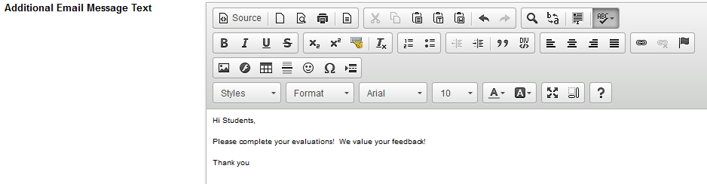

**If a due date has been selected , the preview will display the custom text and default message**

**Please note, 2 course and instructor combinations are randomly selected from the launch and displayed in the preview. If there is only one course in the launch, then the preview will display only that one course.**

**The text “<link will appear here>” appears in blue, underlined, in place of the real embedded link that students will see.**

Hi Students,  
  
Please complete your evaluations!  We value your feedback!  
  
Thank you

You have a pending course evaluation for the course(s) listed below:

ACC101 (02) | Malik, Sonia

SOC250 (43) | Allen, Chad

Due: 04/05/2014 01:00 AM

Please click on the following link to complete the course evaluation(s).   
  
<link will appear here>

If the browser does not open, please copy-paste the link into your browser's Address bar.

**If a due date has not been selected, the preview will display the custom text and default message, but “Due date and time will appear here” is in place of the due date and time.**

**Please note, 2 course and instructor combinations are randomly selected from the launch and displayed in the preview. If there is only one course in the launch, then the preview will display only that one course.**

**The text “<link will appear here>” appears in blue, underlined, in place of the real embedded link that students will see.**

Hi Students,  
  
Please complete your evaluations!  We value your feedback!  
  
Thank you

You have a pending course evaluation for the course(s) listed below:

ACC101 (02) | Malik, Sonia

SOC250 (43) | Allen, Chad

Due: *Due date and time will appear here.*

Please click on the following link to complete the course evaluation(s).   
  
<link will appear here>

If the browser does not open, please copy-paste the link into your browser's Address bar.

**Initial Email Notification Preview – text NOT entered for additional email message text**

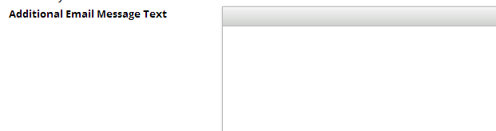

**If no custom text was entered in Additional Email Message Text , the preview will display only the default message. Please note, 2 course and instructor combinations are randomly selected from the launch and displayed in the preview. If there is only one course in the launch, then the preview will display only that one course.**

**The text “<link will appear here>” appears in blue, underlined, in place of the real embedded link that students will see.**

You have a pending course evaluation for the course(s) listed below:

ACC101 (02) | Malik, Sonia

SOC250 (43) | Allen, Chad

Due: 04/05/2014 01:00 AM

Please click on the following link to complete the course evaluation(s).   
  
<link will appear here>

If the browser does not open, please copy-paste the link into your browser's Address bar.

**If a due date has not been selected, the preview will display only the default message, but “Due date and time will appear here” is in place of the due date and time.**

**Please note, 2 course and instructor combinations are randomly selected from the launch and displayed in the preview. If there is only one course in the launch, then the preview will display only that one course.**

**The text “<link will appear here>” appears in blue, underlined, in place of the real embedded link that students will see.**

You have a pending course evaluation for the course(s) listed below:

ACC101 (02) | Malik, Sonia

SOC250 (43) | Allen, Chad

Due: *Due date and time will appear here.*

Please click on the following link to complete the course evaluation(s).   
  
<link will appear here>

If the browser does not open, please copy-paste the link into your browser's Address bar.