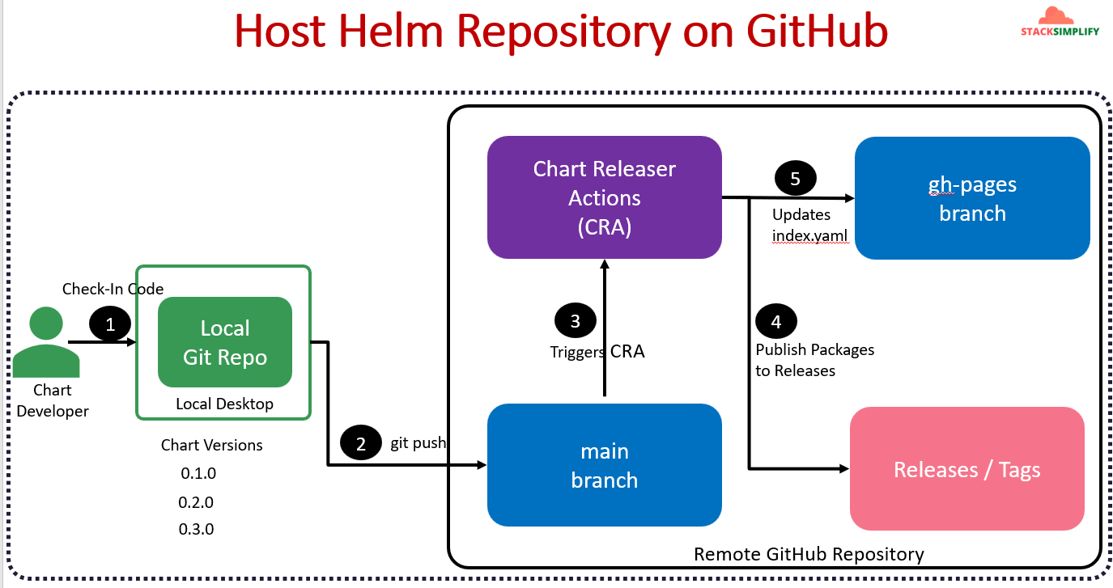

Here's a simplified overview of the process of hosting Helm charts on GitHub:

**Step-by-Step Process**

1. **Create a GitHub Repository**: Start by creating a new GitHub repository named helm-charts-repo to store your Helm charts. Make sure the repository is public and add a README file.
2. **Create a gh-pages Branch**: After creating the repository, create a new branch called gh-pages. This branch will serve as the source for GitHub Pages, which will host our Helm charts.
3. **Enable GitHub Pages**:
   * Go to the repository settings.
   * Under the "Pages" section, set the gh-pages branch as the source for GitHub Pages. GitHub Pages will then publish any content on this branch as a static website.
4. **Add Files to the Repository**:
   * Clone the repository to your local machine.
   * Add the following essential files to the repository:
     + **Helm chart files** (in the charts directory).
     + **GitHub workflow file** for Chart Releaser (chart-releaser-action.yaml), which will automate Helm chart releases.
5. **Commit and Push**:
   * Check in these files to the main branch of your GitHub repository.
   * When changes are pushed to the main branch, it triggers a GitHub Action called "Chart Releaser."
6. **Chart Releaser Action**:
   * This action will package your Helm chart and publish it as a GitHub release.
   * It also updates the index.yaml file in the gh-pages branch, which lists available charts and their versions.
7. **GitHub Pages Updates Automatically**:
   * With every new chart release or chart version update, the index.yaml file in the gh-pages branch is updated.
   * GitHub Pages will republish the site, and the latest charts will be accessible through the GitHub Pages URL.
8. **Access the Hosted Helm Repository**:
   * GitHub Pages generates a URL for your repository. Access this URL to view the Helm repository content.
   * Any updates you make to your Helm charts or versions are automatically reflected on this site.

**Summary of the Workflow**

1. **Main Branch**: Stores the Helm chart source files and the GitHub Actions workflow file.
2. **GitHub Actions (Chart Releaser)**: Packages and publishes the chart, updates index.yaml, and commits it to gh-pages.
3. **GitHub Pages (gh-pages Branch)**: Hosts the index.yaml file and chart packages, making the Helm repository accessible as a static site.

This process allows you to host and manage your Helm charts on GitHub, providing a versioned, accessible Helm repository for others to use.