* Observability is the ability to understand the internal state of a system (application + Infrastructure + Network) by analyzing the data it produces, including logs, metrics, and traces.
* Monitoring(Metrics): involves **tracking system metrics like CPU usage, memory usage, and network performance**. Provides alerts based on predefined thresholds and conditions
  + Monitoring tells us what is happening.
* Logging(Logs): involves the **collection of log data from various components** of a system.
  + Logging explains why it is happening.
* Tracing(Traces): involves tracking the **flow of a request or transaction** as it moves through different services and components within a system.
  + Tracing shows how it is happening.

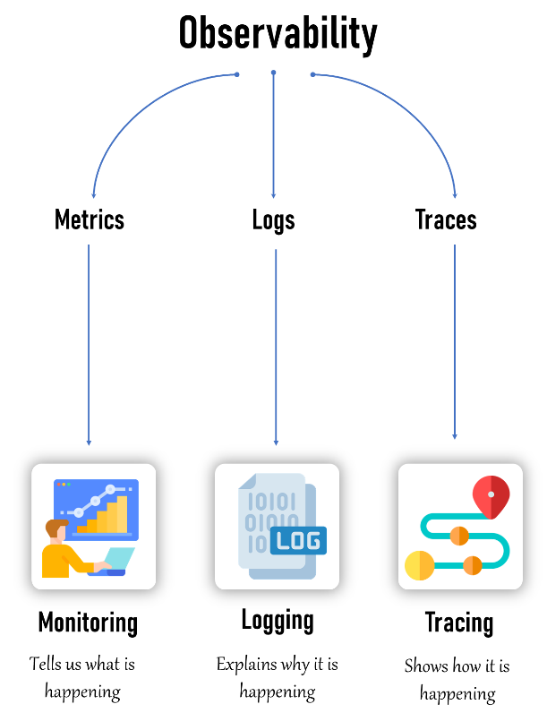

**Why Monitoring?**

Monitoring helps us keep track of our systems to make sure they are running smoothly and without issues. The main purpose of monitoring is to maintain the **health**, **performance**, and **security** of our IT systems.

**Here's why monitoring is so important:**

1. **Detect Problems Early**: Monitoring lets us find problems before they become big issues. If something starts to go wrong, we can fix it quickly, avoiding system crashes or data loss.
2. **Measure Performance**: Monitoring helps us understand how well our systems are performing. We can see if they're running efficiently or if they're slowing down, and then make improvements as needed.
3. **Ensure Availability**: By keeping an eye on systems, we make sure they are always up and available. This is important because downtime can affect users and cost businesses money.

In the broader context of **observability**, monitoring is part of how we watch and understand the internal state of our systems. It gives us important insights so we can take action quickly when things aren't working as expected

**Why Observability?**

* Observability helps us understand why our systems are behaving the way they are.
* It’s like having a detailed map and tools to explore and diagnose issues.
* We use observability to:
  + Diagnose Issues:
  + Understand Behavior:
  + Improve Systems: