What is microservice?

It is a service that exposes its business logic to other API or to external UI application with the help of REST API.

Using REST services, we can establish synchronous communication between multiple API’s or multiple services.

Note: Synchronous communication means when a request comes from an external application ro a microservice, the external application is going to wait for the response so that it can proceed to the next request or function call.

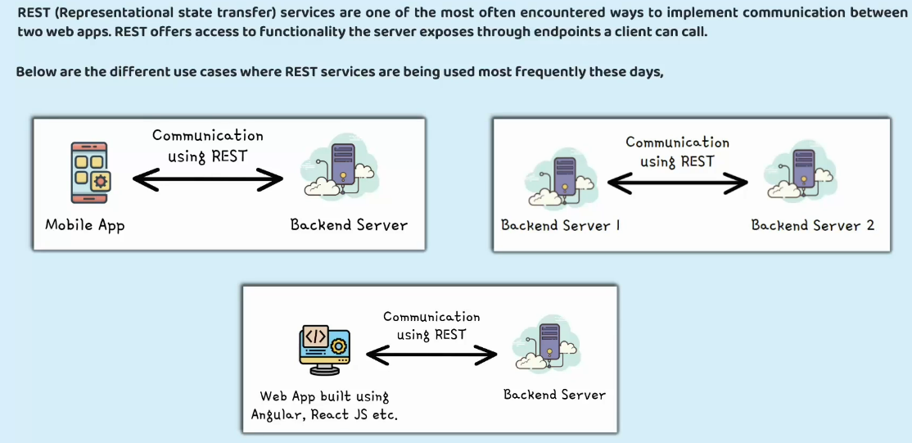

Standard Best practices while Implementing REST Services

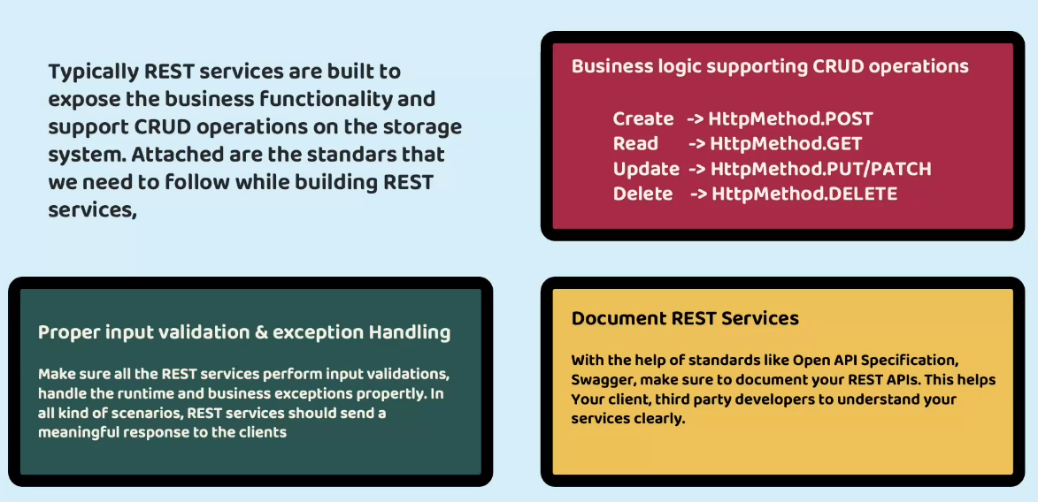

PUT: When you are updating a major chunk of data use PUT  
PATCH: When you are updating a very small set of data use PATCH  
Note: This thing is relative

In a Spring application using Hibernate as the JPA (Java Persistence API) provider, the configuration **spring.jpa.hibernate.ddl-auto** specifies how Hibernate should handle database schema generation.   
This property typically accepts different values to control whether Hibernate should create, update, validate, or none (meaning it should not touch the schema) when the application starts up.

Here's what each value typically means:

**create**: Hibernate creates the database schema when the application starts up, destroying any previous data.

**update**: Hibernate updates the database schema according to the entity mappings when the application starts up, but it doesn't drop existing tables, nor does it recreate them. It only adds new columns, indexes, etc.

**validate**: Hibernate validates the existing database schema against the entity mappings when the application starts up, but it doesn't make any changes to the schema.

**none**: Hibernate does not do anything with the database schema. It assumes that the schema is already created and validated.

The choice of this configuration depends on the development stage and the deployment environment. In development, create or update might be convenient to automatically synchronize the database schema with entity changes. However, in production, it's often safer to use validate or none to prevent accidental modifications to the database schema.

In a Spring Boot application, the **spring.jpa.database-platform** configuration property specifies the database dialect to be used by the Hibernate JPA provider.   
The database dialect determines how Hibernate generates SQL statements specific to the underlying database.

For example,   
if you're using PostgreSQL, the value for spring.jpa.database-platform would typically be org.hibernate.dialect.PostgreSQLDialect.   
Similarly, for MySQL, it would be org.hibernate.dialect.MySQLDialect.

Here's a breakdown:

This class encapsulates the differences between various SQL databases and generates appropriate SQL statements.

By setting this property, you ensure that Hibernate generates SQL statements compatible with your chosen database, which helps in ensuring that your application functions correctly and efficiently with the database system you are using.

In a Spring Boot application, the **spring.datasource.driver-class-name** configuration property specifies the fully qualified name of the JDBC driver class for the database being used. This property tells Spring Boot which Java class to load to establish a connection to the specified database.

For example,

if you are using MySQL, you would set this property to the JDBC driver class provided by MySQL. Similarly, if you are using PostgreSQL, you would set it to the JDBC driver class for PostgreSQL.

This configuration is essential for Spring Boot to establish a connection to the database and execute SQL queries.

In a Spring application, **spring.datasource.url** is a configuration property used to define the URL of the database that your application will connect to.   
This URL typically includes information such as the protocol (like jdbc), the database server's address, port, and the name of the specific database.

For example, a MySQL database URL might look like this:  
spring.datasource.url=jdbc:mysql://localhost:3306/mydatabase

Here:

jdbc:mysql:// indicates the protocol and driver being used (JDBC for MySQL).

localhost:3306 is the address and port of the MySQL server.

mydatabase is the name of the database.

By setting this property in your Spring application's configuration file, you're instructing Spring to use this URL when establishing a connection to the database.

In a Spring Boot application, data.sql and schema.sql are special files that Spring Boot uses during the application startup to initialize the database.

Here's what they do:

**schema.sql**: This file typically contains SQL statements to create the database schema, including tables, indexes, constraints, etc. When Spring Boot starts up, it checks for the presence of schema.sql in the src/main/resources directory. If found, it executes the SQL statements in this file to create the necessary database structure.

For example, schema.sql might contain SQL statements like:

CREATE TABLE users (

id BIGINT AUTO_INCREMENT PRIMARY KEY,

username VARCHAR(50) NOT NULL,

password VARCHAR(100) NOT NULL

);

**data.sql**: This file contains SQL statements to insert data into the database tables. Similar to schema.sql, Spring Boot checks for the presence of data.sql in the src/main/resources directory during startup. If found, it executes the SQL statements in this file after the database schema has been created.

For example, data.sql might contain SQL statements like:

INSERT INTO users (username, password) VALUES ('user1', 'password1');

INSERT INTO users (username, password) VALUES ('user2', 'password2');

Using schema.sql and data.sql allows developers to initialize the database with the required schema structure and seed data without needing to write additional code.

This is particularly useful for development and testing purposes where you want to bootstrap your application's database with predefined schema and data.   
However, in production scenarios, you might prefer more sophisticated approaches like database migrations.

**spring-boot-starter-data-jpa** is a starter module provided by Spring Boot to simplify the setup and configuration of Spring Data JPA in your Spring Boot applications.

Spring Data JPA is a part of the larger Spring Data project, which aims to provide a consistent and easy-to-use approach for working with various data access technologies in a Spring-based application.

Here's what spring-boot-starter-data-jpa does:

**Dependency Management**: It manages dependencies required for using Spring Data JPA and related libraries, such as Hibernate (as the default JPA provider), Spring Data Commons, and other necessary dependencies.

**Auto-Configuration**: It automatically configures beans and components required for setting up Spring Data JPA, including entity managers, transaction managers, data source configuration, and more. This greatly simplifies the configuration process, reducing the amount of boilerplate code you need to write.

**Convention over Configuration**: It follows the principle of convention over configuration, meaning that it provides sensible default configurations and behaviour based on commonly used conventions. However, you can still override these defaults and customize the configuration according to your specific requirements.

**Integration with Spring Boot Features**: It seamlessly integrates with other Spring Boot features, such as externalized configuration (through application.properties or application.yml), property binding, and logging configuration.

By including spring-boot-starter-data-jpa as a dependency in your Spring Boot project, you gain access to powerful data access capabilities provided by Spring Data JPA while benefiting from the simplicity and convenience of Spring Boot's auto-configuration and dependency management features. This makes it easier to develop data-driven applications with Spring Boot.

@MappedSuperclass

@Setter @Getter @ToString

public class BaseEntity {

**@Column(updatable = false)**

    private LocalDateTime createdAt;

    @Column(updatable = false)

    private String createdBy;

    @Column(insertable = false)

    private LocalDateTime updatedAt;

**@Column(insertable = false)**

    private String updatedBy;

}

When we update an existing record, we do not want the spring data JPA to consider this property and update or re-populate the value.  
When we insert a new record, we do not want the spring data JPA to consider this property and update or populate the value, keep it null.

import jakarta.persistence.MappedSuperclass is a Java annotation that is part of the Jakarta Persistence API. This annotation is used to designate a superclass as a mapped superclass, meaning that it is not mapped to a specific table in the database but can define

Here's what it does:

**Inheritance**: When you annotate a class with @MappedSuperclass, you're essentially saying that this class is a superclass for other entity classes, but it won't be mapped to its own table. Instead, its attributes and mappings will be inherited by its subclasses, which will be mapped to their respective tables.

**Common Attributes and Methods**: You can define common attributes and methods in the superclass, which will be inherited by its subclasses. This helps in avoiding code duplication and promoting code reusability.

**No Table Mapping**: Since @MappedSuperclass is not mapped to a specific table, you cannot query or persist instances of the superclass directly. You can only query or persist instances of its subclasses, which are mapped to their own tables.

Here's an example:

@MappedSuperclass

@Setter @Getter @ToString

public class BaseEntity {

    @Column(updatable = false)

    private LocalDateTime createdAt;

    @Column(insertable = false)

    private String createdBy;

    @Column(updatable = false)

    private LocalDateTime updatedAt;

    @Column(insertable = false)

    private String updatedBy;

}

@Entity

@Getter @Setter @ToString

public class Customer extends BaseEntity{

    @Column(name = "customer_id")

    @Id

    @GeneratedValue(strategy = GenerationType.AUTO)

    private int customerId;

    @Column(name = "name")

    private String name;

    @Column(name = "email")

    private String email;

    @Column(name = "mobile_number")

    private String mobileNumber;

}

In this example, BaseEntity is a mapped superclass annotated with @MappedSuperclass. It defines common attributes like createdAt and updatedBy, createdBy, updatedAt which will be inherited by its subclasses. However, instances of BaseEntity will not be persisted to a separate table in the database. Instead, its subclasses will be mapped to their own tables, incorporating the attributes defined in BaseEntity.

The javax.persistence.Entity annotation is used in Java Persistence API (JPA) to designate a class as an entity.

In Java EE (Enterprise Edition) and Jakarta EE, which are platforms for developing enterprise-level Java applications, JPA is a standard API for managing relational data in Java applications. It provides a framework for mapping Java objects to database tables and vice versa, and also includes features for querying and manipulating data.

When you annotate a Java class with @Entity, you're essentially telling the JPA provider (such as Hibernate, EclipseLink, etc.) that instances of this class should be mapped to corresponding records in the database. Each instance of the annotated class represents a row in the database table.

Here's a basic example:

import javax.persistence.Entity;

@Entity

public class Product {

@Id

private Long id;

private String name;

private double price;

// Getters and setters

}

In this example, the Product class is annotated with @Entity, indicating that instances of Product should be persisted in the database.

The @Id annotation designates the primary key field.

When you use javax.persistence.Entity, you're working with the Java Persistence API. However, as of Jakarta EE 9, the package for JPA has been moved from javax.persistence to jakarta.persistence. So, instead of javax.persistence.Entity, you should now use jakarta.persistence.Entity in newer versions of Jakarta EE for the same purpose.

@AllArgsConstructor @NoArgsConstructor

In JPA entities, it's common to have both annotations present, as you often need constructors with and without parameters for different scenarios, such as entity instantiation for data retrieval from the database or object creation for new data insertion.

In JPA (Java Persistence API), javax.persistence.GenerationType is an enum used to specify the primary key generation strategy for entities. This enum is typically used in conjunction with the @GeneratedValue annotation to indicate how the primary key for an entity should be generated by the underlying database.

The possible values of javax.persistence.GenerationType are:

AUTO: This is the default generation strategy. The JPA provider (e.g., Hibernate) selects an appropriate strategy based on the underlying database. It may use identity columns, sequences, or other mechanisms depending on the database.

IDENTITY: This strategy relies on an auto-incremented database column to generate primary key values. This is commonly used with databases like MySQL, PostgreSQL, and SQL Server, which support auto-incrementing columns.

SEQUENCE: This strategy uses a database sequence to generate primary key values. Sequences are database objects that generate unique values, and they are often used in databases like Oracle and PostgreSQL.

TABLE: This strategy involves creating a separate table to hold the next available primary key value for each entity. This table is managed by the JPA provider. It's a portable strategy but might not be as efficient as others, as it requires additional database operations.

Here's an example of how you might use javax.persistence.GenerationType with the @GeneratedValue annotation:

import javax.persistence.Entity;

import javax.persistence.GeneratedValue;

import javax.persistence.GenerationType;

import javax.persistence.Id;

@Entity

public class Product {

@Id

@GeneratedValue(strategy = GenerationType.IDENTITY) // Using IDENTITY strategy

private Long id;

private String name;

private double price;

// Getters and setters

}  
In this example, the @GeneratedValue annotation specifies that the primary key for the Product entity should be generated using the IDENTITY strategy, which typically corresponds to an auto-incrementing column in the database

CREATE TABLE customer(

**customer_id** INT AUTO_INCREMENT PRIMARY KEY,

)

public class Customer extends BaseEntity{

~~@Column(name = "customer_id")~~

    @Id

    @GeneratedValue(strategy = GenerationType.IDENTITY)

    private int **customerId**;

}

The column name and field name are matching, so we can skip the @Column annotation.   
Good practice is to have one.

public interface CustomerRepository extends JpaRepository<Customer, Integer> {

////

}

JpaRepository<Entity class handled by this repository class, Data type of Primary Key>