TRADITIONAL RAIM RESULTS

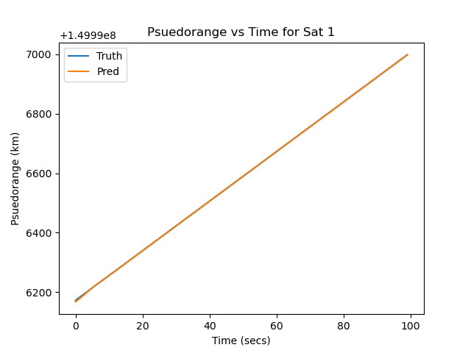The result I received by implementing the Traditional RAIM was a success and worked better than I expected. I used 5 satellites at different locations with the user (receiver) going to 100 different coordinates. This implementation had 8 states (position xyz, velocity xyz, clock error, clock error rate). I used a constant velocity and acceleration was not accounted for. The real/truth pseudorange measurements received a 5 km offset for the 5 different satellites to be able to verify if the EKF and the Traditional RAIM algorithm worked correctly. In short, it needed to be different from the predicted psuedorange to see if the predicted state and predicted pseudorange would adjust accordingly.

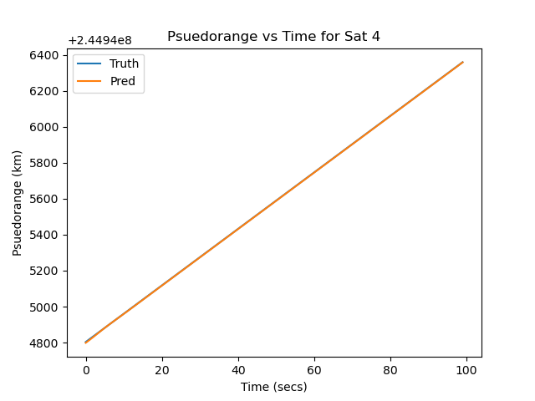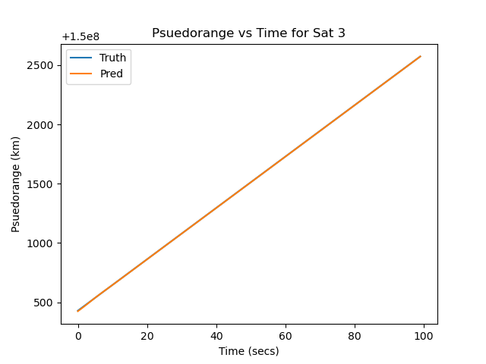

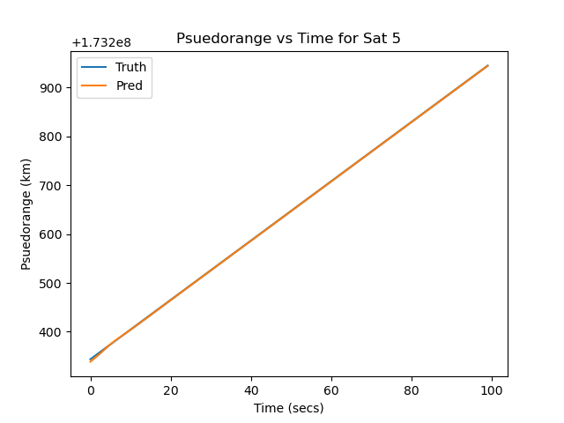

From the graphs above, you can see that the predicted initially was slightly off due to the 5km offset. However, after 3 iterations it fixes itself accordingly is on par with the true pseudorange.

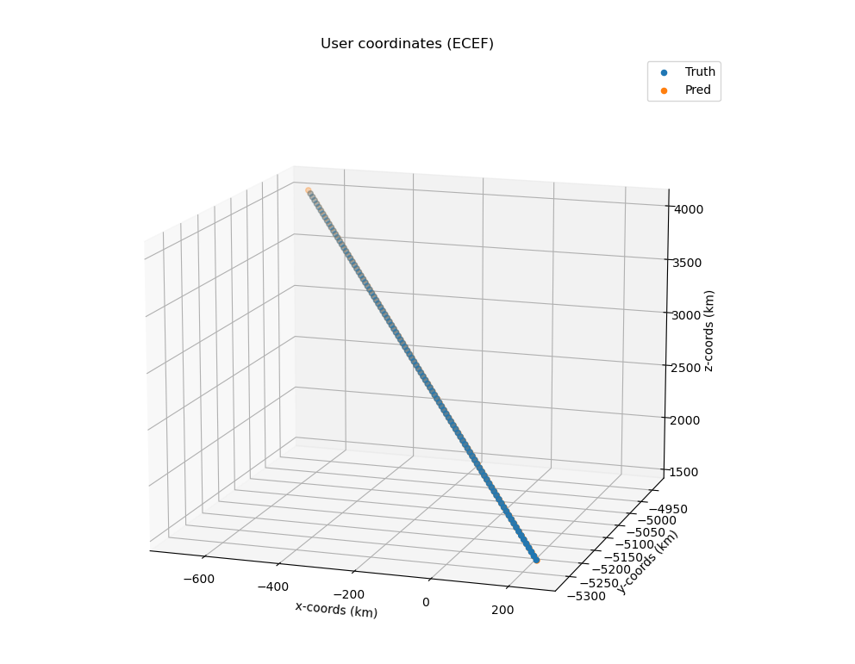

From the graph above, you can also verify that the predicted ECEF coordinates as well quickly adjusted itself after a few iterations to be basically identical to the truth.



The table above shows the residual/innovation (difference between truth and predicted) of each satellite pseudorange after each iteration. It starts off with a 5km offset and drops after the first iteration. The table shows 49 time steps and the rate of adjustment plateaus around the 50th timestep.

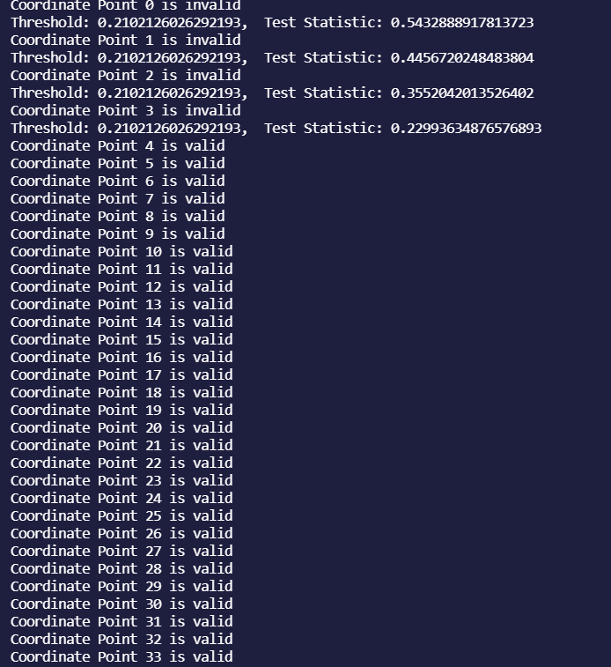

The picture above shows the Traditional RAIM algorithm working. When the coordinate is not equal to or below the threshold of the chi-squared model, it will pop a warning saying the coordinates received is invalid and give how far off statistic wise. If it is equal to or below the threshold, it will say the coordinate is valid.