Canonhouse website info:
- Home page
  - Take off the two buttons “Plan your event” and “view portfolio”
  - Add Promotional Products to the three bullets on the left
  - Delete the “about me” button
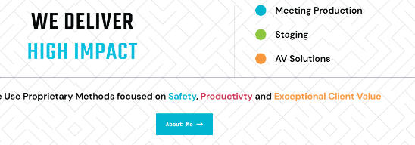

  - Move ad specialties and logo merchandise above the Meeting Specialists area, make it part the the top 4 issues you show before this. Make this “05”.
And delete the contact us button. Instead somehow refer them to the top of the page. And put another picture in instead of the ballistics pic


  - The read more buttons for #’s 01 – 04. I would prefer these texts just come up in a box that appears over the existing area and not take them to another part of the site.
- 01
- Meeting & Event Production
- Over 50 years of production from Broadway and Television to Corporate Meetings...
- Read More
  - Headline: In italics centered:
When the lifts go up, ceiling tiels are coming out, conversations turn to beam placements, load ratings, and there is 4000 pounds hanging over the audience . . .
EXPERIENCE COUNTS.
The types and extent of experience counts even more. We’ve worked in all areas of production from Stage, to Broadcast TV, to Corporate meetings. We bring a wide breath of experiences and backgrounds to your next meeting. A meeting remembered, means a message remembered . . . and action follows. Create a memory for your audience and results will follow. Carry that experience beyond the venue, beyond the dates of your meeting, and gain even more return on your investment.

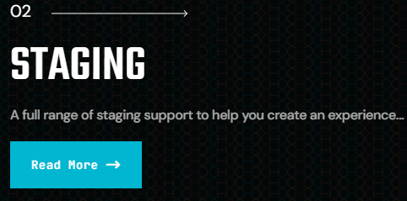

We offer complete staging services for meetings and tradeshows. We can design the set and stage and build it as well. Whether you have a theme to follow, or just want to make a statement, we provide you the best equipment, staging, personnel, and experience to do it.
Many of our clients also use us on simple meetings, screen and drape which we like to bring our own special brand to. No matter how big or how small your budget we are glad to help.
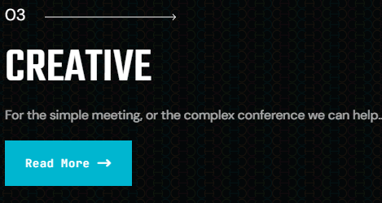

We can help you bring your thoughts and ideas to life. Whether in staging, graphics or PowerPoint, our professional approach will add to your vision and help make it reality.
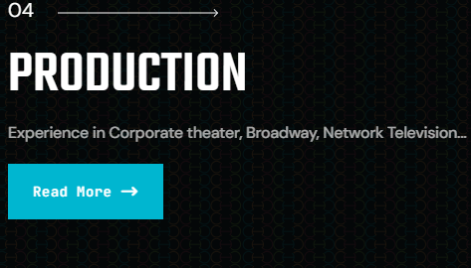

Producing live events, online events or hybrids. We bring the best people and the best equipment to your event and still stay on budget. We can bring in singers and dancers from Broadway, guest speakers, name entertainment, comedy troupes, illusionists, circus performers, anything your meeting needs to make a memorable experience for your audience. Complete video production and post-production is available to you.

2. Services page:
Creative, chapter 3 First text “experience in/out of the ballroom” should be Experiences – plural
Production, Chapter 4: Add,
- Name Entertainment
- Guest Speakers
3. Promotional Products Page
As we discussed make the button for the catalogue at the top and at it’s present location. In addition we talked about clicking on any of the pictures will take you to the catalogue.
For the top 6 boxes
I need to get you new pix for Awards (CHANGE THE TEXT TO AWARDS, and delete “trophies”). SENT we Transfer
Better pix of branded clothing SENT we transfer
New pix for hats and caps use what we have
New pix for backpacks too. SENT with some sports bags and other sports stuff, with other bags.
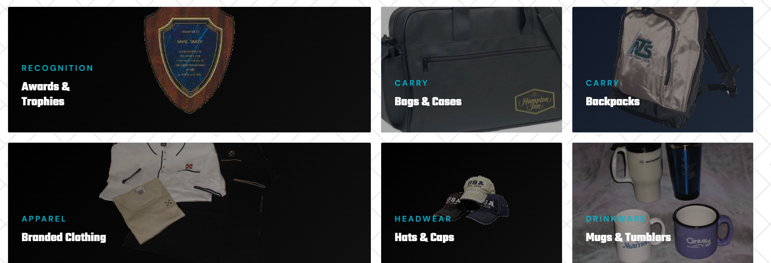

Rename the boxes above:
AWARDS (delete trophies) SPORTS BAGS/PRODUCTS, BACKPACKS & BAGS, BRANDED CLOTHING, HATS AND CAPS, COOLERS AND MUGS (use the newer shots I sent on We Transfer)



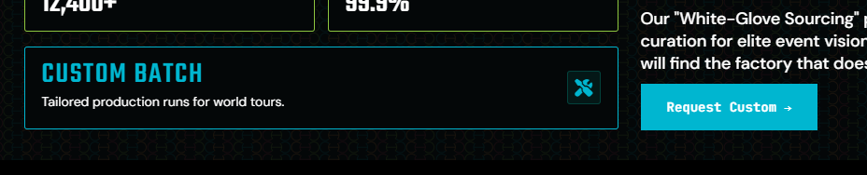
Above, the contact dorothy needs to get to her email: dplatter@thecanonhouse.com

On the above, the “request custom” button should go to Dorothy’s email as well.

Bottom of all pages
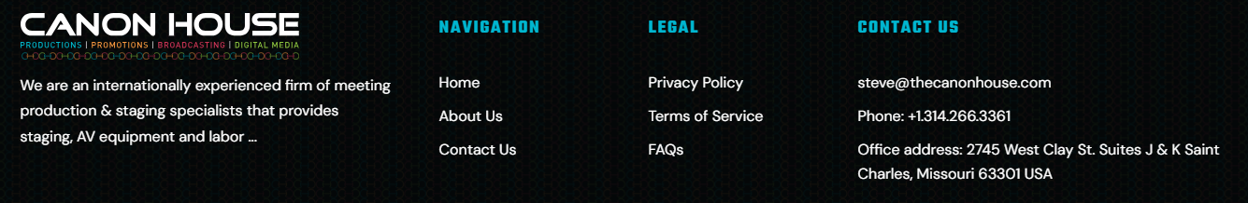
Text under logo:
We are an internationally experienced firm of meeting production, promotions and staging specialists that provides Design, Staging, AV equipment, Labor and Promotional Products.
Delete the “About us” text. Make any other links active.
ADDRESS: We need two:
“Mailing Address: 703 Rolling Wind Drive, O’Fallon, Mo. 63368 USA”
And “Office Address: 2745 West Clay St. Suite K, Saint Charles, Missouri 63301 USA”

