Value page (just call it value)
Take three pieces with pix that change from the current site.
First: SoftSet keep type, text, pix as is. (pix do change) you do not have to use this same header once it comes up, just probably VALUE: SoftSET and leave it at that, then what is below use the words softset and fast set as I have them typed, not as they are on the website

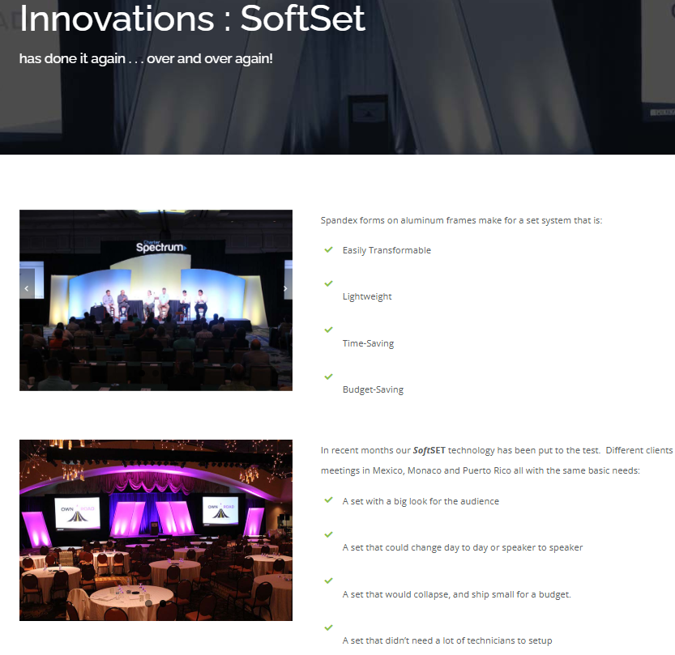

Second is: FastSET (do as I typed to the left here) keep the small tag line under it and keep pix and text below
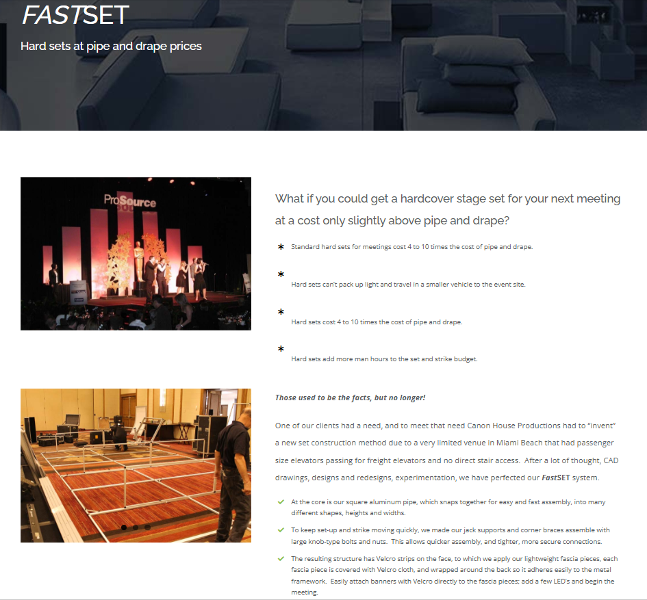

Third: INFOpods – Interactive keep the tag line under it! Keep pix and text below
