ECE 510: Pre-Silicon Validation

Laboratory 1



Nilesh Dattani

PSU ID: 958880624

High Level Block Diagram



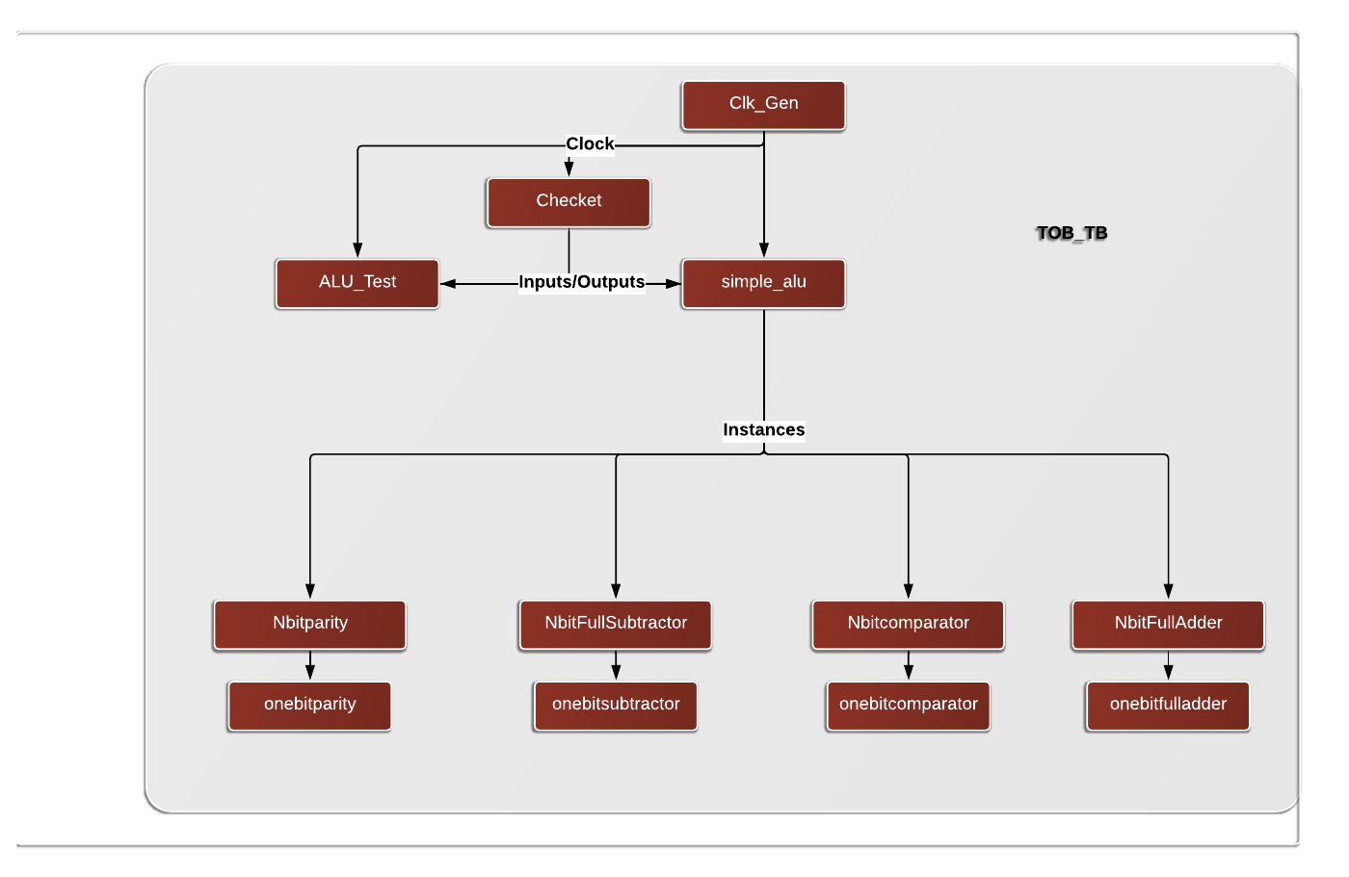

Block Diagram with connections at high level

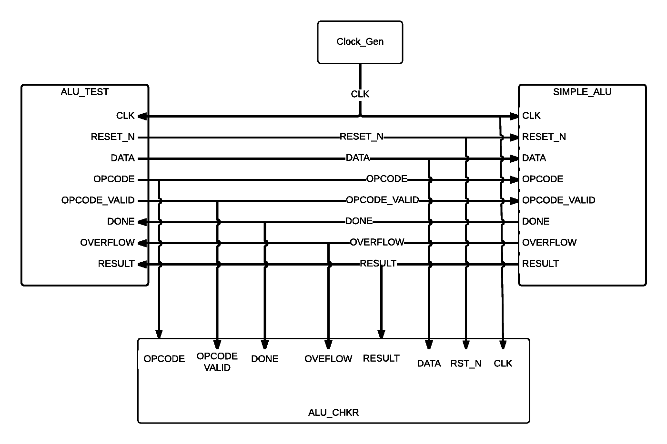

# Assumptions:

* FSM State IDLE should clear the done bit and should not change any other outputs, i.e. hold their values
* Logical Operators are the lowest level of code writing expected
* Delay were not accounted for the simulation
* Race conditions could be ignored
* Arithmetic operations are unsigned operations.

# Observations and Results

* The code was simulated and verified with the tester code provided
* Transcript and the source codes are provided with the report in the submission folder
* Files were arranged as required and submitted to d2l.pdx.edu

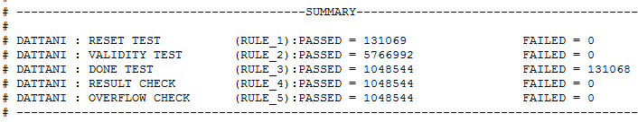

Figure 1: No additional bug introduced

# Individual Bug Checking

# Add separate bugs in the DUT and show the transcript that your checker flags errors for rule#1, 4 & 5. Document where you introduced your bugs in the DUT.

1. Bug introduced for rule 1.

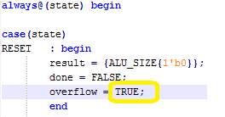

Result Observed: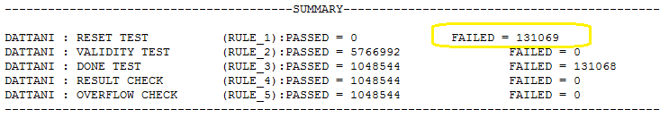

Result Observed when RULE_1 disabled:

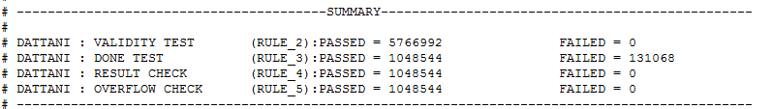

1. Bug Introduced for rule 4

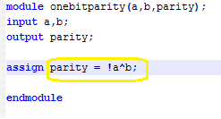

Result Observed:

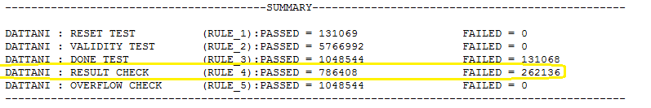

Result Observed when RULE_4 disabled

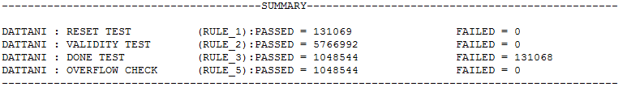

1. Bug introduced for rule 5

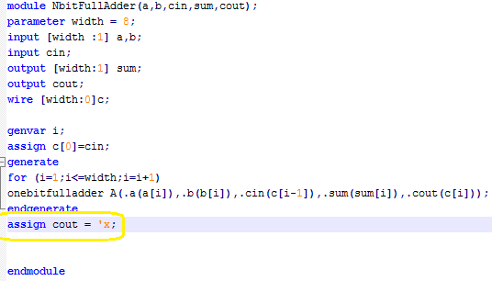

Result Observed:

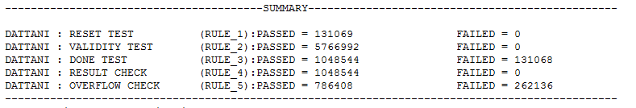

Result Observed when RULE_5 disabled

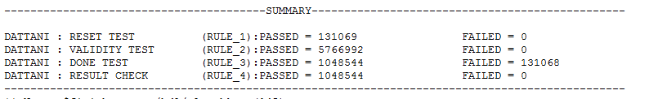

# Add a bug in the test generator and show the transcript that your checker flags errors for rule#2. Document where you introduced your bug in the test generator

Bug Introduced:

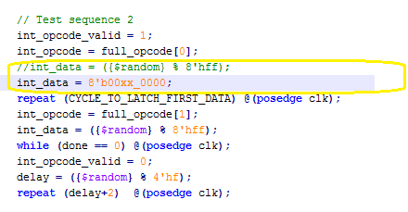

Result Observed:

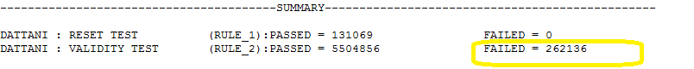

Result Observed when RULE_2 disabled:

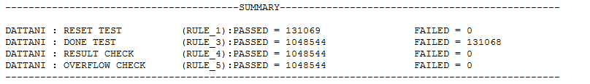

# Bonus: Introduce a bug in the DUT and see if you can get your checker to flag an error for rule#3.

Bug Introduced:

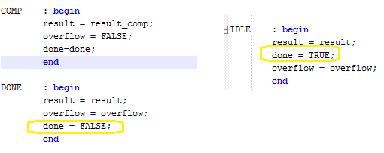

Result Observed:

