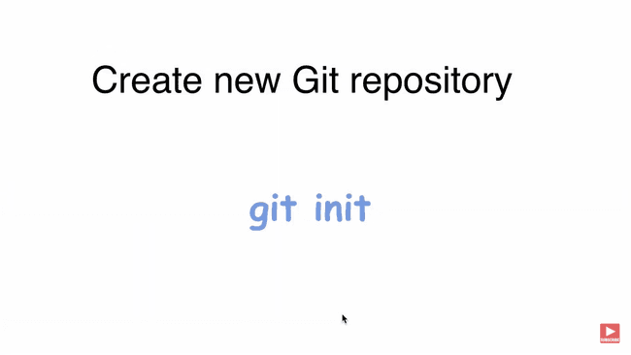

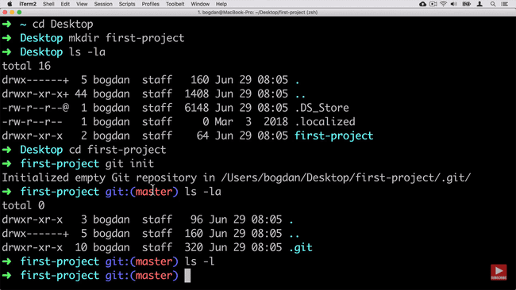

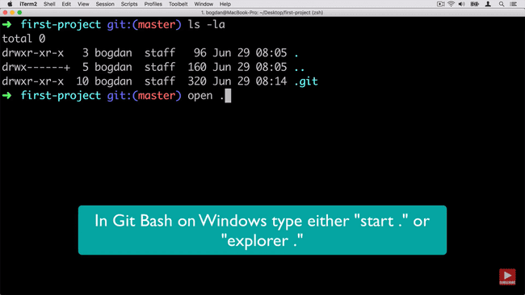

Blob – File

Tree – folder or directory in git

Commit – Different Version

AnnotatedTag – pointer to commit

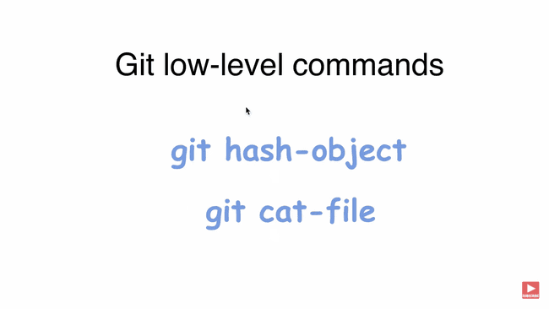hash object create cat read

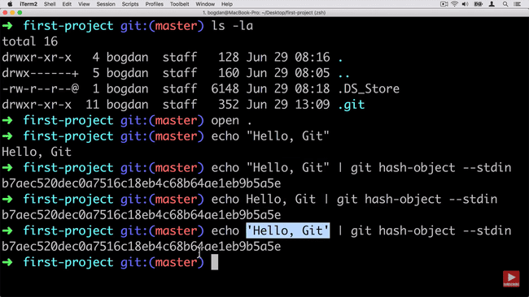

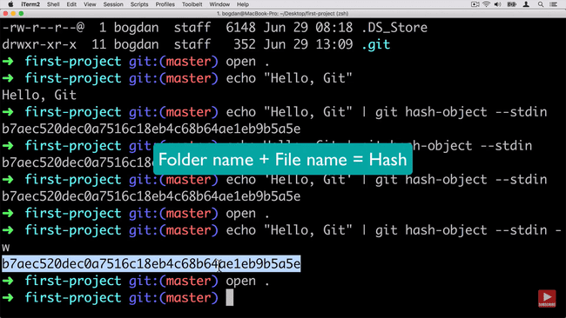

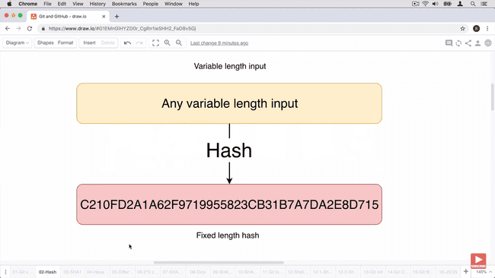

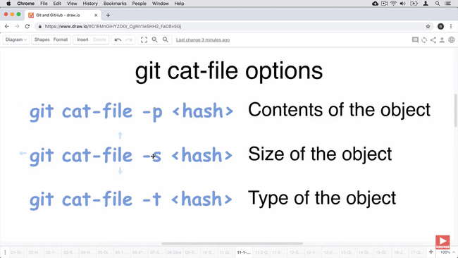

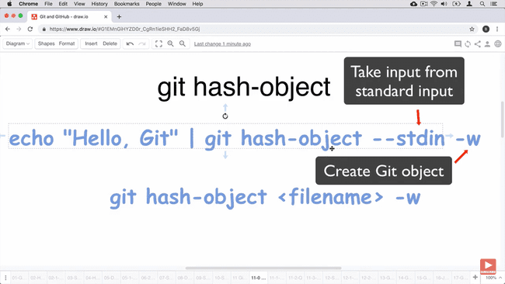

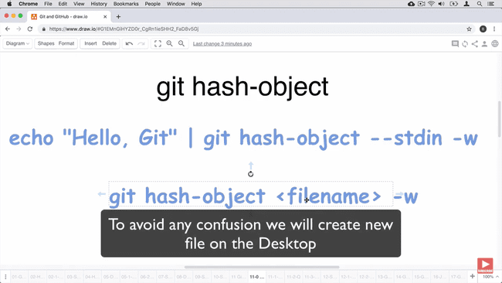

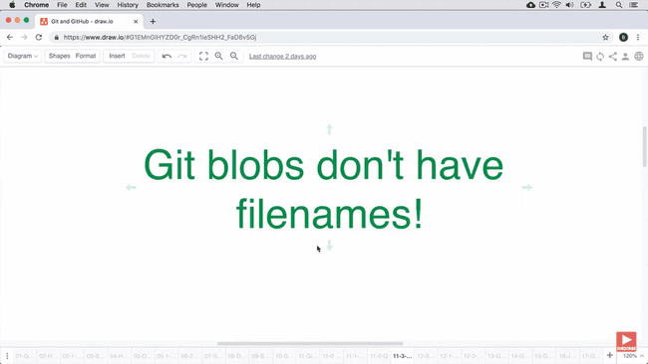

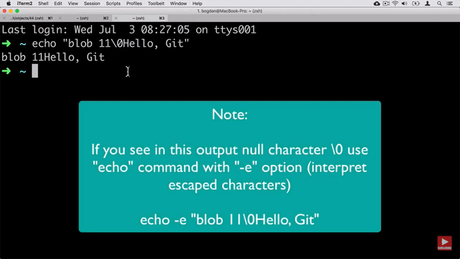

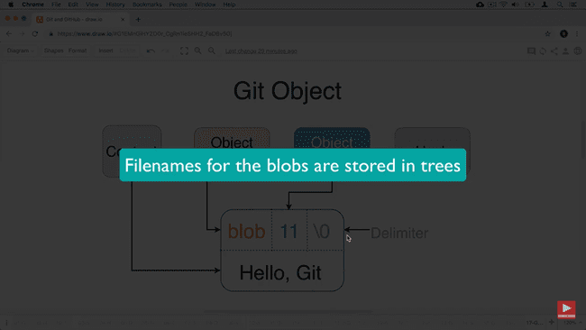

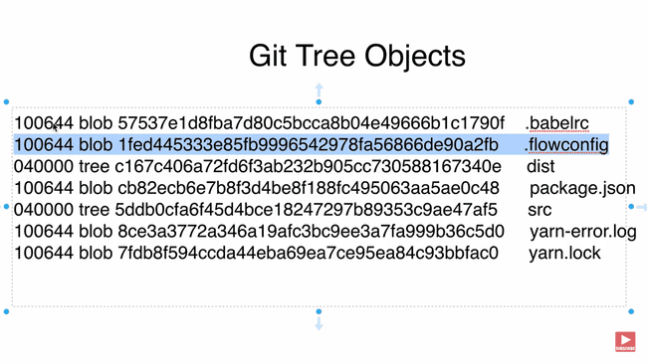

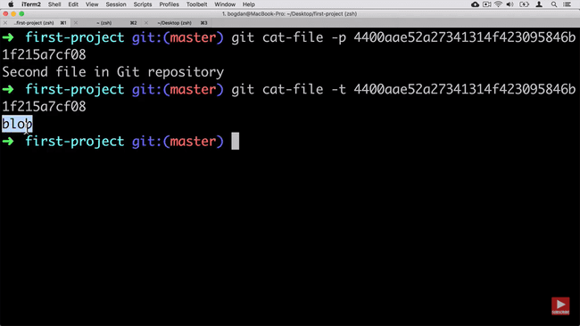

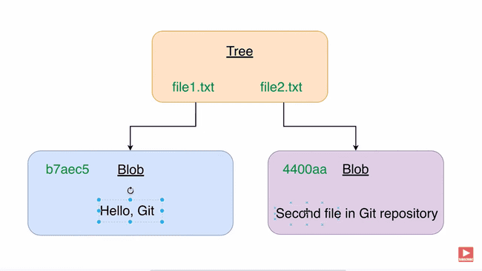

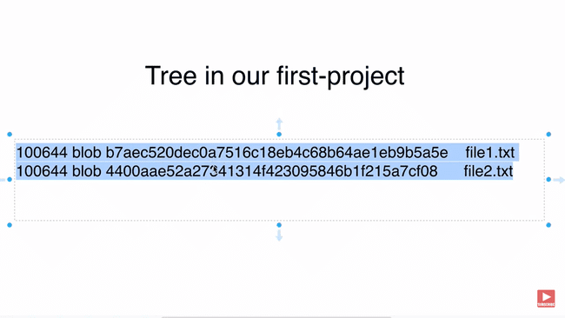

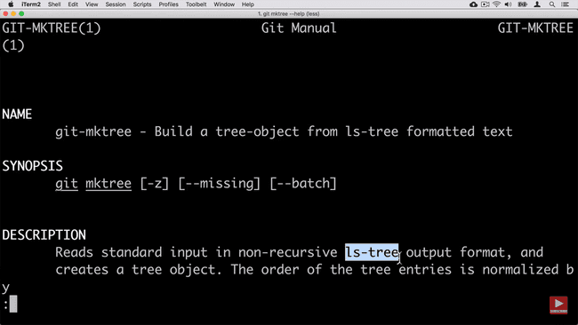

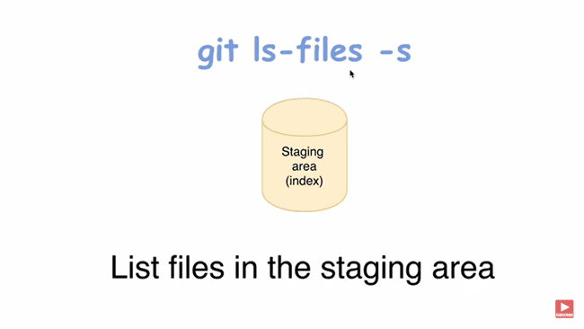

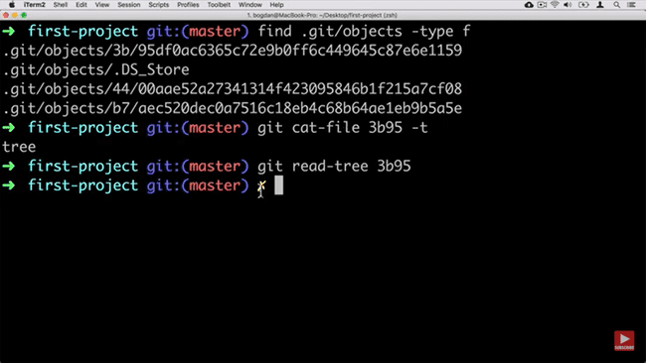

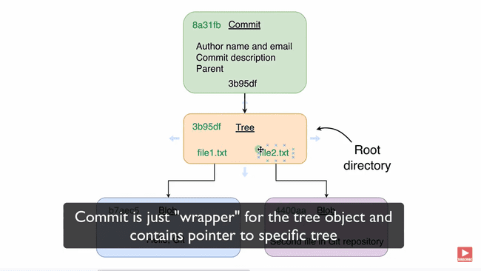

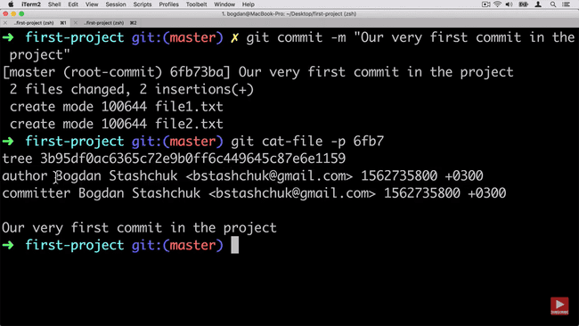

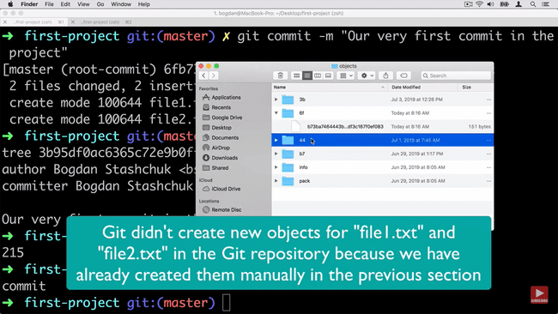

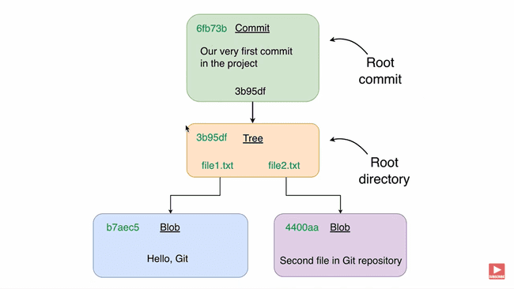

Unpacking git object

Git diff command



