class04.R
nicol
2026-01-16
x <- 1:50
plot(x)
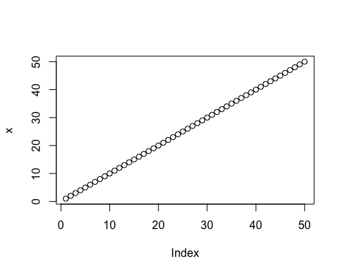
plot(x, sin(x), typ="l", col="pink", lwd=3, xlab="Is it lunch time yet?")
