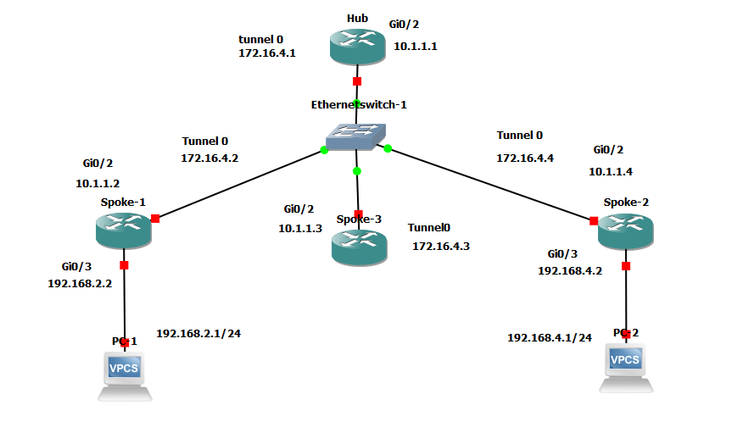

|  |
| --- |
| **HUB** ! hostname PACHI_HUB_PERROKADA   !--- Create an Internet Security Association and Key Management !--- Protocol (ISAKMP) policy for Phase 1 negotiations. crypto isakmp policy 10 hash md5 authentication pre-share   !--- Add dynamic pre-shared keys for all the remote VPN !--- routers. crypto isakmp key cisco123 address 0.0.0.0 0.0.0.0   !--- Create the Phase 2 policy for actual data encryption. crypto ipsec transform-set strong esp-3des esp-md5-hmac   !--- Create an IPSec profile to be applied dynamically to the !--- GRE over IPSec tunnels. crypto ipsec profile cisco set security-association lifetime seconds 120 set transform-set strong   !--- Create a GRE tunnel template which will be applied to !--- all the dynamically created GRE tunnels. interface Tunnel0 ip address 172.16.4.1 255.255.255.0 no ip redirects ip mtu 1440 ip nhrp authentication cisco123 ip nhrp map multicast dynamic ip nhrp network-id 1 no ip split-horizon eigrp 90 no ip next-hop-self eigrp 90 tunnel source Gi0/0 tunnel mode gre multipoint tunnel key 0 tunnel protection ipsec profile cisco   !--- This is the outbound interface. interface Gi0/0 ip address 10.1.1.1 255.255.255.0 duplex auto speed auto no sh   !--- Enable a routing protocol to send and receive !--- dynamic updates about the private networks. router eigrp 90 network 172.16.4.0 no auto-summary End   **Spoke -1** service timestamps debug uptime service timestamps log uptime no service password-encryption ! hostname SPOKE_1 ! no ip domain lookup   !--- Create an ISAKMP policy for Phase 1 negotiations. crypto isakmp policy 10 hash md5 authentication pre-share   !--- Add dynamic pre-shared keys for all the remote VPN !--- routers and the hub router. crypto isakmp key cisco123 address 0.0.0.0 0.0.0.0   !--- Create the Phase 2 policy for actual data encryption. crypto ipsec transform-set strong esp-3des esp-md5-hmac   !--- Create an IPSec profile to be applied dynamically to !--- the GRE over IPSec tunnels. crypto ipsec profile cisco set security-association lifetime seconds 120 set transform-set strong  !--- Create a GRE tunnel template to be applied to !--- all the dynamically created GRE tunnels. interface Tunnel0 ip address 172.16.4.2 255.255.255.0 no ip redirects ip mtu 1440 ip nhrp authentication cisco123 ip nhrp map multicast dynamic ip nhrp map 172.16.4.1 10.1.1.1 ip nhrp map multicast 10.1.1.1 ip nhrp network-id 1 ip ospf network point-to-multipoint ip nhrp nhs 172.16.4.1 tunnel source Gi0/0 tunnel mode gre multipoint tunnel key 0 tunnel protection ipsec profile cisco  !--- This is the outbound interface. interface Gi0/0 ip address 10.1.1.2 255.255.255.0 duplex auto speed auto no sh  !--- This is the inbound interface. interface Gi0/1 ip address 192.168.2.2 255.255.255.0 duplex auto speed auto  no sh ! !--- Enable a routing protocol to send and receive !--- dynamic updates about the private networks. router eigrp 90 network 192.168.2.0 0.0.0.255 network 172.16.4.0 0.0.0.255 no auto-summary ! ip classless ip route 0.0.0.0 0.0.0.0 10.1.1.1 ip route 192.168.4.0 255.255.255.0 Tunnel0 ! end     **Spoke - 2** service timestamps debug datetime msec service timestamps log datetime msec no service password-encryption ! hostname SPOKE_2 ! no ip domain lookup !   !--- Create an ISAKMP policy for Phase 1 negotiations. crypto isakmp policy 10  hash md5  authentication pre-share   !--- Add dynamic pre-shared keys for all the remote VPN !--- routers and the hub router. crypto isakmp key cisco123 address 0.0.0.0 0.0.0.0   !--- Create the Phase 2 policy for actual data encryption. crypto ipsec transform-set strong esp-3des esp-md5-hmac !   !--- Create an IPSec profile to be applied dynamically to !--- the GRE over IPSec tunnels. crypto ipsec profile cisco  set security-association lifetime seconds 120  set transform-set strong    !--- Create a GRE tunnel template to be applied to !--- all the dynamically created GRE tunnels. interface Tunnel0 ip address 172.16.4.3 255.255.255.0 no ip redirects ip mtu 1440 ip nhrp authentication cisco123 ip nhrp map multicast dynamic ip nhrp map 172.16.4.1 10.1.1.1 ip nhrp map multicast 10.1.1.1 ip nhrp network-id 1  ip nhrp nhs 172.16.4.1  tunnel source Gi0/0 tunnel mode gre multipoint tunnel key 0 tunnel protection ipsec profile cisco !   !--- This is the outbound interface. interface Gi0/0 ip address 10.1.1.3 255.255.255.0 duplex auto speed auto no sh ! !   !--- This is the inbound interface. ! !--- Enable a routing protocol to send and receive !--- dynamic updates about the private networks. router eigrp 90 network 172.16.4.0 0.0.0.255 no auto-summary ! ip classless ip route 0.0.0.0 0.0.0.0 10.1.1.1 ip route 192.168.4.0 255.255.255.0 Tunnel0 ip route 192.168.2.0 255.255.255.0 Tunnel0 ! End   **Spoke -3** service timestamps debug uptime service timestamps log uptime no service password-encryption ! hostname SPOKE_3 ! no ip domain lookup   !--- Create an ISAKMP policy for Phase 1 negotiations. crypto isakmp policy 10 hash md5 authentication pre-share   !--- Add dynamic pre-shared keys for all the remote VPN !--- routers and the hub router. crypto isakmp key cisco123 address 0.0.0.0 0.0.0.0 !  !--- Create the Phase 2 policy for actual data encryption. crypto ipsec transform-set strong esp-3des esp-md5-hmac !   !--- Create an IPSec profile to be applied dynamically to !--- the GRE over IPSec tunnels. crypto ipsec profile cisco set security-association lifetime seconds 120 set transform-set strong !   !--- Create a GRE tunnel template to be applied to !--- all the dynamically created GRE tunnels. interface Tunnel0 ip address 172.16.4.4 255.255.255.0 no ip redirects ip mtu 1440 ip nhrp authentication cisco123 ip nhrp map multicast dynamic ip nhrp map 172.16.4.1 10.1.1.1 ip nhrp map multicast 10.1.1.1 ip nhrp network-id 1 ip nhrp network-id 1 ip nhrp nhs 172.16.4.1 tunnel source Gi0/0 tunnel mode gre multipoint tunnel key 0 tunnel protection ipsec profile cisco !   !--- This is the outbound interface. interface Gi0/0 ip address 10.1.1.4 255.255.255.0 duplex auto speed auto no sh ! !--- This is the inbound interface. interface Gi0/1 ip address 192.168.4.2 255.255.255.0 duplex auto speed auto  no sh ! !--- Enable a routing protocol to send and receive !--- dynamic updates about the private networks. router eigrp 90 network 192.168.4.0 0.0.0.255 network 172.16.4.0 0.0.0.255 no auto-summary ! ip classless ip route 0.0.0.0 0.0.0.0 10.1.1.1 ip route 192.168.2.0 255.255.255.0 Tunnel0 ! End   PC 1 ip addr add 192.168.2.1/24 dev eth0 route add default gw 192.168.2.2 PC 2 ip addr add 192.168.4.1/24 dev eth0 route add default gw 192.168.4.2 |