03/06/2019

REINBOLD VALENTIN, BROUTIN MELINE, HUGO DE GROSSI, GUILLAUME GIRARDI

Git Report

With Explanation

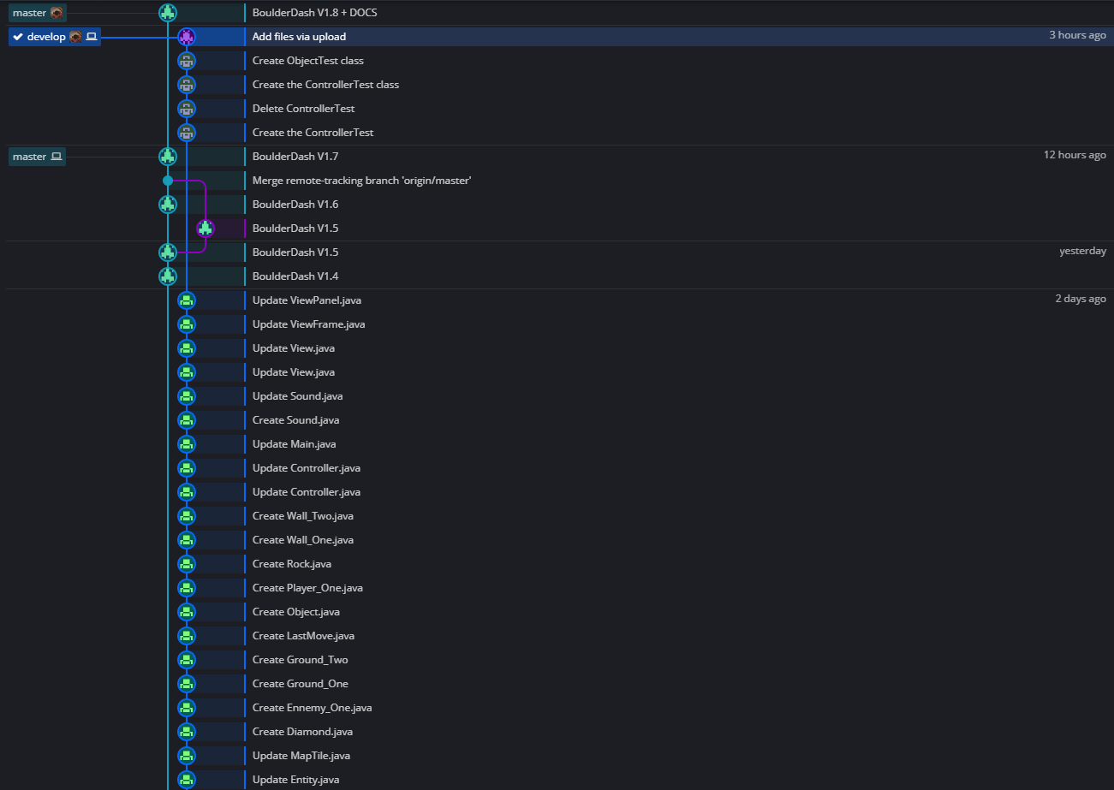



 Guillaume Girardi

 Broutin Méline

 & Hugo De Grossi

 Reinbold Valentin

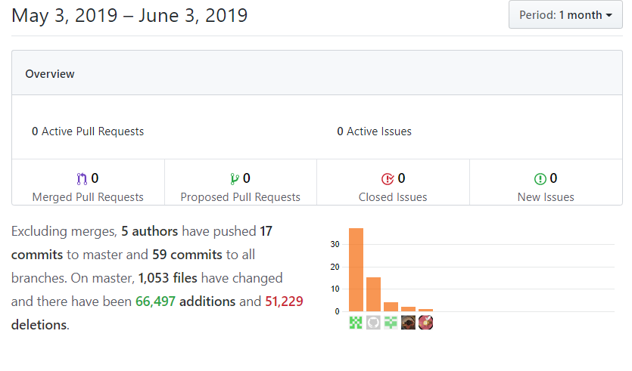

Reinbold Valentin

 & Hugo De Grossi

Guillaume Girardi

Broutin Méline

Valentin had some problems with his GitHub, so he had to commit manually in GitHub, which make him having way more commit than us because he had to update each document one by one.