<https://id.atlassian.com/signup?application=bitbucket&continue=https%3A//bitbucket.org/account/signin/%3Foptintocst%3D1%26next%3D/%3Faidsignup%3D1>

signup:

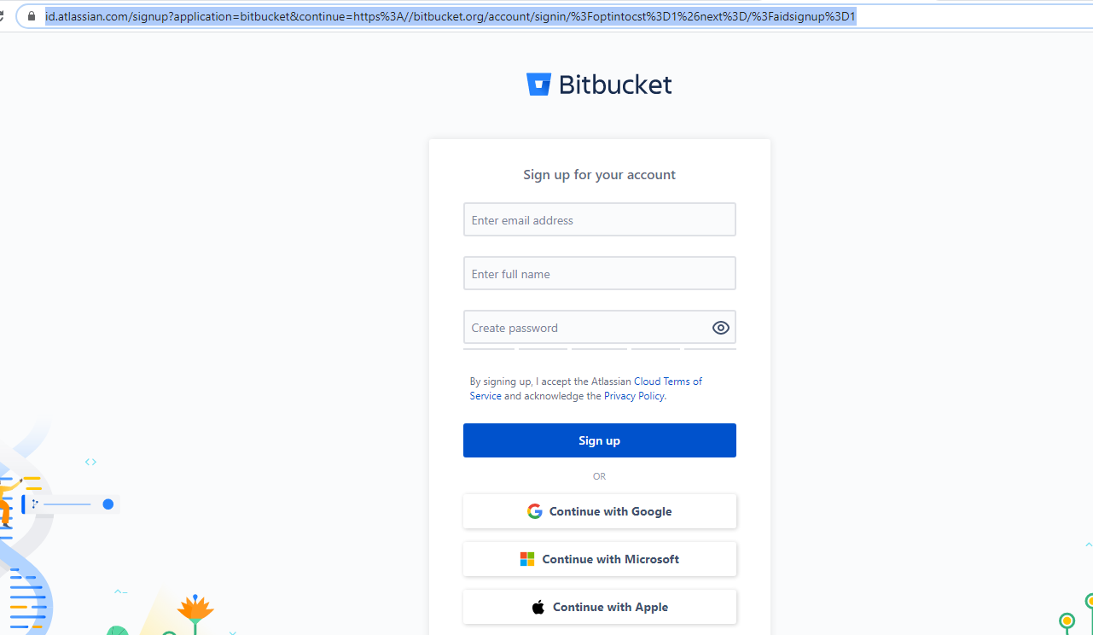

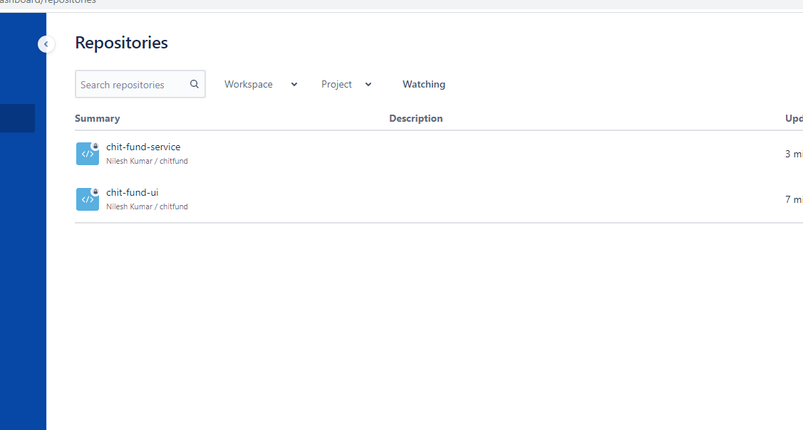

Git bash command:

git init

git add.

git push -f origin master