RKE2 High Availability Kubernetes Cluster – Architecture & Deployment Guide

1. Executive Summary
This document describes the design and deployment of a highly available, production-grade Kubernetes cluster using Rancher Kubernetes Engine 2 (RKE2) . It is designed to be cloud-agnostic and on-prem compatible .

The solution is:
- Cloud-agnostic
- On-prem compatible
- Secure by default
- Fully scriptable from a bastion host

2. High-Level Architecture
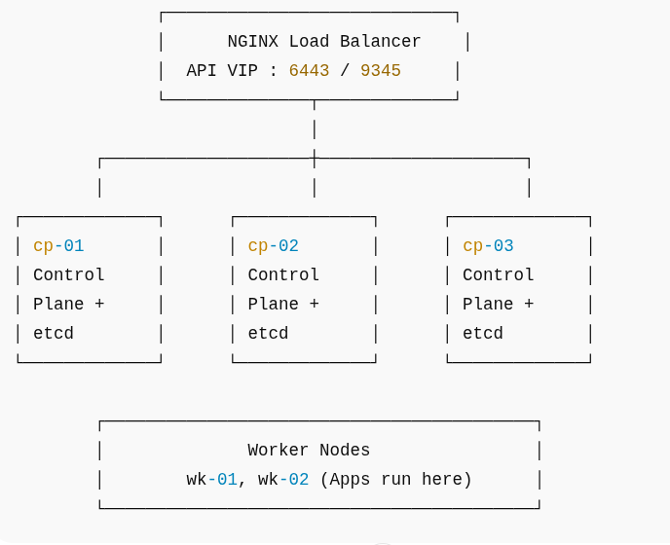
3. Node Inventory
For this setup we have have total 6 nodes for High availabiity , out of which 3 are control plane and 2 are worker node . Apart form these servers , we need one bastian server from where we will run all the automation scripts .

Private IP | Hostname | Role
node-ip | cp-01 | Control Plane + etcd
node-ip | cp-02 | Control Plane + etcd
node-ip | cp-03 | Control Plane + etcd
node-ip | lb-01 | Load Balancer for control plane – Nginx (used here)
node-ip | wk-01 | Worker
node-ip | wk-02 | Worker

Note :- Bastion host should have passwordless SSH access to all nodes . It is required for automation

4. Network & Security Model

Port | Protocol | Source | Purpose
22 | TCP | Bastion IP | SSH
6443 | TCP | Subnet CIDR | Kubernetes API
9345 | TCP | Subnet CIDR | RKE2 Supervisor
2379–2380 | TCP | Subnet CIDR | etcd
10250 | TCP | Subnet CIDR | kubelet
30000–32767 | TCP | Subnet CIDR | NodePort
ICMP | ICMP | Subnet CIDR | Debug

5. Bastion Host Configuration

5.1 SSH Configuration
Passwordless SSH from bastion to all nodes

# nano ~/.ssh/config
paste the following lines into the file .

Note :- Give the network/VPC cidr , user name and the pem file full path

Host 10.0.0.* cp-* wk-* lb-* # replace it with your CIDR
User ubuntu
IdentityFile ~/.ssh/RKE.pem
StrictHostKeyChecking no

5.2 Hostname Resolution
Note :- Not a mandatory step but helpful for the team

# nano /etc/hosts
and paste the following

private-ip of node 1 cp-01
private-ip of node 2 cp-02
private-ip of node 3 cp-03
private-ip of node 4 lb-01
private-ip of node 5 wk-01
private-ip of node 6 wk-02

6. Phase 1 – OS & Kernel Preparation (All Nodes)

Mandatory Kubernetes Requirements
- Swap disabled
- Kernel modules loaded
- Networking sysctl applied

please use the shell script provided below for Phase 1

swapoff -a
sed -i '/ swap / s/^/#/' /etc/fstab
modprobe overlay
modprobe br_netfilter
cat <<EOF >/etc/modules-load.d/k8s.conf
overlay
br_netfilter
EOF
cat <<EOF >/etc/sysctl.d/99-kubernetes-cri.conf
net.bridge.bridge-nf-call-iptables=1
net.bridge.bridge-nf-call-ip6tables=1
net.ipv4.ip_forward=1
EOF
sysctl --system

7. Phase 2 – External NGINX Load Balancer

Purpose
- HA Kubernetes API access
- HA RKE2 supervisor (join traffic)

key ports :-
Port | Usage
6443 | Kubernetes API
9345 | RKE2 cluster bootstrap & remotedialer

Note :-
Nodes must join via 9345
Humans and tools must use 6443

NGINX Stream Configuration

The below configuration needs to be pasted in /etc/nginx/stream.d
and you can name the file as k8s-api.conf .

upstream rke2_api {
least_conn;
server 10.0.0.47:6443; # cp-01 -- replace it with you node ip
server 10.0.0.251:6443; # cp-02 -- replace ip
server 10.0.0.109:6443; # cp-03 -- replace ip
}

upstream rke2_supervisor {
least_conn;
server 10.0.0.47:9345; # cp-01 -- replace ip
server 10.0.0.251:9345; # cp-02 -- replace ip
server 10.0.0.109:9345; # cp-03 -- replace ip
}

server {
listen 6443;
proxy_pass rke2_api;
proxy_timeout 10m;
proxy_connect_timeout 5s;
}

server {
listen 9345;
proxy_pass rke2_supervisor;
proxy_timeout 10m;
proxy_connect_timeout 5s;
}

Register Stream Context in nginx.conf

file --> sudo nano /etc/nginx/nginx.conf
Locate the line “ include /etc/nginx/modules-enabled/*.conf; ”
and paste the following block just below it

stream {
include /etc/nginx/stream.d/*.conf;
}

To verify :-
# sudo nginx -t

8. Phase 3 – RKE2 Control Plane Bootstrap

Step 1: Initialize First Control Plane
Execute this on cp-01 only:

curl -sfL https://get.rke2.io | sh -
systemctl enable rke2-server
systemctl start rke2-server

Step 2: Retrieve Cluster Token

cat /var/lib/rancher/rke2/server/node-token

This token is used by:
- Additional control plane nodes
- Worker nodes

Note :- Please take note of the spaces while copying token & do not modify the token

9. Phase 4 – Join Remaining Control Plane Nodes
On cp-02 and cp-03:

/etc/rancher/rke2/config.yaml
server: https://lb-01:9345
token: <generated-token>
tls-san:
- lb-01
- <node ip>

10. Phase 5 – Worker Node Join

Workers use rke2-agent, not server
curl -sfL https://get.rke2.io | INSTALL_RKE2_TYPE="agent" sh -
cat <<EOF >/etc/rancher/rke2/config.yaml
server: https://lb-01:9345
token: <generated-token>
EOF

systemctl enable rke2-agent
systemctl start rke2-agent

Verify the control plane
Workers should correctly show the nodes on executing the commands below
# kubectl get nodes
# kubectl get po -n kube-system

we can also label the workers node for better visibility and understanding
# kubectl label node wk-01 node-role.kubernetes.io/worker=worker
# kubectl label node wk-02 node-role.kubernetes.io/worker=worker

Note :- Dont forget to export the KUBECONFIG file path to bashrc for kubectl to work

11. AUTOMATION & One-Click Bootstrap Strategy
The entire platform can be fully automated using a controlled, multi-phase bootstrap model.
Automation is achieved by executing a small set of scripts in a strict, deterministic sequence from a bastion host or CI/CD pipeline.

From an operator or CI/CD perspective:
- A single pipeline execution provisions and configures the entire platform
- Internally, the pipeline executes phased steps
The scripts :-
1. preflight-steps.sh
Runs on all control plane and worker nodes
- Performs:
OS hardening and kernel preparation
Swap disablement
Required sysctl and kernel module configuration
Hostname configuration /etc/hosts normalization
Passwordless SSH setup from bastion to all nodes

2. bootstrap-control-plane.sh
Executed from the bastion host
Responsibilities:
Bootstraps the first RKE2 control plane node
Retrieves the dynamically generated cluster token
Joins remaining control plane nodes via the external load balancer
Establishes etcd quorum and HA control plane

3. bootstrap-workers.sh

Executed after control plane stabilization

- Responsibilities:
Distributes the cluster join token securely
Installs and starts rke2-agent on worker nodes
Validates successful node registration

These scripts are available in my github repo and we can use them with any ci/cd tool to achieve the automation

