[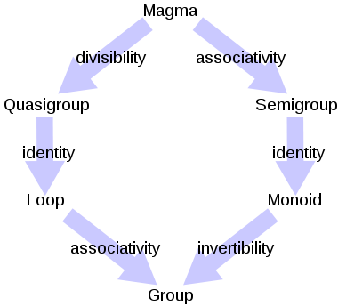](http://en.wikipedia.org/wiki/File:Magma_to_group2.svg)

Group like structures

|  |  |  |  |  |
| --- | --- | --- | --- | --- |
| [**Group**](http://en.wikipedia.org/wiki/Group_(mathematics)) | Yes | Yes | Yes | Yes |
| [**Monoid**](http://en.wikipedia.org/wiki/Monoid) | Yes | Yes | Yes | No |
| [**Semigroup**](http://en.wikipedia.org/wiki/Semigroup) | Yes | Yes | No | No |
| [**Loop**](http://en.wikipedia.org/wiki/Loop_(algebra)) | Yes | No | Yes | Yes |
| [**Quasigroup**](http://en.wikipedia.org/wiki/Quasigroup) | Yes | No | No | No |
| **Magma** | Yes | No | No | No |
| [**Groupoid**](http://en.wikipedia.org/wiki/Groupoid) | No | Yes | Yes | Yes |
| [**Category**](http://en.wikipedia.org/wiki/Category_(mathematics)) | No | Yes | Yes | No |
| [**Semicategory**](http://en.wikipedia.org/w/index.php?title=Semicategory&action=edit&redlink=1) | No | Yes | No | No |

[**Algebraic structures**](http://en.wikipedia.org/wiki/Algebraic_structure)

|  |  |
| --- | --- |
| **Magma 1** | [Set](http://en.wikipedia.org/wiki/Set_(mathematics)) *S* with [binary operation](http://en.wikipedia.org/wiki/Binary_operation) ○ |
|  |  |
| [**Semigroup**](http://en.wikipedia.org/wiki/Semigroup) | [Associative](http://en.wikipedia.org/wiki/Associativity) magma |
|  |  |
| [**Monoid**](http://en.wikipedia.org/wiki/Monoid) | Semigroup (*S*,○) with [identity](http://en.wikipedia.org/wiki/Identity_element) "e" |
|  |  |
| [**Group**](http://en.wikipedia.org/wiki/Group_(mathematics)) | Monoid (*G*,○) admitting [inverses](http://en.wikipedia.org/wiki/Inverse_element) |
|  |  |
| [**Abelian group**](http://en.wikipedia.org/wiki/Abelian_group) | Group (*G*,○), [commutativity](http://en.wikipedia.org/wiki/Commutative_property) of ○ (alternatively, (*A*,+) with identity element 0) |
|  |  |
| [**Ring**](http://en.wikipedia.org/wiki/Ring_(mathematics)) | (*R*,•,+), Abelian group under +, semigroup under • [Distributivity](http://en.wikipedia.org/wiki/Distributive_property) of • over + |
|  |  |
| [**Ring with Unity**](http://en.wikipedia.org/wiki/Ring_with_Unity) | Ring with identity element 1 for • |
|  |  |
| [**Commutative ring**](http://en.wikipedia.org/wiki/Commutative_ring) | Ring with commutativity of • |
|  |  |
| [**Integral domain**](http://en.wikipedia.org/wiki/Integral_domain) | Commutative ring with identity with no zero divisors for • |
|  |  |
| [**Field**](http://en.wikipedia.org/wiki/Field_(mathematics)) | Commutative ring with inverses for • (of non-zero elements) |
|  |  |
| 1Also called groupoid | |