__________________________________________________________________________________________
SOFTWARE REQUIREMENTS SPECIFICATION
Prepared in IEEE 830 style
Untitled Project
Document Information
Prepared by: Unknown
Organization: Unspecified
Version: 1.0
Date Created: 05/03/2026
Document ID | SRS-UNTITLED-PROJECT-001
Document Status | Draft
Prepared For | Unspecified
__________________________________________________________________________________________

Table of Contents
Right-click and update field to generate Table of Contents.
Open in Microsoft Word and use 'Update Field' to refresh page numbers.

Visual Overview
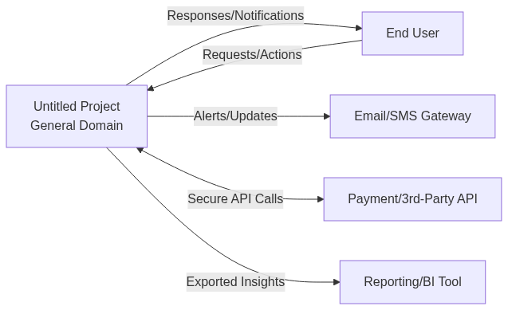  Figure A1: System Context | 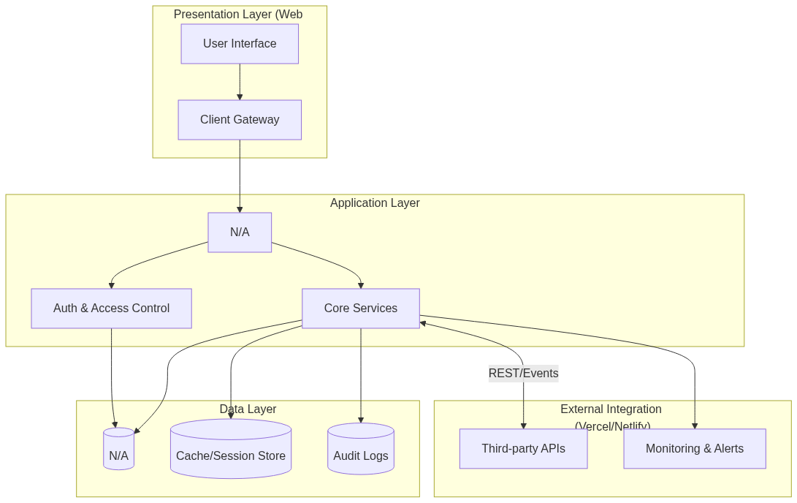  Figure A2: System Architecture
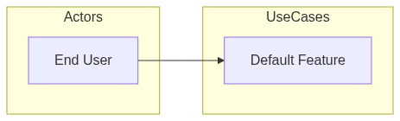  Figure A3: Use Case Diagram | Figure A4: User Workflow
Figure A5: Security Flow | 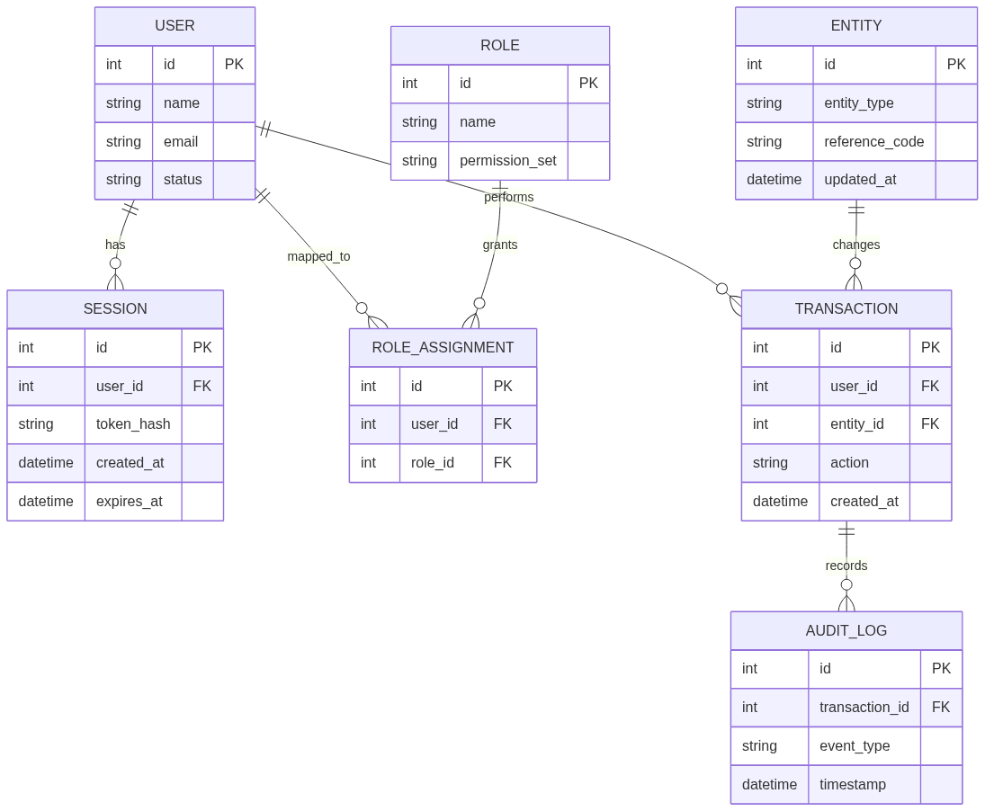  Figure A6: Data ERD

1. Introduction

1.1 Purpose
No problem statement provided. This SRS defines a structured Web Application solution that centralizes core operations, standardizes workflows, improves data quality, and supports auditable execution across key departments. The platform is designed for maintainability, secure role-based access, and progressive enhancement as usage scales.

1.2 Scope of the System
The solution delivers a centralized General platform with secure user access, modular service boundaries, measurable SLAs, and operational reporting. It includes business process automation, data governance controls, and API-ready integration support. Items that are not explicitly listed in this specification remain out of scope for the current release.

Included in scope:
- Default Feature

Excluded from scope:
- Direct replacement of unrelated legacy tools outside defined domain boundaries
- Custom integrations not listed in technical preferences
- Unapproved feature expansions outside the release objective

1.3 Definitions, Acronyms, and Abbreviations
- SRS – Software Requirements Specification
- RBAC – Role-Based Access Control
- CRUD – Create, Read, Update, Delete
- UI – User Interface
- API – Application Programming Interface

1.4 Document Conventions
- IEEE 830-1998 style

2. Feasibility & Cost Estimation
The following cost and effort estimates are based on the COCOMO II model.
Metric | Estimated Value
Estimated Lines of Code (KLOC) | 5.2 KLOC
Development Effort | 14.5 Person-Months
Development Cost | $45,000
Required Schedule | 6 Months

2. Overall Description

2.1 Product Perspective
The product is a Web Application platform operating in the General domain. It serves as a unified control point for business workflows, combining secure identity, transaction lifecycle handling, reporting, and integration readiness. The architecture is designed to support phased rollout, future scaling, and clear separation between UI, service, and data concerns.

Figure 1: System Context Diagram

2.2 Product Features
- Default Feature

2.3 User Classes and Characteristics
- End User: Uses role-specific modules and dashboards relevant to assigned responsibilities.

2.4 Operating Environment
- Modern web browsers (Chrome, Edge, Firefox)
- Containerized API services with managed cloud runtime
- Managed database service with backup and monitoring

2.5 Design and Implementation Constraints
- All sensitive operations must be authenticated and authorized
- APIs should remain backward compatible within the major release
- Document generation and reporting should complete within acceptable SLA limits

2.6 User Documentation
- Administrator setup and role configuration guide
- Operations handbook for day-to-day usage
- Troubleshooting and escalation reference

2.7 Assumptions and Dependencies

Assumptions:
- Stakeholders provide complete business rules and approval logic
- Users have stable internet connectivity and modern browser support

Dependencies:
- Email delivery provider for notifications and review loops
- Database availability for persistent records and audit trails

3. System Architecture
The system follows a layered architecture consisting of: Presentation Layer (Web UI), Application Layer (Backend services), Data Layer (Database), and External Integration Layer (APIs, third-party services).

Figure 2: System Architecture Diagram

4. Functional Requirements

Figure 3: Use Case Diagram

4.1 Default Feature
Description: Standard user flow.

Functional Requirements:
- Support: Default Feature

5. User Workflow
The typical user workflow includes: User logs into the system; System validates credentials; User accesses role-based dashboard; User performs permitted actions; System processes and stores data; User views results or reports.
Figure 4: User Workflow Diagram

6. Non-Functional Requirements

6.1 Performance
- System performance target: Normal under expected user scale 100-1k.
Rationale: User-specified baseline.
- Primary API operations should return within acceptable interactive latency for standard workloads.
Rationale: Usability and productivity.
- Report and document generation pipelines should provide progress status and deterministic completion behavior.
Rationale: Operational reliability.

6.2 Safety
- Critical operations must validate business rules before persisting state changes.
Rationale: Prevent invalid transactions.
- System should provide safe rollback/retry behavior for failed asynchronous operations.
Rationale: Data consistency.

6.3 Security
- Authentication required.
Rationale: Security.
- Role-based authorization must be enforced at API and workflow layers.
Rationale: Access control.
- Sensitive data should be protected in transit and at rest.
Rationale: Compliance and risk reduction.

6.4 Quality
- Maintainable module boundaries and clear service contracts.
Rationale: Long-term extensibility.
- Observable runtime behavior with logs, status endpoints, and workflow events.
Rationale: Supportability.

7. Security Requirements
The system shall: Enforce secure authentication mechanisms; Use encrypted communication channels; Protect sensitive data from unauthorized access; Log security-related events.
Figure 5: Security Flow Diagram

8. Data Requirements
The system shall manage structured data entities and their relationships efficiently.

Figure 6: Entity Relationship Diagram

9. External Interface Requirements

4.1 User Interfaces
Responsive web interface with role-specific dashboards, controlled forms, and guided workflows.
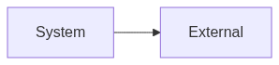
Figure 7: User Interface Diagram

4.2 Hardware Interfaces
Compatible with standard workstation environments and cloud-hosted runtime infrastructure.

Figure 8: Hardware Interface Diagram

Figure 9: Software/API Interface Diagram
Secure HTTPS-based REST APIs with token authentication, request validation, and structured error handling.

10. Assumptions and Dependencies

Assumption 1:
Stakeholders have agreed on the problem statement and scope.
Impact: Scope clarity.

Assumption 2:
Target users: End User.
Impact: Audience.

11. Future Enhancements
- Mobile application support
- Advanced analytics and insights
- Integration with additional third-party services

Appendices
The following appendices provide detailed specifications, models, and analysis for the proposed system.

Appendix A: Detailed User Personas
User Class | Description | Responsibilities | Skills/Requirements
End User | Uses role-specific modules and dashboards relevant to assigned responsibilities. | Perform domain operations, review records, and track workflow status. | Basic process knowledge and familiarity with secure web applications.

Appendix B: Use Case Specifications

Default Feature
Description | Standard user flow.
Inputs | Authenticated user context, validated payload, and policy constraints.
Functional Specs | • The system shall provide a complete default feature workflow with create, validate, update, and close actions.  • The system shall enforce role-based access and approval checkpoints for default feature operations.  • The system shall persist all default feature transactions with timestamps and actor identifiers for traceability.  • The system shall expose filtered views and reports for default feature to support monitoring and decision-making.
Outputs | Persisted transaction result, status update, and user-visible confirmation.
Acceptance Criteria | Operation completes successfully with validation, authorization, and audit logging.

Appendix C: System Models

System Modeling & Design

Core Sequence Diagram
The following sequence diagram illustrates the typical interaction flow between the user, frontend, backend API, and data layer for a primary system action.
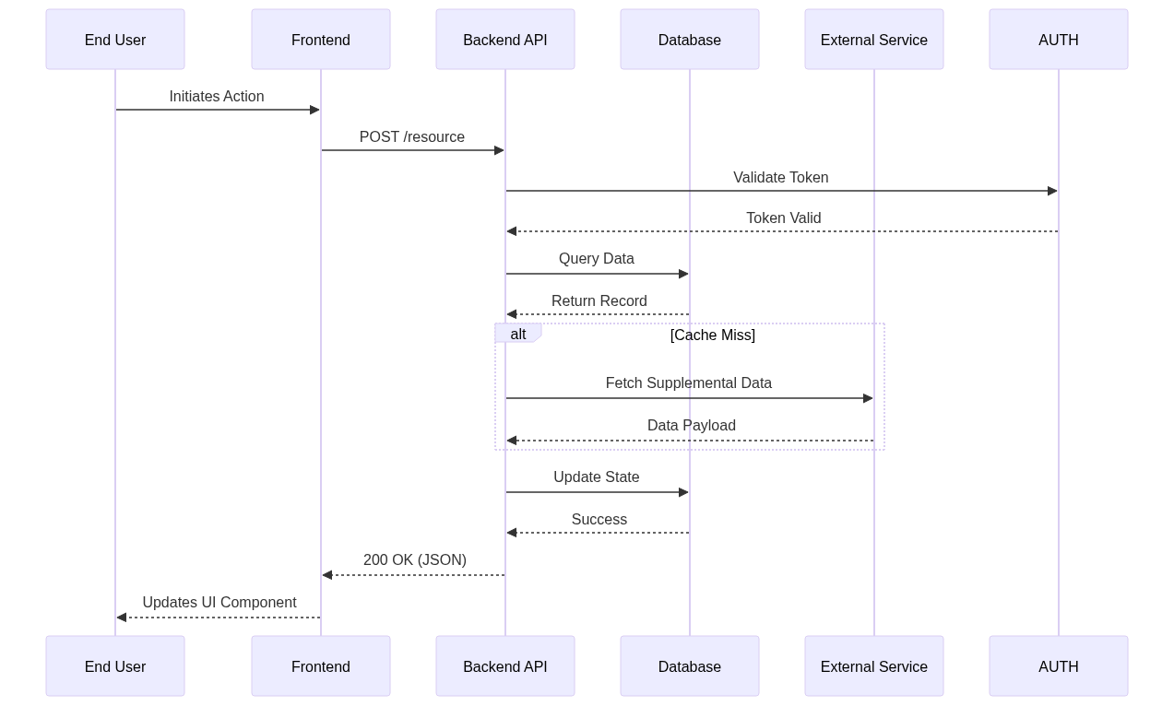
Figure: System Sequence Diagram

Entity State Diagram
The state diagram below depicts the lifecycle of key system entities (e.g., Orders, Tickets, or User Sessions) as they transition through various statuses.
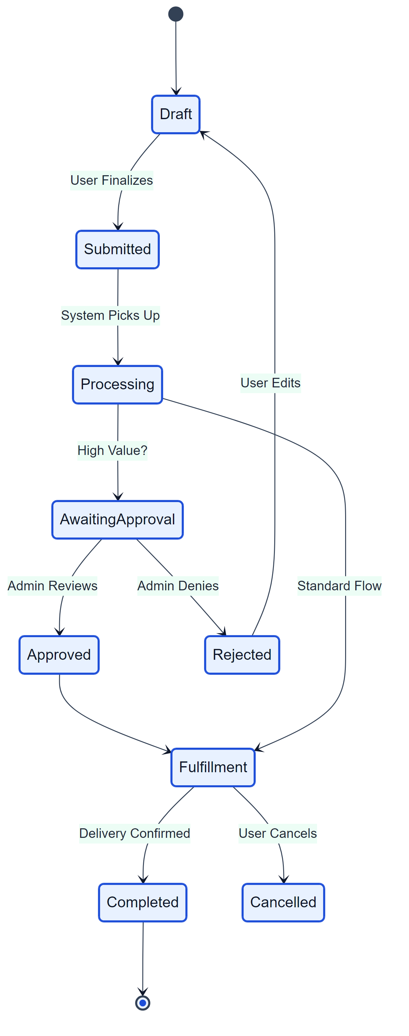
Figure: Entity State Diagram

Appendix D: UI Prototypes

User Interface Prototyping
This section provides a visual reference for the intended user interface layout and key components.

High-Level Wireframe
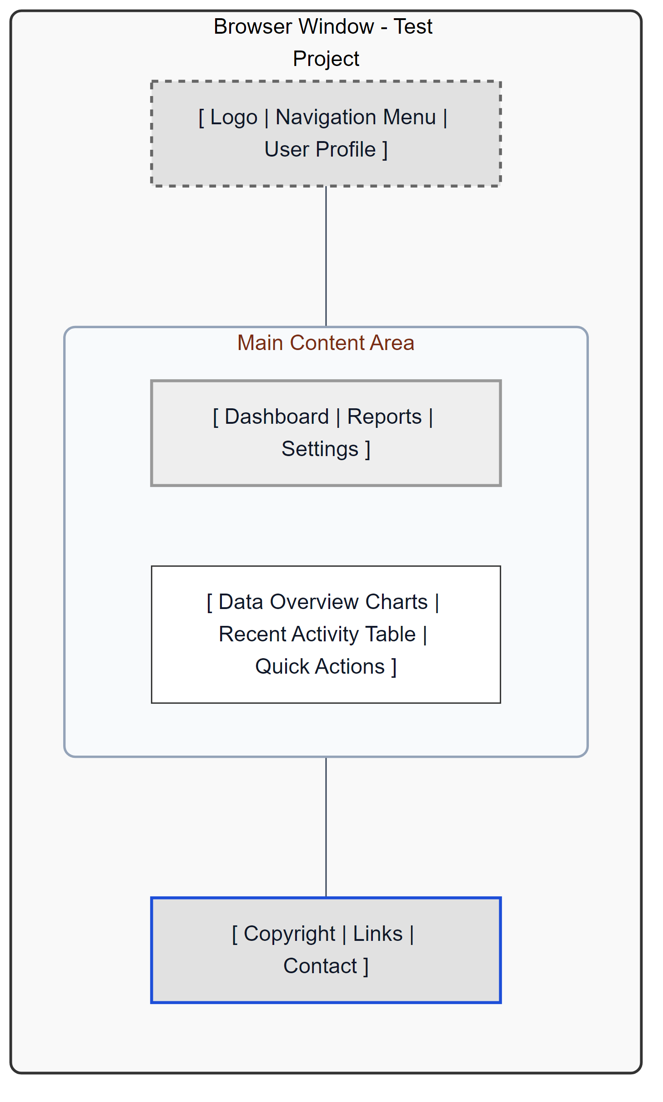
Figure: Main Dashboard Wireframe
The wireframe above represents the structural layout of the main application dashboard, incorporating navigation, content areas, and key interaction zones.

Appendix E: Risk Analysis
Risk | Probability | Impact | Mitigation
Service downtime during peak business operations | Medium | High | Add health checks, retries, and monitored deployment pipeline.
Unauthorized access to sensitive records | Low | High | Enforce RBAC, strong token controls, and audit logs.
Data inconsistency across integrated modules | Medium | Medium | Use validation rules and transactional update patterns.

