__________________________________________________________________________________________
SOFTWARE REQUIREMENTS SPECIFICATION
Prepared in IEEE 830 style
RetailFlow – Inventory & Sales Management System
Document Information
Prepared by: Alex Turner, Sophia Nguyen, Rahul Verma
Organization: NovaEdge Solutions
Version: 1.0
Date Created: 02/09/2026
Document ID | SRS-RETAILFLOW-–-INVENTO-001
Document Status | Draft
Prepared For | NovaEdge Solutions
__________________________________________________________________________________________

Table of Contents
Right-click and update field to generate Table of Contents.
Open in Microsoft Word and use 'Update Field' to refresh page numbers.

Visual Overview
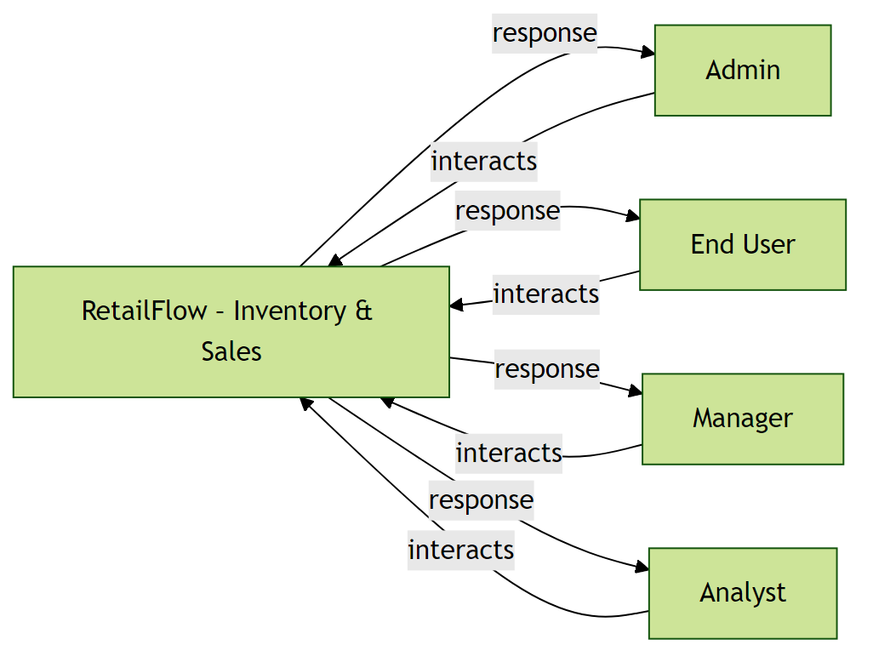  Figure A1: System Context | 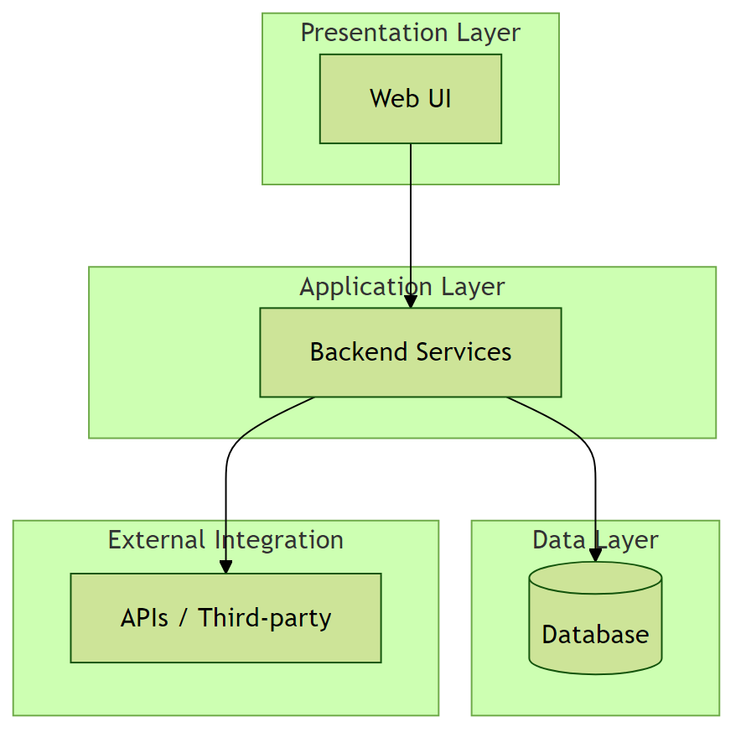  Figure A2: System Architecture
Figure A3: Use Case Diagram | Figure A4: User Workflow
Figure A5: Security Flow | Figure A6: Data ERD

1. Introduction

1.1 Purpose
Small and medium-sized retail businesses struggle to track inventory levels, sales performance, and stock replenishment in real time. Manual tracking and disconnected tools often lead to stockouts, overstocking, revenue loss, and poor decision-making. This system aims to centralize inventory, sales data, and reporting into a single, easy-to-use digital platform.

1.2 Scope of the System
The system provides a centralized platform for E-commerce operations with secure access, reporting, and monitoring. Features outside the specified requirements are excluded.

Included in scope:
- User authentication and authorization
- Product and inventory management
- Sales transaction tracking
- Low-stock alerts and notifications
- Supplier management
- Role-based dashboards
- Daily
- weekly
- and monthly sales reports
- Data export (CSV/PDF)
- System settings and configuration

1.3 Definitions, Acronyms, and Abbreviations
- SRS – Software Requirements Specification
- RBAC – Role-Based Access Control
- CRUD – Create, Read, Update, Delete
- UI – User Interface
- API – Application Programming Interface

1.4 Document Conventions
- IEEE 830-1998 style

2. Feasibility & Cost Estimation
The following cost and effort estimates are based on the COCOMO II model.
Metric | Estimated Value
Estimated Lines of Code (KLOC) | 5.2 KLOC
Development Effort | 14.5 Person-Months
Development Cost | $45,000
Required Schedule | 6 Months

2. Overall Description

2.1 Product Perspective
Web Application in the E-commerce domain. Small and medium-sized retail businesses struggle to track inventory levels, sales performance, and stock replenishment in real time. Manual tracking and disconnected tools often lead to stockouts, overstocking, revenue loss, and poor decision-making. This system aims to centralize inventory, sales data, and reporting into a single, easy-to-use digital platform.
Figure 1: System Context Diagram

2.2 Product Features
- User authentication and authorization
- Product and inventory management
- Sales transaction tracking
- Low-stock alerts and notifications
- Supplier management
- Role-based dashboards
- Daily
- weekly
- and monthly sales reports
- Data export (CSV/PDF)
- System settings and configuration

2.3 User Classes and Characteristics
Admin
End User
Manager
Analyst

2.4 Operating Environment
- Standard web/server environment

2.5 Design and Implementation Constraints

2.6 User Documentation
- User manual to be provided

2.7 Assumptions and Dependencies

3. System Architecture
The system follows a layered architecture consisting of: Presentation Layer (Web UI), Application Layer (Backend services), Data Layer (Database), and External Integration Layer (APIs, third-party services).
Figure 2: System Architecture Diagram

4. Functional Requirements

4.1 User authentication and authorization
Description: User logs into the system → accesses role-based dashboard → adds or updates products → records sales transactions → system updates inventory automatically → user views reports and receives low-stock alerts → exports reports for analysis

Functional Requirements:
- Support: User authentication and authorization

4.2 Product and inventory management

Functional Requirements:
- Support: Product and inventory management

4.3 Sales transaction tracking

Functional Requirements:
- Support: Sales transaction tracking

4.4 Low-stock alerts and notifications

Functional Requirements:
- Support: Low-stock alerts and notifications

4.5 Supplier management

Functional Requirements:
- Support: Supplier management

4.6 Role-based dashboards

Functional Requirements:
- Support: Role-based dashboards

4.7 Daily

Functional Requirements:
- Support: Daily

4.8 weekly

Functional Requirements:
- Support: weekly

4.9 and monthly sales reports

Functional Requirements:
- Support: and monthly sales reports

4.10 Data export (CSV/PDF)

Functional Requirements:
- Support: Data export (CSV/PDF)

4.11 System settings and configuration

Functional Requirements:
- Support: System settings and configuration

5. User Workflow
The typical user workflow includes: User logs into the system; System validates credentials; User accesses role-based dashboard; User performs permitted actions; System processes and stores data; User views results or reports.

Note: The User Flow / Workflow Diagram can be included above.

6. Non-Functional Requirements

6.1 Performance
- Performance: Normal. Scale: 100-1k.
Rationale: User-specified.

6.2 Safety

6.3 Security
- Authentication required.
Rationale: Security.

6.4 Quality

7. Security Requirements
The system shall: Enforce secure authentication mechanisms; Use encrypted communication channels; Protect sensitive data from unauthorized access; Log security-related events.

Note: The Security Flow Diagram can be included above.

8. Data Requirements
The system shall manage structured data entities and their relationships efficiently.

Note: The Entity Relationship Diagram can be included above.

9. External Interface Requirements

4.1 User Interfaces
Web or client UI as appropriate.

4.2 Hardware Interfaces
Standard hardware.
REST/API or as required.

10. Assumptions and Dependencies

Assumption 1:
Stakeholders have agreed on the problem statement and scope.
Impact: Scope clarity.

Assumption 2:
Target users: Admin, End User, Manager, Analyst.
Impact: Audience.

11. Future Enhancements
- Mobile application support
- Advanced analytics and insights
- Integration with additional third-party services

