__________________________________________________________________________________________
SOFTWARE REQUIREMENTS SPECIFICATION
Prepared in IEEE 830 style
Untitled Project
Document Information
Prepared by: Unknown
Organization: Unspecified
Version: 1.0
Date Created: 02/10/2026
Document ID | SRS-UNTITLED-PROJECT-001
Document Status | Draft
Prepared For | Unspecified
__________________________________________________________________________________________

Table of Contents
Right-click and update field to generate Table of Contents.
Open in Microsoft Word and use 'Update Field' to refresh page numbers.

Visual Overview
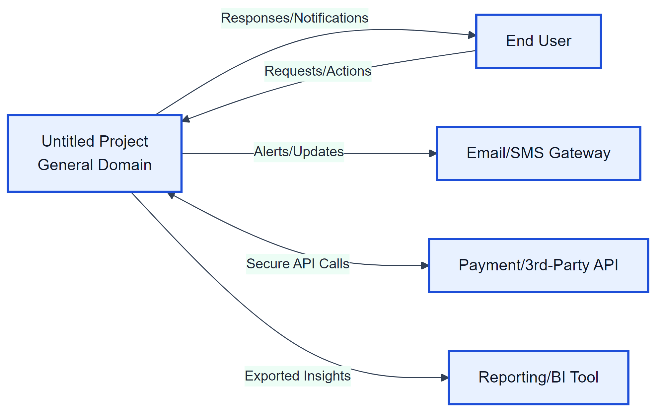  Figure A1: System Context | 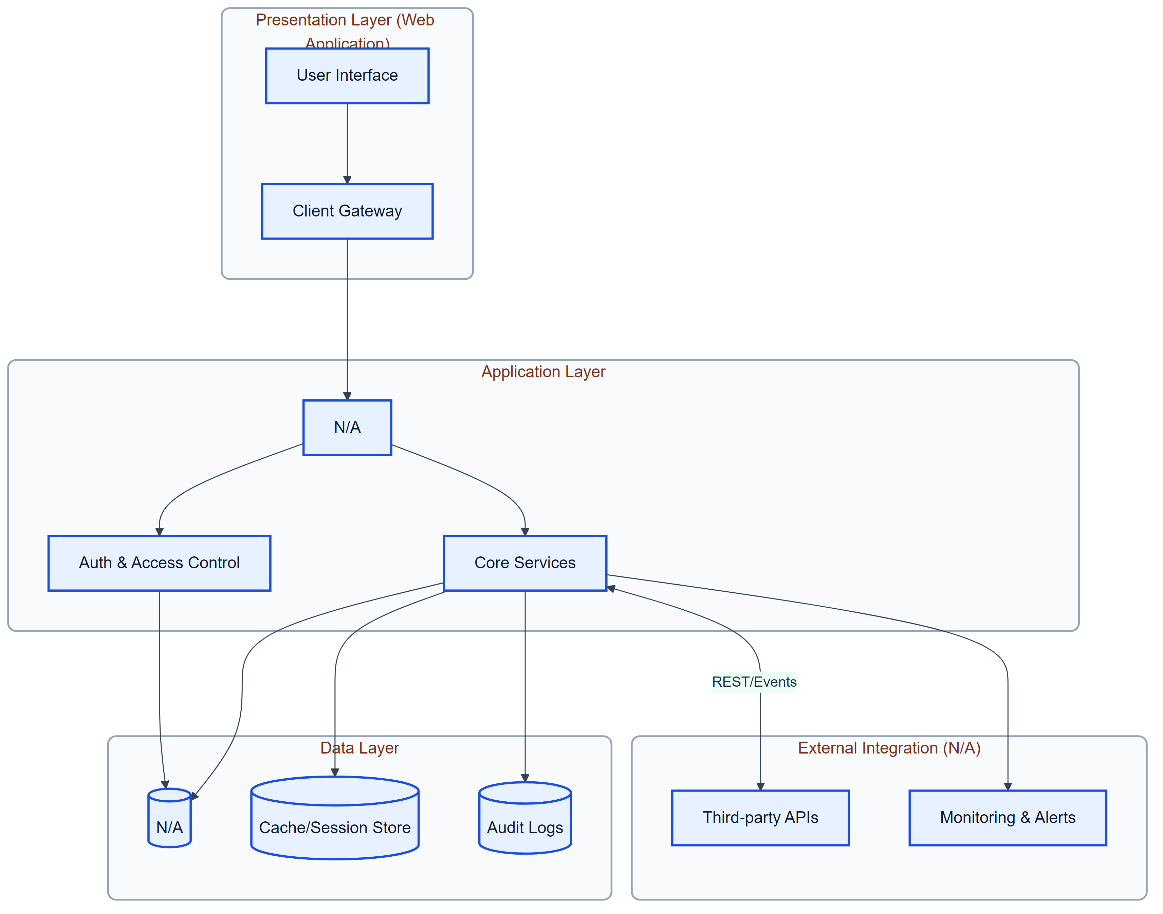  Figure A2: System Architecture
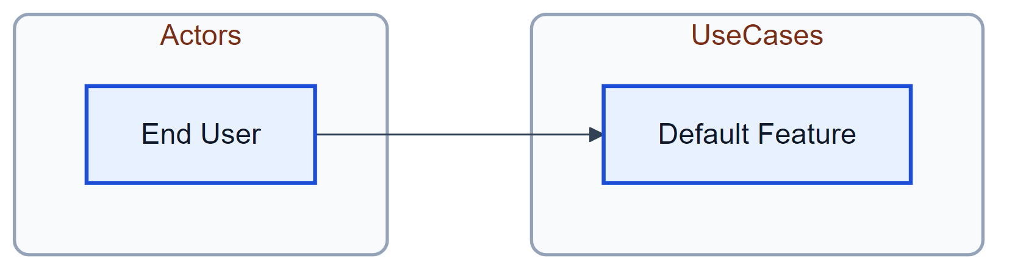  Figure A3: Use Case Diagram | Figure A4: User Workflow
Figure A5: Security Flow | 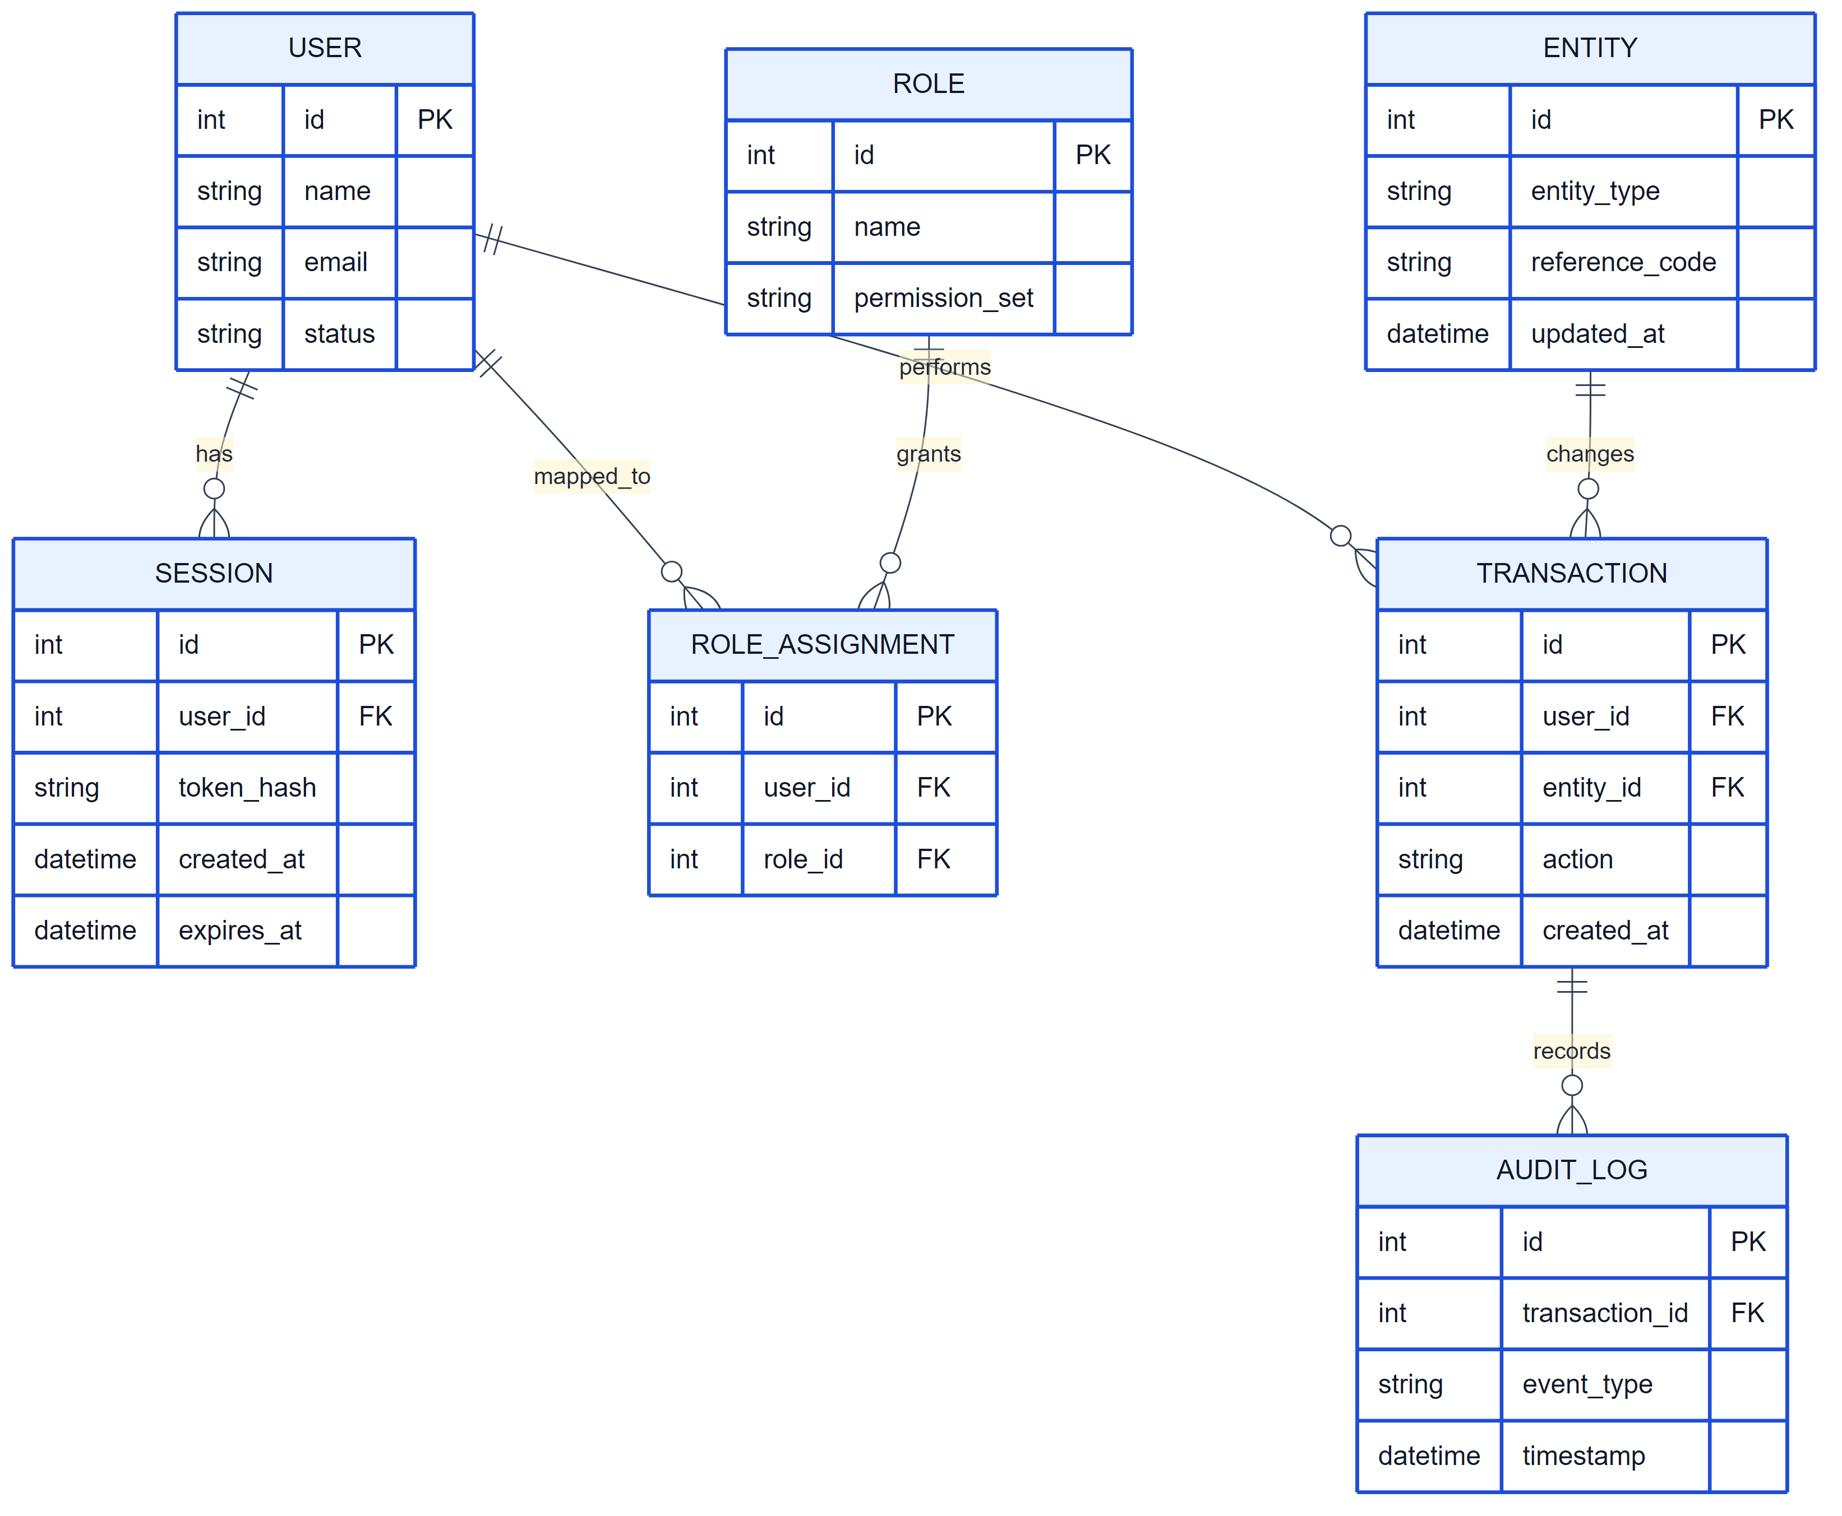  Figure A6: Data ERD

1. Introduction

1.1 Purpose
No problem statement provided.

1.2 Scope of the System
The system provides a centralized platform for General operations with secure access, reporting, and monitoring. Features outside the specified requirements are excluded.

Included in scope:
- Default Feature

1.3 Definitions, Acronyms, and Abbreviations
- SRS – Software Requirements Specification
- RBAC – Role-Based Access Control
- CRUD – Create, Read, Update, Delete
- UI – User Interface
- API – Application Programming Interface

1.4 Document Conventions
- IEEE 830-1998 style

2. Feasibility & Cost Estimation
The following cost and effort estimates are based on the COCOMO II model.
Metric | Estimated Value
Estimated Lines of Code (KLOC) | 5.2 KLOC
Development Effort | 14.5 Person-Months
Development Cost | $45,000
Required Schedule | 6 Months

2. Overall Description

2.1 Product Perspective
Web Application in the General domain. No problem statement provided.
Figure 1: System Context Diagram

2.2 Product Features
- Default Feature

2.3 User Classes and Characteristics
- End User

2.4 Operating Environment
- Standard web/server environment

2.5 Design and Implementation Constraints

2.6 User Documentation
- User manual to be provided

2.7 Assumptions and Dependencies

3. System Architecture
The system follows a layered architecture consisting of: Presentation Layer (Web UI), Application Layer (Backend services), Data Layer (Database), and External Integration Layer (APIs, third-party services).
Figure 2: System Architecture Diagram

4. Functional Requirements
Figure 3: Use Case Diagram

4.1 Default Feature
Description: Standard user flow.

Functional Requirements:
- Support: Default Feature

5. User Workflow
The typical user workflow includes: User logs into the system; System validates credentials; User accesses role-based dashboard; User performs permitted actions; System processes and stores data; User views results or reports.
Figure 4: User Workflow Diagram

6. Non-Functional Requirements

6.1 Performance
- Performance: Real-time. Scale: >100k.
Rationale: User-specified.

6.2 Safety

6.3 Security
- Authentication required.
Rationale: Security.

6.4 Quality

7. Security Requirements
The system shall: Enforce secure authentication mechanisms; Use encrypted communication channels; Protect sensitive data from unauthorized access; Log security-related events.
Figure 5: Security Flow Diagram

8. Data Requirements
The system shall manage structured data entities and their relationships efficiently.
Figure 6: Entity Relationship Diagram

9. External Interface Requirements

4.1 User Interfaces
Web or client UI as appropriate.
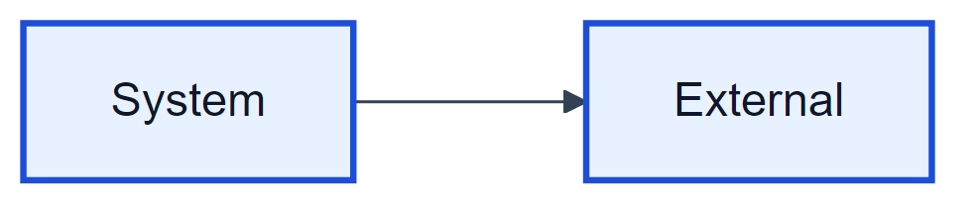
Figure 7: User Interface Diagram

4.2 Hardware Interfaces
Standard hardware.
Figure 8: Hardware Interface Diagram
Figure 9: Software/API Interface Diagram
REST/API or as required.

10. Assumptions and Dependencies

Assumption 1:
Stakeholders have agreed on the problem statement and scope.
Impact: Scope clarity.

Assumption 2:
Target users: End User.
Impact: Audience.

11. Future Enhancements
- Mobile application support
- Advanced analytics and insights
- Integration with additional third-party services

Appendices
The following appendices provide detailed specifications, models, and analysis for the proposed system.

Appendix A: Detailed User Personas
User Class | Description | Responsibilities | Skills/Requirements
End User | [] | N/A | N/A

Appendix B: Use Case Specifications

Default Feature
Description | Standard user flow.
Requirements | • Support: Default Feature

Appendix C: System Models

System Modeling & Design

Core Sequence Diagram
The following sequence diagram illustrates the typical interaction flow between the user, frontend, backend API, and data layer for a primary system action.
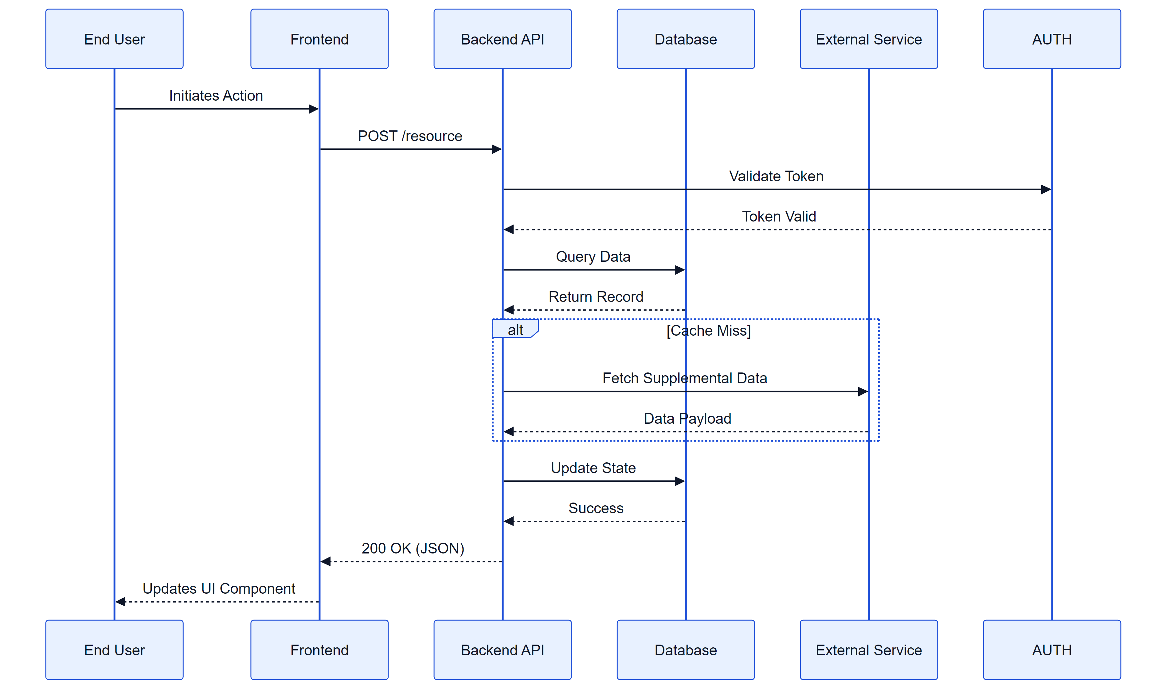
Figure: System Sequence Diagram

Entity State Diagram
The state diagram below depicts the lifecycle of key system entities (e.g., Orders, Tickets, or User Sessions) as they transition through various statuses.
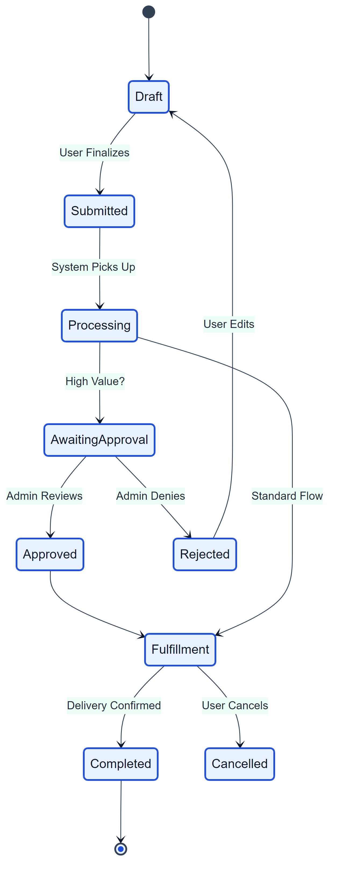
Figure: Entity State Diagram

Appendix D: UI Prototypes

User Interface Prototyping
This section provides a visual reference for the intended user interface layout and key components.

High-Level Wireframe
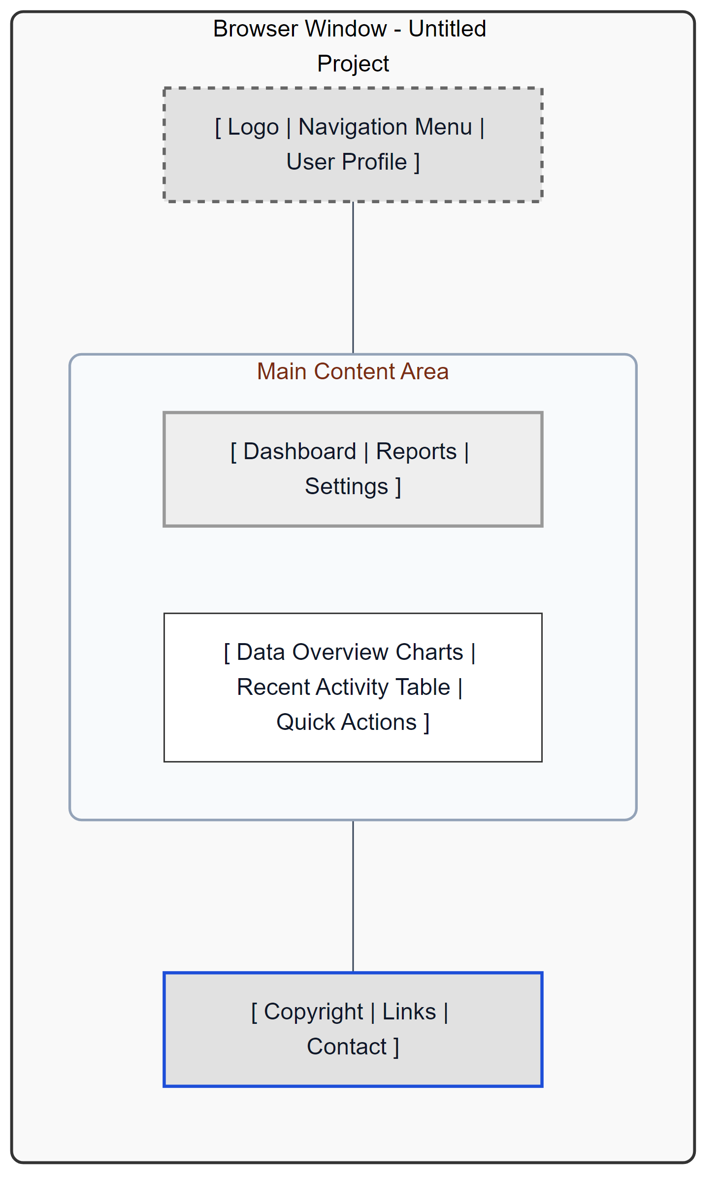
Figure: Main Dashboard Wireframe
The wireframe above represents the structural layout of the main application dashboard, incorporating navigation, content areas, and key interaction zones.

Appendix E: Risk Analysis
No specific risks identified.

Studio Diagram
Generated from DocuVerse Studio.
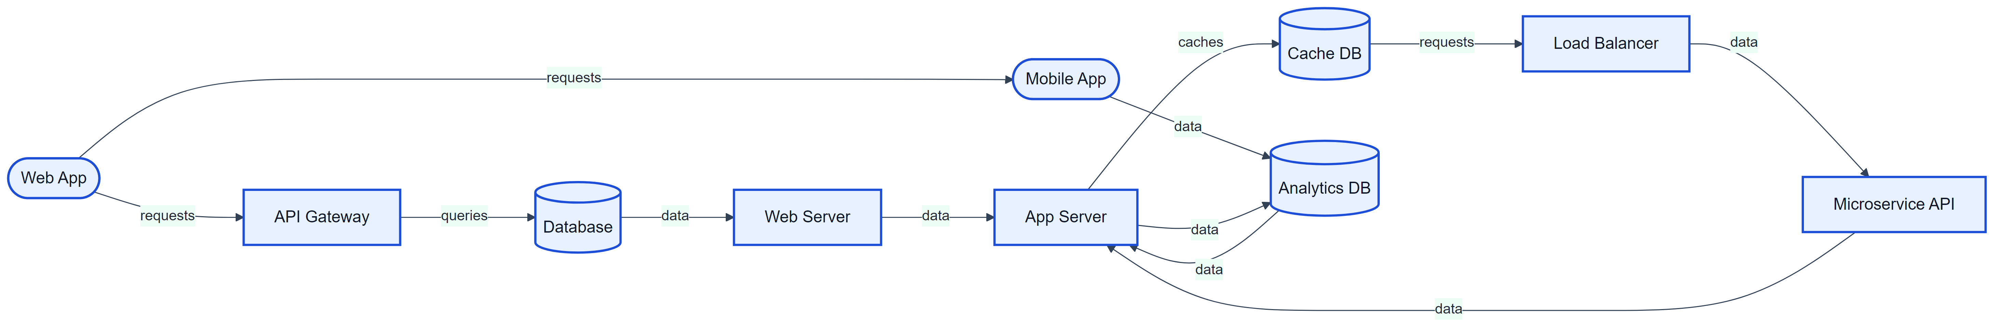

Studio Diagram
Generated from DocuVerse Studio.
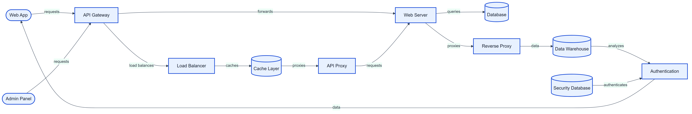

Studio Diagram
Generated from DocuVerse Studio.
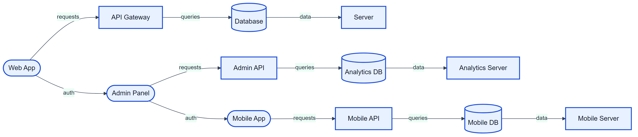

Studio Diagram
Generated from DocuVerse Studio.

Studio Diagram
Generated from DocuVerse Studio.
