__________________________________________________________________________________________
SOFTWARE REQUIREMENTS SPECIFICATION
Prepared in IEEE 830 style
Retail Inventory Optimization System
Document Information
Prepared by: System Analyst Team, Product Engineering Group
Organization: Confidential Enterprise Client
Version: 1.0
Date Created: 02/10/2026
Document ID | SRS-RETAIL-INVENTORY-OPT-001
Document Status | Draft
Prepared For | Confidential Enterprise Client
__________________________________________________________________________________________

Table of Contents
Right-click and update field to generate Table of Contents.
Open in Microsoft Word and use 'Update Field' to refresh page numbers.

Visual Overview
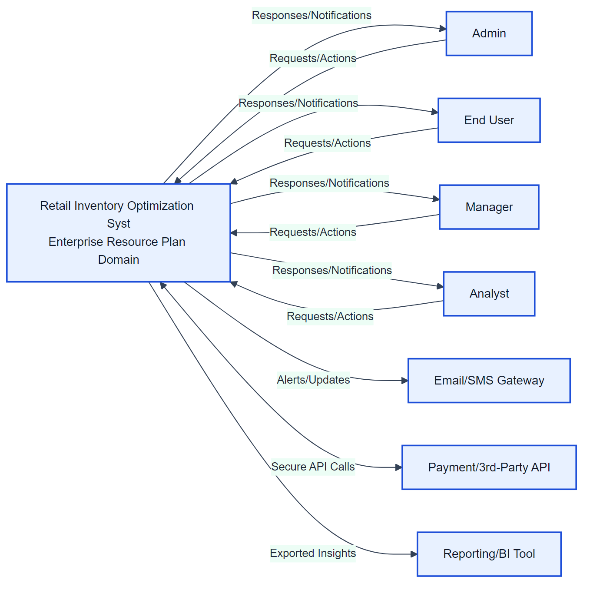  Figure A1: System Context | 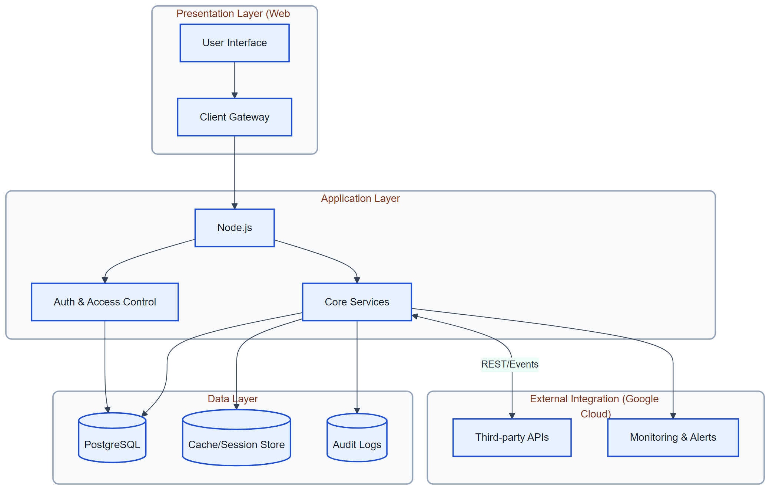  Figure A2: System Architecture
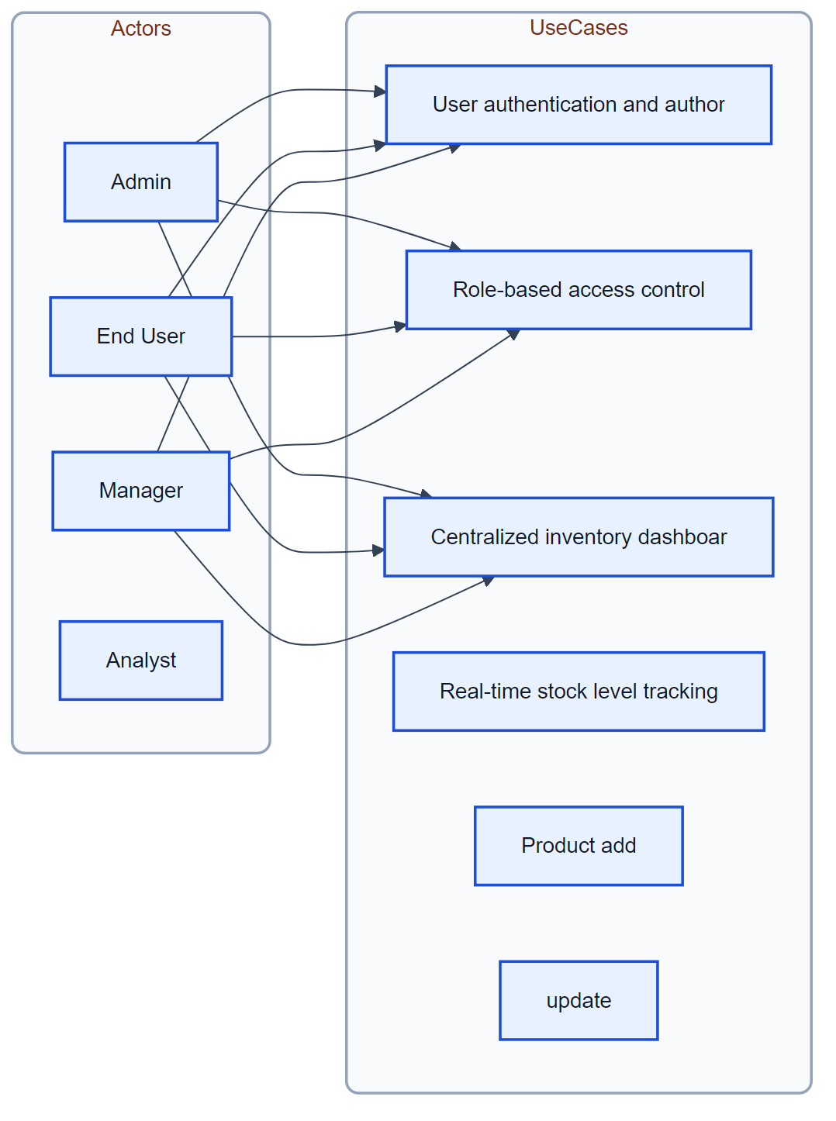  Figure A3: Use Case Diagram | Figure A4: User Workflow
Figure A5: Security Flow | 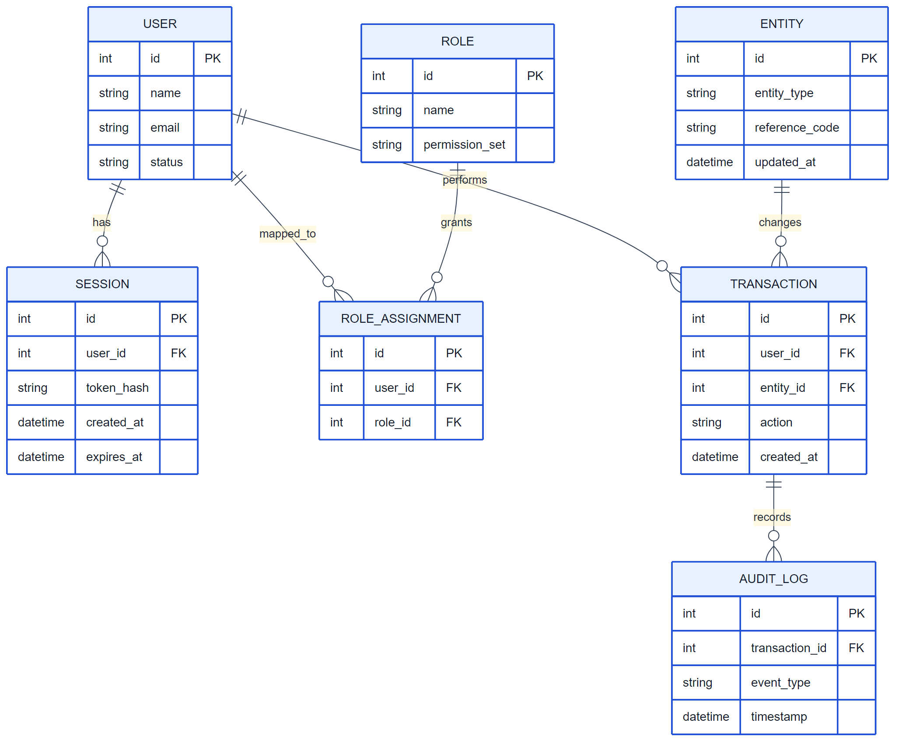  Figure A6: Data ERD

1. Introduction

1.1 Purpose
Retail businesses often face challenges such as overstocking, stock shortages, and lack of real-time visibility into inventory across multiple store locations. Manual inventory tracking leads to inaccurate data, delayed decisions, and increased operational costs. This system aims to centralize inventory management, provide real-time stock visibility, and support data-driven decision-making for retail operations.

1.2 Scope of the System
The system provides a centralized platform for Enterprise Resource Planning operations with secure access, reporting, and monitoring. Features outside the specified requirements are excluded.

Included in scope:
- User authentication and authorization
- Role-based access control
- Centralized inventory dashboard
- Real-time stock level tracking
- Product add
- update
- and delete functionality
- Low-stock and overstock alerts
- Multi-store inventory management
- Inventory movement history
- Report generation (daily
- weekly
- monthly)
- Export reports in CSV and PDF format

1.3 Definitions, Acronyms, and Abbreviations
- SRS – Software Requirements Specification
- RBAC – Role-Based Access Control
- CRUD – Create, Read, Update, Delete
- UI – User Interface
- API – Application Programming Interface

1.4 Document Conventions
- IEEE 830-1998 style

2. Feasibility & Cost Estimation
The following cost and effort estimates are based on the COCOMO II model.
Metric | Estimated Value
Estimated Lines of Code (KLOC) | 5.2 KLOC
Development Effort | 14.5 Person-Months
Development Cost | $45,000
Required Schedule | 6 Months

2. Overall Description

2.1 Product Perspective
Web Application in the Enterprise Resource Planning domain. Retail businesses often face challenges such as overstocking, stock shortages, and lack of real-time visibility into inventory across multiple store locations. Manual inventory tracking leads to inaccurate data, delayed decisions, and increased operational costs. This system aims to centralize inventory management, provide real-time stock visibility, and support data-driven decision-making for retail operations.
Figure 1: System Context Diagram

2.2 Product Features
- User authentication and authorization
- Role-based access control
- Centralized inventory dashboard
- Real-time stock level tracking
- Product add
- update
- and delete functionality
- Low-stock and overstock alerts
- Multi-store inventory management
- Inventory movement history
- Report generation (daily
- weekly
- monthly)
- Export reports in CSV and PDF format

2.3 User Classes and Characteristics
- Admin
- End User
- Manager
- Analyst

2.4 Operating Environment
- Standard web/server environment

2.5 Design and Implementation Constraints

2.6 User Documentation
- User manual to be provided

2.7 Assumptions and Dependencies

3. System Architecture
The system follows a layered architecture consisting of: Presentation Layer (Web UI), Application Layer (Backend services), Data Layer (Database), and External Integration Layer (APIs, third-party services).
Figure 2: System Architecture Diagram

4. Functional Requirements
Figure 3: Use Case Diagram

4.1 User authentication and authorization
Description: User logs into the system → selects store location → views inventory dashboard → monitors stock levels → receives alerts for low or excess stock → generates inventory reports → updates inventory records

Functional Requirements:
- Support: User authentication and authorization

4.2 Role-based access control

Functional Requirements:
- Support: Role-based access control

4.3 Centralized inventory dashboard

Functional Requirements:
- Support: Centralized inventory dashboard

4.4 Real-time stock level tracking

Functional Requirements:
- Support: Real-time stock level tracking

4.5 Product add

Functional Requirements:
- Support: Product add

4.6 update

Functional Requirements:
- Support: update

4.7 and delete functionality

Functional Requirements:
- Support: and delete functionality

4.8 Low-stock and overstock alerts

Functional Requirements:
- Support: Low-stock and overstock alerts

4.9 Multi-store inventory management

Functional Requirements:
- Support: Multi-store inventory management

4.10 Inventory movement history

Functional Requirements:
- Support: Inventory movement history

4.11 Report generation (daily

Functional Requirements:
- Support: Report generation (daily

4.12 weekly

Functional Requirements:
- Support: weekly

4.13 monthly)

Functional Requirements:
- Support: monthly)

4.14 Export reports in CSV and PDF format

Functional Requirements:
- Support: Export reports in CSV and PDF format

5. User Workflow
The typical user workflow includes: User logs into the system; System validates credentials; User accesses role-based dashboard; User performs permitted actions; System processes and stores data; User views results or reports.
Figure 4: User Workflow Diagram

6. Non-Functional Requirements

6.1 Performance
- Performance: Normal. Scale: 100-1k.
Rationale: User-specified.

6.2 Safety

6.3 Security
- Authentication required.
Rationale: Security.

6.4 Quality

7. Security Requirements
The system shall: Enforce secure authentication mechanisms; Use encrypted communication channels; Protect sensitive data from unauthorized access; Log security-related events.
Figure 5: Security Flow Diagram

8. Data Requirements
The system shall manage structured data entities and their relationships efficiently.
Figure 6: Entity Relationship Diagram

9. External Interface Requirements

4.1 User Interfaces
Web or client UI as appropriate.
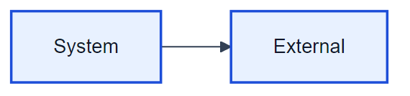
Figure 7: User Interface Diagram

4.2 Hardware Interfaces
Standard hardware.
Figure 8: Hardware Interface Diagram
Figure 9: Software/API Interface Diagram
REST/API or as required.

10. Assumptions and Dependencies

Assumption 1:
Stakeholders have agreed on the problem statement and scope.
Impact: Scope clarity.

Assumption 2:
Target users: Admin, End User, Manager, Analyst.
Impact: Audience.

11. Future Enhancements
- Mobile application support
- Advanced analytics and insights
- Integration with additional third-party services

Appendices
The following appendices provide detailed specifications, models, and analysis for the proposed system.

Appendix A: Detailed User Personas
User Class | Description | Responsibilities | Skills/Requirements
Admin | [] | N/A | N/A
End User | [] | N/A | N/A
Manager | [] | N/A | N/A
Analyst | [] | N/A | N/A

Appendix B: Use Case Specifications

User authentication and authorization
Description | User logs into the system → selects store location → views inventory dashboard → monitors stock levels → receives alerts for low or excess stock → generates inventory reports → updates inventory records
Requirements | • Support: User authentication and authorization

Role-based access control
Description
Requirements | • Support: Role-based access control

Centralized inventory dashboard
Description
Requirements | • Support: Centralized inventory dashboard

Real-time stock level tracking
Description
Requirements | • Support: Real-time stock level tracking

Product add
Description
Requirements | • Support: Product add

update
Description
Requirements | • Support: update

and delete functionality
Description
Requirements | • Support: and delete functionality

Low-stock and overstock alerts
Description
Requirements | • Support: Low-stock and overstock alerts

Multi-store inventory management
Description
Requirements | • Support: Multi-store inventory management

Inventory movement history
Description
Requirements | • Support: Inventory movement history

Report generation (daily
Description
Requirements | • Support: Report generation (daily

weekly
Description
Requirements | • Support: weekly

monthly)
Description
Requirements | • Support: monthly)

Export reports in CSV and PDF format
Description
Requirements | • Support: Export reports in CSV and PDF format

Appendix C: System Models

System Modeling & Design

Core Sequence Diagram
The following sequence diagram illustrates the typical interaction flow between the user, frontend, backend API, and data layer for a primary system action.
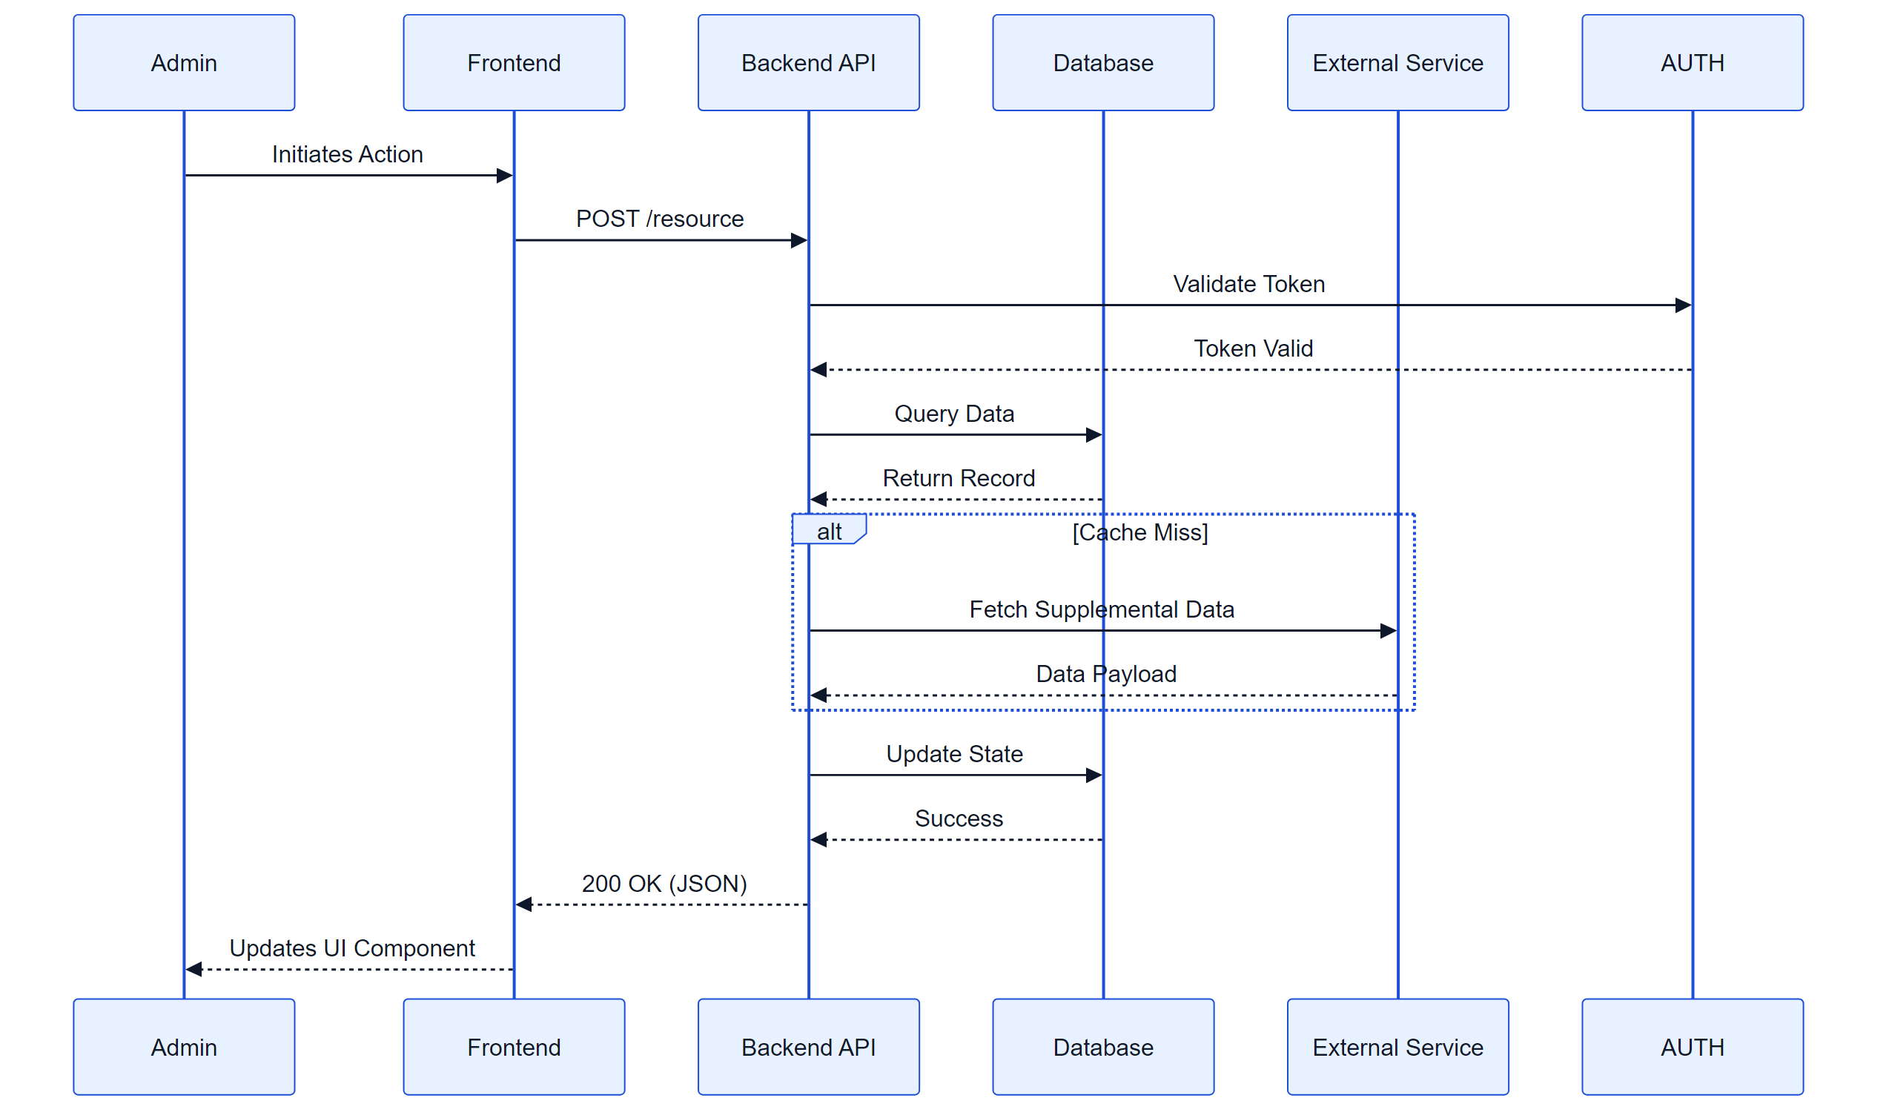
Figure: System Sequence Diagram

Entity State Diagram
The state diagram below depicts the lifecycle of key system entities (e.g., Orders, Tickets, or User Sessions) as they transition through various statuses.
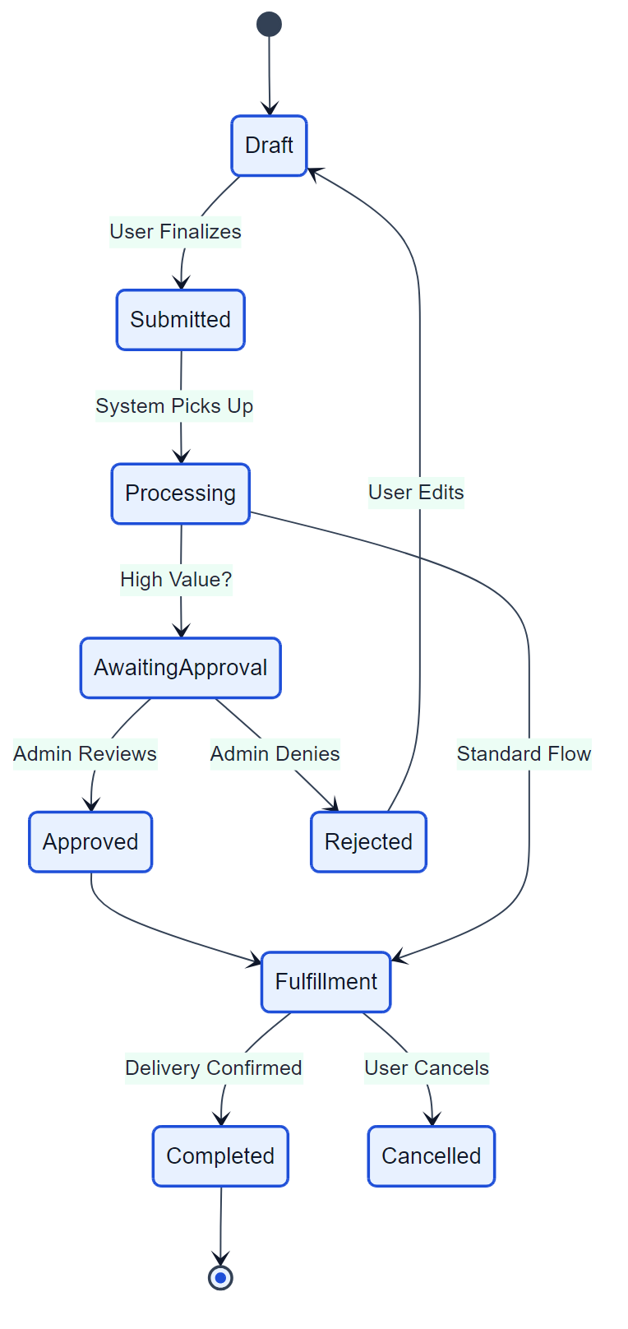
Figure: Entity State Diagram

Appendix D: UI Prototypes

User Interface Prototyping
This section provides a visual reference for the intended user interface layout and key components.

High-Level Wireframe
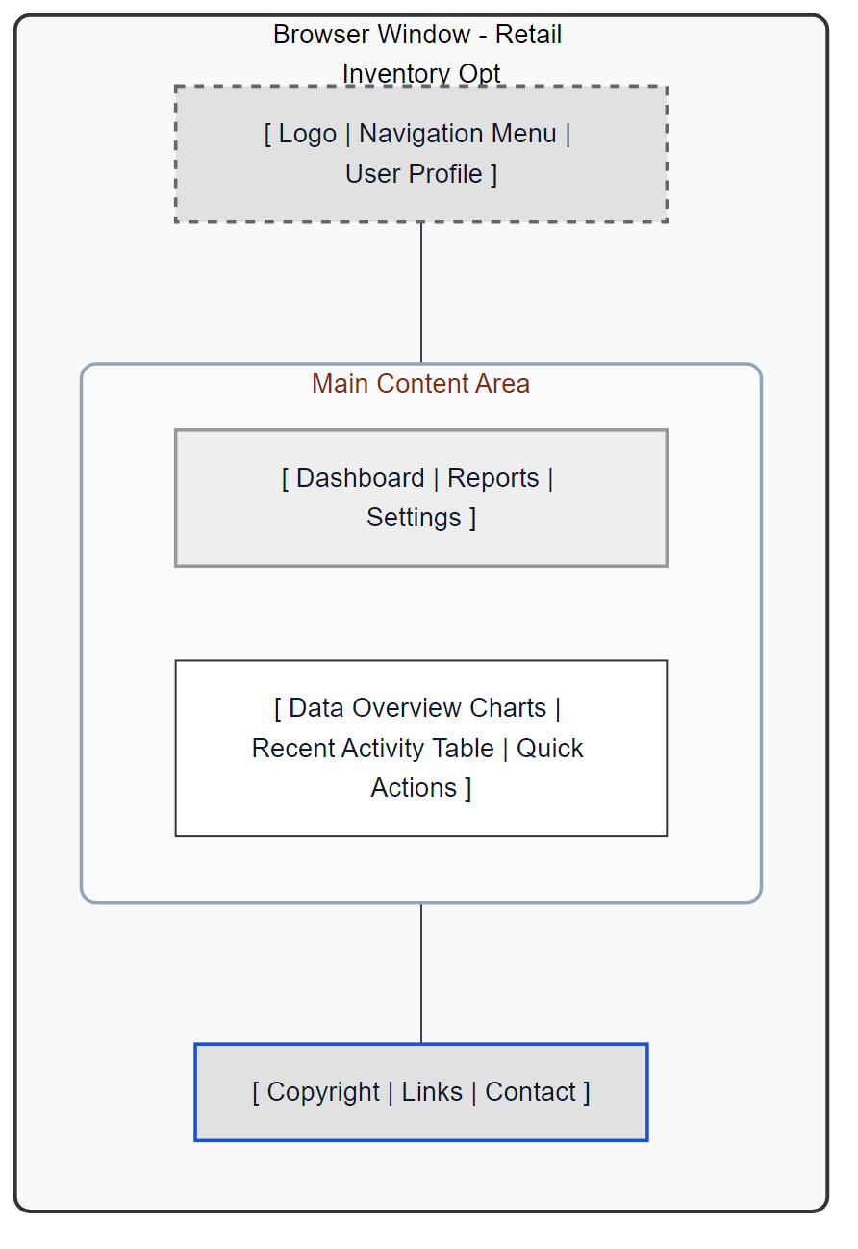
Figure: Main Dashboard Wireframe
The wireframe above represents the structural layout of the main application dashboard, incorporating navigation, content areas, and key interaction zones.

Appendix E: Risk Analysis
No specific risks identified.

