1. (i) In distributed balanced sliding window protocol discuss scenarios when following conditions are true
   1. Sp – lq = ap
   2. ap = sq
   3. sq = ap + lp

(ii) Answer following questions regarding FIFO property of channel in Mutual Exclusion algorithms

1. Why FIFO channel is required in Lamport’s mutual exclusion algorithm?
2. How the FIFO requirement is dropped from Ricarta-Agarwala algorithm?

* + - 1. +2 + 2+ 2+2=10

1. Answer following questions regarding mutual exclusion
   1. How an outdated request message for entering critical section is identified in Suzuki-Kasami’s algorithm”?
   2. How token queue is updated in suzuki kasami’s algorithm?
   3. Provide an example to show that maekawa’s mutual exclusion algorithm is not a deadlock free mutual exclusion algorithm.
   4. Build a valid request set for Maekawa’s algorithm of 7 processes.

1+1+2+3=7

1. Answer following questions from routing algorithms.
   1. Define S-Path.
   2. Let’s assume S’=S U {w}. Define S’-path between a pair of node u and v in terms of defined terms.
   3. Discuss two main disadvantages in Floyd-Warshall routing.
   4. How those disadvantages can be handled?
   5. Derive the message complexity of Chandy-Mishra routing algorithm.

1+1+2+2+3=9

1. Answer following questions from deadlock free packet switching
   1. If an acyclic orientation cover for P of size B exists, then there exists a Deadlock Free Controller with only B buffers at each node.
   2. Find acyclic covers for the following network.

3+3=6

1. Consider the following CHORD ring and answer following questions
2. Assume that hash key of a file is mapped to 7. Also assume that a search for the same file is inititated from node 1. During the search of the file a number of nodes and few entries of finger tables of those nodes will be examined. Populate a table in sequence of visit with format given below.

|  |  |  |  |
| --- | --- | --- | --- |
| Visit id | Node id | Finger table index | Comments |
| 1 |  |  |  |
| 2 |  |  |  |

1. Assume a new node is being inserted with hash value 6 and bootstrapping node is node 1. Write down actions taken by existing node and new joinee node. Draw current ring with updated finger tables.
2. How CHORD handled simultaneous joining of nodes?

4+6+2=12



1. Answer following questions from self stabilization
2. When will we say an algorithm is self stabilizing?
3. Write down two disadvantages of self stabilization algorithm.
4. Let us assume a system of n clocks in a chain ticking at the same rate. Each clock is 3-valued, i,e it ticks as 0, 1, 2, 0, 1, 2… A configuration is valid when all clocks are in same phase. A failure may arbitrarily alter the clock phases. The clocks phases need to be stabilized, i.e. they need to return to the same phase. Design a set of rules for this. Show changes of clock value with a chain of size 5 with initial configuration {0 2 1 0 1}.

2+2+4=8

1. a. Is leader election possible in a synchronous ring in which all but one processor has the same identifier? Give Proof.
2. Modify the LeLann & Chang-Robert’s algorithm for leader election to elect 2 leaders in a unidirectional ring (two processes with the highest IDs).
3. Write a code-snippet to explain extinction of waves in echo algorithm.
4. Prove that, leader election problem and minimum spanning tree problem are same order of magnitude in terms of complexity. 2 + 3 + 3 +4 = 10

4. In the GHS algorithm, let’s say there are two fragments F1 and F2 with level L1 and L2.

Let P be a node belonging to fragment F1 issues a connect request. Please answer the following

questions for L1<L2.

1. Is the connection request from P to Q always accepted immediately? If not what are

the conditions?

1. Q issues an initiate message if the connection request is accepted. What are the

parameters of the initiate message?

1. Let’s assume PQ is the minimum outgoing edge from fragment F2. What would be

the value of state parameter sent along initiate message? Justify your answer.

1. If PQ is not minimum outgoing edge for fragment F2 then what would be the value of

state parameter sent from Q to P? Justify your answer.      **1+1+2+2 = 6**

6. Consider the following algorithm for failure detection among n processes. Each process picks k other processes at random and sends heartbeat messages to each of those processes. If a process Pi receives a heartbeat message from process Pj, it will expect further heartbeats to arrive from Pj at regular intervals. If they stop, after some timeout, Pi declares Pj as having failed and broadcasts this to all of the other processes.

Suppose m random processes fail at once. What is the probability that not all failures will be detected? **5**

**7.** (i) Both cases Process 1 initiate the probing

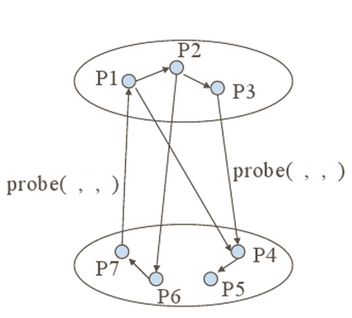

Fill in the probe messages that are passed, in the Chandy-Misra-Haas Algorithm. [2]

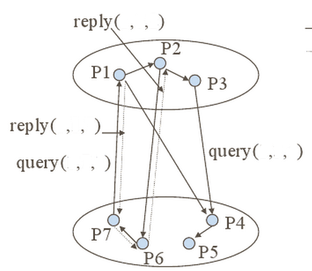

(ii)

Fill in the query and reply messages in Diffusion Computation based Algorithm. [3]

(iii) Give an example of a scenario where Obermarck’s Path pushing Algorithm detects a false deadlock.

(iv) Given Path pushing and Edge chasing algorithms - how is one better than the other in terms of message size?

(v) Derive the upper bound on number of messages exchanged in Chandy-Misra-Haas algorithm (AND model)(Edge chasing) for m processes and n sites. What is the delay in detecting a deadlock? [2 + 3 + 3 + 1 + 3 (2+1)] =12

8.

(i) Prove with an example that in Byzantine General’s Problem with m faulty generals, no solution is possible if total number of generals n < 3m+1(Show with n = 3,m=1)

* + 1. In Phase king algorithm,
    2. Prove that if king of phase k is non faulty then at the end of phase k all non faulty processors have same preference.

b. How many rounds are required for f faulty processors?

c. What is the message complexity? Justify.

d. Prove that if they reach consensus once, they will stick to the consensus arrived.

3 + 4 + 1 + 2 + 2 =12