**INDIAN INSTITUTE OF TECHNOLOGY, KHARAGPUR**

**Department: Computer Science and Engineering**

**Spring Semester: 2013**

Date Time Full Marks: 50

Sub. No: CS60002 Sub. Name: Distributed Systems

Answer as much as you can

1. Give an example to show that vector clocks are more powerful than Lamport’s logical clock.

3

1. Find the Lamport’s logical clock and vector clock time stamp of all the events shown as circles below

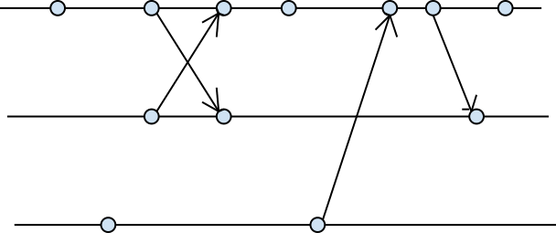

3

1. In Huang’s algorithm prove that W=1 signifies termination.

2

1. Give 3 examples of consistent, in-consistent and transit states from process diagram given below (Note: signifies that local state was recorded at that instant).

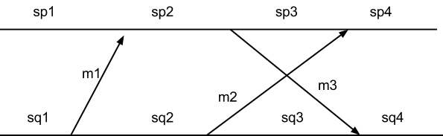

3

1. Two processes P and Q send and receive packets using sliding window protocol. Prove the following

Sp – lq ≤ ap ≤ sq ≤ aq + lp ≤ sp + lp

7

1. Modify the parameters of balanced sliding window protocol in such a manner that it acts as a stop and wait protocol. Show example with packet exchanges among two processes P and Q.

4

1. Consider that Toueg’s algorithm is being used to build routing table of the following network. Let’s assume that pivots are selected in the following order A, B, C, D, E, F and G.

Draw rooted trees (to pass routing table) for A, B and C when they are selected as pivot.

3x2=6

* 1. Find acyclic covers for the following network
  2. If more buffers are used (than acyclic orientation cover), what extra advantage will we get?

4+1=5

* 1. Prove that, each move allowed by Forward Count Controller, is also allowed by Forward State Controller.
  2. A controller that is a “dual” to Forward count Controller is called Backward Count Controller, i.e., it accepts a packet p iff tp > k – fu . Prove that, a Backward Count Controller is a deadlock-free controller.
  3. Copy-release deadlock may arise when the source node holds the copy of the packet until an end-to-end acknowledgement from the destination is received. But, this violates the assumption of deadlock free packet switching, that the buffer becomes empty when the packet is forwarded. Please explain your extension of buffer graph principle to combat against this type of deadlock.

4+6+2=12

* 1. Show that getting any message from all other processes is necessary but not sufficient condition to enter critical section in Lamport’s mutual exclusion algorithm.
  2. Show that being at top of the own request queue is necessary but not sufficient condition to enter critical section for Lamport’s mutual exclusion scheme.
  3. Comment on feasibility of the below message sequence in Lamport’s mutual exclusion algorithm.

2+2+1=5