THREE ADDRESS CODE GENERATION

Three Address Code:

Statements in this language are of the form:

x:=y op z

where x,y and z are names, constants or compiler-generated temporary variables, and ‘op’ stands for any operator.

A more complicated statement like

d:=x+y*z

would have to be translated to

t1:=y*z
t2:=x+t1
d:=t2

where t1 and t2 are compiler-generated temporary variable.

Three-address statements:

x:=y op z assignment

x:=op y unary assignment

x:=y copy

goto L unconditional jump

if x relop goto L conditional jump

param x procedure call

call p n procedure call

return y procedure call

x:=y[i] indexed assignment

x[i]:=y indexed assignment

x:=&y pointer assignment
x:=*y pointer assignment

*x=y pointer assignment

Syntax-Directed Translation into Three-Address Code:

Production | Semantic Rules
S->id:=E  E->E1+E2  E->E1*E2  E->-E1  E->( E1 )  E->id | S.code := E.code || gen(id.place ‘:=’ E.place)  E.place := newtemp;  E.code :=E1.code || E2.code || gen(E.place ‘:=’ E1.place ‘+’ E2.place)  E.place := newtemp;  E.code := E1.code || E2.code || gen(E.place ‘:=’ E1.place ‘*’ E2.place)  E.place := newtemp;  E.code :=E1.code || gen(E.place ‘:=’ ‘uminus’ E1.place)  E.place := E1.place;  E.code := E1.code;  E.place := id.place;  E.code := “”

1>E.place, the name that will hold the value of E, and
2>E.code, the sequence of three-address statements evaluating E.

Implementation of Three-Address Statements:

Eg. a := b * -c + b * -c

Quadruples:(easy to rearrange code for global optimization, lots of temporaries)
# | Op | Arg1 | Arg2 | Res
(0) | uminus | c |  | t1
(1) | * | b | t1 | t2
(2) | uminus | c |  | t3
(3) | * | b | t3 | t4
(4) | + | t2 | t4 | t5
(5) | := | t5 |  | a

Triples: (temporaries are implicit, difficult to rearrange code)
# | Op | Arg1 | Arg2
(0) | uminus | c
(1) | * | b | (0)
(2) | uminus | c
(3) | * | b | (2)
(4) | + | (1) | (3)
(5) | := | a | (4)

Indirect Triples: (temporaries are implicit & easier to rearrange code.
# | Stmt |  | # | Op | Arg1 | Arg2
(0) | (14) | → | (14) | uminus | c
(1) | (15) | → | (15) | * | b | (14)
(2) | (16) | → | (16) | uminus | c
(3) | (17) | → | (17) | * | b | (16)
(4) | (18) | → | (18) | + | (15) | (17)
(5) | (19) | → | (19) | := | a | (18)
Program Triple container

Declarations:

- When we encounter declarations, we need to lay out storage for the declared variables.
- For every local name in a procedure, we create a ST(Symbol Table) entry containing:
  - The type of the name
  - How much storage the name requires
  - A relative offset from the beginning of the static data area or beginning of the activation record.
- For intermediate code generation, we try not to worry about machine-specific issues like word alignment.

- To keep track of the current offset into the static data area or the AR, the compiler maintains a global variable, OFFSET.
- OFFSET is initialized to 0 when we begin compiling.
- After each declaration, OFFSET is incremented by the size of the declared variable

Translation scheme for decls in a procedure:

P -> D { offset := 0 }
D -> D ; D
D -> id : T { enter( id.name, T.type, offset );
offset := offset + T.width }
T -> integer { T.type := integer; T.width := 4 }
T -> real { T.type := real; T.width := 8 }
T -> array [ num ] of T1 { T.type := array( num.val, T1.type );
T.width := num.val * T1.width }
T -> ^ T1 { T.type := pointer( T1.type );
T.width := 4 }

Keeping track of scope

- When nested procedures or blocks are entered, we need to suspend processing declarations in the enclosing scope.

- Let’s change the grammar:

P -> D
D -> D ; D | id : T | proc id ; D ; S

- Suppose we have a separate ST(Symbol table) for each procedure.
- When we enter a procedure declaration, we create a new ST.
- The new ST points back to the ST of the enclosing procedure.
- The name of the procedure is a local for the enclosing procedure.

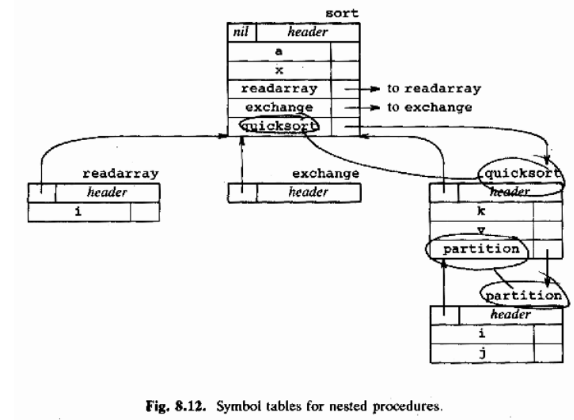

Operations supporting nested STs:

- mktable(previous) creates a new symbol table pointing to previous, and returns a pointer to the new table.
- enter(table,name,type,offset) creates a new entry for name in a symbol table with the given type and offset.
- addwidth(table,width) records the width of ALL the entries in table.
- enterproc(table,name,newtable) creates a new entry for procedure name in ST table, and links it to newtable.

Translation scheme for nested procedures:

- P -> M D { addwidth(top(tblptr), top(offset));
- pop(tblptr); pop(offset) }
- M -> ε { t := mktable(nil);
- push(t,tblptr); push(0,offset); }
- D -> D1 ; D2
- D -> proc id ; N D1 ; S { t := top(tblptr);
- addwidth(t,top(offset));
- pop(tblptr); pop(offset);
- enterproc(top(tblptr),id.name,t) }
- D -> id : T { enter(top(tblptr),id.name,T.type,top(offset));
- top(offset) := top(offset)+T.width }
- N -> ε { t := mktable( top( tblptr ));
- push(t,tblptr); push(0,offset) }

Records:

- Records take a little more work.
- Each record type also needs its own symbol table:

T -> record L D end { T.type := record(top(tblptr));
T.width := top(offset);
pop(tblptr); pop(offset); }
L -> ε { t := mktable(nil);
push(t,tblptr); push(0,offset); }

Adding ST lookups to assignments:

- Let’s attach our assignment grammar to the procedure
declarations grammar.

S -> id := E { p := lookup(id.name);
if p != nil then emit( p ‘:=‘ E.place ) else error }
E -> E1 + E2 { E.place := newtemp();
emit( E.place ‘:=‘ E1.place ‘+’ E2.place ) }
E -> E1 * E2 { E.place := newtemp();
emit( E.place ‘:=‘ E1.place ‘*’ E2.place ) }
E -> - E1 { E.place := newtemp();
emit( E.place ‘:=‘ ‘uminus’ E1.place ) }
E -> ( E1 ) { E.place := E1.place }
E -> id { p := lookup(id.name);
if p != nil then E.place := p else error }

- lookup() now starts with the table top(tblptr) and searches all enclosing scopes.

Prepared by : Anmol Ratan Bhuinya (04CS1035)

