Shameek Bain
02CS1009

Class on 7/11/2005
Directed Acyclic Graph
A directed acyclic graph (DAG!) is a directed graph that contains no cycles. A rooted tree is a special kind of DAG and a DAG is a special kind of directed graph. For example, a DAG may be used to represent common subexpressions in an optimising compiler.

+ +
. . . .
. . . .
* () *<---| ()
. . . . . . | . .
. . . . . . | . |
a b f * a b | f |
. . ^ v
. . | |
a b |--<----

Tree DAG

expression: a*b+f(a*b)

Example of Common Subexpression.
The common subexpression a*b need only be compiled once but its value can be used twice.
A DAG can be used to represent prerequisites in a university course, constraints on operations to be carried out in building construction, in fact an arbitrary partial-order `<'. An edge is drawn from a to b whenever a<b. A partial order `<' satisfies:
(i) transitivity, a<b and b<c implies a<c
(ii) non-reflexive, not(a < a)

Standard graph terminology is used throughout this section. In addition,
for a directed edge e we denote by src(e) and dst(e) the source vertex and
the destination vertex of e. Until Section 3.11, when we speak of the subject DAG we mean the expression DAG without the primary inputs, the
primary outputs, and the edges emanating from or incident to these
vertices; these vertices and edges are treated specially in Section 3.11. For instance, Figure 1 shows a C-code basic block and its corresponding DAG, in which primary inputs are shown as squares and primary outputs as double circles.

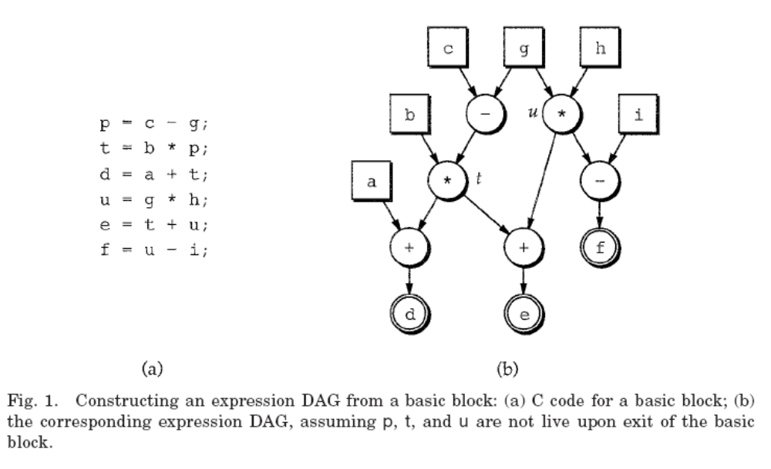
‘Optimizations’ of Basic Blocks
Equivalent transformations: Two basic block are equivalent if they compute the same set of expressions.
-Expressions: are the values of the live variables at the exit of the block.
Two important classes of local transformations:
-structure preserving transformations:
  - common sub expression elimination
  - dead code elimination
  - renaming of temporary variables
  - interchange of two independent adjacent statements.
-algebraic transformations (countlessly many):
  - simplify expressions
  - replace expensive operations with cheaper ones.

The DAG Representation of Basic Blocks

Directed acyclic graphs (DAGs) give a picture of how the value computed by each statement in the basic block is used in the subsequent statements of the block.
Definition: a dag for a basic block is a directed acyclic graph with the following labels on nodes:
- leaves are labeled with either variable names or constants.
  - they are unique identifiers
  - from operators we determine whether l- or r-value.
  - represent initial values of names. Subscript with 0.
- interior nodes are labeled by an operator symbol.
- Nodes are also (optionally) given a sequence of identifiers for labels.
- interior node ≡ computed values
- identifiers in the sequence – have that value.

Example of DAG Representation

t₁:= 4*i
t₂:= a[t₁]
t₃:= 4*i
t₄:= b[t₃]
t₅:= t₂ * t₄
t₆:= prod + t₅
prod:= t₆
t₇:= i + 1
i:= t₇
if i <= 20 goto 1
Three address code

*
+
[]
*
[]
+
<=
a
b
4
i₀
1
20
t₅
t₂
t₄
t₁, t₃
t₇, i
(1)
prod

Corresponding DAG

Utility: Constructing a dag from 3AS is a good way of determining:
- common sub expressions (expressions computed more than once),
- which names are used inside the block but evaluated outside,
- which statements of the block could have their computed value used outside the block.

Constructing a DAG

Input: a basic block. Statements: (i) x:= y op z (ii) x:= op y (iii) x:= y
Output: a dag for the basic block containing:
- a label for each node. For leaves an identifier - constants are permitted. For interior nodes an operator symbol.
- for each node a (possibly empty) list of attached identifiers - constants not permitted.
Method: Initially assume there are no nodes, and node is undefined.
- If node(y) is undefined: created a leaf labeled y, let node(y) be this node. In case(i) if node(z) is undefined create a leaf labeled z and that leaf be node(z).
- In case(i) determine if there is a node labeled op whose left child is node(y) and right child is node(z). If not create such a node, let be n. case(ii), (iii) similar.
- Delete x from the list attached to node(x). Append x to the list of identify for node n and set node(x) to n.
Algorithm DAG: Constructing a DAG
Input: A basic block of three address statements. No pointers or arrayreferences.
Output:A DAG where each node n has a value, VALUE(n), which is anoperator in the case of an interior node or a variable name if the node is a leaf. Also, each node n has a (possibly empty) list of identifiers attached,ID(n).
28
The DAG Representation of Basic Blocks The previous algorithm aims at improving the quality of the target code,but only with respect to register utilization.
There are a number of other issues in the generation of efficient code.One of them is the elimination of redundant computation. Thus, in the sequence
x := b*c*d+b*c*2.0 b := b*c*3.0 y := b*c+1.0
the same computation of b*c is done three times (the fourth occurence isnot the same because
b is reassigned).
The following algorithm identifies and removes common subexpressionsusing a DAG as intermediate representation. This algorithm assumes that there are no array element or pointers in the basic block. Traditional compiler optimizations do not deal naturally with arrayreferences and pointers.
27
Two special operators The [ ] operator is used to index a (one dimensional) array
a:=b[i] can be translated as (1)
l R,b(R)
if i is in register R (2)
l R,M l R,b(R)
if i is memory location M (3)
l R,S(A) l R,b(R)
if i is in stack offset S.
The * operator is similar. For example, (2) abore is replaced by
l R,M l R,*R
26
getreg(y,I) if there is register R such that RD(R) = {y} andNEXTUSE(
y,I) is emptythen
return (R)endif if there is R in REGISTERS such that RD(R) is empty thenreturn(
R)endif
R:= getanyregister()forall
v in RD(R) doAD(
v) := AD(v) - {R}if SYMTAB.loc(
v) is not in AD(v) thengenerate( st R,SYMTAB.loc(v))AD( v) := AD(v) + {SYMTAB.loc(v)}endif
enddoreturn(R)

